

Exploratory Data Analysis – Report and Demonstration
Component 2
Programme: MSc Data and Artificial Intelligence
Module: L7 - Data Mining & Visualisation
Module code: ACCA7015
Lecturer: Dr Nouh Elmitwally
Submission deadline: 2 pm, Wednesday, 29/07/2026
Student name: Natalia Goncearuc
Student ID: 2228229
Table of Contents
Abstract 2
1. Introduction 2
2. Literature Review 3
2.1 Overview of Customer Churn Prediction 3
2.2 Classification Techniques 4
2.3 Clustering Analysis 5
2.4 Evaluation Metrics 5
2.5 Critical Analysis 6
3. Methodology 7
3.1 Dataset Description 7
3.2 Feature Selection 7
3.3 Data Pre-Processing 9
3.4 Tools and Environment 12
4. Classification Models Implementation 12
5. Model Evaluation and Comparison 15
5.1 Evaluation Metrics & Performance Results 15
5.2 Confusion Matrix Analysis 17
5.3 ROC Curve Analysis 19
5.4 Model Comparison 21
6. Clustering 22
6.1 Technique Used: K-Means Clustering 22
6.2 Implementation 22
6.3 Cluster Interpretation 23
6.4 Cluster Visualisation and Analysis 24
7. Results and Discussion 28
8. Business Recommendations 29
9. Conclusion 30
11. Appendices 34

Abstract
Customer churn is a major challenge in the telecommunications industry, directly affecting revenue and customer retention. This study applied machine learning classification and clustering techniques to analyse customer churn behaviour using the Telecom Customer Churn dataset. Logistic Regression, Support Vector Machine (SVM), and Random Forest models were developed and evaluated using Accuracy, Precision, Recall, F1-Score, and AUC metrics. Random Forest achieved the strongest performance, with an accuracy of 60.5% and an AUC of 0.650. Feature importance analysis identified equipment age, service usage, monthly revenue, and handset value as the primary drivers of churn. K-Means clustering further revealed two distinct customer segments: Low-Engagement Churners and High-Value Churners. The findings demonstrate the value of combining predictive modelling and customer segmentation to support data-driven retention strategies and improve customer relationship management in the telecommunications sector.

1. Introduction

Customer retention is very important in the telecommunications industry due to the high competition, which makes it easy for customers to switch providers. Customer churn, or churn rate, has a significant impact on revenue and long-term sustainability[1]. Predicting churn is essential to improving loyalty and gaining a competitive advantage. Advances in data mining and machine learning have allowed organisations to extract insights from customer databases and develop predictive models. By analysing data, companies can identify customers at risk and implement targeted retention strategies [2] [3]. Classification techniques help categorise customers into groups, such as those likely to churn or those likely to stay[4].
This report uses the Telecom Customer Churn dataset, which includes demographics, service subscriptions, and account characteristics. The primary goal is to develop predictive models to classify customer retention outcomes using revenue, service, device, and demographic characteristics. Three classification techniques will be analysed and compared for their effectiveness in identifying churn. In addition, an unsupervised data mining technique, such as clustering, will allow for the analysis of churned customers to uncover hidden patterns and segments. The performance of the models will be evaluated using metrics such as accuracy, precision, recall, and F1 score [5]. The findings will be interpreted in the context of customer retention and will provide practical recommendations for the telecommunications sector.
The report is structured as follows: Section 2 reviews the relevant literature; Section 3 presents the dataset and methodology; Section 4 presents the results and evaluations; Section 5 discusses the findings and their implications; and Section 6 concludes with recommendations for future work.

2. Literature Review

2.1 Overview of Customer Churn Prediction
Customer churn refers to the termination of a customer’s relationship with a company, often driven by dissatisfaction with service quality, pricing, customer experience, or by attractive offers from competitors [6]. In the telecommunications industry, annual churn rates can range from 20% to 40%, creating substantial financial challenges by reducing recurring revenue and lowering customer lifetime value. Since acquiring a new customer is significantly more expensive than retaining an existing one, reducing churn has become a strategic priority for telecom providers [7].
Advances in digital technologies have allowed organisations to gather extensive customer data, including demographics, billing records, usage patterns, and communication behaviour [8]. Analysing this data can identify potential churn and guide proactive retention strategies[9]. Traditional methods often struggle with the complexity of modern datasets, making machine learning and data mining techniques essential for spotting at-risk customers[10]. These methods enable targeted interventions, such as personalised promotions and loyalty programs, improving retention rates and optimising marketing resource allocation [4].

2.2 Classification Techniques
Classification is a supervised machine learning approach for predicting categorical outcomes from historical data. In customer churn prediction, classification models determine whether a customer is likely to churn or remain with the provider. Among the most widely used methods are Logistic Regression, Random Forest, and Support Vector Machine (SVM) [11].
Logistic Regression is a popular baseline model for binary classification problems. It predicts churn probability using a logistic function that relates the predictor variables to the churn outcome[11], [12]. Its strengths include simplicity, computational efficiency, and interpretability, allowing organisations to understand how specific factors influence customer behaviour. However, because Logistic Regression assumes a linear relationship between variables and the target outcome, it may struggle to capture the complex interactions commonly found in telecommunications data[6].
Random Forest is an ensemble learning technique that combines multiple decision trees and aggregates their predictions via majority voting[5]. By using random subsets of observations and features, Random Forest reduces overfitting and improves prediction stability. The model is particularly effective at churn prediction because it can identify nonlinear relationships and variable interactions. Furthermore, Random Forest produces feature importance scores, helping organisations understand which factors contribute most significantly to customer attrition [4].
A Support Vector Machine (SVM) classifies customers by identifying an optimal decision boundary that maximises the separation between churners and non-churners[13]. Through kernel functions, such as the Radial Basis Function (RBF), SVM can model complex nonlinear relationships and often achieves strong predictive performance[11]. However, SVM is computationally demanding, sensitive to parameter selection, and less interpretable than Logistic Regression [6].
Overall, these techniques represent different trade-offs between interpretability, complexity, and predictive accuracy[14]. Comparing their performance provides valuable insight into the most suitable approach for customer churn prediction in telecommunications environments.

2.3 Clustering Analysis
Unlike classification, which predicts predefined outcomes, clustering is an unsupervised learning technique that groups customers based on similar characteristics. In churn analysis, clustering helps identify customer segments that share common behaviours, spending patterns, service usage levels, and potential churn risks[1]. Telecommunications customers often exhibit highly diverse behaviours, making it difficult to identify churn drivers through a single, broad analysis. Clustering addresses this issue by dividing customers into more homogeneous groups [1]. Such segmentation provides deeper insights into customer needs and supports more effective decision-making [7].
Among clustering algorithms, K-Means is among the most widely used due to its simplicity, scalability, and computational efficiency [10]. The algorithm groups data into clusters by assigning customers to the nearest centroid and minimising within-cluster variation. Its ability to process large datasets efficiently makes it particularly suitable for telecommunications applications [1].
The alternative clustering method is Hierarchical Clustering, which reveals nested relationships within data, providing deeper insights into cluster structures [1]. However, it is high in computational complexity and memory requirements, making it less suitable for large-scale datasets [15].

2.4 Evaluation Metrics
Evaluating churn prediction models requires multiple performance metrics, as overall accuracy alone may not adequately reflect a model’s ability to identify customers at risk of churn[12].
Accuracy measures the proportion of correctly classified observations and provides a useful initial comparison between models. However, because churn datasets are often imbalanced, a high accuracy score may not necessarily indicate good churn-detection performance.
To provide a more balanced assessment, Precision, Recall, and F1-Score are commonly used. Precision measures the proportion of predicted churners who actually churn, while Recall evaluates the model’s ability to identify true churners[7]. The F1-Score combines both metrics into a single measure, balancing the trade-off between precision and recall [11].
The Confusion Matrix further supports model evaluation by displaying correct and incorrect classifications[16]. It highlights the number of true positives, true negatives, false positives, and false negatives, enabling analysts to understand the practical consequences of prediction errors[5].
Additionally, the Receiver Operating Characteristic (ROC) Curve and Area Under the Curve (AUC) assess a model’s ability to distinguish between churners and non-churners across different classification thresholds. Higher AUC values indicate stronger discrimination and greater predictive effectiveness [11].

2.5 Critical Analysis
Among the classification techniques reviewed, Logistic Regression offers transparency and ease of interpretation, but is limited by its assumption of linear relationships [12]. SVMs can model more complex patterns and often achieve higher accuracy, though their computational demands and limited interpretability limit their practical appeal in business environments[13]. Random Forest provides the most balanced solution. It effectively captures complex interactions, minimises overfitting through ensemble learning, delivers strong predictive performance, and provides feature importance measures that improve model explainability[12]. These advantages make it one of the most effective algorithms for predicting telecommunications churn. However, effectiveness depends on appropriate parameter tuning and data characteristics [17].
From a segmentation perspective, K-Means offers an effective combination of scalability, efficiency, and clustering quality[10]. Compared with Hierarchical Clustering, it is better suited to large telecom datasets and facilitates the discovery of meaningful customer segments[1]. Classification and clustering techniques offer accurate churn prediction and valuable insights, helping organisations implement targeted retention strategies and enhance customer relationship management [7].

3. Methodology
Based on the literature and the characteristics of the telecom dataset, Logistic Regression, SVM, and Random Forest were selected for classification, while K-Means was selected for customer segmentation [7]. These techniques offer a balance of interpretability, predictive ability, and business insights, enabling churn prediction and the identification of customer segments for targeted retention strategies [14].

3.1 Dataset Description
This study utilised the Telecom_Customer_Churn.csv dataset, which contains customer information collected from a telecommunications service provider. The dataset consists of 100,000 customer records and 100 attributes, making it suitable for large-scale machine learning and customer analytics applications (Figure 1).

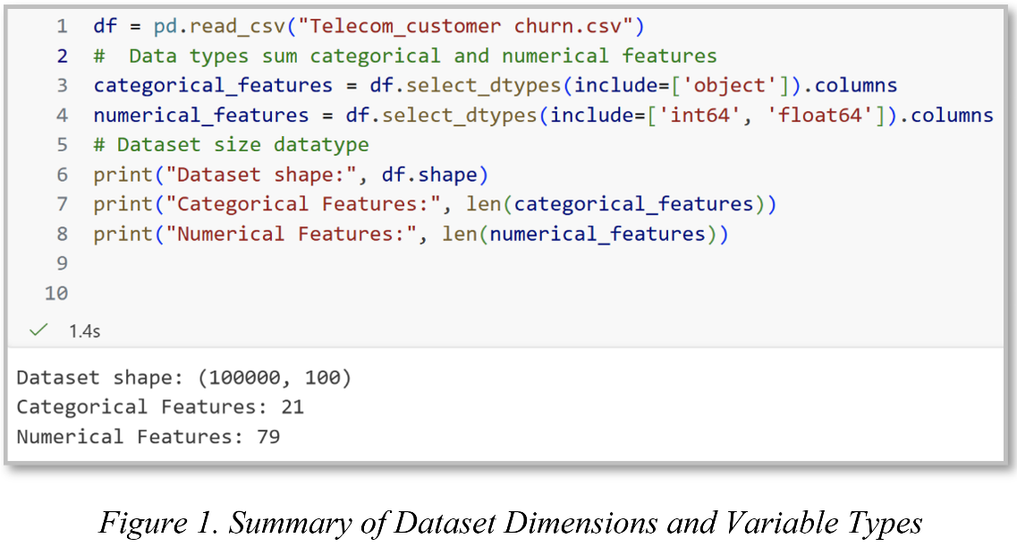

The dataset contained a mixture of numerical and categorical variables. The target variable used in this study is Churn, which indicates whether a customer left the telecommunications provider. True (1) = Customer left the service provider, and False (0) = Customer remained with the service provider.

3.2 Feature Selection
Feature selection was performed to reduce dimensionality, improve computational efficiency, and enhance model performance by retaining variables most relevant to customer churn prediction [8]. A combination of SelectKBest, exploratory data analysis, and domain knowledge was used to identify the most informative features. The selected variables represented five key categories (Table 1). Revenue measures were included because spending behaviour is closely associated with customer value and retention. Service usage variables were selected as indicators of customer engagement and activity levels. Device-related attributes were retained because handset age and value can influence customer satisfaction and loyalty.
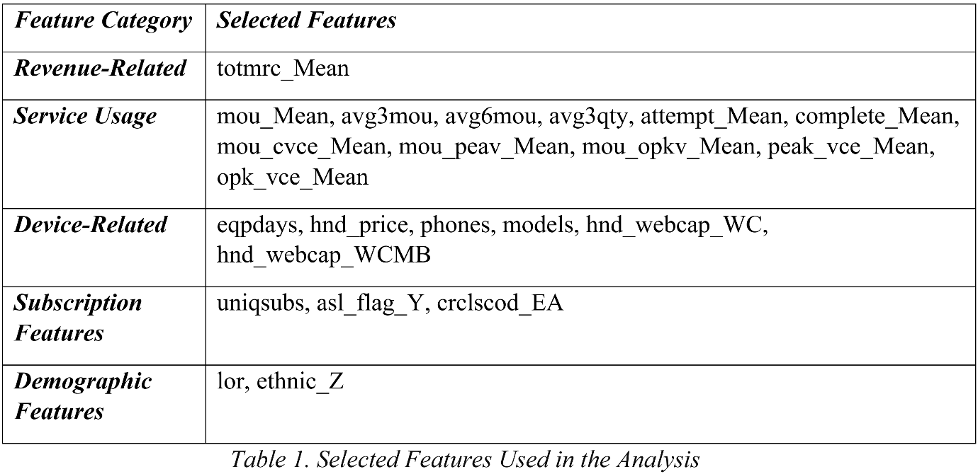
Subscription variables provided additional information regarding customer account characteristics, while demographic features supported customer profiling and segmentation.
A correlation heatmap was generated to examine relationships between variables and churn. The analysis identified features positively and negatively associated with customer churn, supporting feature selection and providing insight into key factors influencing customer attrition (Figure 2).
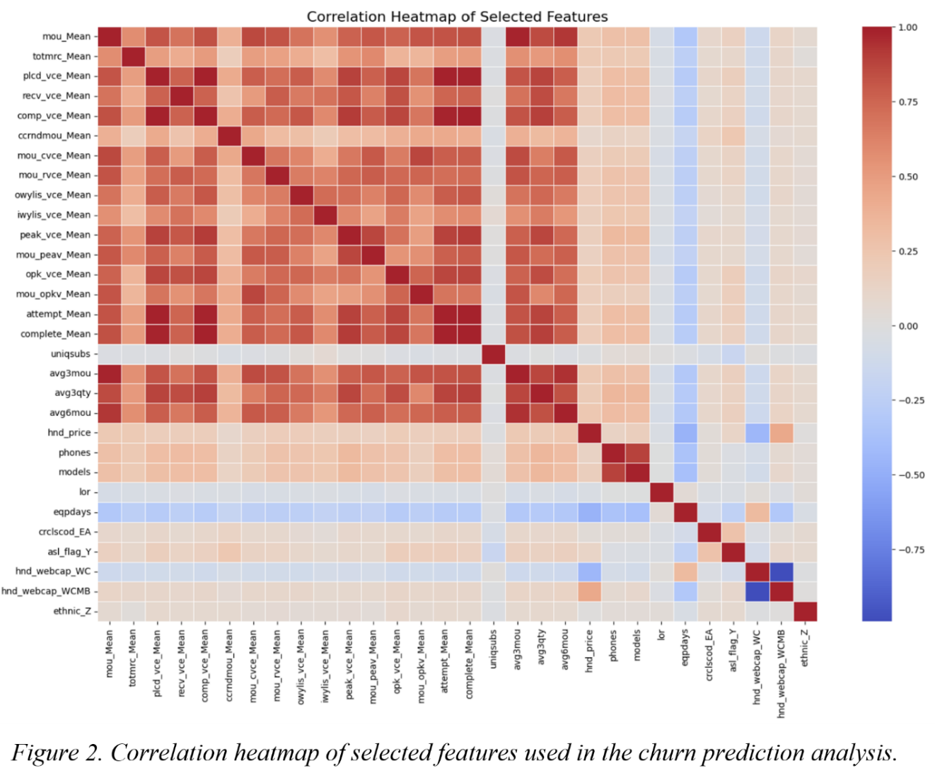

3.3 Data Pre-Processing
Data preprocessing was performed to enhance data quality, ensure compatibility with machine learning algorithms, and support accurate customer churn prediction and segmentation [18]. Figure 3 illustrates the complete preprocessing workflow applied to the Telecom Customer Churn dataset.
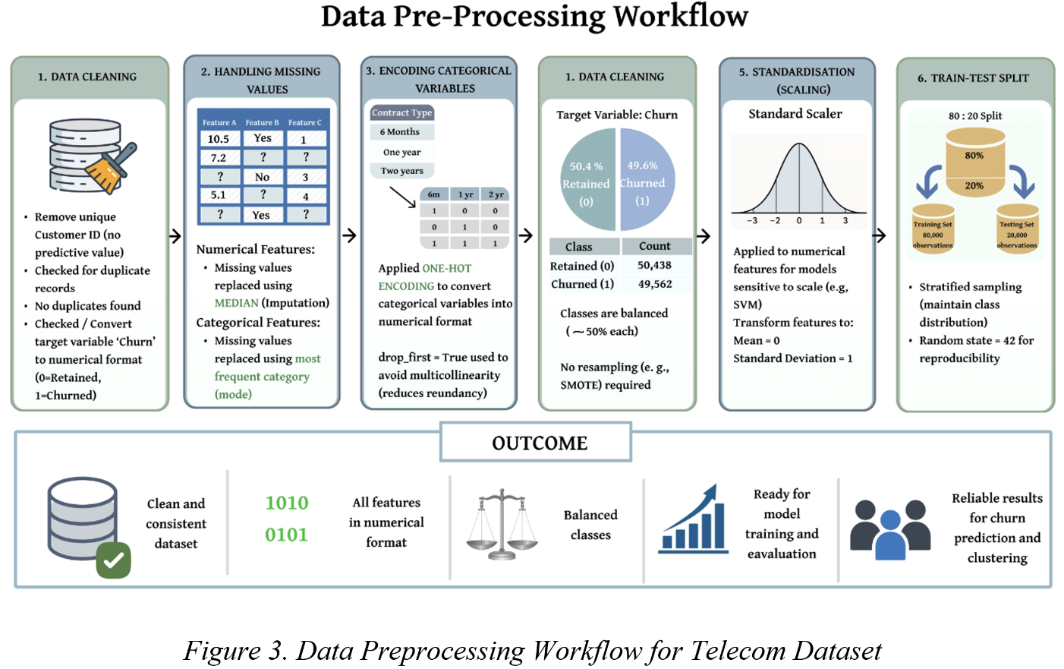

Data preprocessing included removing non-informative variables and checking for duplicates. The Churn variable was coded as 0 (retained) and 1 (churned), and its distribution was reviewed. Missing numerical values were imputed with the median, and categorical variables were imputed with the mode. Categorical features were transformed with One-Hot Encoding for machine learning suitability. Class distribution analysis showed a nearly balanced dataset, with 50.4% retained customers and 49.6% churned customers (Figure 4). Consequently, oversampling techniques such as SMOTE were unnecessary, allowing models to be trained without introducing artificial observations. Feature scaling was performed using StandardScaler before model training, transforming numerical variables to have a mean of zero and a standard deviation of one. This ensured that all features contributed equally and prevented larger-range variables from skewing the results.

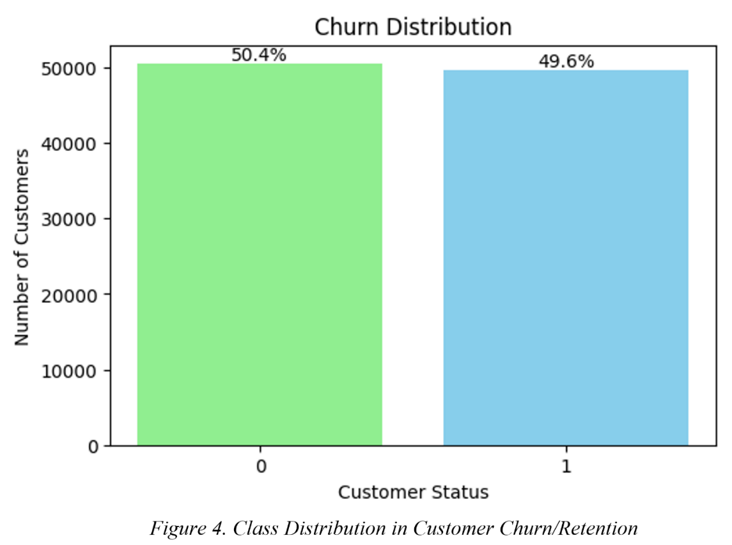
Scaling was particularly important for Support Vector Machine (SVM), Logistic Regression, and K-Means clustering, as these techniques are sensitive to feature magnitudes. In contrast, Random Forest is generally unaffected by scaling because it uses decision-tree splits rather than distance calculations. The dataset was then split into 80% for training (80,000 records) and 20% for testing (20,000 records) (Figure 5) using stratified sampling with random_state = 42 to preserve class distribution and ensure reproducibility. This preprocessing produced a reliable dataset for customer churn prediction and customer segmentation.
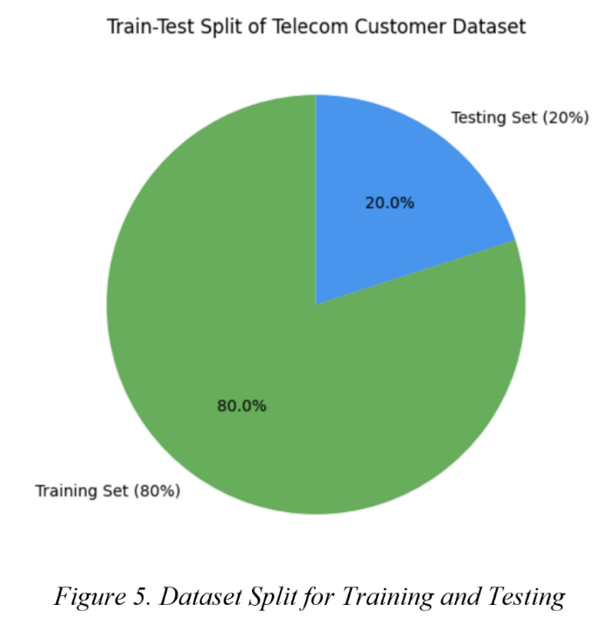

3.4 Tools and Environment
The analysis was conducted in Python using Visual Studio Code (VS Code). Python was selected for its strong support for data mining, machine learning, and data visualisation [19]. Pandas and NumPy were used for data preprocessing and numerical analysis, while Scikit-learn supported feature selection, scaling, model training, clustering, and performance evaluation [19], [3]. Logistic Regression, Random Forest, SVM, and K-Means Clustering were implemented using Scikit-learn. Matplotlib and Seaborn were used for visualisations, including heatmaps, ROC curves, confusion matrices, and feature importance plots[19]. PCA and Silhouette Analysis were applied to support cluster analysis and visualisation.

4. Classification Models Implementation
Based on the literature review, Logistic Regression, Support Vector Machine (SVM), and Random Forest were selected for customer churn prediction (Figure 6).

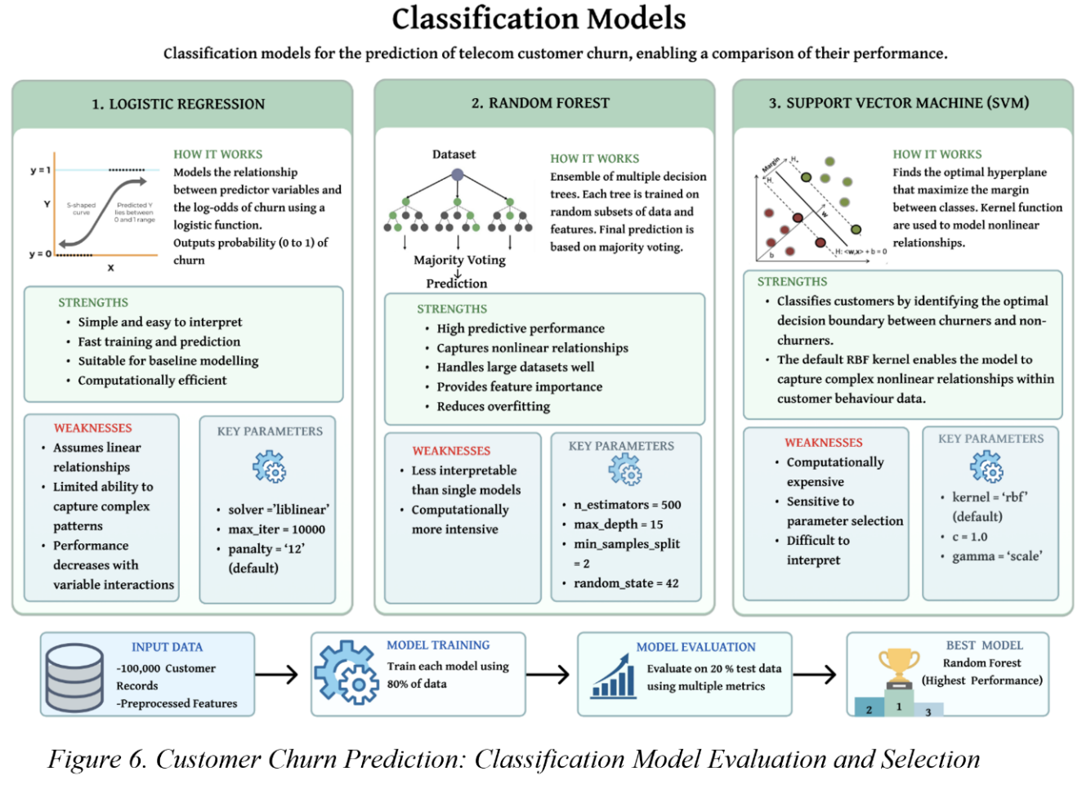

Logistic Regression was implemented using the liblinear solver with max_iter = 10,000 to ensure convergence and stable coefficient estimation. The model served as a baseline classifier due to its simplicity and interpretability (Figure 7).
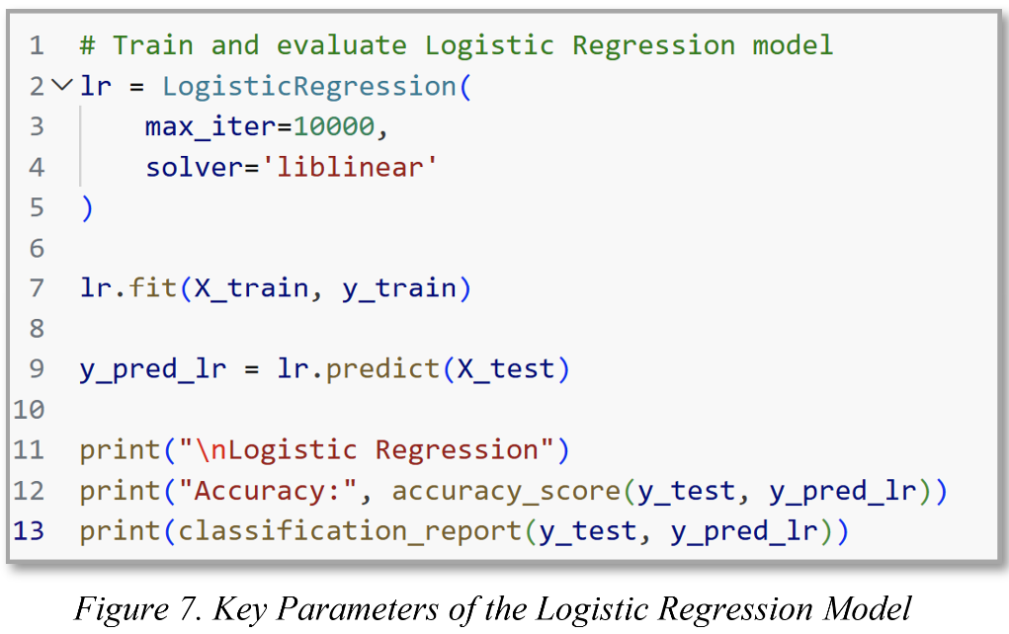
For the SVM model, the default Scikit-learn SVC() configuration was used (Figure 8). This applies the Radial Basis Function (RBF) kernel, which enables the model to capture nonlinear relationships between customer characteristics and churn behaviour. Other parameters remained at their default values, including C = 1.0 and gamma = 'scale'. The model was trained on the scaled training dataset and evaluated on the test dataset. The use of the RBF kernel enabled SVM to identify complex patterns that linear models may not capture, contributing to its moderate predictive performance and the highest Recall score among the evaluated classifiers.
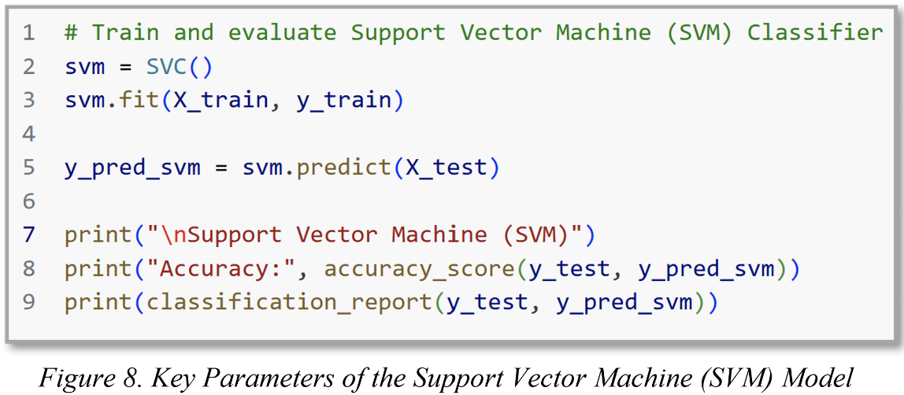

For Random Forest, parameter tuning was conducted by testing different tree depths (Figure 9). The best performance was achieved with max_depth = 15 (Accuracy = 60.6%), and this value was selected for the final model. The classifier was configured with 500 decision trees (n_estimators = 500), max_depth = 15, min_samples_split = 2, min_samples_leaf = 1, and random_state = 42 to ensure reproducibility. These parameters provided a balance between predictive performance and overfitting control, resulting in the highest overall classification accuracy among the evaluated models.

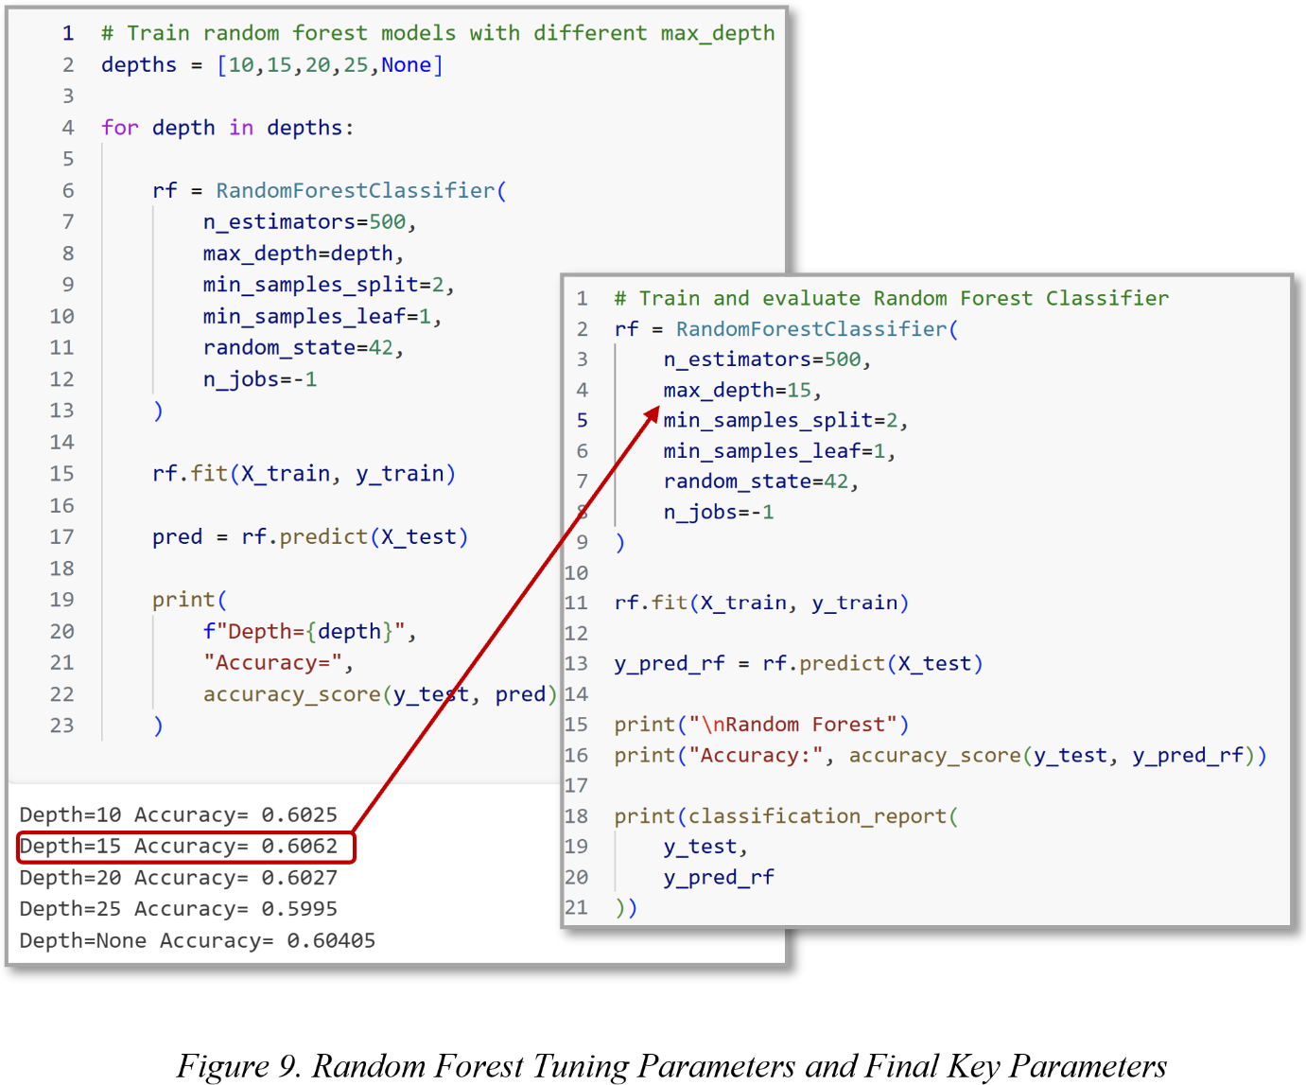

Random Forest outperformed Logistic Regression and SVM in Accuracy, F1-Score, and ROC-AUC, making it the chosen model for feature importance analysis (Figure 10). Its ability to directly measure feature importance helps identify key variables influencing churn prediction, providing valuable insights into the drivers of customer churn.
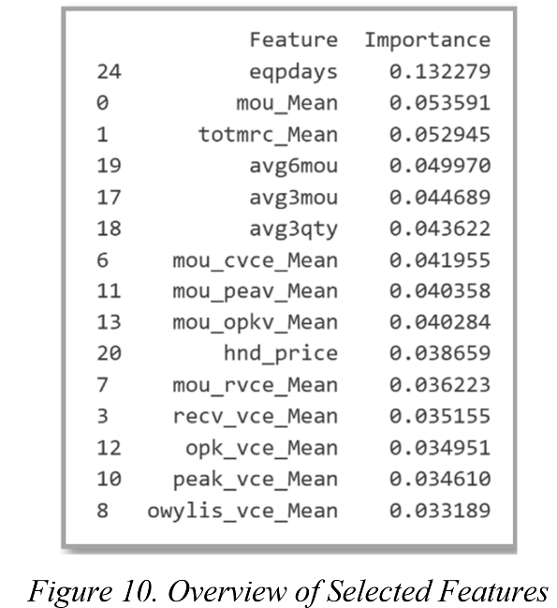

5. Model Evaluation and Comparison

5.1 Evaluation Metrics & Performance Results
To assess the effectiveness of the classification models, a comprehensive evaluation framework was applied (Figure 11). The framework combined classification metrics, confusion matrix analysis, and ROC curve analysis to provide a balanced assessment of model performance.
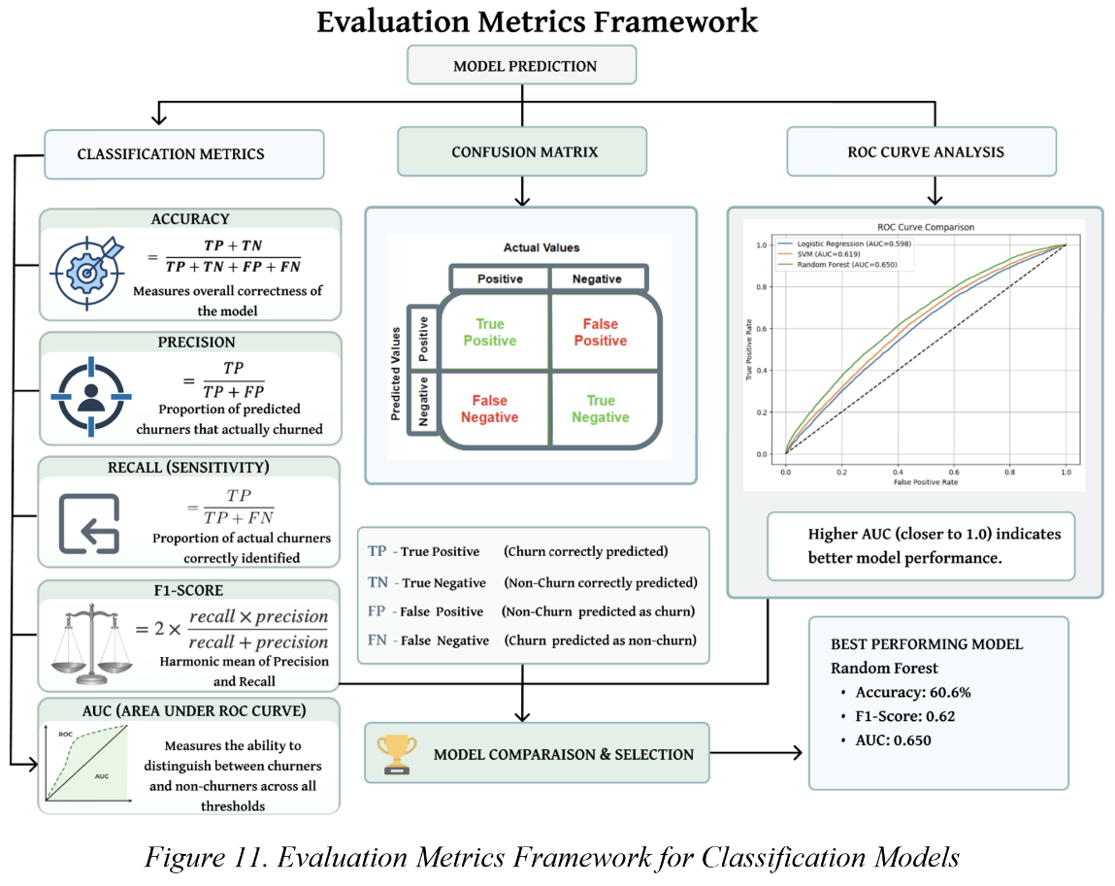

Table 2 (Appendix Figure 28) demonstrates clear differences in the predictive capabilities of the three classification models. Logistic Regression achieved the weakest overall performance, recording the lowest Accuracy (57.0%), F1-Score (0.56), and AUC (0.598). These results suggest that the model was unable to fully capture the complex relationships underlying customer churn behaviour, leading to less reliable predictions.

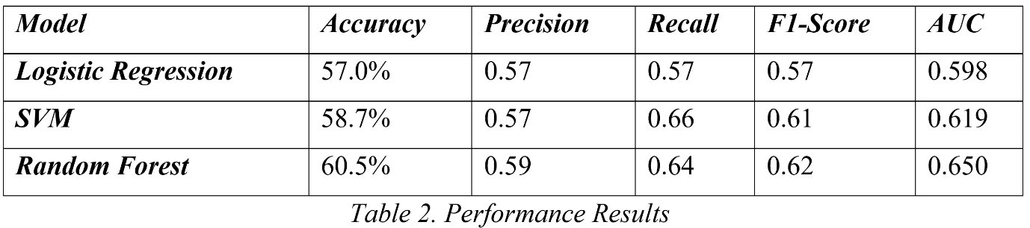

SVM improved upon Logistic Regression and achieved the highest Recall (0.66), indicating a stronger ability to identify customers who eventually churned. However, this improvement came at the expense of Precision (0.57), meaning that more retained customers were incorrectly classified as churners. Among the evaluated models, Random Forest delivered the strongest and most balanced performance. The model achieved the highest Accuracy (60.5%), Precision (0.59), F1-Score (0.62), and AUC (0.650), while maintaining a Recall of 0.64, which was only marginally lower than that of SVM. This indicates that Random Forest identified a large proportion of churners without significantly increasing the number of incorrect churn predictions.
The difference between SVM and Random Forest is particularly important from a business perspective. Although SVM detected slightly more churners, Random Forest produced more reliable predictions overall by achieving higher precision and a better balance between identifying churners and minimising classification errors. This is reflected in its superior F1-Score and AUC, both of which provide stronger evidence of the model's overall effectiveness.
Random Forest consistently outperformed other models across various evaluation measures, indicating it is robust and generalizable across different scenarios. This makes it the most suitable model for customer churn prediction, achieving a strong balance of predictive accuracy and classification reliability.

5.2 Confusion Matrix Analysis
The confusion matrices provide detailed insight into model classification performance by highlighting prediction errors and their impact on churn identification and retention decisions. The Logistic Regression model produced the weakest classification results (Figure 12). Although it correctly identified 5,475 churned customers, it failed to detect 4,437 actual churners. This represents the highest number of missed churn cases among all models. From a business perspective, these missed customers are particularly problematic because they are not targeted by retention strategies and are likely to leave the organisation without intervention. The relatively high number of classification errors suggests that Logistic Regression was unable to effectively capture the complexity of customer churn behaviour.
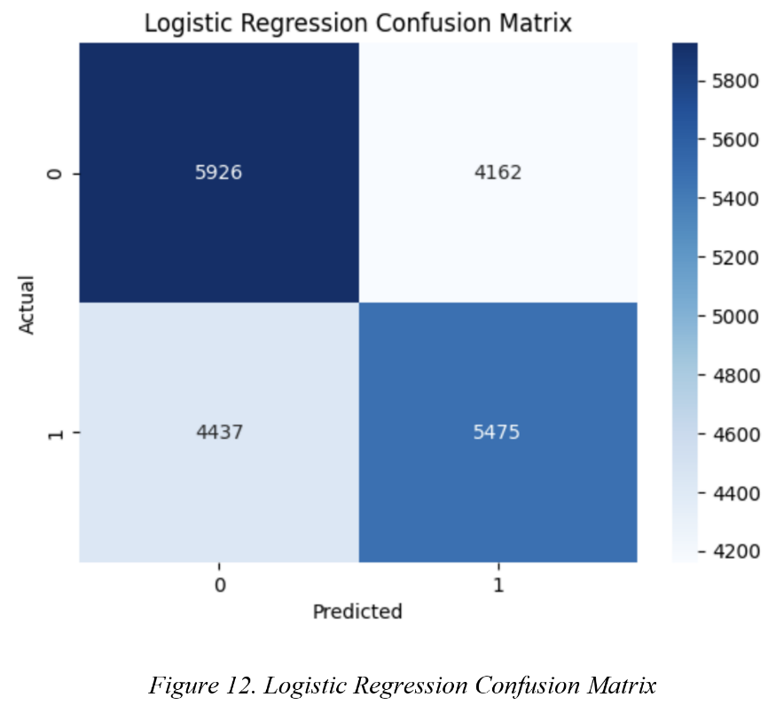
The Support Vector Machine (SVM) demonstrated a noticeable improvement over Logistic Regression (Figure 13). The model correctly identified 6,279 churned customers while reducing the number of missed churners to 3,633. This indicates a stronger ability to detect customers at risk of leaving and explains the SVM's higher recall score. However, this improvement was accompanied by an increase in incorrect churn predictions, leading to more customers being unnecessarily classified as high-risk. SVM effectively detects churners but may raise retention costs by targeting customers unlikely to leave.
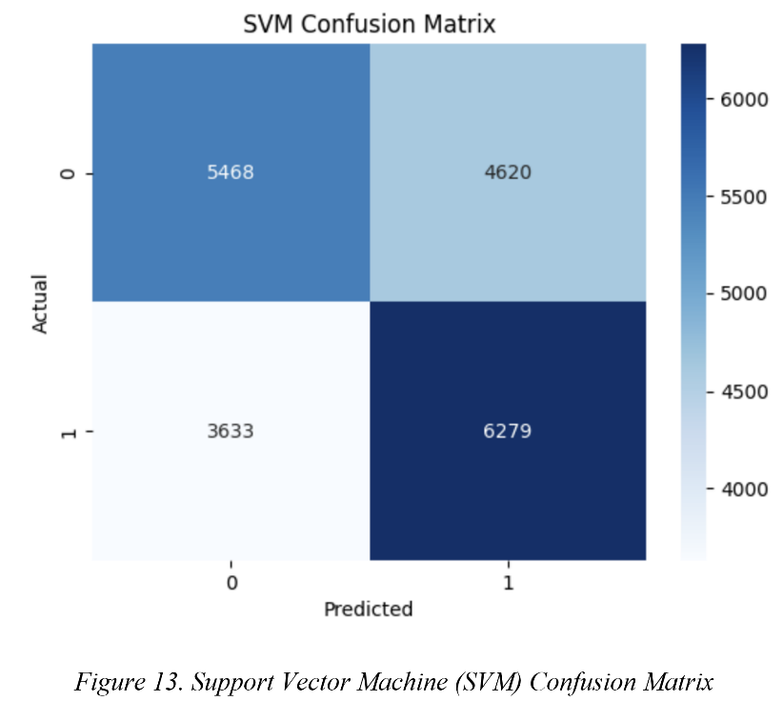
The Random Forest model delivered the strongest overall confusion matrix results. It correctly identified 6,381 churned customers, the highest value among all three models, and produced the lowest number of missed churners (3,531) (Figure 14). This demonstrates that Random Forest was the most effective model at recognising customers who were genuinely at risk of churn. Furthermore, Random Forest maintained a better balance between correctly identifying churners and minimising incorrect predictions than either Logistic Regression or SVM.
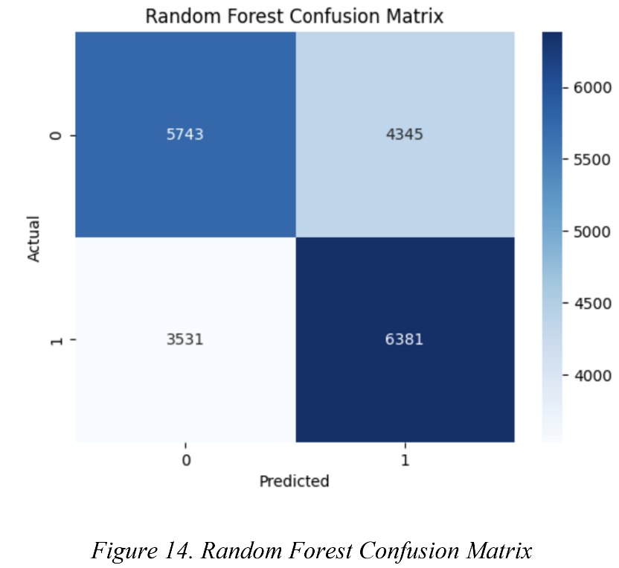
The confusion matrix analysis supports the findings obtained from the evaluation metrics. Although SVM achieved the highest recall, Random Forest correctly identified more churned customers overall while maintaining superior accuracy, precision, F1-score, and AUC. The model therefore achieved the most effective balance between churn detection and classification reliability.
Reducing churn is vital for a business as it reflects lost revenue. The alignment between the confusion matrix results and the evaluation metrics supports selecting Random Forest as the final churn prediction model.

5.3 ROC Curve Analysis
Receiver Operating Characteristic (ROC) curves were generated for all three classification models: Logistic Regression, Support Vector Machine (SVM), and Random Forest (Figure 15).
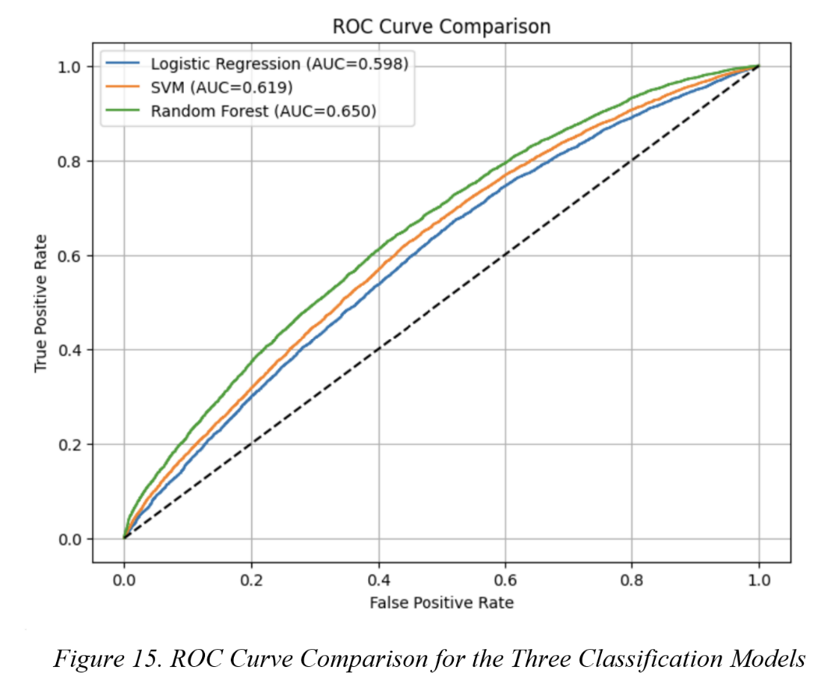

The results show clear differences in their ability to distinguish between churned and retained customers across a range of classification thresholds. The Logistic Regression model achieved the lowest AUC value (0.598), indicating the weakest discriminatory performance among the evaluated models (Figure 16). Its ROC curve remains closest to the diagonal reference line, suggesting that the model has limited capability to separate churners from non-churners. This finding is consistent with previous evaluation results and reflects the limitations of assuming linear relationships within a dataset characterised by complex customer behaviour patterns.
The SVM model demonstrated improved performance, achieving an AUC of 0.619. Throughout most threshold levels, its ROC curve remained above that of Logistic Regression, indicating a stronger ability to identify churned customers while maintaining acceptable classification accuracy. The improvement suggests that the nonlinear decision boundaries produced by the RBF kernel enabled the model to capture behavioural relationships that were not recognised by Logistic Regression.
The Random Forest model achieved the highest AUC value (0.650) and consistently maintained the strongest ROC performance across almost all threshold levels. Its curve remained above both Logistic Regression and SVM, demonstrating superior discrimination capability. This result indicates that Random Forest was more effective at ranking customers by their churn likelihood and provided the most reliable separation between churned and retained customers.
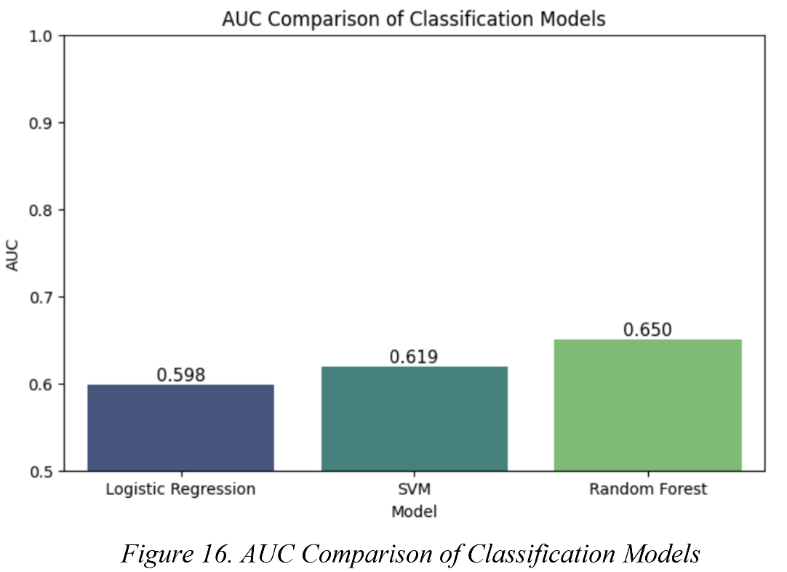

Analysis of the ROC-AUC confirmed that Random Forest is the best-performing model (AUC = 0.650) (Figure 16), demonstrating the strongest ability to differentiate between churners and retained customers, supporting its selection as the final classification model.

5.4 Model Comparison
A comparison of the three classification models demonstrates that Random Forest was the most effective approach for customer churn prediction. Although Logistic Regression and SVM produced acceptable results, neither matched the overall predictive performance achieved by Random Forest.
Logistic Regression performed worst across all evaluation measures, suggesting the model was unable to fully capture the complex relationships among customer behaviour, service usage, revenue, and device characteristics. This indicates a degree of underfitting, where the model's simplicity limited its ability to represent the underlying churn patterns in the dataset.
The SVM model improved performance by introducing nonlinear decision boundaries and achieved the highest Recall (0.66), demonstrating a strong ability to identify churned customers. However, this improvement did not translate into the best overall model performance. Its lower Accuracy, F1-Score, and AUC compared with Random Forest suggest that it was less effective at balancing churn detection with overall classification reliability.
In contrast, Random Forest consistently achieved the strongest results across most evaluation metrics, recording the highest Accuracy (60.5%), Precision (0.59), F1-Score (0.62), and AUC (0.650). The model also maintained a strong Recall (0.64), indicating that it successfully identified a large proportion of churned customers while minimising unnecessary misclassifications. Furthermore, hyperparameter tuning showed that the selected configuration achieved a good balance between model complexity and generalisation performance, with no significant evidence of overfitting.
An additional advantage of Random Forest was its ability to generate feature importance rankings. The identification of variables such as equipment age (eqpdays), service usage (mou_Mean), monthly revenue (totmrc_Mean), and handset value (hnd_price) provided valuable business insights into the factors driving customer churn.
Overall, Random Forest offered the best combination of predictive accuracy, robustness, and interpretability. Consequently, it was selected as the final classification model and served as the foundation for the subsequent clustering analysis and business recommendations.

6. Clustering

6.1 Technique Used: K-Means Clustering
To enhance classification analysis, K-Means Clustering was applied to churned customers to identify distinct groups with similar traits, aiding targeted retention strategies. K-Means was chosen for its effectiveness in revealing hidden patterns in large datasets. The analysis focused solely on churned customers to determine whether different customer types exit for different reasons. The variables selected for clustering were based on the Random Forest feature importance analysis (Figure 17). The variables chosen for analysis were identified as the strongest predictors of customer churn, as shown in the correlation heatmap (Figure 2), and represent key business dimensions, including device characteristics, customer engagement, revenue contribution, and service usage behaviour. Prior to clustering, the features were standardised using StandardScaler to ensure that differences in measurement scales did not bias the clustering.

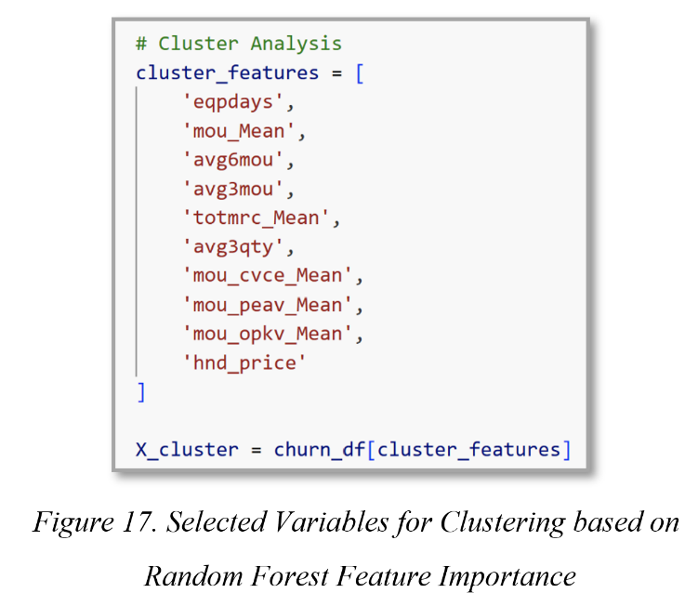

6.2 Implementation
The optimal number of clusters was determined using the elbow method and silhouette analysis. (Figure 18). As a result, a significant reduction in inertia is observed when transitioning from K = 1 to K = 2, followed by increasingly marginal improvements as more clusters are added. The elbow point is at K = 2, suggesting that a two-cluster solution offers the best balance between model simplicity and cluster quality.
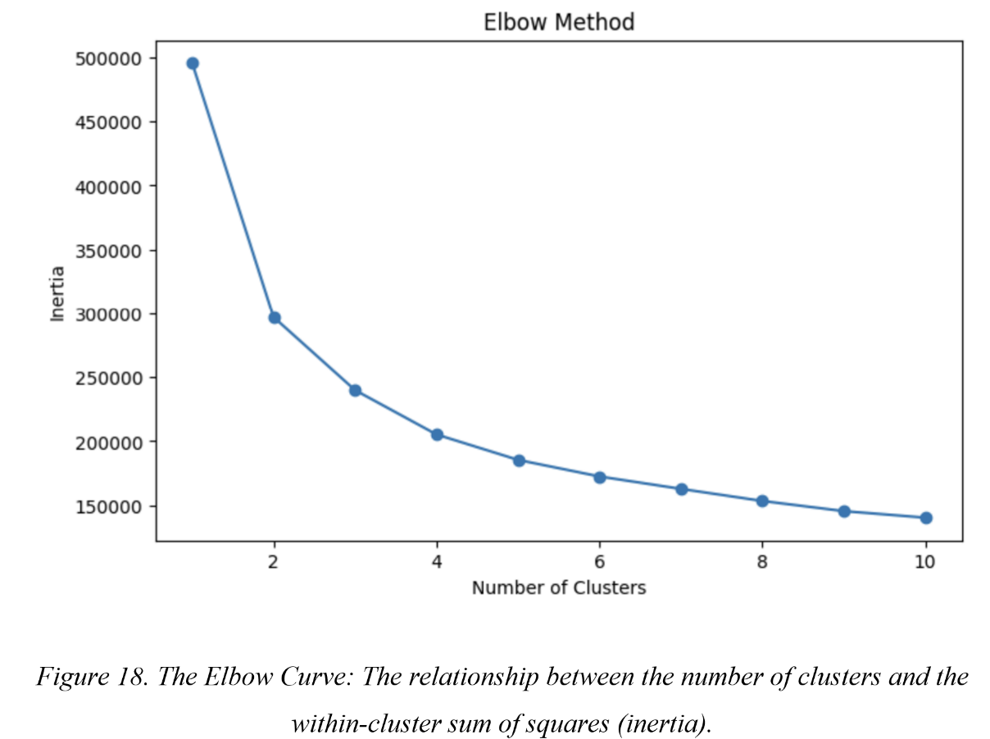

This conclusion is corroborated by the Silhouette Score analysis, which also identified K = 2 as the optimal clustering solution, demonstrating a Silhouette Score of 0.4675. A two-cluster solution was selected for the final K-Means model, offering the best balance between within-cluster similarity and between-cluster separation. The cluster assignments were added to the churned customer dataset for further analysis of segment characteristics.

6.3 Cluster Interpretation
The clustering process identified two distinct groups of churned customers (Figure 19). Cluster 0: Low-Engagement Churners and Cluster 1: High-Value Churners (Table 3).
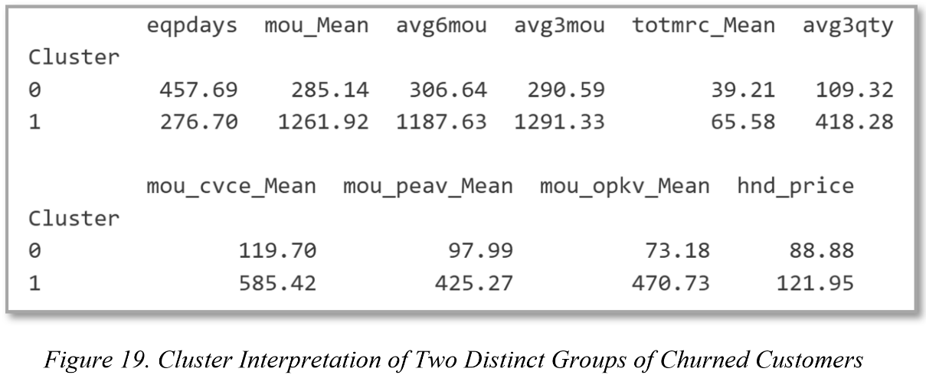

Cluster 0: Low-Engagement Churners represented the largest group of churned customers. Customers in this cluster were characterised by lower service usage, older devices, and lower monthly revenue. Their behavioural profile suggests reduced engagement with the provider and greater sensitivity to pricing. These customers appeared to gradually reduce their activity before churning, indicating that declining usage and ageing devices were important factors in attrition.
Cluster 1: High-Value Churners represented a smaller but more valuable group of churned customers. Customers in this cluster maintained high levels of service usage, generated substantially higher revenue, and generally used newer devices. Unlike Cluster 0, these customers remained highly engaged until they churned. The loss of this segment has a greater financial impact on the organisation due to its higher revenue contribution, highlighting the importance of targeted retention strategies for high-value customers.

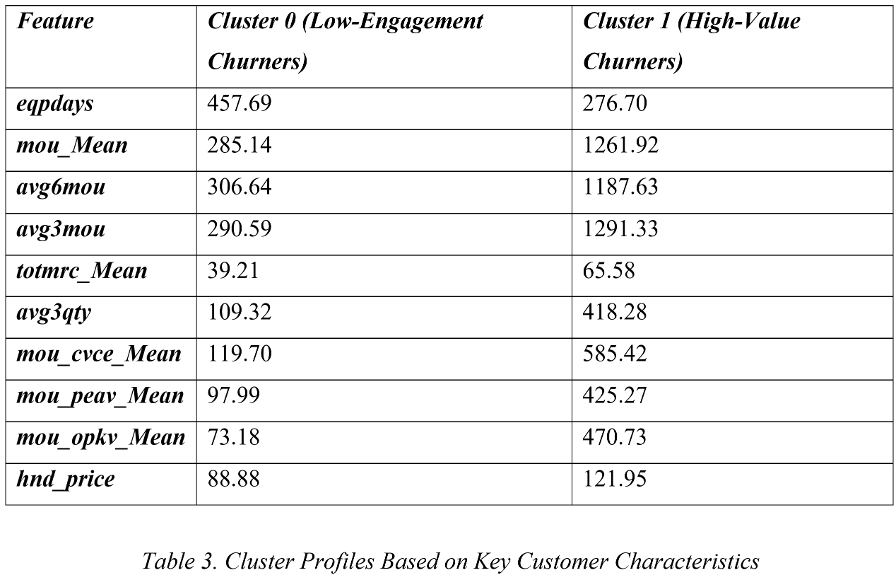

6.4 Cluster Visualisation and Analysis
Several visualisation techniques were used to support cluster interpretation.
The Cluster Distribution plot showed that 79.8% of churned customers were in Cluster 0, while 20.2% were in Cluster 1, indicating that most attrition comes from the low-engagement segment.
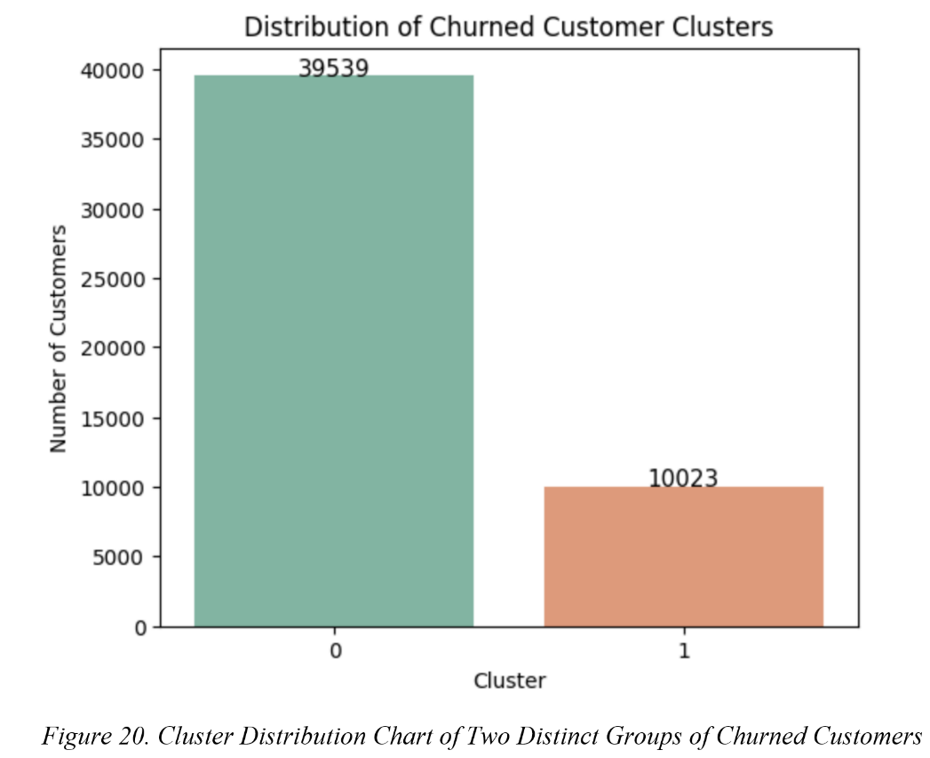

The Revenue vs Usage scatter plot (Figure 21) clearly showed a separation between the two clusters. Cluster 0 focused on lower revenue and lower usage, while Cluster 1 focused on higher revenue and higher usage. This visualisation confirmed the existence of two fundamentally different churn profiles.
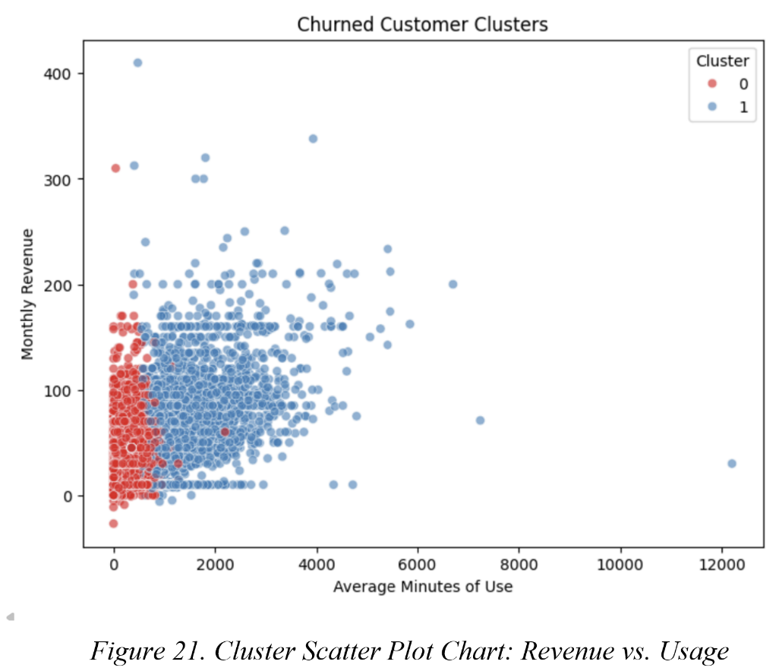

The Cluster Heatmap identified two distinct churn segments. Cluster 0 consists of customers with lower usage, lower revenue, and older devices, suggesting gradual disengagement before churn. Cluster 1 contains highly active customers with higher revenue and newer devices, indicating that factors beyond usage may drive churn. These findings highlight the need for segment-specific retention strategies.

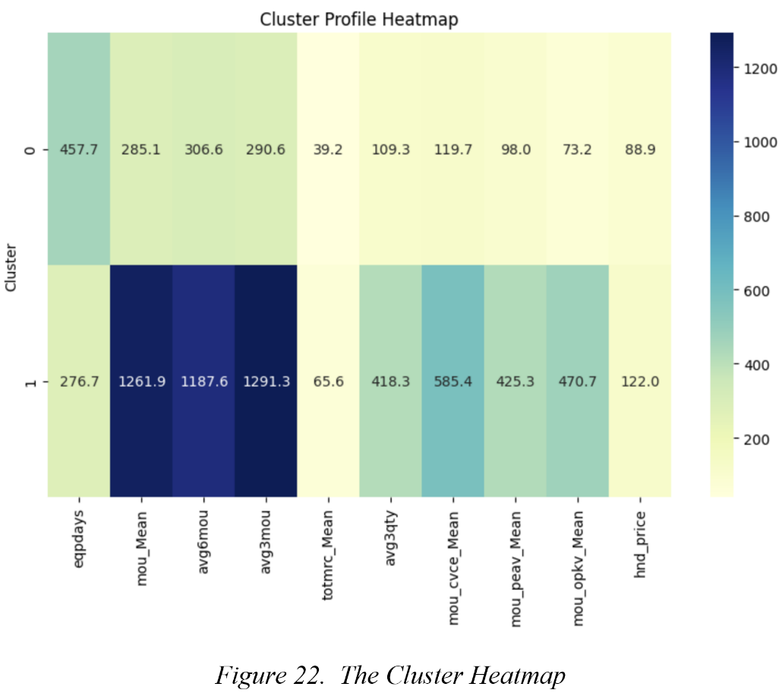

The boxplots (Figures 23, 24, and 25) confirm clear differences between the two churn segments. Cluster 0 customers have older devices, lower revenue, and lower service usage, suggesting gradual disengagement before churn. In contrast, Cluster 1 customers use newer devices and generate substantially higher revenue and usage, indicating that churn among this group is likely driven by factors beyond engagement, making them a higher-value retention priority.

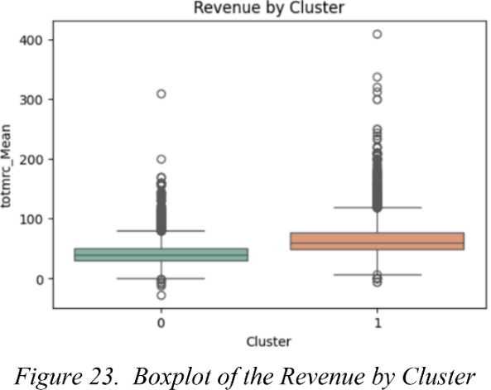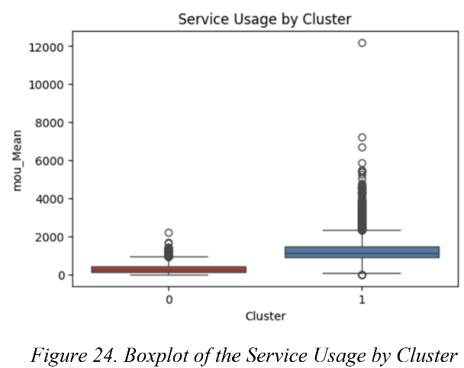

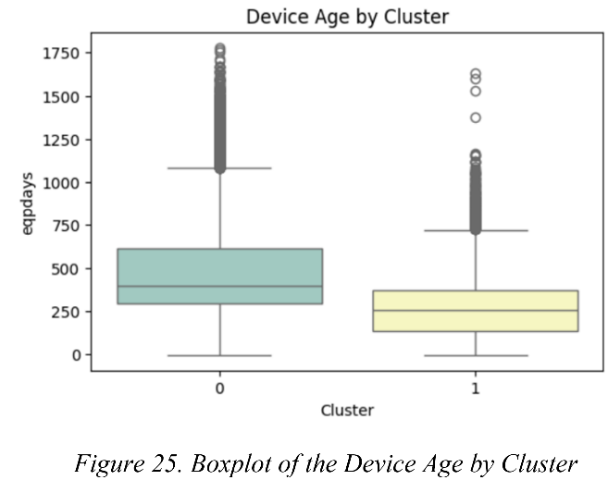

The PCA visualisation (Figure 26) shows a clear separation between Low-Engagement Churners (0) and High-Value Churners (1), indicating that K-Means successfully identified two distinct customer segments with minimal overlap. This suggests meaningful differences in customer behaviour and churn characteristics. The cluster profile comparison (Figure 27) and Table 3 further confirm that High-Value Churners (0) generate considerably higher revenue, exhibit substantially greater service usage, and own newer, higher-priced devices. In contrast, Low-Engagement Churners (1) are characterised by older devices, lower service usage, and lower revenue contribution. These findings validate the clustering solution and demonstrate that churn occurs across different customer profiles, highlighting the importance of segment-specific retention strategies.
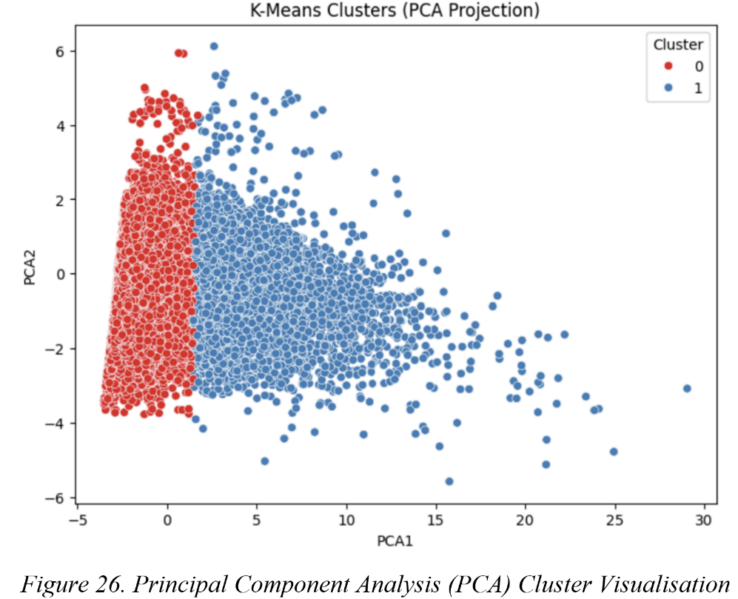

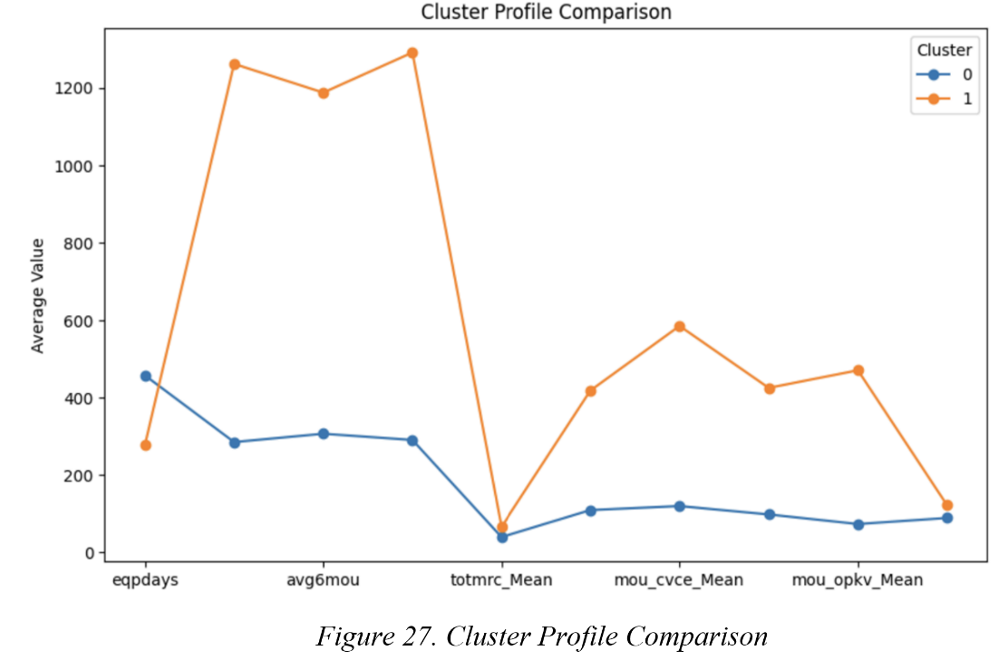

7. Results and Discussion
This section interprets the analytical results, explaining the underlying behavioural patterns and the rationale behind the models' performances to provide context for strategic decision-making.
Model Implications: The superior performance of the Random Forest model suggests that customer churn is driven by complex, non-linear relationships that simpler models, such as Logistic Regression, cannot fully capture. While the SVM model achieved the highest Recall by identifying more at-risk customers, Random Forest provided the best overall balance between Recall and Precision, resulting in the highest F1-score. This balance is important for business decision-making because it accurately identifies potential churners while limiting false positives. Reducing unnecessary retention efforts helps ensure that marketing resources and retention budgets are directed toward customers who are genuinely at risk of leaving.
Feature Implications: The overwhelming importance of equipment age reveals that the device lifecycle is deeply intertwined with customer loyalty. As handsets age, customers become highly susceptible to competitor upgrade incentives. Furthermore, the prominence of usage metrics such as avg6mou and mou_Mean confirms that a gradual decline in service utilisation is a highly reliable early-warning signal of eventual disengagement.
Cluster Implications: The study identified two distinct churn profiles, challenging the assumption that all churning customers behave similarly. The majority, Cluster 0, consists of low-engagement customers whose churn is likely driven by declining perceived value or price sensitivity. In contrast, Cluster 1 contains high-value customers who maintain high usage and spending until churn occurs. Their departure is more likely linked to unmet expectations, poor service experiences, or attractive competitor offers. As these customers contribute significantly more revenue, losing a Cluster 1 customer has a far greater financial impact and requires targeted retention strategies.
Alignment with Literature: These empirical findings align closely with the existing academic literature. Prior studies have shown that ensemble techniques, such as Random Forests, consistently outperform traditional linear approaches when processing complex, non-linear telecom datasets [14]. Additionally, the literature corroborates that dynamic behavioural features (usage) and device characteristics are primary determinants of telecommunication churn behaviour [12].

8. Business Recommendations
Customer retention should be a strategic priority for telecommunications providers, as retaining existing customers is more cost-effective than acquiring new ones. Based on this study, the company should implement a Random Forest model as an early warning system to identify customers at high risk of churn. Continuous monitoring of customer behaviour, particularly declining service usage, would enable timely interventions before contract termination. Retention actions should also be guided by customer lifetime value (CLV) to ensure resources are focused on the most valuable customers.
The analysis identified equipment age (eqpdays) as the strongest predictor of churn. To reduce this risk, the company should introduce proactive device upgrade programmes, trade-in schemes, and flexible financing options to encourage customers to replace ageing devices and remain engaged.
Retention strategies should also be tailored according to the K-Means clusters. Cluster 0, which contains most churners, is characterised by lower usage, older devices, and higher price sensitivity. Targeted discounts, promotional offers, and usage-based rewards may help improve retention. Cluster 1 customers generate higher revenue and remain active before churning; therefore, personalised offers, loyalty programmes, premium support, and contract renewal incentives should be prioritised.
Finally, enhancing the overall customer experience through efficient onboarding, improved self-service tools, responsive support, and simplified interactions can increase satisfaction, strengthen loyalty, and reduce churn.

9. Conclusion
Customer churn is a critical and expensive challenge in the highly competitive telecommunications sector. This report successfully developed a hybrid data mining framework combining predictive classification and unsupervised clustering to proactively manage customer attrition. The comparative analysis demonstrated that the Random Forest ensemble model outperformed both Logistic Regression and Support Vector Machine (SVM) algorithms, achieving the highest Accuracy (60.5%) and Area Under the ROC Curve (0.650). Furthermore, feature importance analysis revealed that equipment age, service usage duration, and monthly revenue are the primary determinants of churn.
Applying K-Means clustering to the churned customer subset showed that churners are not a homogeneous group. The discovery of distinct segments, specifically "Low-Engagement Churners" and "High-Value Churners", highlights that churn is driven by diverse motivations. By utilising predictive models as early warning systems and leveraging clustering for market segmentation, telecommunications providers can deploy highly targeted retention campaigns that optimise marketing budgets.
Limitations and Future Work
This study is limited by its reliance on a single public dataset containing only structured quantitative variables and by its evaluation of models primarily using traditional machine learning metrics. Future research should test the framework across industries, incorporate NLP-based analysis of unstructured data, and apply profit-based and Explainable AI (XAI) evaluation methods.

10. References
[1] M. Pejić Bach, J. Pivar and B. Jaković, "Churn management in telecommunications: Hybrid approach using cluster analysis and decision trees," vol. 14, no. 11, pp.544, 2021,
[2] V. Chang, K. Hall, Q. A. Xu, F. O. Amao, M. A. Ganatra and V. Benson, "Prediction of customer churn behavior in the telecommunication industry using machine learning models," vol. 17, no. 6, pp.231, 2024,
[3] R. Dodda, C. Raghavendra, M. Aashritha, H. V. Macherla and A. R. Kuntla, "A Comparative Study of Machine Learning Algorithms for Predicting Customer Churn: Analyzing Sequential, Random Forest, and Decision Tree Classifier Models", in 2024 5th International Conference on Electronics and Sustainable Communication Systems (ICESC), pp. 1552–1559.
[4] S. K. Wagh, A. A. Andhale, K. S. Wagh, J. R. Pansare, S. P. Ambadekar and S. H. Gawande, "Customer churn prediction in telecom sector using machine learning techniques," vol. 14, pp.100342, 2024,
[5] M. Imani and H. R. Arabnia, "Hyperparameter optimization and combined data sampling techniques in machine learning for customer churn prediction: a comparative analysis," vol. 11, no. 6, pp.167, 2023,
[6] A. Amin, A. Adnan and S. Anwar, "An adaptive learning approach for customer churn prediction in the telecommunication industry using evolutionary computation and Naïve Bayes," vol. 137, pp.110103, 2023,
[7] S. Wu, W. Yau, T. Ong and S. Chong, "Integrated churn prediction and customer segmentation framework for telco business," vol. 9, pp.62118–62136, 2021,
[8] S. O. Abdulsalam, J. F. Ajao, B. F. Balogun and M. O. Arowolo, "A Churn Prediction System for Telecommunication Company Using Random Forest and Convolution Neural Network Algorithms." vol. 7, no. 21, pp.e4, 2022,
[9] V. Chang, J. Bailey, Q. A. Xu and Z. Sun, "Pima Indians diabetes mellitus classification based on machine learning (ML) algorithms," vol. 35, no. 22, pp.16157–16173, 2023,
[10] X. Xiahou and Y. Harada, "B2C E-commerce customer churn prediction based on K-means and SVM," vol. 17, no. 2, pp.458–475, 2022,
[11] P. Lalwani, M. K. Mishra, J. S. Chadha and P. Sethi, "Customer churn prediction system: a machine learning approach," vol. 104, no. 2, pp.271–294, 2022,
[12] A. Manzoor, M. A. Qureshi, E. Kidney and L. Longo, "A review on machine learning methods for customer churn prediction and recommendations for business practitioners," vol. 12, pp.70434–70463, 2024,
[13] B. Durkaya Kurtcan and T. Ozcan, "Predicting customer churn using grey wolf optimization‐based support vector machine with principal component analysis," J.Forecast., vol. 42, no. 6, pp.1329–1340, 2023,
[14] M. Bogaert and L. Delaere, "Ensemble methods in customer churn prediction: A comparative analysis of the state-of-the-art," vol. 11, no. 5, pp.1137, 2023,
[15] M. A. Mahdi, K. M. Hosny and I. Elhenawy, "Scalable clustering algorithms for big data: A review," vol. 9, pp.80015–80027, 2021,
[16] A. Tharwat, "Classification assessment methods," vol. 17, no. 1, pp.168–192, 2021,
[17] Y. Yang and H. Wang, "Random forest-based machine failure prediction: A performance comparison," vol. 15, no. 16, pp.8841, 2025,
[18] S. W. Fujo, S. Subramanian and M. A. Khder, "Customer churn prediction in telecommunication industry using deep learning," vol. 11, no. 1, pp.24, 2022,
[19] M. Dilhara, A. Ketkar and D. Dig, "Understanding software-2.0: A study of machine learning library usage and evolution," vol. 30, no. 4, pp.1–42, 2021,

11. Appendices


