

Introduction to Health and Social Care

Lecturer’s name: Sam Parker (Module Lead)
Assignment Title: Component 1: Portfolio – Two Tasks
Module Code: LCHS4003

Task 1: Community Antenatal Midwifery Services
Task 2: Community Mental Health Services

Student Name: MST MARZIA UMME MOZID
Student ID: 2527557
Submitted on:20-07-2026

Table of Contents

Task 1: Poster...................................................................................................3
Introduction.......................................................................................................3
Explanation of the Community Antenatal Midwifery Services...........................4
Brief History of Community Antenatal Midwifery Services................................4
Current Functioning of the Services.................................................................4
Challenge 1: Midwife Workforce Shortages.....................................................6
Challenge 2: Health Inequalities in Maternity Care..........................................6
Conclusion.......................................................................................................6
References......................................................................................................7
Task 2: Essay.................................................................................................8

Task 1: Poster
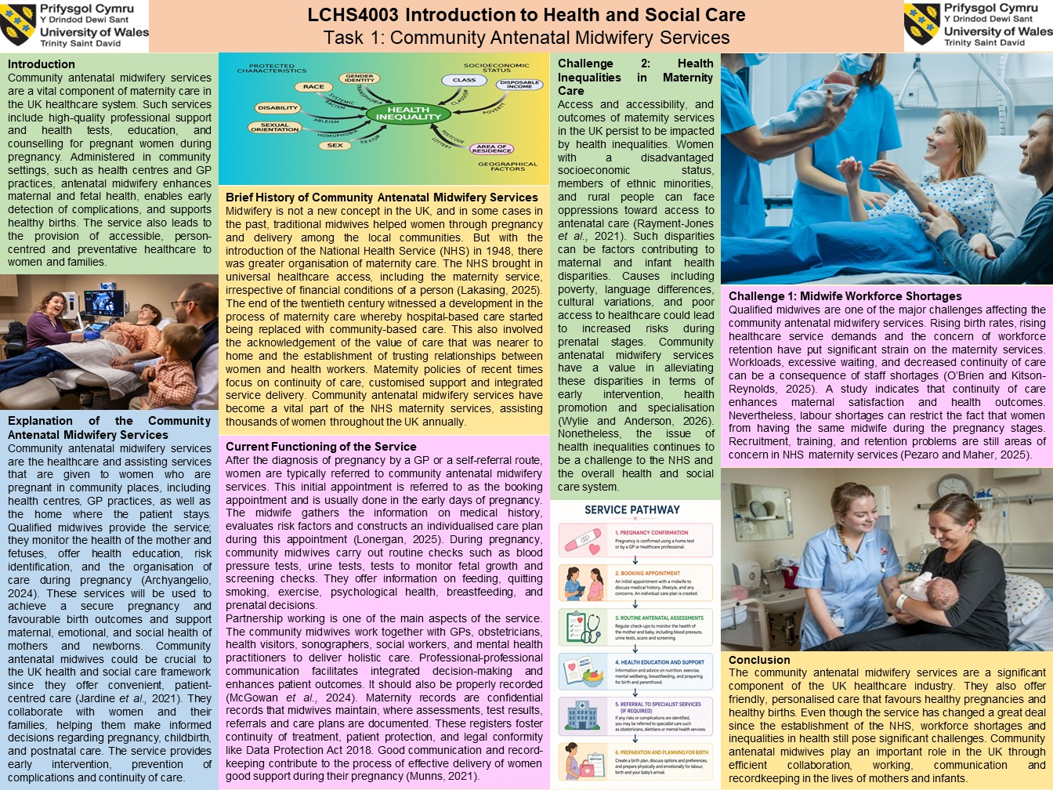

Introduction
Community antenatal midwifery services are a vital component of maternity care in the UK healthcare system. Such services include high-quality professional support and health tests, education, and counselling for pregnant women during pregnancy. Administered in community settings, such as health centres and GP practices, antenatal midwifery enhances maternal and fatal health, enables early detection of complications, and supports healthy births. The service also leads to the provision of accessible, person-centred and preventative healthcare to women and families.

Explanation of the Community Antenatal Midwifery Services
Community antenatal midwifery services are the healthcare and assisting services that are given to women who are pregnant in community places, including health centres, GP practices, as well as the home where the patient stays. Qualified midwives provide the service; they monitor the health of the mother and fetuses, offer health education, risk identification, and the organisation of care during pregnancy (Archyangelio, 2024). These services will be used to achieve a secure pregnancy and favourable birth outcomes and support maternal, emotional, and social health of mothers and newborns. Community antenatal midwives could be crucial to the UK health and social care framework since they offer convenient, patient-centred care (Jardine et al., 2021). They collaborate with women and their families, helping them make informed decisions regarding pregnancy, childbirth, and postnatal care. The service provides early intervention, prevention of complications and continuity of care.

Brief History of Community Antenatal Midwifery Services
Midwifery is not a new concept in the UK, and in some cases in the past, the traditional midwives helped the women through pregnancy and delivery among the locals of the local communities. But with the introduction of the National Health Service (NHS) in 1948, there was greater organisation of maternity care. The NHS brought in universal healthcare access, including the maternity service, irrespective of financial conditions of a person (Lakasing, 2025). The end of the twentieth century witnessed a development in the process of maternity care whereby hospital-based care started being replaced with community-based care. This also involved the acknowledgement of the value of care that was nearer to home and the establishment of trusting relationships between women and health workers. Maternity policies of recent times focus on continuity of care, customised support and integrated service delivery. Community antenatal midwifery services have become a vital part of the NHS maternity services, assisting thousands of women throughout the UK annually.

Current Functioning of the Service
After the diagnosis of pregnancy by a GP or a self-referral route, women are typically referred to community antenatal midwifery services. This initial appointment is referred to as the booking appointment and is usually done in the early days of pregnancy. The midwife gathers the information on medical history, evaluates risk factors and constructs an individualised care plan during this appointment (Lonergan, 2025). During pregnancy, community midwives carry out routine checks such as blood pressure tests, urine tests, tests to monitor fatal growth and screening checks. They offer information on feeding, quitting smoking, exercise, psychological health, breastfeeding, and prenatal decisions.
Partnership working is one of the main aspects of the service. The community midwives work together with GPs, obstetricians, health visitors, sonographers, social workers, and mental health practitioners to deliver holistic care. Professional-professional communication facilitates integrated decision-making and enhances patient outcomes. It should also be properly recorded (McGowan et al., 2024). Maternity records are confidential records that midwives maintain, where assessments, test results, referrals and care plans are documented. These registers foster continuity of treatment, patient protection, and legal conformity like Data Protection Act 2018. Good communication and record-keeping contribute to the process of effective delivery of women good support during their pregnancy (Munns, 2021).
Service Pathway
Pregnancy Confirmation
↓
Booking Appointment
↓
Routine Antenatal Assessments
↓
Health Education and Support.
↓
Referral to Specialist Services (if required)
↓
Preparation and planning for birth.

Challenge 1: Midwife Workforce Shortages
Qualified midwives are one of the major challenges affecting the community antenatal midwifery services. Rising birth rates, rising healthcare service demands and the concern of workforce retention have put significant strain on the maternity services. Workloads, excessive waiting, and decreased continuity of care can be a consequence of staff shortages (O’Brien and Kitson-Reynolds, 2025). A study indicates that continuity of care enhances maternal satisfaction and health outcomes. Nevertheless, labour shortages can restrict the fact that women from having the same midwife during the pregnancy stages. Recruitment, training, and retention problems are still areas of concern in NHS maternity services (Pezaro and Maher, 2025).

Challenge 2: Health Inequalities in Maternity Care
Access and accessibility, and outcomes of maternity services in the UK persist to be impacted by health inequalities. Women with a disadvantaged socioeconomic status, members of ethnic minorities, and rural people can face oppressions toward access to antenatal care (Rayment-Jones et al., 2021). Such disparities can be factors contributing to maternal and infant health disparities. Causes including poverty, language differences, cultural variations, and poor access to healthcare could lead to increased risks during prenatal stages. Community antenatal midwifery services have a value in alleviating these disparities in terms of early intervention, health promotion and specialisation (Wylie and Anderson, 2026). Nonetheless, the issue of health inequalities continues to be a challenge to the NHS and the overall health and social care system.

Conclusion
The community antenatal midwifery services are a significant component of the UK healthcare industry. They also offer friendly, personalised care that favours healthy pregnancies and healthy births. Even though the service has changed a great deal since the establishment of the NHS, workforce shortages and inequalities in health still pose significant challenges. Community antenatal midwives play an important role in the UK through efficient collaboration, working, communication and recordkeeping in the lives of mothers and infants.

References
Archyangelio, A. (2024). International Healthcare Professionals' Handbook: A Success Guide to Working in the UK for Nurses, Midwives and Allied Health Professionals-E-Book: A Success Guide to Working in the UK for Nurses, Midwives and Allied Health Professionals. Elsevier Health Sciences.
Jardine, J., Relph, S., Magee, L. A., von Dadelszen, P., Morris, E., Ross‐Davie, M., ... and Khalil, A. (2021). Maternity services in the UK during the coronavirus disease 2019 pandemic: a national survey of modifications to standard care. BJOG: An International Journal of Obstetrics & Gynaecology, 128(5), 880-889. https://obgyn.onlinelibrary.wiley.com/doi/abs/10.1111/1471-0528.16547
Lakasing, L. (2025). Delivering the Truth: Why NHS maternity care is broken and how we can fix it together. Right Book Press.
Lonergan, G. (2025). Borders, Citizenship, and Pregnancy: Migrant Women’s Experiences of Pregnancy and Maternity Care in the UK. Bristol University Press.
McGowan, J., Attal, B., Kuhn, I., Hinton, L., Draycott, T., Martin, G. P., and Dixon-Woods, M. (2024). Quality and reporting of large-scale improvement programmes: a review of maternity initiatives in the English NHS, 2010–2023. BMJ Quality & Safety, 33(11), 704-715. https://qualitysafety.bmj.com/content/33/11/704.abstract
Munns, A. (2021). Community midwifery: a primary health care approach to care during pregnancy for Aboriginal and Torres Strait Islander women. Australian Journal of Primary Health, 27(1), 57-61. https://connectsci.au/py/article-abstract/27/1/57/90385
O’Brien, M., and Kitson-Reynolds, E. (Eds.). (2025). Respectful Relationships in the Maternity Service: A Guide to Achieving a Positive Midwifery Culture. Springer Nature.
Pezaro, S., and Maher, K. (2025). Surviving and Thriving in Midwifery. John Wiley & Sons.
Rayment-Jones, H., Dalrymple, K., Harris, J., Harden, A., Parslow, E., Georgi, T., and Sandall, J. (2021). Project20: Does continuity of care and community-based antenatal care improve maternal and neonatal birth outcomes for women with social risk factors? A prospective, observational study. PloS one, 16(5), e0250947. https://journals.plos.org/plosone/article?id=10.1371/journal.pone.0250947
Wylie, L., and Anderson, A. (2026). The Midwives' Guide to Key Medical Conditions: Pregnancy and Childbirth-E-Book: Pregnancy and Childbirth. Elsevier Health Sciences.

Task 2: Essay

Introduction
Community mental health services are an important component of the UK health and social care system as they provide mental health care to individuals. These are recovery, independent and social services. This essay will discuss their historical development, discuss their operation at present, and discuss how they contribute to the improvement of the quality of life and wellbeing of service users.

Origins and Historical Development of Community Mental Health Services
In the past, mental health care in the UK was extensively administered in huge mental hospitals, commonly referred to as asylums. The nineteenth and early twentieth centuries were marked by the incarceration and lack of personal care of those with mental illnesses. Negativity towards mental health began to change, though slowly and a lot of reforms were made (Dawson et al., 2021). The introduction of the NHS in 1948 enhanced access to mental health services, and the shift to deinstitutionalisation in the 1960s and 1970s promoted treatment in the community more than in hospital-based settings. The NHS and Community Care Act 1990 and the Mental Health Act 1983 further enforced community-based support by allowing care to be brought nearer to homes and empowering the rights of service users. These reforms were the baseline of the present-day community mental health services that employ the concepts of recovery, empowerment, and social inclusion (Jones, 2023).

Current Functioning of Community Mental Health Services
In the modern era, community mental health services are run by multidisciplinary teams comprising psychiatrists, mental health nurses, psychologists, social workers, occupational therapists and support workers. These practitioners coordinate their efforts to evaluate needs, work out care plans, and to offer continuous assistance to people with mental illness. Partnership working is a significant strength of the service (Lakshmana, Sangeetha and Pandey, 2022). Good communication among healthcare workers, social care providers, families and service users will facilitate coordinated and person-centred care. Proper record-keeping is also crucial as it guides continuity of care, risk management, as well as information sharing, but respects confidentiality as per the Data Protection Act 2018. Nevertheless, there are challenges regardless of the strengths. Increased demand for mental health care, labour shortages, and funding have contributed to increasing waiting times and disparities in service access. Whereas community-based care tends to be effective compared to institutional care, there are challenges that some people might have delays in receiving timely interventions (Morrison-Valfre, 2022). Thus, the advantages of the given service are rather tremendous, though constant investment and development of the workforce are needed to provide equal access and quality of care.

Significance in Enhancing Quality of Life
Community mental health services are important for enhancing the quality of life of service users. Through aid in an environment that is well known to them, people can sustain such relations, engage in learning or working and keep in touch with their community (Thornicroft et al., 2025). This will encourage autonomy and limit social alienation, which are significant in psychological health. In addition, early intervention and constant support for persons can help them to cope with the symptoms, avoiding mental health crises and hospitalisation (Jones, 2023). Recovery-oriented services enable individuals to be actively involved in making decisions about their care to enhance personal wellbeing and confidence. Consequently, community mental health services not only improve health outcomes, but also increase social inclusion and quality of life.

Conclusion
Community mental health services no longer offer the institutional requirement of care, but individual-based community care. They improve recovery, independence, and wellbeing through multidisciplinary collaboration, effective communication, and keeping accurate records. They are required for quality care in the UK, although faced with workforce and demand challenges.

References
Dawson, S., Bierce, A., Feder, G., Macleod, J., Turner, K. M., Zammit, S., and Lewis, N. V. (2021). Trauma-informed approaches to primary and community mental health care: protocol for a mixed-methods systematic review. BMJ open, 11(2), e042112. https://bmjopen.bmj.com/content/11/2/e042112.abstract
Jones, K. (2023). A history of the mental health services. Routledge.
Lakshmana, G., Sangeetha, V., and Pandey, V. (2022). Community perception of accessibility and barriers to utilizing mental health services. Journal of Education and Health Promotion, 11, 56. https://pmc.ncbi.nlm.nih.gov/articles/PMC8974990/
Morrison-Valfre, M. (2022). Foundations of Mental Health Care-E-Book: Foundations of Mental Health Care-E-Book. Elsevier Health Sciences.
Thornicroft, G., Drake, R. E., Gureje, O., Mueser, K. T., and Szmukler, G. (Eds.). (2025). Oxford textbook of community mental health. Oxford University Press.

