
Finance & Economics (M5X01283)
Todor Stoykov 1702643
Describe an appropriate motorsport scenario to which Multi-Criteria Decision Analysis (MCDA) could be applied and identify the likely stakeholders within such a project.
Abstract
Over the past couple of years the decision making difficulty has become higher than ever in the financial world due to the vast changes in the market dictated by the technological advancements and the inevitable process of globalization. This work will evaluate the role of multi-criteria decision analysis (MCDA) in enhancing decision making in the motorsport industry. Over the last three decades the financial decision process is becoming rapidly more and more complicated which shows the importance of creating Multi-Criteria Decision Analysis methods to support the financial decision making.
Introduction
The last decades are known for world globalization and technological advancements making the world more connected which results in the growth of the financial markets into a big global market with strong competition between global companies, organizations and financial institutions in which the fast changes in the economic, social and technological aspect increase the fluctuation and uncertainty in the global financial and economical environment. (CONSTANTIN ZOPOUNIDIS, 2002) To continue with, the instability of the markets increased the role of making efficient decisions and boosted the level of difficulty in the financial decision making process. It is clear that today’s new financial products and services are complicated which leads researchers to deal with financial decision problems by integrating realistic approaches based on quantitative analysis techniques like simulations, forecasting and multi-criteria decision analysis which are very much considered to be essential tools for decision making in the financial and economics world. (CONSTANTIN ZOPOUNIDIS, 2002)This report will focus on the multi-criteria decision process during manufacturers’ decision in what series to compete as part of their marketing program and how they choose the right championship that suits them the best. Moreover, the report will address the decision making process for private teams in choosing what racing equipment to invest in such as race cars and packages offered by manufacturers.
Ford’s factory racing program future
With the 2019 season under way, it becomes the fourth and final year of Chip Ganassi Racing’s contract with Ford to run the factory GT campaign in the sports car racing. For the past three years CGR has been running the Ford program in the FIA World Endurance Championship and its American equivalent the IMSA WeatherTech Sports car Championship, which is why these series are seen as most likely options for Ford to invest in again after their contract ends. (Pruett, 2019)
After a close research of the IMSA paddock by Ford, the possible future outcomes emerged as a couple of main options that stands out amongst the big number of opportunities in the motorsport world.
The first choice for Ford would be to re-sign a new contract with Chip Ganassi Racing so it could keep the Ford GT’s appearance in IMSA and the World Endurance Championship. Moreover, their vision is to sell more of their factory prepared GT race cars to private racing teams in order to make the factory efforts less. Ford already sold one of their GT race cars to a privateer for 2019 in the hands of Ben Keating.
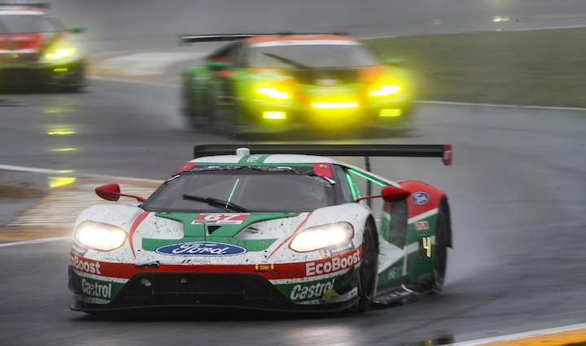
Ben Keating Motorsport 2019
The second option for Ford Performance is seen as a possible shift from GT racing to Daytona Prototype (Dpi) class racing which is the higher class in IMSA. The Multimatic-built Ford GT race car uses the same V6 engine that’s found in the DPi prototypes which boosted rumors that Ford is heading in this direction for 2020, but unlike the GT which came as a full factory program for the first three years, a shift to DPi is likely to happen only if Ford starts selling the potential prototypes to customer racing teams from the outset. In today’s IMSA DPi class there are three official brands: Cadillac, Acura, Mazda and Nissan. To continue with, only Cadillac sells their DPi product to private racing teams from the four brands. If a potential Ford DPi arrives its program will be similar to Cadillac’s because the development of DPi prototypes requires more resources.
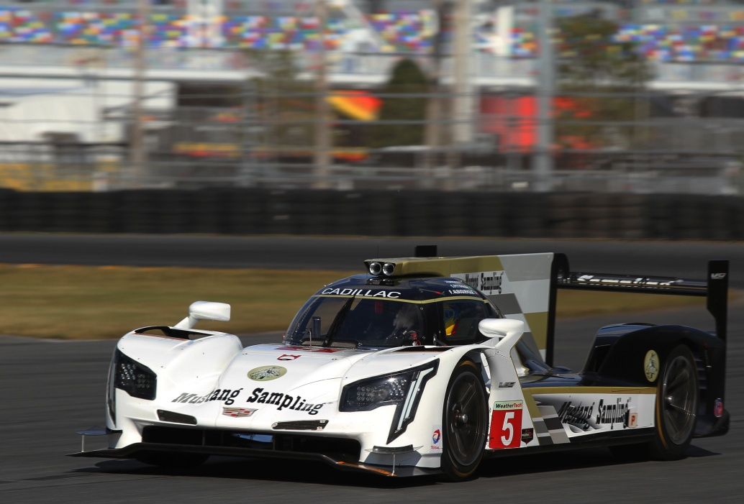
Cadillac’s DPi prototype
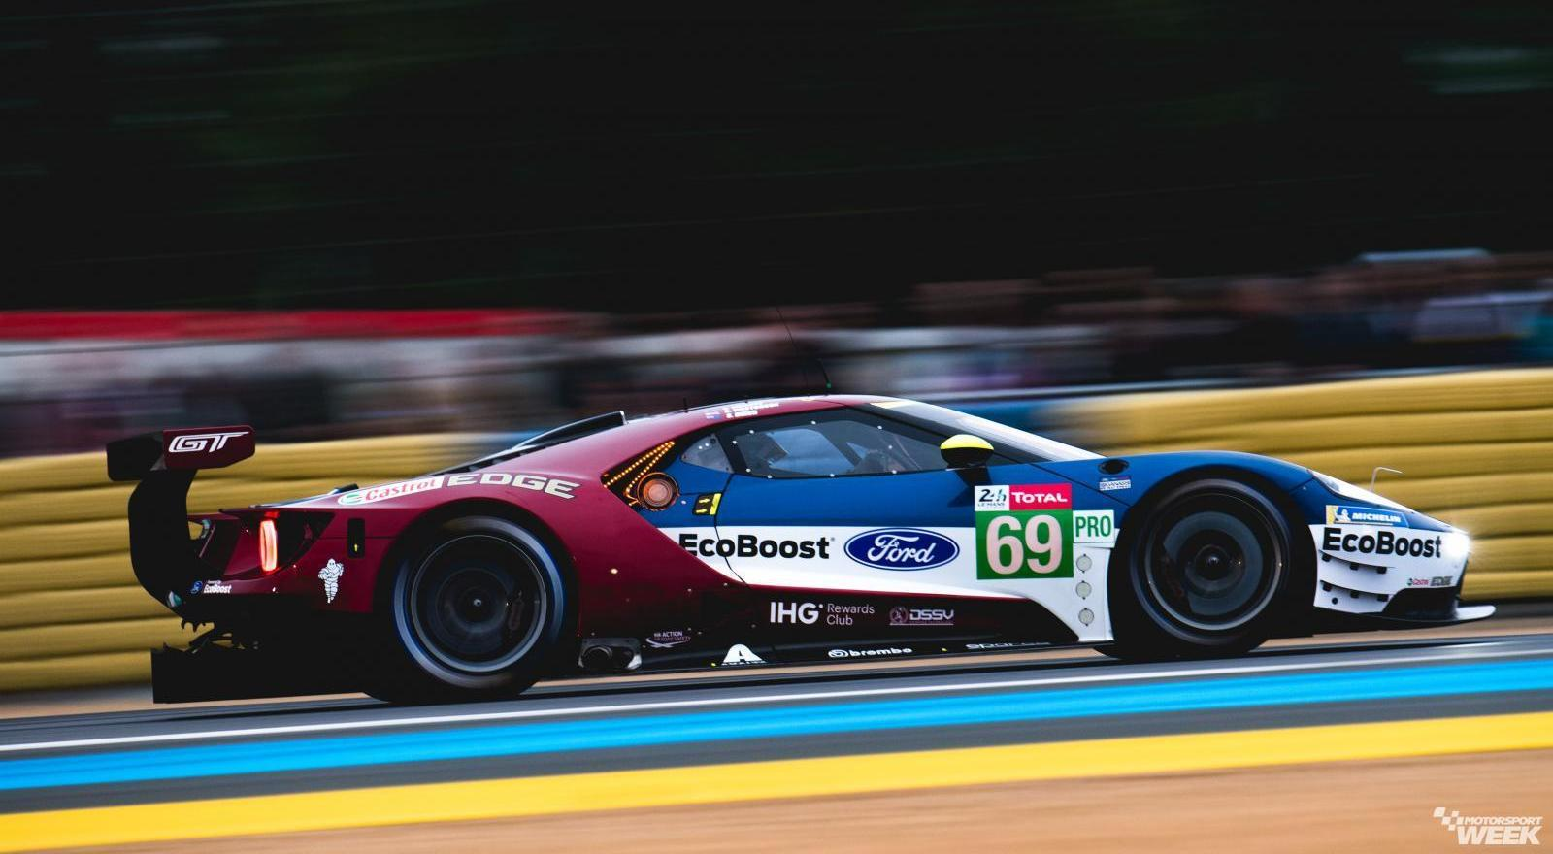
Ford’s factory GT car
Nowadays the automotive industry is making moves towards full electrification from hybrid vehicles and this is taken seriously by Ford in the making of their future motorsport plans. IMSA series guaranteed to implement the hybrid-electric systems in the DPi class in 2022 which means there will be a potential two year gap between the end of the contract Ford has and the beginning of the hybrid DPi era.
Another option for Ford is to join the highest class of racing in the FIA World Endurance Championship where they already compete in the GT class. The higher LMP1 class in the series had an uncertain future up until very recently when the new 2020 rules and regulations were revealed. The new regulations are more brand identity focused, the cars will remain prototype based but their bodywork form will be unique to each brand and represent their body style of road going hypercars or supercars. This was made to mainly cut the costs of the LMP1 budgets to a quarter from the most recent ones.
Ford Performance boss Mark Rushbrook assured that the brand is looking for more opportunities to sell their GT race car product and support packages to privateers like Ben Keating. (Pruett, 2019) The DPi project is still considered as an opportunity for the future but not until the potential hybrid rules come in the series from 2022. With that said Ford remains in IMSA and WEC for 2019 with Chip Ganassi Racing in the GT class as it is seen as the most sure path with the most agile options with a potential move to LMP1 in the same series in 2020 or just simply continuing the GT campaign in which Ford had massive success since it’s return with winning the 24 Hours of Le Mans and standing above the other manufacturers like Porsche, Ferrari, BMW and Aston Martin in this extremely competitive class. Ford also considers the fact that leaving the GT class at the end of 2019 might cause chaos in the series because of the potential BMW exit which will leave the GT class only with three factory teams in hard times in which the series can’t afford to lose any more manufacturers. Another important factor in Ford’s decision is the inevitable implementation of hybrid technology in the GT classes, where they compete, in the near future.
Choosing a GT3 race car
In the last decade GT racing experienced a massive boom and became one of the most intense classes of racing in terms of competition and popularity. The rising popularity of the supercars worldwide has had a big impact on GT racing as there was an explosive growth in the GT3 class. GT3 cars are race car versions of the road legal supercars and GT cars than brands such as Porsche, Lamborghini, Audi, Honda, Ferrari, Mercedes, McLaren, Nissan, Bentley and Aston Martin produce. What is different about these cars is that they aren’t build by specific rules and regulations of a certain championship, actually GT3 cars are race cars made by the brads stated above made to look like their road going models for commercial purposes and then their performance is balanced by the sporting federation that governs the world of motorsport (FIA) to equalize the performance of the cars and leave everything else to the drivers in the series which makes GT3 racing so interesting and popular. This resulted in many big motorsport venues around the world opening their regulations to welcome the GT3 cars including the legendary 24 Hours of Spa, 24 Hours of Nurburgring and 12 Hours of Bathurst. This racing group was intended for customers racing mainly and amateurs who would buy these types of cars to compete with their private teams. This is why the cars are more user friendly than most race car classes including traction control system and ABS which are banned in most racing series.
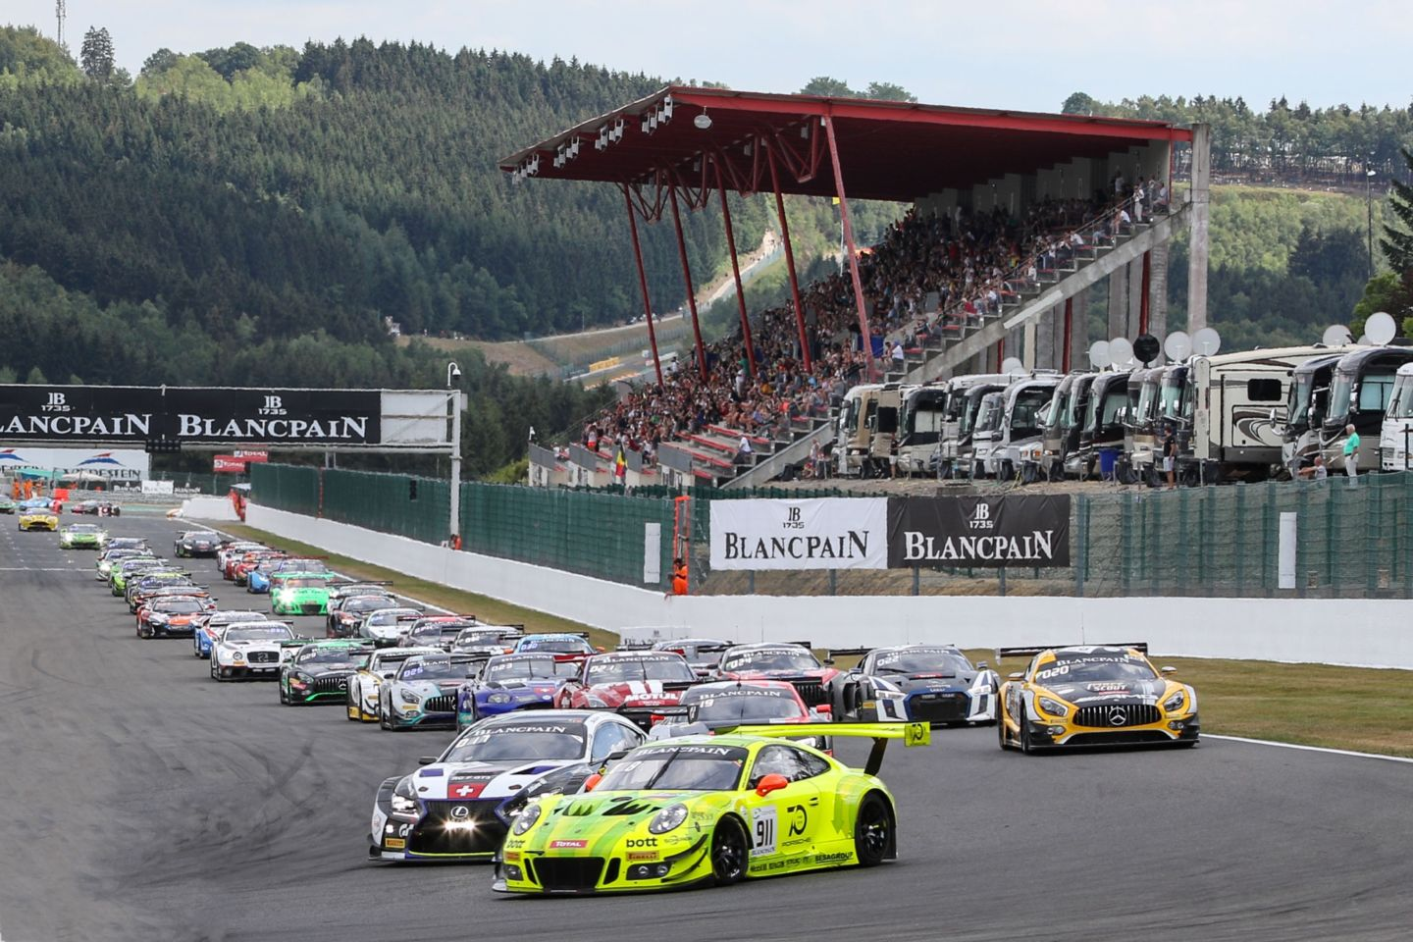
Brands mentioned that the approximate number of GT3 cars sold since 2013 is more than 500 which makes more than $250 million dollars in worth of business without the count of the spare parts which are critical for the car’s maintenance because race cars need to be revised after every race and a lot of parts are being replaced even during the race if something breaks. Likewise the new models of the road going versions, GT3 race cars are being released every three years to enhance their performance and technology and to keep up with the brand images.
In 2018 customers could choose from five manufacturers if they wanted to buy a brand new GT3 car from the brands. Honda, Audi, Lamborghini, Mercedes and Porsche offered this luxury in this year. The sticker prices for the cars without any equipment or spare parts were as it follows:
Honda NSX GT3 - $536,000
Audi R8 LMS - $514,900
Lamborghini Huracan GT3 - $525,000
Mercedes AMG GT3 - $453,000
Porsche 911 GT3R - $495,000
The process of buying a GT3 car is pretty similar through all the brands that offer the service. For instance the Mercedes AMG GT3 cars are being sold by the brand’s performance division (AMG) in Germany. As simple as sending an email to the AMG Customer Management Team and then discussing the details like the car configuration depending on what type of racing it is going to compete in. It could be sprint or endurance racing. Before production begins a pre-production payment needs to be made which is $115,000 in Mercedes’ case. Once the car is being built the factory invites the customer’s team of engineers and mechanics for technical training and making plans for the spare parts order. Once the car is done it could be delivered to your workhouse or in the Mercedes factory, a support engineer is sent to help fire up the vehicle for the first time and provide checks and setup help. The end result is a fast modern race car that produces around 550 horsepower, does from 0-60mph in a bit more than 2 seconds and has a top speed of 200mph. (Tegler, 2018)
Just like their road going brothers, GT3 cars use the same engines which mean V6 for Honda, V8 for Mercedes, V10 for Lamborghini and Audi and flat 6 cylinders for the Porsche. Endurance is from great importance to GT3 cars because of the racing venues that they participate in. To continue with, this is why turbo charged engines are found in all of the GT3 cars as it is seen as the most reliable and effective option.
The car’s wear is from big importance which is why brands state their GT3 machines life time until engine refresh needs to be made by replacing most of the components. All GT3 cars run the same six speed sequential transmission from Xtrac which life cycles are 6,200 miles. GT3 race cars are quite costly to service especially if break downs occur unplanned which happens often in racing. This is why teams offer spare parts packages. There are two types of packages, level 1 and level 2. Level 1 is basic setup equipment while level 2 provides you with everything you need from body panels to alternators. Unfortunately like any new car the GT3 cars suffer from depreciation which depends on the individual car keeping in mind the millage and race history of the car. (Tegler, 2018)
From the above stated it is clear that there are a couple of important criteria that need to be followed when buying a GT3 car: Car price, Life time, Spare parts packages price and level and depreciation.

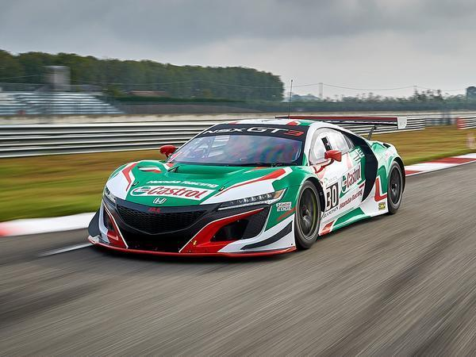
Honda NSX GT3
Price - $536,000 / Engine life time - 9,320 miles / Spare parts package - $123,000 / Depreciation for one season -$36,000
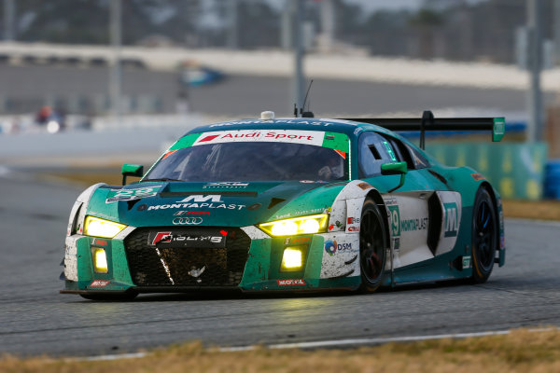
Audi R8 LMS GT3
Price - $514,900 / Engine life time - 12,427 miles / Spare parts package - $90,000 / Depreciation for one season - $60,000

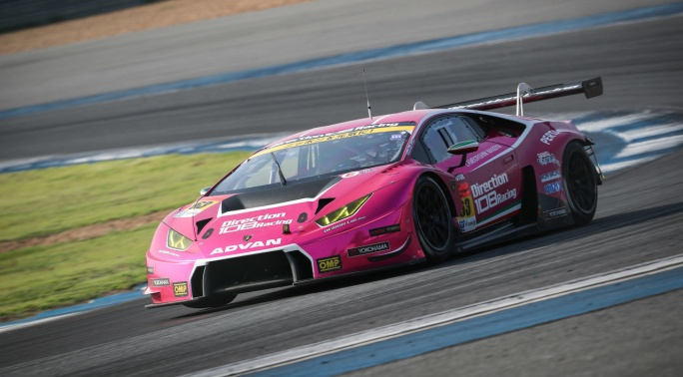
Lamborghini Huracan GT3
Price - $525,000 / Engine life time - 10,000 miles / Spare parts package - $100,000 / Depreciation for one season - $65,000

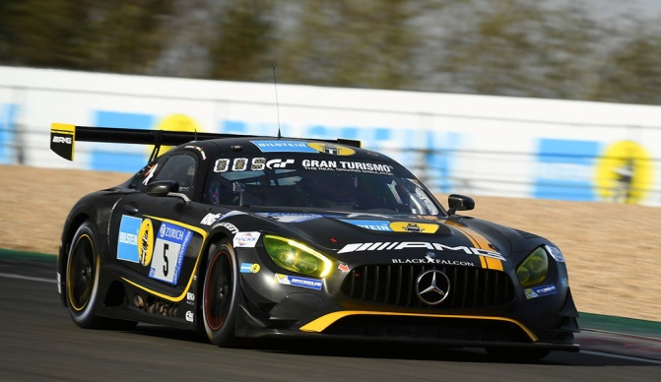
Mercedes AMG GT3
Price - $453,000 / Engine life time - 12,739 miles / Spare parts package - $100,000 / Depreciation for one season - $70,000

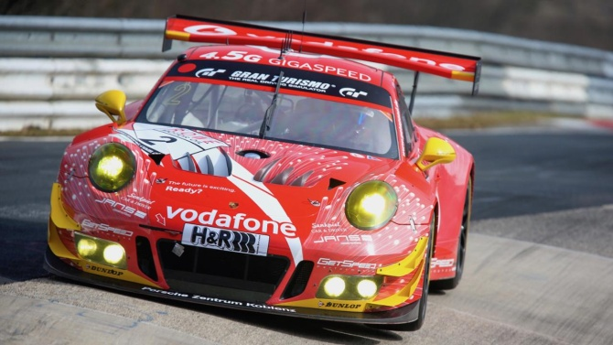
Porsche 911 GT3R
Price - $495,000 / Engine life time - 7,456 miles / Spare parts package - $100,000 / Depreciation for one season - $80,000
Knowing that all cars run the same gear box and it needs it has the same life cycle it will be excluded from the list of decision making. Spare parts packages are from big importance in racing and are purchased with the car usually so the price of the car could be combined with the spare parts package price for enhancing the process. This makes the total prices of the cars as follows:
Honda - $659,000
Audi - $604,900
Lamborghini - $625,000
Mercedes - $553,000
Porsche - $595,000
This leads the Mercedes in the best place in terms of price which is the main issue with buying GT3 race cars; because the depreciation level is similar and it is not seen as important as the other factors could be excluded so more focus can be highlighted on the engine life time. Clearly the Mercedes leads in this category as well so it comes ahead of its competitors by ticking the most boxes in the buyer’s conditions.

Bibliography
CONSTANTIN ZOPOUNIDIS, M. D. (2002). Multi-criteria Decision Aid in Financial Decision Making. JOURNAL OF MULTI-CRITERIA DECISION ANALYSIS , 167–186.
Pruett, M. (2019, April 2). What next for Ford's IMSA program? Retrieved April 2019, from Rracer: https://racer.com/2019/04/02/insight-what-next-for-fords-imsa-program/?fbclid=IwAR3hVJIaVhNSseJocCZhn0xd8DH-aPePeO6tnqaPxRAUHfv3eTUF-Ymo5cw
Tegler, E. (2018, October 10). More exclusive than a supercar: A beginner’s guide to buying a GT3 race car. Retrieved April 2019, from Arstechnica: https://arstechnica.com/cars/2018/10/more-exclusive-than-a-supercar-a-beginners-guide-to-buying-a-gt3-race-car/

