Reflective Review of Learning Journey
Professional Career development
BSMK4005
Cristina-Andreea Pojarnicu (1814440)

3-8-2019

Overview of The Assessment
The reason of this Assignment is to discover what knowledge and skills I had learned in the last 5 weeks of lessons and understand how this helps me to reach my goal.
The content of the Assignment will include different models, theories and learning styles questionnaires such as SWOT ANALYSIS, SMART OBJECTIVE, KOLB LEARNING CYCLE, GO MAD MODEL this will help me to understand how I can react my goal.

Contents Page

1.0 Overview of The Assessment 1
2.0 Contents Page 3
3.0 Introduction 4
4.0 Findings 5
4.1 Kolb’s Learning Style 5
4.2 VARK Questionnaire and Learning Style 6
4.3 Personal Development 7
4.4 Smart Goals 9
4.5 Swot Analysis 10
4.6 GO M.A.D Model 12
4.7 Personal Development Plan 17
5.0 Conclusion 18
6.0 Appendices 19
7.0 Reference List 20

Introduction

Self-development plan helps activities to improve self - knowledge and identity, develop talent and potential, build social capital and employability.
The self-development plan helps also people to improve their quality of life and realize dreams. (Ukessays.com, 2016)

Findings

Kolb’s Learning Style

In 1984, David K. published his model of learning styles from which he developed his inventory of learning styles. He says learning involves acquiring abstract concepts that can be flexibly applied in a variety of situations, in his theory, new experiences provide the impetus for the development of new concepts. The experiential learning theory works on two levels: a four-stage learning cycle and four separate learning styles, he also believed that people's individual learning style emerge because of their genetics, life experiences, and the demands of their current environment. (Mcleod, 2017)
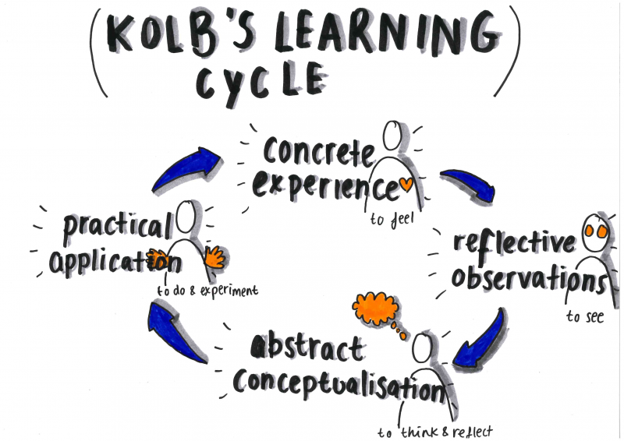

The Learning Experiential Learning Cycle has four stages:
Stage 1: CONCRETE EXPERIENCE is about being involved in a new experience; (Web.cortland.edu, n.d.)
Stage 2: REFLECTIVE OBSERVATION talks about what people are learning while they watch others; (Web.cortland.edu, n.d.)
Stage 3: ABSTRACT CONCEPTUALIZATION talks about what people learned from their experience; (Web.cortland.edu, n.d.)
Stage 4: PRATICAL APPLICATION is about practicing of what they have learn from the experience (Web.cortland.edu, n.d.
Now an example of Experiential Learning Cycle based on people experience will look like:
Stage 1: A concrete experience is when people attend a course as I do. This will be a new experience that help them develop their knowledge.
Stage 2: They are trying to get information based on what they see, hear and learn that can help them improve their skills like IT skills, Academic writing skills and other. This is a situation of a reflective observation.
Stage 3: After they have acquired new knowledge they try to apply what they have learned: like IT skills that will help them to the presentation that they have to do and get better result.
Stage 4: At the end of the course they will developed more other skills and knowledge that they will use in their life or at work.

VARK Questionnaire and Learning Style

Inventories of learning style are designed to help respondents determine their learning style. Typically, these inventories take the form of a questionnaire focusing on how people prefer learning. Respondents select the answers that resemble their own preferences most closely. Inventories of learning styles are based on the idea that when it comes to learning, people have different strengths and preferences. (Verywell Mind, 2018)
There are different types of learning style, now I will use two of them on my personality, and this are:
- Myer Briggs Personality Profiling Test
- Honey & Mumford VARK Questionnaire and Learning Style

Myer Briggs Personality Profiling Test

MBTI stands for Type Indicator of Myers Briggs. This is a tool that is often used to help people understand their own preference for communication and how they interact with others. Awareness of what MBTI is, can help you to tailor your interpersonal approach to various situations and audiences.
This test will help me to discover what kind of personality I have, now my result is:
INFJ Introverted Intuitive Feeling Judging

Introvert (34%) Intuitive (16%) Feeling (31%) Judging (33%)
- You have moderate preference of Introversion over Extraversion (34%)
- You have slight preference of Intuition over Sensing (16%)
- You have moderate preference of Feeling over Thinking (31%)
- You have moderate preference of Judging over Perceiving (33%)
The result of this test is show me that I am a creative, gentile, idealistic, caring, and a sensitive person. (see appendix 1) (Humanmetrics.com, 2019)
Honey & Mumford VARK Questionnaire and Learning Style
The learning styles developed by Peter H and Alan M. has as a base the Kolb’s theory, this theory helped them to identify four distinct styles of learning: activist, theorist, pragmatist, and reflector.
They also developed and VARK Questionnaire which helps people to understand what style they use for learning new things. (Www2.le.ac.uk, n.d.)
After I have done the VARK Questionnaire my result is:
- Visual 10
- Aural 8
- Read/Write 11
- Kinesthetic 7
(see appendix 2)

Personal Development

Personal development plan is a process in our life that never ends. The personal development plan it is a method that helps people discover their skills, qualities, self-awareness and self -assessment in order to improve our potential and set goals. (Skillsyouneed, 2011-2019)
According to Stephen R. Covey who explain us the ‘7 Habit of Effective People’ in our life is very important to have a personal plan development because once we create it, we identify your most important values and beliefs and will help us to achieve our goal. (The Productive Physician, 2017)
The 7 Habit of Effective People are (Models,2008- 2019) :
- Be Proactive – be ready before something happens
- Begin with the End in Mind – having an image of your future
- Put First Things First – the most important priorities coming first
- Think Win-Win – report with other for a mutual agreement
- Seek First to Understand, Then to Be Understood -listen before speaking
- Synergize – working together
- Sharpen the Saw – is about having a balanced program between work, school, friends, family and your-self care
In my opinion, 7 habits of effective people help us understand what we want in our lives and how we organize things to achieve our goals. The Seven habits of Stephen R. Covey are divided into 7 categories, each of which contribute to our personal development. Is telling us how our behavior should be in different situations of our lives, for example, to put first the things that are more important for us and contribute to our personal development, to have an image in mind of our goal and how to do it, take responsibility for our actions, interact with others to arrive at a mutual agreement, listen to others first and understand why they make those decisions and then talk also is tell us that working together with others has more benefits and in the end says that to do all this it is very important to take care of ourselves to have a balance between personal care and social life.
On my personal development plan, I will use as example The Johari Window that is a model who was Developed in the 1950s by American psychologists Joseph Loft and Harry Ingham to helps people to improve the self - confidence, personal development, group development, relationship understanding and their communication with others.
The Johari Window method is divided in four quadrants (Mulder ,P, 2017):
-Open area is about what other people know about you;
-Blind area is about what people know about you and you do not;
-Hidden are is about things that you know about your self and other people do not know;
- Unknown area is about things that you and other people do not know;

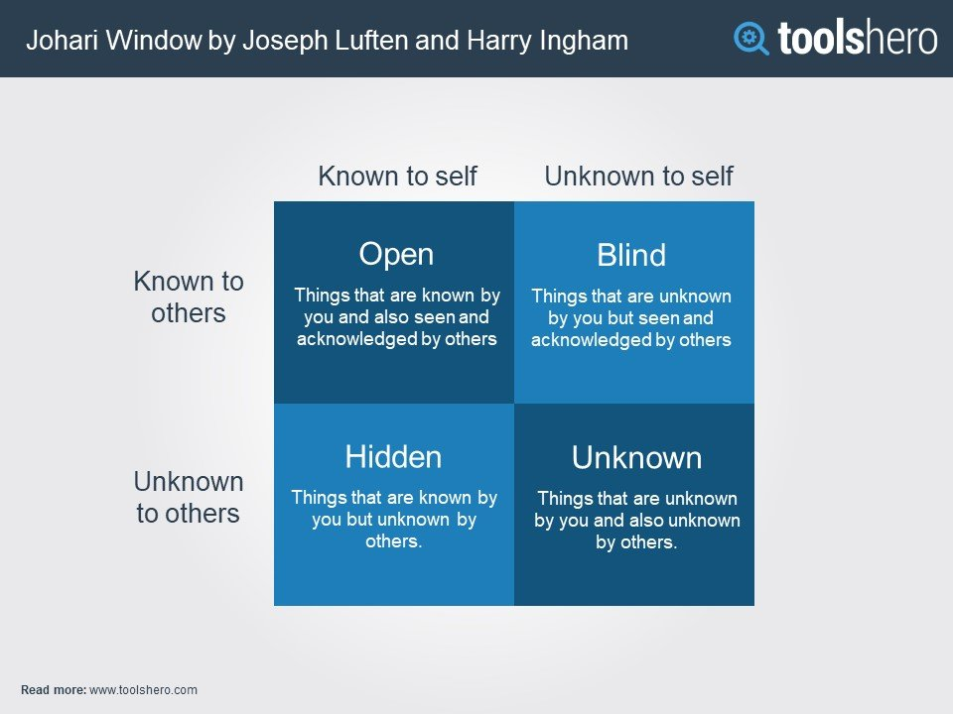
Now the Johari Window method on myself will be like:
Open Area:
I know, and my family know as well that by doing this course and get the certificate, will help me to improve my skills and have more possibility in the future for a better job.
Hidden Area:
I spend a lot of time on my homework and research, I want to make sure that my results are excellent, and I think other people don't understand why I do this course yet.
Blind Area:
I don’t know yet if I have the possibility to get the certificate in the Skills for the work place because I am not sure about my knowledges.
Unknown Area:
None know what will happen in the future.

Smart Goals

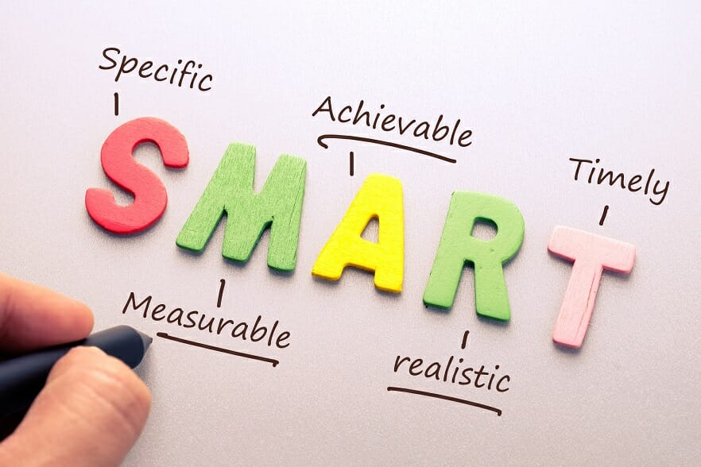
Once you have set your goal, it must be SMART by being smart, it is understood that your goal had to be:
S - specific, significant,
M - measurable, motivational
A - achievable,
R - realistic,
T - time-based, time-bound
(Haughey, 2019)
To make sure my personal goal is Smart I have to recognize exactly what it is, when exactly I will know my goal was accomplished, what I require to complete to reach my specific goal, how long will take me to achieve it and what opportunities it gives me. (Haughey, 2019)
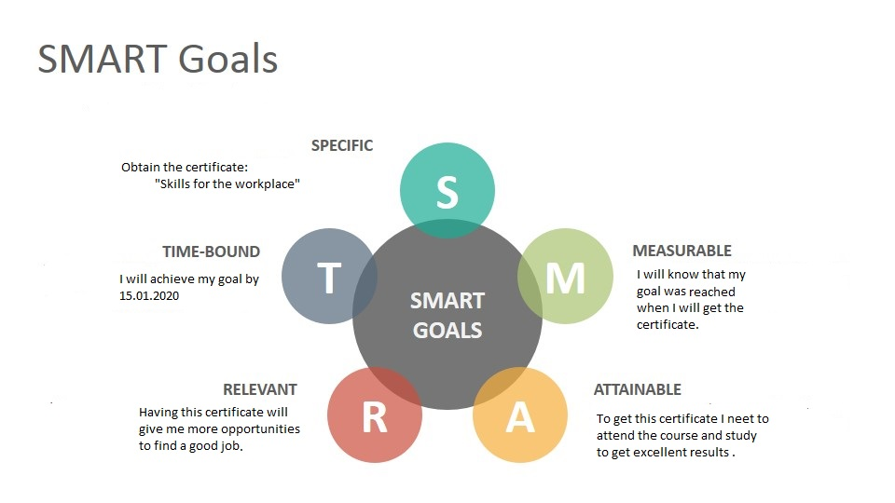

Swot Analysis

Now that I set up my specific goal and know precisely why I want to achieve it, my question is whether I have all the necessary skills to achieve it?
I will create a Swot Analysis to see what skills I have and what I need to improve at myself to obtain the direct answer to my question.
SWOT Analysis is a strategy to recognize your own Strengths(S) and Weaknesses(W) and to clearly identify the great Opportunities(O) and Threats(T) which you face. This strategy will help you to analyze our strengths, weaknesses, opportunities and threats and how we can change it. (Mindtools.com, n.d.)
The Strengths and Weaknesses are internal because are things that you have some control over and can change while the Opportunities and Threats are external because are things from around you that can influence you. (Parsons, 2018)
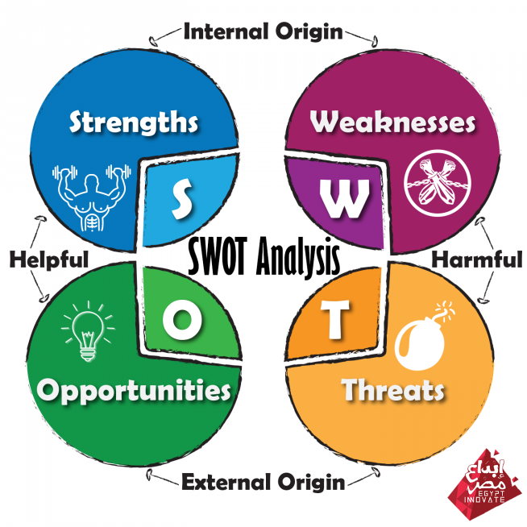

My strengths are:  - Patience  - Hard-worker  - Open Minded  - Flexibility  - Honest  - Friendly  - IT skills  - Time Management | My weaknesses are:  - Impulsive  - Undecide person  - Negative  - Take things to personally  - Team work  - Self-confidence  - Communication
My opportunities are:  - To attend this course  - Improve my skills  - Create a better future  - Possibility for a good job | My threats are:  - My nationality  - Language barrier

The principle of Swot Analysis once you identify what are your Strengths and Weaknesses, Opportunities and Threats is to help you to convert the weaknesses in strengths, the threats in opportunities and the strengths in opportunities.

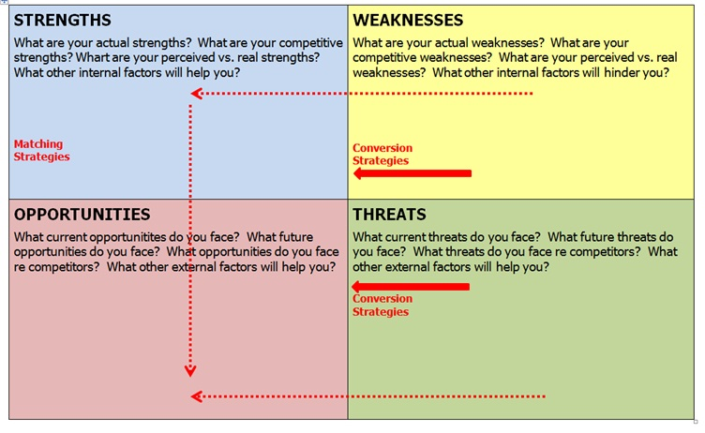
Now I will convert some of my Strengths, Weaknesses, Opportunities and Threats:

STRENGHTS (S) conversion to OPPORTUNITIES (O)
IT Skills (SO)
I can do researches on the internet or in library about what I need to study for my course and how to do my homework better. At the same time, I can use my IT Skills to write better my assessments.
Time Management (SO)
By having the time management like a strength, I can use it like an opportunity to plan my study and my time in the way that I can react every single goal that I have, for example: to do my homework and my assessments in time.

WEAKNESSES (W) conversion to STRENGHTS (S)
Communication skills (WS)
Can become a strength for me because I can improve my communication during this course by interacting with my teachers and my colleagues.
Team-work skills (WS):
This course is giving me the chance to improve my teamwork skills by doing the homework that is required to be done in groups by working with my colleagues will help me to develop my team-work skills.

THREATS (T) conversion to OPPORTUNITIES(O)
Language barrier (TS):
By attending this course and obtaining the certificate that is valid in the UK, my language barrier will no longer be a threat but will become an opportunity.

GO M.A.D Model
Now that I developed my SMART GOAL and I learned how to convert my Strengths in Opportunities, Weaknesses in Strengths and Threats into Opportunities is time to see how I can reach my goal.
I will use the Go M.A.D. Framework model by Gilbert A.&Chakravarty I.
“The Go M.A.D model was developed in 1999 and has been used in over 40 countries across the world to help businesses, teams, and people to accelerate results and enable change”.
(Gomadthinking.com(n.d.)

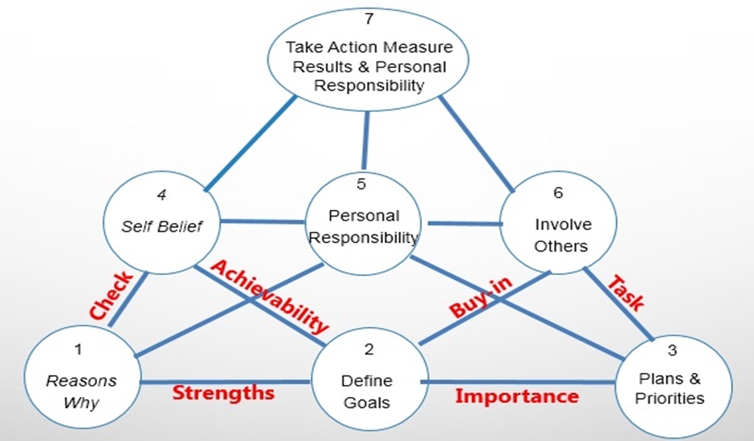
Now if I want to do a GO MAD MODEL for my goal, will look like:
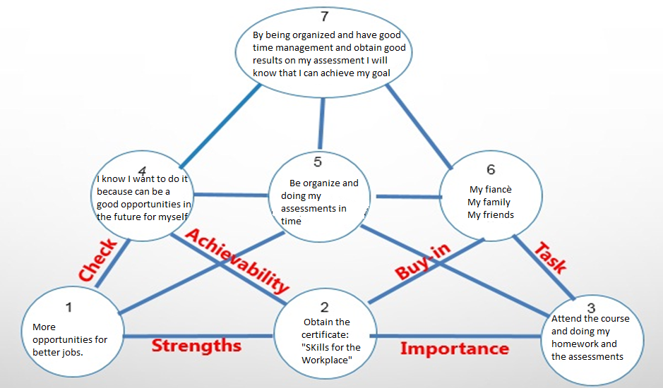

Steps 1: INTERNAL TRIANGLE Step 2: EXTERNAL TRIANGLE

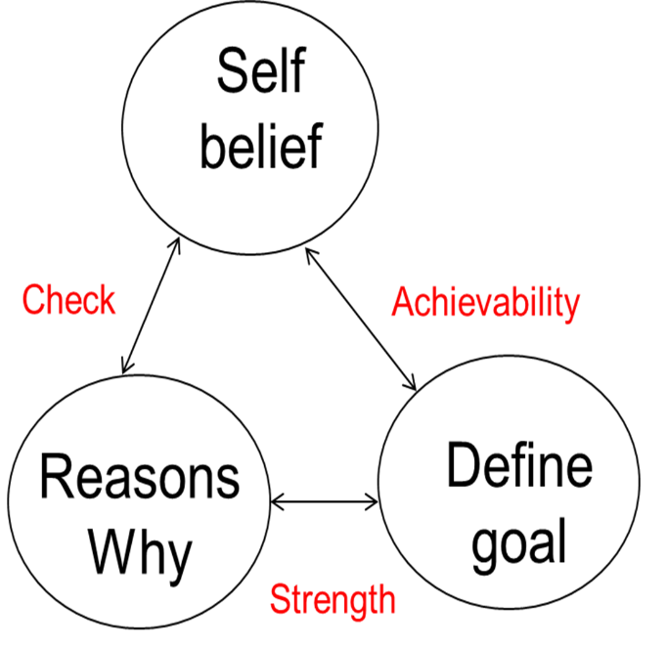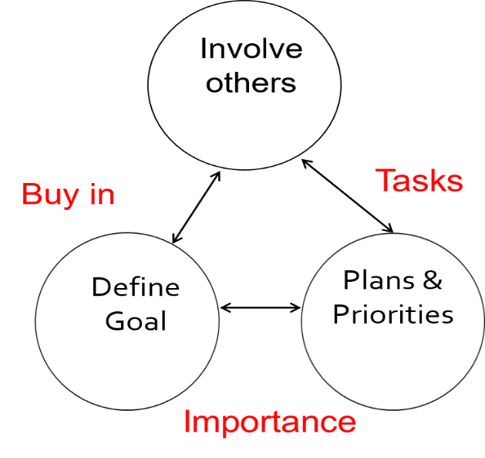

STEP 3: RESULTS AND CELEBRATE

Take action,
Measure result
Personal Responsibility

STEP 1: INTERNAL TRIANGLE

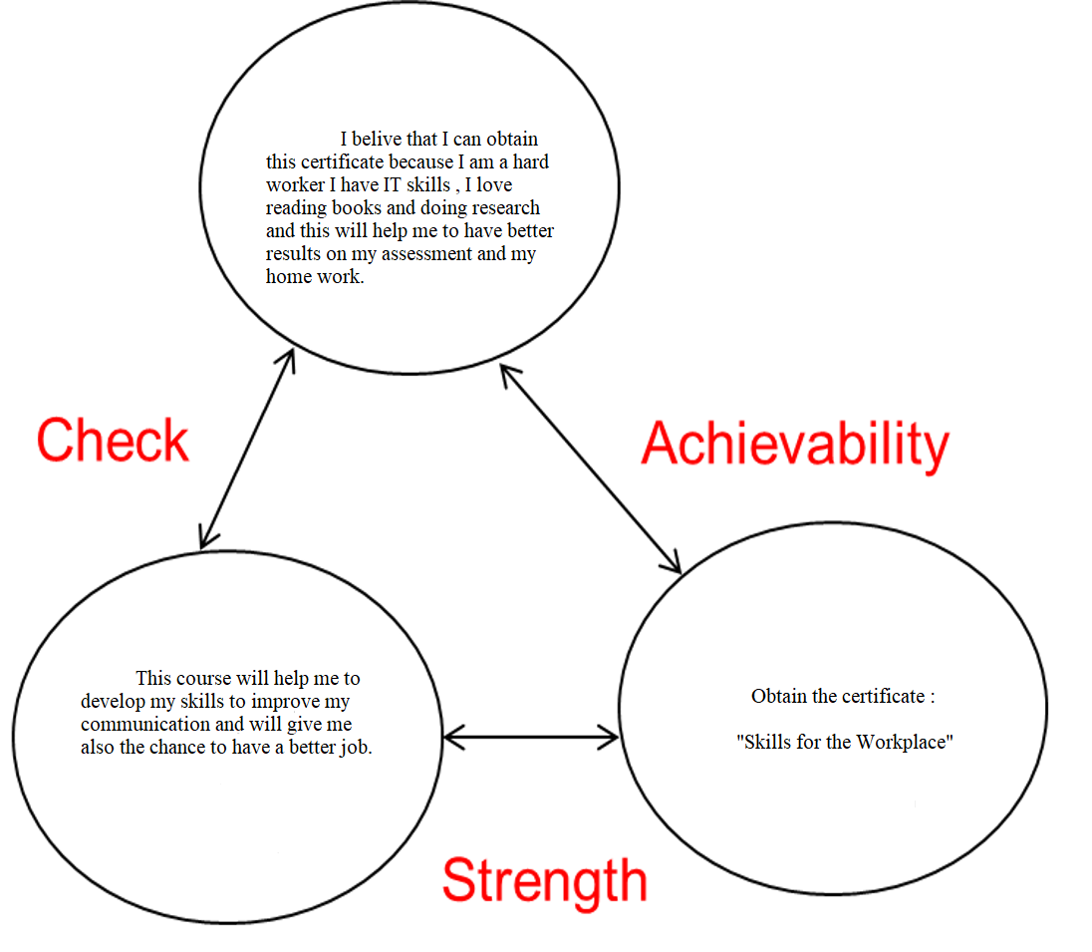

STEP 2: EXTERNAL TRIANGLE

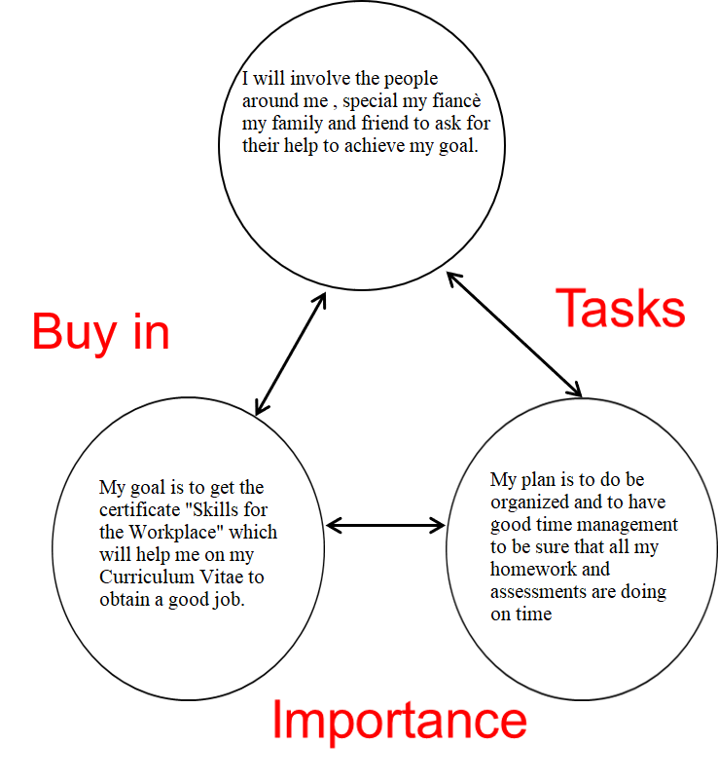
STEP 3: Take action, Measure result, Personal Responsibility
To achieve my goal I must be responsible for my action, I must work hard and stay focused on what I really want to obtain, I must be organized and do my research and I must to attend the course.

Personal Development Plan
Now that I analyze what I have studied in the last five weeks at University, I will create a Personal Plan development, this will help me to remove my gaps and to understand better what knowledge I have.
The knowledge and the skills that I have vested after my studies will help me to reach my goal. (Mindtools.com, 2018)

Development of knowledge | The actions that I will take to reach my goal | Blockers and how they will be removed | Support required | When I will know if I have reached my goal
I want to make progress on my communication, writing and IT skills; | I will do a lot of researching and reading information about how I can create a good assessment; | I don’t use technical terms to much, but I will read books that will help me improving my vocabulary; | I will ask my fiancé to help me with the IT skills and my colleagues to give me more information; | I will know if I have done a good assessment when I will receive the feedback from my teacher.

Conclusion

In conclusion, analyzing what I have learned in the last week gives me the opportunity to better understand why I have this goal. This assessment gives me the opportunity to practice my IT skills and my writing skills to do a lot of research and improve my knowledge.

Appendices

1.http://www.humanmetrics.com/personality/infj-type?EI=-34&SN=-16&TF=-31&JP=33
http://www.humanmetrics.com/personality/infj
2. http://vark-learn.com/the-vark-questionnaire/?p=results

Reference List

1. Skillsyouneed (2011-2019) Personal Development | SkillsYouNeed. [online] Skillsyouneed.com. Available at: https://www.skillsyouneed.com/ps/personal-development.html [Accessed 25 Feb. 2019].
2. The Productive Physician. (2017)."last update 2019" Step by Step: Creating a Personal Mission Statement. [online] Available at: https://productivephysician.com/personal-mission-statement/ [Accessed 25 Feb. 2019].
3. Models, C. (2008-2019). Stephen Covey: Discover The 7 Habits of Highly Effective People. [online] Change Management Coach. Available at: https://www.change-management-coach.com/stephen-covey.html [Accessed 25 Feb. 2019].
4. Mulder, P (2017). Johari Window Model, a powerful Communication Skills model | Tools Hero. [online] Tools Hero. Available at: https://www.toolshero.com/communication-skills/johari-window-model/ [Accessed 28 Feb. 2019].
5. Mindtools.com. (n.d.). SWOT Analysis – Discover New Opportunities, Manage and Eliminate Threats. [online] Available at: https://www.mindtools.com/pages/article/newTMC_05.htm [Accessed 28 Feb. 2019].
6. Haughey, D. (2019). SMART Goals. [online] Project Smart. Available at: https://www.projectsmart.co.uk/smart-goals.php [Accessed 4 Mar. 2019].
7. Parsons, N. (2018). What Is a SWOT Analysis, and How to Do It Right (With Examples) | Live Plan Blog. [online] Live Plan Blog. Available at: https://www.liveplan.com/blog/what-is-a-swot-analysis-and-how-to-do-it-right-with-examples/ [Accessed 4 Mar. 2019].
8. Gomadthinking.com. (n.d.). Go MAD Thinking. [online] Available at: https://www.gomadthinking.com/ [Accessed 4 Mar. 2019].
9. Mcleod, S. (2017). Kolb's Learning Styles and Experiential Learning Cycle | Simply Psychology. [online] Simplypsychology.org. Available at: https://www.simplypsychology.org/learning-kolb.html [Accessed 6 Mar. 2019].
10.Web.cortland.edu. (n.d.). Concrete/Reflective/Abstract/Active � David Kolb. [online] Available at: http://web.cortland.edu/andersmd/learning/Kolb.htm [Accessed 6 Mar. 2019].
11.Verywell Mind. (2018). What Is a Learning Style Inventory and How Is it Used? [online] Available at: https://www.verywellmind.com/what-is-a-learning-style-inventory-2795159 [Accessed 6 Mar. 2019].
12., Humanmetrics.com. (2019). INFJ: Leverage Your Personality Type. [online] Available at: http://www.humanmetrics.com/personality/infj-type?EI=-34&SN=-16&TF=-31&JP=33 [Accessed 7 Mar. 2019].
13.Www2.le.ac.uk. (n.d.). Honey and Mumford — University of Leicester. [online] Available at:https://www2.le.ac.uk/departments/doctoralcollege/training/eresources/teaching/theories/honey-mumford [Accessed 7 Mar. 2019].
14.Mindtools.com. (2018). [online] Available at: https://www.mindtools.com/courses/lnV924x0/PersonalDevelopmentPlanning.pdf [Accessed 7 Mar. 2019].

15. Ukessays.com. (2016). Introduction To Personal Development Plan Personal Development Essay. [online] Available at: https://www.ukessays.com/essays/personal-development/introduction-to-personal-development-plan-personal-development-essay.php [Accessed 7 Mar. 2019].

