I have used AI to create my logo and have used Grammarly in correspondence with my dyslexia

Bright Beginnings: Children’s Mental Health.
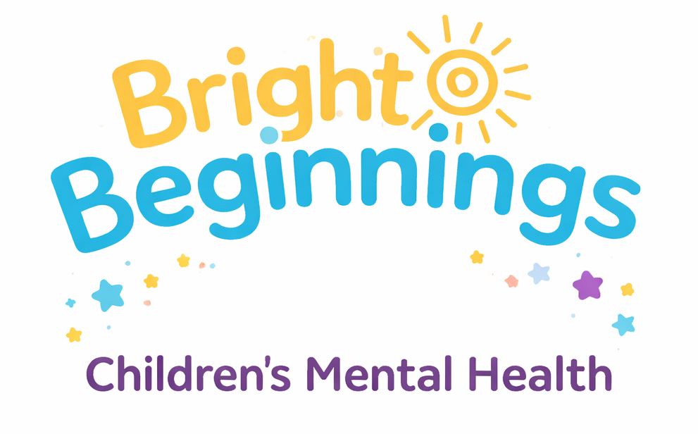

- Induction to my idea
Good afternoon, I am Brionny Coombes, and today I will be pitching a charity idea to help and support children and their families who are going through mental health issues. This charity came to me due to personal experience, and the long waiting lists children have to endure while already struggling.
Do you know how long children and young people have to wait for support for their mental health? Children in Wales (n. d.) declares that thousands of children and young people are being left with long waiting lists for mental health support, and that 26% have attempted to take their own lives, and 44% waited more than one month for any kind of mental health support after seeking help, and almost 9% were turned away.
With Bright Beginnings, Children’s Mental Health, we will get back to the child within 28 days. 28 days is the standard amount to wait for support (NHS, n.d). Bright Beginnings, however, will focus on helping the family and the child who is going through a mental health episode, and we believe that early intervention is the key to a Bright Beginning. Early intervention helps children strengthen the social and emotional skills that underpin learning and everyday life. It also lays foundations for positive long-term mental health and reduces the likelihood of risky behaviours, including smoking and substance use (Early Interventions Foundation, 2021).
We aim to help children feel as normal as we can and to help the family with ways that they can help their child. When we first get our information that a child and family need support, we will do our correct research and talk to the family and the child to see what could be going on. We may also talk to the child’s teacher to see if anything has changed in school leading up to the referral.
And of course, we will be keeping everything confidential, and everything we do will be in the best intentions for the child. Confidentiality means protecting private, sensitive information so it is not seen, shared, or used by anyone who is not approved. It involves keeping personal details secure, avoiding disclosure to people who have no legitimate reason to know them, and ensuring that information is not accessed, passed on, or used without the individual’s clear consent (Petty, 2025).
- Why am I best suited to deliver this idea
I feel like I am the best person to give this pitch because I personally have suffered from bad mental health when I was a teenager, and with the right support put in place, I got better. I want to prevent children from feeling the way I felt during that time. Everyone will handle things differently, and we plan to give the best support.
I am very passionate about mental health in children. I have supported people who have gone through mental health episodes, and I work well with children. All I want to do is to help children in any way possible.
- Why is my idea innovative
There had been increasing pressure to understand how lockdown and school closures had affected the mental health and well-being of children and young people. This understanding was seen as essential for shaping the support they needed as restrictions were gradually lifted. The evidence overview drew on empirical research exploring the psychological and well-being impacts of lockdown during the COVID-19 pandemic, alongside findings from similar health-related crises in the past (Mental Health Foundation, n.d.).
Poverty is a significant factor in the development of mental health difficulties among young people and their families. Evidence from the Emotional Support for Young People programme shows that financial hardship can also reduce a family’s capacity to provide the emotional support children need to thrive (Kelly & Whitworth, 2024). Wider determinants of health, such as economic security, are closely linked to children and young people’s mental health outcomes, and research consistently highlights emotional support as a protective factor that can buffer against poor mental health.
Findings from the Health Foundation’s inquiry into the future health of children and young people reinforce this connection. Participants aged 12–24 described a strong relationship between their mental well-being and the emotional support they received at home, while also recognising that social and economic pressures shaped their families’ ability to offer that support (The Health Foundation, n.d.).
- Benefits of my idea for early years development
If a child is struggling with their mental health, I believe that my charity will be able to address their needs sooner, in the hope of achieving positive outcomes. Anyone working with children is expected to promote their well-being, stay alert to any signs that a child may be at risk, and understand the steps required to ensure their safety. Clear responsibilities are set out in legislation, policy, and professional guidance, which outline how adults should support and safeguard children’s mental health (NSPCC Learning, 2025).
Mental health difficulties can limit children’s developmental opportunities and can continue to influence well-being into adulthood. More than half of adult mental health disorders have their origins in childhood or the teenage years. Importantly, it is not only those with a formal diagnosis who are vulnerable. Children and young people who show emerging or partial symptoms, without meeting full diagnostic criteria, also face a higher likelihood of experiencing mental health challenges later in life (Schlack et al., 2021).
- Challenges and barriers (Initial overview)
The combined pressures of the cost-of-living crisis and the prospect of an economic downturn have created a very challenging fundraising climate for charities. As households face rising expenses and declining real incomes, many donors simply have less capacity to give at the levels they once did. For people trying to manage tight monthly budgets, especially with additional seasonal pressures like Christmas, it can feel difficult to justify making regular donations to their preferred charities when essential costs are already stretching their finances (Palmer, 2023).
Parents may not trust a starting charity, but we at Bright Beginnings will always be keen to keep helping and supporting children and their families who are in need of support.
- Identifying the Audience / Stakeholders
Children who struggle with their mental health often attend school less regularly, which makes delivering support in school settings more difficult. A study published by the Children’s Commissioner in 2022, using NHS data, found that 7–16-year-olds with a probable mental health disorder were over three times more likely to miss more than 15 days of school compared with peers who were unlikely to have such difficulties (Stiebahl, Lally, 2021).
We will also be taking volunteers and working closely with schools, colleges and universities.
When we are working closely with schools, it will be for the benefit of the children who need our support as well as colleges. We will be working with universities, giving information about Bright Beginnings to educate students on children’s mental health, as well as offering students the opportunity to volunteer if they have counselling in their career path.
- Brief financial overview
We can collect donations from the public in many ways, including organising fundraising events. Getting this right matters: effective fundraising not only brings in financial support, but it also helps raise your charity’s profile and communicate the impact it aims to make.
Fundraising is also governed by specific legal requirements that you must follow. Guidance is available that outlines these duties, along with information about the Fundraising Regulator and the Code of Fundraising Practice (Gov, 2026a).
The donations and funding we get will go towards staff training, employees' Paychex and resources we will need to give the right support.
Charities that deliver education within religious settings are permitted to request Enhanced DBS checks for anyone involved in teaching, training, supervising, caring for, or offering advice or guidance to children (Gov, 2026b).
All charities are exposed to various risks, and insurance is an important way to protect your organisation against loss, damage, or liability. Common policies include buildings insurance, contents insurance, and event insurance.
Charities also need cover for third-party liabilities, such as professional indemnity and public liability insurance. If your organisation employs staff or involves volunteers, employers’ liability insurance is a legal requirement. It is also advisable to consider trustee liability insurance and business interruption insurance (PID Insurance Brokers, n.d.).
Conclusion
In conclusion, Bright Beginnings aims to bridge the gap in children’s mental health support by offering timely, compassionate, and family-centred intervention. With long waiting lists leaving many children and young people without the help they urgently need, our charity will provide early, meaningful support within 28 days, giving children the best chance of a healthier future. By working closely with families, schools, and communities, and by upholding the highest standards of safeguarding and confidentiality, we will create a service that truly listens, understands, and acts. Bright Beginnings is built on lived experience, professional insight, and a deep commitment to giving every child the bright start they deserve.

Part B
- Linking the idea to early years development
Children’s social and emotional well-being can be nurtured through high-quality early years experiences, helping to lay the foundations for positive outcomes throughout their lives. Data were collected through semi-structured interviews and examined using thematic analysis. The resulting themes shed light on practitioners’ interpretations of social and emotional well-being and their perspectives on the training available in this area. The findings illustrate how early years practitioners conceptualise social and emotional well-being and reveal the nuanced, often complex dynamics within parent–practitioner relationships. Practitioners also emphasised the significance of staff emotional well-being. It is suggested that future research and professional practice prioritise creating opportunities for reflective dialogue among early years staff and strengthening relationship-building processes (Seaman Giles, 2019).
Around 4.5 million children in the UK are living in poverty. Growing up without adequate resources increases the likelihood of anxiety, low self-esteem and other mental health difficulties. The effects on children’s well-being can look very different depending on their family circumstances and the communities they live in.
When families can’t afford essential items, a child’s physical and emotional health can be affected. Money worries shape everyday experiences, from housing and meals to school life and friendships. Over time, this ongoing stress can influence how children feel, behave and manage challenges (Gearon, 2025).
- Critical reflection and analysis barriers for your charity
This online training course on Children and Young People’s Mental Health introduces learners to what mental health is, the different forms it can take in childhood, and how well-being is supported in school settings. It explores common signs and symptoms, key risk factors, and the myths and stigma that often surround mental health difficulties. The course also covers practical ways to support children’s emotional well-being. After completing the training, learners receive a certificate in Mental Wellbeing in Children and Young People (Flexebee, n.d.).
Children and young people with the most complex mental health needs frequently encounter support systems that are disjointed and challenging to navigate, spanning education, health, social care, youth justice and the voluntary sector (Youth Endowment Fund, 2025). Many small organisations struggle to obtain core, unrestricted or multi-year funding, which restricts their capacity to plan for the long term. Reliance on short-term grants creates instability and forces them to continually search for new financial support. Many small charities also reported feeling overlooked by funders, policymakers and sector infrastructure bodies. According to the research, 78% of survey respondents felt they were not adequately represented in major funding or policy discussions (NCVO, 2025).
- Links to current practice, reports and policies
The UNCRC Committee’s General Comment on Article 24 states that restraint or the use of force should only occur when a child presents an immediate risk of harm to themselves or others, and only after every other method of managing the situation has been tried without success. Children experiencing mental health difficulties are more likely than their peers to react to situations where they feel unsafe or uncomfortable in ways that adults may interpret as ‘challenging behaviour’. In many settings, restrictive practices are still used as a response. The Children’s Commissioner for England has highlighted concerning examples of poor practice, including the inappropriate use of restrictive interventions in mental health services for children with learning disabilities and autism spectrum disorder (gov.wales, 2021).
Bright Beginnings is a charity idea to help and support children and their families who are going through mental health episodes. Poverty remains one of the most urgent issues facing society today, and the number of people affected has continued to rise in recent years. In the UK alone, an estimated 4.3 million children and young people were living in poverty in 2022–23, the equivalent of nine pupils in a typical classroom (Children In Need, 2024).
Children and young people’s mental health has attracted significant public and political attention in recent years, prompting the introduction of numerous initiatives aimed at improving outcomes and strengthening the support available. Much of this policy activity has centred on widening access to help through schools, colleges and NHS Children and Young People’s Mental Health Services (CYPMHS). Key national strategies—including Future in Mind (2015), the Five Year Forward View for Mental Health (2016), the Transforming Children and Young People’s Mental Health Provision green paper (2018), and the NHS Long Term Plan (2019)—have all played an important role in expanding provision to better meet identified needs (Children and Young People’s Mental Health Coalition, 2023).
- Future opportunities and developments
The worsening state of young people’s mental health has become one of the most significant health, social and economic issues of our era. In England, more than one in five children and young people now meet the criteria for a diagnosable mental health condition, yet the NHS is only able to support around 40% of those who need help. Many still aren’t receiving appropriate care, and services are under immense pressure, leaving millions without the support they require (Young Minds, n.d.).
The deterioration in children and young people’s mental health has become one of the most significant challenges of our generation. Around one in five young people aged 8 to 25 now meets the criteria for a common mental health condition, such as anxiety or depression. Yet many continue to experience long delays in accessing support, with early intervention often unavailable or insufficient to meet their needs (Centre for Mental Health, 2026).
- Conclusion
The evidence across early years research, current policy, and the lived realities of families shows a consistent and urgent message: children’s mental health cannot be separated from their early experiences, their environments or the systems designed to support them. High-quality early years provision plays a crucial role in nurturing social and emotional well-being, yet practitioners often face complex relational dynamics, limited training and increasing pressures linked to poverty and family stress. With millions of children growing up without essential resources, the emotional impact of financial hardship continues to shape how they feel, behave and cope with everyday challenges.
At the same time, the wider support landscape remains difficult to navigate. Children with the greatest needs frequently encounter fragmented systems, while small organisations, often best placed to offer community-based, relational support, struggle with unstable funding and limited representation in policy discussions. Although national strategies have expanded access to mental health provision, gaps remain significant, and many children still wait too long for help or receive support that is insufficient for their needs.
Against this backdrop, Bright Beginnings offers a meaningful and timely response. By focusing on early intervention, practitioner training and family-centred support, the charity addresses both the emotional foundations of early childhood and the structural barriers that prevent families from accessing help. Its approach aligns with current policy priorities while filling critical gaps in practice, particularly around poverty-related stress, reflective dialogue among staff and the need for compassionate, preventative support.
Looking ahead, the scale of mental health need among children and young people presents both a challenge and an opportunity. With more than one in five young people now experiencing a diagnosable condition, the demand for accessible, relational and early support will only continue to grow. Bright Beginnings is well-positioned to contribute to a more integrated, equitable and emotionally attuned system, one that ensures every child, regardless of circumstance, has the chance to feel safe, supported and able to thrive.
References

