University of Wales Trinity Saint David

REPORT
Intercultural Competence

Student Name: VICTORIA CHILIANU
Student ID Number: 2208500
The Module Title: Foreign Languages and Cultural Awareness BMIH5003
Lecturer’s Name: LISA BASSLER
Word count: 1091

Executive Summary
In this cultural report, the Chinese culture will be evaluated, to ensure that the business aspects of the Diversity Hotel and Spa in London are compared with a branch in China. A cultural overview is developed to allow the hotel General Manager to understand the context of running such a business in the chosen country. This study will be based on the GLOBE Project analysis and the Confucian Asia cluster of which China is a part. The GLOBE Project research programme is a global assessment analysis of societal culture and leadership (de Luque and Stephan, 2023). The following study will provide the hotel manager with intercultural perspectives and a better understanding of Chinese culture and the manner of behaviour he must have in this country.
The report is based on secondary research, which allows the use of academic journals to direct the researcher to an effective conclusion based on how culture influences the chosen organisation in another country.
Finally, a country analysis is provided to complete the research and identify recommendations that could be used to increase the performance of the General Manager of Diversity Hotel and Spa in China.

Content Table
Executive Summary 1
Introduction 3
Main Body 4
Culture Overview 4
GLOBE Project/Country Analysis 5
Conclusion 8
Recommendations 9
References 10

Introduction
This report enhances the understanding of intercultural competence in terms of key cultural differences, personalised and behaviour China, the chosen country. In addition, cultural background aspects as well as entrepreneurial cultural atmosphere may differ, as there are fewer studies on these aspects compared to traditional Chinese culture perspectives on business (Hsu and Huang, 2016). Therefore, the project will be carried out based on an overview of cultural practises and values in England and China, comparing the degree of In-group Collectivism, Gender Egalitarianism, Power Distance, and Uncertainty Avoidance in these countries. With the help of the GLOBE Project research programme, the manager will be endowed with the knowledge of visualisation that underlies the cultural differences between these two countries.

Main Body

Culture Overview
Confucian Asia Cluster is in the gene of traditional Chinese culture, being pinned in China’s social and political factors as well as in people’s lifestyle in China (Lily et al., 2022). Hence, when a hotel in England, having an Anglo Cluster (Figure 1) cooperates with a Chinese hotel, or a branch in China, it should first consider how to deal with the employees and customers efficiently, in order to provide an efficient service. Even more, Confucian culture influences how people behave, however, it still influences strongly how corporate decisions are taken (Chen et al., 2021). Hence any hotel manager should ensure that Confucian behaviour is critically analysed in order to conduct business effectively.
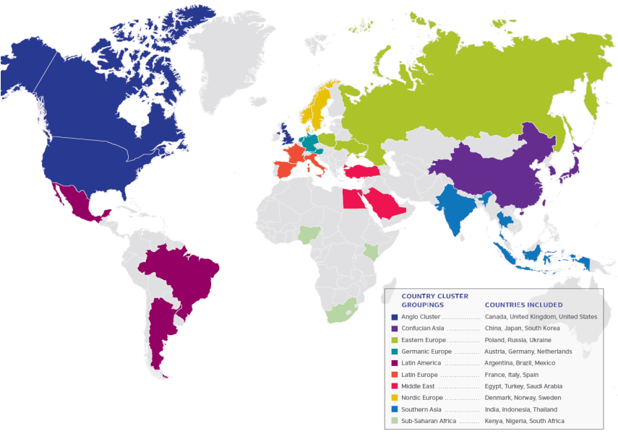
Figure 1. Country Cluster Groupings (British Council, 2018)

In addition to this, terminological differences between cultures can have an influence on business communication. Also, there could be differences from one culture to another, as well as differences from the same culture, such as different localities or rural vs urban citizens, men from one culture vs women from the same culture (Vaughn, 2019). Such cultural differences should be known within the hospitality industry, so it will ensure that all cultural aspects are known and respected.
Therefore, by analysing such aspects, understanding the relationship between behaviour and culture allows the hotel manager to interact with Chinese customers and employees in a way that respects the culture on both sides.

GLOBE Project/Country Analysis
Academic research states that the existing cultural differences are linked to employees’ intention and motivation to express or hold on to their personal views (Kwon and Farndale, 2020). This could strongly affect how the decision-making process takes place at Diversity Hotel and Spa in London as due to miscommunication and free speech errors or conflicts could easily occur. In addition to this, there could be operational differences as members of staff from both cultures have different views and beliefs over certain situations. Therefore, it is important to visualise and understand the differences between these two cultures in order to achieve increased business performance and good employee relations.

For a better understanding of the differences between these two countries, we will compare 4 out of 9 cultural values and practises based on the data collected by the GLOBE Project in 2020 (Figure 2 and Figure 3).
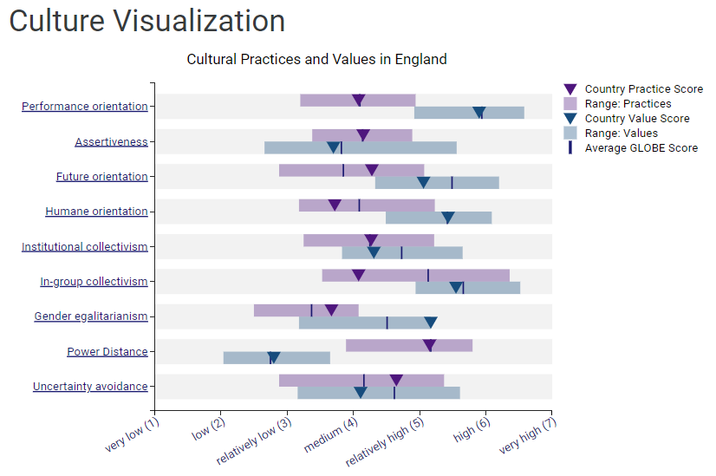
Figure 2. Cultural Practises and Values in England (GLOBE Project, 2020a)

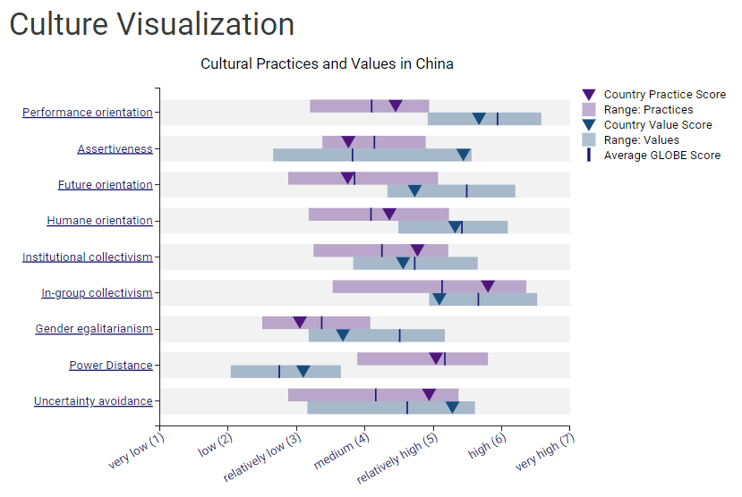
Figure 3. Cultural Practises and Values in China (GLOBE Project, 2020b)

In-group Collectivism- This concept describes the formation of individuals who prioritise collective goals more than personal ones (Galanaki et al., 2020). Even if the value score in both countries exceeds grade 5, only in China is it observed that it has been put into practise far beyond measure. In England, on the other hand, this value exceeds the average level by only 0.8. This describes the ability of the Chinese to work in groups and tend towards business development because multiple opinions and teamwork are much more beneficial than individual work.

Gender Egalitarianism- This idea generates privileging and gender equality between individuals of different genders in a society (Prasad et al., 2020). The Gender Egalitarianism value score in England is higher than in China. Instead, the practise score of both countries looks roughly equal, slightly above the relatively low level [England- 3.67 and China- 3.05]. It goes without saying that living in a European country, the English are receptive to new changes, have an open mind, and are more libertarian in their choices. The Chinese, on the other hand, are still not prone to accept these sudden transformations in which the male sex loses its value, being a country with cultural values rich in traditions.

Power Distance- This principle of analysis helps to identify the individuals of a country who approve or refuse to support status privileges and power differentials (Wang and Lalwani, 2019). In both countries, the value score for power distance is between low and medium levels, but the practical score is above level 5. The difference of 2 levels between expectations and reality is very large. These data show us that none of the countries reflect the equality between groups and individuals and the importance of a person's role in society or in business. Two strong countries from all points of view where it is understood that there are two classes: boss and subordinate. The practical score will not decrease until the subordinates start making independent decisions and increasing their responsibilities.

Uncertainty Avoidance- To avoid the uncertainty of future processes, the company must rely on rules, norms, and procedures (Czarnecka and Szymura-Tyc, 2016). China's values score is 1.17 points relatively higher compared to England, denoting a structured lifestyle based on the laws and social rules of the Chinese. Even so, England tends to grow in this chapter, jumping by 0.54 points above the established limit. Both countries tend to follow the rules for a more structured life.

Conclusion
In conclusion, understanding how culture works will enable the hotel manager to ensure that business communication is carried out effectively. The 4 out of 9 dimensions described will help an English hotel manager to understand the similarities and differences of Chinese society. It is important to know cultural aspects to ensure that business meetings are formal and based on respectful characteristics, without unwanted remarks that could offend individuals of the other culture.

Recommendations
A Hotel General Manager must:
- turn to a local translator or secretary (in the case of not knowing the language at a conversational level);
- to be aware of social, cultural and political events;
- to develop the skills of creating collegial relations and teamwork;
- to use their professional and personal experience to balance these two cultures;
- to adopt the local culture within the hotel;
- to be flexible to changes;
- to demonstrate patience in adapting the hotel's management style.

References
British Council (2018) Educational Pathways of Leaders: an international comparison. Findings of a 30 Country Study of Professional Leaders. Available at: https://www.britishcouncil.org/sites/default/files/1.6_educational-pathways-of-leaders.pdf (Accessed: 1st November 2023).
Chen, S., Cai, W. and Jebran, K. (2021) ‘Does social trust mitigate earnings management? Evidence from China’, Emerging Markets Finance and Trade, 57(10), pp.2995-3016. Available at: https://doi.org/10.1080/1540496X.2019.1675046 (Accessed: 1st November 2023).
Czarnecka, A. and Szymura-Tyc, M. (2016) ‘The competencies of global managers in multinational corporations’, In “Economy Today. An Interdisciplinary Approach to Contemporary Economic Challenges”, ed. P. Urbanek, Ser.“Economy”, Wydawnictwo Uniwersytetu Łódzkiego, Łódź 2016;. Wydawnictwo Uniwersytetu Łódzkiego. Available at: http://hdl.handle.net/11089/18472 (Accessed: 2nd November 2023).
de Luque, M.S. and Stephan, U. (2023) ‘GLOBE Research Program’, In The SAGE Encyclopedia of Leadership Studies (pp.10-4135). Sage. Available at: https://kclpure.kcl.ac.uk/portal/en/publications/globe-research-program (Accessed: 1st November 2023).
Galanaki, E., Papagiannakis, G. and Rapti, A. (2020) ‘Good is not good, when better is expected: discrepancies between ideal and actual collectivism and their effect on organizational commitment’, European Management Review, 17(1), pp.171-184. Available at: https://doi.org/10.1111/emre.12347 (Accessed: 2nd November 2023).
GLOBE Project (2020a) Visualizations of culture and leadership data collected for England. Available at: https://globeproject.com/results/countries/GBR?menu=country#country (Accessed: 2nd November 2023).
GLOBE Project (2020b) Visualizations of culture and leadership data collected for England. Available at: https://globeproject.com/results/countries/CHN?menu=country#country (Accessed: 2nd November 2023).
Hsu, C.H. and Huang, S.S. (2016) ‘Reconfiguring Chinese cultural values and their tourism implications’, Tourism Management, 54, pp.230-242. Available at: https://doi.org/10.1016/j.tourman.2015.11.011 (Accessed: 1st November 2023).
Kwon, B. and Farndale, E. (2020) ‘Employee voice viewed through a cross-cultural lens’, Human Resource Management Review, 30(1), p.100653. Available at: https://doi.org/10.1016/j.hrmr.2018.06.002 (Accessed: 1st November 2023).
Lily, Z., Fanzhu, K. and Xiurang, Y. (2022) ‘Study on the Relationship Between Confucian Filial Piety Culture and Chinese Youth’s Entrepreneurial Intention’, Frontiers in psychology, 12, p.783399. Available at: https://doi.org/10.3389/fpsyg.2021.783399 (Accessed: 1st November 2023).
Prasad, A., Centeno, A., Rhodes, C., Nisar, M.A., Taylor, S., Tienari, J. and Alakavuklar, O.N. (2020) ‘What are men's roles and responsibilities in the feminist project for gender egalitarianism?’, Gender, Work & Organization, 28(4), pp.1579-1599. Available at: https://doi.org/10.1111/gwao.12573 (Accessed: 2nd November 2023).
Vaughn, L. (2019) Psychology and culture: Thinking, feeling and behaving in a global context. London and New York: Routledge.
Wang, J.J. and Lalwani, A.K. (2019) ‘The distinct influence of power distance perception and power distance values on customer satisfaction in response to loyalty programs’, International Journal of Research in Marketing, 36(4), pp.580-596. Available at: https://doi.org/10.1016/j.ijresmar.2018.11.006 (Accessed: 2nd November 2023).

