﻿Festo cyber physical production system

Introduction

When designing anything mechanical there are plenty of methods used to achieve this with guidelines for reaching the objectives. Design for X (DFX) is a methodology that is used that helps initiate and develop design functionality in engineering. There are also many various ways of the DFX to assist with the design for assembly manufacturing with its effectiveness along with focus on the serviceability.

When assessing and reviewing the design for multiple areas of design it’s important to show where the design can improve to improve the design and outline the main design features. In this case we aim to design a robot arm/claw (cobot) that can successfully and reliably pickup and move mobile phones from one working station to another. In addition to this we want to assess the design and functionality with a report to show the process and methods used to achieve the design of the cobot.

The main purpose of this cobot is to transport and place mobile phones from a service station to another station on an industrial scale, where it would be used repeatedly and regularly. The specification and standards will have to coincide with the basic requirements like the measurements of the mobile phone and material used to do so. The material that would be used will need to be appropriate and adequate, and its important to bear in mind, there’s many issues and problems that can go wrong for cobot if the wrong material and design is used, so there is a risk of errors and failures after long term used with the cobot if not designed correctly, and as a result would affect the production flow. With regards to other requirements, the gripper on the cobot will have to pick up the phone wit out damaging the phone too.

There will also be advantages to using cobot gripper, as it will remove workers and people from the danger zones and hazards on production lines. In addition to improving safety, it will also increase the rate of production.

Material selection

When choosing the right material for the cobot, there are various options to consider like metallic, or even carbon fibre and rather than most nonmetals. We need to take into consideration the manufacturing process to determine what’s the most suitable and practical material to use. I would personally say that using a metal for the manufacturing process because of its high strength and durability which is ideal for a product that will be used repeatedly for the same function. In addition to this, metals are relatively cheaper when compared to material like carbon fibre reinforced plastic which has a higher strength to weight ratio but is far too costly to make on and industrial scale. So, when choosing the right metal for the selection, it was decided that a steel alloy was best and as it’s hard and would provide a high-strength grabber. In addition to this, the grabber will likely retain its shape without deforming in anyway. The steel alloy design will also be good in the sense that it won’t fail to carry out the function of grabbing and placing the mobile phone. The only disadvantages of using a steel alloy is that it is still relatively costly and the dense material could cause some problems for the function has a whole as it may cause stress or strain on the cobot for long term and repetitive use.

Main findings

When discussing the assembly, you must take into account the product model from its base components with the aims of successfully obtaining a good design efficiency where most of the key parts play a big role in the design and functionality. Another good method that’s involved in the design process is the design efficiency analysis as it helps gain that higher design efficiency. We start by separating groups of the design into essential and non-essential components of the design. In addition to this the method helps with the functionality and service provided by the design.

The main objective of this design for the cobot gripper and design is to achieve a design efficiency high enough to satisfy the requirements and show reliability. This method helps identify certain aspects that need to be changed for the design.

The way this design efficiency is used is that it separates essential and non-essential components of the design, and the total non-essential parts is divided by the total essential parts to calculate the design efficiency.

“Measures if the project team is exhausting all techniques to optimize the design in its use of material quantities to provide maximum capacity at minimum cost.” www.construction-institute.org.

As you can see from the table below the design efficiency worked out to be 72.7%, which shows that the design is adequately efficient enough for manufacturing. There was also a lot of consideration into what was required for the design and what wasn’t, through looking at alternatives of parts and components. 8 screws was a non-essential part of the design in order to hold the head and body of the design together, however there was consideration on the idea making the body and head as one part rather than separate.

Design Efficiency
Component | How many components? | Essential | Non-Essential
body | 1 | X
Screws | 8 |  | X
Head of cobot | 1 | X
Electrical part | 1 | X
Grip for fingers | 4 | X
Fingers of grippers | 4 | X
Total essential parts = 11
Total non-essential parts = 8 Design efficiency = 72.7%

The requirement of the gripper is to be able to functionally grab the phone without damaging it or dropping it from the docking station and move it to the magazine. grippers are generally moved around mechanically by a driving motion which allows for the grippers to serve their purpose; however, this function can only be applied to an object small enough and not to dense like the mobile phone in this case. As this is an electric repair it does not have a high grip on power but will be suitable to be able to pick up the mobile phone, so it’s important to keep in mind that the grippers are electrical and don’t have a relatively high gripping strength.

With regards to limitations of this design, there’s various limitations that affect the process. the gripper will have limits with regards to the design and manufacturing as there will always be problems and errors in the process of manufacturing. Some of these problems can include worn out machinery and tools, errors in the machining equipment, software and programme issues, worn out materials and poor durability, competency of staff in the manufacturing process and environmental rules/ regulations in the process.

FMEA

FMEA which is (failure modes and effects analysis) is used and plays a big role in the design process. This analysis is very effective and useful and is always used in the designing aspect of things, and in addition to this, the FMEA allows us to work out the issues and faults with data. “Failure modes and effects analysis also documents current knowledge and actions about the risks of failures, for use in continuous improvement. FMEA is used during design to prevent failures.”
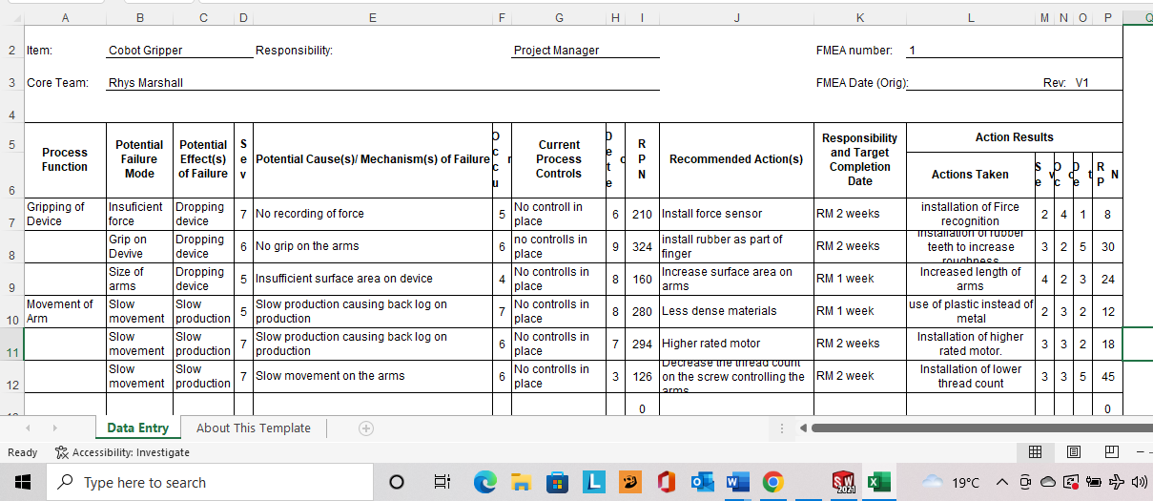

Ishikawa diagram

There’s also the Ishikawa diagram which is a good tool to use as it outlines the root causes of a particular event in manufacturing. So, this method and tool is often used in many manufacturing processes, and by gaining a better understanding of the products cause and effects, it directly helps product development to avoid any quality and standard failures that can arise. As said by Lewis s “diagram is a visualization tool for categorizing the potential causes of a problem. This tool is used in order to identify a problem's root causes.”

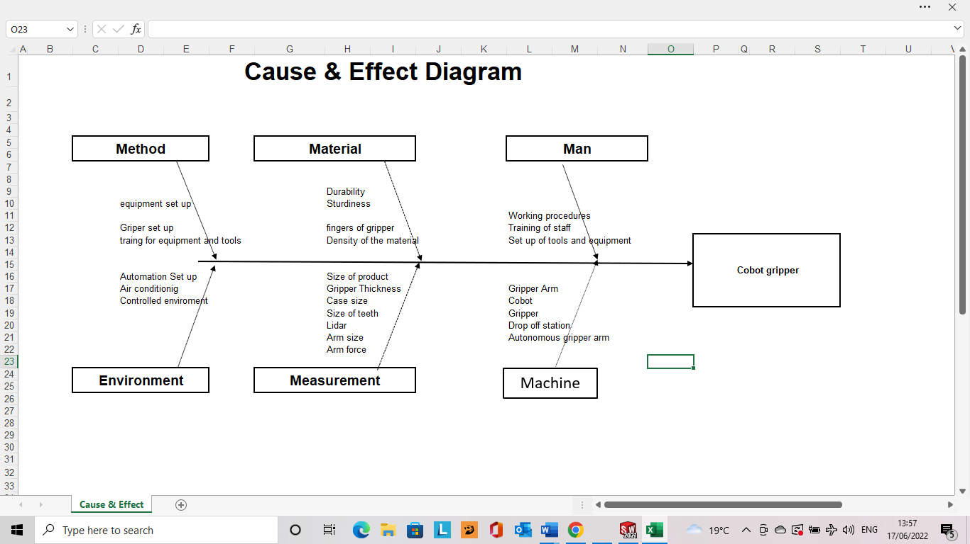

PDS

As part of the design process and establishing the functional requirements and expectations, a product design specification (PDS) table was made for the gripper as you can see below. The importance of the PDS table is that clearly outlines necessities of the gripper along with functional requirements needed for it to be successful and meet the customer requirements.

“A product design specification (PDS) is a document that contains all the requirements, constraints and specifications that a new product must adhere to. Writing a strong product design specification increases the chances of producing an effective product by providing clarity to all stakeholders at every stage.
The PDS is a single document that details what the product needs to do, look like and deliver for the end user. Having this document will guarantee that design teams have clear expectations for the finished product and ensure that all parties are working with the same understanding of exactly what the product will be – saving time and money.” Geddes, D. (2022).
”

 | Environmental | Material and design expectations | safety | aesthetics
Requirements  and expectations | - The product must be made from steel which is recyclable.  - Any non-recyclable parts of the product must be disposed correctly at a waste centre | - Steel alloy material will be used  - Expected life span: 5 years  - Quantity required: 1  - Weight: 1.5kg  - Height: 79mm – 82mm  - Width: 59mm – 61mm  - Length:112mm – 115mm | - During the production of the product, all health and safety standards must be met in accordance with the health and safety at work act (1974) | - The cobot wont have many aesthetic factors as its only used for the purpose of picking up mobile phones and placing them.  - No paint or colour is required

 | Product requirements for customer | Significance and importance  (1-10)
1 | Should have at least 5 years life span | 7
2 | Not lose grip when handling the mobile phone | 9
3 | Should be light weight | 3
4 | Should be robust | 5
5 | Be able to successfully pick up the mobile phone | 10

QFD Quality function development

The Quality function development (QFD) is a method that rates requirements for the customer based on importance and significance. This highly useful and helpful as it helps focus on what your customer is looking for in the product. This method is widely used in many organisations and industry in order to outline where you may be lacking in the product or where you can improve the gripper and its function. With the use of a visual understanding of what the priority is in the cobot gripper to achieve the aims and goals. As you can see above, the table showing importance in certain customer requirements where we applied the method to the design of the cobot gripper. Also below is a QFD diagram.

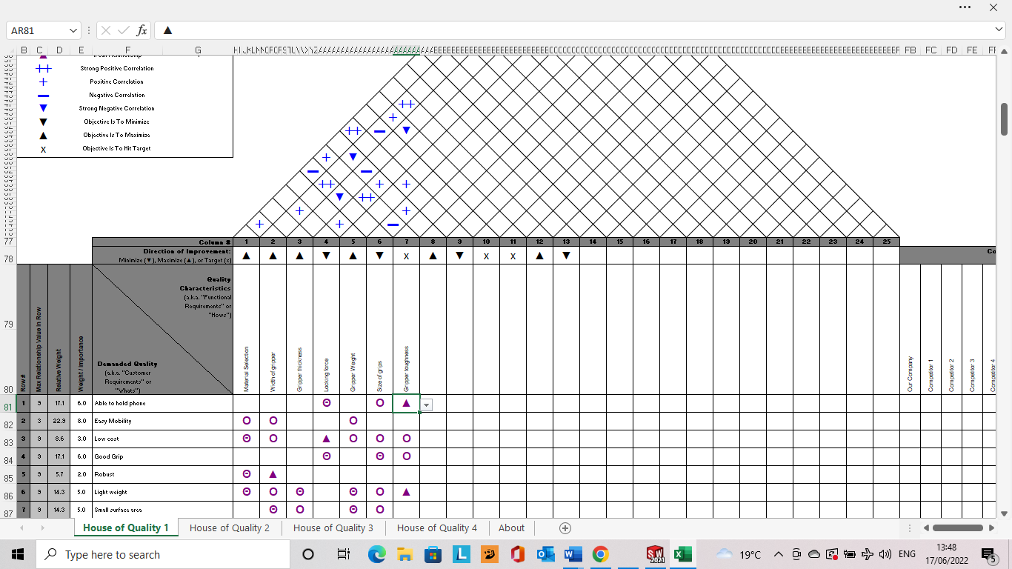

“Quality Function Deployment (QFD) is a structured approach to defining customer needs or requirements and translating them into specific plans to produce products to meet those needs.”

Manufacturing method

There are various ways of manufacturing methods that can apply to the design made for the product, within the manufacturing process there’s many different areas of the product that need to be adequate. Some of the manufacturing processes include software in the robot gripper, the equipment used to make the actual gripper and the labour of carrying out the manufacturing process.

The Various methods of manufacturing Processes:
- Job shop manufacturing.
- Discrete Manufacturing.
- Repetitive Manufacturing.
- Continuous Process Manufacturing.
- Batch Process Manufacturing.

In the case that applies to our manufacturing of the gripper, it will only be a single production of 1 product. The cobot gripper is designed and made for FESTO and purely their customer needs for this one time manufacturing and production.

Manufacturing Process

With regards to the manufacturing process, the cobot gripper will be designed and manufactured into separate components of the head, body, and grippers, with various manufacturing processes that were discussed and considered. The types of manufacturing processes are:
- Casting and molding.
- Machining.
- Joining.
- Shearing and forming.

The main process that is used for this design is the casting method. The casting process is used with material of molten metal, where the molten metal is then poured into a certain desired shape that’s called the mould cavity in order to gain the shape of the finished part. The molten metal is then left to cool over time where the material solidifies to retain the finished shape of the gripper. This method and process works well with steel alloys and is a popular material to be used. In addition to the casting process for the head body and grippers, the parts will need to undergo a grinding phase to allow for a smooth surface finish which is essential, especially for the grippers. This is important to avoid that rough finish on the product. By choosing this method of manufacturing, it helps achieve the goals and aims of the design to meet the customer requirements. So, we can achieve the right finish, shape and dimensions of the design expectations. Furthermore, there is another phase which is essential which is the polishing of the robot gripper which will increase the smoothness of the finish. The polishing process is used to enhance the appearance of the product, along with preventing contamination or oxidation and even to make the surface more reflective and aesthetic.

Design

The design for the cobot gripper is the most important part of the whole process as it outlines and visualises what the finish product will be and its functionality. The aim of the design along with all the other processes like the QFD, FMEA and Ishikawa is supposed to bring focus and action to the desired requirements whilst maintaining a steady process without getting lost in all the problems and complications that can arise from the whole design and manufacturing process. By keeping to a successful design, you can avoid costs and finance to a degree whilst meeting customer requirements, however it is difficult to achieve every aspect of requirements and keep low cost. Furthermore, the design as a whole lets you visualise any faults and errors that need adjusting to rectify the product. As you can see from the technical drawings of the assembly for the cobot gripper, the body part dimensions are sized up to coincide with the mobile phone which was 114mm in length and 60mm wide. The body dimensions coincided with the mobile phone dimension dimensions.

Changes

As part of the design method for the Festo cobot gripper there was some amendments and changes that were applied for the gripper design. The number of screws was decreased from 8 screws to 4 screws, as 8 was non-essential and unnecessary. In addition to this, another change added was making the gripper fingers to stick out to come meet the mobile phone whilst picking it up with the body of the gripper meeting the mobile phone to provide more stability and security for the mobile phone. These relatively small changes both have a great impact on the final design of the FESTO cobot gripper to improve its effectiveness and usefulness.

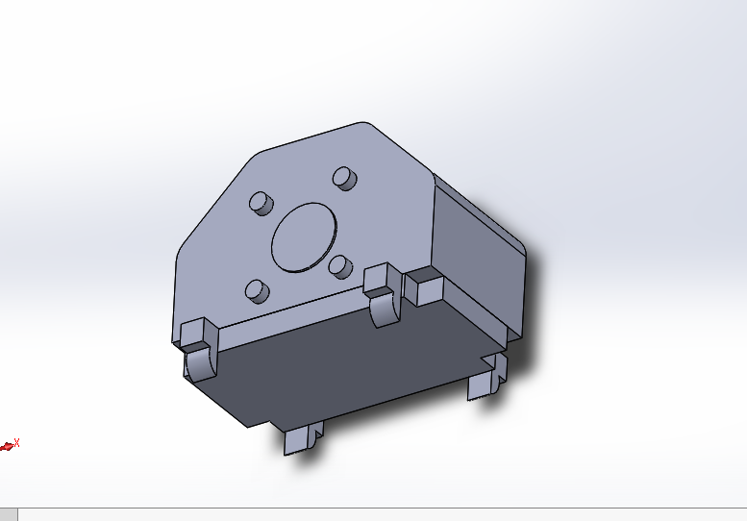
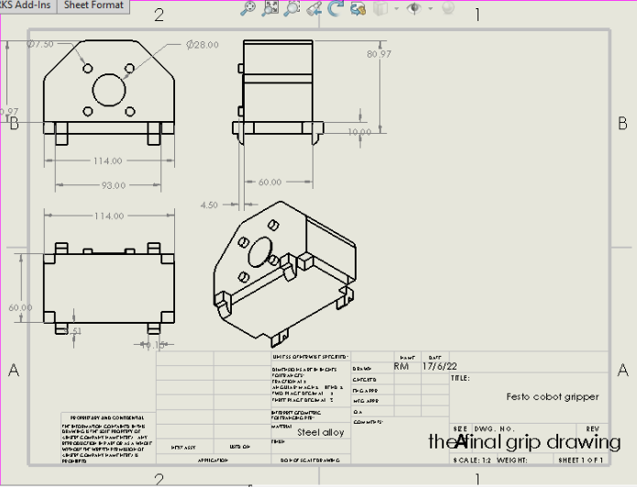

Design Process
The design process on solid works was completed by creating 3 different parts, which were the head, body, and grippers. The 3 parts were all constructed to fit the required dimension to fit all the relevant station and other parts of the FESTO production line like the mobile phone and docking station. The 3 parts were then put together through making an assembly on solid works and using the mate tool to ensure that parts all moved together as one assembly and coincided correctly.
With regards to the parts like the body and head, they design had them being held together with 4 screws. In addition to this, its important that the screws are flush in order to reduce damage to the surface of the body and head and even the mobile phones that the grippers will pick up.

Another aspect of the gripper other than the method of holding the 2 parts together, it’s important to ensure a decent electrical storage in the 2 parts to allow the gripper to function properly. Also, you will need a sensor for grippers so that they can detect how much force is required to pick up the mobile phone with out dropping it or damaging it. This is highly important as if the gripper cant detect the gripping force then, the function will fail completely. In addition to force sensors, the gripper needs to sense its movement, because if the gripper is moving from pick up station to drop off station, whilst moving vertically to pick up the phone, then the gripper needs to be aware of where it is and how far to move to get to the desired location. Once the gripper has moved itself to be directly over the phone, the gripper fingers will move in to close on the mobile phone to gently but firmly clamp on the mobile phone. It also then has to do the reverse action, by gently easing the grip on the phone to release it onto the docking station to complete it’s function and purpose.

Conclusion

To conclude the report and design of the cobot gripper for FESTO, the design method and manufacturing has considered the requirements and functional needs of the customer. Overall, the product and planning behind it has been done and executed successfully to make a viable product with a desired purpose. The design was not perfect but was efficient enough for one time production of the gripper for FESTO, where we’ve gone through all the appropriate phases to achieve this. When looking back on the entire process from start to finish, you can see how many things need to be carried out correctly to achieve the best version of the design, and this report along with the design and manufacturing aspects outline the necessity and importance of using these design and functionality methods to ensure that the customer requirements are fulfilled.

References

American Society for Quality (2019). What Is FMEA? Failure Mode & Effects Analysis | ASQ. [online] Asq.org. Available at: https://asq.org/quality-resources/fmea.

Lewis, S. (2020). What is a Fishbone Diagram (Ishikawa Cause and Effect Diagram)? [online] WhatIs.com. Available at: https://www.techtarget.com/whatis/definition/fishbone-diagram.

www.sciencedirect.com. (n.d.). Quality Function Deployment - an overview | ScienceDirect Topics. [online] Available at: https://www.sciencedirect.com/topics/engineering/quality-function-deployment#:~:text=Quality%20function%20deployment%20(QFD)%20is%20a%20structured%20process%20that%20uses

www.construction-institute.org. (n.d.). CII - Design Efficiency. [online] Available at: https://www.construction-institute.org/resources/knowledgebase/10-10-metrics/design-efficiency#:~:text=Design%20Efficiency%20Definition [Accessed 17 Jun. 2022].

Geddes, D. (2022). What is a product design specification (PDS)? [online] Technical Foam Services. Available at: https://www.technicalfoamservices.co.uk/blog/what-is-a-product-design-specification-pds/#:~:text=A%20product%20design%20specification%20(PDS)%20is%20a%20document%20that%20contains

