Trust, Choice and Democracy: A Sustainability Challenge for Business

By Natalie Lemon

Society is changing. The environment is changing. Economics are changing.

These “three pillars of sustainable development” are becoming unstable, unpredictable. Unchecked globalisation and the proliferation of free market, deregulated, “neoliberal” policies, are experiencing unexpected feedback on a planetary scale. Economic decline, recession, social polarisation, inequities, persistent environmental pollution and diminishing natural resources, are creating “grand challenges” for people and nature (George et al, 2016).

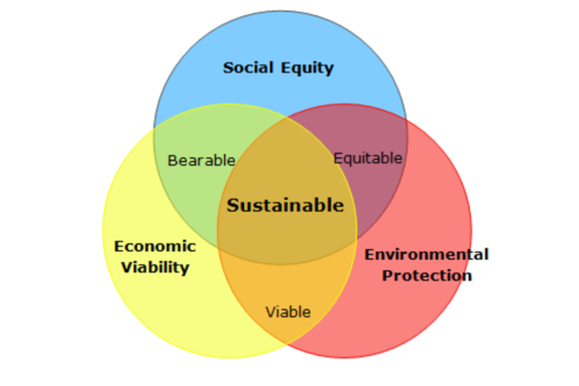
Image Source: FutureLearn.com

In the last 30 years, extensive research into man’s effects on the planet, has generated a higher state of consumer awareness and sense of responsibility for ensuring life can thrive on Earth in future. This awareness translates into consumer intention to purchase (i.e. market demand for) sustainable goods and services (Hosseinpour et al, 2016).

The world of business has to engage with people and the natural world differently, and firms that can’t adapt to these often rapid changes that are taking place, are failing. For some, failure is part of the business plan. So is the illusion of performance, and both of these business models are highly damaging to consumer confidence and trust.
Champniss and Vilà (2011) suggest in their book “Brand Valued”, that businesses jumping aboard the sustainability bandwagon often fail to address social capital – “the strength and inherent value in our societies through… dialogue, shared thinking and widespread trust” – and social equity, devaluing their claims and any actual social-environmental effects of their operations.

Perhaps a result of increased impersonal online and distance consumer behaviour, business engagement with - and understanding of - customers seems to have dropped. Business has forgotten the purpose and meaning of providing goods and services (Champniss, 2011). Products are designed for obsolescence and shamelessly mass marketed at entire populations with indeterminate social values, but with one thing in common - a perceived need to consume. The danger of such detachment from human values, is that business fails to respond to actual needs – for goods and services that are produced in a responsible, equitable and sustainable way. These days a brand can lose its reputation in a single misguided advertisement, a single news story or a single online review or “tweet”.

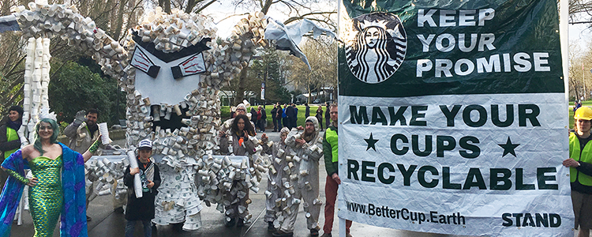
Image Source: Stand.Earth.

Arnold (2010) highlights that much of the green marketing undertaken by business is “greenwash” or “ethical wash” and, effectively, a meaningless or even cynical sales strategy with few or no actual sustainability credentials. Kim et al (2015) identify “corporate hypocrisy” when companies make unsubstantiated claims purely to make capital of social-environmental market claims. So how can consumers make informed choices and develop trust in brands? Champniss (2011) states that “trust – and opportunities to demonstrate trustworthiness – is the crucial outcome of social capital development (after dialogue, shared thinking and engagement)”. The outcome of building social capital is a long-term – sustainable – brand value built on trust. But trust has to be earned.

Kim et al (2015) state that Corporate Social Responsibility (CSR) is a key business tool for increasing the favourability of consumers’ perception of a company or brand and can enhance a firm’s reputation or help restore consumer trust.

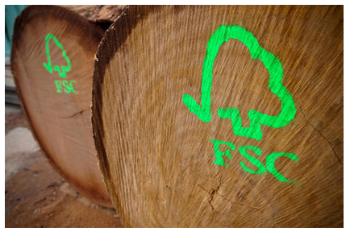
Image Source: Alamy Stock Photo.

Eco-labelling is a very important market device that businesses can use to assure customers of their social-environmental credentials, to help safeguard consumers seeking to make responsible choices. The Forest Stewardship Council (FSC) label is an international brand for timber sourced from sustainably-managed forests and is supported by a rigorous chain of custody certification process (FSC, 2018). It has become highly trusted and endorsed by independent not-for-profit organisations. The Soil Association Organic standard denotes food grown without the use of chemical pesticides and herbicides (Nuttavuthisit, 2017). Fairtrade demonstrates that the producer of a product has received a fair price for it (Arnold, 2009). All these brands seem to engender consumer trust and confidence, and this trust is what Hosseinpour et al (2016) believe is a critical deciding factor in consumers completing a transaction. Common to all of these is their voluntary nature, rigorous certification process, robust compliance audit and monitoring systems – and a strong commitment to walking the walk as well as talking the talk on environment and social capital. It takes effort to demonstrate green credentials.

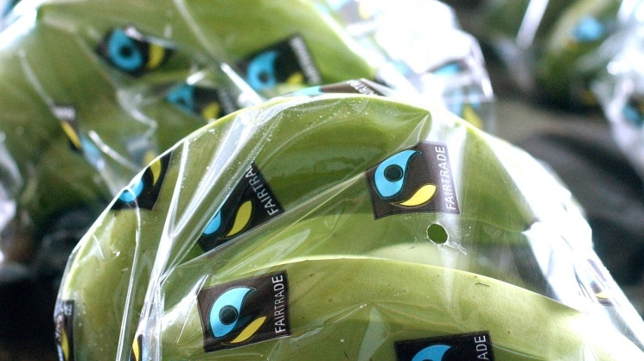
Image Source: Friends of the Earth.

A study by Poore (2018) found that the greatest potential for mitigating the environmental impacts of agriculture occurred where “producers monitor their own impacts, flexibly meet environmental targets by choosing from multiple practises, and communicate their impacts to consumers”. Despite growing evidence of health and environmental benefits of reduced meat consumption, Nuwer (2016) suggests there may be indirect effects on poorer nations of reduced meat production, linking back to the need for a sound understanding of social capital and carefully ensuring social equity on a global scale. Lewandowska (2017) adds that “life cycle thinking” is important in considering the full effects of a company’s operations when marketing green products or lifestyles.

In relation to Poore’s research, Carrington (2018) comments that although labels applied on a voluntary basis could be used to educate consumers about the environmental impact of meat and other agricultural products, government interventions such as subsidies for positive impacts and taxes on animal products could also be used to facilitate the shift away from the most unsustainable food staples.

The reasons for, the extent of, and potential impacts of Government intervention must be cautiously considered. It is widely believed that the EU Common Agricultural Policy is one of the most damaging political interventions in land management in history, causing market distortion, environmental destruction and being economically burdensome (Byrne, 2018). According to Messenger (2018), around 12,000 responses were submitted to a Welsh Government consultation on the post-Brexit future of land management in Wales – a very high level of public interest and engagement in determining the future role of Government in Welsh rural affairs. This is social capital under development.

Certainly there is an incredibly important role for Government in environmental regulation of business in areas such as energy production, manufacturing, waste management etc., ensuring business is held responsible for resource use and pollution. The Producer Responsibility Regulations on Packaging Waste and Emissions Trading Schemes are examples. Another aspect of regulation is freedom of information, since access to information is critical to public awareness and action – the Environmental Information Regulations 2004 is an example. Government intervention can engender trust in this way, but Government policy change can seem contradictory and can damage consumer confidence, e.g. the withdrawal of grants for the purchase of certain electric cars (Hotten, 2018), despite a prior stated commitment to legislate for the replacement of all private diesel and petrol cars with electric by 2040 (BBC, 2017).

Energy companies in the UK are switching to cleaner sources of electricity such as renewables in order to “avoid the UK’s carbon tax” (Ambrose, 2018) and there is evidence that the UK’s carbon footprint is now at its lowest since 1859.
“Every area of industry will be impacted by climate change. And because necessity is the mother of invention, business knows what that means. In the new climate reality, businesses that can innovate and take advantage of the low-carbon transition will be the ones that secure a sustainable future.” (Bakker, 2016)

Technological innovation can be used to either engender or betray trust. The so-called “dieselgate” scandal that hit car manufacturer, Volkwagen in 2015 (Hotten, 2015) is a prime example of corporate deceit (Terry-Armstrong, 2016). VW fitted millions of their diesel cars with sophisticated electronic software that enabled them to defeat emissions testing systems. It was a deliberate attempt to deceive both their customers and the authorities that the vehicles were less polluting than they were, which Aurand et al (2018) called “a case of corporate commissioned greenwashing”. A very public exposure of this betrayal led quickly to a 30% drop in Volkswagen’s share price (brand value) in a few days, a global loss of sales, the cost of product recall and supply-chain and reputational damage on a massive scale (Robertson, 2017). The outpouring of customer concern was interestingly tempered by expressions of brand loyalty, especially - perhaps unsurprisingly - in Germany (Terry-Armstrong, 2016). In opinion surveys, consumer trust in VW and other car brands was similarly poor on grounds of environment, safety and quality issues – perhaps a sign of poor engagement across the industry.

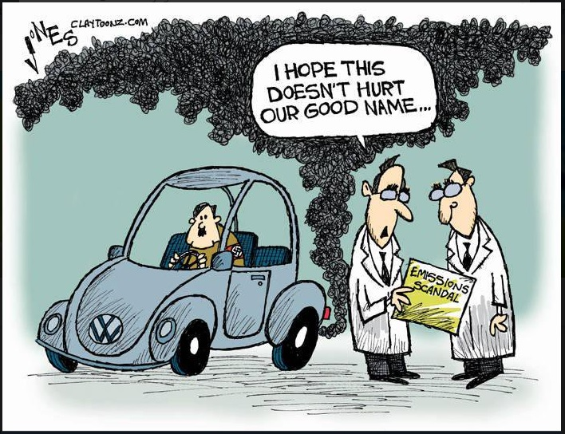
Image Source: Marco Heyligers.

The above example is just one of corporate misuse of power. Business has always been involved in politics through lobbying, and inevitably the conflicts between economics and environment – in the context of competitive social systems - are affecting global efforts to become more sustainable. Undoubtedly, the world is becoming more economically liberal. Economics dominates political discourse. Even apparently environmentally switched-on politicians such as Macron are being criticised for seeming inaction on key issues such as climate change (Chrisafis, 2018). Short-term economic and other party-political issues are taking precedent and big business is playing an influential role in driving the free-market, neoliberal political scene. According to Watts, J. (2018), economically conservative and populist political figures around the world are being funded by wealthy corporations with an interest in fossil fuels, mining/minerals, logging and agriculture to deregulate environmental protection. Big business and its political figureheads are swamping social media with fake news which undermines truth, trust and democracy (Kakutani, 2018).

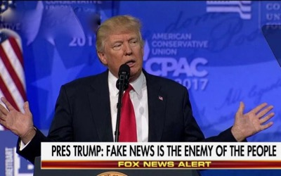
Image Source: Voltairenet.org

Natural resource scarcity is having a strong impact on global politics, in a way that does not immediately seem obvious. Arguably some key political decisions have been based on resources issues. The election of Donald Trump to President of the USA in 2016 was on the back of growing fears over uncontrolled immigration and pressure on resources. Protectionist policies rolled out by Pres. Trump to promote US industries, have re-ignited concerns about fossil fuel use. Countries are increasingly keen to exploit their natural resources and improve their competitiveness or resilience in global markets.
“History tells us that when environments deteriorate, societies turn to supposed strongmen and religious zealots rather than smart, pragmatic leaders... underlying this is environmental stress, which has been building for over two centuries”. (Watts, 2018)

Is it undemocratic to suggest that the election of such leaders is anything other than democratic? Are collective decisions made out of fear or misinformation, valid decisions? Democracy is in dangerous territory. The recent election of Jair Bolsonaro to President in Brazil, has highlighted the potentially devastating misuse of corporate power through social media, his largely online campaign allegedly funded by business with vested interest in Brazil’s natural resources (Telegraph, 2018). Bolsonaro is widely considered to be planning accelerated destruction of the Brazilian rainforest (Gillingham, 2018).
People vote – and thereby exert their democratic rights - in many different ways (Michelletti et al, 2012): through the ballot box they elect politicians who make laws that regulate business and protect the environment. Through associations they collectively change the world around them. They also vote with their money – often in ignorance of the reality of what their vote means for the environment. Everything people choose to spend their money on, creates a demand which business seeks to satisfy, whether that is, electric cars (Prior, M., 2018) or tropical hardwood timber (Jeffree, 2014).
In a monologue on the high level of consumer expenditure on pet grooming compared with lower investment in renewable energy, Professor Brian Cox (in Human Universe, 2018) stated: “In democracies, change happens when people… want it to happen”.

There is evidence of a growing “political consumerism” (Mitchelletti et al, 2012) as a factor of “sustainable citizenship”. Two current examples of this in action are:

1. The public response to plastic pollution following the “Blue Planet II” BBC series (Calderwood, 2018) and the BBC programme, “Drowning in Plastic”, both aired in 2018. These documentaries emphasised the throwaway culture of single-use plastics and heightened levels of public awareness of the impact of everyday decisions (Collins, 2018). Now, consumers are demanding information and action on plastics and packaging waste. In November 2018, measurable changes in consumer behaviour was becoming evident. The supermarket Waitrose’s Food and Drink Report 2019-19 states that their research shows “88% of us have changed how we use plastics after viewing the final episode of Blue Planet” with 44% saying they had “drastically changed” their behaviour (Howie, M., 2018).

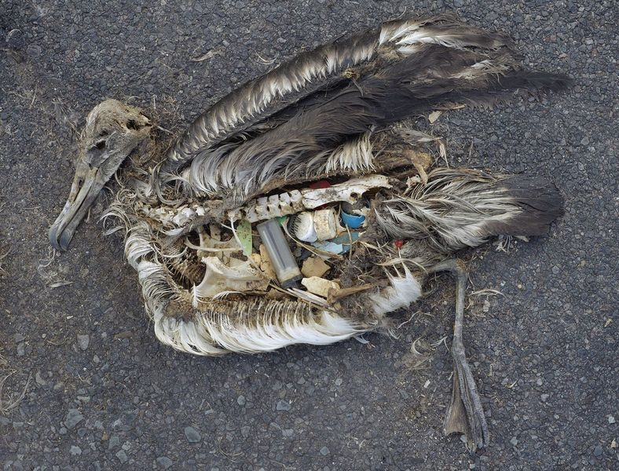
Image Source: Greenpeace UK.

2. The growth of Veganism as a dietary choice in the UK. A recent Guardian report declares that a “third of Britons have stopped or reduced eating meat” (Smithers, R., 2018). It is unclear if there is a link between the price of meat and animal products compared to plant products, and the effects of 10 years of politically-motivated austerity in the UK. Indeed, most of those surveyed attribute their shift towards a plant based diet to animal welfare concerns (55%), human health benefits (45%) and environmental reasons (38%) (Smithers, R., 2018). Since significantly less land and water resources are required to produce 1kg of plant-based food than animal-based food, the ecological benefits seem obvious (Carrington, D., 2018).

So people as consumers have a great amount of power, which can create huge reactions on aggregate, if they have the knowledge to make conscious decisions. Control of information – or to be precise, truth – is a critical element. The globalisation of socio-economic systems and the expansion of the Internet have led to greater flows of information between people; this has inevitably enabled people to form new social collectives and increase the size and power of political campaigns. The sheer potential of social media to affect social and political change, was bound to cause concern for vested interests, therefore the rapidly expanding social media environment has also seen the proliferation of propaganda and infiltration of “fake news”. This situation is engineered to damage the trust that people had developed in the Internet. When trust is broken, people seek leadership in figureheads who speak their language. Cue, the aforementioned rise of the populist.

It may seem logical that behavioural change follows a change in attitude. However it is possible for the opposite to be true. Environmental psychologist, Doug McKenzie-Mohr is a leading advocate of Community Based Social Marketing, which argues that behaviour change can in fact drive attitudinal change at a community scale. Provided the globalisation of information continues to promote the truth, then trust can be restored through information sharing through reliable networks of people who are co-operating and choosing to consume resources responsibly.

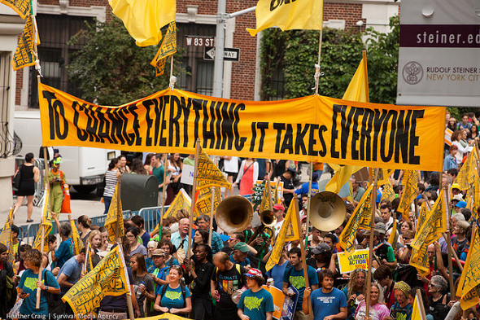
Image Source: New Internationalist.

Conclusion

In a world of increasingly divisive politics, polarised wealth and powerful influences, there remain a number of unifying factors: the state of the environment, human health and an interest in the welfare of future generations.

Big business is powerful and imposes strong control on politicians, the media and supply chains. Marketing using human psychology can exert great influence on consumer behaviour and help entrap citizens in spirals of wasteful consumption of resources. However, resource scarcity and exhaustion will render many such businesses obsolete if they do not adapt, diversify or become more sustainable.

Furthermore, despite seemingly entrenched social systems that tie consumers into vicious cycles of consumption and dependence on unsustainable resources, there is an increasing desire amongst consumers to change their lifestyles to help reduce their personal environmental impact. Translating billions of individual spending decisions into change on a population scale, this desire will affect the market demand for sustainable products and clean technologies that will favour green business and force others to improve their environmental performance. Since knowledge is key to promoting green attitudes and facilitating behaviour change, education is paramount and peer to peer enquiry and knowledge sharing between trusted partners is becoming increasingly important in a world full of charismatic figureheads, party political rhetoric, vested interests and fake news.

References

Ambrose, J. (2018). “British carbon footprint shrinks to smallest since 1859”. The Telegraph Online. https://www.msn.com/en-gb/news/environment/british-carbon-footprint-shrinks-to-smallest-since-1859/ar-BBOu1R2?li=BBoPWjQ&ocid=mailsignout
Published 17.10.2018, accessed 17.10.2018.

Arnold, C. (2010). “Ethical Marketing and The New Consumer”. John Wiley & Sons Ltd. ISBN 978-0-470-74302-7.

Aurand, T. W., Finley, W., Krishnan, W., Sullivan, U., Abresch, J. et al (2018). “The VW Diesel Scandal: A Case of Corporate Commissioned Greenwashing”. Journal of Organisational Psychology, Vol. 18, Iss. 1, (Aug 2018): 23-32.

Bakker, P. (2016). “The role of business in climate change”. World Business Council for Sustainable Development. https://www.wbcsd.org/Overview/News-Insights/Insights-from-the-President/The-role-of-business-in-climate-change
Published 06.09.2016, accessed 05.11.2018.

BBC (2017) “New diesel and petrol vehicles to be banned from 2040 in UK”. https://www.bbc.co.uk/news/uk-40723581
Published 26.07.2017, accessed 10.11.2018.

BBC (2018) “Five products you didn’t know were harming the environment”. https://www.bbc.co.uk/news/science-environment-46070037
Published 02.11.2018, accessed 02.11.2018

Byrne, R. (2018). “The Common Agricultural Policy is dead: long live the BAP”. London School of Economics. http://blogs.lse.ac.uk/brexit/2018/03/21/the-common-agricultural-policy-is-dead-long-live-the-bap/
Published 21.03.2018, accessed 10.11.2018.

Calderwood, I. (2018). “88% of People Who Saw “Blue Planet II” Have Now Changed Their Lifestyle”. Global Citizen https://www.globalcitizen.org/en/content/88-blue-planet-2-changed-david-attenborough/ Published 01.11.2018, accessed 03.11.2018.

Carrington, D. (2018). “Avoiding meat and dairy is ‘single biggest way’ to reduce your impact on Earth”. The Guardian online. https://www.theguardian.com/environment/2018/may/31/avoiding-meat-and-dairy-is-single-biggest-way-to-reduce-your-impact-on-earth
Published 31.05.2018, accessed 03.11.2018.

Carrington, D. (2018). “Meat tax ‘inevitable’ to beat climate and health crises, says report”. The Guardian Online. https://www.theguardian.com/environment/2017/dec/11/meat-tax-inevitable-to-beat-climate-and-health-crises-says-report
Published 11.12.2017, accessed 10.11.2018.

Champniss, G. and Vila, F. R. (2011). “Brand Valued”. John Wiley & Sons Ltd. ISBN 978-1-119-97667-7.

Chrisafis, A. (2018). “Emmanuel Macron under attack over climate change”. The Guardian Online. https://www.theguardian.com/world/2018/sep/04/emmanuel-macron-under-attack-over-climate-change
Published 04.09.2018, accessed 10.11.2018.

Collins, R. (2018). “The Mindful Consumer”. Waitrose and Partners Food and Drink report 2018-19. Waitrose and Partners.

Conaghan, P. (2018). Week 3 Discussion Forum, Activity 3: What Can Business Do? Comments posted Wednesday, 31 October 2018, 4:15 PM. University of Wales Trinity Saint David.

Cox, B. (2018). “The Human Universe”. BBC Television. Episode 5/5. Aired 08.11.2018.

Du Pisani, J. A. (2006). “Sustainable development – historical roots of the concept”. Environmental Sciences, 3:2, 83-96, DOI:10.1080/15693430600688831.

Forum for the Future. (2018). “Future of Sustainability 2018: Living in nonlinear times”. https://thefuturescentre.org/futuresustainability2018/living-in-nonlinear-times/#living-in-nonlinear-times. Website Accessed 05.11.2018.

Friedrich, E. and Wüstenhagen, R. (2017).”Leading organizations through the stages of grief: The development of negative emotions over environmental change”. Business & Society, 56(2), pp.186-213.

FSC-US, (2018). FactSheet: “Why FSC is the best forest management certification system”. Forest Stewardship Council-US.

George, G., Howard-Grenville, J., Joshi, A., and Tihanyi, L. (2016). “Understanding and tackling societal grand challenges through management research”. Academy of Management Journal. 2016, Vol. 59, No. 6, 1880-1895.

Gillingham, E. (2018). “Election of Jair Bolsonaro in Brazil threatens the planet”. The Guardian online. https://www.theguardian.com/world/2018/oct/30/election-of-jair-bolsonaro-in-brazil-threatens-the-planet
Published 30.10.2018, accessed 03.11.2018.

Hillman, M. (2018), “There are three options for tackling climate change. Only one will work”. The Guardian online https://www.msn.com/en-gb/news/indepth/there-are-three-options-in-tackling-climate-change-only-one-will-work/ar-BBP6Y5g?li=BBoPU0R&ocid=mailsignout
Published 31.10.2018, accessed 31.10.2018.

Hosseinpour, M., Nezakati, H., Sidin, S. and Yee, W.F. (2016). “Consumer’s Intention of Purchase Sustainable Products: The Moderating Role of Attitude and Trust”. Journal of Marketing and Management. Vol. 7, Iss. 1, (May 2016): 40-49.

Hotten, R. (2015). “Volkswagen: The scandal explained”. BBC Business. https://www.bbc.co.uk/news/business-34324772
Published 10.12.2015, accessed 10.11.2018.

Hotten, R. (2018). “Electric and hybrid cars: Cuts to Car Grant condemned”. BBC Business. https://www.bbc.co.uk/news/business-45831150
Published 12.10.2018, accessed 12.10.2018.

Howell, J. B. (1999). “The Forest Certification Debate”. Quarterly Journal of Forestry. Vol. 93, No.1. January 1999.

Howie, M. (2018). “Trend #1: The War on Plastic”. Waitrose and Partners Food and Drink report 2018-19. Waitrose and Partners.

Jeffree, M. (2014). “Sustainability and Sales are Key”. Timber Trades Journal. Tonbridge Iss. 6776, (Dec 2014): 30-31.

Kakutani, M. (2018). “The death of truth: how we gave up on facts and ended up with Trump”. The Guardian Online. https://www.theguardian.com/books/2018/jul/14/the-death-of-truth-how-we-gave-up-on-facts-and-ended-up-with-trump
Published 14.07.2018, accessed 10.11.2018.

Kim, H., Hur, W-M., Yeo, J. (2015). “Corporate Brand Trust as a Mediator in the Relationship between Consumer Perception of CSR, Corporate Hypocrisy, and Corporate Reputation”. Sustainability 2015, 7, 3683-3694.

Kingsley, H. (2015). “Corporate Responsibility: Zero Deforestation Commitments”. https://www.clientearth.org/corporate-responsibility-zero-deforestation-commitments/?gclid=EAIaIQobChMI0NCv7v2f3gIVV-R3Ch0x0APsEAAYASAAEgJO5fD_BwE
Client Earth. Published 26.01.2015, accessed 03.11.2018.

Leonard, A., The Story of Stuff Project. (2009). “The Story of Stuff”. Video produced by Tides Foundation, Funders Workgroup for Sustainable Production and Consumption with Free Range Studios. https://www.youtube.com/watch?v=9GorqroigqM Accessed 05.11.2018.

Lewandowska, A., Witczak, J. and Kurczewski, P. (2017). “Green marketing today – a mix of trust, consumer participation and life cycle thinking”. Management. Vol. 21, Iss. 2 (2017): 28-48.

McGrath, M. (2018.) “Climate change: Five cheap ways to remove CO2 from the atmosphere”. BBC Science & Environment. https://www.bbc.co.uk/news/science-environment-45967215
Published 25.10.2018, accessed 25.10.2018.

McKenzie-Mohr, D. (2018). “Fostering Sustainable Behaviour: Community-Based Social Marketing”. http://www.cbsm.com/public/world.lasso
Accessed 03.11.2018.

Messenger, S. (2018). “Brexit: 12,000 respond to farming funding shake-up”. BBC Science website. https://www.bbc.co.uk/news/uk-wales-46062906
Published 01.11.2018, accessed 01.11.2018.

Micheletti, M., Stolle, D., and Berlin, D. (2012). “Habits of Sustainable Citizenship: The Example of Political Consumerism”. Collegium; 2012, Vol. 12, pp. 141-163. Helsinki Collegium for Advanced Studies.

Mommers, J. (04.11.2006). “Forget climate Apocalypse. There’s hope for our warming planet”. TedxMaastrict Talk. https://www.youtube.com/watch?v=gtu9GHhiK0o Accessed 05.11.2018.

Newey, S. (2018). “Give up meat completely or become a ‘flexitarian’ to save the planet, say experts”. The Telegraph Online. https://www.telegraph.co.uk/news/0/give-meat-completely-become-flexitarian-save-planet-say-experts/
Published 10.10.2018, accessed 10.10.2018.

Nunes, M. F., and Park, C. L. (2016). "Caught red-handed: the cost of the Volkswagen Dieselgate", Journal of Global Responsibility, Vol. 7, Issue: 2, pp. 288-302. Emerald Group Publishing Limited.

Nuttavuthisit, K. and Thogersen, J. (2017). “The Importance of Consumer Trust for the Emergence of a Market for Green Products: The Case of Organic Food”. Journal of Business Ethics (2017) 140: pp. 323-337.

Nuwer, R. (2016). “What would happen if the world suddenly went vegetarian?” BBC Future. http://www.bbc.com/future/story/20160926-what-would-happen-if-the-world-suddenly-went-vegetarian
Published 27.09.2016, accessed 10.11.2018.

Poore, J. and Nemcek, T. (2018). “Reducing food’s environmental impacts through producers and consumers”. Science. 360, pp. 987-992 (2018).

Prior, M. (2018). “Just how close are we to an electric future?” Autocar. https://www.msn.com/en-gb/cars/news/matt-prior-just-how-close-are-we-to-an-electric-future/ar-BBPeFwJ?li=AAnZ9Ug&ocid=mailsignout
Published 02.11.2018, accessed 03.11.2018.

Robertson, J. A. (2017). “The danger of Dieselgate: how Volkswagen’s diesel scandal critically damaged the wider market”. Annals in Social Responsibility. Vol. 3, No.1, 2017, pp. 68-69. Emerald Publishing Limited.

Ruggeri, A. (2007). “How climate change will transform business and the workforce”. http://www.bbc.com/future/story/20170705-how-climate-change-could-transform-the-work-force
Published 10.07.2017, accessed 05.11.2018.

Smithers, R. (2018). “Third of Britons have stopped or reduced eating meat – report”. The Guardian online. https://www.msn.com/en-gb/foodanddrink/foodnews/third-of-britons-have-stopped-or-reduced-eating-meat-report/ar-BBPbU6M?li=BBoPRmz&ocid=mailsignout
Published 01.11.2018, accessed 01.11.2018.

Telegraph. (2018). “Jair Bolsonaro accused of creating ‘criminal network’ to spread fake news in Brazil election”. Telegraph Online. https://www.telegraph.co.uk/news/2018/10/18/jair-bolsonaro-accused-creating-criminal-network-spread-fake/
Published 18.10.2018, accessed 10.11.2018.

Terry-Armstrong, N. (2016). “The Volkswagen Scandal – the High Cost of Corporate Deceit”. Busidate, Vol. 24, Issue 1 (Mar 2016). Warringal Publications.

Thomas, I. (2018). “Forestry, Brexit & the Shock Doctrine”. Chartered Forester, Autumn 2018, pp 20-21. Published by Institute of Chartered Foresters.

United Nations. (2018). “Sustainable Development Goals”. https://sustainabledevelopment.un.org/?menu=1300
Accessed 10.11.2018.

Watts, J. (2018). “Our planet can’t take many more populists like Brazil’s Bolsonaro”. The Guardian online. https://www.theguardian.com/commentisfree/2018/oct/24/planet-populists-brazil-jair-bolsonaro-environment
Published 24.10.2018, accessed 03.11.2018.

World Commission on Environment and Development. (1987). “World Commission on Environment and Development: Our Common Future.” W.C.E.D./United Nations.

World Wildlife Fund. (2018). “Farmers and conservationists set out joint vision on post-Brexit plans for Welsh land”. https://www.wwf.org.uk/updates/farmers-and-conservationists-set-out-joint-vision-post-brexit-plans-welsh-land
Published 09.08.2018, accessed 01.11.2018.

