
Operating Systems
ACCA4022
Sophie Foyle (2506393) | [Date] | Computer Architecture and Operating Systems

Contents
Introduction 2
Key functions of general Operating Systems 2
Key Functions 2
Screenshots of viewing, monitoring and managing functions 3
Windows OS CLI Commands 19
Process Management 19
File & Directory Management 20
Network testing/monitoring 22
User Management 23
Task Scheduling 24
24
Linux OS CLI Commands 27
Process Management 27
File and Directory Management 28
Network Testing and Monitoring 29
User Management 31
Task scheduling 32
Windows Operating System Scripts 35
Variables 35
Goto 39
User Input 40
If Statement 41
Array 42
For Loop 45
Functions 48
Linux Operating System Scripts 51
Variables 51
User Input 52
If statement 53
Loop 55
Array 56
Case Statement 56
Functions 57
Conclusion 59
REFERENCES 59
Appendices 61
Tutorial 1 activity notes 61
Lecture activity notes 62
Engagement with an online course. 69

Introduction
Operating Systems are a fundamental aspect of computing systems, as they bridge between the hardware and software. They run processes, manage resources and allow for user interaction. They all largely share the same core functions however as highlighted within this report, there are various key Operation System types. They are designed for different environments, purposes, devices and performances. Researching all of these has allowed a better understanding of how they support general running of computers.

Key functions of general Operating Systems

Key Functions
General operating systems such as Windows, Linux and macOS, all perform core functions to allow a computer to run smoothly. The Kernel is a core part of an operating system, linking the hardware with the software and controls the use of things such as memory and CPU. The Kernel also deals with process managing/scheduling as it handles how programs start, run and end. It holds vital data about each process in process control blocks (PCBs) which monitors things such as memory allocation. The kernel uses virtual memory to manage RAM by making the system think it has more memory than it actually does, so it can allocate space to programs even when physical RAM is limited. [1]

Process Management [2]
- Handles creation, scheduling, and termination of processes.
- Ensures programs run efficiently even when executing multiple processes.

Memory Management [3]
- Allocates memory space to various programmes, as required, to improve performance.
- Allows multiple processes at the same time within memory.

File System Management [4]
- Organises, stores, retrieves, names, and protects files.
- Provides directory structures and access permissions.

Security & Access Control [5]
- Protects data and system integrity through authentication, authorisation, and permissions.
- Prevents unauthorised access and ensures safe execution of programs.

System Performance Monitoring [6]
- Tracks system performance and provides tools for optimization.
- Information is displayed to allow users to understand system behaviour and assess performance of the system.

Screenshots of viewing, monitoring and managing functions
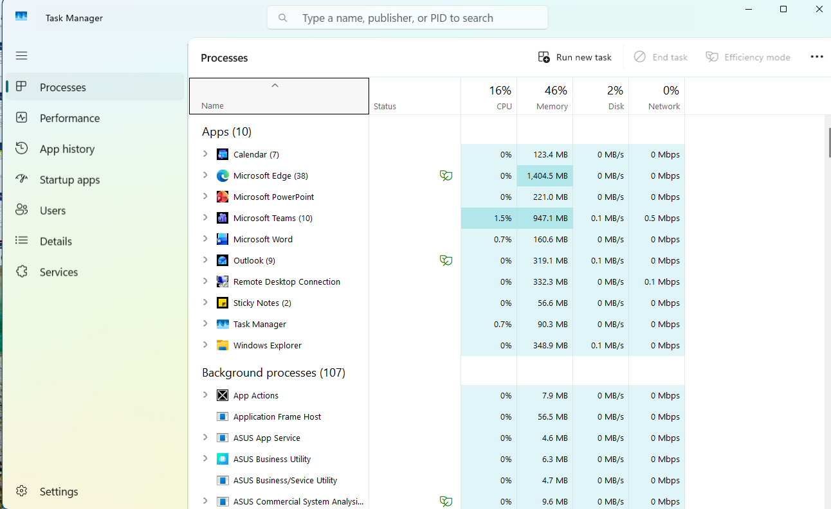
Figure 1: Task manager main Screen, highlighting the running processes in real-time.

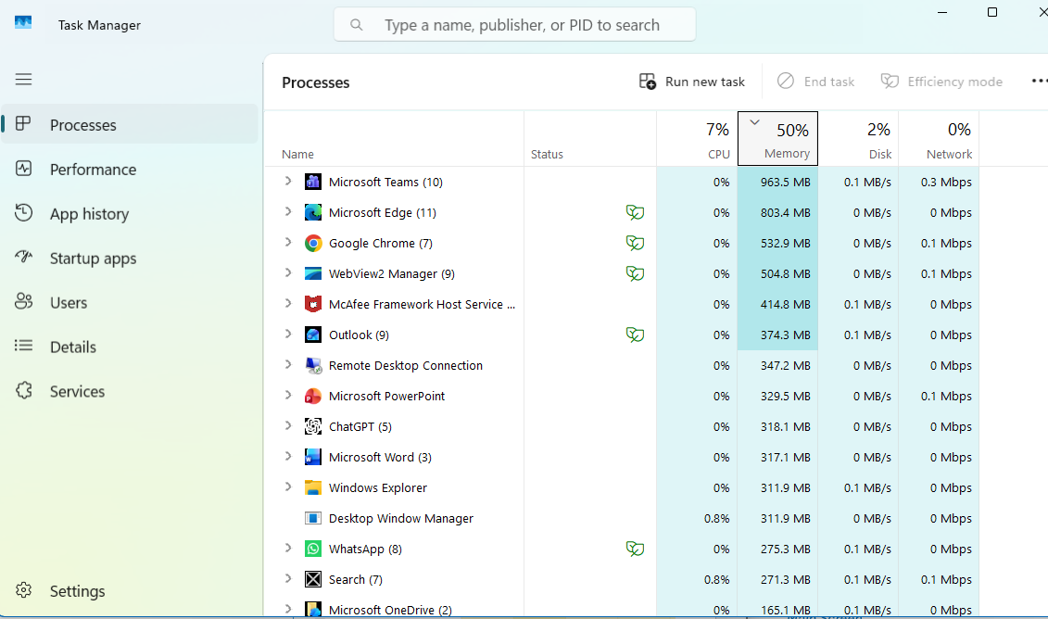 Figure 2: Task manager memory usage, real-time view. This tab shows how the system allocates memory across applications in real time, highlighting which programs are using the most RAM.

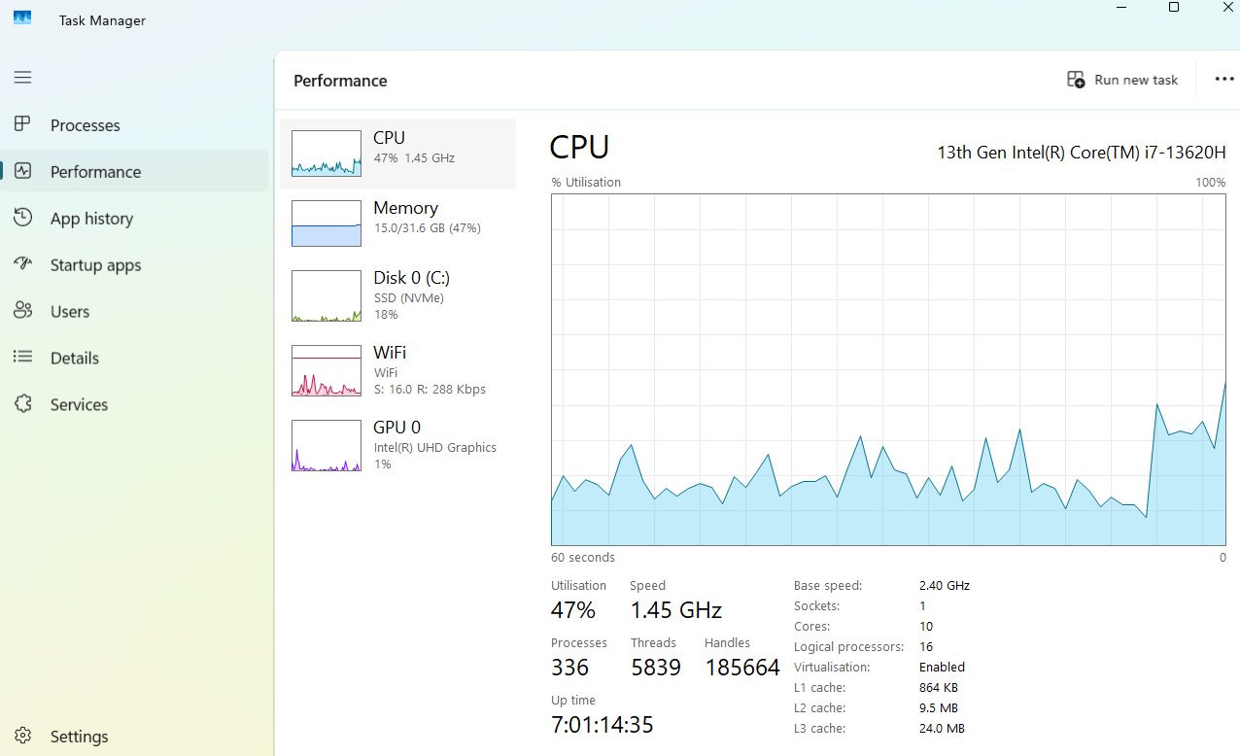
Figure 3: View of the CPU performance in real time view. This tab shows the CPU’s real-time utilisation, speed, and activity levels, showing how the operating system monitors and manages workload.

Task manager also allows us to view performance of the memory, disk, WIFI and GPU
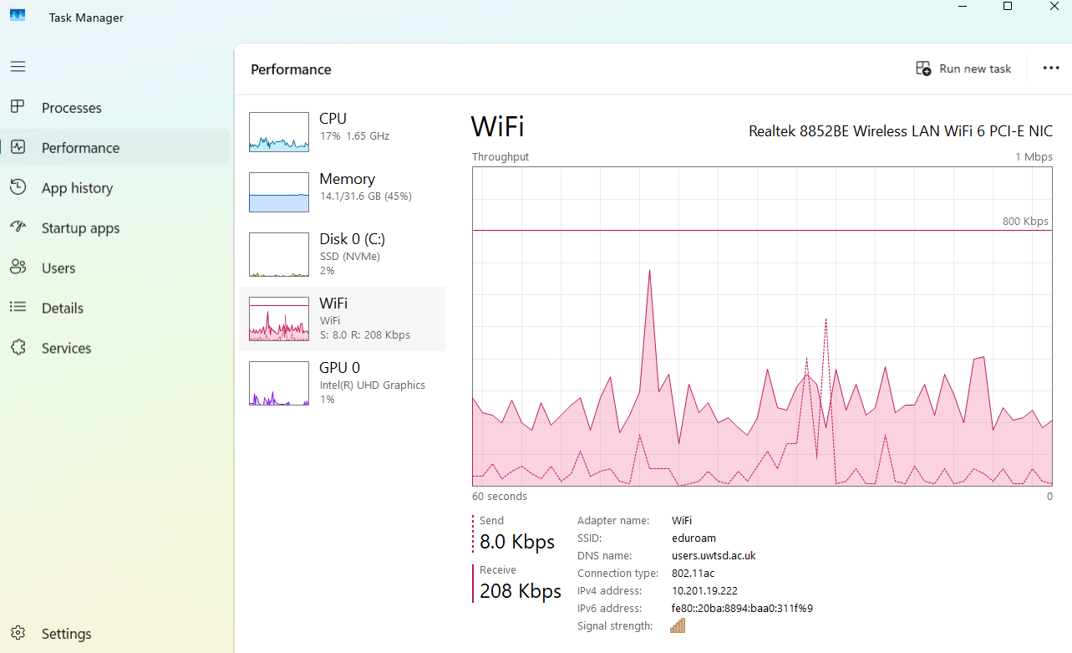
Figure 4: View of the WIFI performance in real time view, displaying send/receive speeds and network connection details. This shows how the operating system monitors network performance.”
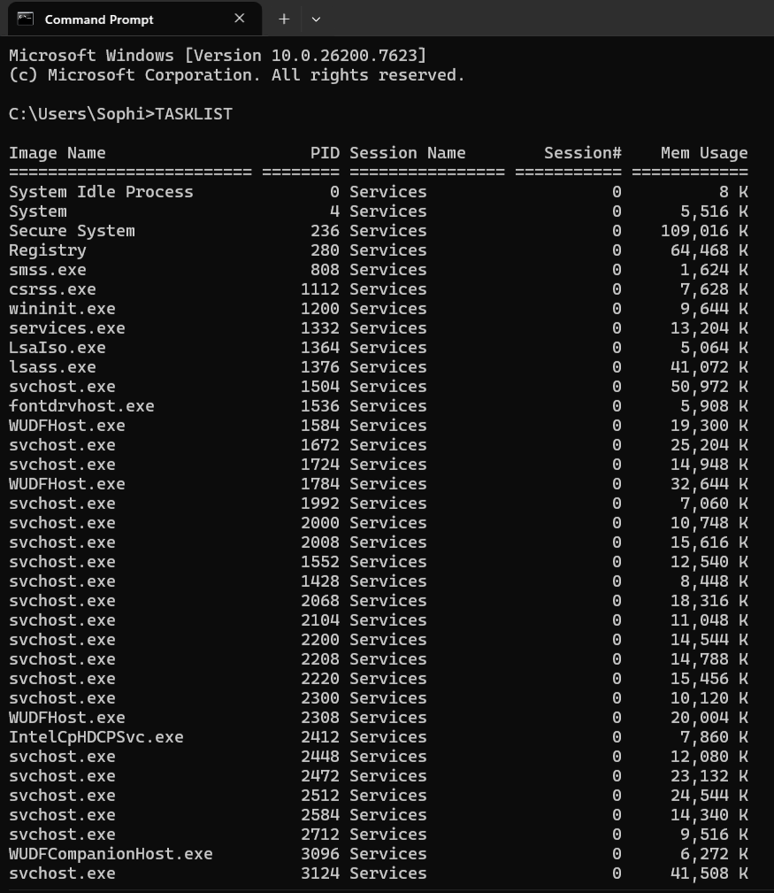
Figure 5: A view of currently running processes from CMD command prompt. In CMD we can use the ‘TASKLIST’ command prompt to view running processes within a windows system. This shows real-time active processes.

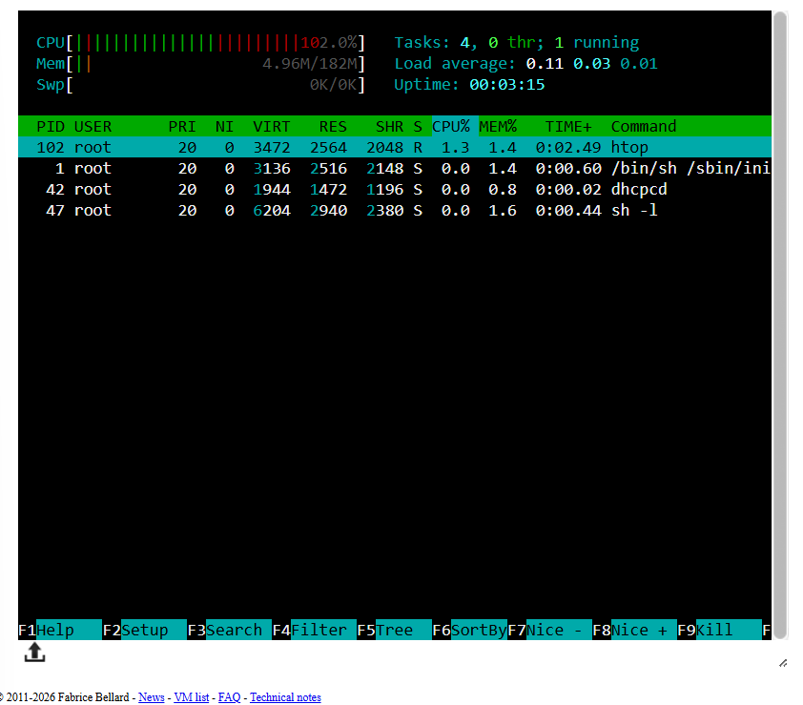
Figure 6: This shows the Linux interactive process monitor. The ‘htop’ command can be used within Linux to open the interactive process monitor which is the Linux equivalent of Task Manager.

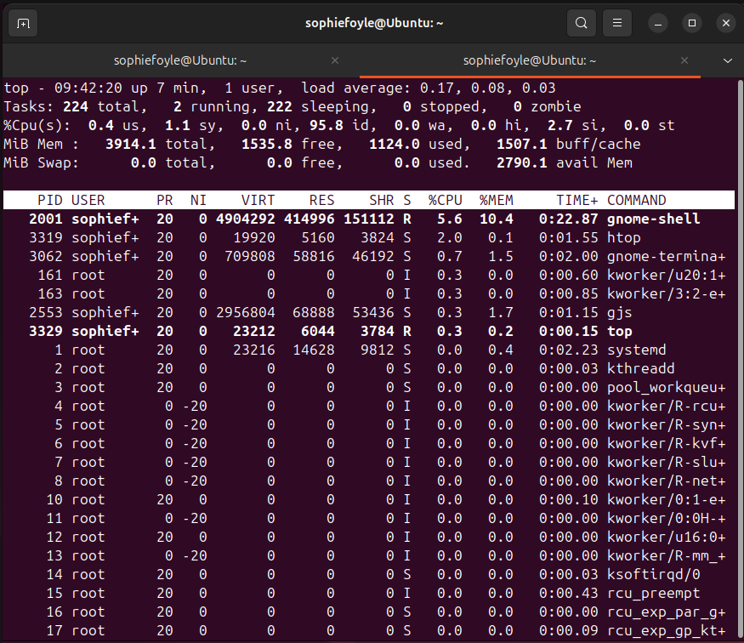
Figure 7: Real-time system monitoring using the top command inside the Ubuntu virtual machine. This view shows how the operating system schedules processes, allocates CPU time, and manages memory usage across active tasks.

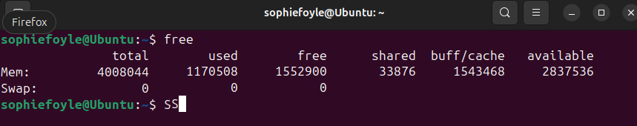
Figure 8: This shows the output of the ‘free’ command inside the virtual machine. This shows how the Operating System divides memory between active processes, cached data, and free space.

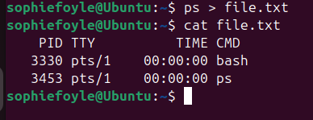
Figure 9: This shows copying all processes to a text file and the output.

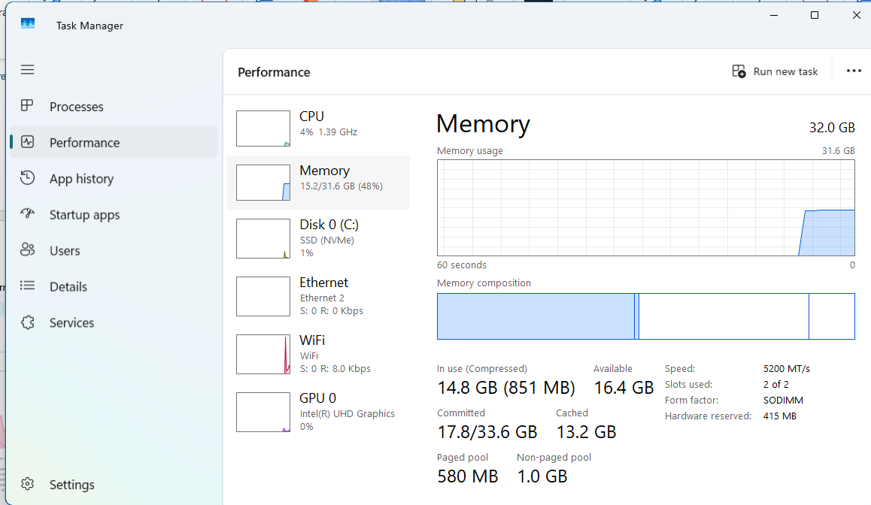
Figure 10: View of the memory usage as shown in Task Manager. This provides a real-time view of how the operating system manages RAM. It displays the total installed memory, how much is currently in use, how much is available, and how memory is divided into categories such as cached, paged, and non-paged pools.

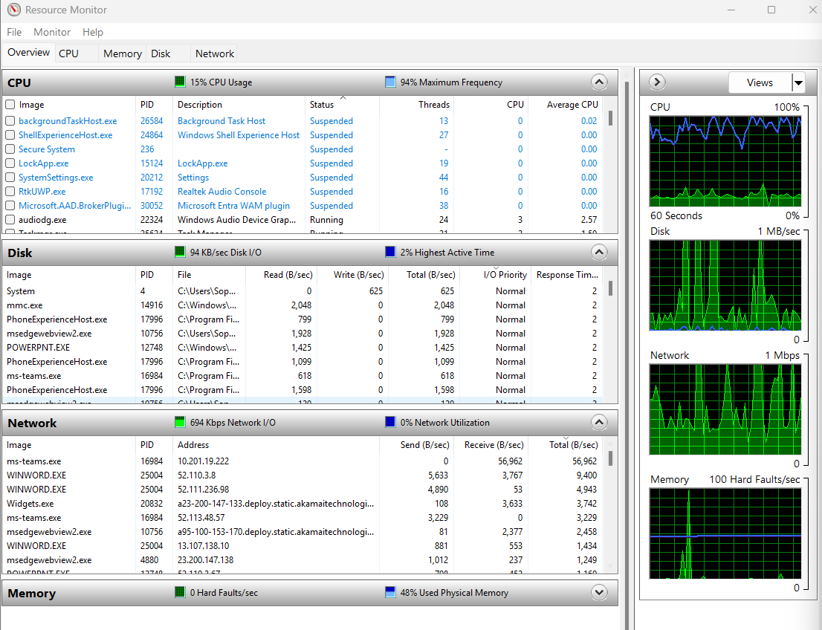
Figure 11: Overview of screenshot monitor. This can be accessed via ‘computer management’ and provides details of the real time activity for CPU, disk, network and memory. It shows how the operating system manages usage across the different processes.

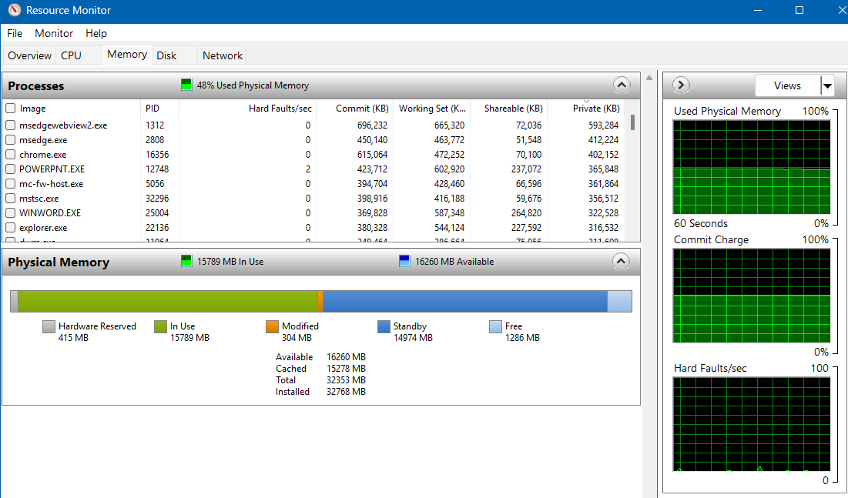
Figure 12: A more detailed view of the memory tab and its live performance.
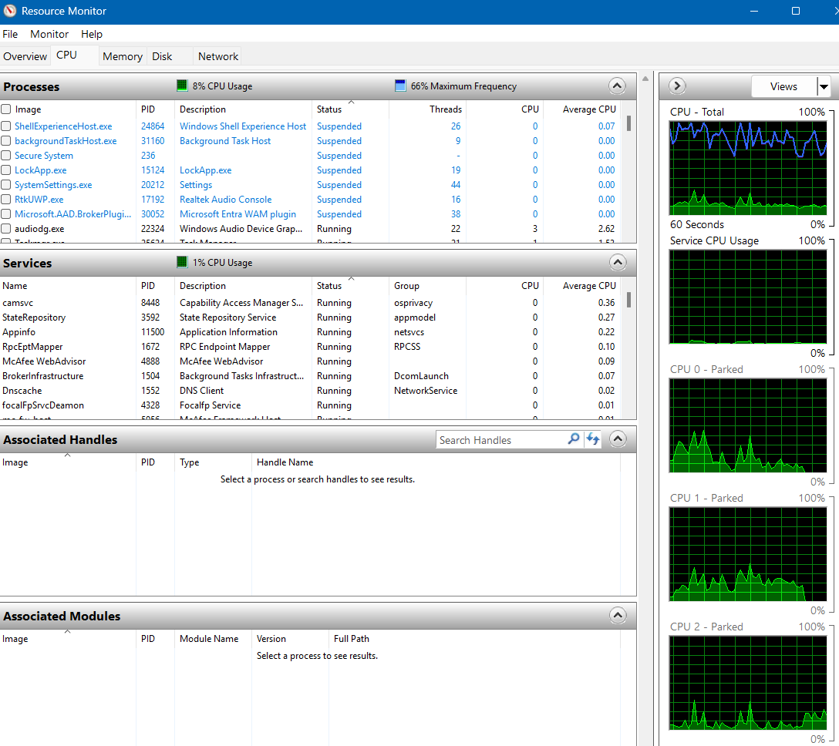
Figure 13: Detailed view of the CPU tab, which shows the CPU usage for live processes.

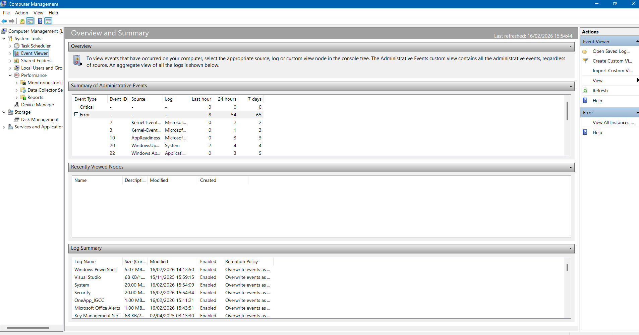
Figure 14: Screenshot of event viewer within performance monitor, which is good for troubleshooting issues as it lets us see the events on the computer.

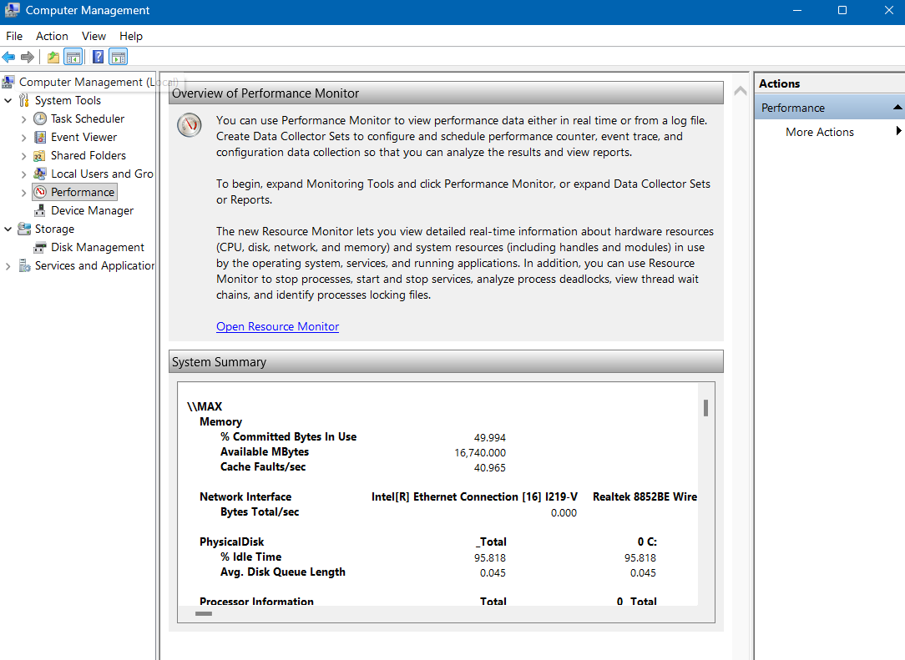
Figure 15: The performance tab can also assist with diagnostics. This screenshot shows an overview of the performance monitor within the computer management tab.

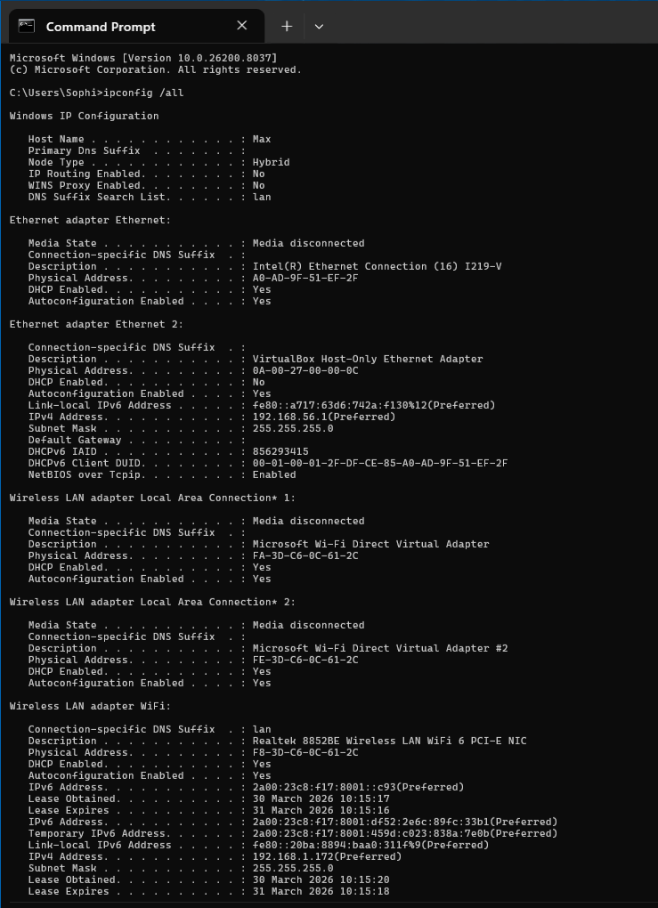
Figure 16: This shows the output of ipconfig /all command in Windows Command Prompt. It shows detailed overview of the network configuration including IP address and DHCP status.
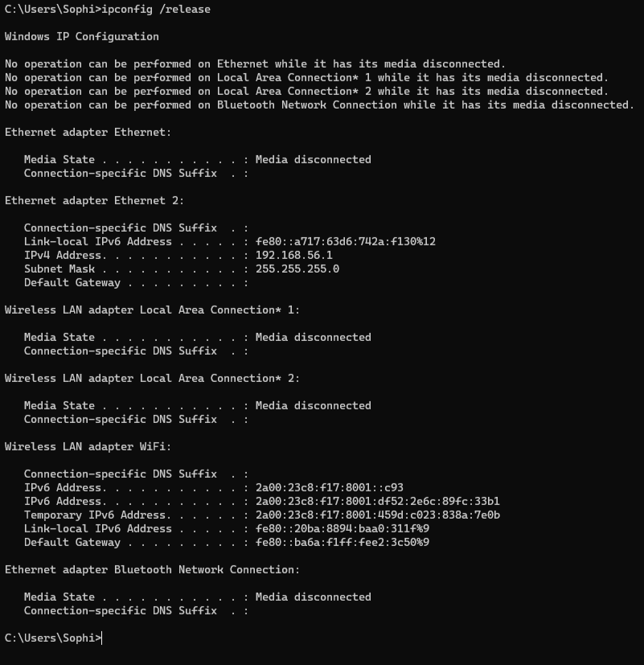
Figure 17: Ifconfig /release disconnects from the current IP address.
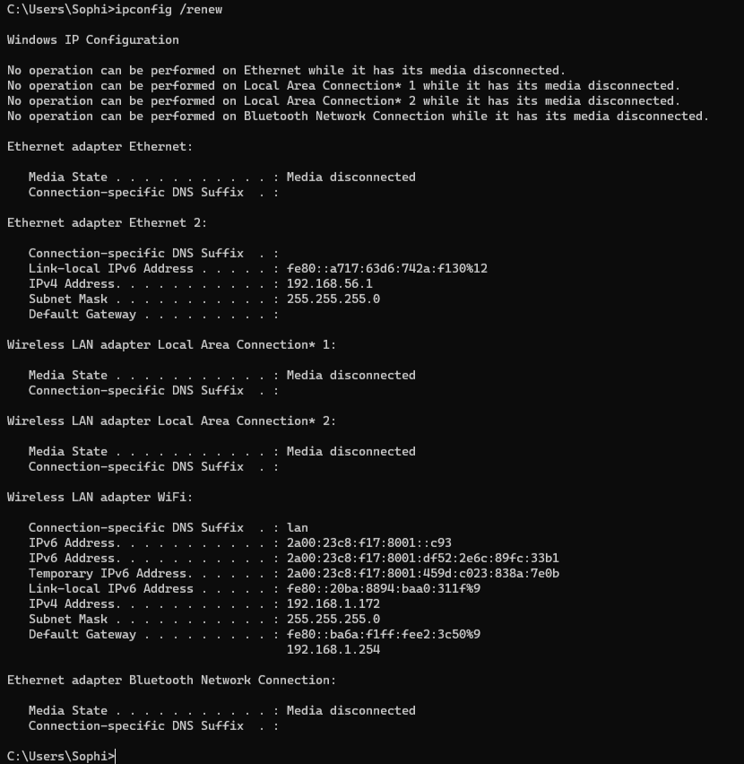Figure 18: ipconfig /renew connects to a new IP address which is commonly used in troubleshooting. However, anything not connected to a network cannot renew as it was never connected.

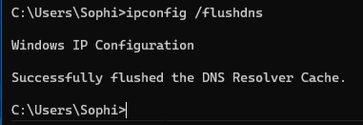
Figure 19: Ipconfig /flushdns clears the cache to resolve connectivity issues.
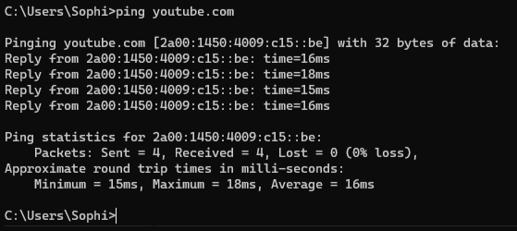
Figure 20: Ping command tests the connection with the specific website you enter – in this case, youtube.com

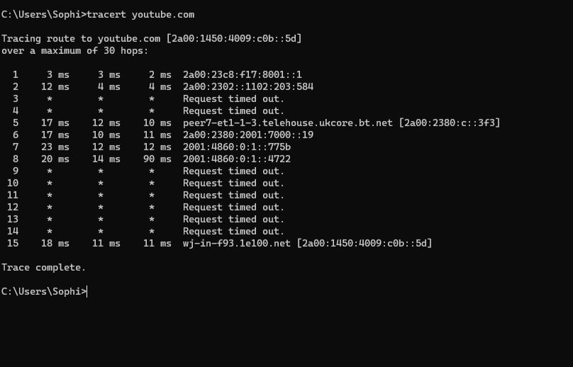
Figure 21: This shows the route the connection takes to reach the site entered (youtube.com), which can be really useful to locate where a poor connection is.

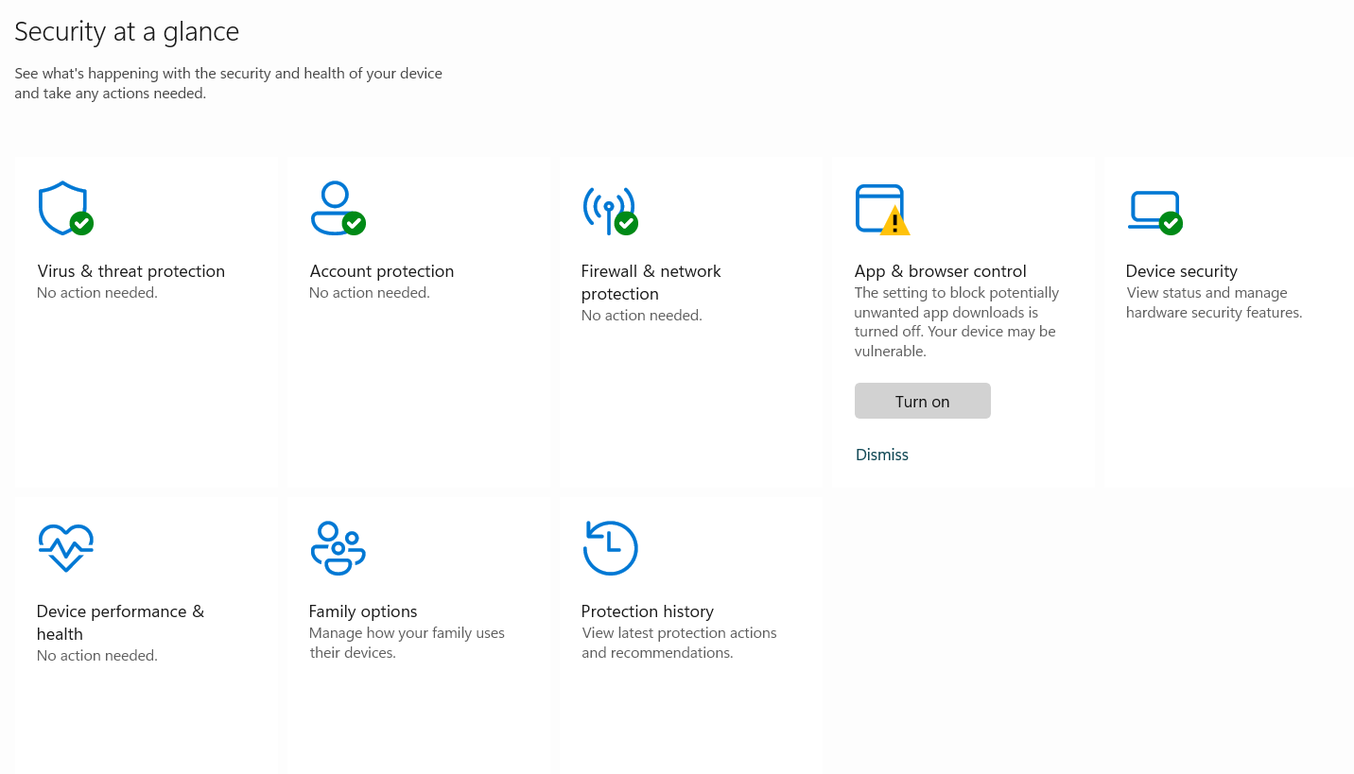Figure 22: This shows windows built in Security features. These features always active to standard settings, however advances rules can be amended, depending on access.

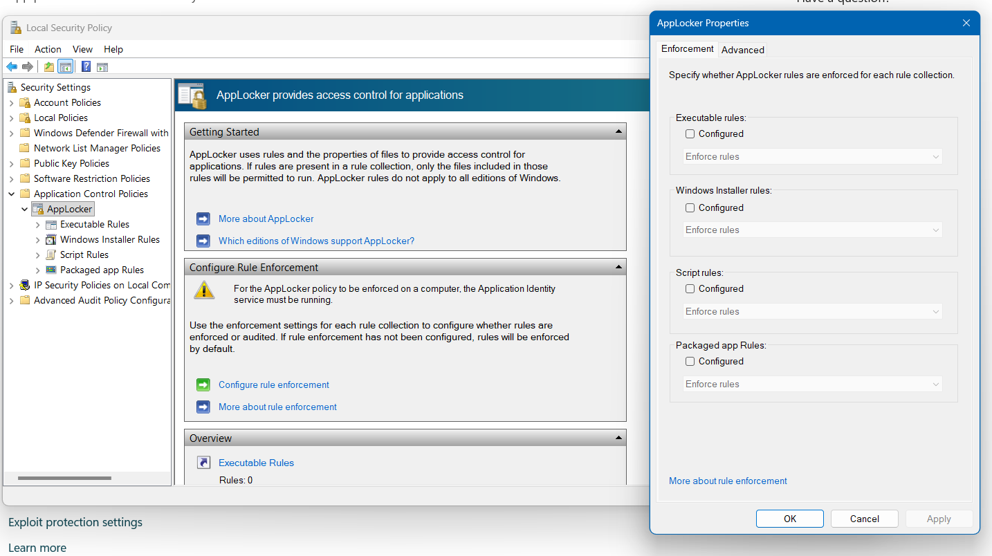
Figure 23: App locker allows administrators to control which apps are open for use on a system, and the rules/access within those apps.

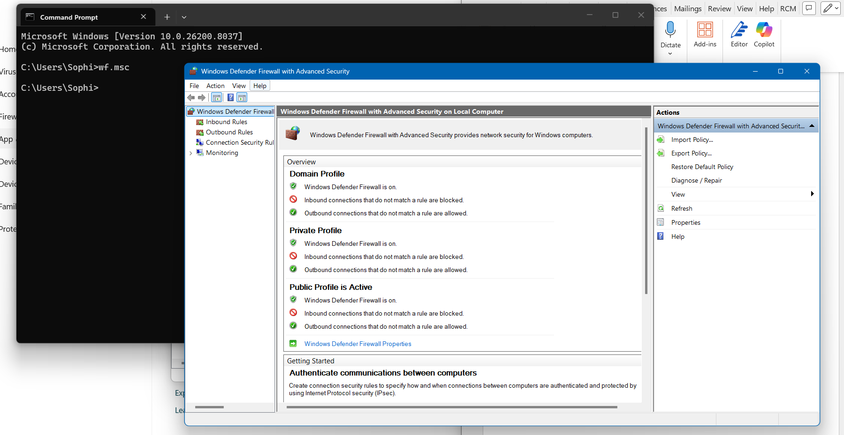
Figure 24: Searching wf.msc into command prompt allows more in depth, advanced controls over firewall rules.

Windows OS CLI Commands

Process Management
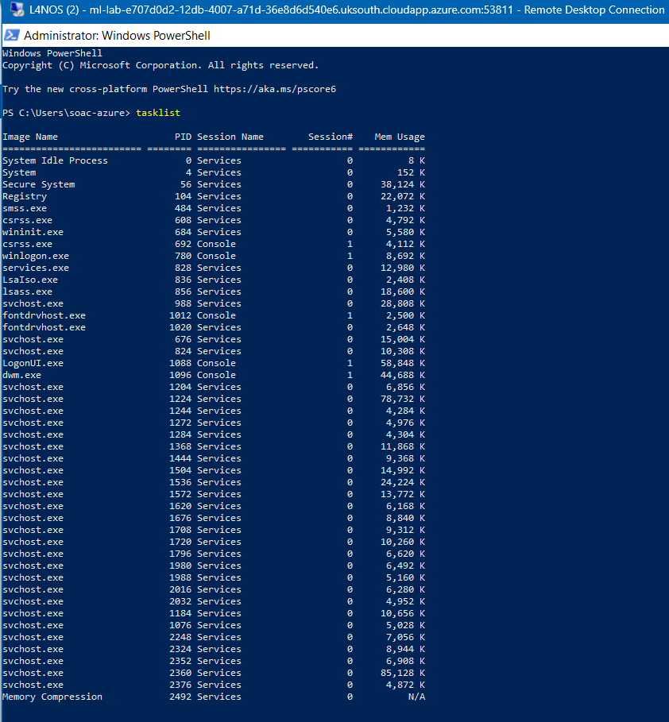
Figure 25: Shows all running processes within Windows, including the name, PID and memory usage. This shows how the operating system manages all activities. [7]

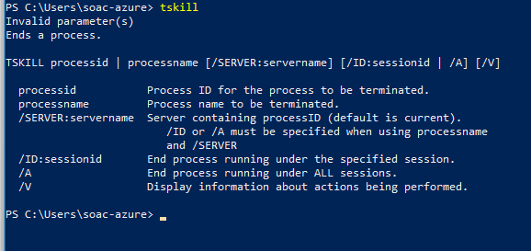
Figure 26: This command ends running processes. You can also provide process ID’s so that it kills a specific process. [8]

File & Directory Management
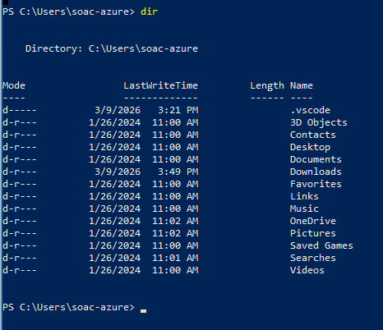
Figure 27: This lists all the files in a directory, including their name and the last date each item was modified. [9]

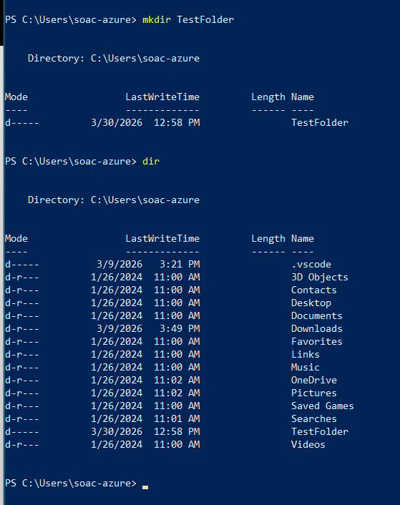
Figure 28: This demonstrates using the mkdir command to create a new folder, and then loading up the directory in which the new TestFolder appears. [10]

Network testing/monitoring
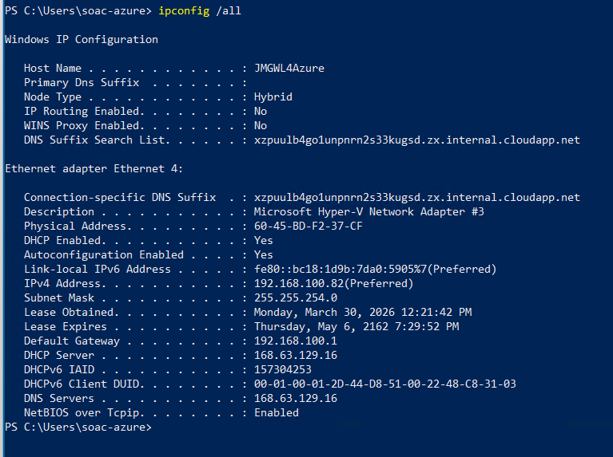
Figure 29: Similar to earlier screenshots done within the command prompt/terminal, this command displays the IP address details, however the above displays the information within PowerShell. [11]

User Management
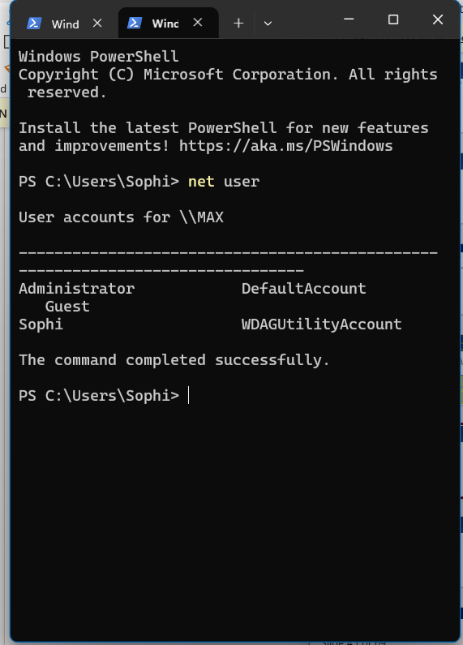
Figure 30: This command lists all users accounts on the system, showing how profiles can be managed and allowing administrators to view wh o has an account to access the device.
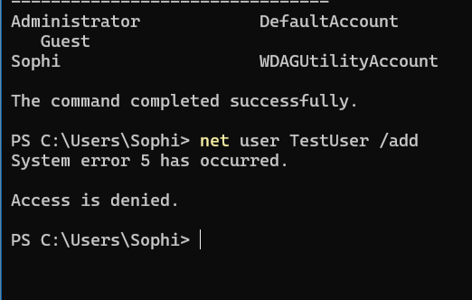
Figure 31: This command allows administrators to add a new user account. Because the user running the command does not have administrator privileges, Windows blocks the action and displays ‘Access is denied’. This demonstrates how the operating system protects user-management functions by restricting them to authorised users only.

Task Scheduling

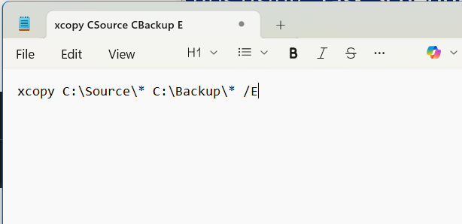
Figure 32: Screenshot of the backup script within Notepad, which will later be used in the automated Task Scheduler actions.
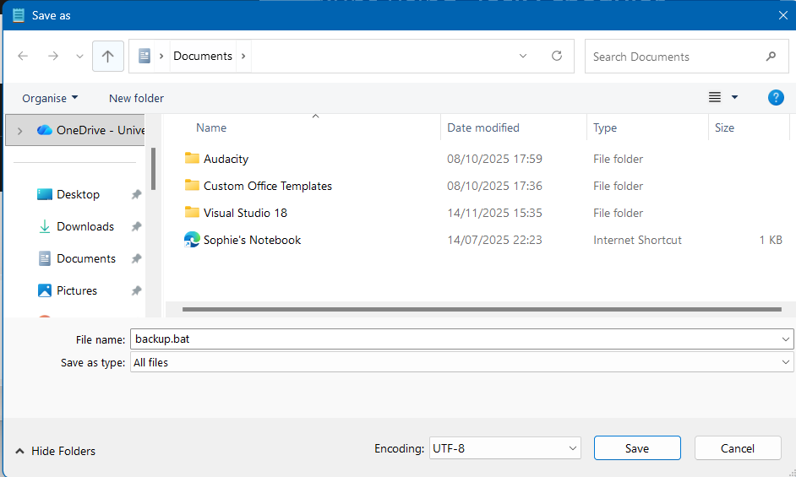
Figure 33: Saving the backup script as a .bat file by selecting ‘All Files’ ensures Windows recognises it as a batch script.

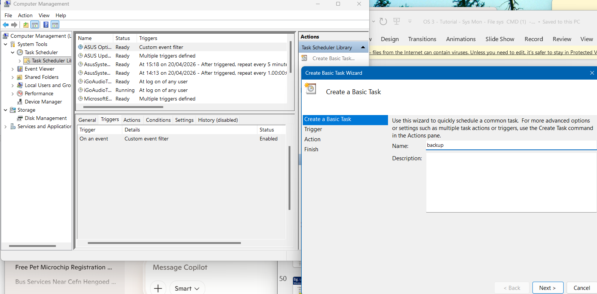
Figure 34: Creating a basic task within Task Scheduler, using the saved batch file, in preparation for automating the back-up.
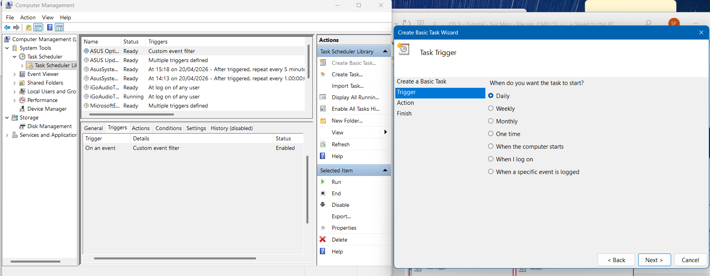
Figure 35: Selecting the frequency of the automated backup within Task Scheduler.

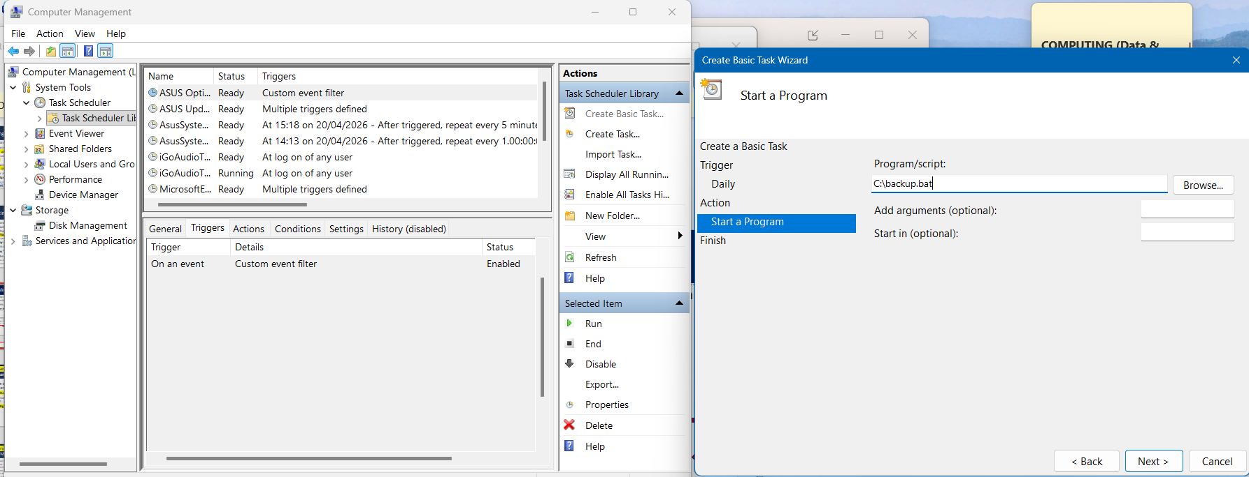
Figure 36: Selecting the backup script as the programme to be run automatically within Task Scheduler.

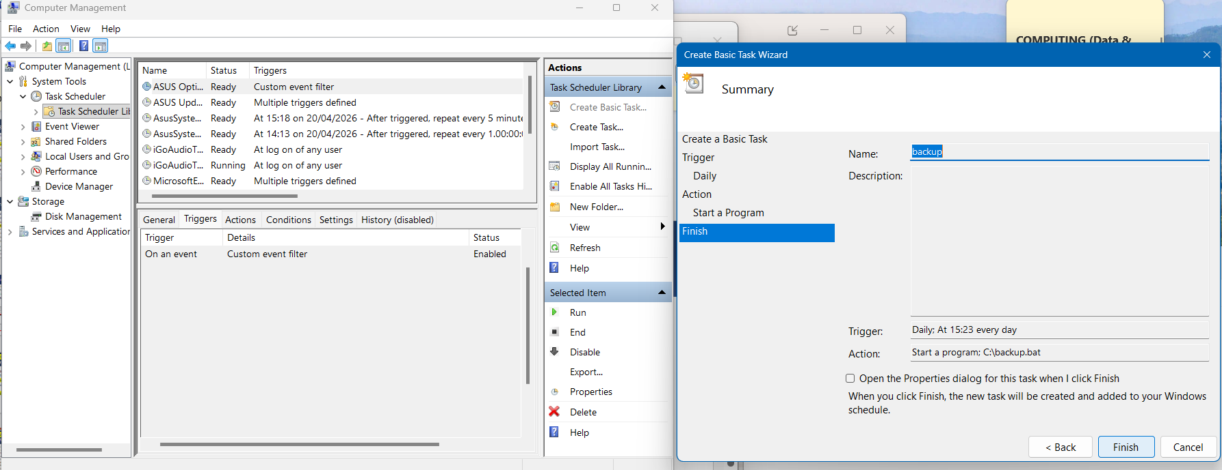
Figure 37: Summary of the scheduled backup task before finalising the automated process.

Linux OS CLI Commands

Process Management
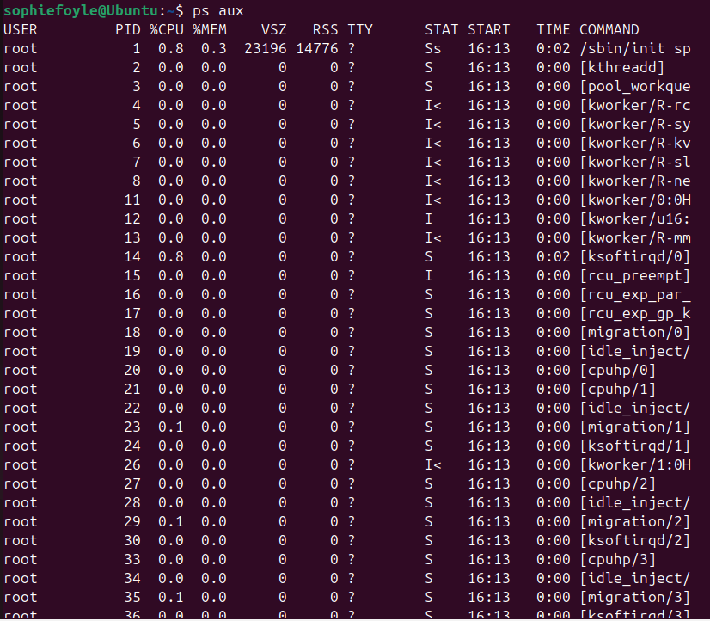
Figure 38: Screenshot of the ‘ps aux’ bash command.
The ‘ps’ command displays all running processes. The extension of this command ‘ps aux’ shows a more detailed and readable overview. Statistics are displayed such as CPU and memory information for each process providing more useful information. [12]

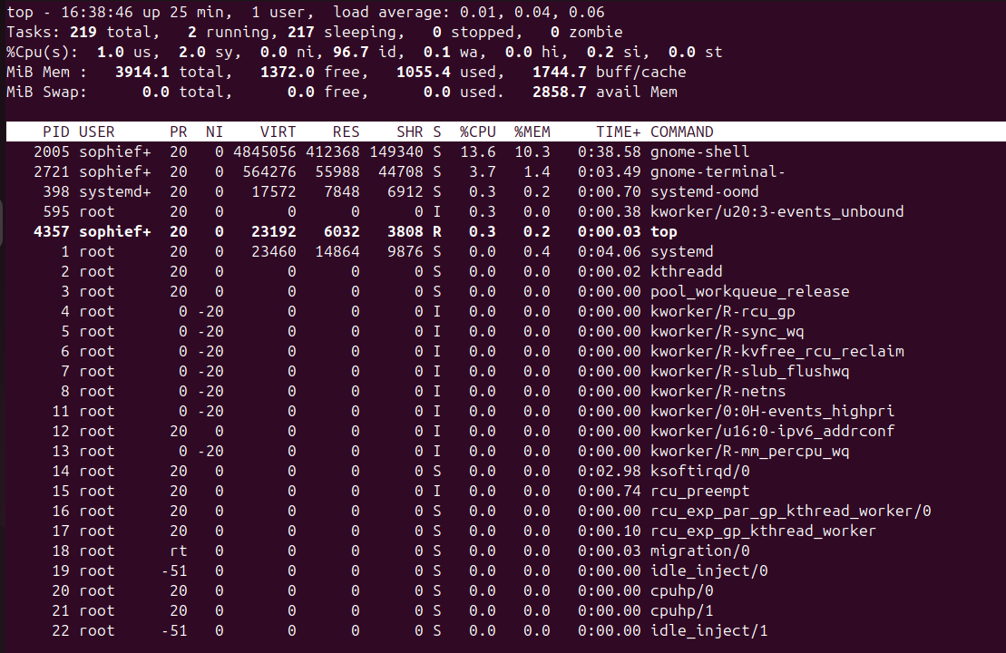
Figure 39: Screenshot of the ‘top’ bash command.
This command allows live monitoring of running processes. It displaying the overall CPU usage and memory usage and continues to refresh for a real-time view. [13]

File and Directory Management
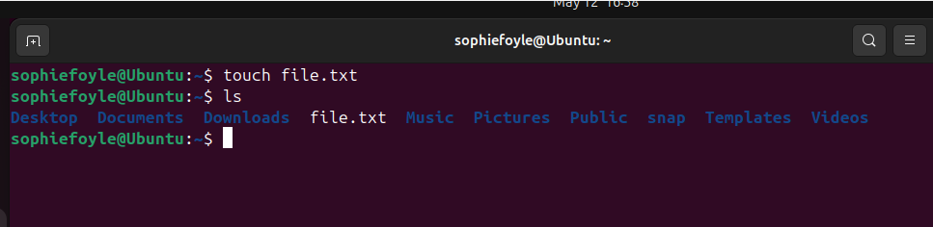
Figure 40: Screenshot of the ‘touch‘ bash command.
This command creates a new empty file.[14]

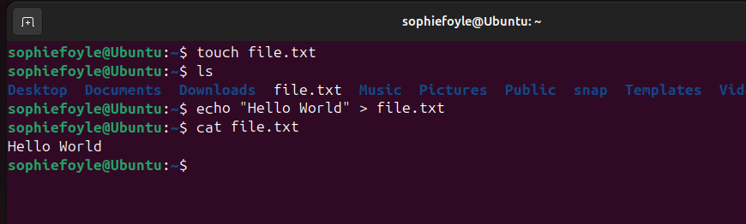
Figure 41: Screenshot of the ‘cat’ bash command.
This can read the file and print its contents for the user to view. [15]

Network Testing and Monitoring
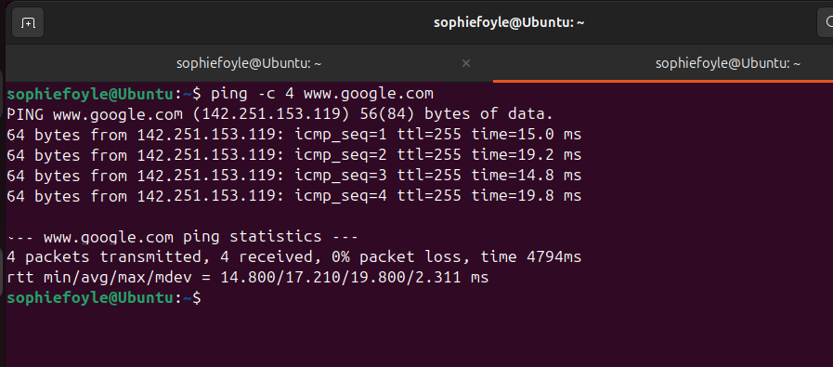Figure 42: Screenshot showing the ‘ping’ bash command.
This is a network testing, troubleshooting and diagnostic tool. It sends one or more Echo Request Packets to the IP address of the specified destination (in this case its google.com) and if there is a reply, that means they can connect. [16]
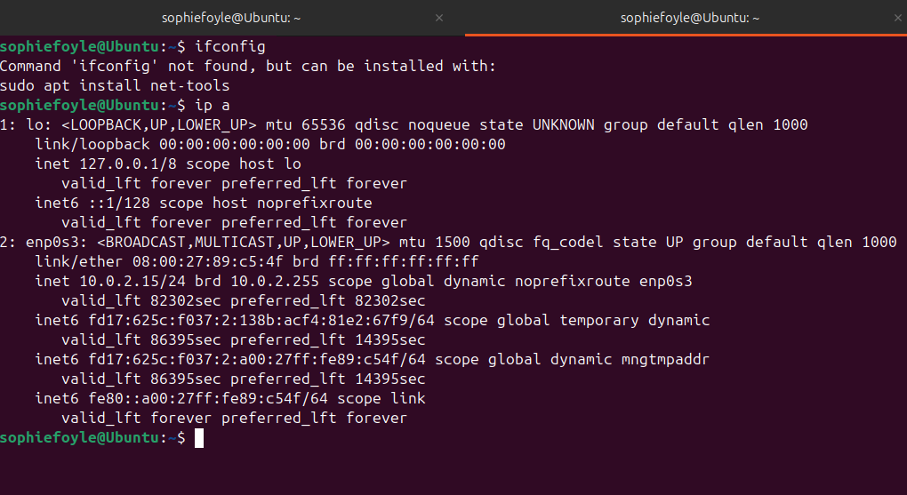
Figure 43: Screenshot showing the use of the ‘ip a’ command.
The ip command is used in place of the older command ‘ifconfig’ and displays all networks and their IP addresses. It provides real-time information in detail and allows the user to configure the network.

User Management
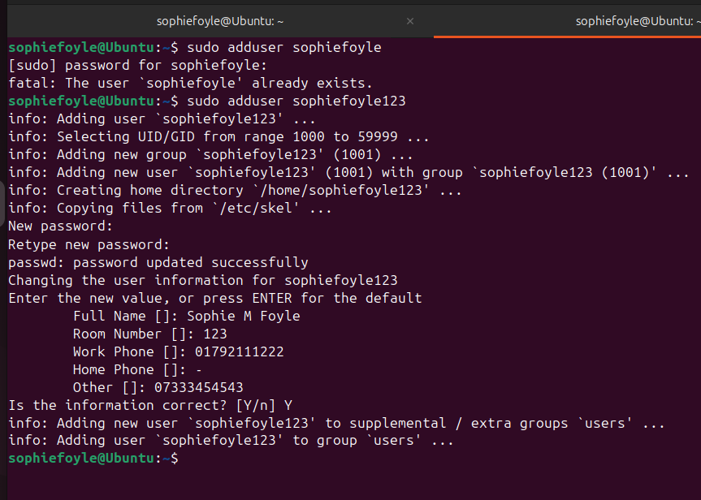
Figure 44: Screenshot showing the ‘sudo’ command.
This command is used to create a new user account. The system prompts for a password, then allows the administrator to set a password for the new user and enter optional details such as name and phone number. The above screenshot demonstrates the process of creating a user and confirming the account was successfully added.

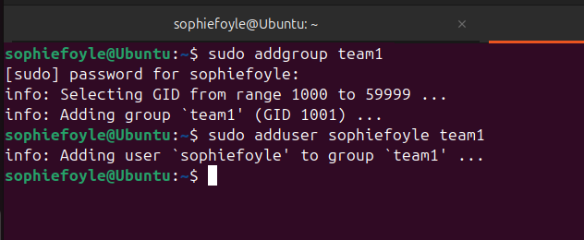
Figure 45: Further demonstrations of the ‘sudo’ command.
This demonstrates the use of ‘sudo addgroup’ to create a new group and ‘sudo adduser username groupname’ to add the new user, or an existing one, to the new group.

Task scheduling
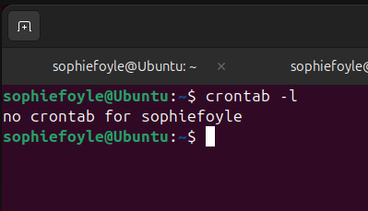
Figure 46: Screenshot demonstrating the ‘crontab’ command.
This command displays schedules tasks for the current user. It is used to see if any automated tasks schedules are already set up. In this case, there are no scheduled tasks for the current user. [17]

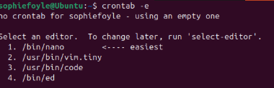
Figure 47: Further use of the ‘crontab’ command.
When using ‘crontab -e’ the system identified there was no current file for the current user and requested they select an editor. Option 1 was selected. [18]
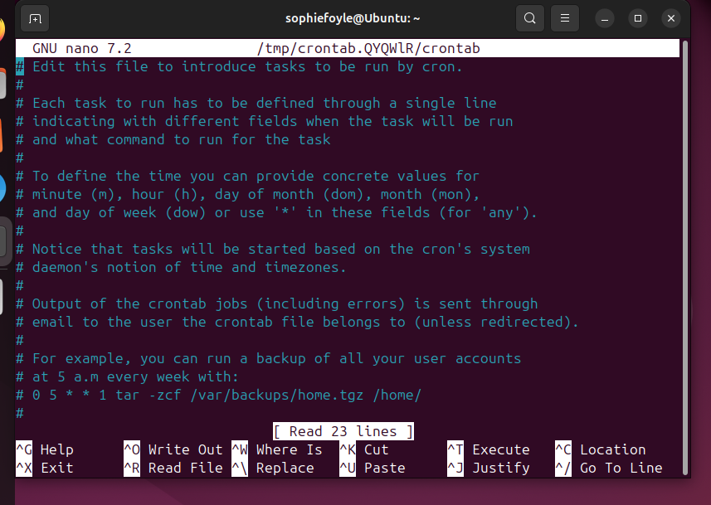
Figure 48: Display after option 1 selected within crontab -e. This displays explanations of how cron works and is the file that appears before adding scheduled tasks.
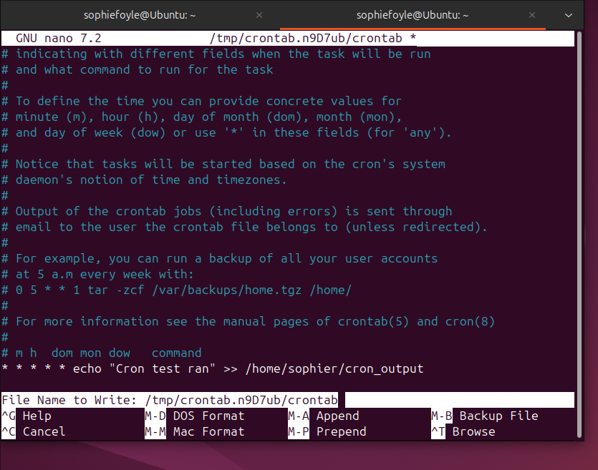
Figure 49: Screenshot of the crontab editor after running the crontab -e command.
This displays the nano text editor and a simple command to be run every minute and write text to a file. This shows how a job is added within the crontab file.

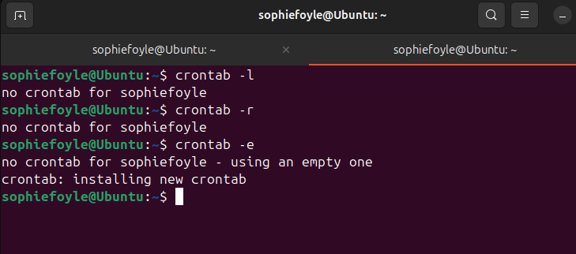
Figure 50: Screenshot of all crontab commands used, including confirmation a new automated task has been added.
This shows the process of checking for automated tasks thorough to attempting to remove a task, which failed as there was not one set up. The last command displays creating a task – showing the full automation process.[19]

Windows Operating System Scripts

Variables
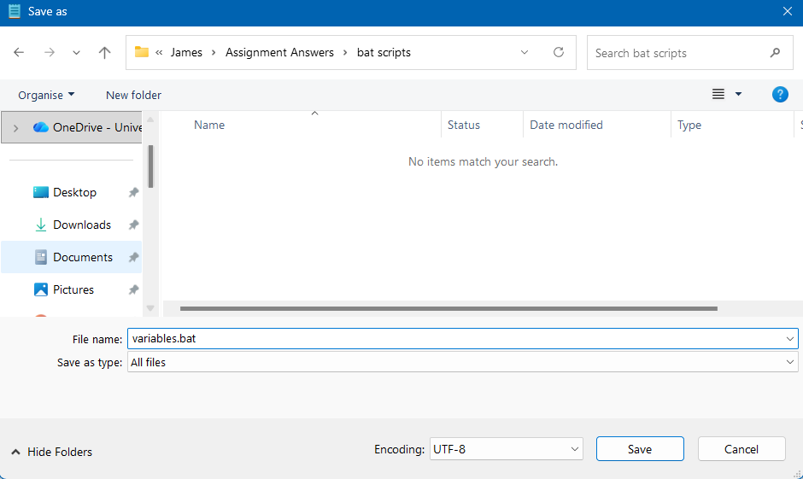
Figure 51: Saving a notepad file as a .bat file with the type ‘all files’ allows the code to run when opened and display an output within command prompt.

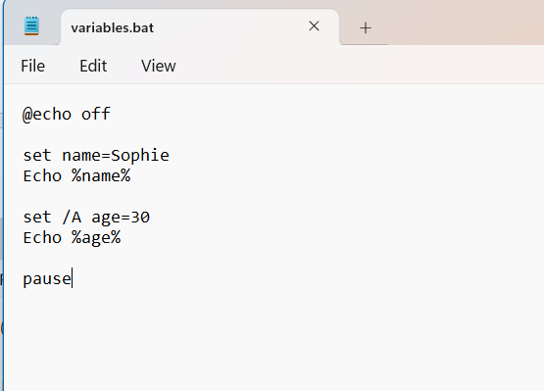
Figure 52: Entering the variables.
Using the ‘pause’ command stops the command prompt from automatically closing once the command has been run. The name and age variables have been set, and must be enclosed in a % sign to be displayed when run. If a variable includes a number, it must be set with /A.

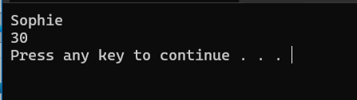
Figure 53: Command prompt displaying the output.
When the file is opened from its saved location, it then displays the variables entered within the command prompt. This can then be extended by combining the multiple variables into one new one, as shown below.

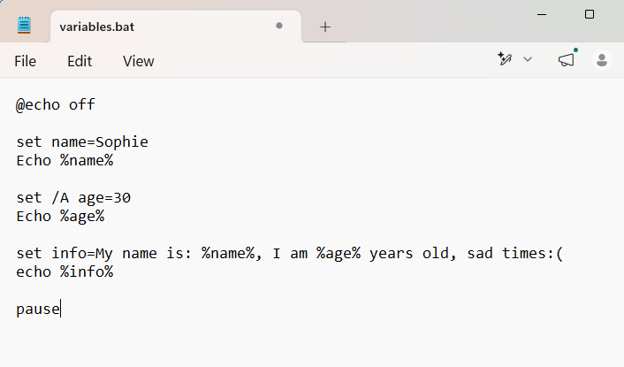
Figure 54: Demonstrating the grouping of variables.

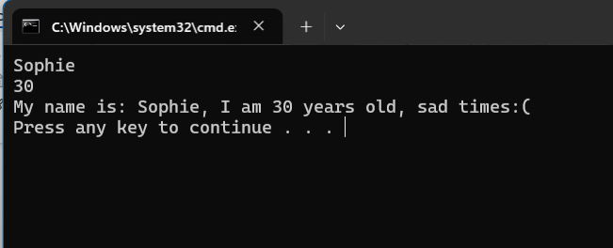
Figure 55: The output of the grouped variables.

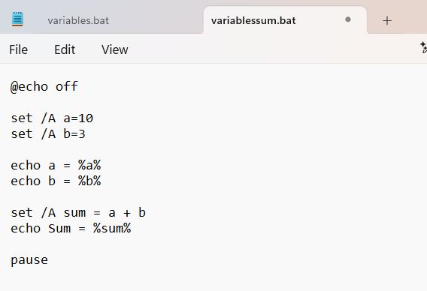
Figure 56: Another extension of the command for variable sum scripts.

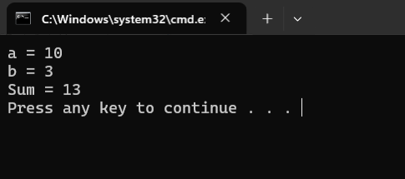
Figure 57: Screenshot of output of the sum variable script.

Goto
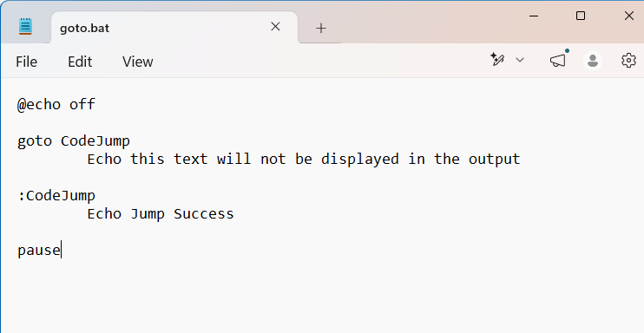
Figure 58: Entering code for the Goto command scripting.
This script demonstrates how the GOTO command allows a Batch program to jump directly to a labelled section. When it runs, it will go straight to the section labelled CodeJump. Due to this, the line before it is skipped and does not get displayed in the output.

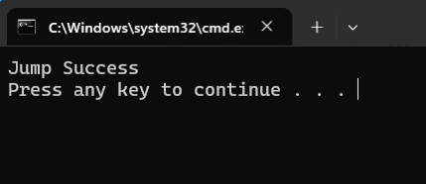
Figure 59: As above, the only output is the text labelled ‘CodeJump’.

User Input
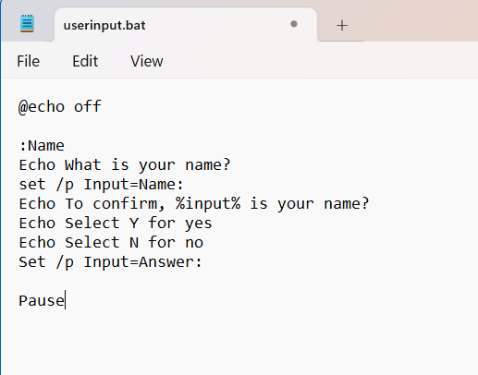
Figure 60: Demonstration of the Input scripting.
This allows for user input and the output display varies, depending on what they enter. It will wait for the user to type something, and this will be stored in the ‘input’ variable.

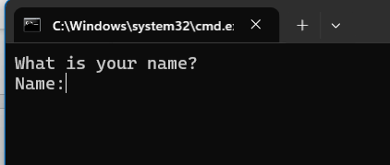
Figure 61: Screenshot showing the scripting waiting for user to input their name, before proceeding to run to scripting.

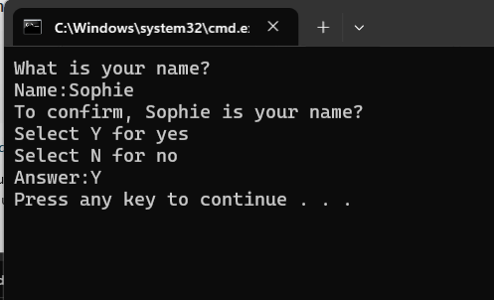
Figure 62: Further demonstration of the user input within the script.

If Statement
The user input script can be further extended to use ‘if’ statements. This alters the final output, depending on what the user enters.

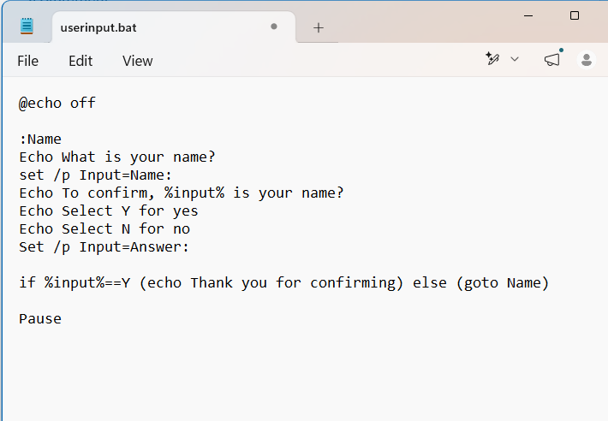
Figure 63: Screenshot showing the extension of the user input script.
If the user confirms their name is correct, it will display a confirmation message. If it is wrong, it will follow the ‘else’ loop and request the user re-enter it.

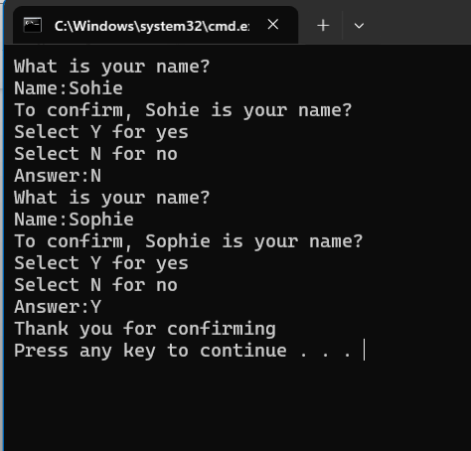
Figure 64: Screenshot showing use of both the ‘if’ and ‘else’ loop.
The user input their name with a typographical error, therefore when they entered ‘N’, the script looped to ask them to re-enter it. The correct name is entered, the user confirmed it is correct, and the ‘if’ loop displayed a confirmation message in the output.

Array
An array is a list of values stored under one group name, and is represented and accessed with a number. [20]
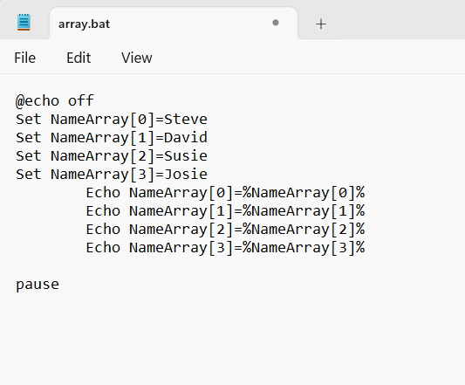
Figure 65: Screenshot showing how each name is assigned to an index number.

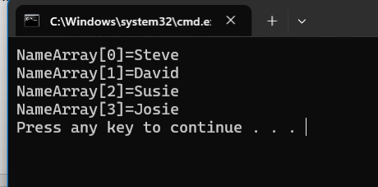
Figure 66: Display of the output of the script.

This script can be extended to include the user of user input, asking the user to select a number, and displaying the relevant name.

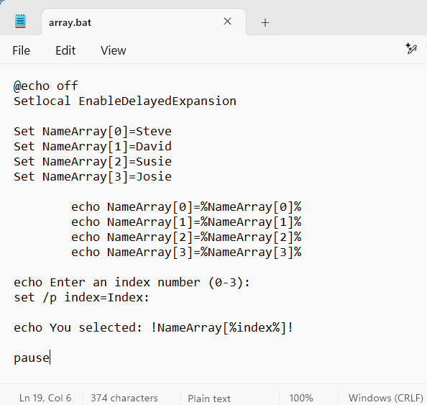
Figure 67: Script including the use of user input to display the name attached to the index number.

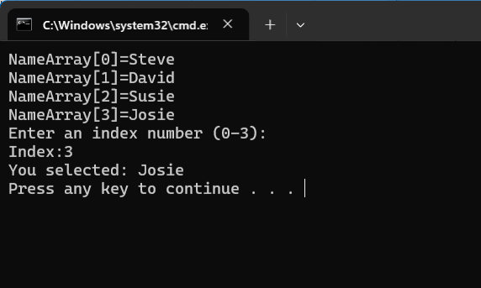
Figure 68: Display of the output of the correct corresponding name.

For Loop
The for loop is used to repeat commands within a list.

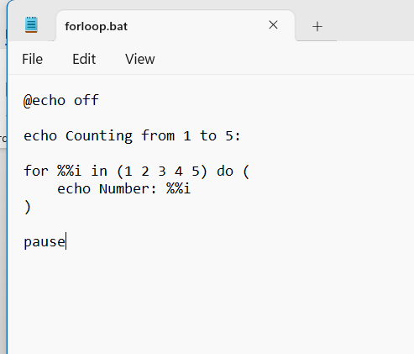
Figure 69: Demonstrating use of the for loop.
The loop will run for each value in the list and will display the number moving through the list and printing it.

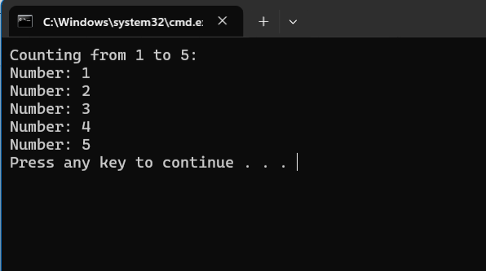
Figure 70: Screenshot of the output.
The for loop can also be used to run through all files in a folder. The command will run the loop to copy each file to another folder.

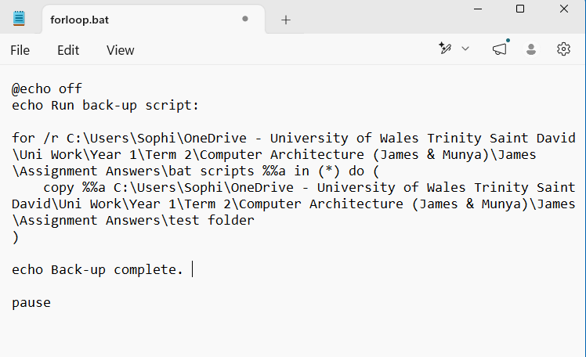
Figure 71: Backup scripting using for loop
This script uses a for loop using the /r switch to go through every file inside the selected folder. The copy command will loop for each file and copy it into the backup folder. When the loop finishes, the script displays a message confirming that the backup is complete.

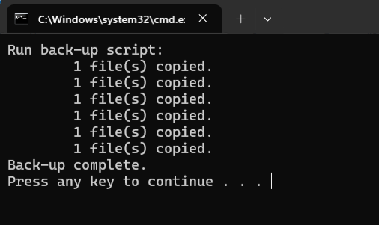
Figure 72: Output confirming the files have been backed up.

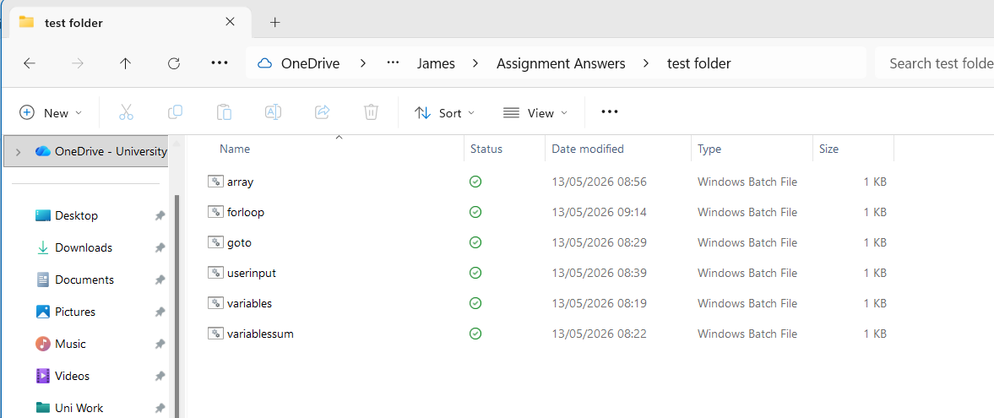
Figure 73: Screenshot showing the ‘test folder’ with the copied files within it, confirming the script ran correctly and successfully backed up the files.

Functions
Functions are a way of labelling a section of code which you can run within the script.
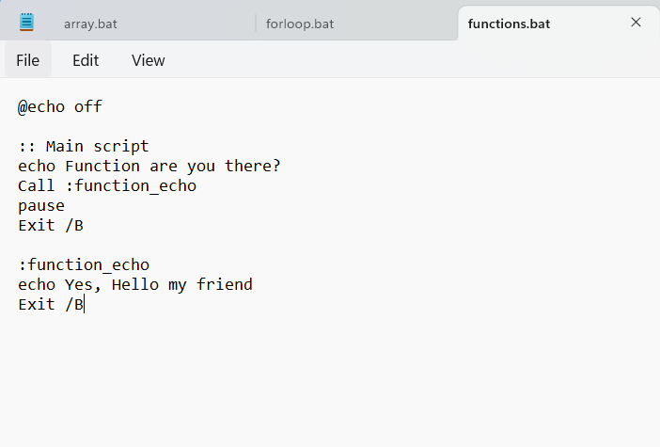
Figure 74: Demonstrating the scripting for functions.
The main script will print ‘function are you there?’. The ‘call :function_echo’ will then call the scripting listed below, labelled ‘function_echo’. This allows the user to generate scripting, and call it within the main script using just the label, rather than repeating lines of full script.

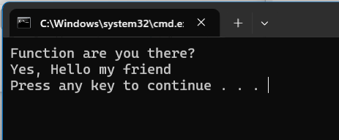
Figure 75: Display of the output.

Multiple functions can be used in scripting to not only prevent having to repeat code, but to keep the scripting neat and organised.

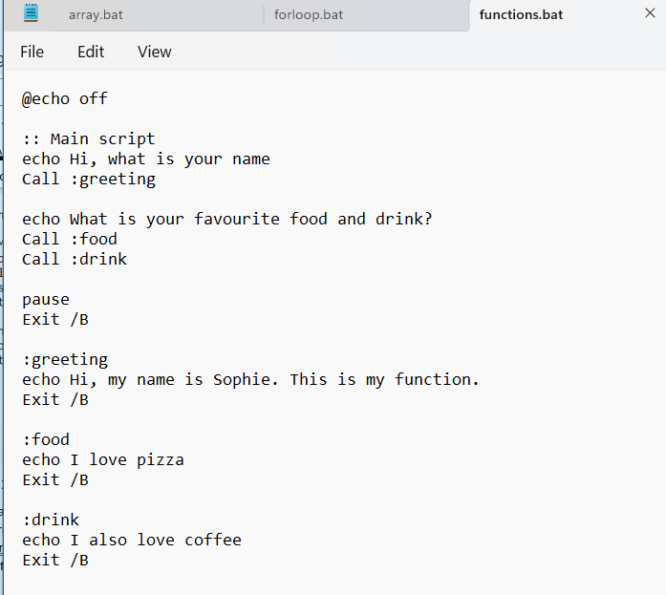
Figure 76: Scripting using multiple functions.

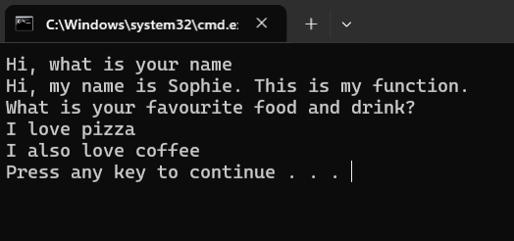
Figure 77: Display of the output when using multiple functions.

Linux Operating System Scripts

Variables
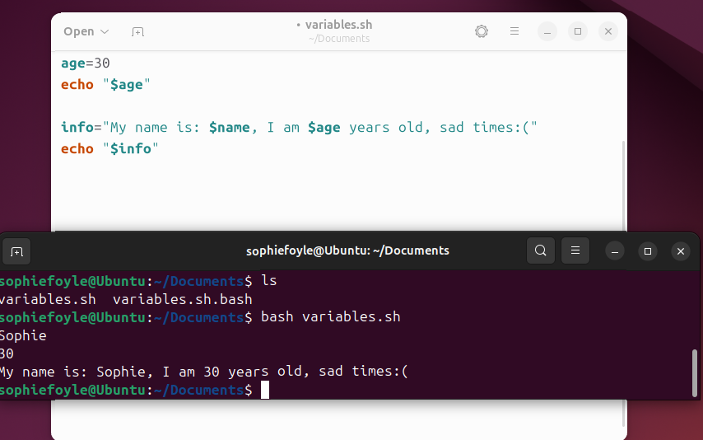
Figure 78: Variables bash scripting and the corresponding output within Linux OS.
Within Linux, the variables can also be grouped together so the user can echo all variables at the same time.

User Input
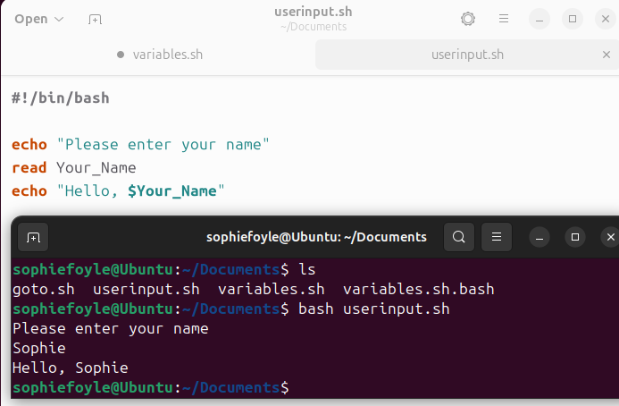
Figure 79: Scripting and output for user input.
The echo text will display a message to the user asking what their name is and allow them to input data. This can then be used to echo out the input.

If statement
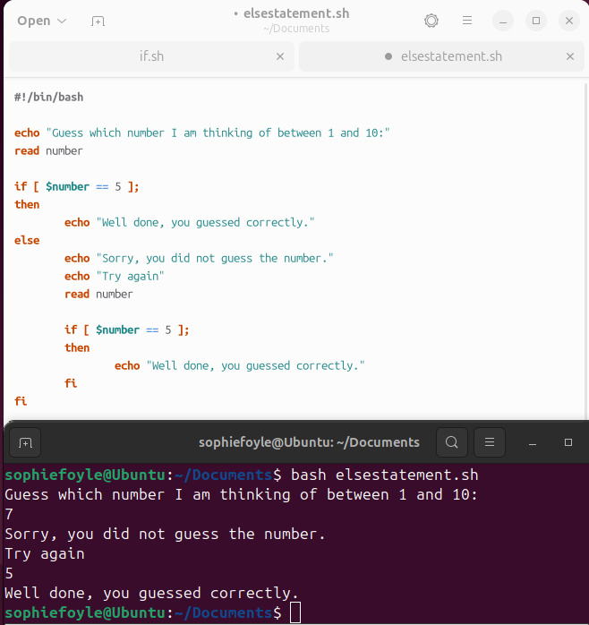

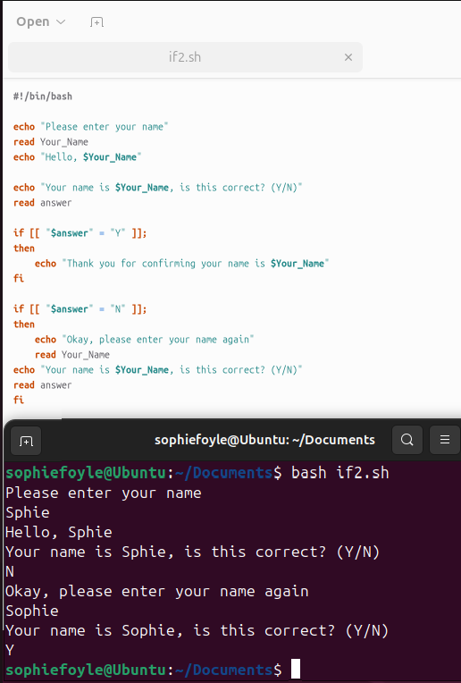 [21]
Figure 80: Scripting and output for if statement.
The if statement above has been used with the user input scripting. Once the user enters their name, the output asks them to confirm if it is correct or not. If the user confirms their name is correct, it will display a confirmation message. If it is wrong, it will follow the if statement and request the user re-enter it. Copilot was used to correct the formatting of the ‘if’ loop in terms of using the ] and [ symbols.

Loop
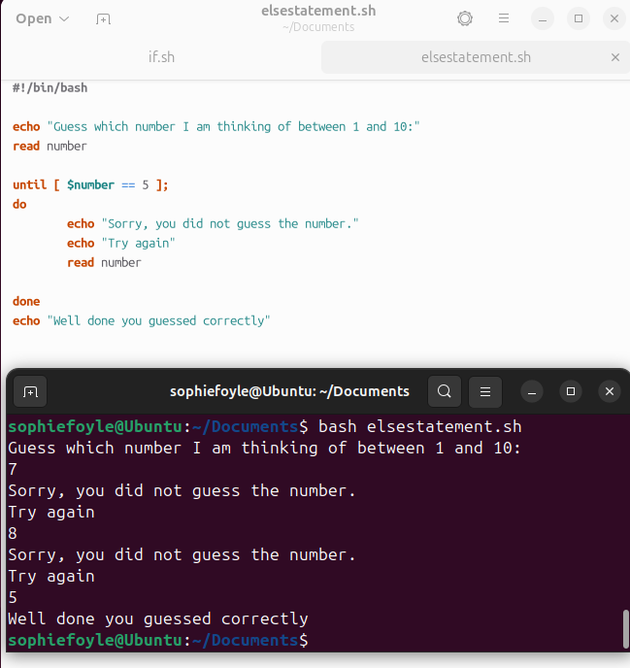
Figure 81: Scripting
and output for a loop.
The loop allows the user to continuously guess a number, until it is correct. The user can continue guessing and it will only end the script once the correct number has been guessed.

Array
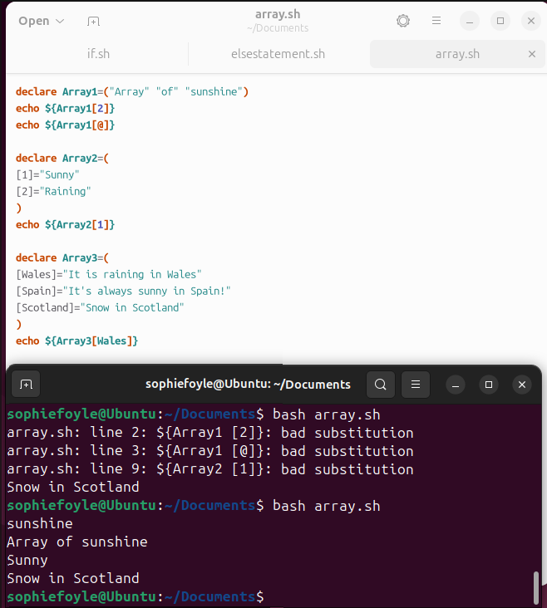
Figure 82: Scripting and output for Arrays.

Case Statement
This is used when there are multiple choices to decide from, without writing loads of ‘if’ statements and are useful when an input could have several values. The command stops running the script once it finds a match so doesn’t require any break statements. [22]

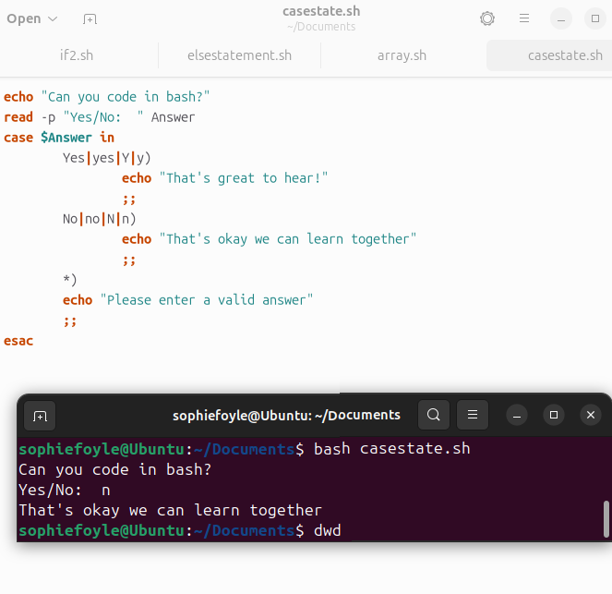
Figure 83: Script and output for case statements.
The user input ‘n’ as a response and although the options were technically ‘Yes’ or ‘No’, due to the case statements, the scripting still ran and gave the correct output.

Functions
Functions in Linux work in the same way as Windows, in the sense they group together commands into one block, so they can be input throughout the script.
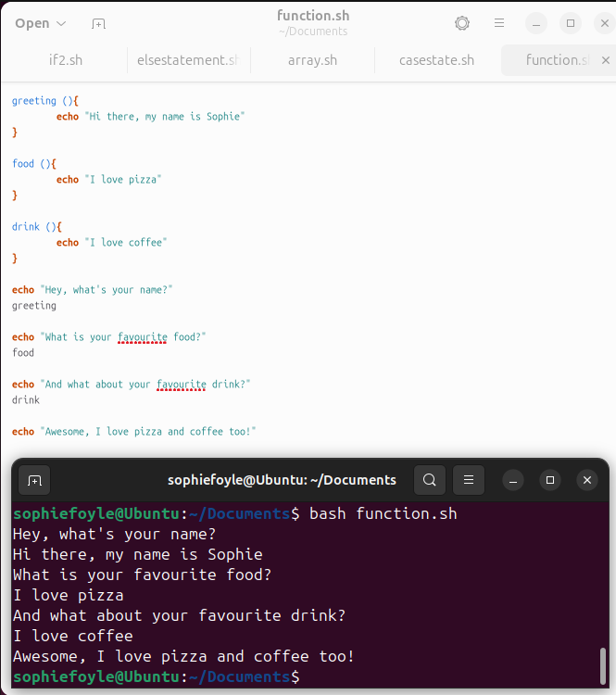
Figure 84: Scripting and output of Function.

Conclusion
The report highlights how both Windows and Linux handle the functions of an Operating System, such as managing processes, memory, files, users and networks. Although the syntax varies between Operating Systems, the main concept and functions are very similar, as are a lot of the structures of the scripts/coding.
The scripting tasks highlight how things like variables, loops, functions and user input are useful across both systems, keeping tasks organised and allowing for more automation.
Overall, it shows how both operating systems have tools to manage and control the system efficiently.

REFERENCES
[1] CodeLucky, “Kernel in Operating System: Core Functions and Memory Management.” Accessed: May 13, 2026. [Online]. Available: https://codelucky.com/kernel-operating-system/
[2] GeeksforGeeks, “Introduction of Process Management.” Accessed: May 13, 2026. [Online]. Available: https://www.geeksforgeeks.org/operating-systems/introduction-of-process-management/
[3] GeeksforGeeks, “Memory Management in Operating System.” Accessed: May 13, 2026. [Online]. Available: https://www.geeksforgeeks.org/operating-systems/memory-management-in-operating-system/
[4] F. Hafeez, “Role of File System in Operating System,” International Journal of Computer Science and Innovation, vol. 2016, no. 3, pp. 117–127, 2016. Accessed: May 13, 2026. [Online]. Available: https://www.researchgate.net/profile/Faheem-Hafeez/publication/305017745_Role_of_File_System_in_Operating_System/links/577f351908ae5f367d33ed01/Role-of-File-System-in-Operating-System.pdf
[5] Fiveable, “OS Security and Access Control.” Accessed: May 13, 2026. [Online]. Available: https://fiveable.me/cybersecurity-and-cryptography/unit-5
[6] D. Wybranietz and D. Haban, “Monitoring and performance measuring distributed systems during operation,” ACM SIGMETRICS Performance Evaluation Review, vol. 16, no. 1, pp. 197–206, 1988. Accessed: May 13, 2026. [Online]. Available: https://dl.acm.org/doi/abs/10.1145/1007771.55618
[7] Microsoft, “tasklist.” Accessed: May 13, 2026. [Online]. Available: https://learn.microsoft.com/en-us/windows-server/administration/windows-commands/tasklist
[8] Microsoft, “tskill.” Accessed: May 13, 2026. [Online]. Available: https://learn.microsoft.com/en-us/windows-server/administration/windows-commands/tskill
[9] Microsoft, “dir.” Accessed: May 13, 2026. [Online]. Available: https://learn.microsoft.com/en-us/windows-server/administration/windows-commands/dir
[10] Microsoft, “mkdir.” Accessed: May 13, 2026. [Online]. Available: https://learn.microsoft.com/en-us/windows-server/administration/windows-commands/mkdir
[11] Microsoft, “ipconfig.” Accessed: May 13, 2026. [Online]. Available: https://learn.microsoft.com/en-us/windows-server/administration/windows-commands/ipconfig
[12] J. Turner, “How to Use the ps aux Command in Linux.” Accessed: May 13, 2026. [Online]. Available: https://www.linode.com/docs/guides/use-the-ps-aux-command-in-linux/
[13] GeeksforGeeks, “top Command in Linux.” Accessed: May 13, 2026. [Online]. Available: https://www.geeksforgeeks.org/linux-unix/top-command-in-linux-with-examples/
[14] W3Schools, “Bash touch Command – Change File Timestamps.” Accessed: May 13, 2026. [Online]. Available: https://www.w3schools.com/bash/bash_touch.php
[15] W3Schools, “Bash cat Command – Concatenate and Display Files.” Accessed: May 13, 2026. [Online]. Available: https://www.w3schools.com/bash/bash_cat.php
[16] D. Panovski, “Ping Command in Linux.” Accessed: May 13, 2026. [Online]. Available: https://linuxize.com/post/linux-ping-command/
[17] GeeksforGeeks, “crontab in Linux.” Accessed: May 13, 2026. [Online]. Available: https://www.geeksforgeeks.org/linux-unix/crontab-in-linux-with-examples/
[18] W3Schools, “Bash crontab Command – Schedule Tasks.” Accessed: May 13, 2026. [Online]. Available: https://www.w3schools.com/bash/bash_cron.php
[19] Microsoft, Microsoft Copilot – AI Assistant. Accessed: May 13, 2026. [Online]. Available: https://copilot.microsoft.com
[20] GeeksforGeeks, “Batch Script – Arrays.” Accessed: May 13, 2026. [Online]. Available: https://www.geeksforgeeks.org/linux-unix/batch-script-arrays/
[21] Microsoft, Microsoft Copilot – AI Assistant. Accessed: May 13, 2026. [Online]. Available: https://copilot.microsoft.com
[22] GeeksforGeeks, “Bash Scripting – Case Statement.” Accessed: May 13, 2026. [Online]. Available: https://www.geeksforgeeks.org/linux-unix/bash-scripting-case-statement/

Appendices

Tutorial 1 activity notes
General-purpose Operating Systems
General-purpose OSs are designed for everyday computing tasks such as browsing, gaming, productivity, and software development. They support a wide range of hardware and applications.
Windows, Linux, macOS.

Mobile Operating Systems
Mobile OSs are optimised for touchscreen devices, low power consumption, and mobile hardware. They manage apps, sensors, connectivity, and security on smartphones and tablets.
Android, Apple iOS.

Network Operating Systems (NOS)
Network OSs are built to manage and support multiple users across a network. They allow resource sharing such as files, printers, email, and media, and include strong security and user-management features. Examples: Unix, FreeBSD, Ubuntu Server, Windows NT/10/11, Windows Server editions.

Real-time Operating Systems (RTOS)
Real-time OSs are highly specialised and designed to process data immediately with strict timing requirements. They are used where delays could cause system failure or safety risks. Examples of use: ATMs, aircraft control systems, heart pacemakers, industrial automation and power-plant control.

Embedded Operating Systems
Embedded OSs run on dedicated hardware inside specific devices. They are lightweight, efficient, and tailored to the device’s purpose. Examples: Embedded Linux, Windows IoT, FreeRTOS, VxWorks, Wear OS.
IoT Edge Operating Systems
IoT Edge OSs support devices located at the “edge” of a network, where data is collected and processed locally before being sent to the cloud. Examples: Lubuntu, Windows IoT, Welotec EdgeOS.

AI & Quantum Operating Systems
These emerging OS types are designed to support advanced computing models.
- AI OSs aim to provide adaptive, interactive, and collaborative system behaviour using built-in AI capabilities.
- Quantum OSs manage quantum processors and allow users to run quantum algorithms. Examples: Kaba AI OS, Windows 12 (AI-enhanced), Riverlane Deltaflow Quantum OS.

Lecture activity notes
Research & document a list of common operating system functions

- Process Management
- Handles creation, scheduling, and termination of processes.
- Ensures programs run efficiently without interfering with each other.

- Memory Management
- Allocates and deallocates memory space as programs need it.
- Keeps track of each byte in RAM to prevent conflicts and optimize performance.

- File System Management
- Organizes, stores, retrieves, names, and protects files.
- Provides directory structures and access permissions.

- Device Management
- Controls and coordinates hardware devices (printers, disks, keyboards, etc.).
- Uses drivers to communicate between hardware and software.

- Security & Access Control
- Protects data and system integrity through authentication, authorization, and permissions.
- Prevents unauthorized access and ensures safe execution of programs.

- User Interface (UI)
- Provides a way for users to interact with the system—GUI (Windows, macOS) or CLI (Linux shells).
- Hides hardware complexity and offers a friendly environment.

- Program Execution & Coordination
- Loads programs into memory and runs them.
- Monitors execution to prevent errors and ensure smooth operation.

- Networking
- Manages communication between devices over networks.
- Supports protocols, resource sharing, and distributed systems.

- Resource Allocation
- Distributes CPU time, memory, and I/O resources among users and programs.
- Ensures fairness and efficiency.

- System Performance Monitoring
- Tracks system performance and provides tools for optimization.
- Helps identify bottlenecks and manage workloads.

Think of a computer like a ship – we’re running it
KERNEL – seed, core or essence

MENTION IN TASK 1 ANSWER:
- Kernel
- Process scheduler
- Screenshot the task manager
- Screenshot of using task list.
- Screenshot of device manager
- BRIEFLY mention virtual memory
- Screenshot some different process lists etc – slide 8 of (OS 2 - Tutorial - OS Functions) Powerpoint – to do with Linux in the browser – can use https://bellard.org/jslinux/ &/or https://console.cloud.google.com/
- Screenshot network manager – showing where internet is connected etc – network& internet or network and sharing centre.

Kernel is the innermost part of the operating system
The sell is the outermost part – it is the operating system user interface.

BSOD – Blue Circle Of Death

LINUX IN BROWSER - https://bellard.org/jslinux/
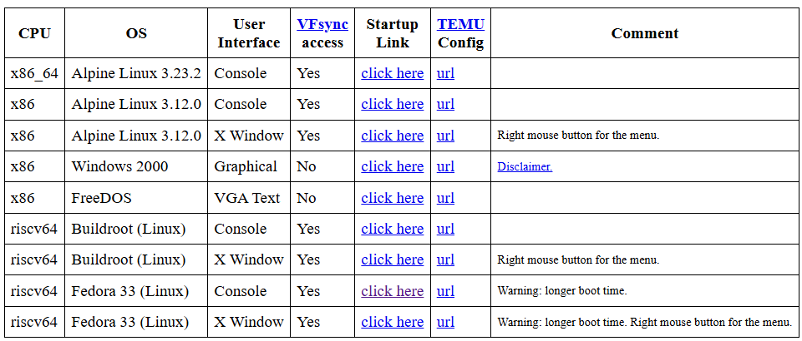

LS – list files
PS – list process

Can also use Google Cloud’s services https://console.cloud.google.com/

OS FUNCTION:
Device management:
Operating system needs to manage input & output devices such as keyboard, speaker, monitor, printer etc
It managed communication via respective ‘device drivers’

Networking function

System security.

COMPUTER MANAGEMENT SYSTEM ADMIN CONSOLE
SLIDES - OS 3 - Lecture - Sys Mon - File sys CMD

Event viewer is good for troubleshooting issues
Lets us see the events on the computer
Can investigate errors

Performance tool is good for diagnostics

TASK 3 – LECTURE NOTES WILL HELP WITH TASK 3
- Q. What are some of the most common standard sub-directories in Linux OSs?
/
The root of the entire filesystem; everything branches from here.

/bin
Essential user commands (binaries) needed for basic system operation. Often symlinked to /usr/bin on modern systems.

/boot
Bootloader files and the Linux kernel. Removing this breaks booting.

/dev
Device files representing hardware (e.g., disks, terminals).

/etc
System-wide configuration files. No binaries here.

/home
Personal directories for each user.

/mnt
Temporary mount point for manually mounted filesystems. (FHS standard.)

/sbin
System binaries for administration (e.g., fsck, mount). (FHS standard.)

/usr
Secondary hierarchy for user utilities and applications. (FHS standard.)

Week 2/3: Tutorial tasks.
Input devices are a means of sending input (data, commands and control signals) to the system for it to process a task, for the user.
- Q). What actions are classed as input? Name some modern common and specialised input devices that are used as part of computer systems.
When we enter information or complete an action.
Typing something on a keyboard, scanning, using a webcam, clicking a mouse, talking into a microphone.
Could be more specialised devices like motion sensors, brain sensors, kinetic cameras.

- Q). What is done with these input signals in order for them to ‘processed’?
They go through a CPU – central processing unit. Takes it in code and displays it in a way humans can understand.

Output devices/systems, are utilised for the purpose of presenting the results of computer processing into usable form for the user.
- Q). Describe some forms of ‘usable output’ and the output systems and devices that facilitate these?
Seeing visible text or numbers on a screen – monitor would be the device to facilitate this. Visual output.
A speaker playing back music. Audio output – via headphones or speakers.
lights – LED’s etc
video playback
Printers

- Q). Give a basic example of Input – Process - Output system that results in a users task being completed effectively (you can name the specific devices involved if you wish)
Using a keyboard to type text., into say a word doc or a google search. You hit enter, the system processes the text and finds relevant pages. The output is the search results
Take a photo on a camera – clicking the button is the input, the camera processes and dispays it as a picture, which humans can understand/see.
Clicking something - for example into a folder, this opens it, and the user can see what is inside the folder.

- Q). Determine some factors you should consider/evaluate when selecting output systems (give examples where you wish).
Quality / size of a monitor
Refresh rate for gaming

Revisit the definition of a computer system, define the three main criteria (and in turn, the principal functional components) that comprise the system.
- Identifying components that comprise Computer Systems
https://www.proprofs.com/quiz-school/story.php?title=computer-parts-quiz_2
- Epic games - PC Building Simulator (2).
- Free PC builder:
https://uk.buildcores.com/builds/2r36gmHp4

Engagement with an online course.
Course Name - Learning PowerShell
URL - https://www.linkedin.com/learning/learning-powershell/how-to-read-the-language?autoSkip=true&resume=false&u=77966930

Completing the Learning PowerShell course helped me build a clearer understanding of how PowerShell works and why it is used for system administration. The course was broken into short videos, making it easier to follow each topic step by step. Throughout the lessons, I learned how to read and write basic PowerShell commands and how the syntax is structured.
Engaging with this course supported my assignment work because it strengthened my confidence and knowledge around what each command does and its uses.


Figure 85: Screenshot of the Learning PowerShell course and checklist of videos.

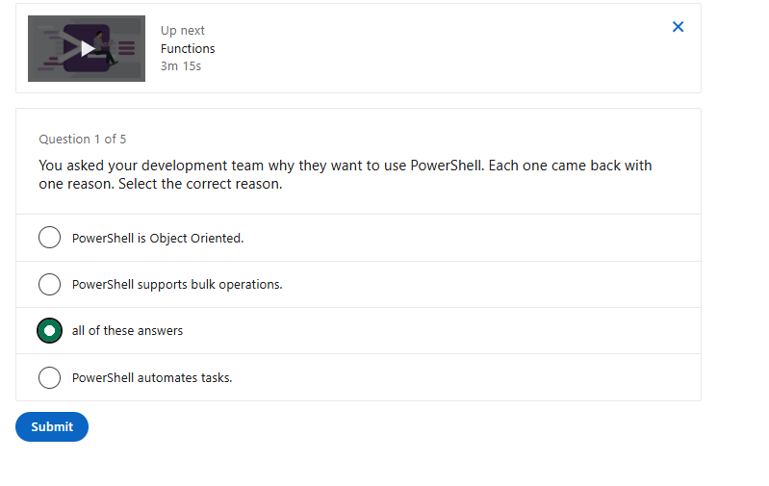
Figure 86: The quiz at the end of one of the sections.


Figure 87: Completion of the quiz.

