DS 1 Template

My Screenshots/Photos
- Please add 4–6 screenshots or photos of your digital life.
- You can use your phone or laptop.
- For each screenshot, write one or two sentences explaining what it shows.

Screenshot/Photo 1
[Insert Photo/Screenshot below]
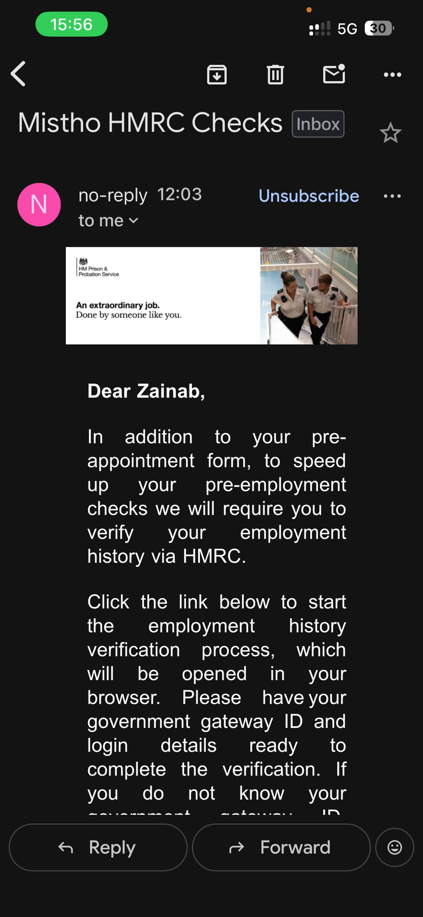
Emails I use them mostly for job applications and bills.
TikTok which is new to me actually but has been fun for both business and pleasure.
Instagram also not used very often but I have my facebook and Instagram linked together, so whatever I have posted on facebook would appear on Instagram.

Screenshot/Photo 2
[Insert Photo/Screenshot below]
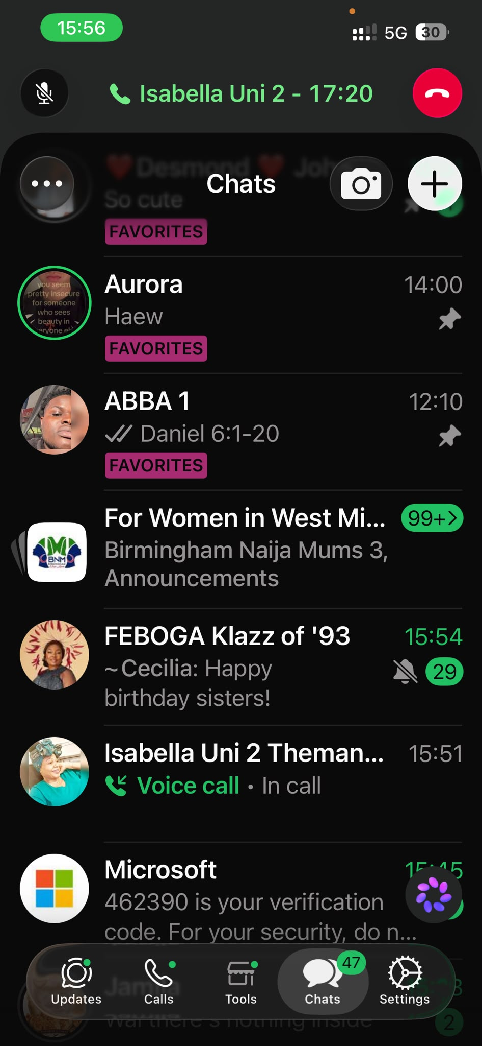
WhatsApp is the most used of the digital tools I know, because I use it to communicate with family, friends and also for my business.

Screenshot/Photo 3
[Insert Photo/Screenshot below]
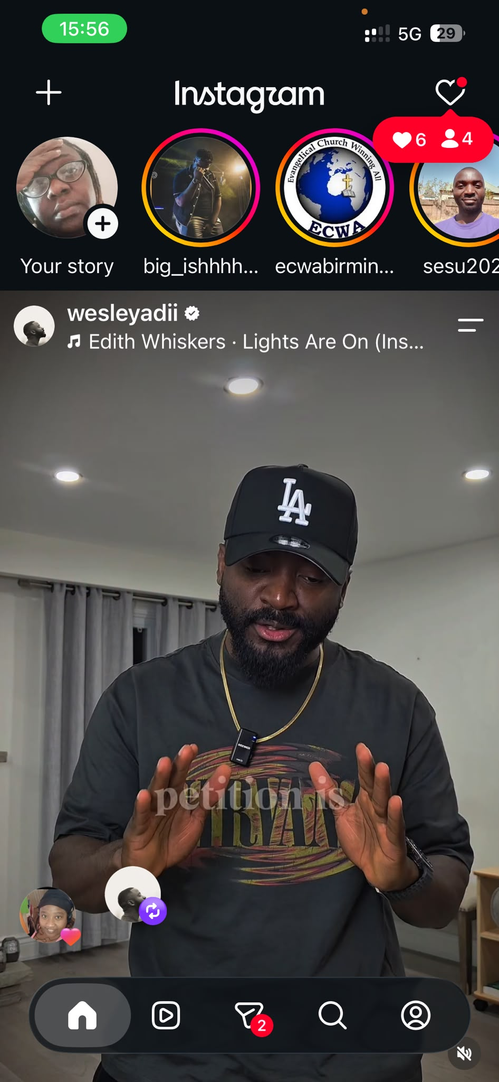
LinkedIn though o have had it for quite a while I have never understood how to use it.

Screenshot/Photo 4
[Insert Photo/Screenshot below]
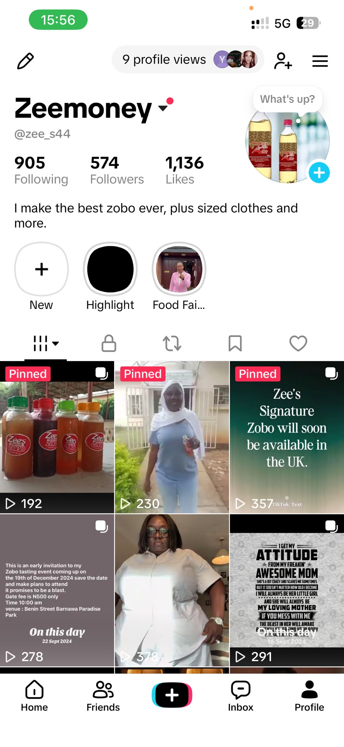
I would like to improve on my usage of emails because I’ve heard people say a good business should have a good list of emails and use it to reach out to more customers.

Screenshot/Photo 5
[Insert Photo/Screenshot below]

[Write what this shows of your digital life]

Screenshot/Photo 6
[Insert Photo/Screenshot below]
[Write what this shows of your digital life]

My Short Reflection
- Write 5–8 simple sentences about your digital life.
- You can use the sentence starters below if helpful.

Sentence starters
- I use digital tools to …
- I feel confident when I …
- I want to improve …
- I often use these tools: …
- I sometimes feel nervous about …
- I hope this module will help me …
- Digital skills are important for me because …
You can write more if you want.

Submission Checklist
Before you submit, please check:
​​​ ☐ I added 4–6 screenshots
☐ I wrote short sentences for each screenshot
☐ I wrote my short reflection
☒ My work is my own
☐ My file opens correctly
​​☐ My file opens correctly

