Program: BSc Cloud Computing

Student name: Ivo Ivanov
Student Number: 2111853

Date: 11/09/2022

Module: Data Analysis and Visualisation
Module code: ACCB4002_LON-REWORK
Lecturer: Koushik Modak
Assignment Title: Experimental Data Analysis
Submission deadline: 12/09/2022

Table of Contents
Introduction…………………………………………………………………………..………..3
Dataset…………………………………………………………………………………..……..3
Dataset Visualisation……………………………………………………………………..……4

Analysis………………………………………………………………………………….…….5

Hypothesis testing………………………………………………………………….…………..5

Testing of hypotheses to various significant level t-test…………………………….…………6

Testing of hypotheses to various significance level t-test: Two – samples Assuming equal Variances………………………………………………………………………………………8

Outliers in the Dataset…………………………………………………………………….……9

Conclusion……………………………………………………………………………………11

References……………………………………………………………………………………11

Introduction
The going with table presents class test results (set out of 20) of 40 Long term 5 school
kids learning math ideas in a local elementary school. The school has
gotten many related applications for nothing from a secretly based web learning
application improvement association. The association wishes to analyse the application's use as a gaining device and trust that the disclosures from the outcomes will assist them with picking whether they ought to happen with the new turn of events.
The outcomes show the kids' accomplishments by utilizing custom regular dials to assist them with learning. The ensuing set shows the results accomplished when the
youths utilize another web-based application to assist with theirs.

The company decided to analyze the data.

Let’s describe a Dataset.

A dataset is a collection of data sets corresponding to each other and representing a given record of the dataset in question.

In the introduction above, we could present like:
What should be included in a Dataset description?
We have two results containing mathematical scores of 40 children (market out of 20). One of the sets is before using the app, and the second set is after using the app.

Num. stud. Before app After app

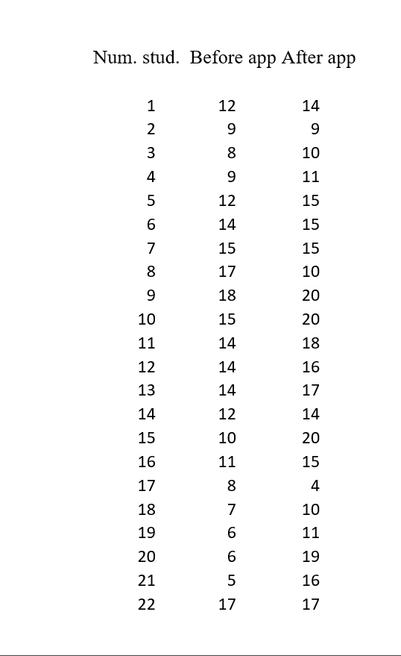
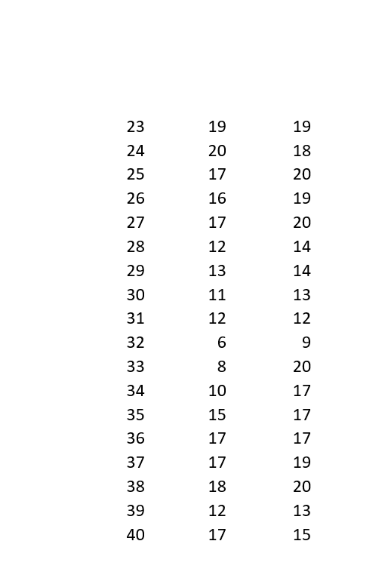

Dataset Visualisation

Figure1. Visualisation of Dataset shows afore - when using the app by 40 children (market out of 20).

Analysis
When we have two different populations (like our task is) assuming unequal variances, the appropriate way to use is Hypothesis analysis.

Hypothesis testing:
A hypothesis test is a crucial method in inferential measurements. It depends on the possibility that we can educate things regarding the populace from an example. Theory testing can be made sense of in five stages.
- Hypothesis
- Significance
- Sample
- P-value
- Decide

Level of significance:
The level of significance should be selected taking into account the key factors such as sample size, test power, and expected losses errors of type I and type II

T-test: two samples assuming unequal variances:
A t-test is used to find out if two sets of data are significantly different from each other. It compares the two sets of data and their mean.
The t-test was developed by William Sealy Gosset (1876-1937). 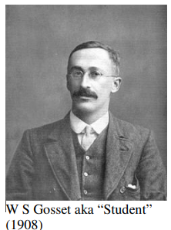[1]

t-test: assuming unequal variances
The t-test with two inconsistent scattering tests can be applied when the examples are regularly dispersed, and the standard deviation of the two populaces is obscure. It is thought to be unstable, and the model is adequately huge.

t-test: assuming equal variances
When should we accept equal variations?
As a rule, if the ratio of the larger variance to the smaller variance is less than 4, then we can assume that the variances are approximately equal and use a t-test for two samples.

Techniques and process for presenting the result
Invalid hypothesis testing is a common method for managing and choosing two understandings of a quantifiable relationship in a model. One execution is known as the Invalid speculation (often addressed by H0 and read as "H-nothing"). This is the likelihood that there is no relationship in the general population and that the relationship in the model mirrors the botch of the model. The invalid hypothesis is that the model relationship "occurred unintentionally".
The other interpretation is called an Elective Hypothesis (regularly addressed as H1). This is the likelihood that there is a relationship in the general population and that the relationship in the model mirrors this relationship in the group.
Learning device decidedly affects their test scores Ha > H0.

Testing hypotheses to various significant level t-test: Two – samples Assuming Unequal Variances.

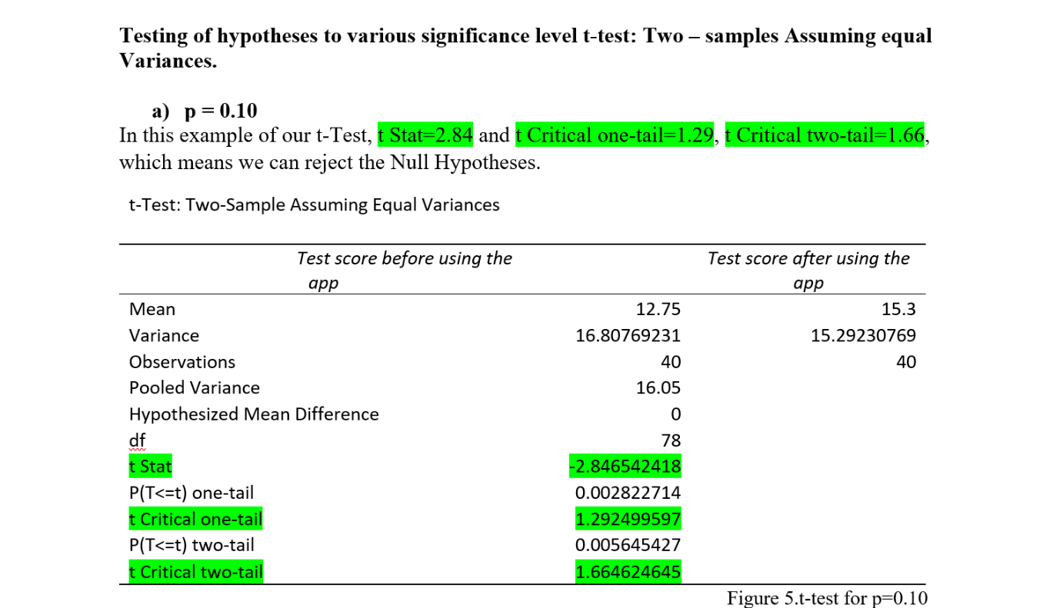

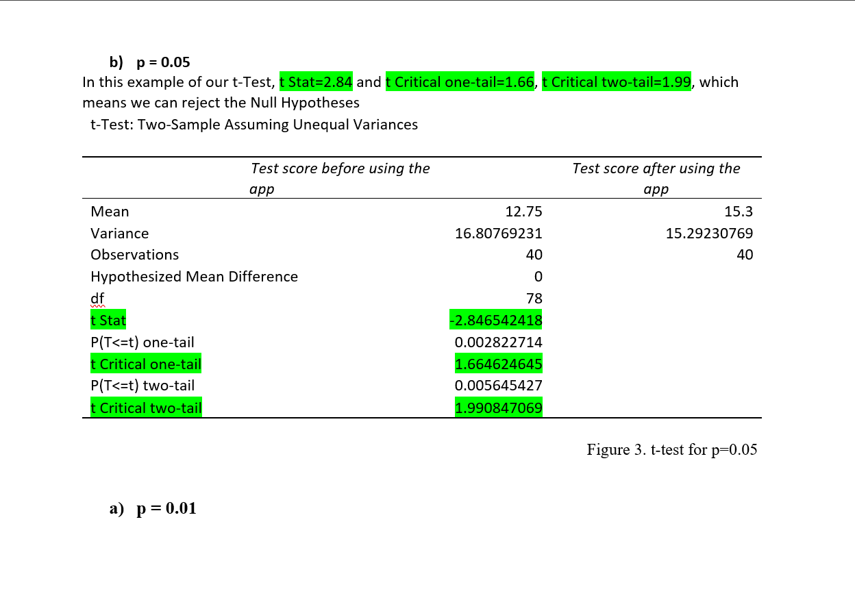

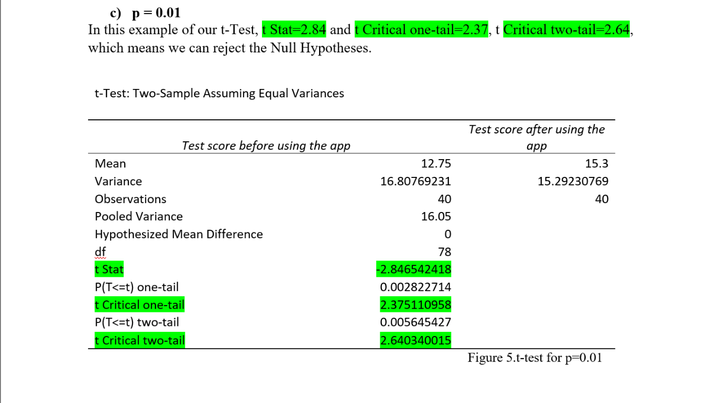

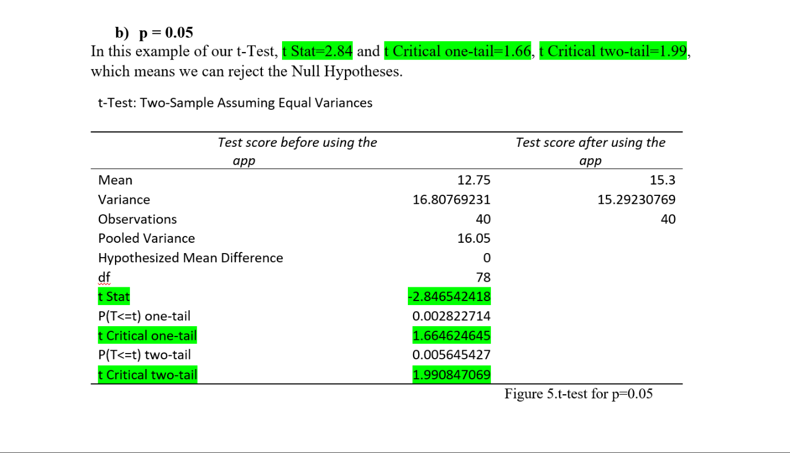

How do you find dataset outliers contradictions?
Deviations are outrageous qualities that stray from most different data of interest in the dataset. They can colossally affect factual examinations, slanting the consequences of speculation testing. Identify potential discrepancies in your dataset and correct them accordingly to get accurate results.

What are extraordinary?

The deviation is the value at the end of the data set. Some discrepancies represent valid values ​​due to natural population variation, while others may be due to imprecise data entry, device error, or other measurement errors. Note that variances are not always some form of dirty or inaccurate data. Delete data. What should be the most important depends on the most likely cause. Actual deviation valid deviation should always be retained in the dataset as it represents the natural variation of the sample.
Example: Actual deviation.
They measure the running time of 100 meters on a sample of 560 students. The data are usually assorted with some deviation from the extremes. As expected, most values ​​are concentrated near the centre. However, variables such as execution time are affected by many other factors, so these extreme values ​​also represent natural variation. Actual variance is likewise found in variables with skewed distributions, wherein many records factors are disbursed in a single course far from the mean. Choosing the correct statistical test or measure is vital if the distribution is skewed or has many variations.

Other differences that do not represent actual values ​​can arise from a lot of potential causes.
• mensuration error
• lapse in data entry or processing
• Non-representative sample
For example Other Deviations.
Repeat the transitional time measurement for a new sample. A participant’s girlfriend accidentally started the timer in the middle of the sprint. Record this time as working hours. This data point is much lower than any other time, so it's a big difference in the data set. This discrepancy is uncertain because it is imprecise and can skew research results.
For instance Contortion of results because of deviations
You work out the normal execution time for all members utilizing your information.
The typical worth is a lot of lower when you turn on the crisis than when you switch it off. Your standard deviation additionally increments when you turn on the emergency, so your factual power is likewise lower.
In actual practice, it can be awkward to differentiate between the different types of emergencies. Calculations and statistical methods can be used to find discrepancies, but the grading of true or false is usually subjective.[2]

Conclusion
A product-based organization fosters an application for learning science. Run a few trials of your application. To come by exact outcomes, they reviewed 40 — 5 years - old understudies. In the study, a similar test was given to 40 non-candidates, and a similar test was given in the wake of applying. The table shows plainly the positive aftereffects of the outcomes. In any case, nitty gritty examination and theories give exact suppositions and hazard-free probabilities. The report examines the information and presents results with differing levels of importance.
References
[1] Box, Joan Fisher, “Guinness, Gosset, Fisher, and Small Samples,” Statistical Science 1987, Vol. 2, No. 1, 45-52
[2] Published on November 30, 2021, by Pritha Bhandari. Revised on January 5, 2022.

