WEBSITE
BMSW4003 Digital Skills and Research Methods Assignment 4

Login Details
www.weebly.com
Mail: 1912879AGG@gmail.com
Pass: Galex260591

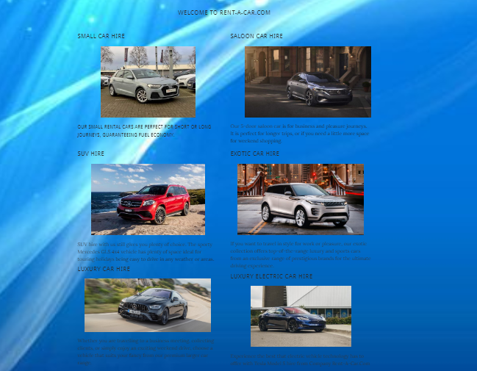
I will start by talking about the first page created on the website, namely the home page.
The way we chose to present our business through the website, through the effects and the carefully chosen colours, we sought to have an advantage of psychological to help our business.
On this page, I used a blue and white background, and I used the Parallax scrolling effect.
The two colours chosen for the background helps the company to express to potential customers that we are confident in what we do, trustworthy and that we like everything to go perfectly.
For writing, I used two colours: black because it expresses the seriousness, independence and professionalism with which we do our job and gold because it represents the quality of services and the wide range of luxury cars owned.
On this page, we have chosen to divide into categories the services offered by the company.
For each category we chose a picture with a car and a short description to help potential customers to choose more easily according to their needs.

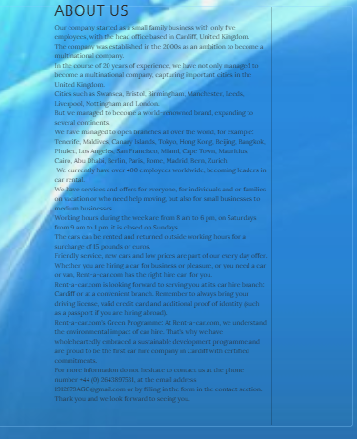

The next page created is the page About that describes our company.
On this page, I chose the background and the Parallax scrolling effect to be like the home page.
In this section, I chose to talk about the Rent-a-car.com company and how it became a world-renowned brand.
The company started as a small family business with only five employees, with the main office based in Cardiff, United Kingdom.
The company was established in the 2000s as an ambition to become a multinational company.
In the course of 20 years of experience, we have not only managed to become a multinational company, capturing important cities in the United Kingdom. But we managed to become a world-renowned brand, expanding to several continents, with over 300 employees, targeting the key cities for business and holidays.

In this section we talked about working hours, the additional fees that are borne by customers if they exceed the company's work schedule.
But also, about the necessary documents that potential customers must present to rent.

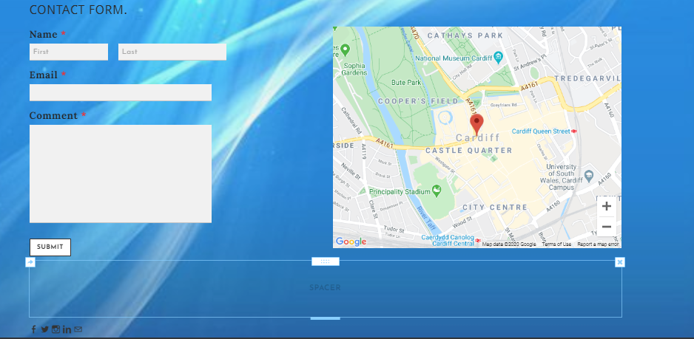

The last page created is the Contact page.
In this page, we decided to present the forms in which potential customers can contact us.
For the background, we kept the same image of colours and effects as on the other pages.
Potential customers can get in touch with us by phone calls by calling the phone number provided, using the company's email address, by filling out the form or using social networks.
To make it easier for potential customers to find the company's branches, we have introduced a map.
The simple structure of the website makes it easy to read and understand by potential customers, and with the help of chosen colours that have a psychological impact, it helps our business to prosper, to transmit positive energy, but also to send a clear message about services quality, affordable prices for anyone, and meeting anyone's requirements.
For this reason, over the course of twenty years, this company started a small family business to expand and become a world brand.

