Image and details collected from: https://angeladuckworth.com/

How Duckworth passes the CRAAP test?
CRAAP test helps to evaluate the information provided in our finding and also help us to understand are this information relevant or not or is it trustworthy or not. CRAAP is an acronym that stands for Currency, Relevance, Authority, Accuracy, and Purpose (Research guides.njit.edu., 2018). The question is whether Duckworth passes the CRAAP test.
Currency: It refers to when the source was established first. It is necessary to understand whether the source is relevant with the time (Researchguides.njit.edu., 2018). The Angela Duckworth test is a short test that measure’s an individual’s ability of maintaining focus and interest and preserving long-term goals. The data an individual provides is a real time data which proves that the source is valid.
Relevance: It is a necessary factor as it determines whether it is relevant with the assignment (Researchguides.njit.edu., 2018). The Duckworth test determines whether a student can maintain his focus on his goals. The test is also designed in a way that measures it properly.
Authority: The grit test has first been established by Angela Lee Duckworth. She is an US born academic, psychologist, and an author in popular science (Researchguides.njit.edu., 2018). She is also a Professor of Psychology at the University of Pennsylvania. There she studies and researches on grit and self-control.
Accuracy: The sources has been tested out by other professionals and it is proven that the output from the source is accurate.
Purpose: Duckworth's study contributes to a growing body of psychological studies on what are informally referred to as "noncognitive talents." The objective is to discover and quantify the different abilities and attributes that contribute to human growth and achievement that are not related to IQ (Researchguides.njit.edu., 2018).
CRAAP test is essential to clear our doubts concerning on their capabilities after googling the resources, according to (Sarah Blakeslee, 2004). After my research and taking Angela’s grit test online, I believe, she is an incredibly talented and trustworthy person. She is known for her research on grit. On her TED lecture (Angela Duckworth TED TALK, 2013) also focused on passion and perseverance for long term goals, also she developed the grit scale to measure of this construct.
So, from my point of view, she passed the CRAAP test.

DIKW Model
DIKW help us to organise our raw data in a systematic order. I used DIKW framework to evaluate the data I collected for analysis Angela’s TED TALK and grit score results. Me and my classmate we took Angela Duckworth grit test online, then we used our individual scores for further evolutions.

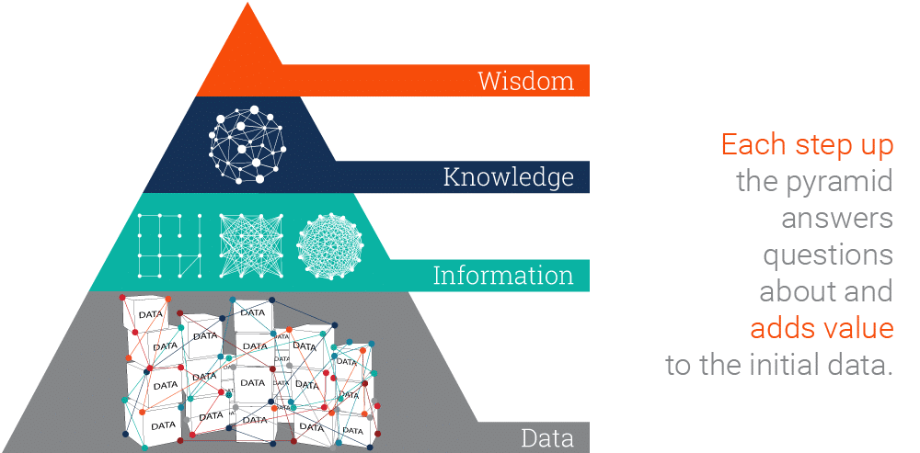

DIKW
- DIKW stands for Data, Information, Knowledge, and Wisdom (Ontotext.com., 2012). The DIKW Pyramid illustrates the connections between data, information, knowledge, and wisdom. Each building brick represents a step toward a higher level - data comes first, followed by information, knowledge, and eventually wisdom. Each stage clarifies various aspects of the original data and adds value to it. The more meaning and context we add to our data, the more information, and insights we extract, enabling us to make more educated, data-driven choices (Ontotext.com., 2012).
Data: Data is a collection of unstructured information, such as numbers or letters (Ontotext.com., 2012). However, data without context might be meaningless and cannot be used without setting a proper structure.
In this assignment, the collection of date from the questionnaire designed in with Microsoft FORMS in class and circulated to with classmates using a weblink. I had collected relevant data such as their grit score and academic level from the questionnaire. A screenshot of my questionnaire I had given that I passed on the student to collect the necessary data. From the questionnaire, we can see that there are inputs in the academic level such as 0, 1, 2, 3 etc. which are individual data.

DIKW Model
- Information

Information: The DIKW Pyramid's next construction component is information. This is data that has been "cleaned" of mistakes and subsequently processed to make it simpler to quantify, display, and analyse for a particular purpose. Depending on the aim, data processing may entail a variety of activities, including merging disparate collections of data, ensuring the obtained data is relevant and correct (validation), and so on (Ontotext.com., 2012). For instance, we may arrange our data in such a manner that linkages between apparently distant and unconnected data pieces become apparent.
Then, we had collected all the data and put it in MS Excel for a scatter diagram. We used this information as our primary data.

DIKW Model

- Knowledge

Knowledge: When we regard information as more than a collection of facts, but also to an end, we transform it into knowledge. This information is often an enterprise's competitive advantage. As we unearth linkages that are not clearly expressed as information, we get additional insight and climb the DIKW pyramid (Ontotext.com., 2012).
Continusly, we compared our primary data with secondary data, to gain our knowledge in the evaluation.

DIKW Model

- Wisdom

Wisdom: Wisdom is the pinnacle of the DIKW model, and in order to reach it, we must address issues such as 'why do something' and 'what is the best solution (Ontotext.com., 2012).' In other terms, wisdom is the application of knowledge. Additionally, while facts and information served as a window into the past, knowledge and wisdom serve as a window into what we do today and what we want to accomplish in the future.
At the end, I used my knowledge to understand the importance and how it is going to help us in our future.

Information:
The questionnaire:

To do our grit survey, we asked these two questions based on our own score from Angela Duckworth online test. Our primary data based on these questionnaires.
Data:
Primary Data:
Academic level |  | Academic level | Grit score
2 |  | 2 | 3.44
3 |  | 3 | 3.45
4 |  | 4 | 4.45
5 |  | 5 | 4.25
6 |  |  | 2.8

Using MS Excel, I had organised all the data first based on the academic levels of the respondents. Later, I calculated the average Grit point for each academic level using the Average function in Excel. Next, I highlighted all the information on academic levels and average grit and prepare a scattered diagram. Our study shows that the grit score is the highest at the academic level of 6. The score is the lowest at the point of academic level 2.
To compare my research, I collected data presented by the school collected by students in January 2020 about grit. As my source of secondary data to gain knowledge.
Secondary Data:

 | Highest academic level | Grit score
 | 2 | 3.56
 | 3 | 3.450079
 | 4 | 3.73037
 | 5 | 3.9921

Knowledge
Comparison between primary data and secondary data:
Primary Data Secondary Data

I compared the two results from our primary data and secondary data. From my analysis primary, secondary data and their scatter graph show completely different results because for primary data, the survey we have done on some number of people. The trendline is going down after level 3, because we did our survey within our peers and may be everyone answered correctly that is why trendline is going down.
On the other side, the graph from secondary data shows different results, the trendline is going higher as the academic level increases, and this survey was held among substantial number of people.
Wisdom:
Based on the comparison between primary and secondary data and graph as well as from my analysis's grit score improves with academic levels. In the secondary data, we can see that there is a clear upward line with academic levels. It refers that a student becomes more prominent in their activities as they advance to higher education. Our secondary data from previous year shows that students have positive output in attaining more grit score as they advance to their academics. Intelligence helps to grow efficiency and wisdom is the ability to increase effectiveness, according to (R L Ackoff, 1989). Also grit and self-control equally goes in same path but not very time perfect., according to (Angela Duckworth, James J. Gross. 2014). Because it gives a good reflection and helps to focus on determination but sometime if the score dose not shows the accepting results also may affect on self-confidence. Carol S Dweck on her TED Leacher ‘The Power of Yet’, (2014), she mentioned about a high school in Chicago, where students had to get a certain number to pass in all courses to graduate, if encase anyone did not pass a course, they got the grade ‘Not Yet’. She found its incredible idea to keep them motivated. Because, when a student dose not pass that is make them think they are less or not worth it, so to keep them motivated ‘Not Yet’ term gives them a chance to overcome their difficulty, from their fixed mind set. So that, the scores and academic level goes high or stay law, from the grit score, a student should take it positively. Angela’s grit scale helps a student to develop their academic level, face new challenges or overcome from their fixed mindset to get greater achievements in their near future.
Conclusion and Recommendations
Grit is an important test as it is helping an individual to gain achievement and success in their life. The higher level a student goes the grit scores goes higher, so grit scores help a student to focus on the target and help them to reflect on their development and achievement. By that scores a student can also personal development action plan which eventually can help them to achieve their goals. Higher level of Self-control, motivation, and grit does not always require pursuing a goal but consistence and passion toward the goal are also works effectively, accorder to (Duckworth, A. and Gross, J.J., 2014). While being naturally intelligent and gifted is admirable, to succeed and prosper, every individual must possess the capacity to endure. Without guts, brilliance may just be untapped potential. Growth and development reflect an individual personal achievement. Growth does not require values increase but development does. That is why, an individual understanding on information and knowledge helps to increase their wisdom, according to ( Ackoff, 1986). Hence, academic student life is the most important to build this attribute. From my point of view instead of taking results in negative viewpoint take it as a challenge to work hard to improve or gain better grit score.
References
Ackoff, R.L., 1989. From data to wisdom. Journal of applied systems analysis, 16(1), pp.3-9.
A clip from Angela Lee Duckworth's TED Talk "Grit: the power of passion and perseverance" from TED Talks Education 2013 available at: https://youtu.be/GfF2e0vyGM4
Angela Duckworth grit test online available at: https://angeladuckworth.com/grit-scale/
Blakeslee, S., 2004. The CRAAP test. Loex Quarterly, 31(3), p.4.
Carol S Dweck, ‘The Power of Yet’, TED TALK, (2014) available at: https://youtu.be/J-swZaKN2Ic
Duckworth, A. (2016). Grit: The power of passion and perseverance. New York Scribner.
Duckworth, A. (2017). Grit: why passion and resilience are the secrets to success. London: Vermilion
Duckworth, A. and Gross, J.J., 2014. Self-control and grit: Related but separable determinants of success. Current directions in psychological science, 23(5), pp.319-325.
Kannangara, C.S., Allen, R.E., Waugh, G., Nahar, N., Khan, S.Z.N., Rogerson, S. and Carson, J. (2018). All That Glitters Is Not Grit: Three Studies of Grit in University Students. Frontiers in psychology, [online] 9, p.1539. Available at: https://www.ncbi.nlm.nih.gov/pubmed/30210389. [Accessed on: 25 Nov 2021]
Lam, K.K.L. and Zhou, M. (2019). Examining the relationship between grit and academic achievement within K‐12 and higher education: A systematic review. Psychology in the Schools, 56(10), pp.1654–1686.
Nicholas, D. and Herman, E. (2014). Information science. Abingdon, Oxon; New York, Ny: Routledge.
Ontotext.com. (2012). Climbing the steps of the Data-Information-Knowledge-Wisdom Pyramid. [online] Ontotext. Available at: https://www.ontotext.com/knowledgehub/fundamentals/dikw-pyramid/. [Accessed on: 23 Nov 2021]
Researchguides.njit.edu. (2018). Research Guides: How to Evaluate Information Sources: CRAAP Test. [online] researchguides.njit.edu. Available at: https://researchguides.njit.edu/evaluate/CRAAP. [Accessed on: 22 Nov 2021]
Rowley, J., 2007. The wisdom hierarchy: representations of the DIKW hierarchy. Journal of information science, 33(2), pp.163-180.

