Strategic Analysis Report

INEOS GROUP


By Lawrence Lui
18 December 2018

Student Number: 1715378
DBA, University of Wales Trinity Saint David
Course: SBTD 7005

Words: 8,124

Table of Contents

- COMPANY SNAPSHOT 1
- INEOS Group: Company Overview 1
- INEOS’ Geographic Operations 1
- INEOS’ Shareholding 1
- INEOS’ Group Management 2
- Analysis of Financial Statements as at 31 DEC 2017 3
- COMPANY ANALYSIS OF INEOS 8
- INEOS’ Businesses 8
- INEOS’ Major Competitors 10
- SWOT ANALYSIS FOR INEOS 11
- SPACE MATRIX ANALYSIS FOR INEOS 18
- PORTER’S FIVE FORCES MODEL FOR INEOS 21
- STRATEGIC OPTIONS THAT INEOS SHOULD TAKE 26
- 1. Financial Strategy & Publicity Strategy 27
- 2. Think-out-of-the-Box Strategy 33
- 3. Preventive Strategy 36
- 4. Adopt the Blue Ocean Strategy 38
- 5. Recruitment Strategy 41
- 6. Develop “INEOS PROGRAM”for INEOS to Retain Talents 42
- 7. Strategic Succession Plan is Critical 43
- REFERENCES 44

COMPANY SNAPSHOT

INEOS Group: Company Overview
Headquartered in London and having vast investments in more than 20 countries, INEOS Group AG (INEOS or “the Group”) is the largest private conglomerate in the UK that produce raw materials that are indispensable in the production of chemicals, textiles, paints, plastics, automotive, biofuel and in the technology side. INEOS has a wide range of products that are related to consumers’ necessities to luxuries including chemicals and agriculture, cosmetics, home and electronics, cosmetics, packaging, rubber, textile materials, papers and film and sheets.

With main offices in Switzerland and the UK, INEOS recorded sales of £19.9bn and profits of £2.5bn from its wholly owned businesses, topping Britain’s privately-owned enterprises from 2015 to 2017.

INEOS’ Geographic Operations
INEOS operates in 24 countries in Europe, the US, Canada, Asia and other regions. With its production facilities located in Germany, Norway, Texas and Koln and together with several offices in all regions, the Group currently has 20,000 employees and continues to extend their blueprint through a number of acquisitions.

INEOS’ Shareholding
Percentages of Total INEOS Limited Share Capital (“LSC”) are as follows:
No. of ordinary shares % of LSC
James Ratcliffe ................................................................. 2,295,391,680 61.804%
Andrew Currie ..................................................................... 711,501,880 19.157%
John Reece ........................................................................... 707,106,440 19.039%
TOTAL .............................................................................. 3,714,000,000 100.000%

INEOS – COMPANY SNAPSHOT

INEOS’ Group Management
Name | Title
Jim Ratcliffe | Chairman
Ashley Reed | CEO, INEOS Enterprises
Gerd Franken | CEO, INEOS Olefins and Polymers Eurpoe
Dennis Seith | President and CEO, INEOS Olefins and Polymers USA
Graham Beesley | CEO, INEOS Oxide
Helen Wright | CEO – Belstaff
Leen Heemskerk | CFO, INEOS Phenol Ltd.
Paul Overment | CEO, INEOS Barex
Peter Williams | CEO, INEOS Technologies Ltd.
Rob Nevin | CEO, C3 Derivatives
Robert Learman | CEO, INEOS ABS and INEOS Oligomers
Andy Currie | Non-Executive Director
Jim Dawson | Non-Executive Director, INEOS Capital
John Reece | Finance Director
Robin Hutson | Chairman – Belstaff

INEOS – FINANCIAL STATEMENT ANALYSIS

Analysis of Financial Statements as at 31 DEC 2017

INEOS Group Holdings S.A.
CONSOLIDATED INCOME STATEMENT FOR THE YEAR ENDED 31 DECEMBER 2017
 |  | 2017 | 2016 | 2015
 |  |  | €m
Revenue.............................................................................................. |  | 15,210.4 | 12,609.9 | 13,729.4
Total cost of sales ............................................................................... |  | (12,524.2) | (10,141.1) | (11,318.4)
Gross profit........................................................................................ |  | 2,686.2 | 2,468.8 | 2,411.0
Distribution costs ................................................................................ |  | (206.5) | (195.3) | (212.1)
Administrative expenses before exceptional items ............................. |  | (418.6) | (385.6) | (372.3)
Exceptional administrative expenses .................................................. |  | - | (21.3) | (16.0)
Total administrative expenses ............................................................. |  | (418.6) | (406.9) | (388.3)
Total expenses .................................................................................... |  | (625.1) | (602.2) | (600.4)
Operating profit ................................................................................ |  | 2,061.1 | 1,866.6 | 1,810.6
Share of profit of associates and jointly controlled entities using  the equity accounting method ............................................................. |  | 143.5 | 29.3 | 74.4
Profit on disposal of fixed assets......................................................... |  | 2.6 | 3.7 | 3.8
Profit before net finance costs.......................................................... |  | 2,207.2 | 1,899.6 | 1,888.8
Total finance income........................................................................... |  | 491.9 | 200.0 | 165.1
Finance costs before exceptional item ................................................ |  | (355.2) | (505.3) | (774.1)
Exceptional finance cost ..................................................................... |  | (44.1) | (20.7) | (131.6)
Total finance costs .............................................................................. |  | (399.3) | (526.0) | (905.7)
Net finance income/(costs).................................................................. |  | 92.6 | (326.0) | (740.6)
Profit before tax from continuing operations ................................. |  | 2,299.8 | 1,573.6 | 1,148.2
Tax charge .......................................................................................... |  | (301.5) | (340.2) | (237.7)
Profit for the year from continuing operation ................................ |  | 1,998.3 | 1,233.4 | 910.5

INEOS – FINANCIAL STATEMENT ANALYSIS

INEOS Group Holdings S.A.
CONSOLIDATED BALANCE SHEET AS AT 31 DECEMBER 2017

Note
 |  | 2017 |  | 2016 |  | 2015
Non-current assets |  |  |  | €m
Property, plant and equipment ................................................... |  | 4,255.4 |  | 4,007.4 |  | 3,508.8
Intangible assets......................................................................... |  | 731.6 |  | 763.9 |  | 706.4
Investments in equity-accounted investees ................................ |  | 351.1 |  | 161.7 |  | 101.4
Other investments ...................................................................... |  | 238.5 |  | 262.2 |  | 243.2
Other financial assets ................................................................. |  | 28.3 |  | 29.2 |  | 29.2
Trade and other receivables ....................................................... |  | 957.4 |  | 1,146.8 |  | 1,114.0
Deferred tax assets ..................................................................... |  | 160.2 |  | 205.1 |  | 200.9
 |  | 6,722.5 |  | 6,576.3 |  | 5,903.9
Current assets
Inventories ................................................................................. |  | 1,246.5 |  | 1,068.1 |  | 956.6
Trade and other receivables ....................................................... |  | 1,712.9 |  | 1,501.8 |  | 1,772.4
Other financial assets ................................................................. |  | - |  | 8.2 |  | 1.1
Cash and cash equivalen |  | 1,366.3 |  | 2,204.1 |  | 1,648.0
 |  | 4,325.7 |  | 4,782.2 |  | 4,378.1
Total assets............................................................................... |  | 11,048.2 |  | 11,358.5 |  | 10,282.0
Equity attributable to owners of the parent
Share capital............................................................................... |  | 0.9 |  | 0.9 |  | 0.9
Share premium........................................................................... |  | 779.4 |  | 779.4 |  | 779.4
Other reserves .......................................................................... |  | (2,183.2) |  | (1,712.5) |  | (1,714.7)
Retained earnings....................................................................... |  | 3,099.7 |  | 1,362.3 |  | 370.2
Total equity............................................................................... |  | 1,696.8 |  | 430.1 |  | (564.2)
Non-current liabilities
Interest-bearing loans and borrowings ...................................... |  | 6,094.9 |  | 7,947.5 |  | 8,008.5
Trade and other payables ........................................................... |  | 120.1 |  | 107.2 |  | 91.7
Employee benefits...................................................................... |  | 701.0 |  | 789.5 |  | 689.1
Provisions .................................................................................. |  | 28.8 |  | 28.5 |  | 25.6
Deferred tax liabilities.............................................................. |  | 202.3 |  | 275.6 |  | 198.1
Other financial liabilities............................................................ |  | 2.3 |  | 0.9 |  | 12.6
 |  | 7,149.4 |  | 9,149.2 |  | 9,025.6
Current liabilities
Interest-bearing loans and borrowings..................................... |  | 63.0 |  | 72.6 |  | 291.8
Trade and other payables ........................................................... |  | 1,877.9 |  | 1,563.4 |  | 1,445.1
Tax payable ................................................................................ |  | 248.4 |  | 124.0 |  | 75.8
Other financial liabilities............................................................ |  | 0.2 |  | - |  | 1.8
Provisions. ................................................................................ |  | 12.5 |  | 19.2 |  | 6.1
 |  | 2,202.0 |  | 1,779.2 |  | 1,820.6
Total liabilities.......................................................................... |  | 9,351.4 |  | 10,928.4 |  | 10,846.2
Total equity and liabilit............................................................ |  | 11,048.2 |  | 11,358.5 |  | 10,282.0

INEOS – FINANCIAL STATEMENT ANALYSIS

- Cash Position
Cash position represents the amount of cash or cash equivalents INEOS had as of 31 Dec 2017. A stable cash position is important as it allows a company to cover its current debts with a combination of cash and liquid assets.

Cash Position | Euro’ m | 2017 | 2016 | 2015
Cash Position |  | 1,366.3 | 2,204.1 | 1,648.0
Current Assets |  | 4,325.7 | 4,782.2 | 4,378.1
Current Liabilities |  | 2,202.0 | 1,779.2 | 1,820.6
Current Ratio |  | 1.96 | 2.69 | 2.40

From the above extracted information, despite that the current ratio is standing at 1.96 (a healthy ratio) as at 31 Dec 2017, INEOS should be aware that it was not as healthy as compared to the previous year end (2.69). Most importantly, it is noted that the cash position has dropped below the total current liabilities. Flipping the Balance Sheet as of 31 Dec 2014 and 31 Dec 2013, the cash position was never below the amount of total current liabilities. It is the first time having this low position in the last five fiscal years. When the cash position drops below the total current liabilities, this should be taken care of because the deteriorating of cash position could cause problem to meet the cash needed to fund growing operations or pay off obligations.

- Liquidity Ratios

Liquidity Ratio |  | 2017 | 2016 | 2015
 | Cash Ratio | 0.52 | 1.24 | 0.91
 | Quick Ratio | 1.40 | 2.08 | 1.88
 | Current Ratio | 1.96 | 2.69 | 2.40

Liquidity ratios analyse the ability of a company to pay of both its current liabilities as they become due as well as their long-term liabilities as they become current. In other words, these ratios show the cash levels of a company and the ability to turn other assets into cash to pay off liabilities and other current liabilities.

INEOS – FINANCIAL STATEMENT ANALYSIS

From the liquidity perspective, the above cash ratio, quick ratio and current ratio are all said to be deteriorating over the last three years. Together with the issue of cash position (discussed in Point 1), the Group has to improve this situation such as the inventory management and short-term investments or the Group can consider the option of IPO which will be covered later in Point 1 of the Section “Strategic External Options that INEOS Should Take”.

- Long-term Loans

It appears to us that the Group has exercised proper monitoring of accounts receivable and trade receivables. Despite the Group had revenue being recorded at Euro 15,210M for the year 2017, which is 20% & 10% higher than 2016 and 2015, its total receivables were recorded at Euro 1,712.9M as of 31 Dec 2017, representing an increase of 14% and a decrease of 3.3% compared to 31 Dec 2016 and 2015. Per the Annual Report 2017 (F-51), there were no significant trade, related party or other receivable balances that were subsequently impaired during these three years.

- Profitability Ratios
Profitability Ratios |  | 2017 | 2016 | 2015
 | Gross Margin Ratio | 0.18 | 0.20 | 0.18
 | Profit Margin Ratio | 0.13 | 0.10 | 0.07
Profitability ratios compare income statement accounts and categories to show a company’s ability to generate profits from its operations. From the angle of profitability, the gross profit ratio has been flat over the last three years, while the net profit ratio has been slightly increasing. This indicates that the Group has not been enlarging the operational profitability of businesses (revenues), and its net profit improvement was as a result of exercising control of expenses.

INEOS – FINANCIAL STATEMENT ANALYSIS

- Solvency Ratios
Solvency Ratios |  | 2017 | 2016 | 2015
Debt to Equity Ratio | Total Liab/ Total Equity | 5.51 | 25.41 | -19.22
Equity Ratio | Total Equity/ Total Assets | 0.15 | 0.04 | 0.05
Debt Ratio | Total Liab/ Assets | 0.85 | 0.96 | 1.05

Solvency ratios (or leverage ratios) measure a company’s ability to sustain operations indefinitely by comparing dent levels with equity, assets and earnings. That is to say, solvency ratios identify going concern issues and a firm’s ability to pay its debts in the long run.

From the angle of the ability to pay debts, the above debt to equity ratios indicate that the Equity Ratio has always been way below the Debt Ratio. Although the equity ratio has improved a bit over the last 3 years, the Group’s total liabilities are however recorded at a very high level, which seriously affects the ability to make payments & debts and meet its obligations. The situation is not optimistic.

COMPANY ANALYSIS OF INEOS

INEOS’ Businesses
A variety of the Group’s businesses has made INEOS to achieve rapid growth in the past 20 years. The businesses cover a wide range of petrochemicals, oil and gas and automotive (INEOS GROUP, 2018).

PETROCHEMICALS
INEOS Enterprises
INEOS Baleycourt
INEOS Calabrian
INEOS Chloro Toluenes
INEOS Compounds
INEOS Melamines
INEOS Paraform
INEOS Salt
INEOS Solvents
INEOS Sulphur Chemicals
INEOS Nutriles
INEOS Olefins & Polymers Europe
INEOS Olefins & Polymers USA
INEOS Oligomers
INEOS Oxide
INEOS Phenol
INEOS Polyolefin Catalyst
INEOS Styrolution
INOVYN

OIL AND GAS
INEOS FPS
INEOS Oil & Gas UK
INEOS Oil & Gas Norway
INEOS Shale
INEOS Trading & Shipping

AUTOMOTIVES
INEOS Automotives

INEOS’ Major Competitors
INEOS’ major competitors include Akzo Nobel N.V., BASF SE, Bayer AG, Monsanto Company, E.I. duPont de Nemours & Company, Lanxess AG, The Dow Chemical Company.
Mossi Ghisolfi Group, CellMark, Guardian Energy and Borregaard ASA.

SWOT ANALYSIS FOR INEOS

INEOS Group specializes in manufacturing petrochemicals, oil products, and specialty chemicals. The group's success in chemical products symbolizes diversified end markets, which likely exempts it from risks associated with a particular market segment. SO (Strengths + Opportunities) Strategies can be used because INEOS’ internal strengths will take advantage of external opportunities. However, factors such as mergers in the chemical industry, competition in the Middle East, and INEOS’ supply chain discrepancies pose threats to the Group.

STRENGTHS | WEAKNESSES
# Barriers of entry are stringent as this industry requires a huge sum of capital  # INEOS has diverse chemical products portfolio | # Unlisted companies are usually less transparent than publicly listed companies
# Chemicals markets are still being expanded in different countries
OPPORTUNITIES | THREATS
# Divestment of Non-core assets | # Merger in the chemical industry in the globe.
# Increasing cross-geography shale gas presence. | # Competition in Middle East is getting more and more intense.
# Go public to improve funding and capital and recruit better talents | # Multinational regulatory requirements, exchange rate fluctuations, etc.
# Purchase of new gas fields  # Strategic business acquisitions | # The drawback in supply chain incurs more operating costs

STRENGTHS

Portfolio of Diverse Chemical Products

INEOS offers products to diversified end markets. For instance, the group supplies its products to its customers in the food and packaging industry through its companies INEOS ABS; INEOS Enterprises; INEOS ABS; INEOS Barex; INEOS Bio; INEOS Compounds; INEOS Olefins & Polymers USA; INEOS Nitriles; INEOS Phenol; INEOS

SWOT ANALYSIS FOR INEOS

Technologies; INEOS Melamines; INEOS Oligomers; INEOS Salt; INEOS Upstream; INEOS Oxide; INEOS Solvents; INEOS Olefins & Polymers Europe; INEOS Paraform and INEOS Styrenics. Through INEOS Upstream, the group specializes in oil and gas exploration and production for energy and manufacturing markets. The Group supplies products to its customers in the pharmaceutical industry through INEOS Olefins & Polymers Europe, INEOS Barex, INEOS ABS, INEOS Enterprises, and INEOS Olefins & Polymers USA.

The group's companies also cater to needs of other markets such as adhesives, agro- chemicals, bio-fuel, coatings, construction, cosmetics, manufacturing, electronics, pipes, textiles, and films and sheets (INEOS GROUP, 2018). In addition, INEOS' companies offer their products to its customers engaged in paints and inks; pulp and paper; rubber and tire; wire and cable; and energy and manufacturing markets. The product supplies to diversified end markets has helped INEOS reduce the risks associated with a particular market segment.

STRENGTHS - Expanding Establishments in Chemical Markets
INEOS has assembled its diverse businesses through many acquisitions from some major chemical companies in the globe. For example, the acquisition of BASF's US & Canadian polystyrene organizations; Innovene from BP; and Rhodia's sulfur synthetics businesses in 2004. In 2005, INEOS framed INEOS Melamines upon the acquiring of the amino resins business of UCB. In 2007, INEOS bought Borealis and half interest of Noretyl Cracker, and furthermore the ABS Business from Lanxess to establish INEOS ABS. In the following year, INEOS acquired the vinyl acetate monomer & the ethyl acetate companies of BP.

Recently, in 2014, INEOS Enterprises acquired Sasol Solvents Germany and the related business in Moers and Herne. In 2015, INEOS Americas LLC, a wholly owned subsidiary of INEOS, acquired the aromatics business from Axiall Corporation for a total of $62.9 million. The acquisition comprises the Cumene plant, based in Pasadena, Texas, with production capacity of 900,000 tonnes of product.

Acquisitions above have enabled INEOS to be a giant global chemicals group. The domain of INEOS empire is hence getting more and more dominant.
SWOT ANALYSIS FOR INEOS

WEAKNESSES - Lack of Transparency

Although the private status of INEOS allows it to be exempt from stringent scrutiny by listing authorities and other governmental bodies as opposed to the examinations faced by publicly-held competitors, people’s confidence to the financial records provided by the Group is always not as high as they have towards public companies. These may make some customers prudent, and result in INEOS losing business to publicly-listed competitors such as Bayers or Dow Chemicals, whose business and financial performances are more transparent. In addition, the Group does not enjoy the opportunities of having access to capital market funding, e.g. public debt or equity markets.

As a result, INEOS has to rely on cash generated through its operations to fund expansion and growth opportunities.

Transparency sometimes can be a crucial factor to another country. Taking China’s Huawei Technologies Co. Ltd. (“Huawei”) as an example of large private company, the U.S. has had big concerns over the past few years about the practice of Chinese firms (e.g. ZTE and Huawei) to “use stolen American intellectual property, to involve in forced technology transfers, and to be used as arms of the Chinese government's objectives in terms of information technology in particular” (Mangan, 2018). Huawei apparently has been the top target to be banned by the U.S government recently. In early December 2018, reportedly Huawei had broken U.S. sanctions against Iran, the CFO of Huawei was arrested in Canada under the advice from the U.S.

Although Huawei is not fully comparable to INEOS, its private & giant nature is however similar. INEOS’ chemicals, pipelines and gas can also be an issue of national safety in the eyes of another country. Advanced countries are mindful of private companies particularly as to whether their corporate financial status is true and whether they will pose national security threats to them. It indicates that low transparency of a giant private corporation may create skeptic and distrust in the minds of the public and even the Government of other nations. Hence, going public seems to be a good choice for INEOS which will be delivered in our later section “Strategic External Options for INEOS to Take” in this report.
SWOT ANALYSIS FOR INEOS

OPPORTUNITIES
Buy New Gas Fields

Latest new licenses of gas fields keep strengthening INEOS’ shale gas and natural gas supplies in Europe.

In 2016, INEOS purchased assets with the aim to broaden its product supplies and maintain its leading industry position in natural gas and shale gas in Europe. For example, in April 2016, INEOS Europe AG and Rex Energy entered into a new contract for the purchase of natural gas liquids from the Appalachian shale gas basin (GlobeNewswire News Room, 2018). The natural gas liquids will be transported through the Mariner East infrastructure and shipment of propane and butane began in 2017. This contract enlarged the Group’s supply portfolio as a long-term sourcing which the US natural gas liquids for its European markets can be competitively priced.

In December 2015, INEOS won 21 new shale gas licenses in the East Midlands and the North West. Areas include Runcorn and North Yorkshire which both are close to INEOS’ existing plants. INEOS was awarded 700,000 acres on top of its existing 300,000 acres and the Group is now one of the UK’s biggest shale gas players. These new licenses therefore provide a strategic edge against the competitors.

OPPORTUNITIES - Divestment of Non-Core Assets

In 2015 and 2016, INEOS disposed of some non-core assets namely INEOS ChlorVinyls and INEOS Styrenics so as to concentrate more on its core businesses.

The sale of INEOS Styrenics to Synthos S.A. for a total of E80 million represents a milestone in the unremitting development of the EPS business. In 2015, INEOS ChlorVinyls, a wholly owned subsidiary of INEOS, announced the completion of the sale of its 35.7% interest in Suzhou Huasu Plastics, China, to Westlake Chemical Corporation. With this deal, it brings an end INEOS ChlorVinyls’ involvement in this PVC Joint Venture.

Proceeds from disposal of non-core assets helped reduce the Group’s debts which could further strengthen its balance sheet.
SWOT ANALYSIS FOR INEOS

OPPORTUNITIES - Increasing Development of Cross-Geography Shale Gas

INEOS has been involved in acquiring and selling of shale gas in the US and other countries. Taking the deal in May 2015 for example, INEOS entered into the deal with IGas making it the UKs third largest shale gas group. The deal represents an acquisition of a 50% interest in seven IGas shale gas licenses in the North West of England and a 60% interest in three petroleum exploration and development (PEDL) licenses and a 50% interest in a further four licenses. In Scotland, INEOS fully acquired IGas’ entire interest in PEDL 133. In addition, INEOS has the option to acquire 20% in two IGas East Midland shale gas licenses. INEOS also will assume operatorship of four PEDL in phases.

INEOS recently has commenced its shipments to Europe, further expanding its geographic distribution. For example, in March 2016, the INEOS Intrepid, the world’s largest LNG multi gas carrier, left the US shores carrying INEOS’s first shale gas shipment to Europe. The shipment of shale gas was from the U.S. to Norway, and it is a shipment of 27,500 cubic meters of ethane. Moreover, in November 2015, INEOS entered into an agreement with ExxonMobil Chemical Limited and Shell Chemicals Europe BV to supply ethane from the US shale gas from Grange mouth to the Fife Ethylene Plant in Scotland.

Cross-geography shale gas expansion and sales will further strengthen INEOS’ natural gas and shale gas offerings in the US and Europe and could further strengthen its revenues from these regions.

OPPORTUNITIES - Strategic Business Acquisitions
INEOS is focusing upon growing and expanding product offerings through strategic business acquisitions. For example, in 2017, the company announced plans to acquire oil and gas assets from Dong Energy for US$1.3 billion. Also, INEOS agreed to acquire the Forties Pipeline System (FPS) and associated pipelines and facilities from BP. The 235-mile Forties pipeline system links 85 North Sea oil and gas assets to the UK mainland and the INEOS site in Grangemouth in Scotland. Again in 2017, INEOS Oxide announced that, following clearance by the European Commission, the company acquired Arkema’s Oxo alcohol business, which included the acquisition of Arkema’s stake in

SWOT ANALYSIS FOR INEOS

Oxochimie, the JV at Lavéra between INEOS and Arkema, producing butryaldehyde and oxo alcohols (butanol and 2-ethyl hexanol).

In December 2015, INEOS Enterprises planned to acquire all (100%) of the shares of Befesa Valorizacion de Azufre (BVA). BVA is a regional market leader for sulphuric acid and oleum located in Bilbao, Spain. The plant is one of the most modern one in Europe with the capacity to produce 340,000mt per year of sulphuric acid and related products. The acquisition will complement INEOS existing Sulphur Chemicals Business in the UK, effectively doubling the production capacity and adding a Continental European dimension to the asset base.

Such strategic acquisitions could help INEOS expand its geographical presence, increase its product offerings, and enhance its revenues and profit margins.

THREATS
Increasing Competition from Middle East and Consolidation in the Global Chemical Industry

The Middle East companies are currently expanding their business segments including chemicals and petrochemicals. This rising chemical capacity in the Middle East poses a significant challenge to INEOS. Chemicals and petrochemicals typically generate higher margins because the manufacturing costs in the Middle East are cheaper. INEOS will eventually find it difficult to compete with low-cost petrochemical imports from the Middle East.

More and more companies are seeking economies of scale and cost advantages through mergers. Reasons for mergers in the industry could be the wish to reduce overheads and marketing expenses, achieve higher efficiencies in purchases and logistics, and improve geographic reach. Mergers in the industry would jeopardize pricing pressures and industry competition, and then this would also affect INEOS’ market position.

SWOT ANALYSIS FOR INEOS

THREATS – INEOS’ Risk Variables
Regulatory Requirements and Exchange Rate Fluctuations
Due to its multinational nature with huge sum of transaction amounts, INEOS might quite often experience exchange rate fluctuations, different regulatory requirements, and restrictions on its ability to repatriate earnings from some foreign countries. The Group might also face changes in the political or economic conditions in the foreign countries it operates in. Such factors could negatively impact INEOS’ operations powerfully.

THREATS - Supply Chain Flaws Could Increase Operating Costs
One of the major cost components of chemical manufacturers such as INEOS is the welding and cooperation of its supply chain. As a fact in this industry, virtually all chemicals require inexhaustible raw chemicals and some of these can be hazardous in nature. The transportation from the origin to buyers/users requires sophisticated supply chain mechanisms. Moreover, the Group has manufacturing operations in many countries where it has to import substantial portion of its raw materials, which makes it highly vulnerable to supply chain disruptions.

Hence, supply chain discrepancies increase operating costs and pose a significant threat to the Group. There should be adequate resources allocated to upkeeping advanced systems as well as performing periodic internal audits on these mechanisms.

SPACE MATRIX FOR INEOS

SPACE MATRIX ANALYSIS FOR INEOS
The Strategic Position & Action Evaluation matrix (“SPACE Matrix”) is a strategic management tool that concentrates on forming strategies that are concerned with the competitive position of an organization. The SPACE Matrix has four quadrants where each of them suggests a nature of type of strategy:
- Aggressive
- Conservative
- Defensive
- Competitive
(Radder and Louw, 1998)

Let’s tailor make a SPACE matrix for INEOS. The SPACE matrix is based on four areas of analysis:
Internal Strategic Dimensions: Financial Strength (FS), Competitive Advantage (CA)
External Strategic Dimensions: Environmental Stability (ES), Industry Strength (IS)

Here is how we get to know the calculated values for the X-axis - competitive advantage (CA), industry strength (IS), and Y-axis – environmental stability (ES) and financial strength (FS) dimensions. Each individual variable using rating scale for each dimension. For CA and ES, we use a scale from -6 (worst) to -1 (best). For IS and FS, we rate from +1 (worst) to +6 (best).

Plotting values in the below table, score of each dimension of the Matrix can be obtained:
SPACE MATRIX FOR INEOS

Plotting the Values of SPACE Matrix for INEOS:

SPACE MATRIX – INEOS GROUP
INEOS | INTERNAL STRATEGIC POSITION | EXTERNAL STRATEGIC POSITION
AXIS X | Competitive Advantage (CA) | Industry Strength (IS)
AXIS X | Product Quality -1 | Barriers of Entry +6
AXIS X | Market share -1 | Ease of Financing +3
AXIS X | Brand & Image -3 | Growth Potential +5
AXIS X | Product Life Cycle -2 | Mergers +5
AXIS X | Average: -1.75 | Average: +4.75
AXIS X | Total Axis X score: 3.00
 | Financial Strength (FS) | Environmental Stability (ES)
AXIS Y | Cash Flow +4 | Technology -1
AXIS Y | Liquidity +5 | Inflation -2
AXIS Y | Leverage +5 | Demand Elasticity -4
AXIS Y | Return on Assets +6 | Waste Management -2
AXIS Y | Average: +5.00 | Average: -2.25
AXIS Y | Total Axis Y score: 2.75

SPACE MATRIX FOR INEOS

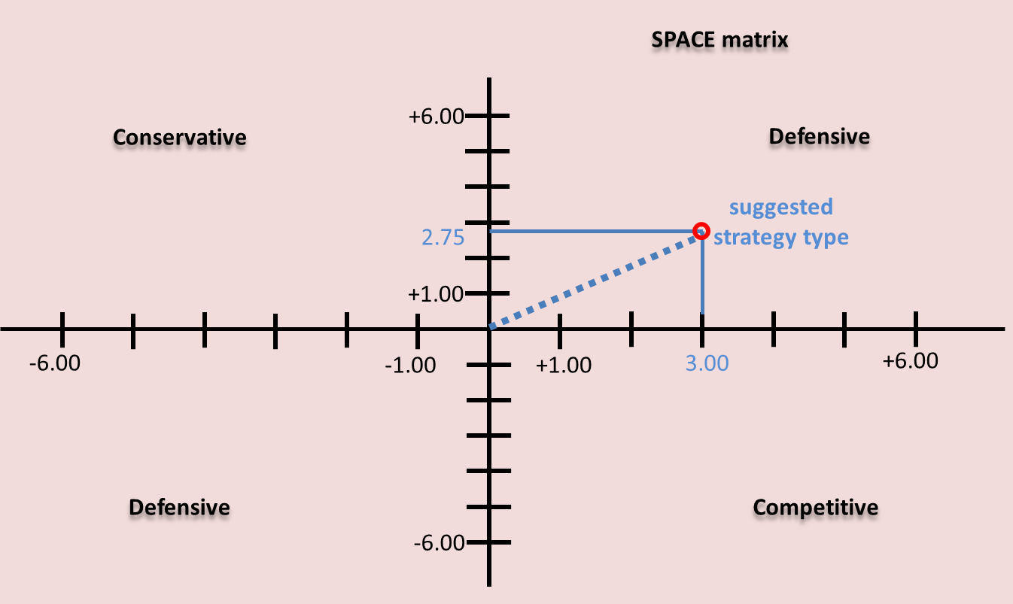

This SPACE matrix indicates that INEOS should pursue an aggressive strategy. INEOS has a competitive position in the market with business growth. INEOS should take the right direction to use internal strengths to develop market penetration and market development strategy. The way of achieving this is to have a better plan for product development, merger with other companies in the industry, and acquisition of competitors.

PORTER’S FIVE FORCES MODEL FOR INEOS

Porter's Five Forces model comprises of the following competitive forces:
- Barriers to entry
- Threat of substitutes
- Bargaining power of buyers
- Bargaining power of suppliers
- Rivalry among the existing players
(Porter, 2008)
Some consider government as the sixth force in this model as governmental intervention is obvious in some countries.
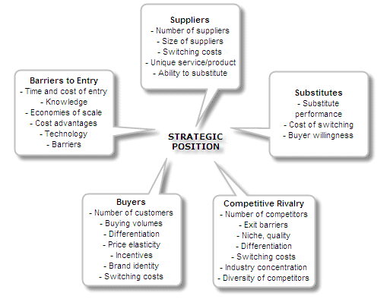

PORTER’S 5 FORCES FOR INEOS

Force 1: Barriers to entry
Barriers to entry measure how easy or difficult it is for new entrants to enter into the industry to compete with INEOS. This involves the following factors:
Cost advantages (economies of scale, economies of scope);
Access to production inputs and financing;
Government policies and taxation;
Production cycle and learning curve;
Capital requirements;
Access to distribution channels;
Patents, branding, and image also fall into this category.

From the above, we can tell that INEOS has a strong stand because the barriers to entry are so high that it will involve significant amount of capital and resources and that the existing industry leaders are enjoying economies of scale and economies of scope.

Force 2: Threat of substitutes
Taking ethyl acetate as an example, it is reported that the global ethyl acetate market will grow at a CAGR of 5.75% on average per year during 2018 - 2022 (Marketjournal24.com, 2018). According to the report, one of the prime movers for this market is the speedy expansion in the flavors and fragrances industry. Ethyl acetate is used in air fresheners, perfumes, soaps, and cosmetics as it provides a pleasant fragrance.

PORTER’S 5 FORCES FOR INEOS

Hence, in regards of product substitutability, the end users have an option whether to put on perfumes and products of fragrance, and there are many options in the market. The key vendors such as Celanese Corporation, Eastman Chemical, Jubilant Life Sciences, Lonza and SEKAB are major competitors providing many choices in the market. These vendors are providing substitutes for the consumers.

Also, the report states that there are harmful effects of ethyl acetate which gets released into the environment as emissions (Businesswire.com, 2018). It is highly inflammable and can severely harm the workers. That means this kind of products may eventually beget tougher government regulations especially in Europe. We recommend the Group to enter into Thailand and Vietnam for lower manufacturing costs and less stringent environmental requirements, which we will cover later in the section “Strategic Options that INEOS Should Take”.

Force 3: Bargaining power of buyers
Every enterprise should consider one question, i.e., how strong the position of buyers is. Although INEOS is a conglomerate that has many different businesses and products, virtually none of them is monopoly in the market. This means that buyers and suppliers have options to choose from, and there is always a pricing pressure. The loyalty of buyers and suppliers is questionable.

PORTER’S 5 FORCES FOR INEOS

Force 4: Bargaining power of suppliers
The cost of switching a supplier is high in the petrochemicals industry, therefore, the bargaining power of INEOS’ suppliers is high. INEOS should cultivate the relationship with its suppliers. Although the suppliers are limited, INEOS should avoid making purchases from one supplier in its requisition of elements so as to prevent over-reliance on one single vendor.

Force 5: Rivalry among the existing players
The rivalry among the existing suppliers is fiery. Mergers and acquisitions are increasingly popular than ever. Taking the merger of Bayer and Monsanto Company in 2016 as an example, we can look at the financial numbers and the significance of the two giant companies as well as robust product portfolios merge together:

Bayer and Monsanto Company

Bayer and Monsanto Company
 | 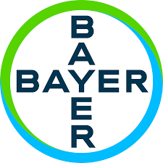 | 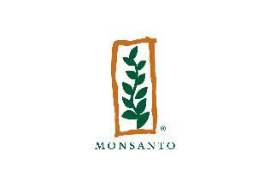
Bayer’s number of employees 2017 | 99,820 employees | 20,500 employees
Bayer’s total assets 2017 | Euro 129.5 billion | Euro 17.53 billion
Bayer’s total revenue 2017 | Euro 35 billion | Euro 3.09 billion

PORTER’S 5 FORCES FOR INEOS

Bayer, a German pharmaceutical and chemical company, won the approval from the US Justice Department to buy agricultural giant Monsanto. Bayer and Monsanto first announced the $60 billion deal in September 2016, saying the move would boost agriculture research and innovation.

Dana Varinsky, who holds an M.A. in journalism and political science from NYU and is the science and innovation editor at Business Insider, reported the view of Robb Fraley that by year 2050, and the demand for food will double as the world population will reach 10 billion. Robb Fraley is Monsanto's outgoing Chief Technology Officer. He opined that the merger of Monsanto and Bayer would allow the companies to invest in and create more innovation, and it would have to take a huge amount of innovation in order to double the world's food supply (Varinsky, 2018).

According to Bayer’s official website, the company emphasizes very much on innovation in agriculture. They believe agriculture is part of the solution under the worldwide challenges such as a changing climate, limited natural resources, and an ever-growing population (Bayer.com, 2018).

Therefore, from the above views of the 2 companies, they hold the same vision of the world agriculture. Such a merger is perceived to create more innovations and opportunities for both companies. For INEOS, the Group may consider to undertake more mergers to maintain its industry position or to enlarge the market share.

STRATEGIC OPTIONS THAT INEOS SHOULD TAKE

Here we provide some strategic options that INEOS can consider:

STRATEGIC OPTIONS FOR INEOS TO CONSIDER
1 | Financial Strategy and Publicity Strategy - Go listed on the stock exchange for part of INEOS’ businesses
2 | Think-out-of-the-box Strategy – Take M & A strategies in Thailand and Vietnam
3 | Preventive Strategy – Work out a plan to minimize the risks as a result of Brexit
4 | Blue Ocean Strategy should be adopted
5 | Recruitment Strategy - Improve INEOS’ Image as an employer and get more talented people
6 | Develop “INEOS” PROGRAM for INEOS
7 | Strategic Succession Plan is critical

STRATEGIC OPTIONS THAT INEOS SHOULD TAKE

Financial Strategy & Publicity Strategy – Go Public for Part of the INEOS’
businesses

There are some dominant advantages for a company to go listed (Hunsaker, 2017). These positive traits must be balanced off against the disadvantages, which we will point out in the latter part of this section for the group management to take reference to.

It is definitely a question raised by the public as to why INEOS has not gone public. While group management have not made a decision so far, we as the consultant would like to point out the distinct advantages and disadvantages of initial public offering (“IPO”) for INEOS to consider.

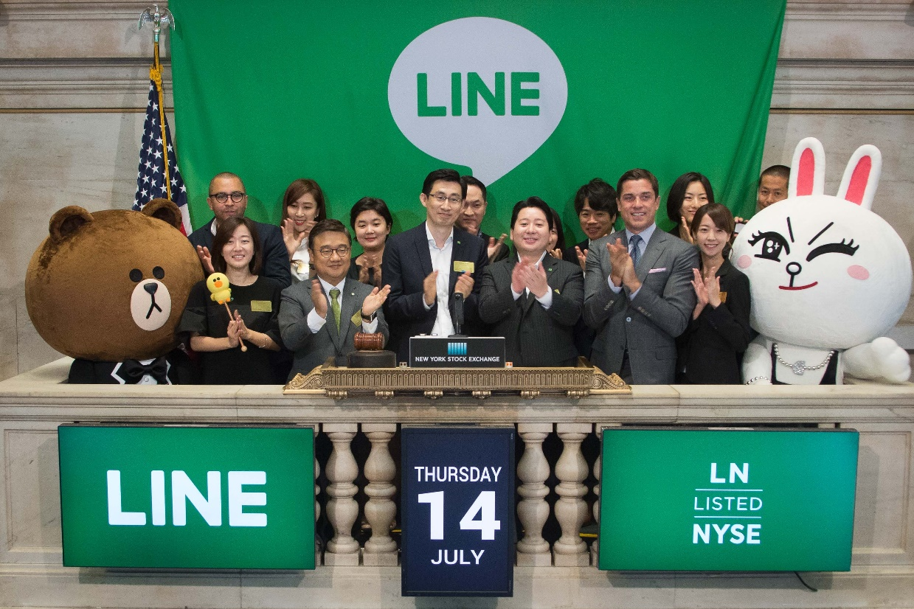

STRATEGIC OPTIONS THAT INEOS SHOULD TAKE

Fundraising
The proceeds from an IPO undoubtedly provide justification for INEOS to go public even without looking at the other benefits, especially considering the future investment opportunities available because of the new capital. INEOS may use an initial public offering to finance research and development which is particularly important for the Group’s chemical products, hire new employees, repay bank loans, support capital expenditures, acquire new technology companies, or to bankroll any number of other possibilities which INEOS could not afford or did not want to be involved in the past. An IPO as a result could bring new capital, imaginative R & D, and new products to INEOS. This can strengthen the leadership status in the industry and outdistance the competitors. The capital provided by a successful IPO is meaningful and usually ample, and can transform the growth trajectory of INEOS (Morgan, 2013).

Opportunity for Rewarding Founders and Top Management
INEOS’ stakeholders have contributed significant amounts of time and resources with the hopes of raising this high growth company. These founders together with the investors might not be very satisfied of the financial return when they align such returns to their contributions. If INEOS is going to have an IPO, it would create significance for the stakeholders because they can likely receive a big sum of money, or liquefy the capital they have tied up in INEOS. We trust that it is very attractive to founders and group management who often feel that it is time to get financial rewards or compensation after years of contributing “sweat equity.”

STRATEGIC OPTIONS THAT INEOS SHOULD TAKE

Publicity and Credibility
INEOS has been a low-profile enterprise, especially to the people who are not familiar to the U.K. market. IPO is the most efficient way of promoting to the people and companies around the globe know about INEOS. Under its growing stage, INEOS needs to enhance exposure to potential companies and customers about its products, thereby driving the product demand and mutual trust. An IPO is certainly the best way to thrust INEOS into the public spotlight. Worldwide analysts around the world are aware of every IPO and help their clients decide whether to invest or not. In fact, based on the huge size of INEOS, it is relatively easy to gather news agencies to bring people attention if there is an IPO.

Achieving credibility is another rationale for IPO. The stringent checking and audit of books and records which a group must go through before an IPO impels people to trust public companies more than private ones. IPO usually leads to increased credibility for a company and its products (Hunsaker, 2017).

Moody’s Credit Rating
The latest rating by Moody’s on INEOS was rated “Ba2” in Sep 2017. If INEOS goes public, its financial status will be healthier due to new capital coming in. The credit rating will bring the Group some advantages such as negotiations on loan interest rate with the banks and financial institutions and investor’s confidence on the Group as a whole.

STRATEGIC OPTIONS THAT INEOS SHOULD TAKE

Reduced overall cost of capital
INEOS’ management should consider the fact that the cost of capital for private companies usually requires higher interest rates to receive loans from banks. An IPO can reduce very much the difficulty of receiving additional capital. The increased assurance towards a public company will likely result in lower interest rates on loans, as the company is perceived as being a less risky enterprise. Besides, INEOS can raise additional capital through subsequent offerings in the stock market, which is usually more straightforward than raising capital through a private funding round.

Acquire other businesses/ recruit good talents by using stock as payment
If INEOS has become a public company, it can use of publicly-traded stock as a means of payment. Public stock is actually a form of currency that can be traded at a market price at any time, which can be advantageous and constructive when recruiting experienced and talented employees or acquiring other businesses. Offering employees with stock or stock options allows INEOS to be proactive and competitive when hiring top-tier talents. Moreover, acquisitions are crucial for INEOS to continue to grow, and any acquisition will require a big sum of money. So, it is wiser to use stock to deal with acquisitions.

STRATEGIC OPTIONS THAT INEOS SHOULD TAKE

Disadvantages of IPO
Additional regulatory requirements and disclosures
All listing authorities such as The Securities and Exchange Commission (SEC), the United Kingdom Financial Services Authority (FSA), and the United Kingdom Financial Reporting Council (FRC) all have burdensome and costly requirements. Reporting a company’s financial position publicly requires more stringent financial and opertational controls, an outstanding financial reporting team, an audit committee, and an internal audit team, etc. Although these responsibilities would cost millions of pounds every year, we think that it is worthwhile for INEOS to go public.

Market pressures
Apparently, INEOS’ founders have a long-term view with a vision of how INEOS will develop years from now. Conversely in the stock market, people have a very short-term, profit-driven view. People are very much interested in stock price targets which are rated by investment banks (usually 52-week target), while some professionals are short-term traders who emphasize on quarterly results and even monthly sales data. Hence, failing to fulfill the public’s short-term expectations may cause the company to lose value.

STRATEGIC OPTIONS THAT INEOS SHOULD TAKE

Potential loss of control
One major disadvantage of an IPO is founders may lose control of their company. Going public means receiving a lot of investments from public shareholders. Therefore, it is natural that shareholders expect the company to act in their best interest, even if it means going in a direction the founders dislike. If shareholders feel the company is not operating in a way that will reward them, they will desire to appoint new leadership.

Transaction costs
Initial public offerings are expensive. Beyond the recurring expenses of public company regulatory compliance, the IPO transaction process comes at a significant cost. The largest cost of a public offering is underwriters’ fees – a charge between 5% and 7% of the gross proceeds. Besides, other transaction costs will be incurred such as hiring a financial reporting advisor, lawyers, and other specialty groups & consultants.

STRATEGIC OPTIONS THAT INEOS SHOULD TAKE

Think-out-of-the-Box Strategy – Should take Mergers & Acquisitions Strategies in Thailand and/or Vietnam
As a matter of fact, INEOS has to bear high labour cost in Europe and USA and fulfill stringent regulatory & environmental standards. We recommend INEOS to consider proceeding M & A with local petrochemicals companies in Thailand and/or Vietnam. There are several reasons to do businesses in these two dynamic countries:
- Steadily-high GDP growth. Many large corporations started their investments in Thailand and Vietnam.
GDP GROWTH RATES of THAILAND AND VIETNAM
 | Thailand   | Vietnam  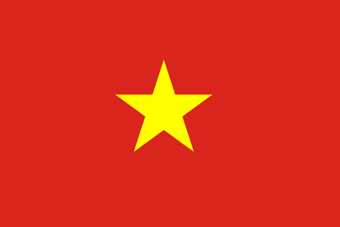
2017 | 3.9% | 6.8%
2016 | 3.3% | 6.2%
2015 | 3.0% | 6.7%
2014 | 1.0% | 6.0%
2013 | 2.7% | 5.4%
- Labour costs is a major reason why we pick these two attractive countries. According to tradingeconomics.com, Vietnam’s average hourly wages (manufacturing) per hour in 2018 is only USD 0.25, while in Thailand it is USD 1.60 per hour. These rates represent just 1.1% and 7.3% compared to that of the U.S. (USD 21.82) respectively (Tradingeconomics.com, 2018). In the UK, the manufacturing hourly wage is USD 21.30.
STRATEGIC OPTIONS THAT INEOS SHOULD TAKE

Obviously, it is beneficial to INEOS by expanding to Thailand and Vietnam which can lower manufacturing labour costs, increase the product competitivity of INEOS, and increase profits.

- Market development – Based on the good reputation and large size of the Group, INEOS can attract new customers and new suppliers in these new, developing Asian regions. In addition, the world trade is changing from the West to the East.
- These two countries are filled with skilled labour and friendly people. This helps to ensure productivity is what has been planned.
- Both Thailand and Vietnam will benefit from China’s One Belt One Road Plan, which is related to infrastructure investment, education, construction materials, railway and highway, automobile, real estate, power grid, and iron and steel.
- Both countries have large domestic markets, and the governmental policies are business-friendly.
- Some places such as Bangkok and Ho Chi Minh City have a developed infrastructure and the transportation facilities are strong. The industries are provided with top-of-the-world facilities.
- The Governments offer lucrative incentives to the foreign businesses, e.g., the Board of Investment in Thailand offers tax benefits and exemption on import duties.
- Productivity can further be ensured when we consider the weather in Thailand and Vietnam. These two countries have no winter. In Europe and certain parts of the U.S., cold weather causes suspension of plant operations which lowers productivity.

STRATEGIC OPTIONS THAT INEOS SHOULD TAKE

Taking ethyl acetate as an example, industry experts reported that the demand for ethyl acetate in APAC countries is growing. Factors such as easy accessibility of petrochemical feedstock and cost-effective labor contribute to the growth of the market in APAC. Hence, INEOS should consider using M & A strategies to Thailand & Vietnam because this will allow INEOS to capture the opportunities. Here are some petrochemicals companies in Thailand and Vietnam for INEOS to consider:

Petrochemicals Companies in Thailand and Vietnam that
INEOS Can Consider to Merge with
Thailand | Vietnam
Continental Petrochemicals  (Thailand) Co. Ltd. | Nghi Son Refinery and Petrochemicals LLC
PTT Global Chemical Public Co. Ltd. | Binh Son Refining and Petrochemicals Joint Stock Company
SCG Chemicals Co., Ltd. | Eobod
Union Thai Polyplast Co., Ltd. | AP Petrochemical (Vietnam) Co., Ltd.
Keiteq Co., Ltd. | Qatar Petrochemical Company (Qapco)

STRATEGIC OPTIONS THAT INEOS SHOULD TAKE

Preventive Strategy - Work out a plan to minimize the risks as a result of Brexit
In this complex and ever-changing world, significant and far-reaching events sometimes take place sooner than expected. Brexit is an example of how British national citizens voted to change the British and European system according to their wish. INEOS should be alert to how Brexit will influence the organization and businesses, and work out a plan to avoid the risks as much as it can.


Risks brought by Brexit
The trade between European Union and Britain is enormous. Around 60% of Britain’s external trade is with a country (countries) in the EU (TheCityUK, 2014). As a UK giant, INEOS has significant trades between the UK and the EU countries. INEOS

STRATEGIC OPTIONS THAT INEOS SHOULD TAKE

should instantly review the Group’s & subsidiaries’ existing contracts with these EU countries and estimate the additional burden or tax effects that the Group will likely suffer from Brexit. It is because these consequences of Brexit will affect INEOS:
- UK’s trade relations with any EU countries could be affected negatively, because the current trade agreements would no longer be effective until clauses are rewritten (Busch and Matthes, 2018).
- Brexit would mean higher EU trade barriers.
- Trade transaction costs will increase which means INEOS’ net profit will decrease.
- Customs clearance requirements for INEOS’ products will be delayed for UK’s companies exporting to the EU. The demand from EU will decrease because no one wants delays, and these EU countries may seek products from other countries.
- After Brexit, British firms would have to pay the EU import tariffs if they wanted to export to the EU (Busch and Matthes, 2018).
- For some products, EU tariff rates are greatly increased. It is ten percent for passenger vehicles and 15 percent for food items (Springford, Tilford and Whyte, 2014).

Therefore, it is imminent for INEOS to review its agreements with EU countries and calculate new taxes because the agreements should be strategically planned ahead before they are being entered into. INEOS should review their price competitiveness in the market.

STRATEGIC OPTIONS THAT INEOS SHOULD TAKE

Adopt the Blue Ocean Strategy
As mentioned in the Financial Analysis section, during 2015 – 2017, INEOS’s cash position was getting worse. The cash position has dropped below the total current liabilities. From the liquidity perspective, the cash ratio, quick ratio and current ratio are all said to be deteriorating as well. From the angle of profitability, the gross profit ratio has been flat over the last three years, which indicates that the Group has not been enlarging the operational profitability of businesses (revenues).

Hence, we recommend the Group to use Blue Ocean Strategy. To start, INEOS can identify the needs of INEOS’ target markets and what are they lack of. Then, create uncontested market space and make the competition irrelevant by looking at what existing organizations are doing well or doing unwell so as to differentiate INEOS with others.
Blue Ocean strategies will give the Group idea to push the boundaries of the industries and offer customers unique values, thereby creating and capturing new demand in the market.

We suggest that, following the overwhelming success of its Land Rovers, INEOS’ Automobiles can consider putting R & D resources in innovating a luxurious brand of sports cars. Sports cars bring a larger profit margin and the demand in the world will be larger than ever. The supportive reason is that the number of millionaires continue to grow. The following shows the world distribution of ultra-wealthy millionaires (with wealth over USD50 million).
STRATEGIC OPTIONS THAT INEOS SHOULD TAKE

World distribution of ultra-wealthy millionaires (with wealth over USD 50M)
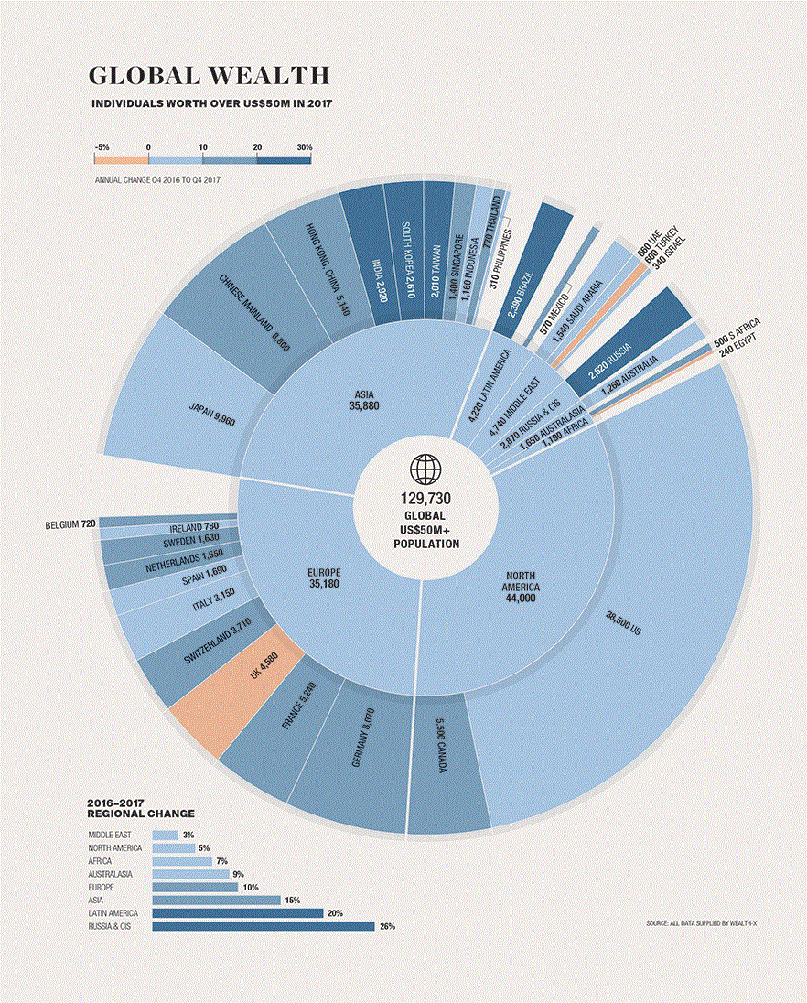
(Desjardins, 2018)

STRATEGIC OPTIONS THAT INEOS SHOULD TAKE

The Wealth Report chart shows that the number of ultra-wealthy people, i.e., those with net assets of $50 million or more. INEOS can take reference to the chart and understand which markets have the largest number of super-rich people.

The chart is in line with the statistics of The Wealth Report Attitudes Survey, in which 72% of respondents said their clients’ wealth had increased during the year. This took the global population to 129,730 (as in the chart in the previous page) with a total worth of US$26.4 trillion. That 10% rise in the ultra-wealthy population marks a notably more rapid rate of growth than in the previous five years, where there was a cumulative 18% increase (Gilmore, 2018)

Hence, INEOS can opt to capture the luxurious sports car market and the demand will very likely grow as the number of millionaires keeps increasing over the years. INEOS should always keep this in mind:

INNOVATION (KEEP INNOVATING, NEVER STOP.)

QUALITY (COMPETE ON QUALITY, NOT ON PRICES.)

EFFICIENCY
STRATEGIC OPTIONS THAT INEOS SHOULD TAKE

Recruitment Strategy - Improve INEOS’ Image as an Employer and Get more Talented People

According to TARGETjobs.com, a survey was conducted to understand the university students’ attitudes towards employers and 73,517 students responded. INEOS was only ranked 269th out of the 300 preferred employers (TARGETjobs, 2018). This might indicate that INEOS either has not established a very good publicity in universities or in the minds of graduates, INEOS is not a place good enough to work at.

INEOS should take this issue seriously because one of the requirements of long-term growth of a company is to have good people to work with. Some good people start with the post of Management Trainees who are fresh graduates from college and universities. In addition, the general public also might have the same view that INEOS is not a company good enough to work with.

The Group should do the following:
1 | Do more marketing to improve the Group’s overall image
2 | Introduce to the public the Group’s businesses
3 | Take heart in recruiting good talents and do more roadshows in universities.

STRATEGIC OPTIONS THAT INEOS SHOULD TAKE

Develop “INEOS PROGRAM”for INEOS to Retain Talents

Currently, INEOS has operations in 24 countries. It happens quite often that in the real world, the employee all of a sudden has a wish to work in other countries, or it could be their spouse who has to be relocated to another country so the employee wants to follow him or her.

Based on the geographical spread of businesses, we suggest INEOS to create a program called International Network Employment Opportunities Services (also same abbreviation of INEOS), which will allow employees to be relocated freely based on their desire. The Human Resources can send out the list of worldwide opportunities weekly so that employees are informed of the opportunities as early as possible and they will have sufficient time to discuss with their spouses and family.

There are some advantages if this INEOS program is created. The management will be able to retain the talented employee because he/ she will still be in INEOS Group. It will also make known to the employees as to the latest developments in other locations.

STRATEGIC OPTIONS THAT INEOS SHOULD TAKE

Strategic Succession Plan is Critical

To recapitulate, the percentages of Total INEOS Limited Share Capital (“LSC”) are as follows:
No. of ordinary shares % of LSC
James Ratcliffe ................................................................. 2,295,391,680 61.804%
Andrew Currie ..................................................................... 711,501,880 19.157%
John Reece ........................................................................... 707,106,440 19.039%
TOTAL .............................................................................. 3,714,000,000 100.000%

Different to most of the other large corporations or listed companies, INEOS’ ownership structure is narrow and as a private group the Management should seriously consider ahead the succession plan. The significance is to minimize the impact of turbulence should any important accident/ event happen.

Management’s Succession planning becomes easier when the Group focuses on the bigger arena of continuity. Leadership succession is only one element of good continuity thinking. Leaders should always ask themselves these questions: "What things could stop or affect the flow of our business, and how well are we prepared?" and “If I am not here, who is doing my job?”

REFERENCES

Busch, B. and Matthes, J. (2018). Brexit: The Economic Impact – A Survey. [online] Hdl.handle.net. Available at: http://hdl.handle.net/10419/166656 [Accessed 1 Dec. 2018].

Businesswire.com. (2018). Global Ethyl Acetate Market 2018-2022 - Key Vendors Are Celanese, Eastman Chemical Co, INEOS, Jubilant Life Sciences, Lonza & SEKAB - ResearchAndMarkets.com. [online] Available at: https://www.businesswire.com/news/home/20181002005871/en/Global-Ethyl-Acetate-Market-2018-2022---Key [Accessed 8 Dec. 2018].

Desjardins, J. (2018). The World's Ultra-Wealthy Population, in One Chart. [online] Visual Capitalist. Available at: https://www.visualcapitalist.com/worlds-ultra-wealthy-population-chart/ [Accessed 13 Dec. 2018].

Gilmore, G. (2018). The super-rich and where they are based. [online] Knightfrank.com. Available at: https://www.knightfrank.com/wealthreport/2018/global-wealth/new-order [Accessed 15 Dec. 2018].

GlobeNewswire News Room. (2018). INEOS Europe AG and Rex Energy Announce a New Agreement for the Purchase of Natural Gas Liquids from the Appalachian Basin for Offtake to Europe. [online] Available at: https://globenewswire.com/news-release/2016/04/11/827536/0/en/INEOS-Europe-AG-and-Rex-Energy-Announce-a-New-Agreement-for-the-Purchase-of-Natural-Gas-Liquids-from-the-Appalachian-Basin-for-Offtake-to-Europe.html [Accessed 7 Dec. 2018].

Hunsaker, M. (2017). IPO Advantages and Disadvantages | IPOhub. [online] IPOhub. Available at: https://www.ipohub.org/ipo-advantages-disadvantages/ [Accessed 24 Nov. 2018].

INEOS GROUP. (2018). INEOS' MARKETS AND APPLICATIONS. [online] Available at: https://www.ineos.com/markets/ [Accessed 6 Dec. 2018].

Mangan, D. (2018). John Bolton 'knew in advance' about arrest of Huawei executive; official says Trump did not. [online] CNBC. Available at: https://www.cnbc.com/2018/12/06/national-security-advisor-bolton-knew-before-huawei-executive-arrest.html [Accessed 7 Dec. 2018].

Marketjournal24.com. (2018). Ethyl Acetate Market Size in 2022 And What Will be the Growth Rate – Market Journal. [online] Available at: https://marketjournal24.com/ethyl-acetate-market-size-in-2022-and-what-will-be-the-growth-rate/ [Accessed 7 Dec. 2018].

Moody’s Rating Action (2017). Moody's upgrades Ineos Group Holdings to Ba2, stable outlook. [online] Available at: https://www.moodys.com/research/Moodys-upgrades-Ineos-Group-Holdings-to-Ba2-stable-outlook--PR_373786?WT.mc_id=AM%7eRmluYW56ZW4ubmV0X1JTQl9SYXRpbmdzX05ld3NfTm9fVHJhbnNsYXRpb25z%7e20171019_PR_373786 [Accessed 26 Nov. 2018].

Morgan, T. (2013). Advantages and disadvantages of an IPO. [online] AZ Big Media. Available at: https://azbigmedia.com/advantages-disadvantages-ipo/ [Accessed 3 Dec. 2018].

Porter, Michael E. "The Five Competitive Forces That Shape Strategy." Special Issue on HBS Centennial. Harvard Business Review 86, no. 1 (January 2008): 78–93.
Radder, L. and Louw, L. (1998). The SPACE matrix: A tool for calibrating competition. Long Range Planning, 31(4), pp.549-559.

Springford, J., Tilford, S. and Whyte, P. (2014). Brexit: The Economic Impact - A Survey. [online] Cer.org.uk. Available at: http://www.cer.org.uk/sites/default/files/smc_final_report_june2014.pdf [Accessed 9 Dec. 2018].

TheCityUK (2014). Analysing the Case for EU Membership: How Does the Economic Evidence Stack Up?. Available at http://www.thecityuk.com/ [Accessed 1 Dec. 2018].

Tradingeconomics.com. (2018). Vietnam Wages In Industry and Construction | 2018 | Data | Chart | Calendar. [online] Available at: https://tradingeconomics.com/vietnam/wages-in-manufacturing, https://tradingeconomics.com/thailand/labour-costs, and https://tradingeconomics.com/united-states/wages-in-manufacturing [Accessed 15 Dec. 2018].

Varinsky, D. (2018). The $66 billion Bayer-Monsanto merger just got a major green light — but farmers are terrified. [online] Business Insider. Available at: https://www.businessinsider.com/bayer-monsanto-merger-has-farmers-worried-2018-4 [Accessed 26 Nov. 2018].

TARGETjobs. (2018). UK300. [online] Available at: https://targetjobs.co.uk/uk300 [Accessed 2 Dec. 2018].

Wilson, F., Blakely, E. and Snyder, M. (1999). Fortress America: Gated Communities in the United States. Contemporary Sociology, 28(1), p.83.

