INTERNATIONAL BUSINESS COMMUNICATIONS

Student name: Gheorghe Bogatii
Student ID: 2020309

Executive summary
In this study, international business communication practices of the UK have been delivered. The organisations of the UK need to follow an inclusive business communication practice. In the study, the communication practice of the British has been evaluated in the shed of Diageo which is a UK-based organization. The study has used Hofstede's cultural model, and Samovar, Jandt’s theories. A critical evaluation of cultural sensitivity experienced by Diageo in the UK has been delivered along with communication barriers and a set of communication strategies and other recommendations of an inclusive workplace culture.

Table of Contents
1. Introduction 4
1.1 Overview of Diageo 4
2. Discussion 5
2.1 Application of international and intercultural communication theories in the UK 5
2.2 Critical evaluation of cultural sensitivity in the context of doing business in the United Kingdom 8
2.3 Discussion and analysis of different cultural barriers experienced by the diverse workforce in the UK 11
2.4 Appropriate communication strategies and recommendations 12
2.4.1 Communication strategies 12
2.4.2 Other recommendations 13
Conclusion 13
Reference list 15

1. Introduction
An inclusive approach to communication in a workplace takes approaches in ensures that every member or employee, client, or consumer feels equally respected and valued. Effective communication is the basis of the success of most businesses. Basically, the business communication style of the British is indirect communication (World business culture, 2023). The people strongly avoid the creation of conflicts in the workplace and all the required measures are taken by them in order to remain polite. In this study, the inclusive business culture of the UK in the context of the business operations of Diageo has been evaluated.

1.1 Overview of Diageo
For Diageo, Great Britain will always be the home of the company. The inclusive business culture of Diageo supports the business communication style of the UK. The well-being of employees and consumers lies at the heart of the culture of Diageo. At Diageo, the inclusive business culture of the company focuses on celebrating life (Diageo, 2023). The workplace culture of Diageo is rooted in a deep sense of its purpose. The inclusive workplace culture of Diageo motivates its workforce to work together to deliver great performance in an environment that can allow the workforce to flourish.
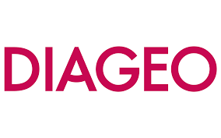
Figure 1: Logo of Diageo
(Diageo, 2023)

2. Discussion

2.1 Application of international and intercultural communication theories in the UK
According to the study by Carter and Lamoreaux, (2022), international communication denotes any symbolic interaction between individuals from different countries. On the other hand, intercultural communication is communication between individuals of different cultures in which culture is considered the determining factor in the context of communication (Aririguzoh, 2022). In order to understand the cultural dimensions of the UK which can impact the international business communication of Diageo, Hofstede’s cultural dimension has been used. The UK has a 35 score in PDI which denotes the fact that the society of the UK focuses on minimising inequalities among people. This style of intercultural communication influences Diageo to maintain equality among the employees and consumers. A score of 89 is the highest individualist score which delivers the fact that the people of the UK are highly private. In the UK, the route through which people get happiness is self-fulfilment.
In this context, Diageo provides chances for its employees to celebrate life at Diageo, and in this way, they foster the route to happiness. The UK is a highly masculine society and is driven by the concept of success. Diageo provides proper training to its workforce in order to make them able to drive the success of the firm. Having a low score of 35 on the uncertainty avoidance index denotes that the UK society shows greater ease in unpredictable situations (Hofstede Insights, 2018). In this context, Diageo is able to adopt change according to changing scenarios. It also indicates that the UK society is more inclusive and open and is inclined to participate in risk-taking behaviours. The United Kingdom scores neutral on long-term orientation which denotes that the society has a link to its past the same time dealing with present challenges. A high score in indulgence denotes that the people of the UK have a positive attitude toward having fun and enjoying life. This is followed by Diageo and the company provides chances to its workforce to have fun in a flexible working environment which also offers them to celebrate their lives (Diageo, 2023).
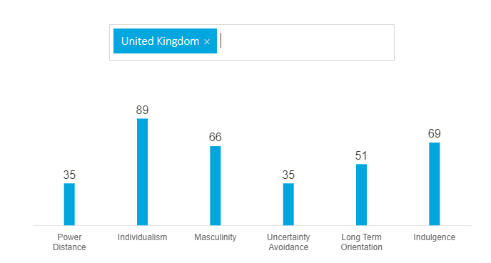
Figure 2: Cultural evaluation of the UK through Hofstede’s Cultural Dimension
(Source: Hofstede Insights, 2018)
Jandt’s theory of intercultural communication delivers the factors related to intercultural communicators (Jandt, 2020). This theory denotes that organisations must provide increased attention to contemporary social issues such as social class identity, gender identification, refugees, and gender identification. In this perspective, Diageo views diversity in the broadest possible sense including ethnicity, gender, and age. The company champions diversity and inclusion across the business of the company, with the partners and communities of the company. Diageo believes that everyone must be able to thrive in an environment that values their contribution and celebrates what makes the people unique (Diageo, 2022). Diageo embraces diversity in every sense including ethnicity, gender, ability, sexual orientation, experience, background, and many others. The company has developed its target “Society 2030: Spirit of Progress” action plan. The action plan sets ambitious and bold goals for diversity and inclusivity. Diageo values gender equality, and diversity and makes practices and policies which make inclusive culture. 38% of the Executive Committee and 60% of the board members of Diageo are females (Diageo, 2022). Diageo employs over 27000 individuals across 70 different nations of the globe. The aim of Diageo is to increase leadership representation from ethnically diverse backgrounds to almost 45% by 2030 (Diageo, 2022).
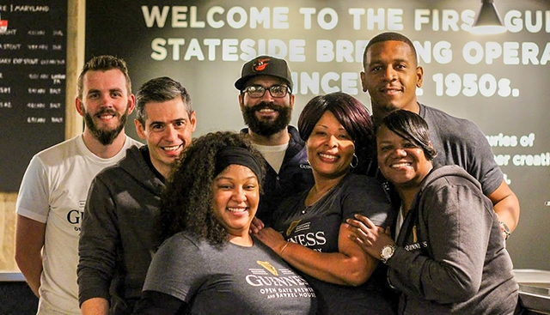
Figure 3: Inclusive workplace culture of Diageo
(Source: Diageo, 2022)
According to Samovar's theory of intercultural communication, it is imperative for Diageo to understand the different cultures and develop practical skills to improve intercultural communication with individuals from other cultures (Halverson-Wente and Halverson-Wente, 2018). In one of the parts of this theory, the importance of communication and cultures has been derived. The people of the UK value planning and punctuality. The ability of cultures in modifying and shaping the view of reality has been derived from the theory. In this context, punctuality and planning can have a great impact on the operations of Diageo in the context of doing business in the UK. According to this theory, the knowledge of intercultural communication must be put into practice by Diageo and converted the knowledge into an action plan to drive the practice of intercultural communication within the business (Halverson-Wente and Halverson-Wente, 2018).

2.2 Critical evaluation of cultural sensitivity in the context of doing business in the United Kingdom
According to the study by Shepherd et al., (2019), maintaining cultural sensitivity in the workplace helps in integrating more viewpoints and spreading awareness of different cultural identities and values. In other words, cultural sensitivity is a skill set that allows people to learn and understand individuals whose cultural backgrounds are different from their own. The fundamental principles of business cultures in the UK include politeness, punctuality, courtesy, and discipline. The society of the UK is multi-ethnic and multilingual with notable differences in culture between the capital of the country London, and other regions. The population of the UK sees itself as well-mannered, well-educated, and understanding individuals conscious about classes (Darling-Hammond et al., 2019). When meeting for the first time, the people of the UK shake hands firmly and always maintain eye contact. Punctuality is very vital in the context of business meetings in the UK (van Eerde and Azar, 2019). For example, Diageo provides its employees with the chance to maintain a work-life balance which represents that the company values the cultural sensitivity of the UK. On the other hand, in the business culture of the UK, valuing diversity and people from different backgrounds takes a great place. For example, Diageo gives importance to diversity and inclusion practices at the workplace of the company. According to Diageo, the employees of the company are given a chance to create a more sustainable and inclusive society and shape a future that is worth celebrating. For example, Diageo has been named the no.1 UK organisation that represents female leadership in 2020. Diageo celebrates the commitment of the company to diverse leadership and it is named in the review of Hampton Alexander review. Since 2016, for Diageo, the Hampton Alexander review has acted as a vital catalyst for change (Diageo, 2023).
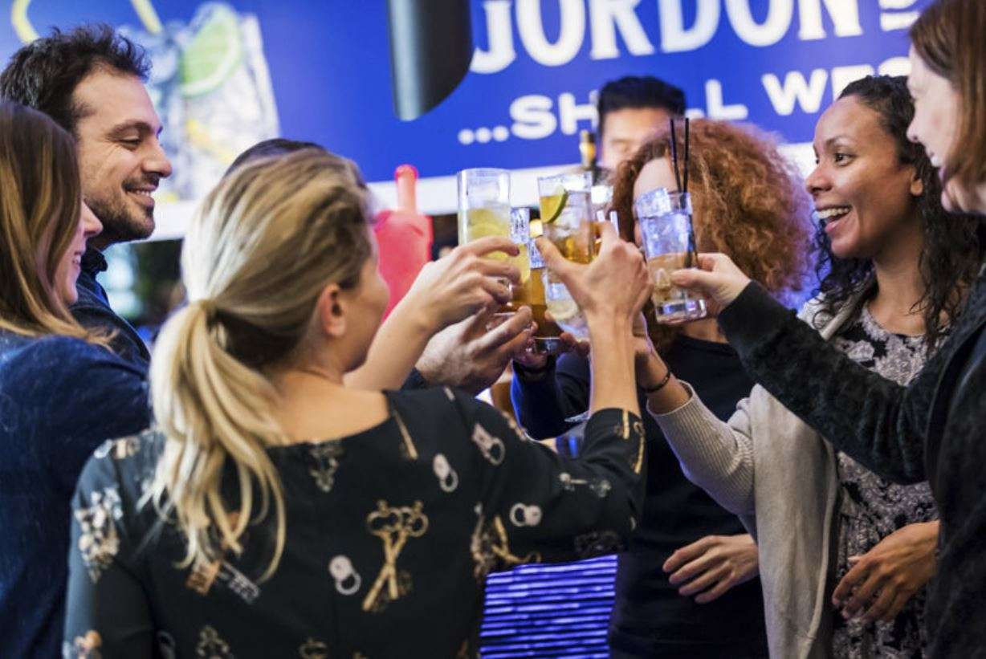
Figure 4: Celebrating women's leadership at Diageo
(Diageo, 2023)
On the contrary, the creation of a sense of belonging in the workplace is another vital dimension of cultural sensitivity in intercultural communication in the UK (Gradellini et al., 2021). For example, across the globe, Diageo has a number of inclusive Employee Resources and Business groups. The function of these groups is to generate thought-provoking work to facilitate the business and workplace of Diageo. The groups support both future leaders and present leaders to develop certain skills such as communication, team building, project management, and others. From women to all ethnic groups, the UK supports people belonging to all cultural backgrounds and this is an important business culture of the country. For example, Diageo employs employees from diverse backgrounds in the hope to empower them. Over the last 18 months, Diageo has launched its international flexible working philosophy which offers increased flexibility to the employees to employees belonging from all cultures (Diageo, 2022). On the other hand, the leaders of Diageo were named in the international 2022 Empower Ethnic Minority Role Model List.
According to the study by, supporting people from minority backgrounds is a vital cultural sensitivity of the UK. Diageo follows this intercultural business sensitivity of the UK. Following this aspect, Diageo develops a diverse workplace where everyone gets an equal chance to give their best and contribute to the success of the firm. The Empower Role Model Lists of Diageo deliver the fact that Diageo is breaking down the barriers for individuals of colour within the international business (Diageo, 2022c). The employee-led network of Diageo has been established for the ethnically diverse allies and employees of the UK. For example, Louise Prasad is the HR director of Diageo in the UK and represents an ethnic group. Beyond the business of Diageo, the company has also asked the marketing agencies of the company to share the business representations of the company toward ethnic groups through marketing campaigns.
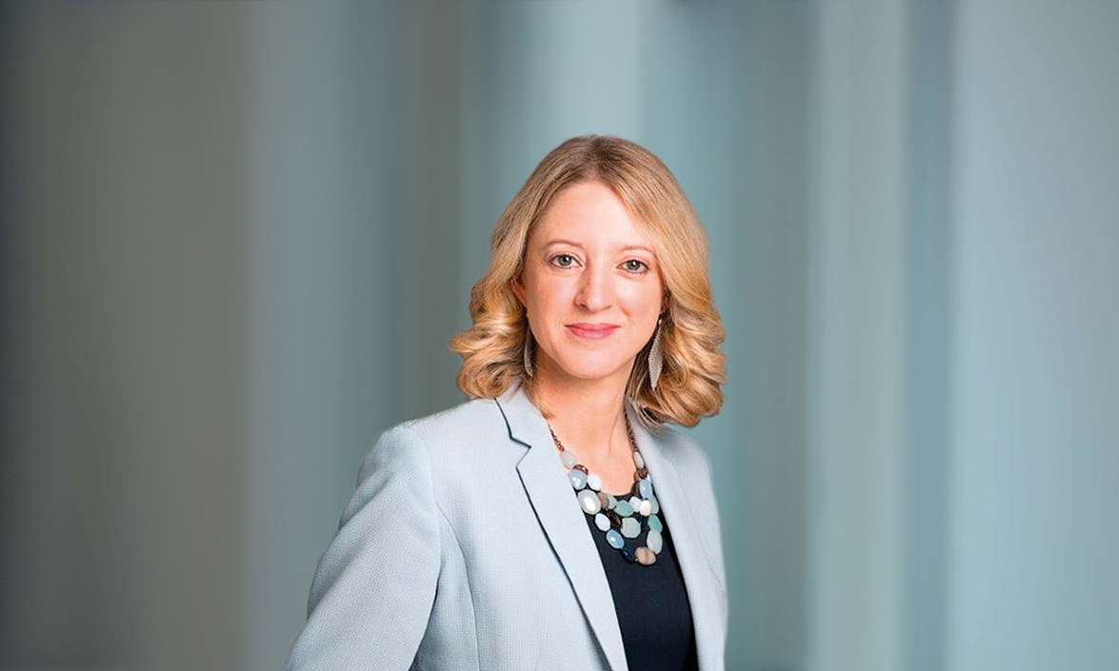
Figure 5: Louise Prashad, the HR manager of Diageo, a representative of the Empower Ethnic Minority Role Model Lists
(Source: Diageo, 2022)

2.3 Discussion and analysis of different cultural barriers experienced by the diverse workforce in the UK
Unconscious bias is one of the vital cultural barriers experienced by the diverse workforce in the United Kingdom (Kele and Cassell, 2022). Unconscious bias indicates any associations made between different factors such as culture, gender, and race without the practice of conscious awareness. This indicates that the UK society automatically has an affinity or preference for those who are similar to them. For example, unconscious bias in the form of the gender pay gap is still practiced in Diageo. In spite of providing positions to women in executives and leadership positions, it can be seen that Diageo fails to meet the gap between men and women in the context of gender pay. According to the data from the UK government, 74% of UK firms pay high wage rates to men compared to females (BBC, 2018). In the context of Diageo, it provides higher pay to women, and from the perspective of a masculine society of the UK, it is not justified.
On the contrary, the communication barrier is another challenge faced by UK businesses within the diverse workforce culture (Evans and Suklun, 2017). Organisations that hire a culturally diverse range of employees experience that there are problems with communication among the teams. For example, as Diageo employs employees from diverse cultures, it can experience the challenges of maintaining effective communication between the team members of the company. This can be a vital issue that can impact the workplace fertility of the company. On the contrary, ethnicity can remain a vital challenge for a culturally diverse workplace in the United Kingdom (Mckinsey and Company, 2023). The term ethnicity indicates a social group that identifies each other on the basis of shared attributes. On the other hand, the UK society also experiences challenges in the context of training within a diverse workforce (Smith and Ruiz, 2020). Sensitivity training is a form of education that focuses on making employees aware of different cultural prejudices and developing their sense of empathy toward other people in the organisation. During the time of COVID-19, providing this training became extremely difficult for the major organisations of the UK including Diageo. For example, it became extremely difficult for Diageo to provide this training session in an effective manner to the employees as the entire workforce changed due to changing rules and regulations of the government (BBC, 2020).

2.4 Appropriate communication strategies and recommendations

2.4.1 Communication strategies
Using inclusive language
Diageo can use inclusive language to meet the intercultural communication barrier among its diverse workforce. The use of inclusive language in the internal comms indicates the avoidance of phrases, words, or times reflecting prejudiced opinions of any particular group (Hallett, 2019). The use of a diversity-attuned dictionary is growing day by day and it is vital for Diageo to stay on top of the growing trends. Striving toward gender neutrality, for instance, can involve shifting away from any referring to the group of individuals as "guys". The term can be replaced by "team". In addition, having the workforce add their pronouns to their social profiles and email signatures is another easy way that Diageo can follow for avoiding the assumptions of gender.
Educating the employees
Older generations in the current workforce might not be entirely educated on some topics surrounding inclusion and diversity (Rudolph et al., 2020). These employees have not talked about the workplace throughout their entire careers. Henceforth, educating these employees is the key to driving success in Diageo.
Avoiding one-sided communication
Understanding a diverse workforce requires listening to them carefully. A great way to do so for Diageo is to open communications or forum platforms where employees can host the conversations.

2.4.2 Other recommendations
Checking the social media activities
It is recommended to Diageo make use of social media platforms to promote the diversified values and principles of the company. On the other hand, social media has the ability to encourage causal conversation between colleagues of Diageo and thereby can help the company in building healthy workplace relationships (Pekkala and van Zoonen, 2021). It can be the easiest and quickest way for Diageo to employees its diverse workforce to interact with colleagues even after work. In addition, posting about inclusive strategies, practices, and cultures on social media can also make the consumers of Diageo feel like the company values people from different backgrounds and this can increase the consumer base of the company.
Creation of cultural events and collection of regular feedback
Diageo is recommended to celebrate the diverse nature of its team. Diageo needs to listen to the diverse workforce of the firm and must try to gather regular feedback from the employees. Also, arranging a one-on-one session between employees and community members to ensure that the diverse workforce has a safe place to work and brings their views to the table (Bonaccio et al., 2019).

Conclusion
In conclusion, it can be stated that inclusive workplace culture plays a vital role in business communication in the United Kingdom. The study has focused on generating the inclusive Business communication practices of Diageo with the help of theories and models of international and intercultural communication. It can be seen that Diageo provides opportunities to employees irrespective of gender, race, ethnicity, and others. Still, the company faces some problems which can be mitigated if the company follows the inclusive workplace communication strategies and other recommendations delivered in the study.

Reference list
Aririguzoh, S. (2022). Communication competencies, culture and SDGs: effective processes to cross-cultural communication. Humanities and Social Sciences Communications, 9(1). doi:https://doi.org/10.1057/s41599-022-01109-4.
BBC (2018). Gender pay gap: Men still earn more than women at most firms. BBC News. [online] 21 Feb. Available at: https://www.bbc.com/news/business-43129339. [Accessed 29 Mar. 2023].
BBC (2020). Whisky sour and lockdown tumbleweed. BBC News. [online] 5 Aug. Available at: https://www.bbc.com/news/uk-scotland-scotland-business-53661187 [Accessed 29 Mar. 2023].
Bonaccio, S., Connelly, C.E., Gellatly, I.R., Jetha, A. and Martin Ginis, K.A. (2019). The Participation of People with Disabilities in the Workplace Across the Employment Cycle: Employer Concerns and Research Evidence. Journal of Business and Psychology, 35(35). doi:https://doi.org/10.1007/s10869-018-9602-5.
Carter, M.J. and Lamoreaux, L.V. (2022). Symbolic Interactionism and Global Public Health. Handbook of Social Sciences and Global Public Health, pp.1–18. doi:https://doi.org/10.1007/978-3-030-96778-9_39-1.
Darling-Hammond, L., Flook, L., Cook-Harvey, C., Barron, B. and Osher, D. (2019). Implications for educational practice of the science of learning and development. Applied Developmental Science, [online] 24(2), pp.1–44. Available at: https://www.tandfonline.com/doi/full/10.1080/10888691.2018.1537791.
Diageo (2022a). Champion inclusion and diversity. [online] www.diageo.com. Available at: https://www.diageo.com/en/esg/champion-inclusion-and-diversity. [Accessed 29 Mar. 2023].
Diageo (2022b). Diageo employee recognised in the flexible working Timewise Power List. [online] www.diageo.com. Available at: https://www.diageo.com/en/news-and-media/stories/2022/diageo-employee-recognised-in-the-flexible-working-timewise-power-list [Accessed 29 Mar. 2023].
Diageo (2022c). Diageo leaders named in global 2022 Empower Ethnic Minority Role Model Lists. [online] www.diageo.com. Available at: https://www.diageo.com/en/news-and-media/stories/2022/diageo-leaders-named-in-global-2022-empower-ethnic-minority-role-model-lists [Accessed 29 Mar. 2023].
Diageo (2023a). Diageo named No 1 UK company for female leadership representation in 2020 Hampton-Alexander Review. [online] Diageo. Available at: https://www.diageo.com/en/news-and-media/stories/2021/diageo-named-no-1-uk-company-for-female-leadership-representation-in-2020-hampton-alexander-review.
Diageo (2023b). Purpose, culture and values. [online] Diageo. Available at: https://www.diageo.com/en/careers/why-diageo/purpose-culture-and-values. [Accessed 29 Mar. 2023].
Evans, A. and Suklun, H. (2017). Workplace diversity and intercultural communication: A phenomenological study. Cogent Business & Management, [online] 4(1). doi:https://doi.org/10.1080/23311975.2017.1408943.
Gradellini, C., Gómez-Cantarino, S., Dominguez-Isabel, P., Molina-Gallego, B., Mecugni, D. and Ugarte-Gurrutxaga, M.I. (2021). Cultural Competence and Cultural Sensitivity Education in University Nursing Courses. A Scoping Review. Frontiers in Psychology, 12. doi:https://doi.org/10.3389/fpsyg.2021.682920.
Hallett, R. (2019). Inclusive language policy: why bother enforcing one at work? [online] Raconteur. Available at: https://www.raconteur.net/hr/diversity-inclusion/inclusive-language-policy/ [Accessed 29 Mar. 2023].
Halverson-Wente, L. and Halverson-Wente, M. w (2018). Chapter 1 – Introduction to Intercultural Communication. mlpp.pressbooks.pub. [online] Available at: https://mlpp.pressbooks.pub/interculturalcommunicationcompetence/chapter/terms/. [Accessed 29 Mar. 2023].
Hofstede Insights (2018). Country Comparison - Hofstede Insights. [online] Hofstede Insights. Available at: https://www.hofstede-insights.com/country-comparison/the-uk/. [Accessed 29 Mar. 2023].
Jandt, F.E. (2020). Intercultural Communication. [online] SAGE Publications Inc. Available at: https://us.sagepub.com/en-us/nam/intercultural-communication/book226037 [Accessed 23 Jan. 2020].
Kele, J.E. and Cassell, C.M. (2022). The Face of the Firm: The Impact of Employer Branding on Diversity. British Journal of Management. doi:https://doi.org/10.1111/1467-8551.12608.
Mckinsey and Company (2023). Problems amid progress: Improving lives and livelihoods for ethnic minorities in the United Kingdom. [online] McKinsey & Company. Available at: https://www.mckinsey.com/industries/public-and-social-sector/our-insights/problems-amid-progress-improving-lives-and-livelihoods-for-ethnic-minorities-in-the-united-kingdom. [Accessed 29 Mar. 2023].
Pekkala, K. and van Zoonen, W. (2021). Work-related social media use: The mediating role of social media communication self-efficacy. European Management Journal, 40(1). doi:https://doi.org/10.1016/j.emj.2021.03.004.
Rudolph, C.W., Rauvola, R.S., Costanza, D.P. and Zacher, H. (2020). Generations and Generational Differences: Debunking Myths in Organizational Science and Practice and Paving New Paths Forward. Journal of Business and Psychology, 36. doi:https://doi.org/10.1007/s10869-020-09715-2.
Shepherd, S.M., Willis-Esqueda, C., Newton, D., Sivasubramaniam, D. and Paradies, Y. (2019). The challenge of cultural competence in the workplace: perspectives of healthcare providers. BMC Health Services Research, [online] 19(1), pp.1–11. doi:https://doi.org/10.1186/s12913-019-3959-7.
Smith, S.M. and Ruiz, J. (2020). Challenges and Barriers in Virtual teams: a Literature Review. SN Applied Sciences, [online] 2(6). doi:https://doi.org/10.1007/s42452-020-2801-5.
van Eerde, W. and Azar, S. (2019). Too Late? What Do You Mean? Cultural Norms Regarding Lateness for Meetings and Appointments. Cross-Cultural Research, 54(2-3), pp.111–129. doi:https://doi.org/10.1177/1069397119866132.
World business culture (2023). British Communication Styles. [online] World Business Culture. Available at: https://www.worldbusinessculture.com/country-profiles/great-britain/business-communication-style/. [Accessed 29 Mar. 2023].

