DS 1 Template

My Screenshots/Photos
- Please add 4–6 screenshots or photos of your digital life.
- You can use your phone or laptop.
- For each screenshot, write one or two sentences explaining what it shows.

Screenshot/Photo 1
[Insert Photo/Screenshot below]
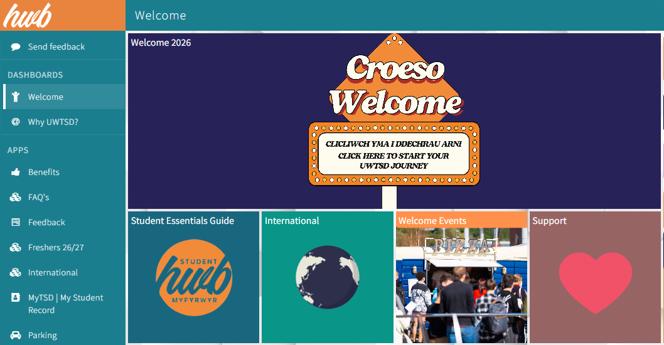

[Write what this shows of your digital life]

Screenshot/Photo 2
[Insert Photo/Screenshot below]
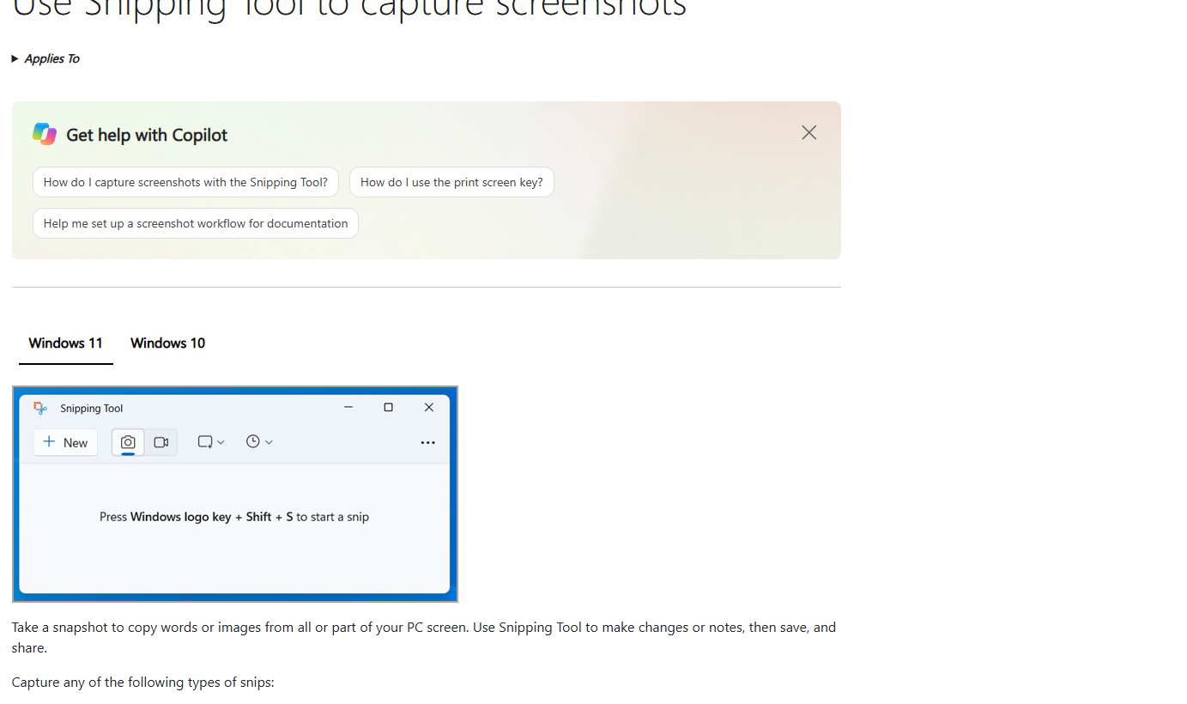
[Write what this shows of your digital life]

Screenshot/Photo 3
[Insert Photo/Screenshot below]
The image shows how to use copilot
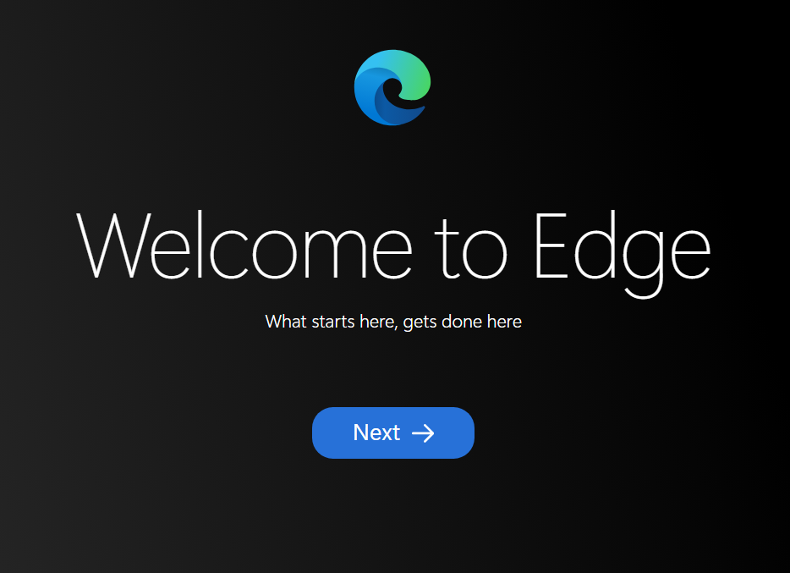
[Write what this shows of your digital life]
The photo shows the welcome page for Edge.

Screenshot/Photo 4
[Insert Photo/Screenshot below]
[Write what this shows of your digital life]

Screenshot/Photo 5
[Insert Photo/Screenshot below]
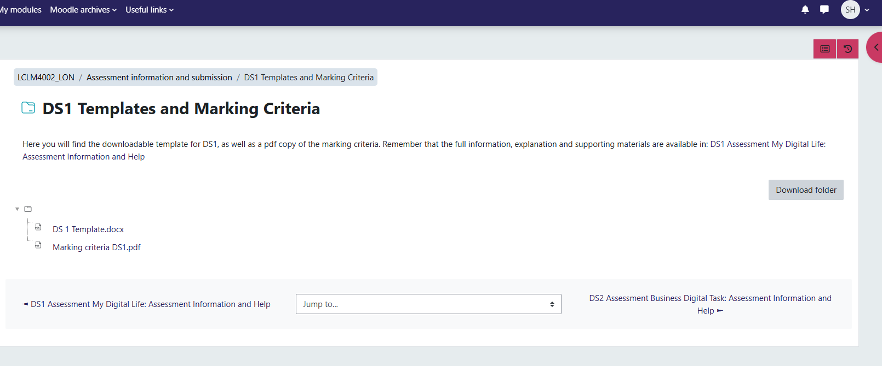
[Write what this shows of your digital life]
This shows the assignment and template to be submitted.

Screenshot/Photo 6
[Insert Photo/Screenshot below]

[Write what this shows of your digital life]
This shows all the available financial support available for me during the course.
Financial supports links.

My Short Reflection
- Write 5–8 simple sentences about your digital life.
- You can use the sentence starters below if helpful.
• I use my phone every day.
• I go online for schoolwork.
• I watch videos on the internet.
• I chat with my friends online.
• I use apps to learn new things.
• I try to stay safe online.
• Digital technology helps me every day.

Sentence starters
- I use digital tools to …
- I feel confident when I …
- I want to improve …
- I often use these tools: …
- I sometimes feel nervous about …
- I hope this module will help me …
- Digital skills are important for me because …
You can write more if you want.

Submission Checklist
Before you submit, please check:
​​​ ☒ I added 4–6 screenshots
☒ I wrote short sentences for each screenshot
☒ I wrote my short reflection
☒ My work is my own
☒ My file opens correctly
​​☒ My file opens correctly

