THE GLOBAL BUSINESS ENVIRONMENT

Name: Anton Mersinkov ID: 2014039
Course: The Global Business Environment LCBB4005
Lecture: Gregory Cowan
Institution: University Of Wales Trinity Saint David
Location: London Campus
Date: 04.05.2021

Table of Contents
The Global Business Environment 2
Impact of the Pandemic and the Forces that have influenced the Business Environment of the Fashion Industry 4
PESTLE Analysis of Fashion Industry 5
Political Factors 5
Economic Factors 5
Social Factors 6
Technological Factors 6
Legal Factors 6
Environmental Factors 7
Opportunities and Challenges Presented in the Fashion Industry 8
SWOT Analysis 8
Strengths 8
Weaknesses 10
Opportunities 10
Threats 10
References 12

The Global Business Environment

Introduction
A business environment is a sum of all influences and conditions that affect the organisation. Companies should analyse their business environment because it will help them to understand their organisations internally and externally and have that ability to formulate organisational strategies based on the business environment. For example a new technology may change a whole industry and those who adapt faster than other will have more benefits. For this reason, the business environment should be analysed to keep up with the continuous changes that occur. The business environment is divided into macro, micro, and internal environments. The microenvironment is the immediate environment with a firm and could influence the business’ routine activities (Khajeheian et al., 2018). Macro environment is the overall environment that impacts decision making, working, strategy and performance of a business (Arvaniti, 2010). Internal environment impacts the external environment but can be controlled.
In this report we will review how these internal and external forces are influencing the fashion industry. More specifically how the Pandemic impact the industry.
Some of the trends in the fashion business environment include digitisation of operations, fast fashion, and the need for customers to spend less but still get high quality products (McMaster et al., 2020). Based on the impact of the Covid-19 pandemic, this business environment should be analysed by examining the political, social, economic, environmental and technological factors. Even though the effects of the pandemic on the fashion business have been very serious, the effects can still be controlled by different business strategies based on the changing business environment. Managers will be able to find effective solutions that will conform to the changing stakeholder preferences by analysing the business environment.

Impact of the Pandemic and the Forces that have influenced the Business Environment of the Fashion Industry
Since governments directed shut down of manufacturing plants as well as event cancellations such as fashion shows and catwalks, plus closure of physical shops (Zhao and Kim, 2021). Furthermore the supply chains were heavily affected and so global fashion brands have been unable to fulfil the consumer demand. At the same time, as a result of the pandemic, fashion brands have been able to explore new opportunities, such as venturing into making fashionable face masks (D’Adamo and Lupi, 2021).
It was estimated that the profits for the worldwide fashion industry would reduce by 27 percent each year as of 2020; however, the industry is currently regaining positive growth of up to 4 percent (Brydges et al., 2021). In 2018, the Global Fashion Index Analysis (MGFI) indicated that 56 percent of international fashion companies failed to recover their capital costs, and it was expected that more fashion companies would be forced to shut down in a year or two due to bankruptcy (Kannappan, 2020).
Since the industry is interconnected, it has made it increasingly difficult for businesses to make future plans. Even though the severity and duration of the coronavirus pandemic are unknown, the fashion industry still seems to be beginning its struggle because of the negative impact its supply and demand has experienced (Brydges et al., 2020). Due to the highly connected global supply chain, fashion businesses have undergone severe strain as they attempted to manage the outcome of the pandemic on several fronts as movement restrictions were imposed simultaneously, which stopped manufacturing in major global manufacturers like China.

PESTLE Analysis of Fashion Industry

Political Factors
The profitability and revenue of the fashion industry are influenced by government policies. Such regulations affect consumer buying habits, the economy, and international trade laws (Chakraborty and Biswas, 2020). Each country follows its political rules, which eventually affect the products that are allowed to be exported, imported, and distributed in stores. The covid-19 pandemic has led to restrictions in movement and general lockdowns that have affected the profits of the fashion industry, especially since Fashion Company stores have been forced to shut down globally in an effort to comply with the regulations of the respective countries.
Furthermore Brexit was another recent event that affect the UK fashion industry in particular or those foreign companies that have solid presence in UK. This is due to the new taxes, tariffs and customs for import and export of stocks.

Economic Factors
According to Gazzola et al. (2020), a strong economy enables customers to purchase their desired products. The covid-19 pandemic has led to the decline of most economies around the world, and as a result, the consumer now prefers to save money and buy strictly necessary products. Since the beginning of the pandemic, unemployment levels increased, and more consumers are using their income to pay their bills (Todeschini et al., 2020). At the same time, customer preference seems to have shifted towards rentable clothing because of its cost-effectiveness, and these services are now preferred online. This appears to be a positive trend because the industry can modify and invest more in online interests, and this may translate to more profits for the fashion companies.

Social Factors
Consumer preferences impact the social aspect of the fashion industry. For example, consumers currently prefer shopping online, and since the pandemic, consumers are spending more money to purchase fashion products than before. Fashion companies like Adidas recorded an increase in online transactions by up to 159 percent between February and April 2020 (Gaudenzi et al., 2021). Therefore, it has become necessary for major fashion industry players to enhance the demand online so that they can adopt the social methods of engagement. However this significant increase in sales is not absolutely correct due to the large number of returned stocks. Nowadays the consumers tend to purchase much more, however the available returns tend to reduce the actual profits.

Technological Factors
Through advancements in technology, fashion companies are adopting new software, hardware, and systems. The industry is largely popularised the use of social media platforms to reach global audiences. Fashion companies use websites to present their catalogues where customers can order products through social media or the website and have them shipped to their different locations worldwide. Companies like Gucci and Louis Vuitton are competing to introduce unique aspects to their online presence so that they can grow their global customer base. Many of the global fashion houses presented their catwalk collections in very new innovative ways.

Legal Factors
The fashion industry is expected to abide by the regulations and rules of a specific country. This is done by following inflation costs, tax restrictions, and export restrictions. In the past, consumers have boycotted fashion brands that fail to follow legal rules like adhering to workers’ rights. The pandemic has accelerated the need to pursue such laws because a lack of doing so may lead to the collapse of the company.

Environmental Factors
Since the Covid-19 outbreak, environmental sustainability has not been focussed on in terms of sustainable recycling and production. Instead, fashion companies are increasingly focused on enhancing personal protection from spreading the covid-19 virus like manufacturing masks and PPEs (Anshari et al., 2021). Environmental factors are also significant because of the increased health hazards, scarce raw materials, and the need to conduct business ethically. Also, covid-19 has presented major difficulties to fashion companies by harming manufacturing facilities maintenance.
In the internal environment, marketing managers have become important to fashion companies because consumers need to be attracted through the use of technological components like social media, websites, emails, and so on so that they can order products online while adhering to the covid-19 protocols imposed in different countries (Black, 2020). Marketing managers, for instance, are expected to ensure that the products are delivered in a timely manner so that a strong consumer relationship can be maintained. Such aspects
of the internal environment need to be controlled to ensure competitive advantage.
Figure 1: Internal Environment
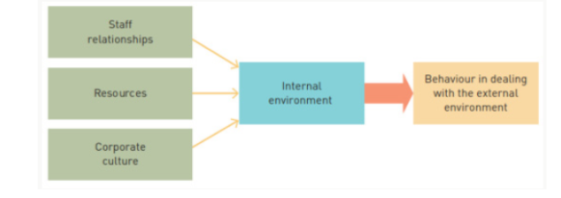
On the other hand, the microenvironment is important in the fashion industry because it help decide the corporate strategy. The fashion industry is aiming to fulfil customer needs by setting up online shops that enable easy purchase and delivery of products. Furthermore, the initial outbreak of Covid-19 halted manufacturing activities because of the social distancing protocols but now manufacturing is opening up and fashion companies are experiencing an increase in profits which has gone up by 4 percent compared to 2020 (Khajeheian et al., 2018).
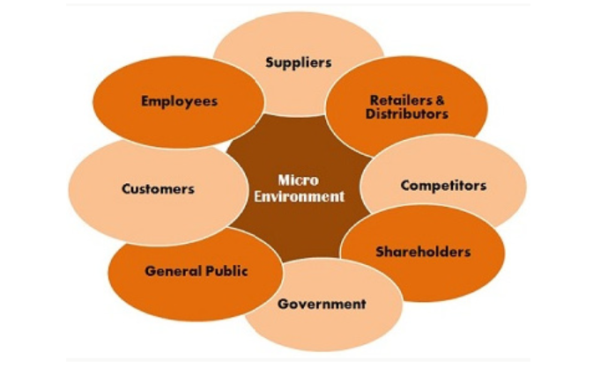
Figure 2: Microenvironment Factors

Opportunities and Challenges Presented in the Fashion Industry

SWOT Analysis

Strengths
- The covid-19 pandemic has led to the digital shift within the fashion industry distribution chain via e-commerce. Before Covid-19 online clothing sales were already growing, where between 2014 to 2019, online sales increased by 125 percent (McMaster et al., 2020). Currently, even those consumers that were reluctant to make online purchases are embracing it, where in 2020, e-commerce sales increased by 24 percent (Zhao and Kim, 2021). Furthermore, fashion brands can utilise social media tools with no additional fees to sell products.
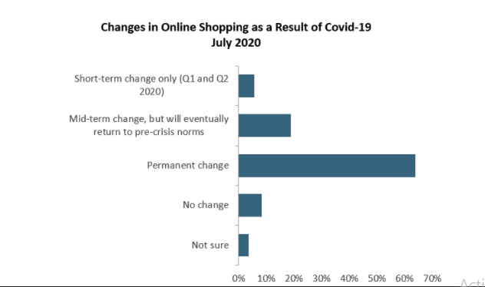
Figure 3: Online Shopping Statistics
- The fashion industry is adapting to social distancing measures; and so, the personal shopping experience is expected to grow. This presents an opportunity for fashion brands to form a connection with consumers and understand the needs of customers; as a result, the consumer will gain from getting a personalised experience (D’Adamo and Lupi, 2021). Fashion brands like Prada have introduced a virtual shopping experience so that consumers can access product advice just like in a physical store. It is evident that Covid-19 is leading to fashion trends like technology investments, e-commerce, personalised consumer shopping experience, and purposeful marketing that will be present even after the pandemic ends.

Weaknesses
- Many fashion companies had to close down because of the severe decline in sales. For example, the crisis damaged the manufacturing, distribution, and supply of the fashion industry. This means that the logistics and infrastructure of the businesses were weak, and it meant that some companies had to close their outlets in order to cut losses.
- Work-from-home directives as a result of the lockdowns meant that fashion companies had to send most of their staff home, and this made it difficult for them to ensure accountability and compliance.

Opportunities
- Technology investments, e-commerce, and personalised consumer shopping experience, and purposeful marketing that will be present even after the pandemic ends.
- The personal shopping experience is expected to grow. This presents an opportunity for fashion brands to form a connection with consumers and understand the needs of customers; as a result, the consumer will gain from getting a personalised experience.
- Fashion brands can utilise social media tools with no additional fees to sell products.

Threats
- The main threat is the fact that many key players in the fashion industry depend on other countries to provide them with raw materials like cotton. So, if the supplying countries increase the material price, it can lead to loss of low for the industry.
- The delays caused of covid-19 restrictions are causing also many issues for the brands. New collections could be delayed as a result.
- Fashion brands may lack the ability to comply with the norms of different nations.

E-commerce and other digital methods are increasingly being adapted by global fashion companies, especially now that use of online services has dramatically increased because more consumers are home and are increasingly browsing through social media and other sites. However, fashion companies should not rely only on this (Brydges et al., 2020). As a benefit can be said that fashion brands are able to increase awareness and establish customer loyalty.
The covid-19 pandemic has led to consumers spending less on fashion wear, and even though this may take more time to recover fully, fashion companies need to shift and modify products to suit the current indoor status of most consumers (Chakraborty and Biswas, 2020). It might be unrealistic for certain fashion brands to produce clothing like pyjamas (which are increasingly likely to generate more sales during the pandemic) and may risk losing customers that associate the brand with a certain standard of product. On the positive side, modifications may shift the profits of fashion companies and lead to improved brand recognition and acquisition of new consumers that will provide a competitive edge.

References
Anshari, M., Almunawar, M.N. and Lim, S.A., 2021. Development of the Digital Marketplace in the Fashion Industry. In Handbook of Research on Innovation and Development of E-Commerce and E-Business in ASEAN (pp. 219-230). IGI Global.
Arvaniti, C., 2010. The Evolution of E-Business Environment in Fashion Sector. In 2010 International Conference on Intelligent Systems, Modelling and Simulation (pp. 443-449). IEEE.
Black, S., 2020. Fashion in a Time of Crisis. The Journal of Design, Creative Process & the Fashion Industry, 12(3), 327-330
Brydges, T., Heinze, L. and Retamal, M., 2021. Changing geographies of fashion during the Covid‐19: The Australian case. Geographical Research.
Brydges, T., Retamal, M. and Hanlon, M., 2020. Will COVID-19 support the transition to a more sustainable fashion industry? Sustainability: Science, Practice and Policy, 16(1), pp.298-308.
Chakraborty, S. and Biswas, M.C., 2020. Impact of COVID-19 on the Textile, Apparel and Fashion Manufacturing Industry Supply Chain: Case Study on a Ready-Made Garment Manufacturing Industry. Apparel and Fashion Manufacturing Industry Supply Chain: Case Study on a Ready-Made Garment Manufacturing Industry (July 15, 2020).
D’Adamo, I. and Lupi, G., 2021. Sustainability and resilience after COVID-19: A circular premium in the fashion industry.
Gaudenzi, B., Mola, L. and Rossignoli, C., 2021. Hitting or missing the target: Resources and capabilities for alternative e-commerce pathways in the fashion industry. Industrial Marketing Management, 93, pp.124-136.
Gazzola, P., Pavione, E., Pezzetti, R. and Grechi, D., 2020. Trends in the fashion industry. The perception of sustainability and circular economy: A gender/generation quantitative approach. Sustainability, 12(7), p.2809.
Kannappan, S., 2020. Marketing agility and E-Commerce agility in the light of COVID-19 pandemic: A study with reference to fast fashion brands. Asian Journal of Interdisciplinary Research, 3(4), pp.1-13.
Khajeheian, D., Friedrichsen, M. and Mödinger, W., 2018. An introduction to competitiveness in fast changing business environment. In Competitiveness in emerging markets (pp. 3-11). Springer, Cham.
McMaster, M., Nettleton, C., Tom, C., Xu, B., Cao, C. and Qiao, P., 2020. Risk management: rethinking fashion supply chain management for multinational corporations in light of the COVID-19 outbreak. Journal of Risk and Financial Management, 13(8), p.173.
Sharma, P., Leung, T.Y., Kingshott, R.P., Davcik, N.S. and Cardinali, S., 2020. Managing uncertainty during a global pandemic: An international business perspective. Journal of business research, 116, pp.188-192.
Todeschini, B.V., Cortimiglia, M.N. and de Medeiros, J.F., 2020. Collaboration practices in the fashion industry: Environmentally sustainable innovations in the value chain. Environmental Science & Policy, 106, pp.1-11.
Zhao, L. and Kim, K., 2021. Responding to the COVID-19 Pandemic: Practices and Strategies of the Global Clothing and Textile Value Chain. Clothing and Textiles Research Journal, p.0887302X21994207.

