Student name: Elena Madalina Vilceanu
Student ID number: 1815431
The module title: Marketing Essentials BMIH4005
Your lecturer’s name: Luciana Suardi
Word Count: 1.375

Component A (50%) Marketing Plan (1250 words)
Select a hotel brand from the below table but could be situated anywhere globally. Remember the purpose of this plan is to identify an issue or marketing opportunity and create a communications strategy for your chosen hotel in the current climate. Be imaginative in your messaging thinking about improving, changing, or introducing new ideas. Think about analysing the micro and macro environment to provide new direction for the business. Use examples to support your case as well as industry research and evidence.
Introduction
The purpose of your marketing plan/what it is about
Who it is being prepared for?
Briefly introduce the key areas/Frameworks/Theorists you will use to frame your plan SOSTAC, 4’Ps, Bowmans etc..
Situation Analysis
5 'C's
-Company: SWOT analysis (Micro analysis)
-Customers: Segmentation and Targeting/ Customer profile's'
-Competitors: Perceptual positioning map, Bowmans strategy clock
-Collaborators: Demonstrate an awareness of your organisations B2B Relationships, Partnerships, Franchises.
-Climate: PESTLE (Macro analysis)
Objectives
-SMART target: Summarise the aims of your marketing plan in one sentence.
Strategy
Discuss and explain your organisations value proposition. How the organisation differentiates, how will you communicate the value proposition, how will it be delivered.
Link value proposition to our customer segments, how will this affect targeting and positioning of the organisation.
Tactics
Marketing mix:
-Product - What is the destination currently offering?
-Place (Distribution) – How will customers locate the area? Which channels will be used?
-Price – What is the pricing strategy within the area? Linked to market research and/or marketing environment analysis and/or customer value, are there a variety of price points for visitors- how will this be displayed/shared.
-Promotion – How will the hotel be advertised? What strategies? RACE/ Communications Mix
Action
Gannt Chart of marketing activities: Marketing channels schedule
Justify your marketing channels schedule, what informed your decisions.
Control
Discuss how we will measure success? New customers? Positive attitudes towards brand? Increase profits? etc..
Conclusion
Summarise your marketing plan challenges and outline any recommendations you have.
References
You will be expected to use credible reference sources (minimum of 15) for information used within your marketing plan. Your references are not part of the word count.
Appendices
Supporting materials are not part of the word count
Slides attached to end of word document

Component B (50%) Presentation - To be held W/C 06/03/2023
(slide submission by 23.55 GMT on the 10/03/2023 to be attached to the end of your marketing plan document)
The exercise will require the student to undertake the role of a marketing professional and they will compile a marketing plan and a presentation of the marketing plan.
The presentation must be based on your written marketing plan, and act as an illustration of it, which allows you, the student, to expand on your highlighted concepts and ideas and discuss how these could be marketed to the customer segments you have identified.
The presentation will be delivered using PowerPoint to lecturers via an online platform, and must last for 5 minutes (this is a timed exercise, and you will not be permitted to go over the time, with marks potentially being deducted for a presentation that is short or over time).
Wordcount: 400 words + - 10%. You must display your wordcount on your cover page.

Contents
INTRODUCTION 6
Situational Analysis 6
5C’s 6
Company 6
Customers 7
Competitors 7
Collaborators 9
Climate 9
Objectives 10
Strategy 10
Tactics 11
Product 11
Price 11
Place 11
Promotion 11
Action 11
Control 12
Conclusion 12
References 12
Appendices 15

Component A – Marketing Plan

INTRODUCTION

The marketing plan for Travelodge aims to address key issues and opportunities in the competitive hospitality industry. The plan will analyse external factors, such as changing market trends, economic uncertainty, and shifting consumer preferences. It will explore ways to improve all aspects of the business, from guest experience to digital marketing and loyalty programs. Various frameworks, including the 4 Ps, marketing mix, and Bowmans' Strategic Clock, will provide a comprehensive strategy to enhance Travelodge's brand and reach a broader customer base.

By analysing the micro and macro environment, new directions can be identified for Travelodge to help build a more sustainable and profitable business.

Situational Analysis

A situational analysis for Travelodge would be a comprehensive assessment of the internal and external factors affecting the company's operations, performance, and competitiveness in the hotel industry. The analysis would include an examination of the company's strengths, weaknesses, opportunities, and threats (SWOT analysis), as well as assessing the macro-environmental factors that could impact its operations.

5C’s

Company
Travelodge Hotel is a UK-based hotel company founded in 1985. The company has over 500 hotels in the UK, Ireland, and Spain and they aim to provide affordable accommodation and good customer service (Travelodge, 2023). The hotel has an aging image and reputation as it has not undergone significant changes over the years.
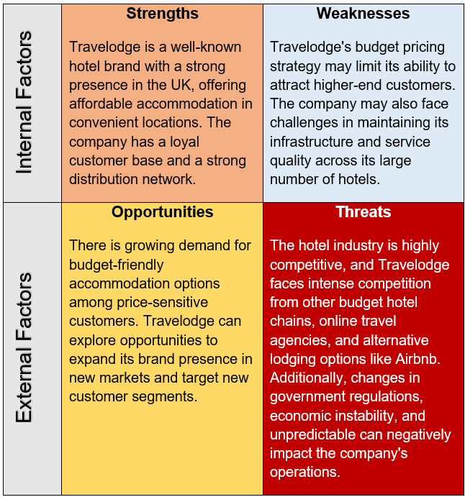

(Elena, 2023)

Customers
The customers of Travelodge hotels are individuals who are looking for affordable accommodation. They could be budget-conscious travelers, families, or business travelers looking to minimize expenses.
According to Srivastava (2012), low-income customers tend to be more devoted as they have less resources for information to assess their options and greater switching costs.

Competitors
Travelodge faces competition from other budget hotel chains such as Premier Inn, Ibis, and Holiday Inn Express. These competitors also offer affordable accommodation and similar amenities, so Travelodge needs to differentiate itself from them to attract more customers.
- A perceptual positioning map is a visual tool that helps to understand how a brand is perceived by customers in relation to its competitors. To create one for Travelodge Hotel, it will be compared to two of its main competitors in the market: Premier Inn and Holiday Inn Express.
High Quality

Holiday Inn Express
Low Price High Price

Premier Inn
Travelodge

Low Quality
As it can be seen, Travelodge is positioned in the mid-low range of price, but slightly lower than Premier Inn and Holiday Inn Express. In terms of quality, Travelodge is positioned in the mid-range, but slightly lower than Premier Inn.
This positioning suggests that Travelodge is a good option for customers who are looking for an affordable hotel.

- Bowman's Strategy Clock is a model that helps businesses evaluate their competitive position in the market based on two factors: price and perceived value. The framework consists of eight possible strategies, each with a different level of price and perceived value. Here is the Bowmans Strategy Clock for Travelodge Hotel:
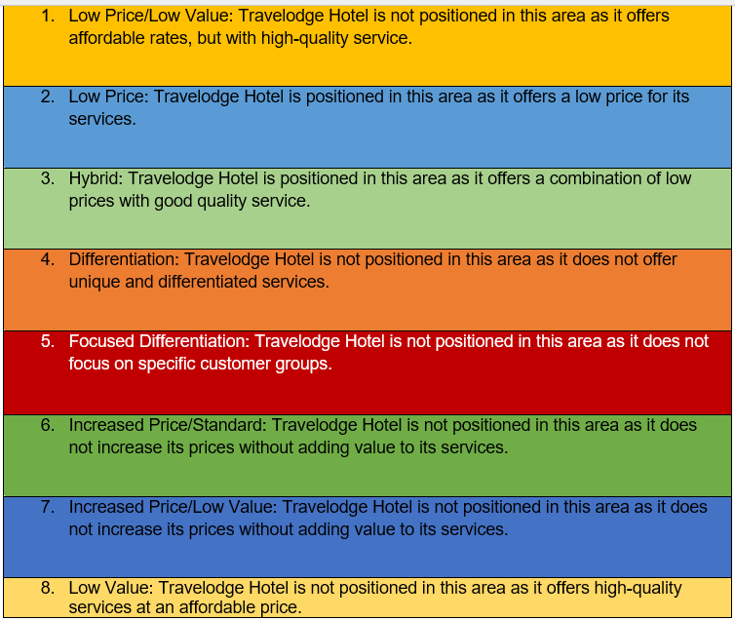
(Elena, 2023)

Collaborators
Travelodge Hotel collaborates with online travel agencies, airlines, and tour operators to attract customers.
They also work with local tourism boards and attractions to provide guests with information and deals. The company also works with suppliers and contractors to maintain and improve their facilities and services. Travelodge has partnered with companies such as Uber and Amazon to enhance their guests' experience.

Climate
The hospitality industry is constantly evolving, and Travelodge Hotel needs to adapt to changing customer needs and preferences. To have a better understanding, the table below will analyse the macro environment (PESTLE).
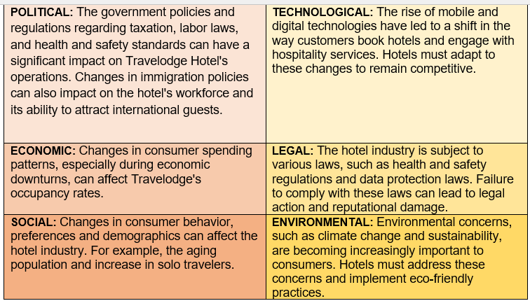
(Elena, 2023)

Objectives
The SMART target of the marketing plan is to develop and implement strategies to drive sustainable growth and profitability for Travelodge by identifying new business directions and opportunities. The objective is to increase customer engagement, attract new customers, and retain existing ones while driving operational efficiency and cost savings. It can be done by focusing on innovative marketing campaigns, enhancing customer experience, optimizing distribution channels, and leveraging technology to improve operations. The target is to achieve measurable results in revenue growth, market share, customer satisfaction, and employee engagement while reducing costs and improving profitability.

Strategy
Our mission is to deliver affordable travel for everyone. We are the low cost choice for leisure and business travel (Travelodge, 2023)
To increase customer loyalty and expand its reach, Travelodge should adopt a multi-pronged approach. Firstly, the company should use targeted online advertising and social media campaigns to promote its low-cost offerings to budget-conscious travellers. Secondly, implementing a customer loyalty program with exclusive perks can help Travelodge build stronger relationships with existing customers and encourage repeat bookings. Lastly, the company should expand its partnerships with travel agents and tour operators to increase brand exposure and attract new customers.
Its value proposition is to provide clean, comfortable, and convenient rooms at competitive prices. To differentiate itself from competitors, Travelodge focuses on delivering consistent quality across its properties, regardless of location.

Tactics
The marketing mix for Travelodge Hotel includes the following:
Product: Travelodge Hotel provides affordable and comfortable accommodation to travellers with various rooms, including standard, family, and accessible rooms. The rooms are equipped with Wi-Fi, TV, and tea/coffee-making facilities. Improved product alternatives are created to provide customers the greatest deal possible (Hill et al, 2011).
Price: The Travelodge Hotel has a tiered pricing system based on room type and location and offers promotions such as a 5% discount for direct website bookings. Their aim is to offer affordable prices to customers.
Place: Travelodge Hotel has over 570 hotels in the UK, Ireland, and Spain. The hotels are strategically located in city centers, near major highways, and airports. The hotel chain also has a mobile app, making it easy for customers to book rooms on-the-go.
Promotion: Travelodge Hotel uses a range of marketing channels to promote its services, including social media, email marketing, and traditional advertising. The hotel also has a loyalty program that rewards customers with free stays and other benefits.

Action
To outline various channels and tactics that Travelodge Hotel should use to reach its target audience and promote its products or services, the following Gantt Chart will highlight the main activities that could be used to increase its audience and brand awareness. The Gantt Chart is a crucial component of a company's marketing strategy and is used to plan and coordinate the timing, content, and distribution of marketing materials across different channels.

Social Media Marketing
Email Marketing
Influencer Marketing
Events and Sponsorship
Direct Mail Marketing
 | May | June | July | August | September

As part of a marketing strategy, these factors have been chosen with attention to detail as each of them has a specific purpose and can be justified as follows:

Social Media Marketing: Leveraging popular social media platforms like Facebook, Instagram, and Twitter to connect with customers, showcase the hotel's amenities and attract new bookings.

Email Marketing: Regularly send subscribers newsletters, promotions, and special offers.

Influencer Marketing: Partnering with relevant influencers to promote the hotel and attract new guests.

Events and Sponsorship: Sponsorship of local events or hosting events at the hotel to increase visibility and attract new guests.

Direct Mail Marketing: Targeted mail campaigns to previous or prospective guests in the hotel's geographic region.

Control
The success of Travelodge Hotel will be measured by key performance indicators (KPIs) that reflect the effectiveness of marketing efforts in driving revenue growth, increasing brand awareness, and improving customer satisfaction. The KPIs include revenue growth, return on investment (ROI), website traffic and conversions, social media engagement, and customer satisfaction surveys. Monthly and quarterly assessments will track revenue growth, while ROI will determine the most effective marketing channels and strategies. Travelodge can improve the user experience and optimise the booking process by monitoring website traffic and conversions. Social media engagement will measure the effectiveness of marketing campaigns in raising brand awareness. Finally, regular customer surveys will help to identify areas for improvement.

Conclusion
Travelodge Hotel faces challenges in increasing brand awareness, targeting a wider audience, enhancing its online presence, and improving customer satisfaction. However, these can be overcome through social media, search engine optimization, content marketing, customer relationship management, loyalty programs, collaboration with bloggers/influencers, trade shows, personalised experiences, and sustainability practices. Moreover, incorporating sustainability practices can create a positive image and attract environmentally conscious customers. A customer-centric approach, leveraging technology, and creating a unique value proposition can improve Travelodge Hotel's marketing plan in the competitive hospitality industry.

References
AvForums, (2021) Travelodge v Premier Inn
Available at: https://www.avforums.com/threads/travelodge-v-premier-inn.2355899/
(Accessed: 24 February 2023)

BestBookDirect, (2023) Premier Inn vs Travelodge
Available at: https://www.bestbookdirect.com/premier-inn-vs-travelodge.html
(Accessed: 27 February 2023)

Customuniversitypapers, (2019) Travelodge Marketing Plan
Available at: https://customuniversitypapers.com/2019/12/18/travelodge-marketing-plan/
(Accessed: 26 February 2023)

Desklib, (2020) Marketing Plan of Travelodge : Assignment
Available at: https://desklib.com/document/marketing-plan-of-travelodge/
(Accessed: 27 February 2023)

HH, (2022) Travelodge: Comprehensive Business Analysis and International Expansion Plan
Available at: https://toughnickel.com/industries/Travelodge-Comprehensive-Business-Analysis-and-International-Expansion-Plan
(Accessed: 27 February 2023)

PhD Essay, (2022) Travelodge is private hospitality industry
Available at: https://phdessay.com/travelodge/
(Accessed: 24 February 2023)

Strivastava, M. and Rai, A. (2012) Customer Loyalty Attributes: A Perspective
Available at: https://management-review.nmims.edu/2012/10/customer-loyalty-attributes-a-perspective/
(Accessed: 01 March 2023)

StudentShare, (2022) Situational and Pestle Analysis of Travelodge Hotel
Available at: https://studentshare.org/marketing/1866087-situational-analysis-on-travelodge-hotel-to-include-swot-pestle-porteraposs-fiveforces
(Accessed: 27 February 2023)

StudyModeResearch, (2018) Travelodge UK
Available at: https://www.studymode.com/essays/Travelodge-1426545.html
(Accessed: 28 February 2023)

StudyModeResearch, (2018) Marketing Strategies for Travelodge
Available at: https://www.studymode.com/essays/Marketing-Strategies-For-Travelodge-1083468.html
(Accessed: 26 February 2023)

StudyMoose, (2016) Travelodge Company PEST Analysis
Available at: https://studymoose.com/travelodge-analysis-and-pest-analysis-essay
(Accessed: 25 February 2023)

TermPaper Warehouse, (2023) Travelodge
Available at: https://www.termpaperwarehouse.com/essay-on/Travelodge/366778
(Accessed: 26 February 2023)

The Sunday Times, (2022) Travelodge v Premier Inn: battle of the budget hotel
Available at : https://www.thetimes.co.uk/article/travelodge-v-premier-inn-battle-of-the-budget-hotels-bwmblq7g2
(Accessed: 24 February 2023)

Travelodge, (2023) Our Company
Available at: https://travelodge.wpengine.com/about/our-company/
(Accessed: 28 February 2023)

UKessay.com, (2015) Travelodge And Budget Hotels In The Uk Tourism Essay
Available at: https://www.ukessays.com/essays/tourism/travelodge-and-budget-hotels-in-the-uk-tourism-essay.php
(Accessed: 24 February 2023)

Appendices


