Synthesize a solution to a potential REAL-LIFE scenario
Coffee Capulus Report

Table of Contents
2 Introduction 2
3 Main Body 3
3.1 BYOD Software 3
3.2 Policy Guideline 3
3.3 Network Topology 6
4 Conclusion 8
5 References 9

Introduction

The following report will disclose guidelines on a BYOD policy in order to try and protect data as well as the intellectual property of the company from being compromised. The policy should also exempt Coffee Capulus from any wrongdoing committed a-la an employee in breach of the terms of service provided by Capulus and state the potential punishment for such acts.
Furthermore, this document will also contain info on a recommended BYOD software to be applied to the network, allowing employees the ability to connect their own devices (i.e. smartphone, tablet and/or laptop) to Capulus’ network domain. The disadvantages of not utilizing this software will also be discussed further on.
Penultimately will be the discussion on an example of the topology of the various networks accessing the Capulus domain on the DNS server. This will go over the protection that has been added to the network routers to deter any malicious activity and ensure the company will be protected by the courts should someone gain unauthorized access.
Finally the report will wrap up what has been said in this document to re-clarify any important information so that the company can be able to digest this document more easily.

Main Body

BYOD Software

BYOD (Bring Your Own Device) is to help not only promote productivity amongst employees with their personal devices, but to also protect valuable data both personal and the company’s intellectual property. Sophos, an American BYOD software company highlights the danger mobile devices can pose to data security. They state that in the report of the “2010 Annual US Cost of a Data Breach” study, 35% of US Companies were the victim of a data breach as a result of a lost/stolen personal device. They continue to drive the point home by reminding the reader of the Sony PlayStation breach that occurred back in 2011, potentially exposing personal information such as debit card information and user details and passwords from over 100 million accounts. [1]
As for suggesting which BYOD software to go with, I would recommend Sophos. After absorbing several companies which have also worked on network management, Sophos seems to have the most use for a large enterprise.
Sophos Business products extends from Network protection to Cloud protection, Email phishing threat safety and server safeguards. They provide an API service as part of their range as well. [2]

Policy Guideline

Below is a proposed BYOD policy from a template provided by Megan Berry [3] for Coffee Capulus to use at their discretion to protect their interests and intellectual property in the event an employee goes against the following terms and conditions of the company, it is recommended an attorney be present to see if any other legal safeguards are needed in addition:

Coffee Capulus provides its employees the use of any smart technology and laptops to use at work given they consent to the following terms below. Rejecting or failing to abide by these conditions laid out will prompt the loss of this privilege as Coffee Capulus reserves the right to prevent the use of personal devices at a moment’s notice in order to safeguard Coffee Capulus’ data and intellectual property. This policy may alter at any time concerning different scenarios and all employees consenting will be asked to reconsider in the event of new terms. Employees who wish to continue to use their personal devices on Coffee Capulus’ network must again agree to the policy presented before them.
Support and Personal Devices:
- Smartphones using Android, Windows, iOS or Blackberry are permitted to connect, however if any model has shown continued vulnerability your privilege of use will be revoked
- Android Tablets and iPads are permitted to connect, however if any tablet has shown continued vulnerability your privilege of use will be revoked
- Issues related to connecting to Coffee Capulus’ network is to be relayed to an IT consultant in the company
- An IT member within the company must be consulted to connect any personal devices to Coffee Capulus’ network and for provision of apps for work productivity
- Any physical device issues are not the responsibility of Coffee Capulus, and therefore you must consult your device manufacturer/service provider
Acceptable Use:
- Coffee Capulus states that moral agreeable business activities that affects support/growth of the business as acceptable use
- Coffee Capulus also states that personal use on company time of reasonable communication and limited recreation such as emergency notifications or reading as acceptable use
- Certain websites are blocked to employees at the discretion of Coffee Capulus whilst they are connected to the network of Coffee Capulus
- Recording and the taking of pictures is prohibited on-site unless proof of authorization is available
- The following apps are allowed: Facebook, Facebook Messenger, Weather, Notes, Gmail, Outlook, etc.
- Employees have permission to access work-related apps and resources: contacts, notes, email, calendars, Microsoft Teams, etc.
- The following uses of personal devices is considered not acceptable use: Storage of illicit information, Storage of proprietary information of which is the ownership of another company, antisocial behaviour towards others including fellow employees, etc.
Security:
- All personal devices are required to be set up with password protection on the device itself, as well as requiring a strong password to access the network of Coffee Capulus
- A strong password is defined as having twelve characters, having a combination of both upper and lower case, symbols and numbers
- New passwords are required every 60 days after network creation or password rotation, and cannot be the previous 12 passwords created
- Devices when left idle for 5 minutes must lock itself with a pin/password and must lock out access when the incorrect password/pin is entered three times. To regain access, you must contact IT with proof of identity
- Devices that have had their OS tampered with (such as jailbroken/rooted devices) are strictly forbidden from accessing the network of Coffee Capulus
- Apps not on a list of approval are prevented from being downloaded by employees, and are prohibited from accessing such apps
- Unsupported devices are unable to connect to Coffee Capulus’ network if they are not on a list of approval
- Devices not for any practical use such as business activities will not be allowed access on Coffee Capulus’ network
- Employees will be given a limited pool of data defined by Coffee Capulus’ IT department
- Coffee Capulus has the right to remotely wipe an employee’s device of data in the event of the following: data/policy breach, a virus or other considerable threat such as ransomware, termination of employment or if the device is lost
Disclaimers:
- Coffee Capulus will not reimburse an employee should their device falter in result of their own actions and therefore falls onto the employee to be personally liable for costs related to their device. Furthermore, Coffee Capulus will not pay costs towards phone/data plans unless a considerable amount of data has been used on behalf of the company (i.e. prolonged sanctioned calls/sanctioned online team meetings)
- The employee is responsible for taking extra care in protecting their personal data by backup up important information and contacts, in the event of a remote wipe
- Coffee Capulus can take away the privilege of connecting personal devices to their network at any given moment without notice
- Employees must report lost or stolen devices to Coffee Capulus within 24 hours, whilst also notifying their service provider
- Employees must always adhere to the terms and conditions, whilst using their devices in a moral and suitably acceptable way
- Coffee Capulus has the right to terminate employment as a result of failing to follow this policy, alongside using other reasonable disciplinary actions
- Employees take full responsibility for the following but not limited to loss of company/personal data whether partially or fully due to system crashes, viruses, malware, or any other soft/hardware failures

Network Topology

The following network topologies are examples of demonstrating how the network(s) may look alongside their configuration. A basic network was created using Packet Tracer in order to simulate connectivity between Coffee Capulus company network, connecting to the cloud and home routers should employees agree to the policy for use at home.
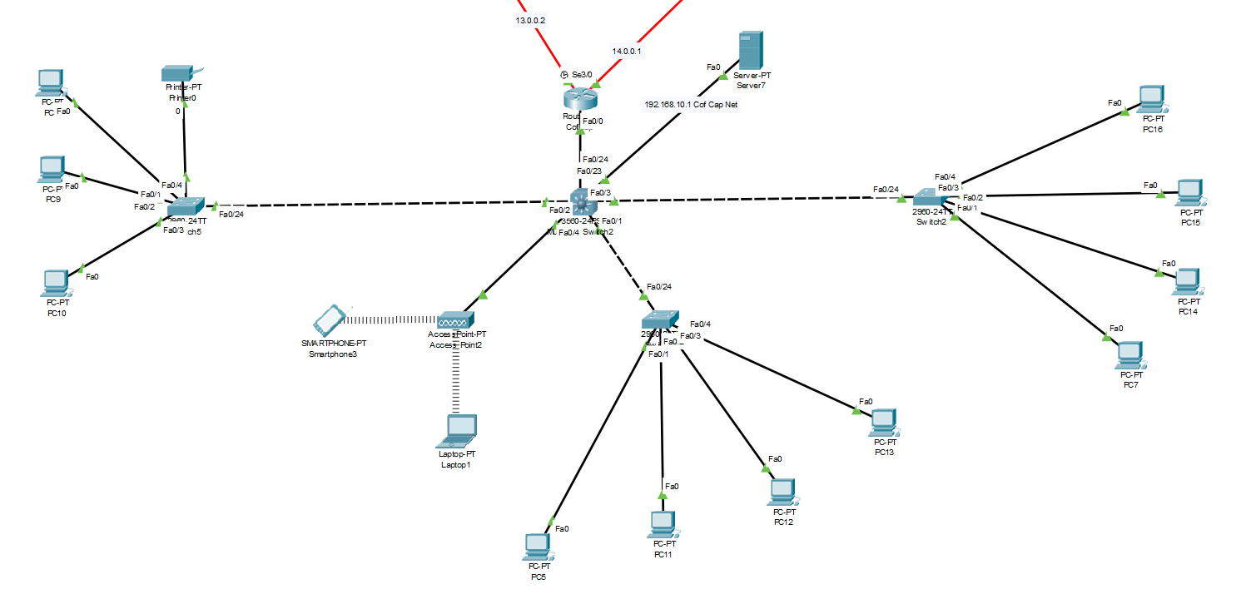
Fig. 1 Example of the Coffee Capulus Network
Figure 1 displays a basic network of Coffee Capulus’ network, with a wireless access point for employees to be able to connect to. These access points have been configured to use WPA2-PSK, as it is far more secure than the outdated WEP keys. Of course, in reality there would be far more access points in this network since the company mostly uses wireless connections. The switches branching off from the multilayer switch may represent the offices in certain departments such as support, IT or marketing as such. This network runs off the 192.168.10.0 address on the router. All routers are configured to use SSH for secure remote login from one device to another for better encryption.
A DHCP server is present in the network to provide an IPV4 address to either a PC or personal device when connecting to the router/access point, configured to support only https and set with a start IP address when providing addresses to devices. This is to prevent an accident where a device may take a static device’s IP.
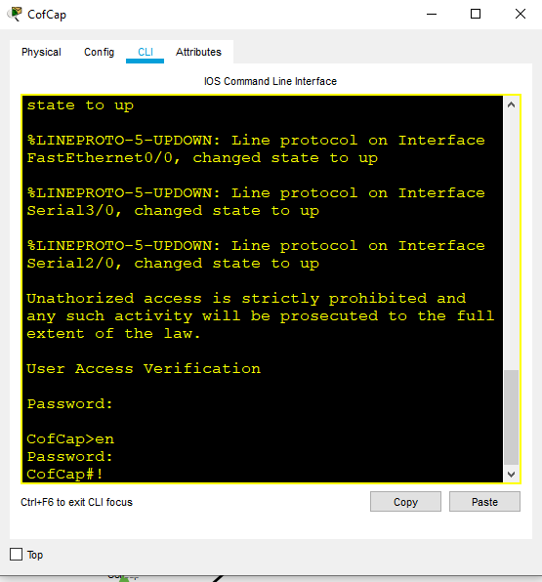
Fig. 2 Password prompt and banner on Router CLI
All routers are password protected on both normal entry and using the enable command for higher access, accompanied by a banner message declaring that any unauthorized access is strictly forbidden, as seen in figure 2. This is to help safeguard the company in the event of a breach and the perpetrator when caught can be brought to the full extent of the law. Without that simple message, the courts can rule in favour of the perpetrator as there was nothing there to have dissuaded them.
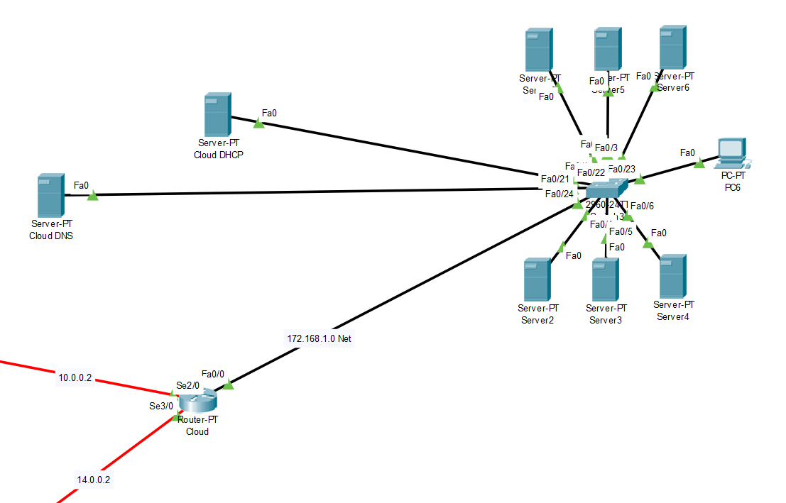
Fig. 3 Cloud Network Example
Figure 3 highlights what the Cloud may look like using the 172.168.1.0 address for this purpose, with several servers present lying dormant for use. Another DHCP is present, as well as a single PC which was used to test pinging from one router network to another, all of which were successful (however, potentially may fail the first time but has always succeeded on subsequent attempts). There is also a DNS server present as an example which can be used to redirect users connecting to go onto Coffee Capulus’ web domain.
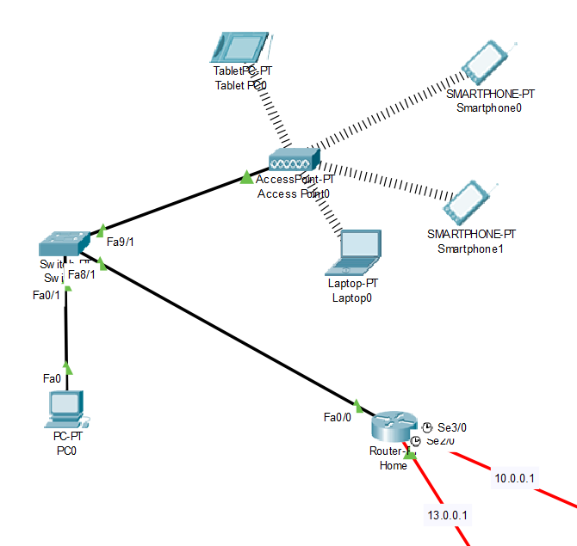
Fig. 4 Home Network
An example of what a home network may be, although the router is more likely to be running as a wireless one compared to a normal router configured to have an access point. The access point here however shows what devices the employee at home may have connected or around. There however is potential for this home network to be vulnerable as there may still be people using the old WEP passwords on their routers, which now is more susceptible to attack compared to more recent advancements in security.
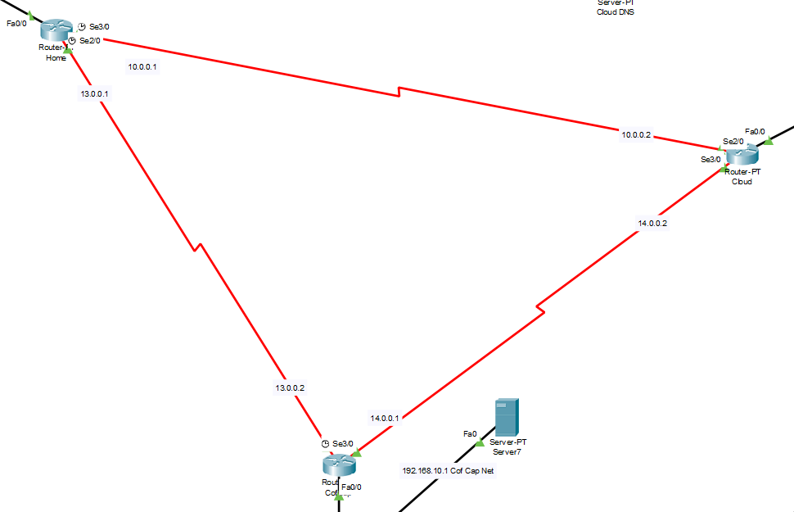
Fig. 5 Interlinked Routers
This final figure shows each router from each network; Home, Cloud and the Coffee Capulus network all connected using Ips such as 10.0.0.0, 13.0.0.0 and 14.0.0.0. This connection in packet tracer is to help see if personal devices on one network can ping another on an entirely different network, which turns out to be true. This shows that all devices are connected properly through the right ports and serials have been assigned the correct IP. Each router is protected by banners and passwords so that the support of the law is on the company’s side.

Conclusion

In conclusion, it is in Coffee Capulus best interest to not only apply a BYOD policy in order to protect its intellectual property and the data of its employees, but to also invest in BYOD software protection to ensure a much smoother experience in safeguarding all possible avenues of vulnerability which smart and personal devices possess when brought into the mix of the company’s network. If Sophos is not possible, further research into other possible BYOD software would be advisable.

References

[1] | Sophos, “7 Tips for Securing Mobile Workers,” 2020. [Online]. Available: https://www.sophos.com/en-us/security-news-trends/security-trends/7-tips-for-securing-mobile-workers.aspx. [Accessed 17 April 2020].
[2] | Sophos, “Sophos Products,” 2020. [Online]. Available: https://www.sophos.com/en-us/products.aspx. [Accessed 17 April 2020].
[3] | M. Berry, “BYOD Policy Template,” IT Manager Daily, [Online]. Available: http://www.itmanagerdaily.com/byod-policy-template/. [Accessed 17 April 2020].

marking criteria and Student FEEDBACK

This section details the assessment criteria. The extent to which these are demonstrated by you determines your mark. The marks available for each criterion are shown. Lecturers will use the space provided to comment on the achievement of the task(s), including those areas in which you have performed well and areas that would benefit from development/improvement.

Common Assessment Criteria Applied (Assignment 1) | Marks available | Marks  awarded
1. Engagement with Literature Skills
Extent of research and/or own reading, selection of credible sources, application of appropriate referencing conventions.
Limited references which are only websites. Need to improve this area by using peer reviewed articles by utilising the university online resources and journals. Did not demonstrated diversity of sources and materials used. (Grade mark: 40.00%) | 15 | 6
2. Knowledge and Understanding Skills
Extent of knowledge and understanding of concepts and underlying principles associated with the discipline.
Need to demonstrate more depth of the research, see comment above which can help in this area. Did not use IEEE report format. (Grade mark: 40.00%) | 15 | 6
3. Cognitive and Intellectual Skills
Analysis, evaluation and synthesis; logic, argument and judgement; analytical reflection; organisation of ideas and evidence
You have discussed BOYD, the design policy. No DFD done. Your discussion lacks critical analysis and evaluation. (Grade mark: 47.50%) | 40 | 19
4. Practical Application Skills
Deployment of methods, materials, tools and techniques; application of concepts; formulation of innovative and creative solutions to solve problems.
Your practical design considered security measures within most core devices (routers). Most host in the same LAN can communicate but cannot access devices outside its LAN such as the servers. In short a working design, not all devices configured and not all core devices have passwords (Grade mark: 60.00%) | 20 | 12
5. Transferable Skills for Life and Professional Practice
Attributes in professional practice: individual and collaborative working; deployment of appropriate media; presentation and organisation.
Your work could do with formatting alignment/justify to make it look more professional. Some grammatical errors and some areas the sentences could be clearer. (Grade mark: 50.00%) | 10 | 5

Assignment Mark (Assessment marks are subject to ratification at the Exam Board. These comments and marks are to give feedback on module work and are for guidance only until they are confirmed. ) | Late Submission Penalties (tick if appropriate) |  | 48%
 | Up to four weeks late |  | 48%
 | First Attempt? |  | 48%

