
Skills for the Workplace
Module Assignment Submission
Student Name: | Martine Kennedy
Student Number: | 2010990
Module No: | BMSK4006
Module Title: | Part 1 Business Plan

Statement of Confirmation of Authenticity
By the act of making this submission, the student declares that this is the work of the student named above. The work has not, in whole or in part, been knowingly presented elsewhere for assessment, or where assessment has been built on a previous assessment, this has been identified. Where materials have been used from other sources it has been properly acknowledged. If this statement is untrue, the student acknowledges that an assessment offence has been committed.
Attention is drawn to the plagiarism and unfair practice policies of both the University and of ILM.

Table of Contents
Title Page 3
Executive Summary 4
Business/Industry Overview 4
Market Analysis and Competition 5
Sales and Marketing Plan 5
Product or Service Offerings 5
Pricing Strategy 5
Sales and Distribution 5
Advertising and Promotion 5
Ownership and Management Plan 6
Operating Plan 6
Financial Plan 6
Appendices 7

Executive Summary

My name is Martine Kennedy, a mother of one. I have lived in London for around 23 years and moved back to Cardiff a few years back to be closer to family. I am soon to complete my first year, level 4, which was my short term goal at the start of the course. Once completed, I will focus on obtaining my BA Honours degree, which will require a further two years of study.

My business proposal is providing a whelping service for the Dam and puppies, operating, 365 days, 24 hours a day. Based in South Wales, Tiny Pups takes the labour away from the owner during those first few weeks your puppies arrive. We all live hectic lifestyles, therefore let us nurture your pups with constant care and attention. Our staff members will ensure they are fed within the allotted timeframes and both mum and puppies are comfortable throughout the process, until they are ready to return home. With a large open space adjacent to the allocated inside area, the dogs are able to freely run around. As the premises is an extension to a residential space, it has that home from home feeling. All our staff are first aid trained and qualified in caring for animals. They truly have a passion for taking care of your dogs.

Business/Industry Overview

The author has decided to propose a business plan on providing a service, whereby they care for the Dam and puppies for the first couple of weeks of life. It would be operational 365 days a year, 24 hours a day. During the first 2 weeks of life, it is imperative the dogs are feeding, and the mother does not turn on them, therefore constant care is required to ensure the puppies are safe and live.

The idea behind the process is that once the pups are delivered the owner would then bring them to the business, where they would be looked after with constant care for a duration of approximately two weeks. The customer would need to sign a legally binding contract beforehand, which outlines liability in the event things go wrong, and/or key areas of responsibilities throughout the process. For example, it would be the owners responsibility for any vetting cost which may occur. They would provide food and worming supplies for the dogs, to ensure there is consistency with what the animal is used to at home.

Dog breeding has seen a significant rise in the UK over recent years. Pet owners has also seen a rise from “22% in 2011, to 33% in 2021”, according to Statista (2021) – see appendix.

When liaising with various, breeders, dog owners the student has identified this service would be of interest to many – see appendix

The author firstly asked 30 people to complete a questionnaire. This included people who breed dogs regularly and those who have pet dogs in which they plan to have a litter at some point. – see appendix. The figures show that 76% of people stated they would use a whelping service, with only 24% replying no.

Out of those who said they would not use the service 100% of them advised it is too expensive, which would cut into the profit of selling the puppies. It was the general consensus they would rather do it themselves.

However, those who would be interested claim the process in time consuming and would rather someone else take on this task.

As the student will be working alongside her brother, the business would fall under “partnership” in the initial stages. An investment of £5,000 would be invested by him, into the company, along with his time. He has experience in this field, mainly from the breeders perspective and in the position whereby he would be included on the work schedule. Additionally, he has built up solid connections with breeders across the country, which is positive from the marketing perspective.

With the current status on the economy and overheads in mind, the author decided it would be beneficial to initially start up the business from home, opposed to renting/buying premises. The location has large open grounds and the area in which would be used is an extension of her home. She therefore has sufficient space, which is separate from home living. After a 12 month period the student envisages expanding the business to larger premises, including other areas within the pet world. This would also include online facilities, dog clothing, dog hampers, treats.

Market Analysis and Competition

PMFA (2019) research suggests that there are approximately “9 million dogs across the UK” – see appendix . We have seen significant rises in the dog population.

The author completed a PESTLE analysis and SWOT – see appendix

On conclusion, the PESTLE highlights the potential barriers which could affect the business. The key areas of legislations as they stand today and potential changes in the future. Rightly so there are many laws and regulations surrounding dog breeding, to ensure animals are not subject to unhealthy living surroundings. As with any business, the knock on effect of increased tax etc are all areas to reflect upon when starting up a business. We saw a huge jump in sales of dogs during the pandemic, will these sales now stabilise or reduce now that society is returning to normal.

The student recognises her strengths and weaknesses following on from completing the SWOT. This line of business is a new challenge for her, both from the business set up to the day to day work involved. She acknowledges the need for training with this field and experience of the business operations. The emphasis on improving her time management skills to ensure success. See appendix for completed SMART plan.

There are many dog services available, but few purely concentrate on the proposed business plan locally. Whilst the student has researched businesses locally within their home environment. They are only able to offer the care of 1-2 litters at any one time. More importantly they do not hold all legal paperwork and/or training certificates. Businesses with a similar service, are then further out, Liverpool, Essex, Telford.

The author has adequate space to accommodate up to 6 litters at a time and purely dedicated to one service. She would ensure all legal documentation, and or certificates are kept up to date. This would put the author in a good position in selling her services and would use this as her USP.

Sales and Marketing Plan

With social media having a huge impact in society, the student feels it best to market such a business with Facebook, Instagram, and Twitter. This would keep marketing cost to a minimum whilst promoting the business to huge numbers across the UK. Additionally I personal website would be used. Whilst the premises location is based in South Wales, after discussing the business plan with breeders, it is felt that if you are providing a high quality establishment, people will place their business with you, irrespective of location.

Her targeted market would be dog breeders and dog owners. Licensed breeders are easily marketed as their business is available via the internet. Dog owners would be targeted through social media. The student decided to use social media, as it is very popular within this line of business.

The students projection of sales is broken down into a 12 month period – see appendix. As outlined above, she would be in partnership with her brother, who has experience in this field, as well as local contacts within the dog breeding industry. This would be a great way of introducing the business.

Breakdown as follows:

Month 1 and 2:

1 litter per week = duration of stay, 2 weeks

Total sales for the month = £1,600

Total number of customers

Product or Service Offerings

Pricing Strategy

Sales and Distribution

Advertising and Promotion

Ownership and Management Plan

Operating Plan

Financial Plan

References

UWTSD (2021) Course: Managing Enterprise in the 21st Century (BMSK4006) (uwtsd.ac.uk)

Available at:

https://www.moodle.uwtsd.ac.uk [Accessed: 15/6/21]

Ebay UK

Available at:

https://www. ALPHAPET® 6 Panel Dog Puppy Whelping Cage Playpen Fence inc Base & Fleece Bed | eBay [Accessed: 1/7/21]

Money supermarket (2021) quote simply business/new business
Available at:

https://www.Business Insurance (simplybusiness.co.uk) [Accessed: 10/7/21]

Animal Courses direct (2021) Level 3 award in small animal care and welfare

Available at:

https://www.Level 3 Award in Small Animal Care and Welfare - Animal Courses Direct [Accessed:28/6/21]

Gov.UK (2021) Apply for a licence/animal boarding establishment license

Available at:

https://www.General Fees and Charges with effect from 1 August 2017 (cardiff.gov.uk) [Accessed: 6/7/21]

Ebay UK

Available at:

https://www.VET FLEECE Dog Bed Greenback Whelping Fleece Puppy Pro Bedding | FREE Delivery | eBay [Accessed: 17/6/21]

Amazon UK (2021)

Available at:

https://www.Aodaer Pack of 6 Paw Print Blanket Dog Cat Soft Warm Blankets Washable Sleep Mat for Small Animals, Black, Grey, Beige, Light Blue, Red, Rose Red, 70 x 100 cm : Amazon.co.uk: Pet Supplies [Accessed: 17/6/21]

Amazon UK (2021)

Available at:

https://www. Pecute Pet Heat Pad Medium 40x50cm,Constant Heating Safe Electric Heated Mat Anti Bite Waterproof with Removable Flannel Cover & Fire Retardant Cotton, Soft Cosy for Puppies Kittens(2 Covers) : Amazon.co.uk: Pet Supplies [Accessed: 17/6/21]

Premier 1 (2021)

Available at:

https://www.Shopping Cart - Premier1Supplies [Accessed:16/6/21]

Amazon UK (2021)

Available at:

https://www.ClearO2 15L Pure Breathing Oxygen Can with Mask and Tube | Made in Britain : Amazon.co.uk: Health & Personal Care [Accessed 16/6/21]

The Incubator shop (2021)

Available at:

https://www.Shopping Basket Contents at The Incubator Shop [Accessed: 15/6/21]

Amazon UK (2021)

Available at:

https://www.Life Saver Whelping Kit for Puppies, Includes Life Drops, Iodine, Hand Sanitiser, All essential Items Sterile Packed : Amazon.co.uk: Pet Supplies [Accessed: 12/6/21]

AO (2020)

Available at:

https://www.WTL82051W | Beko Washing Machine | White | ao.com [Accessed: 13/6/21]

Amazon UK (2021)

Available at:

https://www.AniForte BARF Complete 500g for Dogs - 100% Natural Barf Supplement with Minerals, Vitamins and Herbs - Premium Quality, Rich in Calcium & Ideal as Daily All-Round Care for Raw Food Diets : Amazon.co.uk: Pet Supplies [Accessed: 12/7/21]

Amazon UK (2021)

Available at:

https://www.PetExx Stomach Settler 15ml - fast acting probiotic paste for dogs and cats with diarrhoea and upset digestive systems/stomachs - formulated by vets : Amazon.co.uk: Pet Supplies [Accessed: 13/7/21]

Screwfix (2021)

Available at:

https://www.IMPAX IM800I 700W Inverter Generator 230V | Generators | Screwfix.com [Accessed: 13/7/21]

Wix Logo maker

Available at:

https://www.Wix Logo Maker [Accessed:13/6/21]

Statista (2021)

Available at:

https://www.Dog ownership in the UK 2021 | Statista [Accessed 7/7/21]

PFMA (2019)

Available at:

https://www.Dog Population 2019 | PFMA [Accessed: 2/7/21]

Appendices

Appendix

% of dog owners in the UK

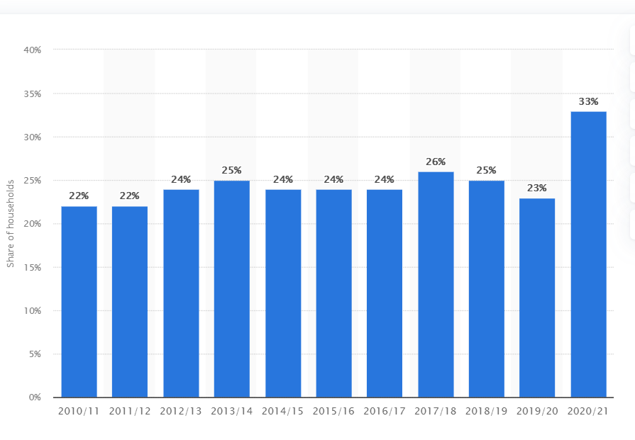

Appendix

Questionnaire

Q1.

Would you use a whelping service?

(circle to indicate answer)

If yes go to Q2

If no go to Q3

Yes No

Q2

What appeals to you about such a service?................................................................................................................................................................................................................................................................................................................................................................................

Q3

Why would you not use a service for your dogs?....................................................................................................................................................................................................................................................................................................................................................................................

Q4.

Do you breed dogs regularly? If so, how often on average?...............................................................................................................................................................................................................................................................................................................................................................................

Appendix

Data obtained from dog breeders/owners

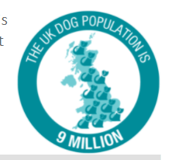

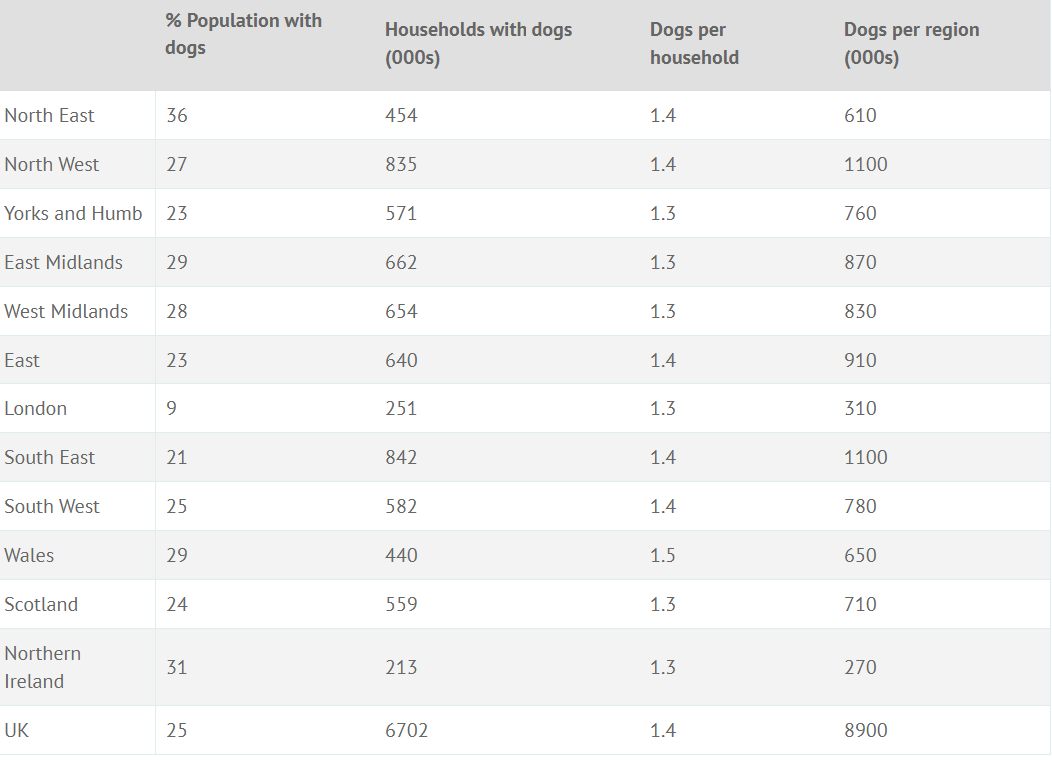

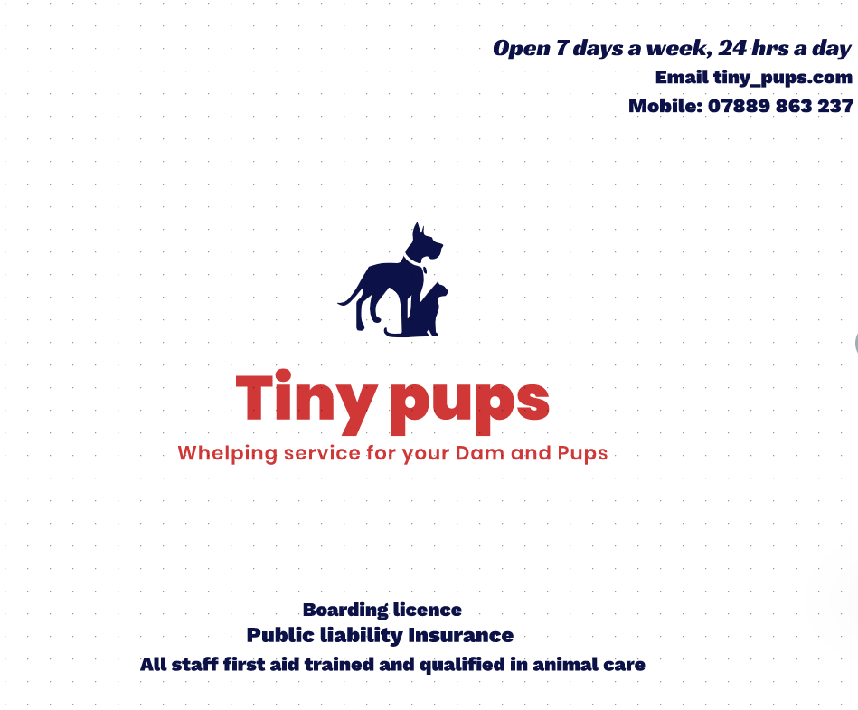

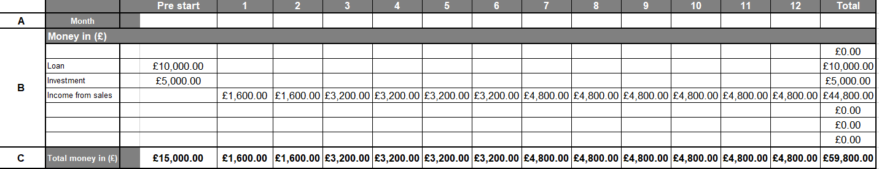

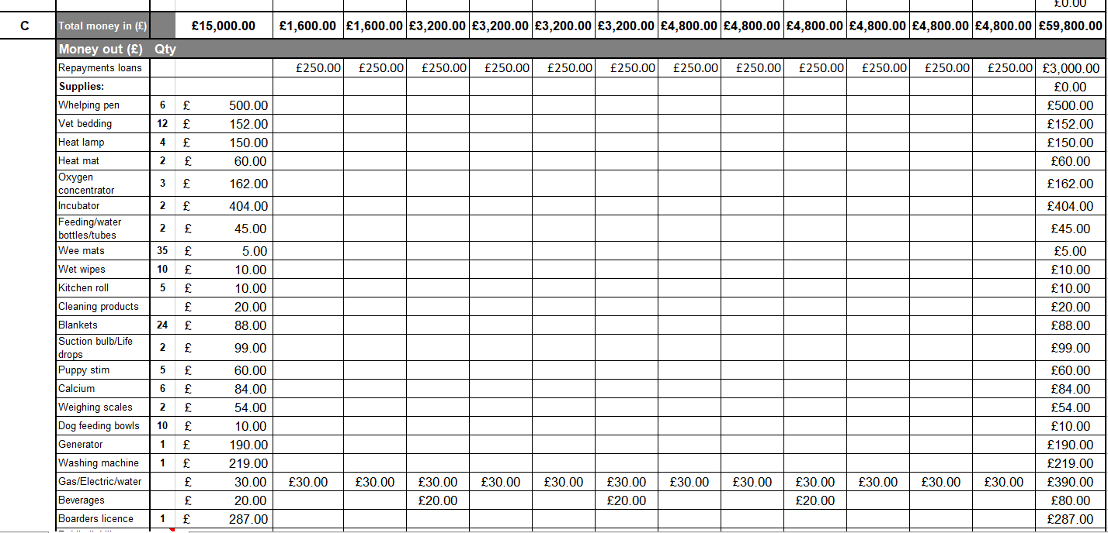

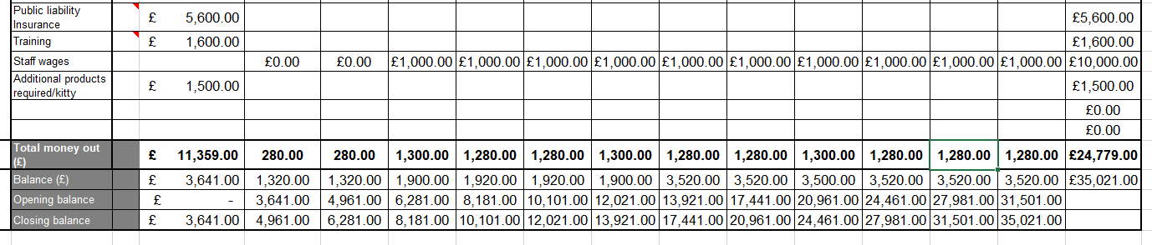

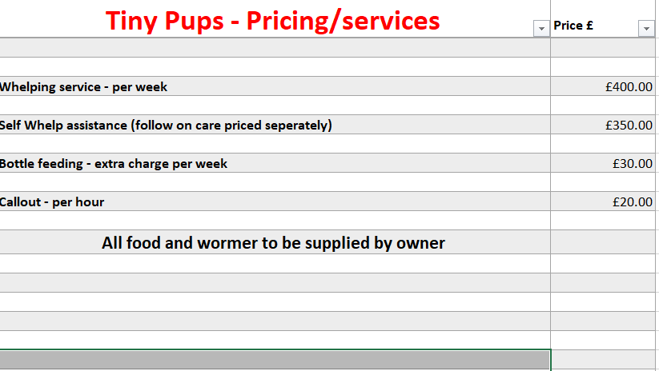

PESTLE Analysis
Political | New legislations are constantly being imposed in regard to dog breeding in the UK, which could interfere with the business. If breeders are unable to comply, this would have a negative impact on the business.  Increased tax, reduces profit margins, therefore the client may decide to take on such duties themselves to recover cost.  Perhaps the government will in time will update legislations to make dog breeding illegal, which would have a significant impact on the business.
Economic | The COVID pandemic has had a huge financial impact on the economy forcing many businesses to close, in particular small businesses. Perhaps starting a new business in the current climate, may be challenging.  The current status on the economy may result in financial services being reluctant to approve small business loans/grants.  We have seen a significant rise in people buying dogs during the pandemic, sales may now slow down as we return to normal.
Sociological | The pandemic has forced many to work from home or lose their job which may free up individuals time to in fact care for the pup themselves. This would have a negative impact on the business.  With more sales in dogs, this has had a knock on effect with the rise of attacks also.
Technological | Technology heavily used for marketing the business and plays a key role in interacting with customers. Fully functioning equipment needed at all times.  Countries like China who have technology to make small numbers
Legal | Imposed licensing fees for dog breeding, could have a knock on effect with such businesses. This would naturally increase the owners outgoings, whereby they may feel it necessary to regain monies from other areas of the process.  Legally binding agreements/contracts would need to be in place between both parties. There is a strong element of trust the client places with the business. In the event something goes wrong during the care of animals, it could possibly raise the issue of where liability lies.  Legal requirements as to the premises, number of dogs at any one time, could refrain from boarding licences being issued by the council.
Environmental | In line with government legislations certain breeds of dogs are illegal. Important for all staff to fully aware, as failing to do so would have severe repercussions on the business.  Concerned parents of children being in close contact with excrement.

Appendix ? – Martine’s SWOT analysis

SWOT - MK

STRENGTHS  Experience in working in face to face Customer Service environment  I am confident in trying new things  I have maths and English skills  I am self-motivated | WEAKNESSES  Do not currently hold any qualifications working with animals  Have never run my own business previously  Time management needs improvement.
OPPORTUNITIES  By applying myself in all areas of development will enable me to run a successful business.  Would open up other opportunities within this line of business and other areas. | THREATS  By not obtaining the relevant qualifications within this line of business, could potentially reduce the amount of business I obtain.  A business venture could fail if I do not apply myself accordingly and apply strong time management in all aspects of my life

S | M | A | R | T
Do not hold any qualifications for small animals | Complete training on first aid and animal care for small animals | 10 | Open College Network, West Midlands | 31/12/23
Have not run my own business previously | Continue to study – complete, Level 4 | 10 | UWTSD | 31/9/21
Time management to be improved | Continue to accept support from friends/family | 10 | Friends/family | 31/8/21

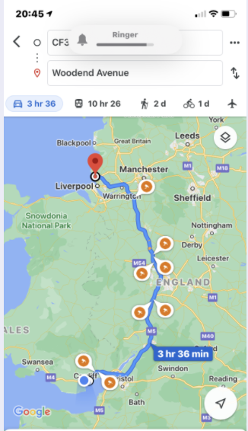

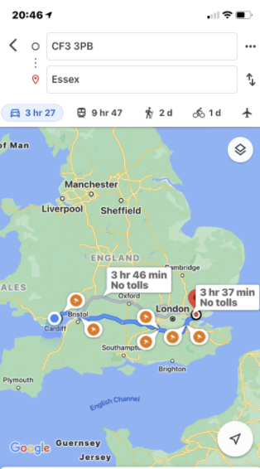

Appendix
Cost associated with business start-up:
Public liability insurance:


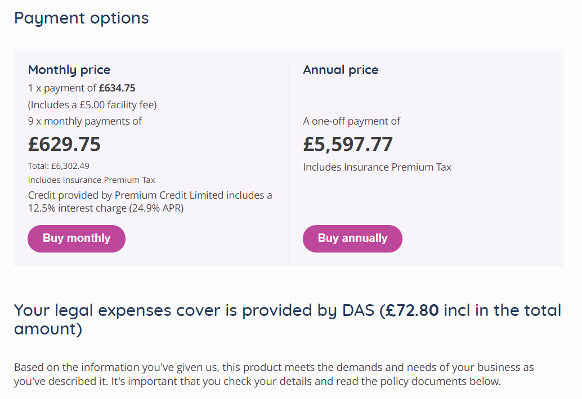

Boarders license


Appendix

Training cost and qualification summary.
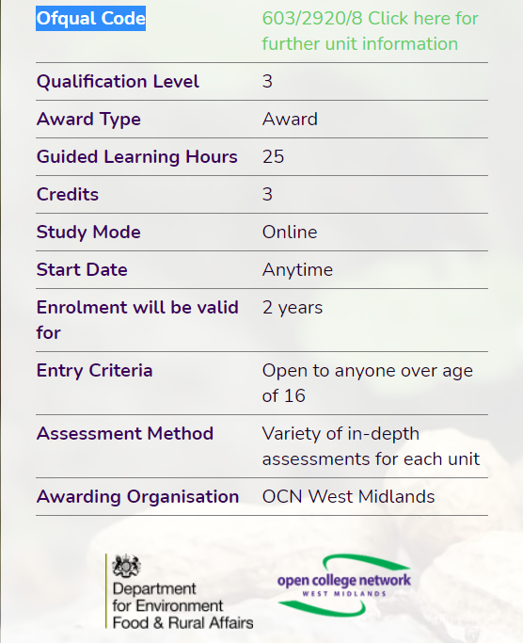


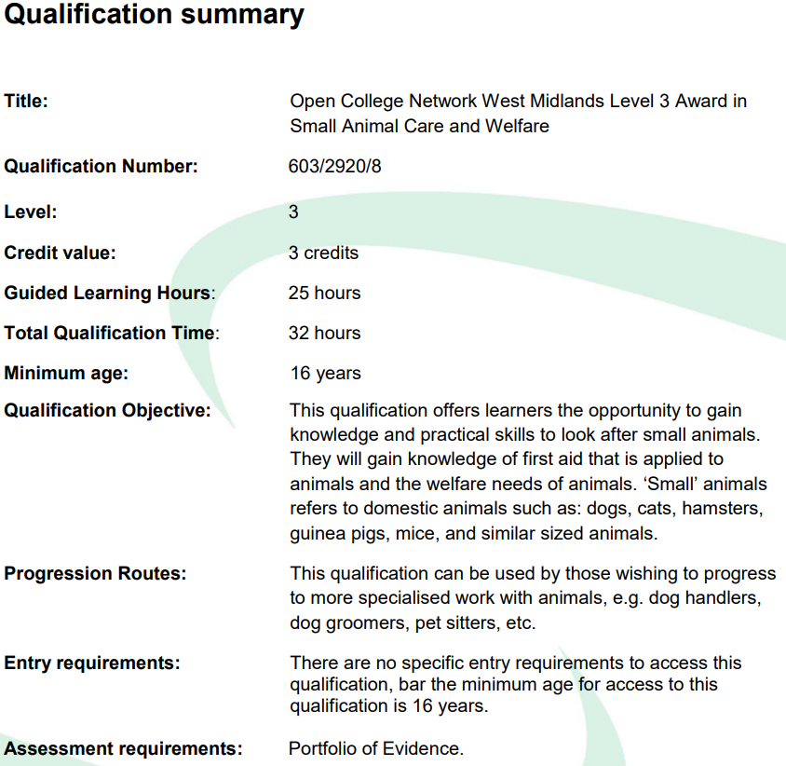

Supplies:
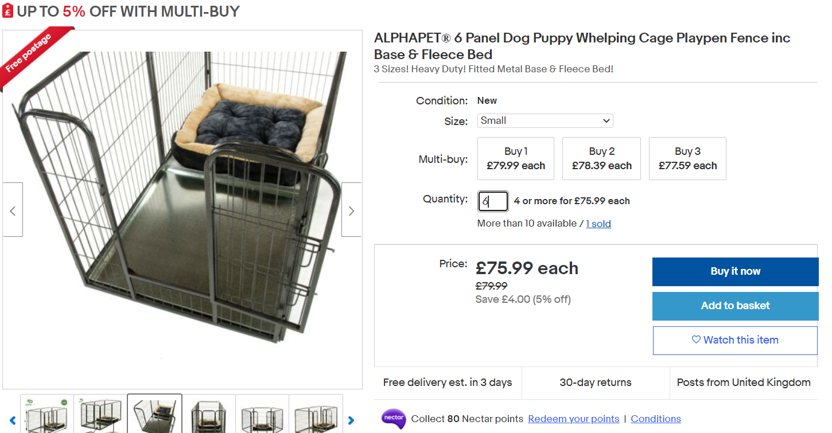

MARTINE KENNEDY
51 WAUN DDYFAL, BIRCH GROVE, CARDIFF, CF14 4PT
TEL: 51 WAUN DDYFAL, BIRCH GROVE, CF14 4PT, CARDIFF 07889863551 EMAIL: martine_kennedy@yahoo.com

PROFESSIONAL SUMMARY | A highly motivated individual with a strong focus to succeed. With over 10 years’ experience within Customer Service, I can effectively communicate at all levels. Strong management skills and an empathic approach, as well as the ability to motivate and develop a team. I excel in the implementation of company procedures, whilst maintaining excellent customer service always.

WORK HISTORY | FEBRUARY 2018-CURRENT  Catering Assistant | Tasty Tucker | Cardiff  - Management of shop, complying to food hygiene regulations always.  - Excellent face to face customer service.  - Complaint handling.  - Preparation of dishes, within an extremely busy environment.  - Management of stock control, ensuring cost effective for the business.  - Handling of cash  JANUARY 2016-JULY 2017  Office Administrator - Part time | Sainsburys | London  - General administration duties focused on delivering an excellent service to customers.  - Followed complaints escalation process.  - Compiled and reported customer feedback to appropriate management, for corrective action.  NOVEMBER 2011-MARCH 2015  Customer Service Manager | Maintel Europe Ltd | London  - Managed 24 CS personnel and monitored performance, ensuring SLA's were met.  - Client meetings ensuring specifications are adhered to.  - Compiled weekly forecast of projects direct to the CEO.  - Effective communication with Project Managers/Co-ordinators to ensure works completed in a timely manner.  - Managed end of the month invoicing for all projects.  - Management of complaints and customer feedback procedures.  - Weekly meetings with Senior Management facilitating effected liaison internally to increase productivity.  - Implemented CS procedures in accordance with BSI regulations.  - Researched and facilitated staff training, which included internal and external sources.  JANUARY 2010-NOVEMBER 2011  Customer Service Supervisor | Maintel Europe Ltd | London  SEPTEMBER 2009-JANUARY 2010  Project Manager | Maintel Europe Ltd | London  JANUARY 2009-SEPTEMBER 2009  Project Co-Ordinator | Maintel Europe Ltd | London  AUGUST 2008-JANUARY 2009  Customer Service Advisor | Maintel Europe Ltd | London

SKILLS
  - Microsoft office  - Effective communicator  - Strong listening skills | - Committed to customer  - satisfaction  - Driven to achieve my goals

EDUCATION | Certificate of Higher Education: Skills for the workplace (ILM)  University Trinity Saint David - Cardiff  GCSE  Rumney High School - Cardiff  6 GCSE grades A-C, which include maths and English.

HOBBIES AND INTERESTS | Keeping fit and spending quality time with my daughter.  References available on request.

