`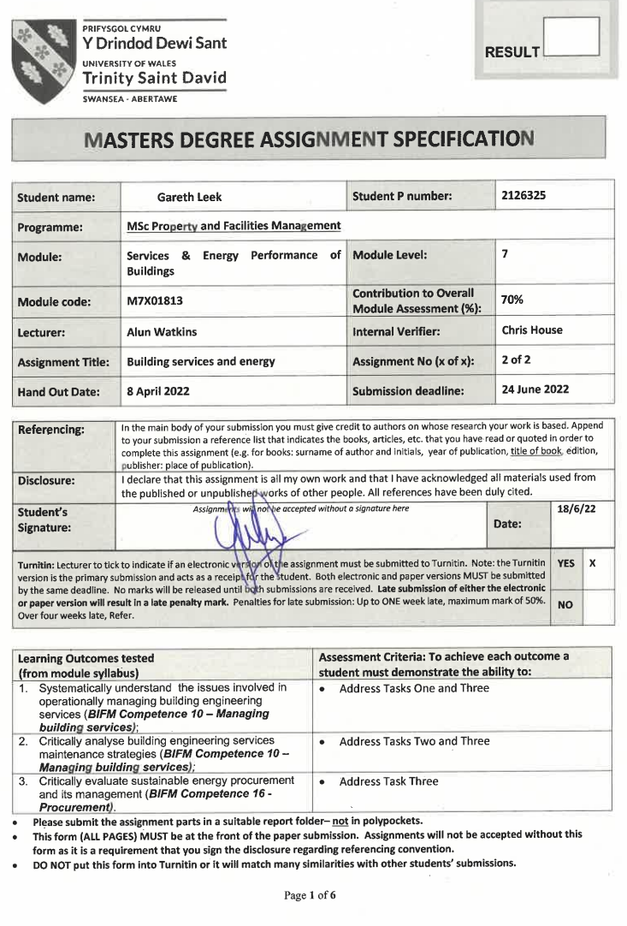
TASK DESCRIPTION

(Lecturer – please insert task(s) / questions / what the student must do, here)

  - Describe briefly with the aid of plans, schematic diagrams, photographs and a schedule of major items of plant, the thermal comfort strategy of a case study building (either residential or non-residential). Describe the building fabric, how the various building services interact with it, and any apparent defects or maintenance issues. Case study building to be confirmed by the tutor before 3rd May.

  - Establish a quantitative baseline for the building’s current energy performance using data sources such as: Building Energy Modelling (SAP/SBEM/PHPP/IES); Energy Performance Certificates; utility meter records; Building Monitoring Systems Data. Data sets to be confirmed by the tutor before 10th May.

  - Describe a “Medium Term Retrofit Plan” (of between 5 and 20 years) consisting of improvements to the building fabric, installation of an appropriate replacement heating system and renewable energy generation/storage, so the building can be ‘Net Zero’ in operational carbon emissions. Describe where your plan aligns with the existing maintenance strategy/budget and what works would be additional. Estimate the quantitative improvements in energy consumption that could be achieved compared to your baseline. Provide an estimate of capital costs and the resulting impact on running costs.

The indicative word count is approximately 4000 (+/- 500 words). Sections 1 and 2 should be approximately 1000 words each. Section 3 should be approximately 2000 words. Each section should contain up to 10 photos, graphs or tables.

Table of Contents
Question One 5
1.0 What is thermal comfort? 5
1.1 Introducing the case study 5
1.2 Schedule of plant 6
1.2.1 Mains electrical supply 6
1.2.2 Mains gas supply 7
1.2.3 Mains water supply 7
1.2.4 Heating plant 7
1.2.5 Air conditioning 8
1.2.6 Domestic hot water 8
1.2.7 Ventilation 8
1.2.8 Task lighting 9
1.2.9 Restaurant gas boilers 9
1.3 Building fabric 9
1.4 Building fabric interface with building services 9
1.5 Thermal comfort strategy 10
1.6 Defects and maintenance issues 10
Question Two 11
2.0 Defining the scope 11
2.1 Data analysis approach 11
2.2 What is benchmarking? 11
2.3 Electricity analysis 12
2.4 Gas analysis 13
2.5 Biomass analysis 15
2.6 Energy types- analysis 15
2.7 External benchmarking analysis 15
2.7.1 Display Energy Certificate 15
2.7.2 CIBSE Benchmarking 15
2.8 Conclusions 17
2.8.1 Electricity 17
2.8.2 Gas 17
2.9 Baseline 17
Question Three 18
3.0 Path to Net Zero 18
3.1 What is Net Zero? 18
3.2 Interventions- building fabric 20
3.3 Interventions- decarbonisation 21
3.3.1 Space heating (main building and staff restaurant) 21
3.3.2 Solar photovoltaic array 21
3.3.3 Mechanical ventilation with heat recovery (MVHR) 22
3.3.4 LED lighting 23
3.4 Impact of phase 1 – Net Zero interventions 24
3.4.1 Commentary 24
3.4.2 Illustration of phase 1 impact 25
3.5 Maintenance strategy 25
3.5.1 Maintenance budget alignment 25
3.6 Net Zero Phase 1-Timeline 26
4.0 References 27
5.0 Bibliography 29
6.0 Appendix 1 30
6.1 Appendix 2 33
6.2 Appendix 3 38
6.3 Appendix 4 39
6.4 Appendix 5 40
6.5 Appendix 6 41

Word count= 4,387

Question One

1.0 What is thermal comfort?
The Health and Safety Executive (HSE) state that thermal comfort is very difficult to define as you need to take into account a range of environmental, work-related and personal factors.
Thermal comfort is not measured by room temperature, but by the number of employees complaining of thermal discomfort, HSE (2022). As there is a mixture of personal and environmental factors determining how the end user feels, picture below.
Picture 1: Thermal comfort jigsaw
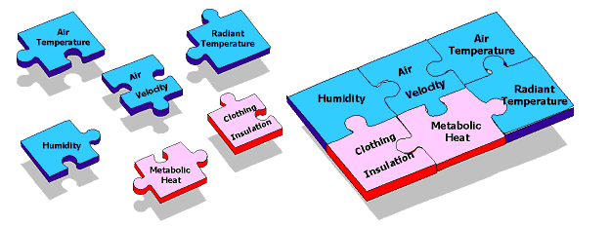
Source: HSE (2022)
The impact of heat transfer from a person’s metabolic heat can be considerable via conduction, convection, radiation and evaporation. Thomas (2006) writes, we feel comfortable if we can maintain our thermal balance without much effort, and uncomfortable in our environment if we have to shiver to generate heat or sweat profusely to lose it.
The strategy for a workplace to pacify the needs of unique individuals, will always remain a challenge.

1.1 Introducing the case study
Companies House (CH) is an Executive Agency and requires an estate for its workforce to carry out office-based working.
Location: Cardiff, Wales
Size: 25,382m² office, 7,000m² storage.
Tenure: Freehold
Building occupation: Circa 1,700 (pre (COVID:19)
Built: 1976
Land area: 4 Hectares
Main office size: Approximately 120m x 50m wide.
The accommodation comprises a five storied main building with a two-storey adjoining repository.
The building is not listed or located within a conservation area.
Picture 2: CH, Cardiff
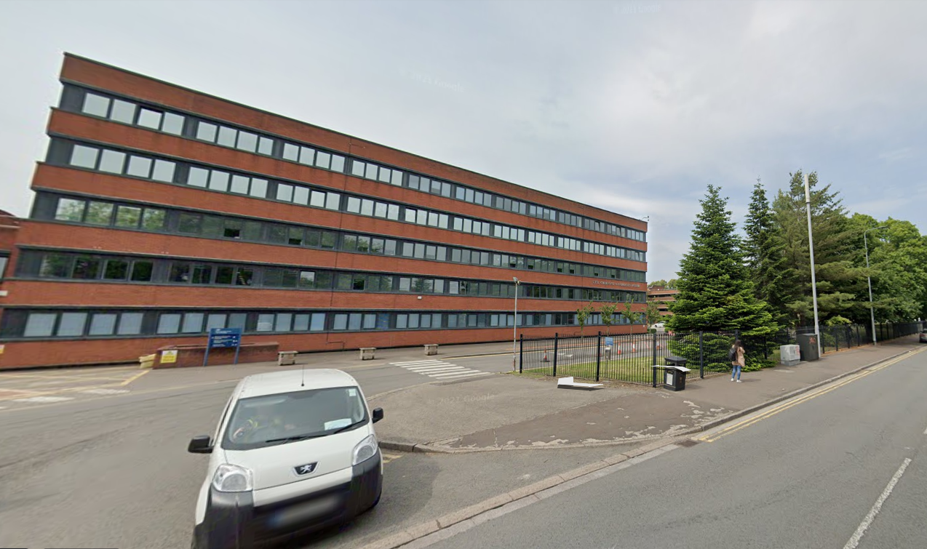
Source: Google earth (2021)

1.2 Schedule of plant

1.2.1 Mains electrical supply
There is one main incoming supply, detailed in Appendix 1. It supplies five 11kV high voltage switches. The manufacturer of the switches is South Wales Switchgear. Three of the switches are CH responsibility. The remaining two switches are the responsibility of the distribution network owner, Western Power. Arrangment below:
Figure 1: Case study high voltage switches arrangement
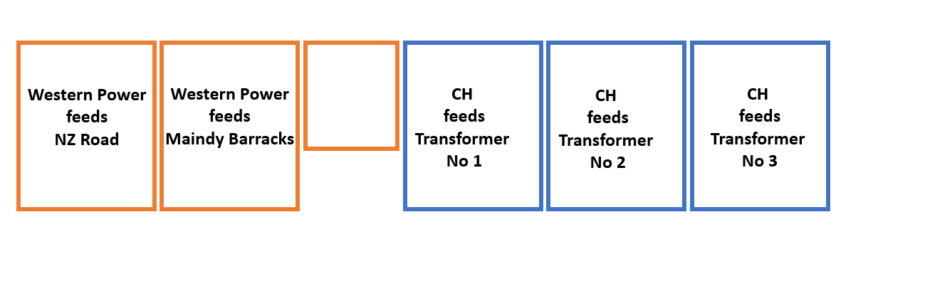
Source: Leek (2022)

The power is distributed within the building, via three transformers and low voltage equipment, schematic drawing:
Figure 2: CH internal electrical distribution

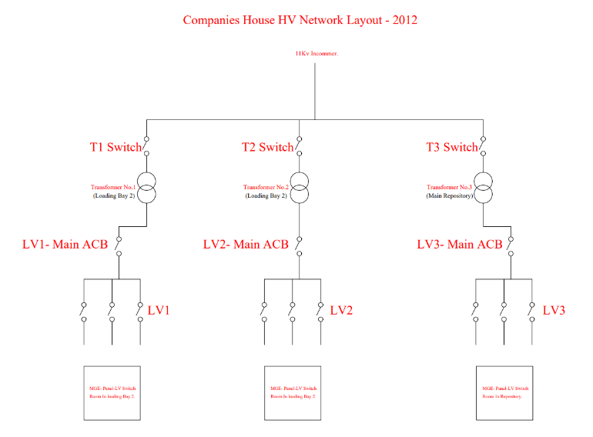
Source: Companies House (2012)

1.2.2 Mains gas supply
There are two incoming gas supplies to the site, see appendix 1, however only one supply is active. It serves the restaurant and the space heating system, both metered separately.
Three gas governors/regulators control the gas pressure entering site with two gas boosters.

1.2.3 Mains water supply
Two 80mm incoming water mains feed the site. One serves the main water tanks and drinking water systems, the other feeds the perimeter fire hydrant. See appendix 1.

1.2.4 Heating plant
The heating system is served by a biomass and condensing gas boiler mix, controlled by a Building Management System (BMS). It supplies the main office block, there is no space heating in the repository.
The systems schematics and zone distribution plans can be found within appendix 2.

Table 1: Heating system major plant schedule
Item | Picture | Manufacturer | Detail
Biomass boiler | 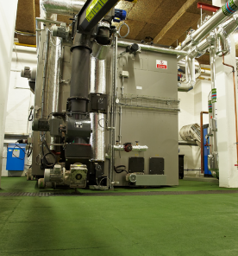 | Froling | 500kW output.  Biomass boilers use materials such as wood chips or wood pellets as a fuel source BRSIA (2017)
Condensing gas boilers  x 2 | 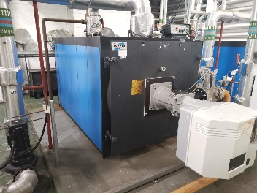 | I.VAR Industry Superac 1220 | 1.3MW output.  Gas condensing boilers use an additional heat exchanger to extract extra heat by condensing water vapour from the products of combustion CIBSE (2012)
Heat pumps-variable speed drives  x 8 | 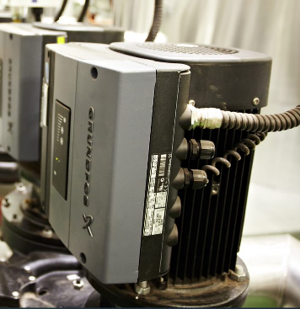 | Grundfos TPE | Electrical motors drive pumps.  In applications where demand on the system is variable, pumps are fitted with variable speed drives BSRIA (2017)
Heating pipes | 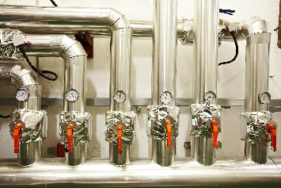 | NA | Transfer of hot water throughout heating network. Pipes are identified (flow and return) and insulated with phenolic foam.
Source: Leek (2022)

1.2.5 Air conditioning
The legacy server farm on site is served by CRAC (Computer Room Air Conditioning) units, providing cooling to the space.
There are ten air handlers and ten condensers. The manufacturer is Denco.

1.2.6 Domestic hot water
The hot water serving the toilets and office kitchen areas is decentralised and heated via electric 3kW boilers or electrical Zipp hydro taps.

1.2.7 Ventilation
The office block relies on natural ventilation achieved from manual operation of windows. The site’s location means there is no requirement to keep urban noise pollution out.

1.2.8 Task lighting
60% of the building is fitted with Ansell endurance LED recessed panels, with the remainder being fluorescent T8 fittings.

1.2.9 Restaurant gas boilers
There are two small condensing gas boilers serving the restaurant with hot water.

1.3 Building fabric
A reinforced concrete frame building with concrete columns at approximately 3m centres and a flat concrete slab spanning between the columns. There are 300mm long reinforced concrete drop heads either side of the top of the external columns.
The external walls are of cavity masonry construction, with no insulation.
The extent of any insulation on the flat roof is not known, therefore presumed not present.
The windows are double glazed.

1.4 Building fabric interface with building services
The building services when working properly they often tend to be ignored or taken for granted, whilst poor performance can cause discomfort and occupant dissatisfaction and contribute to reduced productivity, CIBSE (2005).
The building services and fabric works well considering the buildings year of construction.
The biomass boiler is sized to meet the baseload demand of the building, the gas boilers provide heat output for:
- low demand,
- high demand or
- biomass failure.
Although some biomass boilers can modulate, they are inherently most efficient and lowest polluting when run at high output with as few stops and starts as possible, CIBSE (2016).
The heating boilers charge the thermal stores with hot water, ready for network distribution, via five perimeter convector heating zones, then finally finned convectors in areas of occupation. The pipework is lagged and moves through the site within voids and risers. Asbestos containing materials have commonly been identified in these locations, making access for maintenance challenging.
During the heating season the concrete framed building retains heat well, when at target temperature. However, following long periods of inoccupation, such as bank holiday periods, the buildings fabric can take time to return to previous heat retention levels.
The electrical infrastructure is predominately affixed to ceiling slabs within voids, or walls. It travels between floors in dedicated electrical risers.
Foul drainage pipework departs from the main building within the centre of the light wells, it then travels underneath the building, to exit the site.
The main incoming water mains enters the basement from New Zealand Road, and then supplies the water tanks in the roof plant rooms. Some tanks serve the toilets and other wider networks. The fire hydrant main serves a small area in the repository and an external fire main encircling 70% of the external perimeter.

1.5 Thermal comfort strategy
- Target temperature is a minimum 21ºC, buildings such as offices, the internal conditions may be specified as requiring a resultant temperature of 22±2°C, according to BRSIA (2017).
- Housekeeping arrangements in winter and summer to activate/disengage magnetic fire door retainers respectively. This has some control of draft through put. Similar staff communications are shared for manual window controls, blinds, personal fan usage and employee dress code.
- Occupation parameters set manually on the BMS, empowering it to automatically control heating output, factoring in start/stop optimisation (below), thermostatic controls and weather compensation.
Figure 3: Heating optimisation graph
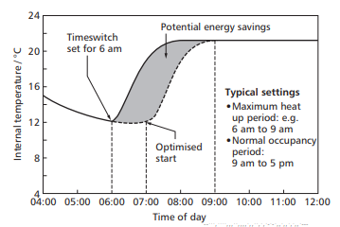
Source: CIBSE (2012)

1.6 Defects and maintenance issues
There are 20 recorded maintenance defects outstanding, noted within Appendix 5. In addition to the corrective maintenance list, there are structural defects identified, following condition surveys. Defects identified include, missing pointing, spalling concrete, and damp penetration etc.
The maintenance backlog is circa £410,000. It includes plant approaching or at the end of its economic life.
There are inherent minor unresolved issues with the design of the heating system:
- Following prolonged periods of inoccupation, when the heating system is switched off, it can take a sustained period of heat output to return the fabric of the building back to temperature.
- The heating distribution network balancing and zonal controls, identified in appendix 2, are not designed in harmony with the orientation and building fabric. Heat output is demanded from the top floor in the winter, due to roof heat losses. The implication of executing this requirement is to the detriment of middle floor occupiers (over heating) and energy efficiency, as all the floors share 4 heating zones, that are intertwined.
- The building air tightness and resistance to inward and external air leakage, is in keeping with age of construction. Draft complaints recorded.

Question Two

2.0 Defining the scope
The case study is a large, complex site, with variable factors needing to be unravelled, to draw conclusions and identify recommendations.
To narrow the scope, the data and recommendations presented are reflective of the following:
- The building`s energy is in scope for analysis, as per the brief, not the organisations own strategic NZ trajectory.
- The building will always be fully occupied. This is a realistic statement due to the strategic positioning of the building and alignment to government hub occupation principles.
- Water consumption associated carbon is excluded from analysis. According to the BSI (2018), it defines energy as electricity, fuels, heat, compressed air and other similar media.

2.1 Data analysis approach
- All consumption is based upon a financial reporting year.
- The most current conversion factors have been used in all years, for consistency of benchmarking.
- IT server farms imminently destined for the cloud electrical consumption are excluded from building analysis. It is permitted as separable from the Display Energy Certificate (DEC), as it is not a fair reflection of operational performance. The building may exclude activities that consume energy, and which are not considered typical of that building type. Including these activities could reduce the validity of the comparison, CLG (2008).
- Due data capture inaccuracies of occupancy levels, during the last 2 years (COVID-19), benchmarking will be analysed via kWh/m².

2.2 What is benchmarking?
To benchmark, firstly you need to undertake data collection of the energy in use, for it to be analysed and then reported upon. According to the Chartered Institute of Building Services Engineers (CIBSE) Energy benchmarks can assist with the evaluation of operational energy use and is a valuable way of making informed decisions relating to the design and operation of buildings, CIBSE (2022).
CIBSE define this, as follows:

Figure 4: Energy monitoring and targeting approach
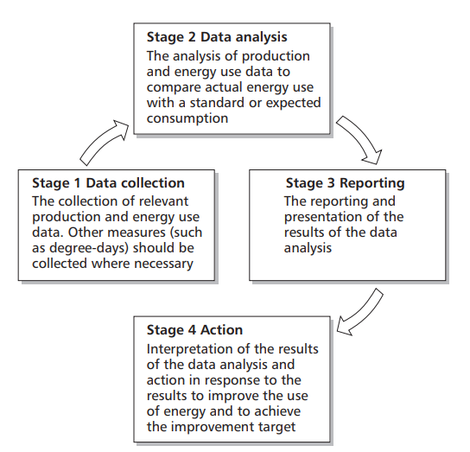
Source: CIBSE (2012)

2.3 Electricity analysis
The following graphs provide electricity kWh consumption analysis, the data has been extracted from invoices and reconciled via manual readings.
Figure 5: Electricity kWh consumption 2021-2022
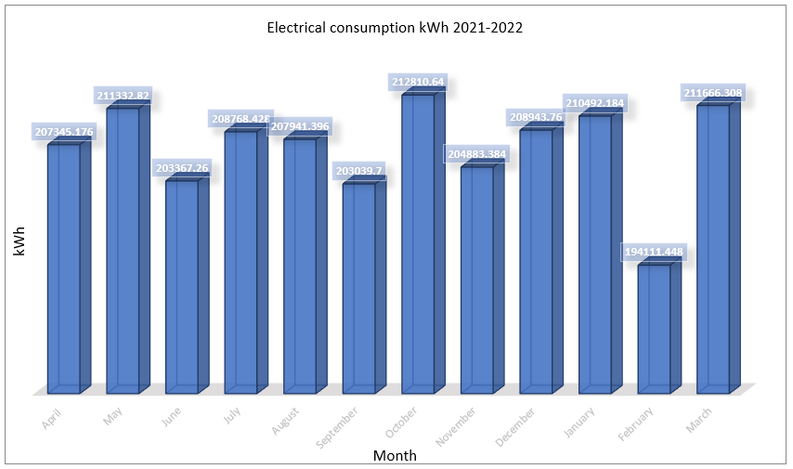
Source: Leek (2022)

Figure 6: Electricity kWh consumption 3-year comparison
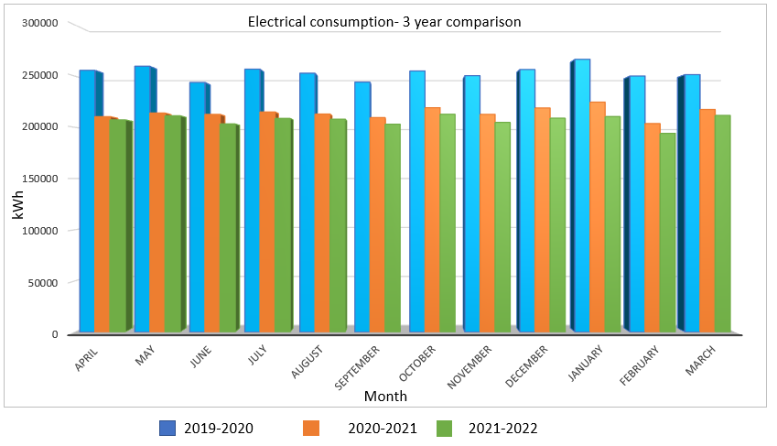
Source: Leek (2022)

2.4 Gas analysis
The following graphs provide monthly gas Kwh consumption analysis, the data has been taken direct from invoices and reconciled with the gas meters readings.
The gas consumption has been benchmarked over years 2019/2020 and 2021/2022. This is reflective of comparative performance, as high gas usage was identified during 2020/2021, due to a biomass boiler defect.
The gas consumption has been proportioned as follows:
- restaurant services (13%)
- space heating (87%)
The restaurant services gas is used for negligible heating requirements, hot water, and cooking.
Figure 7: Case Study kWh gas usage by meter 2021-2022

Source: Leek
Figure 8: Gas consumption 2021-2022

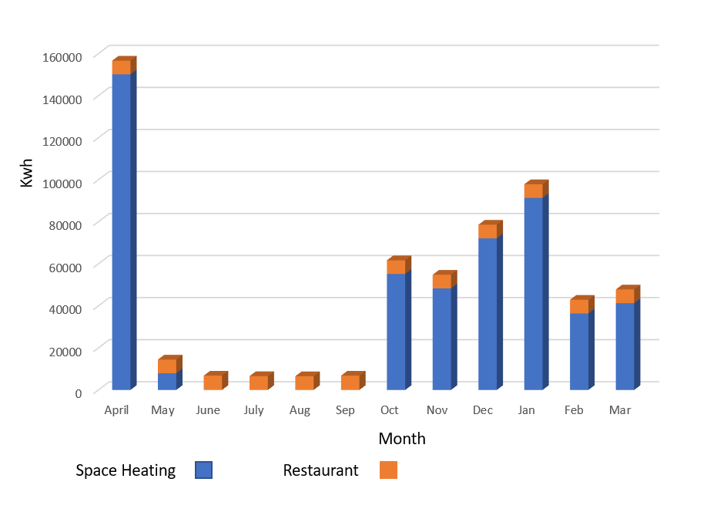
Source: Leek (2022)

Figure 9: Gas kWh consumption 2-year comparison (2019/2020 & 2021/2022)

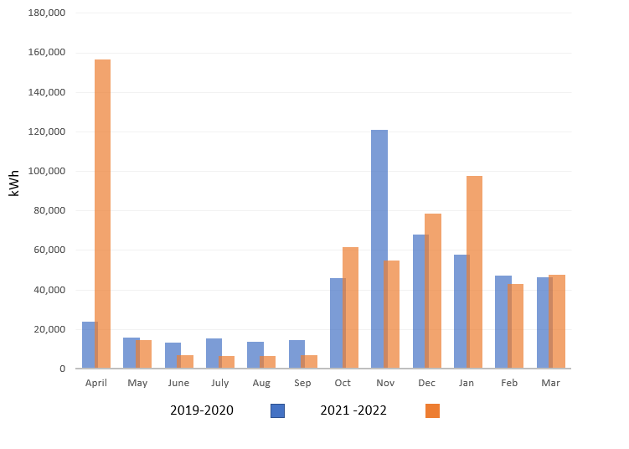

Source: Leek (2022)

2.5 Biomass analysis
The biomass heat output is recorded via manual meter readings, example of the meter reading logs detailed within appendix 3.
Conceptually, burning biomass fuel would be zero carbon if it were delivered without the use of fossil fuels. In fact, biomass is assigned a carbon emission factor of 0.013 kgCO₂ per kWh to account for the carbon emissions associated with transport and processing CIBSE (2012)
Note: The carbon conversion factor was revised to 0.01545 kgCO₂ per kWh, source, BEIS (2022)

2.6 Energy types- analysis
Table 2: Building energy analysis
Energy | Year | kWh | Cost £ (000) | CO₂ (t) | kWh/m² | Net Zero Baseline
Electricity | 2019/2020 | 3,043,226 | 624 | 770 | 93
Electricity | 2020/2021 | 2,571,149 | 552 | 651 | 79
Electricity | 2021/2022 | 2,487,402 | 558 | 630 | 76
Gas | 2019/2020 | 484,434 | 20 | 89 | 19
Gas | 2020/2021 | 856,818 | 30 | 157 | 33
Gas | 2021/2022 | 581,536 | 24 | 106.5 | 22
Biomass | 2019/2020 | 598,000 | 23 (net | 9 | 24
Biomass | 2020/2021 | 373,000 | 18 (net) | 6 | 14
Biomass | 2021/2022 | 652,000 | 24 (net) | 11 | 26
Source: Leek

2.7 External benchmarking analysis

2.7.1 Display Energy Certificate
Display Energy Certificates (DECs) are designed to show the energy performance of public buildings. They use a scale that runs from ‘A’ to ‘G’ - ‘A’ being the most efficient and ‘G’ being the least, GOV (2022)
The building has a DEC operational rating of C with a score of 56.
The DEC can be found within Appendix 4.

2.7.2 CIBSE Benchmarking
The CIBSE energy benchmarking tool allows the user to align operational parameters with comparable consumption groupings. In the case study example, central government, offices, and unique DEC electricity/gas kWh/m² where inputted. The online benchmarking tool is based upon the CIBSE Energy Efficiencies in Buildings, Guide F (2012).

Figure 10: CIBSE Electricity Benchmarking
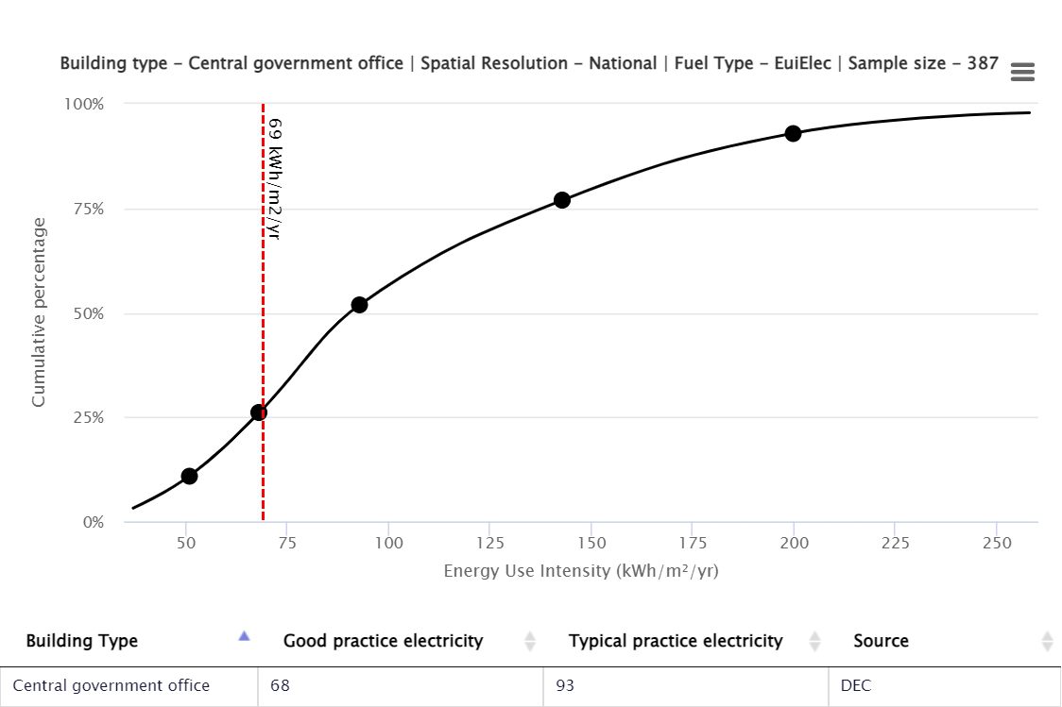

Figure 11: CIBSE Gas Benchmarking

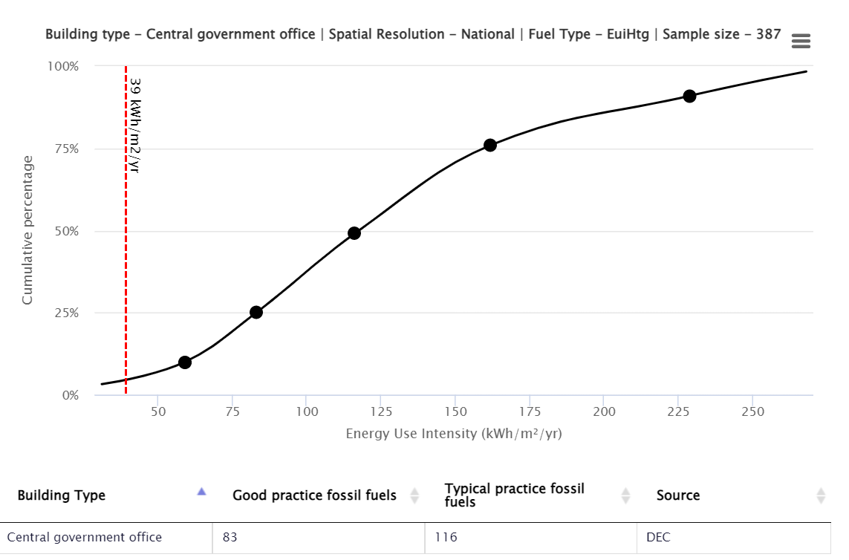
Source: CIBSE (2022)

2.8 Conclusions
Table 3: kWh/m2 review
Benchmark |  | Electricity  (kWh/m²) | Gas/other fuels  (kWh/m²)
DEC | Typical | 95 | 111
DEC | Actual | 69 | 39
CIBSE | Typical | 93 | 116
CIBSE | Actual | 69 | 39
Manual | Actual | 76 | 22
Source: Leek (2022)

- The DEC operational score, a holistic combination of all energy sources, is 44% better than
typical.

2.8.1 Electricity
- The overall kWh consumption reduced by 3.36%, compared to previous year. This reduction is attributed to the installation of an Uninterrupted Power Supply (UPS) system. The UPS draws significant load, and the replacement system is more efficient.
- Current comparisons with 2019-20, unimpacted by (COVID-19) indicate an 18% reduction. It is therefore reflective of employee’s current attendance levels in the workplace.
- CH is 27% better than typical, when benchmarked against the DEC kWh/m²and 26% better when compared to the CIBSE energy benchmarking tools, typical kWh/m².
- Peak demand is currently circa 250kW.

2.8.2 Gas
- Gas performance is good when compared with external kWh/m² benchmarks.
- There was a significant spike in consumption in the last quarter of 2021, due to a biomass boiler defect.
- Restaurant services gas consumption is consistent and accounts for circa 13% of total consumption.
- The total as and biomass kWh output totals 1.2MW, this proves current gas boilers are specified correctly, and can be referenced for intervention decision making.

2.9 Baseline
Setting a baseline year for energy consumption and emissions gives a set point against which any change can be measured. For emissions reduction of an operational estate this must reflect the energy and associated emissions used within, GOV (2021).
The consumption of electricity in 2019/2020, is an indicative year of business-as-usual (BAU) performance. Occupation levels were steady, therefore there is an expectancy these levels will be reached again, upon recovered occupation levels.
Gas and biomass consumption data are not significantly influenced by occupation.
2019/2020 will be the baseline year.

Table 4: NZ baseline year
Energy source | kWh | CO₂ (t)
Electricity | 3,043,226 | 770
Gas | 484,434 | 89
Biomass | 598,000 | 9
Baseline total |  | 868
Source: Leek (2022)

Question Three

3.0 Path to Net Zero
The case studies trajectory to NZ is segregated into phases, in readiness for 2050 or before. Phase 1 is being explored at this stage.
The rationale for this is twofold:
- More interventions could be explored within the case study, with a light touch approach, instead efforts have been diverted to key interventions, to ensure quality of review is not diluted.
- There is currently a timeframe spanning 28 years for public bodies affiliated with Whitehall, to achieve NZ status. Reviewing and implementing the technologies beyond the medium-term, risks missed opportunities of technological advances, that are actively being developed within a buoyant industry.

3.1 What is Net Zero?
According to the Government net zero means our total emissions are equal to or less than the emissions we remove from the environment, UK Parliament (2018). It is now prescribed in law that the United Kingdom will achieve NZ by 2050.
An organisation needs to reduce its operational emissions to zero or as low as possible with residual emissions covered by either the decarbonisation of the national grid or sequestration. Operational emissions that are mostly associated with the energy consumption of the day-to-day use of the building, primarily space and water heating, electricity and cooling. Prior to intervention technologies, a strategy for delivery is required, to highlight alternative interventions are the first stage of action, CIBSE (2020).
CIBSE Guide L (2020), recommends applying the following hierarchy of energy management principles:
- reduce demand.
- meet end use demand efficiently.
- supply from low-carbon and renewable sources.
Reducing demand can be simple and cost neutral, therefore a provisional CO² (t) saving will be included to reflect this.
The Government published a NZ playbook, as a public body, the building will need to adopt. A NZ roadmap is defined as follows:
Figure 12: Public body NZ roadmap
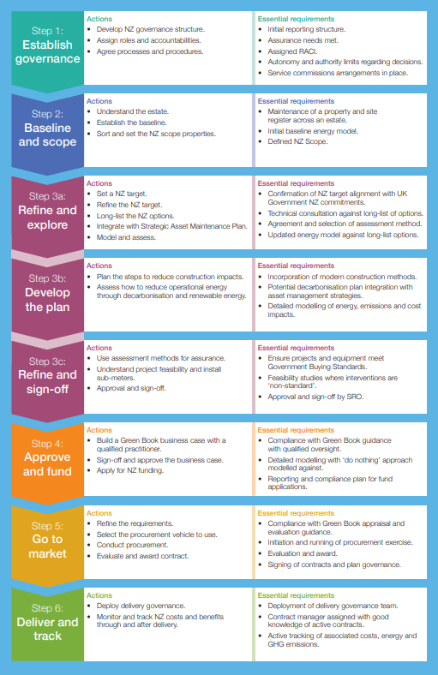
Source: GOV (2021)
As CIBSE previously alluded to, a key component to achieve NZ is the decarbonisation of the national grid, as it unfeasible for most buildings to be self-sufficient and generate sufficient energy. The Business Enterprise and Industrial Strategy, NZ power sector scenarios report (2022), forecasts the grid could be decarbonised by circa 2030.

3.2 Interventions- building fabric
U-Value is a sum of the thermal resistances of the layers that make up an entire building element, Kingspan (2022).
Picture 3: Case study building fabric enhancements
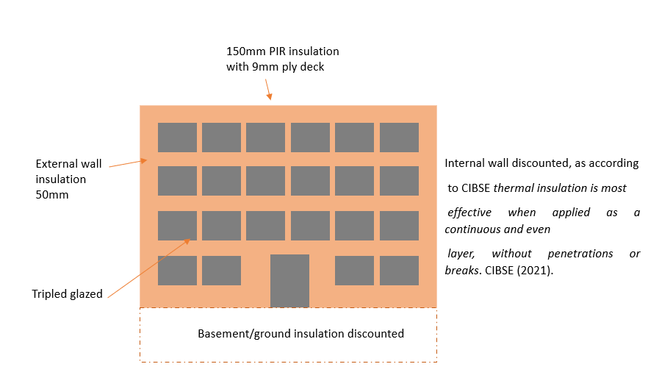
Source: Leek (2022)
Table 5: Building fabric interventions
Component | Current- U-Value | Intervention- U-Value | Indicative  U-Value performance | CapEx cost to retrofit £ (000)
Roof Slab | Concrete cast (medium)  0.32 | PIR insulation board with ply board  0.018  (not repository) | 0.338 | (membrane replacement included)  2000
Wall | External (0.77) & internal brick (0.2)  Total  0.97 | External wall insulation with cladding finish  0.12  (not repository) | 1.09 | 2,500
Windows | Double glazed  1.2 | Triple glazed  1.0 | 1.0 | 3,500
Total |  |  |  | 8,000
Source: Leek (2022)
The principle of the calculation method is as follows: ⎯ to obtain the thermal resistance of each thermally homogeneous part of the component; ⎯ to combine these individual resistances so as to obtain the total thermal resistance of the component, including (where appropriate) the effect of surface resistances, BS (2007).
Before adopting fabric enhancements, it is imperative to prevent unintended consequences. RICS writes, what we're doing in a lot of cases, is trapping the moisture in as well as the heat, so we're creating warm, humid homes rather than warm, dry homes. There is a balance to be struck, because we have to intervene in a way that doesn’t undermine the functioning of the building, RICS (2022).

3.3 Interventions- decarbonisation

3.3.1 Space heating (main building and staff restaurant)
Air source heat pumps may be used to extract heat either from outside air or from ventilation exhaust air. When outside air is used as a heat source, the COP tends to decline as the air temperature drops. COP is a measure of efficiency, a COP of 3.5 being roughly equivalent to an efficiency of 350%; i.e. inputting one unit of electricity provides 3.5 units of heat output, CIBSE (2009).
Proposal to replace the existing gas condensing boilers and decarbonise, using new air source heat pumps (ASHP) systems on a like for like basis, supplementing the existing biomass boiler.
The ASHP`s can charge, the existing 11,000l thermal stores, along with the biomass boiler continuing to provide heat for the site baseload. The proposal is not ignoring industry concerns regarding the credibility of biomass and its claimed carbon neutrality, instead it is acknowledging the carbon impact of its replacement (CO² emissions created from manufacture and installation, likewise, are not ignored).
The biomass boiler replacement should be delayed until the end of its working life.
Picture 4: Mitsubishi monobloc- air source heat pump

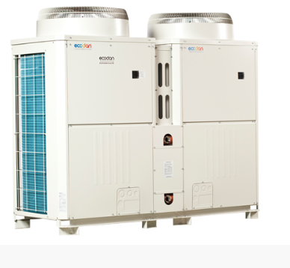
Source: Mitsubishi (2022)
The above Mitsubishi unit is 668kW, a minimum of 4 would need to be installed, to replace the 2 x 1,300kW gas condensing boilers.

3.3.2 Solar photovoltaic array
Photovoltaic (PV) systems convert energy from the sun into electricity through semiconductor cells, CIBSE (2009).
The orientation of the solar PV could face southeast/southwest, as panels will be portable.
Monocrystalline silicon are the most efficient solar cells but the highest cost. A single monocrystalline PV cell (100 cm²) typically produces a voltage of about 0.5 volts at a current of up to 3 amps, i.e. a peak power of about 1.5 Wp. A number of cells, typically 36 or 72, are connected in series to form a module that produces a higher, more useful, voltage than a single cell, according to, CIBSE (2009).
The main building and repository roof has a large flat area, circa 6,000m², however this includes areas obstructed or shaded, making them unsuitable for solar PV.
A PV system will yield maximum output during summer months, therefore, to identify whether all the electricity generated by a new PV array will be used on site (giving maximum value by off-setting purchased daytime tariff electricity).
It is estimated there is space for a 300kWp solar array, circa 1,200 panels. This indicates there is not sufficient generation to cover the full electrical building load, especially during the winter when the electrical demand will rise in other areas, due to the avoidance of natural gas.
Battery storage from PV and ambitions to export to the national grid, should be a consideration in later intervention phases.
Picture 5: Case study roof
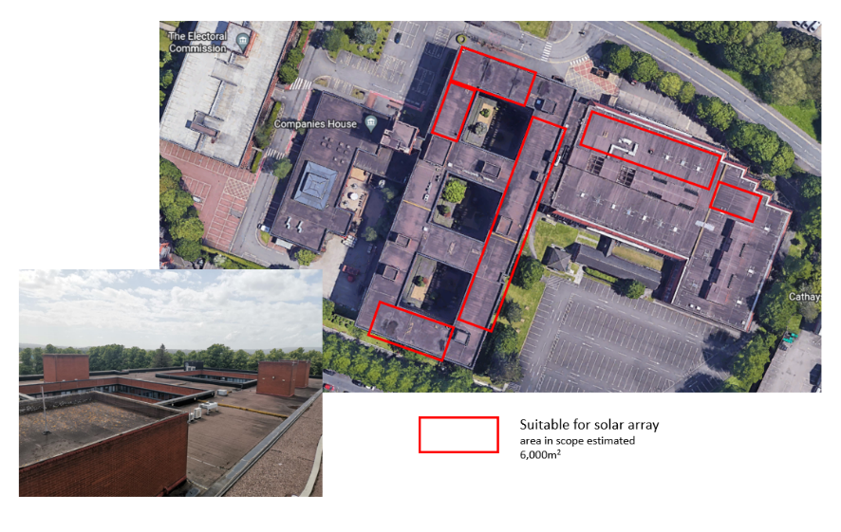
Source: Google (2022)

3.3.3 Mechanical ventilation with heat recovery (MVHR)
A central unit contains a supply fan, an extract fan, a plate heat exchanger and filters to protect the other components from clogging, BRSIA (2017).
One legacy server farm will remain on site, as all other server farms are migrating to the cloud.
There is opportunity for reducing the demand on the ASHP within the legacy server farm, by the movement of heat from the server rooms to other cooler areas of the building, such as the adjacent, unheated repository. Server rooms require consistency of air quality and humidity, it is therefore not viable to extract air from the server rooms and replace with outside air, as strict humidity control will be compromised.
However, if air was extracted from the server rooms, recirculated through a heat exchanger such as a heat recovery unit before returning to the server room, then humidity levels will not be affected. Due to proximity to an unheated internal area, where cooler air can be drawn from, this is an option. Areas in scope:
Picture 6: Server farm proximity to repository
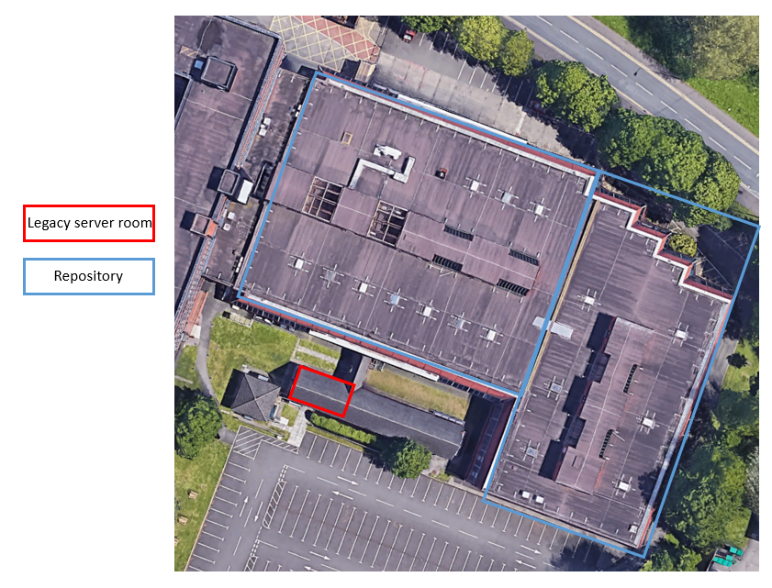
Source: Google (2022)
The system will not deliver heating savings because the repository space is not heated for occupancy. Financial savings will be achieved by the reduction of electricity consumption.
Because the maximum cooling requirement usually coincides with maximum outside temperature, free cooling is unlikely to reduce the peak cooling load or size of chiller. However, it can reduce the running hours of the chiller, CIBSE (2012). Therefore, the resilience and duty of the air conditioning system will be strengthened.

3.3.4 LED lighting
In an LED lamp, an electrical current is passed across semiconductor material (usually silicon). As electrons migrate between charged atoms in the semiconductor, photons of light are released, EST (2016)
40% of the building uses florescent 72W T8 luminaires, this equates to circa 500 units.
The proposed replacement is a 30W LED recessed luminaire, plugging into the current lighting control system. Noting in parallel with the replacement `like for like` energy savings, further savings would be realised through occupancy sensing, daylight savings etc.
LED lighting is the most efficient type of lighting system currently available, EST (2016)

3.4 Impact of phase 1 – Net Zero interventions
Table 6: Impact of phase 1 NZ Interventions per year
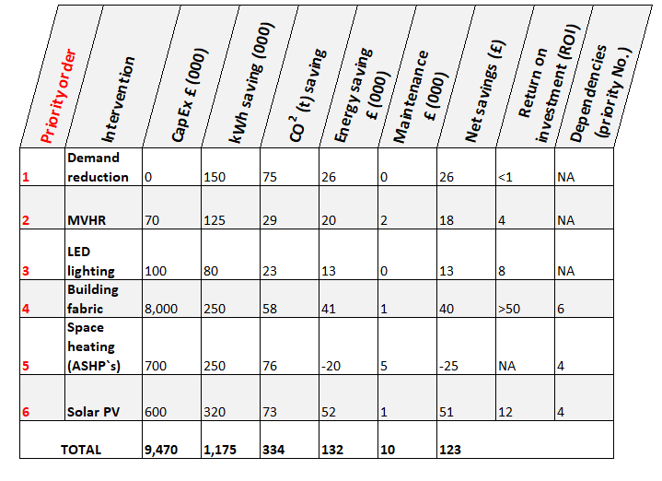
Source: Leek (2022)

3.4.1 Commentary
- Future energy market prices not factored into ROI calculations.
- Prioritised by quickest payback, noting dependencies on interventions, have been considered. i.e., although the building fabric has a long payback, it is critical for the success of the ASHP`s, whose temperature output is not comparable to gas.
- Building fabric costs are significant versus ROI.
- Circa 9.5m CapEx required to achieve potential 334 CO² (t) baseline saving over 6 years, equating to 34% reduction from the baseline.
- The installation of ASHP`s would remove the case studies current reliance on natural gas by circa 94%, excluding cooking requirements and hot water during phase 1. Electrical consumption would increase, however.
- Any ASHP energy savings are attributed to fabric enhancements versus efficiency of plant.

3.4.2 Illustration of phase 1 impact
Figure 13: Phase 1-Interventions path to Net Zero
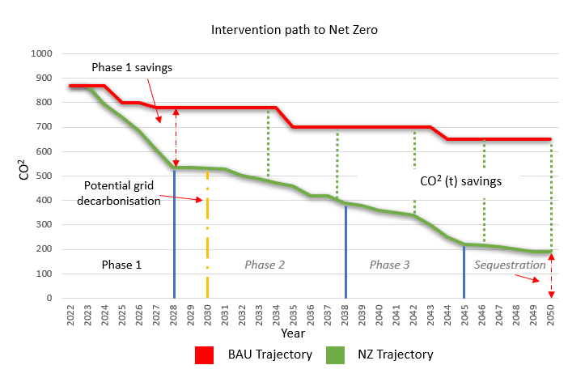
Source: Leek (2022)

3.5 Maintenance strategy
The maintenance strategy is a mixture of preventative, corrective, and condition maintenance. All maintenance approaches have advantages and disadvantages, with cost being an influencing factor.
In response to NZ, it would be advantageous for the Facilities Management function to:
- Ensure future strategy is agile, to ensure it repetitively recognises the `optimum` maintenance, specific to its needs.
The approach will become progressively more crucial, if the current economic and environmental climate gains further traction with business decision making, as Lind suggests unique and complex objects with a strong interaction with the environment makes it almost impossible to predict the degradation process and the lift-time of different components. Economic changes also affect what is rational to do with a specific building, Lind et al (2012).
- Inclusion within the demand reduction review the need to proactively seek, challenge, and reduce or remove assets on current maintenance schedules for energy, carbon, and cost savings.

3.5.1 Maintenance budget alignment
The interventions need to be included in the 5 yearly pipeline works programme, Appendix 6. From reviewing this in parallel with the NZ interventions, there are scheduling issues, observations:
- 300k has been allocated over the period, for planned maintenance/asset replacement. Upon a demand reduction review and overhaul of the associated maintenance strategy, a proportion of this forecasted spend, could be reallocated to NZ.
- The roof membrane replacement (critical to insulation and solar PV interventions) is already in scope/budget at £1.5m. This, along with a notional view, 100k of the planned maintenance can be redistributed, would reduce the NZ spend from £9.5m to circa £7.9m, or a 12% reduction in phase 1.
- All remaining pipeline works are critical to the safety and operation of the building.

3.6 Net Zero Phase 1-Timeline
Figure 14: Phase 1 NZ timeline
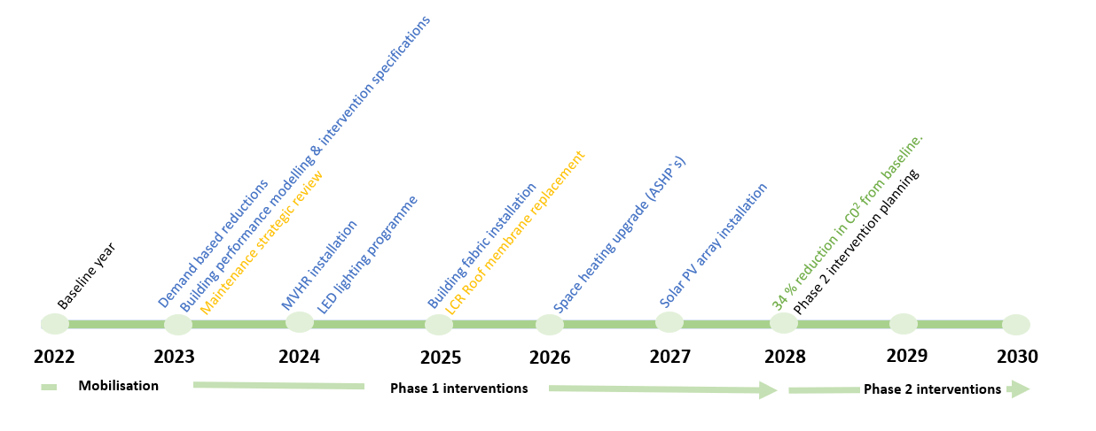
Source: Leek (2022)

4.0 References
British Standard 2007, Building components and building elements — Thermal resistance and thermal transmittance — Calculation method (ISO 6946:2007). Available at: https://shop.bsigroup.com/products/building-components-and-building-elements-thermal-resistance-and-thermal-transmittance-calculation-method-1/standard
Accessed on: 22 June 2022
BSI 2018, ISO 50001:2018 Energy management systems - Requirements with guidance for use. Available at: BS EN ISO 50001:2018 - TC | 31 Aug 2018 | BSI Shop (bsigroup.com)
Accessed on: 17 June 2022
BSRIA 2017, The Illustrated Guide to Mechanical Building Services 3rd Edition. Available at: Illustrated Guide to Mechanical Building Services 3rd Edition (BG31/2017), Bleicher D, ISBN 978-0-86022-758-8 (bsria.com)
Accessed on: 22 June 2022
CIBSE 2005, KSE: Managing your building services. Available at: https://www.cibse.org/knowledge/knowledge-items/detail?id=a0q20000008I7k7AAC#:~:text=A%20section%20on%20managing%20and,and%20auditing%20building%20services%20performance.
Accessed on: 23 June 2022
CIBSE 2009, KS14: Energy efficient heating: an overview. Available at: https://www.cibse.org/Knowledge/knowledge-items/detail?id=a0q20000008I7gP
Accessed on: 16 June 2022
CIBSE 2009, KS15: Capturing solar energy. Available at: https://www.cibse.org/Knowledge/knowledge-items/detail?id=a0q20000008I7gQ
Accessed on: 22 June 2022
CIBSE 2012, Energy efficiency in buildings Guide F 3rd edition. Available at: https://www.cibse.org/knowledge/knowledge-items/detail?id=a0q20000008I7oTAAS
Accessed on: 23 June 2022
CIBSE 2016, Guide B1 Heating. Available at: https://www.cibse.org/knowledge/knowledge-items/detail?id=a0q20000008JuAsAAK
Accessed on: 22 June 2022
CIBSE 2020, Guide L Sustainability (2020). Available at: https://www.cibse.org/knowledge/knowledge-items/detail?id=a0q3Y00000Hw3fvQAB
Accessed on: 22 June 2022
CIBSE 2021, Environmental design Guide A. Available at: https://www.cibse.org/knowledge/knowledge-items/detail?id=a0q20000008I79JAAS
Accessed on: 22 June 2022
CIBSE 2022, The Energy Benchmarking Tool. Available at: https://www.cibse.org/knowledge/digital-tools/the-energy-benchmarking-tool-(beta-version)
Accessed on: 19 June 2022
Communities and Local Government 2008, The Government’s methodology for the production of Operational Ratings, Display Energy Certificates and Advisory Reports. Available at:
https://assets.publishing.service.gov.uk/government/uploads/system/uploads/attachment_data/file/7806/998942.pdf
Accessed on: 19 June 2022
Energy Savings Trust, The right light Selecting low energy lighting. Available at:
https://www.energysavingtrust.org.uk/sites/default/files/reports/EST%20Lighting%20Guide%20-%20the%20Right%20Light.pdf
Accessed on: 23 June 2022
GOV 2021, Net Zero Estate Playbook. Available at: https://assets.publishing.service.gov.uk/government/uploads/system/uploads/attachment_data/file/1035417/Net_Zero_Estate_Playbook__1_.pdf
Accessed on: 15 June 2022
GOV 2022, Check a public building's Display Energy Certificate. Available at: https://www.gov.uk/check-energy-performance-public-building
Accessed on: 22 June 2022
HSE 2022, Thermal comfort. Available at:
https://www.hse.gov.uk/temperature/thermal/
Accessed on: 19 June 2022
Kingspan 2022, What are U-values, R-values and lambda values? Available at: https://www.kingspan.com/gb/en-gb/products/insulation-boards/insulation-technical-hub/articles-and-advice/what-are-u-values-r-values-and-lambda-values
Accessed on: 18 June 2022
LIND, H. et al 2012, Building maintenance strategies: planning under uncertainty. Available at: https://www.emerald.com/insight/content/doi/10.1108/02637471211198152/full/html
Accessed on: 19 June 2022
RICS 2022, Why buildings fail: damp can become dangerous. Available at: https://ww3.rics.org/uk/en/modus/business-and-skills/surveying-stories/why-buildings-fail--damp-can-become-dangerous.html?cid=smo|linkedin|modus|rics.org|content||18-June
Accessed on: 15 June 2022
Thomas 2006, Environmental design: an introduction for architects and engineers (3rd ed.). Available at: https://www.taylorfrancis.com/books/mono/10.4324/9780203013663/environmental-design-randall-thomas
Accessed on: 16 June 2022
UK Parliament 2022, Global net zero commitments. Available at: https://commonslibrary.parliament.uk/global-net-zero-commitments/#:~:text=In%20simple%20terms%2C%20%27net%20zero,seen%20as%20a%20realistic%20option.
Accessed on: 22 June 2022

5.0 Bibliography

AECOM 2020, Spon’s Architects’ and Builders’ Price Book 2021. Taylor & Francis Group.

British Standard 2007, Building components and building elements — Thermal resistance and thermal transmittance — Calculation method (ISO 6946:2007). Available at: https://shop.bsigroup.com/products/building-components-and-building-elements-thermal-resistance-and-thermal-transmittance-calculation-method-1/standard
Accessed on: 22 June 2022

BSRIA (2017) The illustrative guide to mechanical building services. 3rd ed. Stratford. Bishops. PP14

Chartered Institute of Building Services Engineers – KSE (2005): Managing your building services. London. CIBSE.

Chartered Institute of Building Services Engineers – KS14 (2009): Energy efficient heating: an overview. London. CIBSE.

Chartered Institute of Building Services Engineers – KS15 (2009) – KS15: Capturing solar energy. London. CIBSE.

Chartered Institute of Building Services Engineers - Guide F (2012) – Energy Efficiency in Buildings. 3rd ed. London. CIBSE.

Chartered Institute of Building Services Engineers – (2016) – Guide B1 Heating. London. CIBSE.

Chartered Institute of Building Services Engineers – (2021) – Environmental design Guide A. London. CIBSE.

Communities and Local Government 2008, The Government’s methodology for the production of Operational Ratings, Display Energy Certificates and Advisory Reports. Available at:
https://assets.publishing.service.gov.uk/government/uploads/system/uploads/attachment_data/file/7806/998942.pdf
Accessed on: 19 June 2022

GOV.UK 2021, Net Zero Estate Playbook. Available at: https://assets.publishing.service.gov.uk/government/uploads/system/uploads/attachment_data/file/1035417/Net_Zero_Estate_Playbook__1_.pdf
Accessed on: 22 June 2022

Hall, & Greeno, R. (2009). Building services handbook incorporating current building and construction regulations (5th ed.). Butterworth-Heinemann.

Lind, & Muyingo, H. (2012). Building maintenance strategies: planning under uncertainty. Property Management, 30(1), 14–28. https://doi.org/10.1108/02637471211198152

Thomas. (2006). Environmental design: an introduction for architects and engineers (3rd ed.). Taylor & Francis.

6.0 Appendix 1
Incoming utilities to site
Electricity
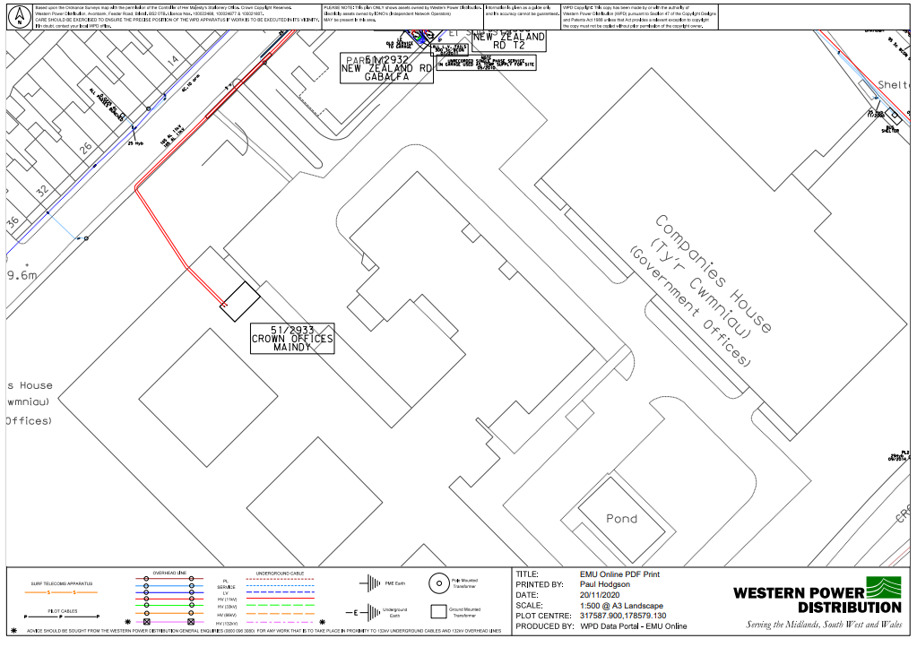
Source: Western Power (2021)

Gas
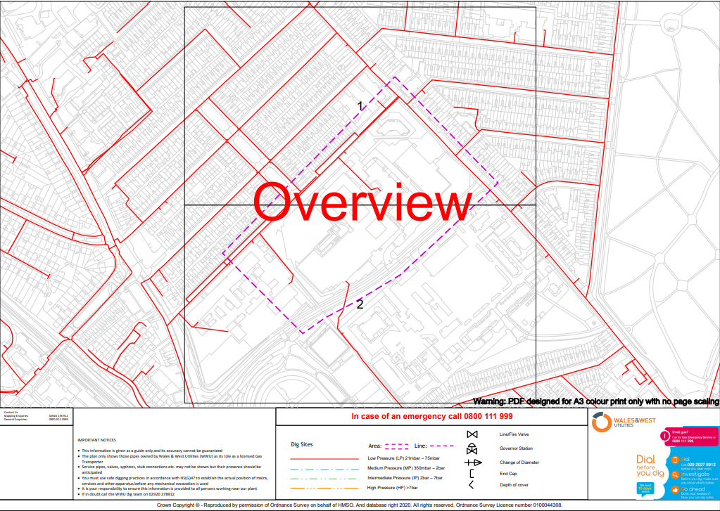
Source: Wales and West Utilities (2021)
Water
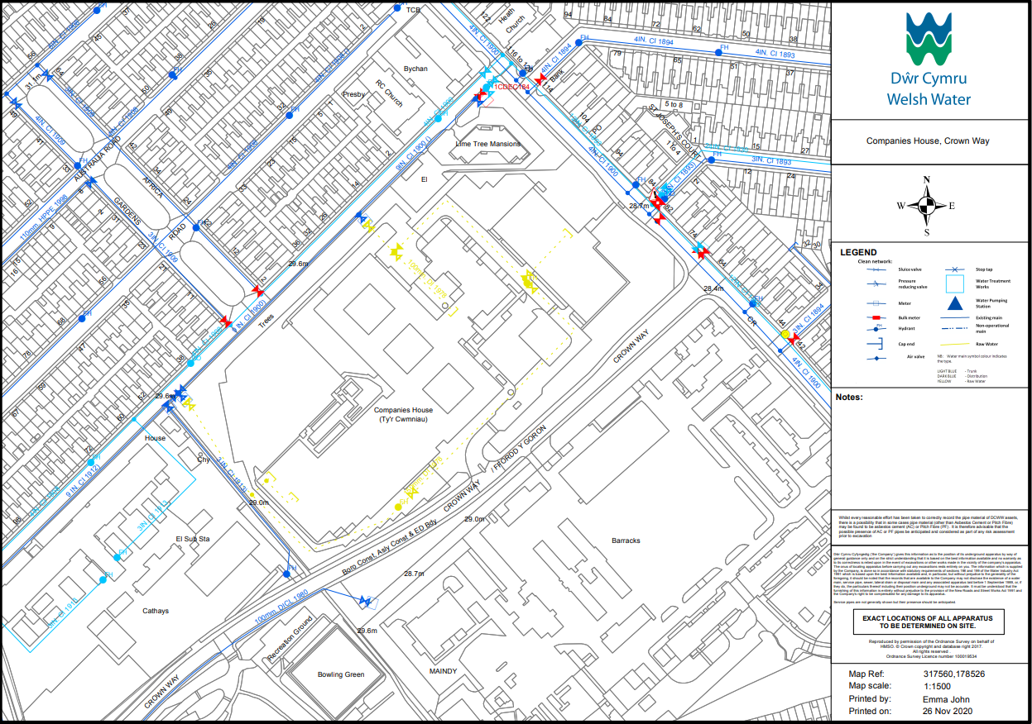
Source: Welsh Water (2021)

6.1 Appendix 2
Heating System Schematic
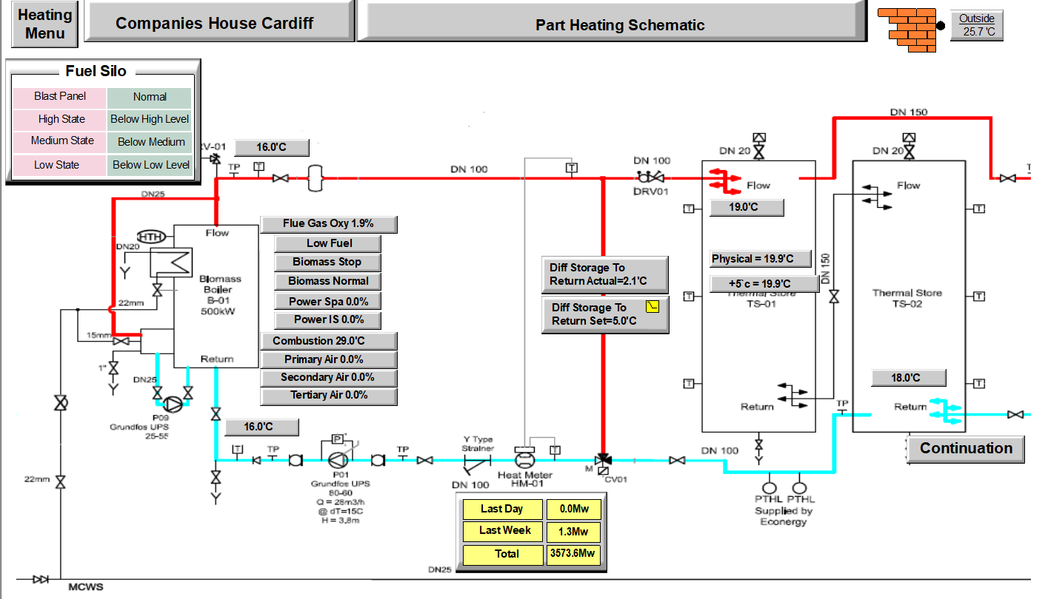
Source: Schneider (2022)
Heating System Schematic

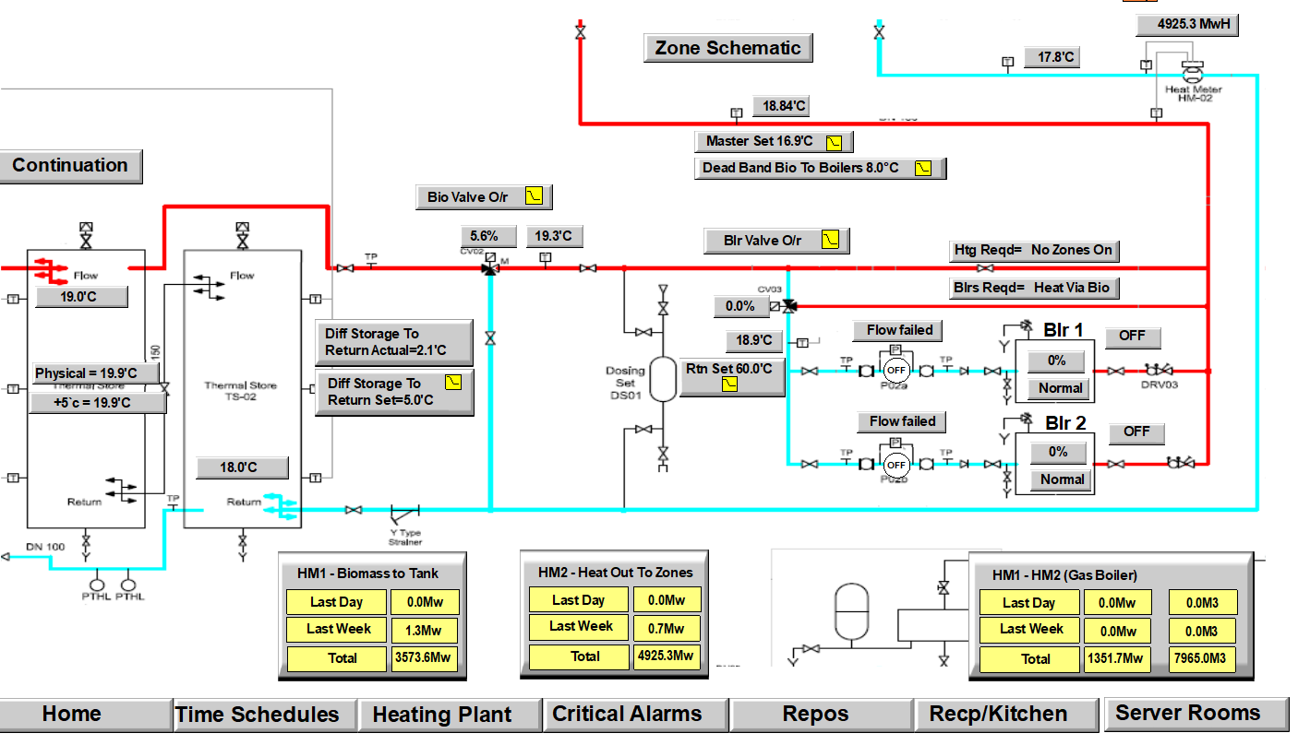
Source: Schneider (2022)
Heating Zone Distribution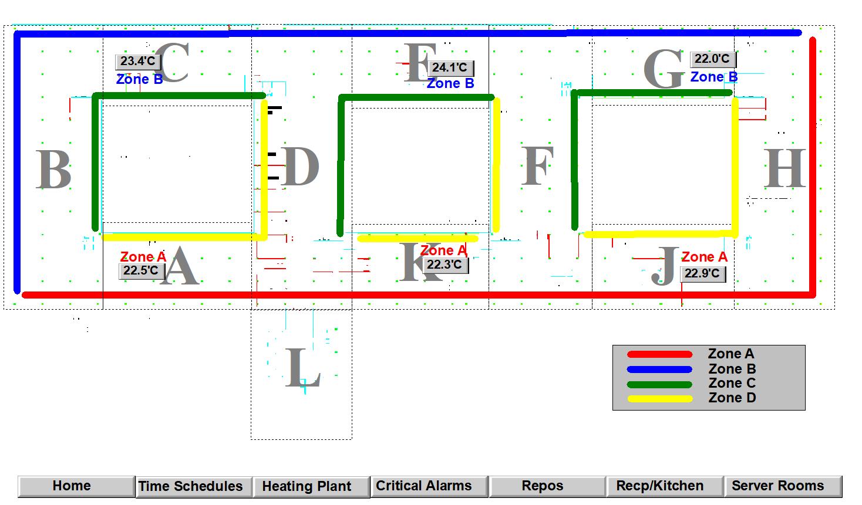 Source: Schneider (2022)
Heating Zone Distribution

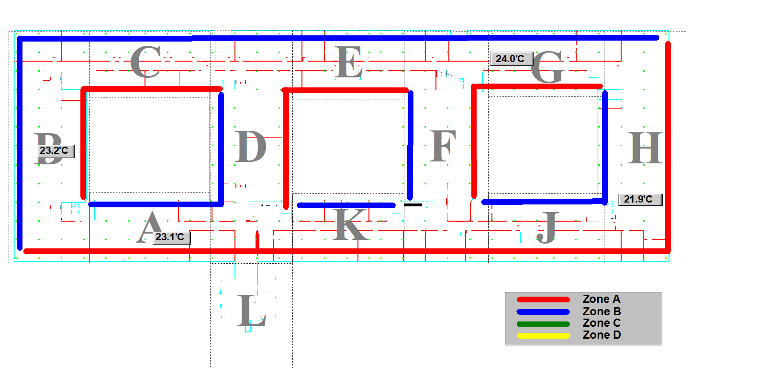
Source: Schneider (2022)

Heating Isolation and balancing valves (typical floor)
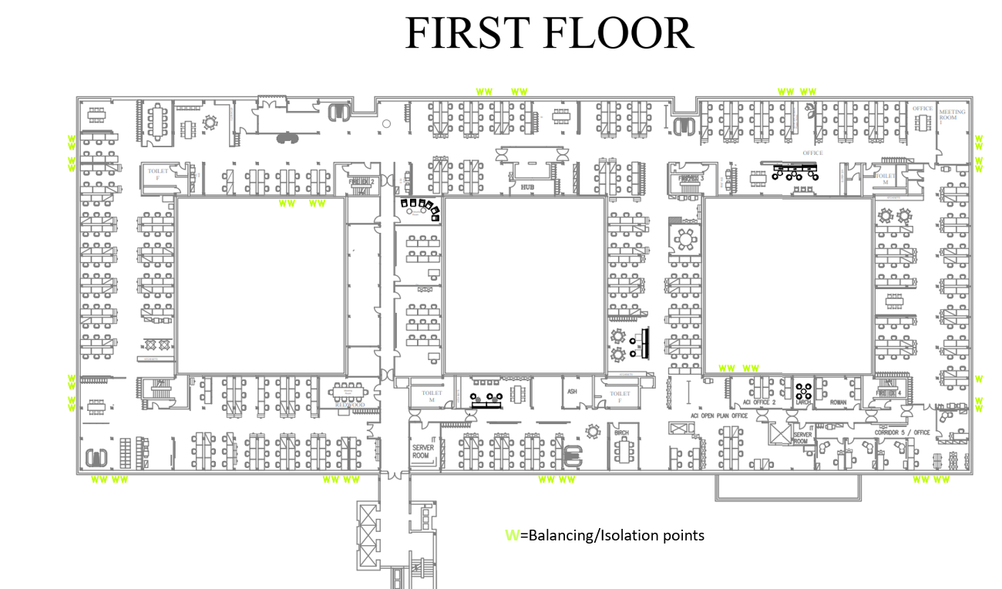

Source: Santia (2021)

6.2 Appendix 3
Weekly utility meter log-example
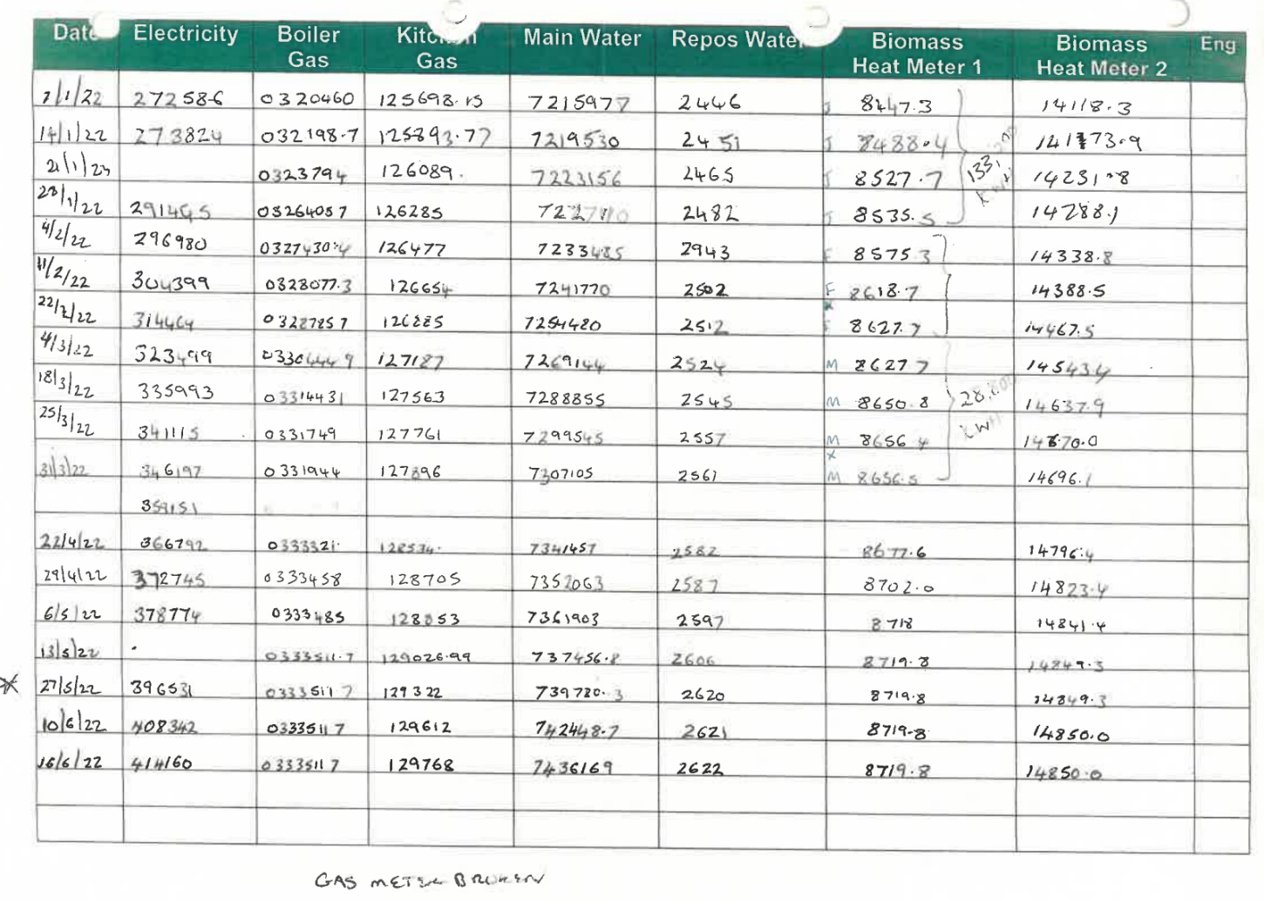

Source: Companies House (2022)

6.3 Appendix 4
Display Energy Certificate
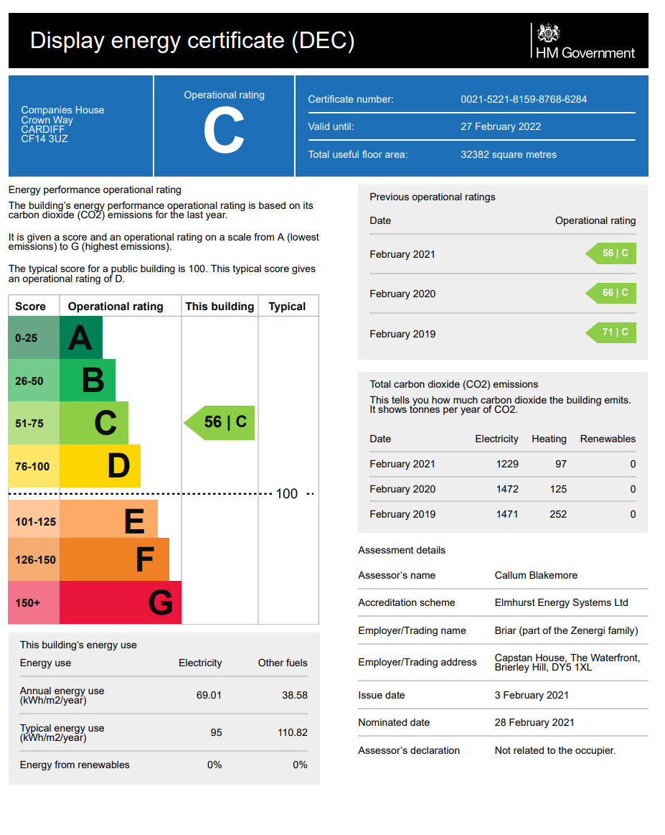

Source: Briar Associates (2021)

6.4 Appendix 5
Outstanding maintenance
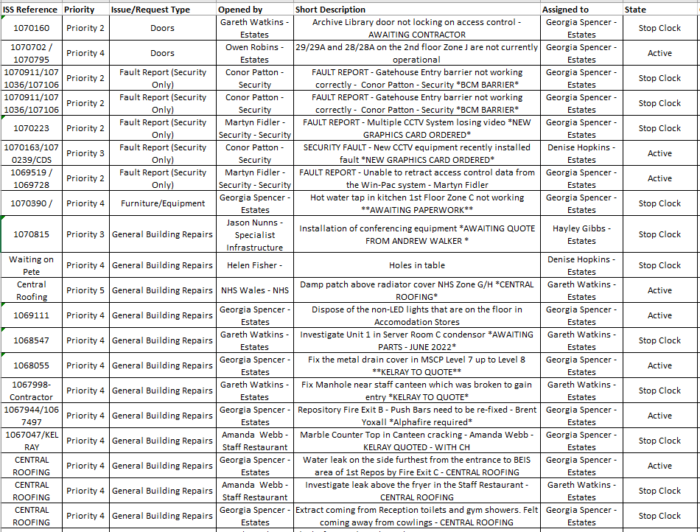
Source: Companies House (2022)

6.5 Appendix 6
Pipeline case study works
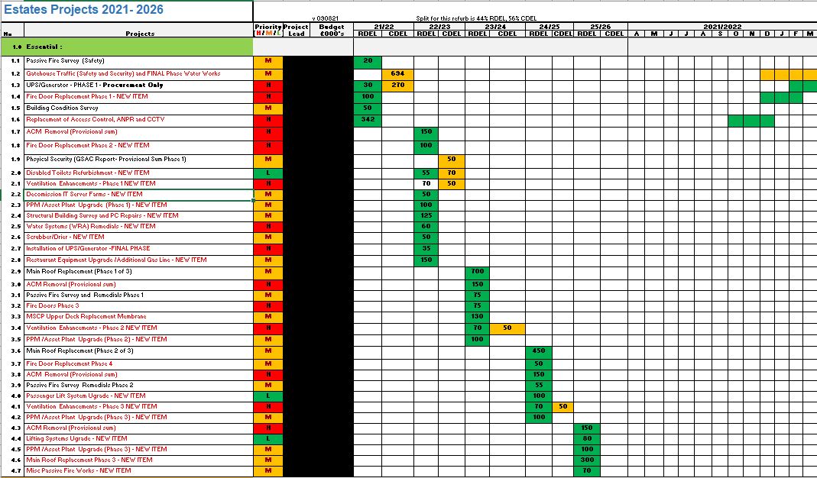

Source: Companies House (2022)

