
Master of Business Administration
LCMB7035 - Dissertation
ESG Communication, Pharmaceutical Innovation and Corporate Reputation in the Post-Pandemic Era: An Extended Literature Review with Comparative Insights from AstraZeneca plc and GSK plc
Student | Mohammed Nur Navi Jahin
Student ID | 2503765
Supervisor | Ebad Banissi
Assessment | Dissertation
Word Count | 16498
Submission date | 25 September 2026

Declaration
I declare that this dissertation is my own work and that all sources used have been acknowledged in accordance with UWTSD Harvard / Cite Them Right requirements. The dissertation has not been submitted, in whole or in part, for another academic award. All assistance, including permitted generative AI support, is disclosed in the following acknowledgement. I accept responsibility for the accuracy, originality and academic integrity of the submitted work.
Signed: Mohammed Nur Navi Jahin
Date: 2 September 2026

Acknowledgements
I would like to thank my supervisor, Ebad Banissi, for the detailed guidance that shaped the Extended Literature Review, strengthened the critical discussion and clarified the final dissertation structure. I also acknowledge the support of the UWTSD academic staff and library services in providing research guidance and access to scholarly materials. Finally, I am grateful to my family for their patience and encouragement throughout the project.

AI Use Acknowledgement
Generative AI was used for research planning, drafting support, language refinement, structural review and quality assurance. It was not used as a substitute for academic sources or independent analysis. All substantive claims, citations and interpretations were checked against the available source materials, and the student reviewed and accepts responsibility for the final work.

Abstract
This dissertation evaluates the conditions that dictate the association between social and governance communication, pharmaceutical innovation with corporative reputation in the post pandemic pharmaceutical sector. This analysis utilizes a structured Extended Literature Review. The review is informed by systematic-review principles as well as PRISMA 2020 reporting. The verified search base consists of 820 exported documents, which were derived from ScienceDirect and PubMed.After deduplication and screening, 15 studies were assessed and retained as 10 core and five contextual sources. Manual abductive thematic, conceptual and narrative synthesis was complemented by bounded comparative insights from AstraZeneca plc and GSK plc for 2022-2025. The review finds that neither communication nor innovation produces reputation directly. ESG communication has potential reputational relevance when claims are material, specific, balanced, comparable and aligned with conduct. Innovation has potential legitimacy value when scientific capability is translated into safe, accessible, affordable and responsive public value. Stakeholder, signalling, legitimacy and corporate reputation theories provide complementary explanations, while responsible innovation, institutional theory and dynamic capabilities clarify public value, context and capability. The AstraZeneca-GSK comparison identifies increasingly measurable narratives and different access strengths.However, company reports and one independent index cannot establish stakeholder opinion or reputational superiority. The dissertation contributes an evidence-informed conditional framework which connects communication quality and innovation capability to multiple factors, such as credibility, responsible public value, stakeholder evaluation, legitimacy and reputation.Apart from that, it also identifies organisational, stakeholder, institutional, communication and temporal boundary conditions. It recommends accountable claim governance, stable indicators and balanced disclosure.Furthermore, it also suggests responsible access planning and longitudinal multi-stakeholder testing.
Keywords: ESG communication; pharmaceutical innovation; corporate reputation; stakeholder trust; Extended Literature Review; AstraZeneca; GSK

List of Tables
Table 1.1. Literature gaps and the dissertation response | 3
Table 2.1. Research-onion alignment | 6
Table 2.2. Evidence hierarchy and decision rule | 8
Table 3.1. Profile of the formal academic corpus | 13
Table 3.2. Comparative theoretical contribution | 18
Table 3.3. Evidence-derived propositions concerning ESG communication | 23
Table 3.4. Pharmaceutical innovation taxonomy | 23
Table 3.5. Measures and the constructs they most plausibly capture | 28
Table 3.6. Descriptive AstraZeneca-GSK evidence base for Chapter 4 | 31
Table 3.7. Conditions affecting the proposed relationships | 32
Table 3.8. Status of the identified research gaps | 35
Table 4.1. Adjudication of core and supporting theoretical perspectives | 40
Table 4.2. Contradictions, explanations and boundary conditions | 42
Table 4.3. AstraZeneca and GSK: analytical comparison of matched evidence, 2022-2025 | 43
Table 4.4. Provisional propositions and future empirical testing | 47
Table 4.5. Synthesis of answers to the research questions | 47
Table 5.1. Evidence-linked managerial action framework | 53
Table A1. Search families | 72
Table B1. Common summary scoring | 72
Table C1. Evidence-to-theme examples | 73
Table D1. Symmetrical document comparison | 73
Table E1. Formal academic corpus: source fingerprints | 74
Table E2. Role of additional sources | 75

List of Figures
Figure 2.1. Evidence-to-concept review workflow | 7
Figure 2.2. PRISMA 2020 flow of the verified academic search | 10
Figure 2.3. Evidence-to-theme coding pathway | 11
Figure 3.1. Evidence-derived relational framework | 32
Figure 4.1. Evidence-informed integrative framework | 46
Figure 6.1. Final evidence-informed integrative framework | 61

List of Abbreviations
Abbreviation | Meaning
CSR | Corporate social responsibility
ELR | Extended Literature Review
ESG | Environmental, social and governance
FY | Financial year
KPI | Key performance indicator
PRISMA | Preferred Reporting Items for Systematic Reviews and Meta-Analyses
R&D | Research and development
RQ | Research question
SDG | Sustainable Development Goal
UK | United Kingdom

Table of Contents
Declaration I
Acknowledgements II
AI Use Acknowledgement III
Abstract IV
List of Tables V
List of Figures VI
List of Abbreviations VII
Chapter 1: Introduction 1
1.1 Background 1
1.2 Business Problem 2
1.3 Literature Gap 2
1.4 Research Aim 3
1.5 Research Objectives 3
1.6 Research Questions 4
1.7 Scope 4
1.8 Dissertation Structure 5
Chapter 2: Methodology of the Literature Review 6
2.1 Introduction and methodological positioning 6
2.2 Review questions and analytical framework 6
2.3 Scope and evidence hierarchy 7
2.4 Search strategy and information sources 8
2.5 Eligibility, screening and PRISMA reporting 9
2.6 Quality appraisal and evidence weighting 10
2.7 Extraction and manual abductive synthesis 11
2.8 Comparative company protocol, trustworthiness and ethics 11
2.9 Limitations and chapter summary 12
Chapter 3: Thematic Literature Review 13
3.1 Introduction, scope and evidence boundary 13
3.2 Theoretical foundations and comparative explanatory value 14
3.2.1 Stakeholder theory: audiences, obligations and unequal influence 14
3.2.2 Legitimacy theory: acceptance, conformity and repair 15
3.2.3 Signalling theory: information asymmetry and credibility 16
3.2.4 Corporate reputation theory: accumulated and comparative evaluation 16
3.2.5 Supporting lenses: capabilities, institutions and responsible innovation 17
3.3 ESG communication: from reporting volume to credible stakeholder communication 18
3.3.1 Reporting evolution and materiality 19
3.3.2 Disclosure quantity, quality and comparability 19
3.3.3 Credibility, selective disclosure and the claim-action relationship 20
3.3.4 Engagement, digital communication and contestability 22
3.4 Pharmaceutical innovation, responsibility and public value 23
3.4.1 Innovation capability and distributed ecosystems 23
3.4.2 Responsible innovation and public value 24
3.4.3 Access, affordability and the COVID-19 legacy 25
3.4.4 The limited direct evidence on innovation and reputation 26
3.5 Corporate reputation, trust and related constructs 27
3.6 Integrating ESG communication, pharmaceutical innovation and reputation 29
3.6.1 Complementarity, tension and reciprocal pathways 29
3.6.2 Comparative illustrations from AstraZeneca and GSK 30
3.6.3 Evidence-derived relational framework 31
3.7 Research gaps and implications for the dissertation 33
3.7.1 Theoretical integration gap 33
3.7.2 Measurement and methodological gap 33
3.7.3 Sector, geographic and temporal gap 34
3.7.4 Disclosure and adverse-evidence gap 34
3.7.5 Comparative and managerial gap 34
3.8 Chapter conclusion 35
Chapter 4: Discussion 37
4.1 Introduction 37
4.2 RQ1: ESG communication after COVID-19 37
4.3 RQ2: Innovation, trust and legitimacy 38
4.4 Comparative evaluation of theoretical explanations 40
4.5 Contradictions and boundary conditions 41
4.6 AstraZeneca and GSK: comparative interpretation 42
4.7 Refinement of the conceptual framework 45
4.8 Provisional theoretical propositions 47
4.9 Summary 47
Chapter 5: Implications 49
5.1 Introduction 49
5.2 Theoretical implications 49
5.3 Managerial implications 51
5.3.1 Govern communication as an accountability system 51
5.3.2 Connect innovation management to responsible public value 51
5.3.3 Preserve measurement continuity and managerial ownership 52
5.4 Policy and reporting implications 54
5.5 Implications for responsible pharmaceutical innovation 55
5.6 Future research implications 56
5.7 Chapter summary 57
Chapter 6: Conclusion 58
6.1 Introduction 58
6.2 Overall conclusion against the aim and objectives 58
6.3 Conclusions by research question 58
6.4 Contribution of the dissertation 59
6.5 Limitations 60
6.6 Final framework and empirical testing 60
6.7 Final conclusion 61
References 62
Appendices 72
Appendix A: Linked search families and operational status 72
Appendix B: Seven-domain summary rubric 72
Appendix C: Worked coding examples 73
Appendix D: AstraZeneca-GSK comparison protocol 73
Appendix E: Formal academic corpus and analytical fingerprints 73

Chapter 1: Introduction

1.1 Background
The pharmaceutical sector holds a unique position in society. Pharmaceutical companies generate monetary profit by conducting scientific research and maintaining business activities. On the other hand, these companies can have a tremendous impact on public health, cost of healthcare and access to treatment. During the lockdown period of COVID-19, the world encountered advancement in scientific capabilities as it developed medicine and created rapid vaccines to tackle the pandemic. This timeline also exposed the urgent need of public investment, regulatory coordination, manufacturing capacity, and global distribution. This period triggered a massive debate on intellectual property, affordability and unbiased access (Wouters et al., 2021; Gold, 2022). As a result, the pharmaceutical sector became an indicator of technical competence and also an area of social investigation.
The post-pandemic environment ensured that this investigation was not just a mere emergency response. Stakeholders gave greater attention to how pharmaceutical companies address environmental, social and governance (ESG) responsibilities alongside innovation. ESG communication includes sustainability and annual reports, access commitments, governance disclosures and digital communication. It may reduce information asymmetry and explain how scientific activity contributes to public value. However, communication does not establish performance. ESG ratings differ because providers use different scopes, measurements and weightings (Berg, Kölbel and Rigobon, 2022).On the other hand, pharmaceutical reports may omit or marginalise adverse controversies (Schwoy, Dutzi and Messing, 2025). The credibility of ESG reporting is contingent upon specificity, balance, and consistency with conduct.
Corporate reputation is not equivalent to marketing or immediate image. It develops through accumulated stakeholder evaluations of a firm and its expected conduct (Fombrun and Shanley, 1990; Barnett, Jermier and Lafferty, 2006). A range of players, such as healthcare professionals, regulators, employees, investors, governments and communities may apply different standards. Innovation may support perceptions of competence. On the other hand, concerns about pricing, safety, transparency and access may weaken trust in corporate motives. Legitimacy concerns whether conduct is socially acceptable and is related to, but distinct from, comparative reputation (Suchman, 1995; Deephouse and Carter, 2005). The post-pandemic problem is therefore how stakeholders interpret corporate claims, technical capability, responsible conduct and public value after the exceptional visibility of the pandemic response.

1.2 Business Problem
Pharmaceutical organisations increasingly include innovation, access, sustainability and social value in corporate reporting. Three uncertainties may complicate this practice. First, communication creates visibility although does not verify performance. Second, innovation indicates technical capability. However, it is insufficient to establish responsible public value. Third, stakeholders may apply different priorities and evidence when evaluating reputation. A meta-analysis identifies a generally positive association between sustainability disclosure and corporate reputation, although it varies by national context, research design and reputation measure (Pajuelo-Moreno, Barroso-Méndez and Gallardo-Vázquez, 2024). Recent pharmaceutical evidence also associates ESG controversies with reputational risk, although market responses may change according to issue and firm characteristics (Akyildirim et al., 2026).
Managers must make a decision on what to communicate and how to substantiate claims.They should also decide how to address different stakeholder expectations without overstating outcomes. Communication which exceeds performance may generate scepticism.On the other hand, innovation narratives that ignore affordability and access may privilege commercial achievement over social responsibility. Conversely, limited communication may prevent stakeholders from evaluating genuine contributions.As a result, understanding when ESG communication and innovation may support trust, legitimacy and reputation emerge as a strategic and societal problem.

1.3 Literature Gap
Existing literature provides significant but incomplete explanations. ESG studies regularly analyse disclosure, financial performance and corporate reputation without addressing pharmaceutical innovation. Innovation research often prioritises R&D productivity, patents and collaboration. However, it does not examine how public value is communicated and evaluated. Pharmaceutical studies commonly examine factors such as access, CSR, vaccine trust or individual stakeholder groups separately. Theoretical studies apply stakeholder, legitimacy and signalling perspectives but less often integrate them with corporate reputation theory and responsible innovation.
The resulting gaps and the dissertation's response are summarised below.
Table 1.1. Literature gaps and the dissertation response
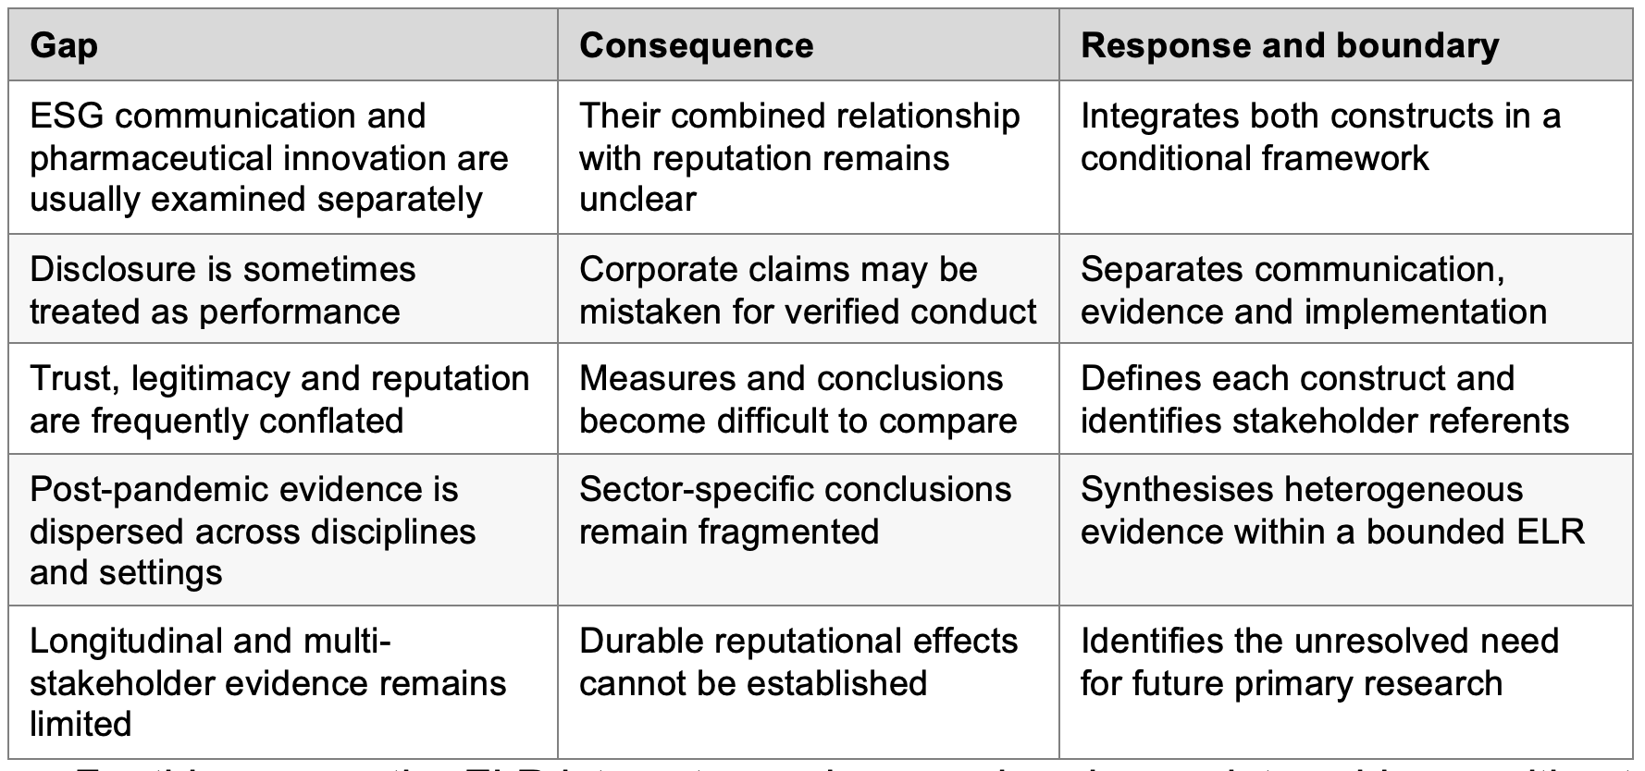
For this reason, the ELR integrates and reorganises incomplete evidence without claiming to close gaps that require longitudinal or multi-stakeholder primary data. Its contribution is conditional: ESG communication quality and responsible innovation may inform corporate reputation through stakeholder-specific trust and legitimacy judgements. AstraZeneca plc and GSK plc provide comparative illustrations of organisational positioning, but their reports are treated as corporate claims rather than evidence of stakeholder opinion.

1.4 Research Aim
To critically evaluate how ESG communication and pharmaceutical innovation contribute to corporate reputation in the post-pandemic pharmaceutical sector, using a structured Extended Literature Review and comparative illustrations from AstraZeneca plc and GSK plc.

1.5 Research Objectives
1. Critically review the evolution of ESG communication within the pharmaceutical sector.
2. Critically examine the conditions under which pharmaceutical innovation may contribute to stakeholder trust and corporate reputation.
3. Analyse the theoretical relationships between ESG communication, legitimacy, signalling, stakeholder engagement and corporate reputation.
4. Critically evaluate current debates and inconsistencies within the literature.
5. Develop an integrated and conditional conceptual framework explaining how ESG communication and innovation may jointly contribute to corporate reputation.
6. Identify implications for pharmaceutical managers and future research.

1.6 Research Questions
The primary research question is:
How and under what conditions are ESG communication and pharmaceutical innovation associated with corporate reputation in the post-pandemic pharmaceutical sector?
The supporting questions are:
1. How has ESG communication evolved within the pharmaceutical sector following COVID-19?
2. Under what conditions may pharmaceutical innovation contribute to stakeholder trust and organisational legitimacy?
3. What theoretical perspectives best explain the relationship between ESG communication and corporate reputation?
4. What major debates and research gaps remain?
5. How can ESG communication and innovation be integrated into a conceptual model of corporate reputation?

1.7 Scope
The primary comparative period for AstraZeneca and GSK is limited within the timeline 2022-2025 as it demonstrates transformation from instant emergency response to a long-term narrative buildup, which includes factors, such as, ESG commitments, innovation, access, preparedness and reputation. It should be considered as a study boundary not a proposition that pandemic was over universally in 2022. Only up-to-date and available publications and company documents from 2026 have been utilized for this analysis. Hence 2026 should not be considered as a complete reporting year.
The study uses public secondary evidence and does not collect personal or confidential participant data. AstraZeneca and GSK provide comparative illustrations of reporting and selected outcomes, not evidence of reputation effects. The ELR analyses patterns, contradictions and plausible mechanisms. Heterogeneous methods and reputation measures prevent statistical aggregation and strong causal conclusions.

1.8 Dissertation Structure
Chapter 2 explains the ELR design, documented search process, eligibility criteria, quality appraisal, manual extraction and abductive thematic and narrative synthesis. Chapter 3 develops the thematic evidence base concerning ESG communication, pharmaceutical innovation, corporate reputation and research gaps; it also presents an initial relational framework. Chapter 4 answers the research questions through critical discussion, examines contradictions and boundary conditions, compares AstraZeneca and GSK and refines the framework. Chapter 5 develops theoretical, managerial, policy, reporting and responsible-innovation implications. Chapter 6 consolidates the answers, contribution, limitations and priorities for future testing.

Chapter 2: Methodology of the Literature Review

2.1 Introduction and methodological positioning
This chapter demonstrates the process in which evidence was selected, categorized, appraised and synthesized in order to study ESG communication, pharmaceutical innovation and corporate reputation. A structured extended literature review(ELR) based on systematic-review principles was utilized to build a connection between heterogeneous management, communication and pharmaceutical studies without applying a detailed and complete systematic review (Tranfield, Denyer and Smart, 2003; Grant and Booth, 2009; Snyder, 2019).
Saunders, Lewis and Thornhill (2019) provide the broader design logic. On the other hand, review-specific methods guide the procedure. The study is interpretive and uses an abductive approach. Stakeholder, legitimacy, signalling and corporate reputation theories sensitised the initial reading. Recurring and contradictory patterns refined the conceptual explanation. The review is a qualitative, mono-method, secondary documentary study with a cross-period analytical horizon.
Table 2.1. Research-onion alignment
Layer | Decision | Application
Philosophy | Interpretivism | Examines how responsibility, innovation and reputation are represented and evaluated
Approach | Abduction | Moves iteratively between theory, evidence, contradiction and framework refinement
Choice | Qualitative mono-method | Synthesises textual and documentary evidence without statistical aggregation
Strategy | Structured ELR | Uses documented searching, screening, appraisal and synthesis
Time horizon | Cross-period | Academic evidence from 2015-2026; comparative analysis centred on 2022-2025
Techniques | Manual extraction and synthesis | Preserves source-linked decisions and researcher judgement

2.2 Review questions and analytical framework
The primary question asks: How and under what conditions are ESG communication and pharmaceutical innovation associated with corporate reputation in the post-pandemic pharmaceutical sector? The supporting questions address multiple factors, such as ESG communication, innovation, trust, explanatory theories, debates, gaps, and an integrated model.
In management research, CIMO connects context, interventions or focal practices, mechanisms and outcomes (Denyer, Tranfield and van Aken, 2008). Here, the pharmaceutical sector and post-pandemic transition form the context; ESG communication and pharmaceutical innovation are the focal practices; credibility, trust, stakeholder interpretation and legitimacy are possible mechanisms; and corporate reputation is the outcome. CIMO structures extraction but does not predetermine the themes.
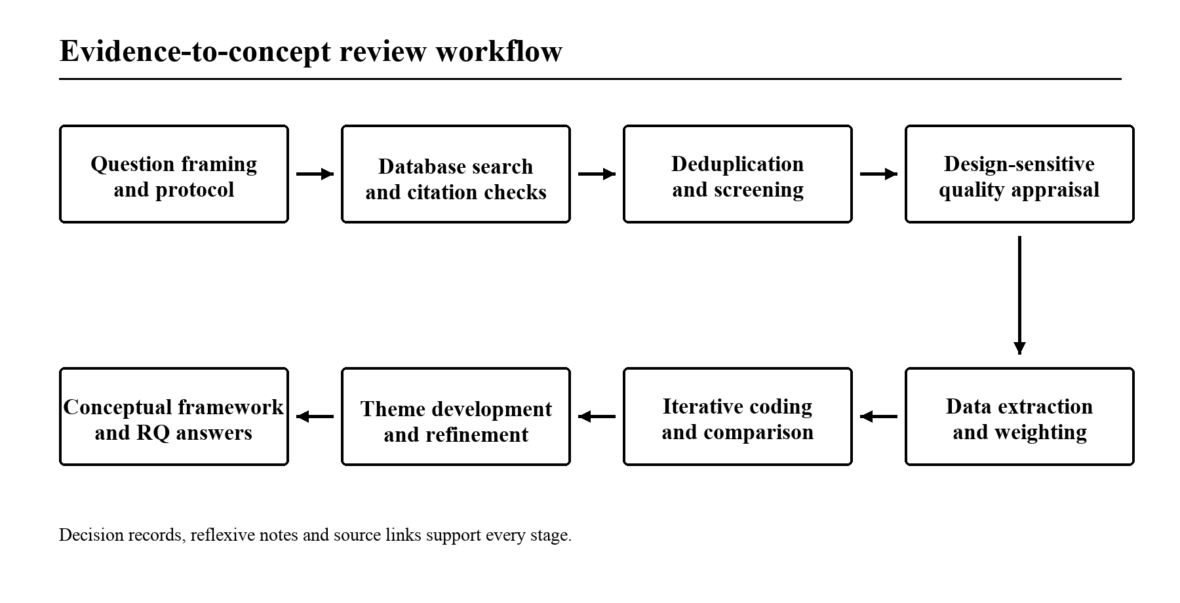
Figure 2.1. Evidence-to-concept review workflow
Note: The process was supported by preserved exports, screening decisions, appraisal records, extraction notes and source-linked coding.

2.3 Scope and evidence hierarchy
The academic search window is limited between 2015 and 2026.It allows pre-pandemic context and later developments. The company comparison was operationally limited to 2022-2025.The goal was to capture movement from emergency response towards longer-term ESG, innovation and reputation narratives. This is a study boundary.It is not a claim that the pandemic ended universally in 2022. Material published in 2026 was treated only as available-to-date evidence.
Five evidence roles were kept distinct. All 15 assessed studies entered the thematic synthesis.Out of these 15 studies, 10 core studies received greater direct interpretive weight.On the other hand, five contextual studies were used mainly to explain mechanisms or transferable tensions. Supporting empirical literature extended the discussion without entering the formal PRISMA corpus. Foundational theory and methodology defined concepts and procedures.Apart from that, independent assessments calibrated selected corporate claims.AstraZeneca and GSK reports represented organisational positioning instead of stakeholder opinion.
Table 2.2. Evidence hierarchy and decision rule
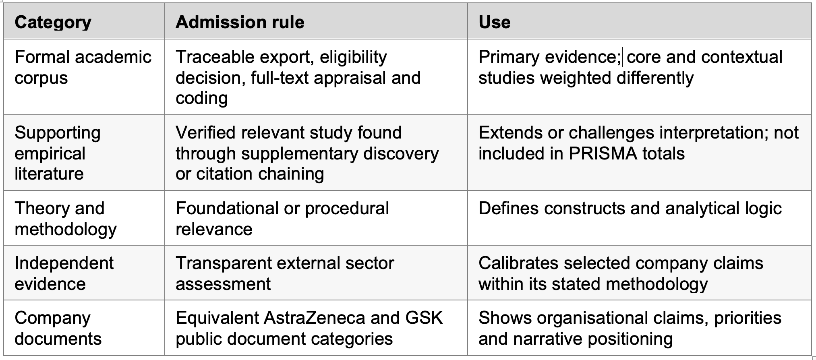

2.4 Search strategy and information sources
The tested formal search, utilized connected factors, such as, ESG-communication, pharmaceutical-sector and reputation-related concepts. The ScienceDirect adaptation was ("ESG communication" OR "sustainability communication" OR "sustainability reporting") AND (pharmaceutical OR "life sciences") AND ("corporate reputation" OR legitimacy OR credibility OR trust).A PubMed adaptation which corresponds to the search, was recorded. Broader innovation and theory searches were applied but generated poor results due to unstable pagination and fragmented exports. As a result, the study accepted three connected search families as a transparent sensitivity framework instead of demonstrated as three completed formal searches. Their terms and operational status are included in Appendix A.
The verified exports contained 807 ScienceDirect and 13 PubMed records. Scorpus, Web of Science, Emerald and Business Source Premier did not produce traceable exports through the available institutional route. Business Source Complete produced one separately preserved candidate. However, it was not admitted because substitution for the registered database had not been approved. Google Scholar supported supplementary discovery and citation checking only (Gusenbauer and Haddaway, 2020). The formal evidence base is consequently transparent although weighted towards one publisher platform and one biomedical database. This may underrepresent management, reputation and communication research.

2.5 Eligibility, screening and PRISMA reporting
Eligible studies were peer-reviewed English-language publications from 2015-2026 addressing at least two central constructs or making a strong theoretical or pharmaceutical-sector contribution. Relevant reviews and conceptual studies were included when they offered analysable evidence or explicit synthesis. Conference abstracts, non-research opinion, blogs, promotional material, duplicates, out-of-period records and studies without a sufficiently direct relationship to the questions were excluded. Foundational sources, company documents and independent assessments were analysed outside the formal corpus.
Deduplication used DOI, title, author and year, followed by manual checking. The verified exports contained 820 records; one duplicate was removed, leaving 819 records for title-and-abstract screening. Of these, 803 were excluded: 695 lacked a sufficiently direct relationship, 62 were outside the publication boundary and 46 did not meet the publication-type requirement. Sixteen reports were sought for retrieval; one was not retrieved. Fifteen full texts were assessed and retained as 10 core and five contextual studies. PRISMA 2020 reports this verified flow without implying that inaccessible databases were searched successfully (Page et al., 2021).
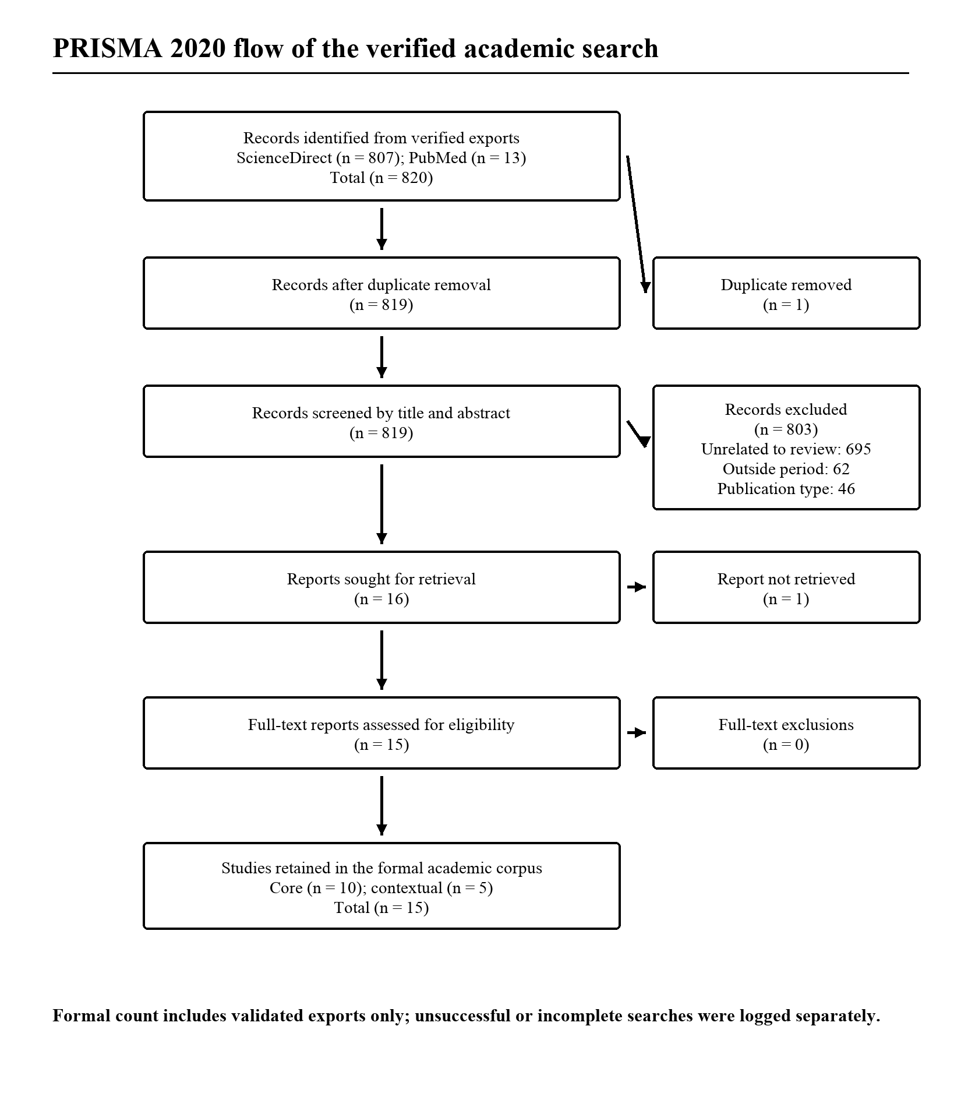
Figure 2.2. PRISMA 2020 flow of the verified academic search
Note: One duplicate was removed from 820 exported records. The unretrieved report was not appraised or included.
One reviewer completed screening. Written criteria, a second-pass check of uncertain records, recorded reasons and a preserved decision trail reduced inconsistency, but inter-reviewer agreement cannot be claimed.

2.6 Quality appraisal and evidence weighting
Quality appraisal combined design-sensitive prompts with a common seven-domain summary. Qualitative and documentary studies were considered against CASP-informed principles; mixed-method studies against MMAT; quantitative observational studies against relevant JBI principles; and literature reviews against adapted AMSTAR 2 criteria (Critical Appraisal Skills Programme, 2018; Shea et al., 2017; Hong et al., 2019; JBI, 2026). These tools informed design-appropriate questions rather than interchangeable numerical scales.
In order to conduct cross study comparison, every source was given 0 to 2 points for factors, such as, aim clarity, design suitability, corpus transparency, analytical rigour, evidential support, limitations and relevance, which can result in a maximum of 14 points. Scores of 11-14 were classified as high, 7-10 as moderate and 0-6 as low. Twelve studies were high quality and three moderate. Scores guided interpretive weight rather than certainty: stronger direct evidence informed principal conclusions, while moderate, indirect or context-specific evidence was qualified and contradictory evidence retained.

2.7 Extraction and manual abductive synthesis
Extraction recorded a plethora of elements, such as publication details, context, design, stakeholder group, communication channel, innovation type, theoretical lens, reputation-related construct, findings, limitations, appraisal and research-question links. Thomas and Harden's (2008) thematic synthesis supported movement from evidence units to descriptive and analytical themes. Braun and Clarke (2006) informed reflexive reading, comparison and theme refinement. Narrative synthesis explained methodological and contextual variation rather than forcing unlike outcomes into a common effect (Popay et al., 2006).
The analysis moved iteratively between deductive sensitising concepts and inductive codes. The preserved chain is as described here: evidence unit -> initial code -> descriptive category -> analytical theme -> research question -> interpretive conclusion. Appendix C provides worked examples from the formal corpus. Conceptual relationships are presented as conditional propositions
Figure 2.3. Evidence-to-theme coding pathway

2.8 Comparative company protocol, trustworthiness and ethics
Equivalent segments derived from authorized company reports were chosen symmetrically. These sections include innovation, ESG or sustainability priorities, access commitments and governance. Each of these factors were analyzed in consideration of multiple aspects,such as claim specificity, evidential support, acknowledged constraints, comparability and relevant independent calibration. The protocol is included in Appendix D. Legitimacy and impression-management may be achievable by corporate narratives, although it is not sufficient enough to describe reputation (Suchman, 1995; Merkl-Davies and Brennan, 2007).
Credibility is contingent upon evidence linked with source. It also relies upon retention of disconfirming material. Dated protocol and decision records are required for dependability.On the other hand, transferability is contingent upon explicit sector, period and source boundaries.Lastly, confirmability depends on reflexive notes and traceable interpretation (Lincoln and Guba, 1985). The study utilizes only public secondary material.It does not use any participant or confidential personal data. Ethical practice requires accurate attribution and copyright-respecting use.It also demands clear separation of corporate claims from independent evidence.

2.9 Limitations and chapter summary
The narrow verified database may play a significant role in redirecting the review towards biomedical and publishers-specific literature. A small corpus can prove to be a limiting factor for thematic saturation. On the other hand, eligibility based on only English language may restrict geographic breadth.Lastly, limited direct stakeholder evidence weakens conclusions about reputation. Single-reviewer decisions increase selection risk.Meanwhile, heterogeneous methods prevent statistical aggregation.Along with that, company reporting may prove to be overrepresening intended legitimacy strategies. These constraints reduce breadth and confidence, particularly for management communication and stakeholder response.However,they do not invalidate a bounded, transparent ELR.
This method promotes a careful abductive synthesis based on 15 appraised formal studies and distinctive supplementary evidence. Chapter 3 implements the hierarchy and builds source quality.It also construct boundaries.

Chapter 3: Thematic Literature Review

3.1 Introduction, scope and evidence boundary
This chapter critically synthesises literature concerning ESG communication, pharmaceutical innovation and corporate reputation in the post-pandemic pharmaceutical sector. It follows the Extended Literature Review which was described in Chapter 2. It is organised thematically instead of as an author-by-author catalogue. The discussion moves from theoretical foundations to several aspects, namely, ESG communication, pharmaceutical innovation, corporate reputation. It also develops into integration of the concepts and the gaps that justify the dissertation's conceptual contribution.
The formal academic corpus consists of 15 evaluated full-text sources. Out of these 15 studies, ten are considered core studies and five are considered contextual studies. The concepts and procedures are defined by theory and methodology. Independent evaluations provide external context. These source roles remain distinctive throughout the analysis.
Table 3.1. Profile of the formal academic corpus
ID | Year | Country or context | Design | Sector | Principal construct | Quality
SCR-0001 | 2025 | International listed firms | Documentary content analysis | Pharmaceutical and textile | ESG controversy disclosure | High
SCR-0019 | 2024 | Multinational | Cross-sectional secondary analysis | Life sciences | ESG and innovation resources | High
SCR-0037 | 2023 | Ghana | Two-wave buyer survey | Pharmaceutical | Environmental reputation and satisfaction | High
SCR-0072 | 2023 | Belgium | Mixed exploratory study | Cross-sector | Materiality and SDG priorities | High
SCR-0075 | 2019 | Multinational reports | Documentary content analysis | Pharmaceutical | CSR reporting consistency | High
SCR-0089 | 2025 | Pharmaceutical reporting | Document-based analytical roadmap | Pharmaceutical | ESG assessment and governance | Moderate
SCR-0096 | 2017 | Sweden | Longitudinal qualitative case | Non-pharmaceutical | Reporting tensions | High
SCR-0116 | 2024 | Italy | Bibliometric and automated document analysis | Pharmaceutical and chemical | Sustainability disclosure | High
SCR-0117 | 2017 | India-focused | Exploratory literature review | Pharmaceutical | Sustainable practices | Moderate
SCR-0125 | 2023 | Buyer-supplier setting | Mixed textual and quantitative analysis | Chemical and pharmaceutical | Responsibility communication | High
SCR-0155 | 2018 | United States | Comparative content analysis | Pharmaceutical | CSR and external framing | High
SCR-0330 | 2021 | International literature | Literature review | Pharmaceutical | CSR and organisational performance | High
SCR-0538 | 2021 | Belgium | Comparative indicator analysis | Pharmaceutical and retail | SDG indicator alignment | High
SCR-0590 | 2017 | United States | Mixed organisational case | Biotechnology | Circular-economy measurement | Moderate
SCR-0808 | 2025 | Multinational reports | Comparative document analysis | Pharmaceutical and cosmeceutical | Climate-target comparability | High
Twelve out of fifteen studies were scored with a high evaluation rating and the other three were scored with a moderate rating. Quality cannot resolve contextual limits. Multiple high rated studies are not considered direct as they are cross-sector, pre-pandemic and they are focused on a narrow stakeholder group. As a result, the synthesis attributes, highest priority to high-quality and direct pharmaceutical evidence. Moderate and contextual studies are utilized to solidify qualified explanations instead of being included in principal conclusions.
The academic timeline is 2015-2026. Prior studies contribute in providing context and studies published in 2026 consist of available-to-date updates. The main comparative period begins from 2022 and extends until 2025. This period contributes in capturing transition from emergency communication towards long-term ESG, innovation, public-value, trust and reputation narratives. This is not a historical endpoint, rather a study boundary.
The analysis is guided by three distinctive factors. ESG communication does not refer to ESG performance. Credibility of a report, website or post is contingent upon evidence, balance and conduct. Innovation capability is separated from responsible innovation and public value due to the fact that technical competence does not by itself demonstrate affordability, access, safety or responsiveness. Corporate reputation is separated from multiple factors, such as identity, image, legitimacy and trust. The question is not whether more communication or innovation automatically produces better reputation. Instead, the question is under what conditions the evidence supports an association.

3.2 Theoretical foundations and comparative explanatory value

3.2.1 Stakeholder theory: audiences, obligations and unequal influence
Stakeholder theory focuses on players, such as healthcare professionals, employees, investors, regulators, governments, partners and patients who either impact or are impacted by pharmaceutical policies (Freeman, 1984). Donaldson and Preston's (1995)distinction which is descriptive, normative and instrumental, demonstrates the reason why communication can map audiences, increase cooperation, or recognize commitments beyond reputational benefit. Mitchell, Agle and Wood’s (1997) salience model includes power, legitimacy, and urgency, although it does not equate managerial priority with moral entitlement. Stakeholders equipped with legitimate access or safety concerns may demonstrate limited influence. As a result, involvement may include genuine learning or support a predetermined position (Greenwood, 2007).
Contextual evidence with high scores align with this caution. Beyne and Moratis (2023) proves that materiality and SDG priorities may change, depending upon stakeholder priorities, capacity and communication constraints. Frostenson and Helin (2017) encounter frictions between financial rationality, sustainability, and selective reporting. Neither study proves that reporting is neutral or that stakeholder needs determine decisions. Pirson and Malhotra (2011) establish further distinction between competence, integrity, transparency, and benevolence in stakeholder trust. Stakeholder theory categorizes evaluators and commitments. However, it does not explain signal credibility and the distinction between social acceptance and comparative reputation.

3.2.2 Legitimacy theory: acceptance, conformity and repair
Legitimacy is achieved through determining whether conduct is considered as desirable or appropriate within socially constructed norms. Suchman(1995) demonstrates a distinction between pragmatic, moral and cognitive legitimacy. Regulatory authorization cannot resolve moral disputes regarding pricing, trial inclusion, environmental harm and data integrity. ESG communication can establish conformity or support recovery after controversy although external evidence along with stakeholder experience, can either validate or contradict it.
Legitimacy does not indicate reputation. Deephouse and Carter (2005) establish a distinction between comparative standing and social acceptance. A firm may be authorized as a pharmaceutical producer, although it may lack preferability or credibility in comparison with other competitors. Evidence with high scores reinforces the distinction. According to Schwoy, Dutzi and Messing (2025), some ESG controversies manifested repetition and some were confined to legal sections or even omitted. Frostenson and Helin (2017) demonstrates the influence of competing logic in shaping reporting. These findings show that publication of a sustainability report is not sufficient to establish legitimacy.

3.2.3 Signalling theory: information asymmetry and credibility
Signalling theory explains communication under information asymmetry. Observable signals may communicate hidden qualities, although their value depends on the signaller, receiver, cost, observability, consistency and environment (Spence, 1973; Connelly et al., 2011). This becomes important where non-specialists cannot directly evaluate a range of aspects, such as discovery, trials, manufacturing controls or long-term impact. ESG metrics, access plans, clinical evidence and assurance may signal competence or responsibility. On the other hand, vague or easily imitated claims discriminate less effectively. Prior conduct also changes reception as expectation violations affect reliance on later signals (Gomulya and Mishina, 2017).
The formal evidence identifies specific credibility conditions. The moderate-rated roadmap by Singh and Kumar (2025) links credibility to policies, actions, certification, outcomes and governance. However, it does not independently verify implementation. High-rated studies show variation in target boundaries and reporting categories (Calciolari, Cesarini and Ruberti, 2024; Grant et al., 2025). Signalling theory explains why specificity and verification matter. Meanwhile, stakeholder theory is needed to identify the receiver and legitimacy theory to assess normative acceptance. Lastly, reputation theory is useful for explaining accumulated evaluation.

3.2.4 Corporate reputation theory: accumulated and comparative evaluation
Reputation theory determines the main outcome. Reputation develops on the basis of stakeholders’ interpretation of different signals(Fombrun and Shanley, 1990). Prominence is not the same as recognition for a valued quality(Rindova et al., 2005). Factors, such as, observer judgement, familiarity, expectations and favorability demonstrate relationships, although they are distinct factors(Barnett, Jermier and Lafferty, 2006; Lange, Lee and Dai, 2011). As a result, reputation emerges as an accumulative and stakeholder specific phenomena. There exists a difference of value between elements, such as, media visibility, investor evaluation and patient loyalty (Walker, 2010; Ponzi, Fombrun and Gardberg, 2011).
The high-rated formal study by Opoku, Adomako and Tran (2023) provides one bounded mechanism: among pharmaceutical-firm buyers in Ghana, environmental reputation was associated with satisfaction and performance, with ethical behaviour moderating and satisfaction mediating the pathway. This supports stakeholder-specific evaluation but does not measure corporate communication, represent all audiences or establish a sector-wide causal effect.

3.2.5 Supporting lenses: capabilities, institutions and responsible innovation
The resource-based review considers elements, such as knowledge, R&D routines, partnership networks and relational credibility as resources with extreme potential(Barney, 1991). Dynamic-capabilities theory emphasizes sensing, seizing and reconfiguration in response to changing environments(Teece, Pisano and Shuen, 1997; Teece, 2007). Both of these studies demonstrate the process in which pharmaceutical firms develop a combination of science, manufacturing, partnerships, and regulation during disruption.
These perspectives may also instrumentalise stakeholders. A capability can be commercially valuable without being socially legitimate, and reputation is conferred by external evaluators rather than owned by the company. Responsible-innovation theory consequently adds anticipation, reflexivity, inclusion and responsiveness (Stilgoe, Owen and Macnaghten, 2013), directing attention to whose needs are addressed, whose risks are accepted and whether innovation systems respond when evidence or social priorities change.

Institutional theory explains the reason behind firm’s utilization of similar ESG formats. DiMaggio and Powell categorize factors, such as, coercive, mimetic and normative pressures. It also determines regulation, professional standards, and peer reporting. Similarity can produce better comparability, but it may also generate standardized language without significant change. Dynamic capabilities demonstrate adaptation from an organizational perspective. Institutional theory provides explanations on conformity and diffusion. Responsible innovation investigates the alignment between capability and anticipation, inclusion and responsiveness. The central explanatory architecture consists of stakeholder theory, signaling theory, legitimacy theory and corporate reputation theory.

Table 3.2. Comparative theoretical contribution
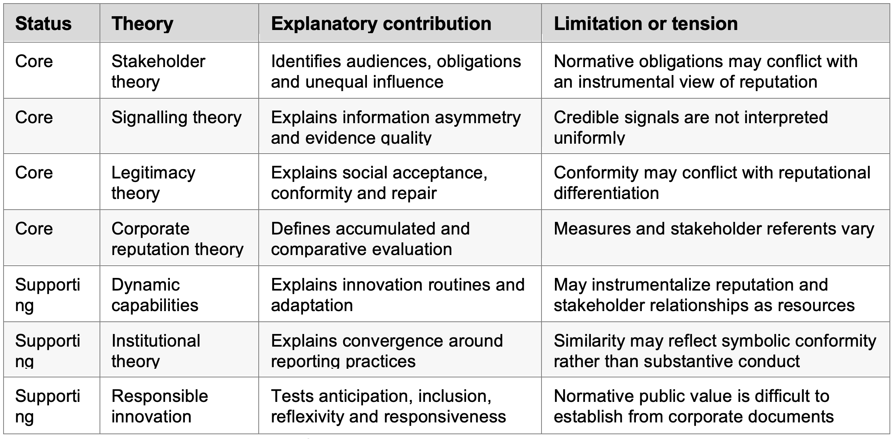
The theories do not manifest interchangeability or complete harmony. A resource based review considers reputation as a valuable asset. Stakeholder theory on the other hand, determines commitments as a significant factor regardless of whether they provide any strategic return. Institutional theory explains the reason behind convergence of reporting. Signaling theory demonstrates the impact of credible specificity in differentiating one firm from another. Legitimacy deals with acceptable conformity. Comparative standing is a significant part of reputation. Their combined value demonstrates a conditional process where different stakeholders interpret the claims and conduct with regard to institutional constraints and prior expectations. The evidence does not allow equating that process with a linear causal model.

3.3 ESG communication: from reporting volume to credible stakeholder communication
Four related practices need to be separated from each other. Corporate reporting refers to a formal production of periodic reports. Disclosure consists of available information along with its boundaries. Communication strategy deals with selecting, framing and coordinating messages across channels. Stakeholder dialogue is generated through reciprocal communication as well as evidence of organizational response. A firm may disclose an extensive amount of information failing to maintain balanced communication. It may invite dialogue without providing stakeholders meaningful authority.

3.3.1 Reporting evolution and materiality
ESG communication has increased its scope by including reports, ratings, websites, and social media along with voluntary CSR and sustainability disclosure. CSR foregrounds duties and stakeholder relationships, whereas ESG also responds to investor demand for comparable risk information; both remain shaped by organisational and institutional conditions (Hahn and Kühnen, 2013; Eccles, Krzus and Ribot, 2015).
In pharmaceuticals, access, trial inclusion, antimicrobial resistance, safety, supply resilience, data governance and environmental liabilities may be socially material even when short-term financial effects are uncertain. Credible communication must identify priorities, boundaries and affected stakeholders.
Beyne and Moratis (2023) show that materiality assessments and SDG priorities vary with stakeholder priorities, capacity and communication limits. Their setting demonstrates how reporting content is constructed through selection, but cannot establish how AstraZeneca or GSK prioritise issues. Malay (2021) identifies inconsistency between business sustainability indicators and national SDG indicators; indicator presence does not prove target consistency, implementation or reputational value.
During COVID-19, attention centred on trials, authorisation, production and supply; from 2022 it also concerned preparedness, long-term access, affordability, environmental consequences and governance. An emergency-achievement narrative may lose credibility if it ignores the continuing distribution of benefits and risks.

3.3.2 Disclosure quantity, quality and comparability
The formal evidence separates disclosure quantity from quality. Demir and Min (2019) found broad coverage in leading pharmaceutical reports, although only four of eleven material topics appeared in every report. As a result, A long report may omit issues important to patients, regulators or communities. The study included AstraZeneca and GSK but predates the comparative period and measures reported content instead of authenticity or stakeholder response.
The high-rated study by Calciolari, Cesarini and Ruberti (2024) found increased pharmaceutical disclosure across environmental categories but differences from the chemical sector, especially in climate communication. Its Italian reports and automated classification illuminate patterns. However, it also limits interpretation of narrative meaning. Chaturvedi et al. (2017), rated moderate, provide a pre-pandemic baseline linking pharmaceutical sustainability to cleaner production, energy, waste and stakeholder communication; their mixed-source review is used as qualified sector context rather than principal evidence.
Grant et al. (2025) show why claims are difficult to compare when targets differ in years, scopes, baselines, offsets and interim trajectories. Singh and Kumar (2025) propose connecting evidence, actions, certification, outcomes and reporting, but their roadmap is not independent validation. The evidence supports a quality test based on specificity, boundaries, measurable progress and consistency rather than report length or fashionable terminology.
Comparability is also undermined by measurement disagreement. Berg, Kölbel and Rigobon (2022), in supporting cross-industry evidence, report substantial divergence among six ESG rating agencies due to the differences in scope, measurement and weighting. Consequently, Ratings can be useful signals to particular users without constituting a stable measure of underlying performance. The formal source Malay (2021) reaches a related conclusion at indicator level: a metric cannot be compared fairly unless its target, boundary and reference system are clear.
Pajuelo-Moreno, Barroso-Mendez and Gallardo-Vazquez (2024) report a generally positive disclosure-reputation association across 92 articles, moderated by measurement, method and national context. This supports a conditional relationship, not a universal or causal effect.

3.3.3 Credibility, selective disclosure and the claim-action relationship
Communication emerges as a significant reputational factor when stakeholders initiate comparison between claims and conduct. Cho et al (2015) demonstrates how contradicting demands generates inconsistency between corporate talk, decisions and action, on the basis of hypocrisy and organizational-facade concepts. Christensen, Morsing and Thyssen (2013) propose a more intricate perspective on ambitious CSR communication. A future oriented language may demonstrate commitments which the organization has not achieved yet although it does not automatically indicate deception. The imperative question concerns whether aspiration manifests specificity, accountability, and is followed by progress.
Greenwashing research identifies risks of selective or symbolic communication. Delmas and Burbano (2011) locate drivers at external, organisational and individual levels. Lyon and Montgomery (2015) on the other hand, show that greenwashing includes selective disclosure and symbolic behaviour as opposed to only false statements. Moratis (2016) similarly links claim credibility to specificity, consistency and organisational evidence. These ideas are relevant to pharmaceutical access, health equity, safety and governance claims, although the original focus is environmental.
Schwoy, Dutzi and Messing (2025) provide the strongest formal evidence with regard to this concern. According to their content analysis of 190 ESG controversies, most controversies were either disclosed only once or were limited to legal reporting. Additionally, 26% of the controversies were not even disclosed. Assurance and reporting benchmarks failed to ensure balanced presentation. The study does not measure stakeholder reactions or demonstrate that every omission was intentional. It does show that the existence of an ESG report is not evidence that material adverse information has been integrated into the organisation's public account.
Cook, LaVan and Zilic (2018) add an external-framing dimension. Comparing US pharmaceutical CSR reports with business press, they found weaker external visibility for environmental and sustainability language than for economic language. Their frequency-based, US design cannot measure full stakeholder reputationHowever, it indicates that self-presentation and external interpretation may diverge.
Schniederjans and Khalajhedayati (2023) examine multiple elements,such as responsibility reports, buyer-supplier relations, sentiment, topic alignment and score trends among chemical and pharmaceutical firms. Positive sentiment and some relational alignment were associated with improving responsibility-score trends.However, topic alignment was not associated.Hence, communication, stakeholder alignment and outcomes should remain distinct variables.
The claim-action relationship should be read as a condition of credibility .It should not be interpreted as a mechanical test in which every gap proves deception. An aspirational target may be a legitimate commitment if it has a baseline, milestones, accountability and corrective disclosure. A report may also be accurate.On the other hand, it may prove to be incomplete in a way that creates a misleading overall impression. The most defensible analysis examines what is claimed, what evidence is supplied and what is absent. It also evaluates how boundaries are defined and whether later conduct updates the claim.

3.3.4 Engagement, digital communication and contestability
Stakeholder communication ranges from one-way information to response and involvement (Morsing and Schultz, 2006). Publishing an access commitment states a position; reporting progress and responding to criticism is more accountable; involving patients, health systems or communities gives stakeholders greater influence. Engagement is contingent upon several factors, such as, participant, relevance, actual influence and visible response
Digital channels significantly contribute to increasing speed, reach and contestability. Gyftopoulos et al. (2024) demonstrates that social media posts on pharmaceuticals during COVID-19 illustrated high interaction and dispersion of different emotions, including fear. This indicates visibility rather than durable trust. Responses include several elements, such as, criticism, misinformation, support, news, and experience. As a result, engagement may indicate disagreement along with approval.
Digital communication may also increase the amount of counter signals. Stakeholders can conduct a comparison between company statements and regulatory outcomes, independent evaluations, patient experiences and scientific evidence. The communication environment can prove to be less controlled compared to a formal annual report. However, it can also be responsible for increasing the reputation cost of a claim-action gap. Positive sentiments in company-owned channels can be interpreted as stakeholder trust only if this narrative is supported by the audience, measure and method.
The synthesis produces five evidence-derived propositions for later evaluation. They organise the literature but are not treated as tested causal hypotheses.
Table 3.3. Evidence-derived propositions concerning ESG communication
Proposition | Evidential basis | Qualification
More disclosure does not necessarily mean better communication | Inconsistent topic coverage and controversy omission | Quantity cannot establish materiality, balance or stakeholder relevance
Credibility depends on specificity, balance and evidence | Variation in baselines, scopes, milestones and external framing | Credibility remains stakeholder- and context-dependent
Adverse disclosure is central to accountability | Strong high-quality controversy evidence | Omission does not by itself prove intention or reputational harm
Dialogue is meaningful only when accompanied by responsiveness | Engagement and stakeholder-theory literature | Interaction or consultation alone does not demonstrate influence
Digital visibility is not equivalent to trust | Social-media engagement evidence | Attention can include criticism, fear and contestation

3.4 Pharmaceutical innovation, responsibility and public value
Innovation is treated as a multidimensional process rather than a single R&D measure.
Table 3.4. Pharmaceutical innovation taxonomy
Type | Illustrative focus | Relevant ESG or reputation question
Product | Medicines, vaccines, diagnostics and delivery technologies | Clinical value, safety and unmet need
Process | Discovery, trials, data and regulatory routines | Integrity, efficiency and inclusion
Manufacturing | Production, quality, waste, energy and resilience | Environmental impact and supply reliability
Access | Affordability, allocation, licensing and delivery | Distribution of public value
Organisational | Governance, capabilities and internal coordination | Accountability and responsiveness
Ecosystem | Partnerships with universities, governments and suppliers | Attribution, shared responsibility and legitimacy

3.4.1 Innovation capability and distributed ecosystems
Pharmaceutical innovation combines discovery, clinical development, regulatory review, manufacturing, supply and delivery. It is uncertain, costly and distributed across organisations. The resource-based and dynamic-capability perspectives explain how firms build and renew scientific, organisational and relational capabilities. Open-innovation theory highlights knowledge flows across firms, universities, public agencies and specialist partners (Chesbrough, 2003). Pharmaceutical innovation should therefore be analysed as an ecosystem rather than as the isolated achievement of a single company.
The high-rated formal study by Subramanian, Jain and Bhattacharyya (2024) examines 86 multinational life-sciences organisations and reports that composite and individual ESG scores were associated with R&D expenditure, which the study used as an innovation-output proxy. R&D expenditure is more appropriately interpreted here as an innovation-resource or commitment indicator than as a direct measure of innovation output. Its cross-sectional design and mixed life-sciences sample do not establish innovation quality, public value or reputation. The defensible conclusion is therefore an association with innovation capacity under certain organisational conditions, not that ESG communication causes innovation.
The moderate-rated review by Chaturvedi et al. (2017) indicates that pharmaceutical sustainability has involved cleaner production, waste reduction, energy efficiency and stakeholder communication. Veleva, Bodkin and Todorova (2017), also rated moderate, provide a contextual biotech case in which measurement and employee engagement supported a zero-waste programme. These sources illustrate operational foundations for environmental claims but do not provide strong evidence of external reputation.
Open innovation can broaden expertise and share risk, but may also create coordination, appropriation and accountability problems (Reichman and Simpson, 2016; Schuhmacher et al., 2022). Credible narratives should identify public, academic, commercial and regulatory contributions rather than present ecosystem achievements as the work of one firm.

3.4.2 Responsible innovation and public value
Responsible-innovation theory asks how innovation is developed, for whom and with what consequences.Multiple factors,such as anticipation, reflexivity, inclusion and responsiveness direct attention to safety, access, assumptions, affected groups and adaptation during shift in evidence or social needs (Stilgoe, Owen and Macnaghten, 2013).
This perspective links innovation to ESG without collapsing the concepts. Environmental responsibility includes research, manufacturing, product and supply-chain effects. Social responsibility includes disease priorities, trial diversity, affordability and access. Governance includes multiple elements, such as safety, evidence integrity, ethical conduct, data management and accountability. Innovation can substantiate an ESG narrative when these responsibilities are embedded in development and delivery as opposed to added as a separate communications layer.
The formal literature demonstrates why this is contested. Saxena, Balani and Srivastava (2021) describe a weak and still developing relationship among several aspects, such as CSR, sustainability, environmental performance, community image and organisational growth in the pharmaceutical sector. Their broad source base and earlier search date limit direct comparison with the post-pandemic corpus. Lee et al. (2019) and Bae et al. (2022), retained as supporting academic evidence as opposed to formal PRISMA studies, show that stakeholders may regard new-drug development and public-health activity as central responsibility. However, they disagree over whether ordinary commercial R&D should count as CSR. This disagreement is analytically valuable. Innovation aligned with unmet need may create public value, although labelling all commercial innovation as responsibility can hide questions about pricing, priority-setting and distribution.

3.4.3 Access, affordability and the COVID-19 legacy
Access is the most significant boundary criteria when it comes to reputational meaning of innovation. According to Wouters et al. (2021), elements, such as, production, affordability, allocation, and deployment emerge as connected requirements of global vaccine access. Gupta(2021) explains that designing innovative systems for delivery is a prerequisite for pandemic preparedness in an environment with limited resources. Gold(2022) points out challenges between intellectual property, public contribution, and access. These sources have different priorities. However, they commonly distinguish technical development from social availability.
Trust evidence reinforces this distinction. Falcone et al. (2022), used as supporting academic evidence, find that trust in vaccine manufacturers, regulators and scientific institutions jointly shaped vaccination intention, with competence and intention evaluated differently. Pirson and Malhotra (2011) provide a broader conceptual explanation.A stakeholder may trust technical competence.On the other hand, they may question benevolence, integrity or motive. Pharmaceutical innovation may strengthen scientific trust without resolving concern about commercial intent.
The Access to Medicine Foundation's (2024a, 2024b, 2024c) independent assessment provides external contextual evidence for comparing corporate narratives. It ranked GSK second and AstraZeneca fifth among 20 large research-based pharmaceutical companies under a defined access methodology. It identified strengths in product delivery, priority R&D, governance and patient-reach monitoring.On the other hand,it encountered limitations in access-plan quality, geographic breadth and sector-wide implementation. The assessment is not a comprehensive reputation measure.It does not establish stakeholder response.Instead, it calibrates selected access and governance claims.
As a result, the post-pandemic legacy is dual.Visibility around scientific competence and collaboration increased due to COVID-19. However, it also exposed dependence on public funding, manufacturing capacity, allocation systems and trust. A pharmaceutical firm may have a strong technical achievement and credible ESG narrative. Meanwhile, it may still face legitimacy concerns if access is perceived as inequitable. Responsible innovation affects whether innovation can be interpreted as public value.

3.4.4 The limited direct evidence on innovation and reputation
The formal corpus contains adjacent as opposed to comprehensive evidence on the innovation-reputation relationship. Subramanian et al. (2024) connect ESG conditions to an R&D proxy, but not reputation. Veleva et al. (2017) connect operational measurement and employee engagement to environmental practice, but not external standing. Saxena et al. (2021) describe a developing CSR-performance relationship, but with heterogeneous source types. Opoku et al. (2023) provide a stakeholder-perception mechanism linking environmental reputation, satisfaction and performance, but do not examine innovation narratives. The evidence therefore supports a plausible integrated explanation without demonstrating a single direct pathway.
Supporting green-innovation studies often report positive associations between ESG performance or disclosure and innovation through financing, governance or analyst attention (Ruan, Yang and Dong, 2024; Yang et al., 2024; Zhang, Lai and Jie, 2024). These findings are useful for mechanism generation but are not direct pharmaceutical evidence. Their Chinese listed-firm settings, environmental-patent outcomes and different institutional conditions restrict transferability. They should support a conditional proposition about resources and governance.

3.5 Corporate reputation, trust and related constructs
Corporate reputation is frequently used as a general label for positive organisational evaluation, but this creates analytical confusion. Barnett, Jermier and Lafferty (2006) show that reputation research has referred to awareness, assessment and an intangible asset. Walker (2010) identifies continuing inconsistency in definition, measurement and theory. Lange, Lee and Dai (2011) distinguish familiarity, expectations about future conduct and general favourability. The operational definition used throughout this dissertation is: corporate reputation is the accumulated and comparative evaluation of an organisation's conduct and capabilities by identifiable stakeholder groups over time.
This definition creates a distinction between four related constructs. Identity deals with the way organizational members understand the firm. Image indicates an immediate impression on the mind of the audience. Legitimacy compares acceptance with social norms. Reputation refers to a judgment which is more durable and competitive. Deephouse and Carter (2005) demonstrates why legitimacy and reputation should not be compared under the same scale. Conformity may contribute in ensuring legitimacy. Reputation on the other hand, can be influenced by differentiation and comparative evaluation. ESG communication is capable of changing image in a short amount of time, contribute to ensuring legitimacy through conformity. Additionally, it can contribute to reputation utilizing, repeated and credible evidence.
Trust is a mechanism and evaluative condition related to reputation. A patient may trust scientific competence although may question pricing motives. An investor may prioritise governance controls. On the other hand, a community affected by manufacturing or supply decisions may evaluate evidence differently from a regulator. Opoku et al. (2023) provide one bounded pathway. Environmental reputation was associated with satisfaction and brand performance among Ghanaian pharmaceutical buyers, with ethical behaviour moderating the relationship. This does not establish a universal reputation effect.
Different choices on measurement criteria prevent combining all the findings. Schäfer (2026), regarded as supporting available-to-date evidence, demonstrates that factors such as product, quality, competence, performance, and satisfaction contributed in ensuring patient loyalty, after analyzing a German vaccine market. This finding stems from patient experience and medical trust, which cannot be applied in the case of employees, regulators or population without access.
Table 3.5. Measures and the constructs they most plausibly capture
Measure | Likely construct | Interpretive limit
Market reaction | Investor evaluation | Does not represent patients, regulators or communities
Patient loyalty | Patient experience and brand loyalty | Product- and market-specific rather than corporate-wide
Media sentiment | External visibility and framing | Attention or tone is not durable reputation
ESG rating | Provider-specific ESG assessment | Scope, measurement and weighting differ
Corporate ranking | Generalised prominence or favourability | May obscure stakeholder and issue differences
Trust survey | Stakeholder-specific trust | Requires a named audience and trust dimension
Disclosure score | Reporting coverage or quality | Does not verify conduct or stakeholder response
The formal corpus and additional sources have different roles. Retained studies address particular audiences, firms, countries or measures.Theory defines constructs.On the other hand, company reports provide claims.Lastly, independent assessments introduce an external evaluative standpoint. Treating these materials as if they measured the same outcome would create false precision.As a result, the dissertation identifies the audience, document type, period and evidential status relevant to each claim. A favourable company statement can demonstrate positioning.It can not prove public approval.A negative external assessment can challenge a narrative without representing every stakeholder.
This distinction is particularly important after the pandemic. This is due to the fact that visibility and evaluation may move at different speeds. Scientific achievements can prove to be useful in order to generate immediate prominence. On the other hand, judgements about fairness, access or integrity develop through repeated experience. A company may receive favourable investor evaluations and criticism from patients or civil-society organisations at the same time. The analysis must preserve disagreement. It should not compress it into one overall reputation score.
Reputation may also operate in both directions. ESG communication and innovation may influence evaluation, while an established reputation may attract talent, partners and investment that support future innovation. Unsal and Hippler (2024) report that misconduct in US pharmaceutical firms was followed by fewer approvals, patents, partnerships and grants. The observational design cannot isolate all mechanisms.However,it supports a reciprocal possibility.Conduct and reputation can affect future innovation resources.Hence, reputation should not be treated only as a final dependent variable.
The most defensible conclusion depends on certain conditions. Reputation is not an asset that a company can manufacture through disclosure. It is an external evaluation updated through experience, comparison, evidence and time. Trust may connect communication and conduct to that evaluation, although different stakeholders can reach different conclusions. Chapter 3 identifies the audience, trust dimension and evidence source whenever it uses the terms trust or reputation.

3.6 Integrating ESG communication, pharmaceutical innovation and reputation

3.6.1 Complementarity, tension and reciprocal pathways
ESG communication can make innovation, governance and access practices visible. On the other hand, innovation can provide substantive evidence for claims about scientific contribution and public value. Credibility may support stakeholder engagement and trust. Apart from that, repeated conduct may contribute to legitimacy and reputation. However, each relationship has conditions and possible failure points.
First, communication quality is significant. Schwoy et al. (2025), Demir and Min (2019), Calciolari et al. (2024) and Grant et al. (2025) show variation in several aspects, such as reporting coverage, controversy disclosure, category balance and target comparability. Communication may reduce information asymmetry only when the audience can understand what is included, excluded and measured. More communication can also increase exposure to scrutiny if claims are broad and evidence is weak.
Second, innovation must generate public value. Subramanian et al. (2024) demonstrates a positive connection between ESG scores and R&D expenditure.The literature on access demonstrates the importance of production, affordability, allocation, and delivery. Innovation can have a positive impact on competence perception, although may fail to resolve moral legitimacy issues.
Access is not an optional addition to a technical narrative; it affects how the social value of innovation is interpreted.
Third, stakeholder evaluation is not uniform. Opoku et al. (2023) identify a buyer-based pathway involving environmental reputation, satisfaction and performance, while other audiences may prioritise scientific integrity, affordability, safety or access. A dominant audience's judgement cannot represent the organisation's entire reputation.
Fourth, the relationship may be reciprocal. Reputation can enable partnerships and resources, although misconduct may reduce later innovation opportunities (Unsal and Hippler, 2024).As a result, the framework treats reputation as both an accumulated evaluation and a possible influence on future capability.

3.6.2 Comparative illustrations from AstraZeneca and GSK
AstraZeneca and GSK are used as bounded organisational illustrations within the 2022-2025 comparative period. Their reports are not included in the formal academic corpus and cannot establish stakeholder opinion. They show how organisations present their own relationship among science, access, environmental responsibility, governance, global health and reputation.
A matched series of annual and sustainability reports for 2022-2025 is used for each company. AstraZeneca presents scientific strategy, access, environmental protection and ethics as connected parts of corporate value. GSK on the other hand, connects innovation with a range of elements, such as access, global health and health security, environment, inclusion, ethical standards and product governance (AstraZeneca, 2023a, 2023b, 2024a, 2024b, 2025a, 2025b, 2026a, 2026b; GSK, 2023a, 2023b, 2024a, 2024b, 2025a, 2025b, 2026a, 2026b). The similarity is analytically important as both firms operate under common pressures from regulation, investors, reporting expectations and peer comparison. Institutional convergence can encourage comparable language, although shared language alone has limited evidential value.
The Access to Medicine Foundation assessment provides an independent counterpoint. Its methodology recognises selected strengths in GSK's product delivery and priority R&D. It also identifies strength in AstraZeneca's governance and monitoring of patient reach. It also recognises continuing access-plan limitations and limited sector-wide implementation (Access to Medicine Foundation, 2024a, 2024b, 2024c). The comparison neither proves nor disproves the company narratives. It demonstrates the analytical value of juxtaposing organisational claims with an external assessment that uses different criteria and evidence.
Table 3.6. Descriptive AstraZeneca-GSK evidence base for Chapter 4
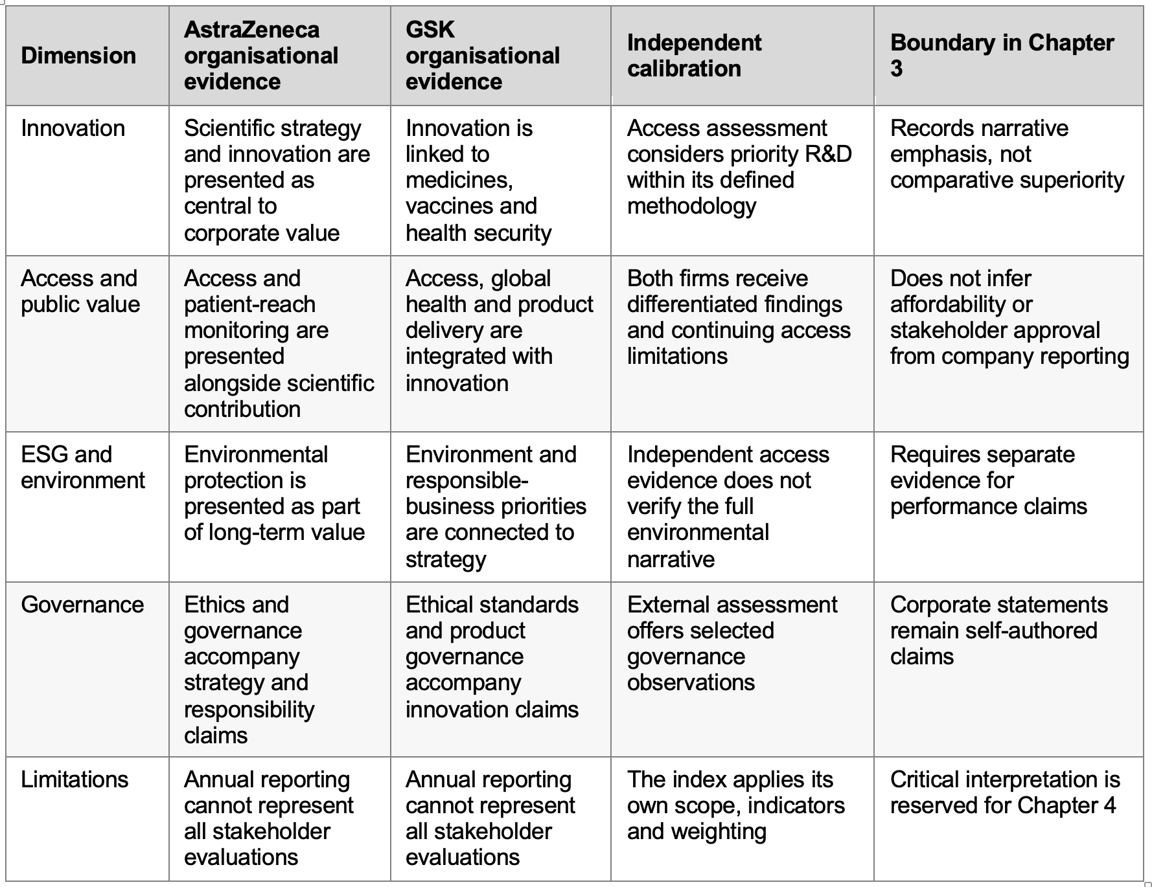
Sources: AstraZeneca (2025a), GSK (2026a) and Access to Medicine Foundation (2024a, 2024b, 2024c); document positioning and calibration only.
The comparison must remain symmetrical. It would be inappropriate to select only favourable examples, infer reputation from report language or treat one external index as a complete measure of public trust. Chapter 3 therefore establishes comparable evidence categories only. Chapter 4 will evaluate the similarities, differences, contradictions and theoretical meaning.

3.6.3 Evidence-derived relational framework
The synthesis is aligned with an initial provisional framework. ESG communication quality and pharmaceutical innovation capability emerge as distinct inputs. Communication quality may contribute to signal credibility when claims are material, specific, balanced and evidenced. Innovation capability may contribute to responsible access and public value when technical achievement is linked to safety, affordability, distribution and responsiveness. Stakeholders may use these signals to form competence, integrity, transparency and benevolence judgements. This may inform legitimacy and, through repeated evaluation, corporate reputation. Reputation may also influence access to resources, partnerships and stakeholder tolerance.
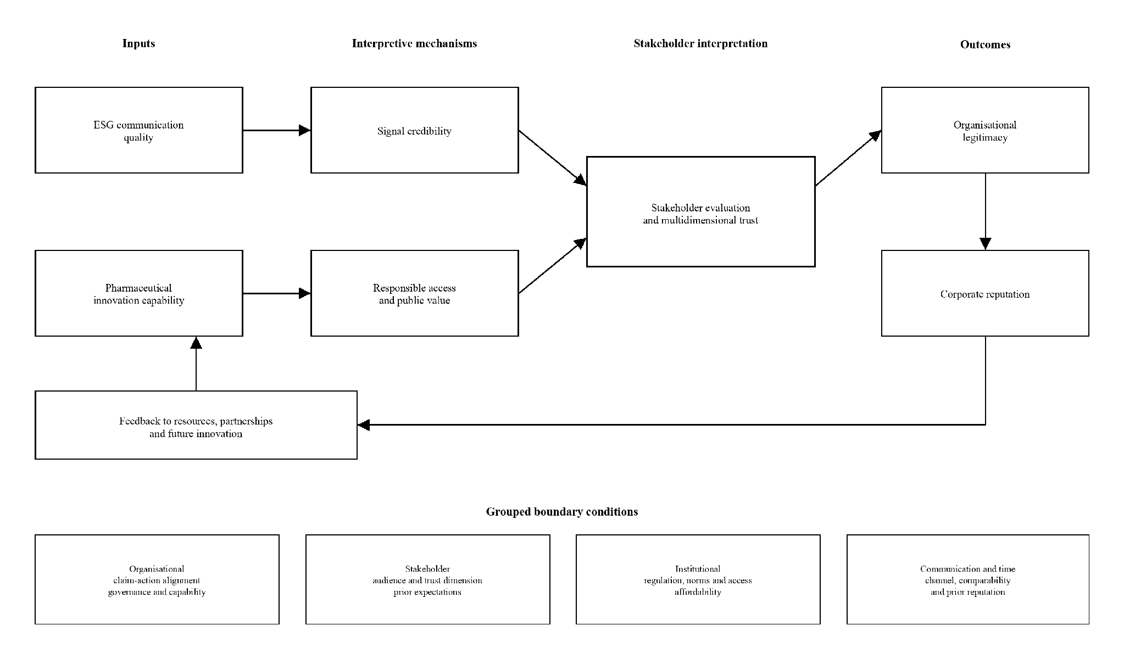
Figure 3.1. Evidence-derived relational framework for ESG communication, pharmaceutical innovation and corporate reputation
Note: The arrows show evidence-derived relationships and possible mechanisms, not demonstrated causal effects. Boundary conditions are grouped as organisational, stakeholder, institutional, and communication and temporal conditions.
Figure 3.1 is the initial evidence-derived framework. It differs from a simple ESG-to-reputation model by placing communication quality as opposed to disclosure volume at the starting point. Thus, it separates innovation capability from responsible access and public value.It also treats trust as multidimensional. It keeps legitimacy distinct from reputation. Included studies support parts of the model. However, no single study tests the complete pathway. Chapter 4 therefore refines its mechanisms and evidential strength. On the other hand, Chapter 6 consolidates the final framework
Table 3.7. Conditions affecting the proposed relationships
Proposed relationship | Strengthening condition | Weakening or reversing condition | Interpretation rule
ESG communication to signal credibility | Specific metrics, clear scope, balance and evidence | Vague ambition, selective disclosure or claim-action gap | Assess claim quality, omissions and counter-evidence
Innovation capability to public value | Unmet-need alignment, safety, access planning and affordability | Novelty without equitable delivery or transparent attribution | Separate technical competence from responsible outcomes
Credible signals to stakeholder trust | Consistency, responsiveness and relevant evidence | Prior controversy or conflicting external information | Identify stakeholder group and trust dimension
Trust to organisational legitimacy | Conduct matches social and professional expectations | Perceived opportunism, exclusion or unresolved harm | Distinguish pragmatic, moral and cognitive legitimacy
Legitimacy and repeated evaluation to reputation | Consistent favourable judgements across relevant audiences | Temporary visibility, prominence without quality or audience conflict | Specify evaluator, period and reputation measure
The table ensures that the model is analytically usable without any exaggeration of its status. A controversy can evaluate the link between communication and credibility. Access limitation can determine the connection between innovation and public value. The connection between trust and legitimacy can be evaluated by stakeholder disagreement. Lastly, conflicting reputation analyzes the final relationship. Time holds significant value as communication may produce immediate prominence whereas trust and reputation demands repetition of evaluation. Prior reputation contributes to shaping reception. Conduct will update judgment and institutional expectations will manipulate the standard of evaluation

3.7 Research gaps and implications for the dissertation

3.7.1 Theoretical integration gap
The literature commonly implements stakeholder theory, legitimacy theory or signaling theory, independent of each other. Each theory can provide a certain part of the explanation. Stakeholder theory determines audiences and commitments. Legitimacy theory on the other hand, demonstrates social acceptance. Signaling theory is crucial for identifying information asymmetry. Reputation theory contributes to defining accumulated evaluation. Institutional theory focuses on convergence. Dynamic capabilities and responsible innovation remain supporting lenses for resources and public value. Few studies integrate these perspectives with pharmaceutical access. Directionality remains unresolved as reputation may also support resources and relationships which enable future innovation.

3.7.2 Measurement and methodological gap
The evidence uses proxies which are not equivalent. Disclosure scores measure reporting instead of performance. ESG ratings may diverge. On the other hand, engagement may measure visibility as opposed to trust. Market value may reflect investor response. Apart from that, patient loyalty concerns one audience instead of overall corporate standing. Formal studies include multiple elements, such as content analysis, report comparison, cross-sectional sector assessment, stakeholder perception and literature review. However, none tests the complete ESG-innovation-reputation pathway. Longitudinal, multi-stakeholder research is required to examine claims, conduct, controversy, correction and later evaluation together.

3.7.3 Sector, geographic and temporal gap
Pharmaceutical-specific evidence is still limited relative to general ESG and finance research. The formal corpus includes pharmaceutical and life-sciences studies. However, several sources are cross-sector, country-specific or focused on environmental operations. Evidence from Belgium, Italy, Ghana, India, US settings and wider life-sciences samples cannot be assumed to transfer uniformly to UK-based global firms. The academic window includes 2015-2026, although the main comparative question concerns 2022-2025. Research remains underdeveloped on whether the high visibility of COVID-19 scientific achievement changed into durable post-pandemic trust after attention shifted towards access, affordability, preparedness and long-term responsibility.

3.7.4 Disclosure and adverse-evidence gap
Positive corporate communication is easier to collect compared to multiple factors, such as silence, omission, correction and adverse experience. The formal controversy evidence shows the reason behind adverse disclosure requiring systematic attention. Future research should compare corporate reports with several aspects, namely, independent assessments, regulatory evidence, health-system perspectives and external media framing. The aim is to test the completeness and accountability of the narrative.

3.7.5 Comparative and managerial gap
AstraZeneca and GSK provide a useful comparison as both are large UK-listed pharmaceutical firms. They are equipped with extensive public reporting and visible innovation portfolios. Similar language may reflect common institutional pressures as opposed to identical practice. The dissertation compares equivalent categories. It treats corporate reports to be claims requiring contextual calibration. The literature supports specificity, balanced disclosure, evidence of access and responsiveness. However it does not establish a universal level of communication intensity. The managerial implication is to align communication with material conduct and make progress and limitations visible.
Table 3.8. Status of the identified research gaps
Gap | Status in this dissertation | Remaining requirement
Fragmented theoretical explanations | Partly addressed through an integrated conditional framework | Empirical comparison of competing mechanisms
Confusion among communication, performance, trust, legitimacy and reputation | Addressed conceptually through explicit definitions and evidence boundaries | Consistent operational measures in future studies
Limited UK multi-stakeholder evidence | Unresolved | Primary research with patients, professionals, regulators, employees and investors
Limited longitudinal reputation evidence | Unresolved | Longitudinal study of claims, conduct, controversy and later evaluation
Company-claim comparison | Partly addressed through symmetrical documentary evidence | Wider independent performance verification and stakeholder evidence
Narrow formal academic corpus | Transparently bounded, not resolved | Broader validated database coverage and replicated screening

3.8 Chapter conclusion
RQ1: ESG communication evolution. Pharmaceutical ESG communication has broadened across formal reporting, metrics, access commitments and digital channels. However, the strongest formal evidence shows that coverage, target comparability and adverse disclosure emerge as uneven. Evolution in format does not establish improved credibility.
RQ2: Innovation, trust and legitimacy. Innovation may strengthen competence-related trust when it demonstrates scientific and delivery capability. Its legitimacy remains conditional on several factors, such as safety, unmet need, access, affordability, inclusion and responsiveness. The literature does not support treating R&D expenditure as an innovation output. It does not support technical achievement as sufficient public value.
RQ3: Theoretical explanation. Stakeholder, signalling, legitimacy and corporate reputation theories form the four-theory explanatory core. Dynamic capabilities, institutional theory and responsible innovation are three supporting lenses which clarify resources, conformity and public value without independently explaining reputation formation. Their tensions show why reputation cannot be reduced to either a strategic asset or a direct result of disclosure.
RQ4: Debates and gaps. The principal debate concerns the contrast between disclosure and performance, aspiration and selective communication. Comparison between competence and benevolence, legitimacy and reputation holds significant value. In addition to that, comparison between convergence and differentiation is also pertinent. Evidence constraints emerge due to small corpus, disciplinary imbalance, heterogeneous measures and scarce longitudinal multi-stakeholder research.
RQ5: Integrated model. The synthesis supports a provisional pathway from ESG communication quality and innovation capability through signal credibility, responsible access and public value, stakeholder evaluation and legitimacy towards accumulated reputation. No included study tests the complete pathway.
The formal corpus illustrates a conditional synthesis instead of a causal conclusion. Evidence gathered from AstraZeneca and GSK provides a symmetrical document base. Comparative interpretation, theory evaluation and framework refinement will be discussed in chapter 4.

Chapter 4: Discussion

4.1 Introduction
This chapter provides interpretations of the thematic synthesis through the research questions, competing theories, contradictory evidence and the AstraZeneca-GSK comparison. It addresses the primary question: how and under what conditions are ESG communication and pharmaceutical innovation associated with corporate reputation in the post-pandemic pharmaceutical sector? Peer-reviewed studies support the principal arguments. Company publications show corporate representation. Apart from that, independent assessment provides external comparison. The central argument is that neither ESG communication nor pharmaceutical innovation produces corporate reputation directly. Communication must first become credible. Meanwhile, innovation must be translated into responsible public value. Stakeholders interpret both through different trust and legitimacy judgements, from which reputation may accumulate over time.
Sections 4.2-4.5 answer RQ1-RQ4 through thematic and theoretical synthesis. Section 4.6 examines how the identified issues appear in matched AstraZeneca and GSK reporting, without treating company publications as stakeholder-reputation evidence. Apart from that, section 4.7 integrates the findings into an evidence-informed conceptual framework. Section 4.8 evaluates provisional propositions. Lastly, Section 4.9 consolidates the answers to all five questions. The analysis asks when communication and innovation can inform reputation judgements.
Across these sections, each major issue is examined through the same analytical sequence. This sequence includes finding, contradiction, explanation, boundary condition and theoretical implication.

4.2 RQ1: ESG communication after COVID-19
The evidence does not establish a sharp pre-COVID or post-COVID discontinuity. Pre-pandemic studies already found broad pharmaceutical CSR reporting alongside inconsistent material-topic coverage (Cook, LaVan and Zilic, 2018; Demir and Min, 2019). Later evidence places greater emphasis on measurable ESG categories, access commitments, governance and climate targets, although elements such as category differences, non-equivalent target years, scopes, baselines and offsets persist (Calciolari, Cesarini and Ruberti, 2024; Grant et al., 2025).Consequently, post-COVID development is best understood as a change in emphasis and evaluative expectations as opposed to an objectively timed transformation. Heightened visibility of pharmaceutical science, supply and access has made claims about preparedness, affordability and public value more open to comparison with conduct and external evidence.
Institutional pressures help explain the convergence of reporting formats. Meanwhile, signalling theory explains why specificity, observability and comparability determine the possibility of claims reducing uncertainty. Increased disclosure volume can coexist with weak accountability due to unclear material boundaries.
Adverse disclosure provides a sharper credibility test. Schwoy, Dutzi and Messing (2025) found that controversies were sometimes mentioned once or were confined to legal reporting. They also demonstrate that assurance did not guarantee balance. This does not prove intentional omission or stakeholder disapproval. However, it shows why report publication alone cannot establish accountability.
Aspirational communication can create an accountable commitment in cases where it identifies a baseline, milestones and correction (Christensen, Morsing and Thyssen, 2013).An accurate statement may still mislead if material boundaries are hidden.
Answer to RQ1. Pharmaceutical ESG communication in the post-COVID period shows greater emphasis on quantified commitments, access, governance and climate accountability. However, the evidence does not prove a discrete temporal break or a direct reputation effect. Its potential reputational relevance depends on materiality, specificity, balance, comparability, adverse disclosure and alignment with later conduct.
Managerial implication. Increasing disclosure volume is insufficient. Pharmaceutical managers should prioritise material, measurable and externally contestable commitments that stakeholders can subsequently compare with organisational conduct.

4.3 RQ2: Innovation, trust and legitimacy
Innovation capability must be distinguished from the public value through which it may become legitimate. Subramanian, Jain and Bhattacharyya (2024) associate ESG scores with R&D expenditure in multinational life-sciences organisations, but expenditure is an input rather than evidence of successful, safe or socially available innovation. Dynamic-capability theory explains adaptation (Teece, Pisano and Shuen, 1997), not whether priorities are socially acceptable. Technical achievement can inform a competence judgement; responsible access, affordability and responsiveness inform separate fairness and integrity judgements.
Responsible-innovation and stakeholder perspectives supply that evaluative step. Anticipation, reflexivity, inclusion and responsiveness direct attention to unmet need, safety, affordability and delivery (Stilgoe, Owen and Macnaghten, 2013). Wouters et al. (2021) similarly treat production, affordability, allocation and deployment as connected access conditions. Technical innovation may therefore support competence-based trust, whereas responsible and accessible innovation may support moral legitimacy. Combined stakeholder evaluation can have reputational implications, although the reviewed evidence does not test these stages as a complete sequential pathway (Pirson and Malhotra, 2011; Falcone et al., 2022).
Opoku, Adomako and Tran (2023) associate environmental reputation with satisfaction and brand performance among Ghanaian pharmaceutical buyers, but one buyer group cannot represent patients, regulators, investors or communities.
A medicine may demonstrate competence while its pricing or allocation creates a different moral judgement. Innovation is not inherently reputation-enhancing. Its meaning is contingent upon the distribution of benefits and risks and on the stakeholder and trust dimension considered.
Answer to RQ2. Pharmaceutical innovation may contribute to trust and legitimacy when technical capability is translated into safe, accessible, affordable and responsive public value. Technical success or R&D expenditure alone supports, at most, a competence signal. It does not establish moral legitimacy, stakeholder trust or corporate reputation.
Managerial implication. Innovation reporting should connect scientific milestones to patient access, affordability, safety and delivery outcomes. This allows managers to demonstrate both technical capability and the responsible distribution of its benefits.

4.4 Comparative evaluation of theoretical explanations
Four theories form the explanatory core. Stakeholder theory identifies who evaluates the organisation and why power, legitimacy and urgency influence attention (Freeman, 1984; Mitchell, Agle and Wood, 1997). Signalling theory explains whether specific, observable and difficult-to-imitate evidence reduces uncertainty (Connelly et al., 2011). Legitimacy theory explains pragmatic, moral and cognitive acceptance (Suchman, 1995).On the other hand, corporate reputation theory explains how comparative evaluations accumulate across information sources, stakeholders and time (Fombrun and Shanley, 1990; Barnett, Jermier and Lafferty, 2006). Legitimacy remains distinct from comparative standing. According to this theory, a firm may be accepted as a pharmaceutical producer and still being evaluated less favourably than a peer (Deephouse and Carter, 2005).
Three perspectives have supporting as opposed to equivalent status. Institutional theory explains reporting convergence under shared rules and norms (DiMaggio and Powell, 1983).Responsible innovation evaluates whether capability creates socially acceptable value. Dynamic-capability theory explains organisational adaptation and innovation inputs. None independently explains reputation formation.
Table 4.1. Adjudication of core and supporting theoretical perspectives
Theory and status | What it explains | What it does not explain | Role in the integrated framework
Stakeholder theory - core | Who evaluates and why obligations differ | How credibility forms or evaluations accumulate | Specifies stakeholder context and salience
Signalling theory - core | Credibility under information asymmetry | Moral acceptability or long-term comparative standing | Explains the communication-to-credibility mechanism
Legitimacy theory - core | Social acceptance of organisational conduct | Comparative evaluation between firms | Provides a possible evaluative stage before reputation
Corporate reputation theory - core | Accumulated, comparative evaluation over time | Initial credibility or the social value of innovation | Defines the distal evaluative outcome
Responsible innovation - supporting | Whether innovation addresses access, safety and public value | How reputation accumulates | Evaluates the social content of innovation
Institutional theory - supporting | Why reporting practices converge | Whether claims are responsible or credible | Defines regulatory and normative context
Dynamic capabilities - supporting | Adaptation and innovation capability | Social acceptability or reputation | Explains an organisational input
The adjudication prevents theoretical double counting: signal credibility is not trust, trust is not legitimacy, and legitimacy is not reputation. Each transition requires evidence about the evaluator, conduct and period.
Answer to RQ3. No single theory explains the full relationship. Stakeholder, signalling, legitimacy and corporate reputation theories jointly explain evaluator, credibility, acceptance and accumulated comparison; responsible innovation, institutional theory and dynamic capabilities clarify public value, context and organisational inputs. The appropriate explanation is integrated and non-linear, with clearly bounded theoretical roles.

4.5 Contradictions and boundary conditions
Apparent inconsistency is analytically useful as studies measure different constructs. Disclosure scores evaluate content.R&D expenditure indicates resources.On the other hand, digital engagement records attention and buyer satisfaction captures one relationship. Treating them as interchangeable would inflate the relationship by conceptual error. ESG rating divergence further shows how scope and weighting alter evaluation (Berg, Kölbel and Rigobon, 2022).
The main substantive contradiction concerns aspiration and performance. Aspirational communication may create commitments. However, controversy evidence shows that adverse information may be displaced or omitted (Schwoy, Dutzi and Messing, 2025). A future-oriented claim becomes more credible due to measurable milestones, acknowledged uncertainty and correction. A claim-action gap raises credibility risk, although it does not prove deception or reputational damage.
Stakeholder and institutional boundaries are equally important. Opoku et al. (2023) support a buyer-specific pathway. Meanwhile, Cook, LaVan and Zilic (2018) show divergence between company and external media emphases. One organisation may receive favourable competence judgements and moral criticism simultaneously. Evidence from Ghana, Belgium, Italy and the United States cannot be transferred uniformly to global UK-listed firms.
Time introduces a final asymmetry. Communication can generate immediate visibility. Legitimacy and reputation on the other hand, require repeated evaluation. Prior reputation shapes how new signals are interpreted, and later conduct can confirm or reverse an initial judgement.
Table 4.2. Contradictions, explanations and boundary conditions
Apparent contradiction | Explanation | Principal boundary condition | Interpretive implication
ESG disclosure versus accountability | Reporting may omit adverse or materially relevant information | Materiality, balance and assurance scope | Disclosure quantity is not communication credibility
Innovation versus reputation | Innovation may demonstrate competence while access remains disputed | Affordability, safety and distribution | Technical success is not moral legitimacy
Company versus external narrative | Organisational and external sources emphasise different issues | Information source and stakeholder group | Reputation is multi-source and stakeholder-specific
ESG ratings disagree | Methods apply different scopes and weightings | Measurement design | One score is not an objective reputation measure
Immediate visibility versus accumulated evaluation | Communication effects and reputational evaluation operate on different time horizons | Prior reputation, repetition and correction | Short-term attention is not long-term reputation
Heterogeneous evidence requires interpretive synthesis instead of numerical aggregation. Documentary studies can support conclusions about reporting, although cannot observe stakeholder interpretation. Stakeholder studies are context-specific. Several innovation studies rely on indirect proxies. Non-equivalent findings cannot simply be averaged without erasing the constructs and contexts that produced them.
Answer to RQ4. The central debates remain unresolved due to the fact that the evidence differs in multiple factors, such as construct, stakeholder, institution, information source, measurement method and time horizon. The literature supports a conditional explanation. On the other hand, limited database coverage and scarce longitudinal, multi-stakeholder evidence prevent claims of sector-wide saturation or universal effects.

4.6 AstraZeneca and GSK: comparative interpretation
The comparison uses matched annual and sustainability reporting for 2022-2025: eight company publications for AstraZeneca and eight for GSK. This expands the evidence beyond one annual report per company while preserving equivalent years and document functions. AstraZeneca organises its account around science, access, environmental protection and ethics; GSK uses six responsible-business areas spanning access, global health, environment, inclusion, ethical standards and product governance (AstraZeneca, 2023a, 2023b, 2024a, 2024b, 2025a, 2025b, 2026a, 2026b; GSK, 2023a, 2023b, 2024a, 2024b, 2025a, 2025b, 2026a, 2026b). Selected metrics receive limited external assurance. This improves confidence in those data points without assuring every narrative claim or either company's reputation.
The series shows convergence in reporting form but different emphases and trajectories. Both increasingly connect innovation to access and environmental responsibility. AstraZeneca's cumulative access-programme reach rose from 44.63 million in 2022 to 108 million in 2025, while patient-access reach rose from 12.83 million to 14.7 million. Its reported Scope 1 and 2 reduction increased from 59.3% to 88.1% against a 2015 baseline, but Scope 3 moved from 18.6% to 24% above the 2019 baseline. GSK maintained an annual scorecard across six areas, although its metric set narrowed from 23 in 2022 to 13 in 2025. Its annual lower-income-country reach moved from 73.0 million in 2022 to 88.9 million in 2023, 90.6 million in 2024 and 76.8 million in 2025, while Scope 1 and 2 emissions fell from 715 to approximately 557 thousand tonnes CO2e. These are company-defined indicators, not directly comparable impact or reputation measures.
The Access to Medicine Foundation provides a common external method. Its 2024 Index placed GSK second with 3.72 and AstraZeneca fifth with 3.43. Company profiles permit closer comparison of governance, R&D access planning and delivery while also identifying weaknesses in both approaches (Access to Medicine Foundation, 2024a, 2024b, 2024c).
Table 4.3. AstraZeneca and GSK: analytical comparison of matched evidence, 2022-2025
Dimension | AstraZeneca | GSK | Comparative interpretation | Theoretical interpretation
Reporting approach | Annual and sustainability reports for each year; strategy remains organised around science, access, environment and ethics | Annual and ESG or responsible-business reports for each year; six priority areas supported by an annual performance rating | Both develop structured, partly assured reporting; changing labels and metrics require year-sensitive interpretation | Institutional convergence shapes format; specificity and continuity affect signal credibility
Innovation indicators | 2025: 16 positive Phase III studies, 38 development-programme progression events and 97 regulatory events reported | 2025: GBP8 billion innovation sales, five major approvals, seven pivotal trial starts and 17 Phase III or registration assets reported | Both signal scientific capability, but non-equivalent measures prevent a direct innovation ranking | Dynamic capabilities explain inputs; responsible innovation asks whether capability becomes public value
Access trajectory | Access-programme reach increased from 44.63m in 2022 to 66.4m in 2023, 90.5m in 2024 and 108m in 2025; patient-access reach rose from 12.83m to 14.7m | Annual lower-income-country reach changed from 73.0m in 2022 to 88.9m, 90.6m and 76.8m; cumulative impact since 2021 was reported separately | AstraZeneca's series is cumulative; GSK's annual series fluctuates with product and procurement cycles; neither establishes comparative public approval | Access informs responsible-public-value and fairness judgements, not reputation directly
Environmental trajectory | Scope 1 and 2 reduction improved from 59.3% in 2022 to 88.1% in 2025 against 2015; Scope 3 rose from 18.6% to 24% above 2019 | Scope 1 and 2 emissions fell from 715kt in 2022 to about 557kt in 2025 against a 2020 baseline; value-chain reduction remains more difficult | Both report operational progress and value-chain tension; different baselines and boundaries preclude a simple ranking | Progress can support credibility; unresolved Scope 3 or value-chain performance acts as a counter-signal
Accountability architecture | Annual targets, reporting criteria and selected assurance; 17 of 24 targets expiring in 2025 were met | Performance rating across six areas; metrics narrowed from 23 in 2022 to 13 in 2025, with 92% met or exceeded in 2025 | Quantification improves contestability, but changing scorecards and self-defined targets limit longitudinal equivalence | Signalling credibility depends on stable, comparable and externally contestable evidence
2024 Access to Medicine Index | Fifth; score 3.43 | Second; score 3.72 | GSK performs more strongly within the Index; this is not a general reputation ranking | Independent assessment provides a third-party signal and potential counter-signal to company narratives
Governance and R&D access | Governance rank fourth (4.32); access plans for 44 of 54 late-stage projects; strong public patient-reach methodology | Governance rank third (4.36); access plans for 38 of 43 late-stage projects; stronger priority-disease pipeline | GSK is marginally stronger in governance and broader priority R&D; AstraZeneca is distinguished by public outcome measurement | Stakeholder and responsible-innovation perspectives distinguish governance, access planning and outcome accountability
Product Delivery | Fourth (3.51); recognised for reporting access-strategy outcomes | First (3.77); licensing, supranational supply and capacity building are comparative strengths | GSK has the clearer delivery advantage under the common methodology | Delivery provides stronger public-value evidence than innovation claims or expenditure alone
Sources: AstraZeneca (2023a, 2023b, 2024a, 2024b, 2025a, 2025b, 2026a, 2026b), GSK (2023a, 2023b, 2024a, 2024b, 2025a, 2025b, 2026a, 2026b) and Access to Medicine Foundation (2024a, 2024b, 2024c). Company figures remain company-reported unless independently assessed; definitions and baselines differ.
Three conclusions follow. First, GSK has stronger independent evidence for priority R&D access and Product Delivery, while AstraZeneca's clearest distinction is transparent patient-reach and access-outcome measurement. Second, both firms make their claims increasingly measurable, but changing indicators, non-equivalent reach measures and different environmental baselines restrict direct ranking. Third, the time series reveals unfinished progress rather than uniformly favourable movement: AstraZeneca's operational emissions fall while Scope 3 rises, and GSK's annual reach varies while the number of scorecard metrics falls. Neither company publication measures patient, professional, regulator, employee, investor or community evaluation. The comparison supports longitudinal interpretation of reporting and selected outcomes, not reputational superiority.
Managerial implication. The comparison indicates that measurement continuity, access-oriented innovation indicators and independent assessment strengthen the credibility of corporate narratives. Managers should retain comparable KPIs, connect innovation to access and affordability, and report value-chain difficulties alongside operational gains. Changing metrics or highlighting only favourable performance weakens longitudinal accountability.

4.7 Refinement of the conceptual framework
The Chapter 3 framework is refined as an evidence-informed integrative conceptual framework as opposed to presented as a completely new or empirically validated model. Communication quality and innovation capability remain separate inputs.This is due to the fact that one concerns the credibility of claims and the other organisational capacity. They may interact with each other.However, neither can be considered as a proxy for the other. Innovation passes through responsible access and public value.On the other hand, communication passes through signal credibility. This prevents technical novelty and disclosure quantity from entering the model as reputational outcomes.
Figure 4.1 refines the initial Figure 3.1 by distinguishing stronger review support from provisional relationships.It also makes boundary conditions and temporal feedback explicit.
Third, stakeholder trust is specified as multidimensional. Competence, integrity, transparency and benevolence can be evaluated differently by different audiences. Trust may contribute to pragmatic, moral or cognitive legitimacy.However,neither trust nor legitimacy is identical to accumulated comparative reputation. Fourth, the framework is reciprocal.Prior reputation moderates new signals.On the other hand, later reputation can affect partnerships, resources and future innovation capacity.
Boundary conditions operate at multiple levels, such as organisational, stakeholder, institutional, communication and temporal levels.Governance and claim-conduct alignment can play a role in the case of credibility.Audience and trust dimension affect interpretation.Regulation and affordability shape legitimacy.Apart from that, channel and counter-evidence can impact contestability.Lastly, prior reputation and later correction affect evaluation over time.
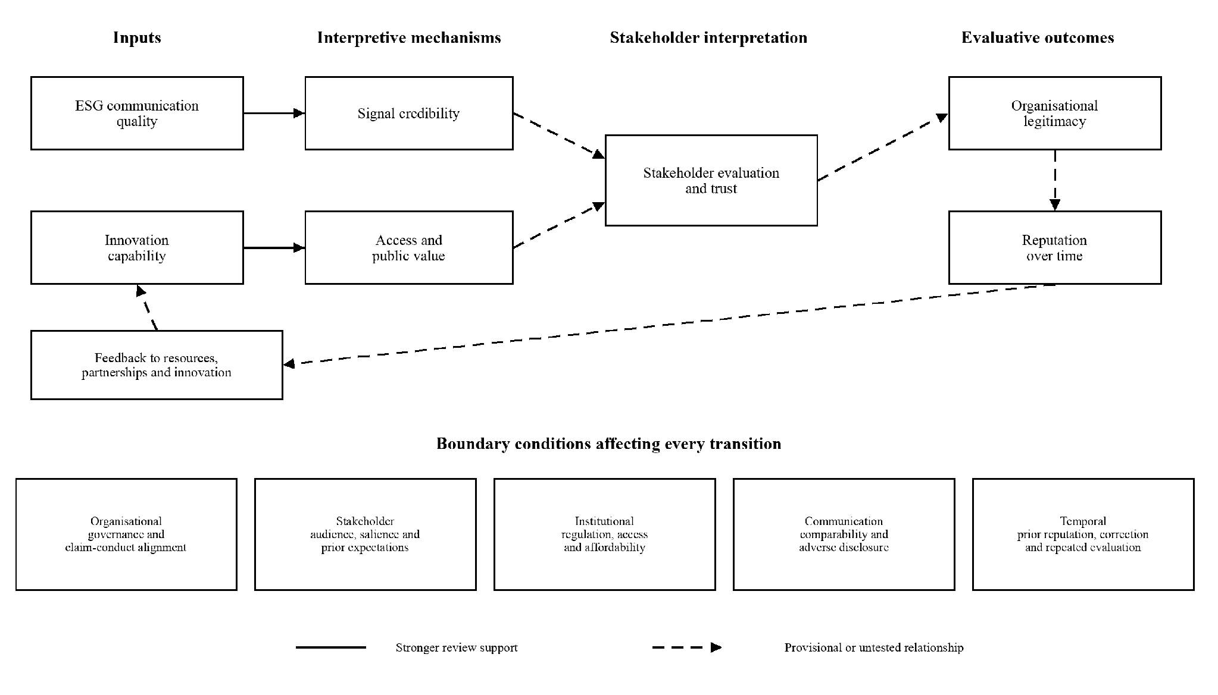
Figure 4.1. Evidence-informed integrative framework linking ESG communication, pharmaceutical innovation and corporate reputation
Note: Solid arrows indicate relationships with stronger support in the reviewed evidence; dashed arrows indicate theoretically plausible but empirically untested relationships. Boundary conditions affect every transition. The figure does not represent demonstrated causal effects.
The two initial pathways have different meanings. ESG communication quality informs credibility when claims are material, balanced, specific and verifiable.Innovation capability informs responsible public value when science is connected to access, affordability, safety and responsiveness. The later dashed pathway reflects a more provisional interpretation.Stakeholders may use those signals to form multiple factors,such as competence, integrity, transparency and benevolence judgements, which may inform legitimacy and accumulated reputation. The dashed feedback loop recognises that prior reputation can shape interpretation .Over the period of time,it may also affect partnerships, resources and innovation capacity. The reviewed studies support components of this architecture.However, no included study tests the complete sequence.
Answer to RQ5. The synthesis supports a conditional pathway from communication quality and innovation capability through credibility and responsible public value to stakeholder-specific evaluation, legitimacy and accumulated reputation, with feedback and organisational, stakeholder, institutional, communication and temporal boundary conditions. The framework is an evidence-informed synthesis for future testing, not a confirmed causal model.

4.8 Provisional theoretical propositions
Five propositions summarise the refined explanation and make their unequal evidential status explicit.
Table 4.4. Provisional propositions and future empirical testing
Proposition | Statement | Evidence strength | Appropriate future testing
P1 | ESG communication may support reputation when claims are material, specific, balanced, evidenced and conduct-aligned | Strongest documentary support | Longitudinal comparison of claims, conduct, correction and stakeholder evaluation
P2 | Pharmaceutical innovation may support legitimacy when capability is connected to access, affordability, safety and responsiveness | Moderate conceptual and empirical support | Linked innovation, access and stakeholder-outcome study
P3 | Stakeholder-specific trust may help explain how communication and innovation inform reputation evaluations | Moderate but context-specific support | Multi-stakeholder survey or panel distinguishing trust dimensions
P4 | Prior reputation may moderate the interpretation of new ESG and innovation signals | Predominantly theoretical; limited direct longitudinal evidence | Longitudinal design comparing prior standing, new signals and later evaluation
P5 | Legitimacy and reputation may develop differently across stakeholders and over time | Conceptually strong but empirically limited | Multi-stakeholder longitudinal panel
P1 has the clearest documentary basis; P2 and P3 combine context-specific findings with wider literature; P4 is mainly theory-derived; and P5 is conceptually strong but weakly tested over time. All five are analytical refinements for future empirical testing, not confirmed findings.

4.9 Summary
The primary question receives a qualified answer. Neither ESG communication nor pharmaceutical innovation produces corporate reputation directly. Communication must become credible, and innovation must become responsible public value. Stakeholders interpret those signals differently; trust and legitimacy may inform reputation, which accumulates across evidence sources and over time.
Table 4.5. Synthesis of answers to the research questions

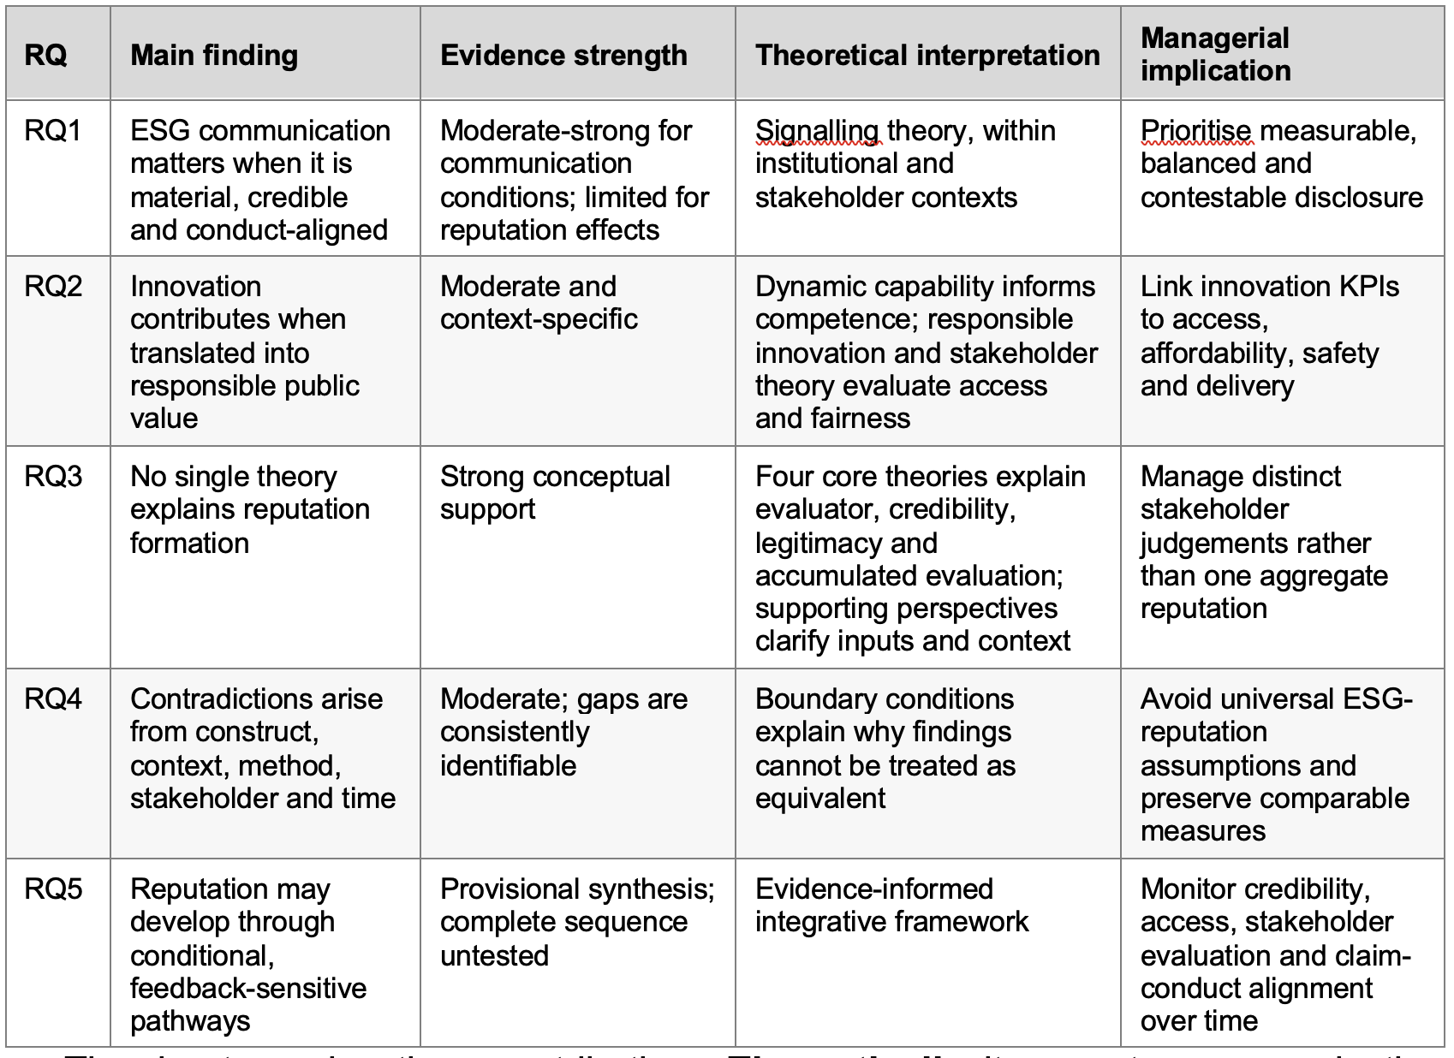
The chapter makes three contributions. Theoretically, it separates communication quality and innovation capability from the interpretive mechanisms through which they may inform legitimacy and reputation. In evidence-synthesis terms, it shows that pharmaceutical evidence remains fragmented, stakeholder-specific and often dependent on company-defined indicators; the AstraZeneca-GSK comparison therefore illustrates organisational reporting and selected outcomes without demonstrating stakeholder reputation. Managerially, it identifies the importance of material communication, responsible innovation, measurable access, stable KPIs, balanced disclosure and independent assessment. Chapter 5 develops the theoretical, managerial, policy and reporting implications without repeating the present discussion.

Chapter 5: Implications

5.1 Introduction
Chapter 4 concluded that ESG communication and pharmaceutical innovation do not produce corporate reputation directly. Communication has potential reputational relevance when it becomes credible, while innovation has potential legitimacy value when technical capability is translated into responsible public value. Stakeholders interpret both through different competence, integrity, transparency and benevolence judgements, and those evaluations may accumulate into legitimacy and reputation over time. This chapter translates that conditional argument into implications for theory, pharmaceutical management, policy and reporting, responsible innovation and future research.
The chapter does not repeat the research-question answers or present final conclusions, which remain the purpose of Chapter 6. It principally fulfils Objective 6 by identifying implications for pharmaceutical managers and future research. It also extends the theoretical and policy significance of the integrated framework. It asks about the changes in aspects, such as conceptual reasoning, managerial practice, reporting architecture and research design if the relationships identified in Chapter 4 are conditional and stakeholder-specific. Recommendations are consequently proportional to the evidence. Documentary findings support stronger implications for communication and accountability. On the other hand, trust, legitimacy, reputation and feedback pathways emerge as propositions which require empirical examination.

5.2 Theoretical implications
The first implication is that ESG communication, ESG performance and corporate reputation should be separated analytically. Signalling theory explains how specific and observable evidence can reduce information asymmetry, although it does not establish moral acceptability or favourable comparative evaluation (Connelly et al., 2011). Legitimacy theory addresses social acceptance. On the other hand, corporate reputation concerns accumulated and comparative evaluation across audiences and time (Suchman, 1995; Deephouse and Carter, 2005; Barnett, Jermier and Lafferty, 2006). The review challenges models which treat disclosure quantity or an ESG score as a direct antecedent of a single reputation outcome. Communication quality is more defensibly positioned as an input to stakeholder interpretation.
Second, pharmaceutical innovation needs to go through a dual evaluation. Dynamic capability can explain scientific adaptation and organisational capacity. However, technical competence does not determine whether innovation is accessible, affordable, safe or responsive. Responsible-innovation theory adds multiple factors, such as anticipation, inclusion, reflexivity and responsiveness. Access research shows that production, allocation, affordability and delivery are interconnected (Stilgoe, Owen and Macnaghten, 2013; Wouters et al., 2021). Innovation theory in this sector should be able to distinguish capability from responsible public value. This distinction also corrects the use of R&D expenditure as an innovation-output or social-impact proxy, and expenditure indicates resource commitment(Subramanian, Jain and Bhattacharyya, 2024).
Third, stakeholder heterogeneity should be part of the model as opposed to treated as statistical noise. Stakeholder theory identifies different interests and degrees of salience. Trust research on the other hand, shows that competence, integrity, transparency and benevolence may manifest different degree of imprtance across stakeholder relationships (Freeman, 1984; Mitchell, Agle and Wood, 1997; Pirson and Malhotra, 2011). A company can receive favourable competence evaluations from one audience and moral criticism from another. Reputation should be conceptualised as a set of potentially divergent evaluations instead of a uniformly held asset. Evidence concerning Ghanaian pharmaceutical buyers supports one bounded stakeholder pathway, although it cannot represent patients, regulators, investors and communities collectively (Opoku, Adomako and Tran, 2023).
Finally, the framework implies reciprocal and temporal relationships. Prior reputation may affect the interpretation of new signals. Apart from that, later reputation may influence partnerships, stakeholder tolerance and access to resources. This does not confirm reverse causality. Instead, it identifies a theoretical limitation in one-directional ESG-to-reputation models. The strongest contribution of the framework is consequently integrative as opposed to predictive. It specifies constructs, possible transitions and boundary conditions which future studies can test without collapsing credibility, trust, legitimacy and reputation.

5.3 Managerial implications

5.3.1 Govern communication as an accountability system
The evidence does not support a strategy of communicating more in case of communication, ESG, corporate affairs and investor-relations managers. Reporting breadth can coexist with omitted controversies, unclear material boundaries and incomparable targets (Demir and Min, 2019; Grant et al., 2025; Schwoy, Dutzi and Messing, 2025).As a result, communication governance should begin with a material claim register. For each significant ESG or innovation claim, managers should record several elements, such as responsible executive, baseline, measurement boundary, target, evidence source, known limitation and date for progress. This develops communication into an accountable commitment system.
Materiality should be considered as specific to stakeholders only. Investors may require climate exposure and governance information. On the other hand, patients and health systems may prioritise multiple factors, namely, access, affordability, safety and continuity of supply. Employees emphasize on culture and integrity. Meanwhile, communities will focus on evaluating environmental and local-health effects. A single aggregated narrative will not be able to manifest these differences. Managers should map each material claim to the stakeholder group most affected and relevant trust dimension. Such mapping does not guarantee trust. However, it prevents investor-oriented disclosure from being mistaken for broad stakeholder approval.
Balanced disclosure proves to be central in the case of credibility. By identifying milestones and accountability, aspirational statements can create useful commitments. However, they become less credible when protected from counter evidence or later correction (Christensen, Morsing and Thyssen, 2013). Managers should report a range of information, such as adverse performance, delayed targets, changed assumptions and unresolved trade-offs along with achievements. Corrections should explain what changed and whether previous trend comparisons are still valid. This is particularly important in cases where operational environmental improvement coexists with value-chain difficulty

5.3.2 Connect innovation management to responsible public value
Innovation governance should not end at scientific milestones, approvals or expenditure. Portfolio and R&D leaders should include responsible-public-value criteria at relevant decision points. These points are as follows: unmet-need alignment, safety, trial inclusion, affordability, manufacturing readiness, distribution and responsiveness to health-system constraints. The purpose is not to make every research programme identical. It is to require an explicit account of who may benefit, what may restrict access. Along with that, the aim is to identify how delivery assumptions will be reviewed
Innovation communication should create a distinction between inputs, outputs, access and outcomes. Expenditure, pipeline progress and approvals show different aspects of capability. On the other hand, availability can be determined from several factors, such as licensing, supply, affordability and patient reach. Different evidences should be accumulated in order to identify health outcomes. Combining unlike indicators into one innovation narrative can play a role in exaggerating certainty. It may also prevent fair comparison. The AstraZeneca-GSK analysis proves to be significant in order to describe the problem. Each company reports substantial scientific and access activity. However, the indicators may use different periods, definitions and units. Managers should avoid peer rankings unless measures emerge as equivalent. They must also provide clear explanation on cumulative versus annual reach.
Independent assessment can prove to be useful for improving contestability. The Access to Medicine Foundation comparison identifies strengths and limitations under a common method, including GSK's stronger Product Delivery position and AstraZeneca's patient-reach measurement strength (Access to Medicine Foundation, 2024a, 2024b, 2024c). Managers should use such assessments as learning and challenge mechanisms as opposed to promotional badges. A favourable ranking applies to the assessed dimensions. It should not be considered as a comprehensive reputation measure. Less favourable findings should be incorporated into action plans and later reporting.

5.3.3 Preserve measurement continuity and managerial ownership
Longitudinal accountability requires indicators which are stable. Managers may legitimately revise a KPI when strategy, regulation or measurement quality changes, but the earlier and revised series should be reconciled where possible. Reports should state definition changes, restate historical values when feasible and explain why continuity cannot be preserved when it is not feasible. In the absence of this control, apparent improvement may reflect a changed denominator or scorecard as opposed to changed performance.
Responsibility for reputation-relevant evidence should be distributed. Communication teams cannot repair weak access design, environmental performance or governance through wording. R&D, market access, medical affairs, supply, sustainability, compliance and corporate affairs should jointly review high-risk claims. A cross-functional review should ask whether the claim is material, whether the evidence is proportionate, whether omitted information changes its meaning and whether stakeholders can compare the claim with later conduct. This gives managers control over the quality and accountability of the signals they produce, while treating reputation as an externally conferred evaluation.
Table 5.1. Evidence-linked managerial action framework
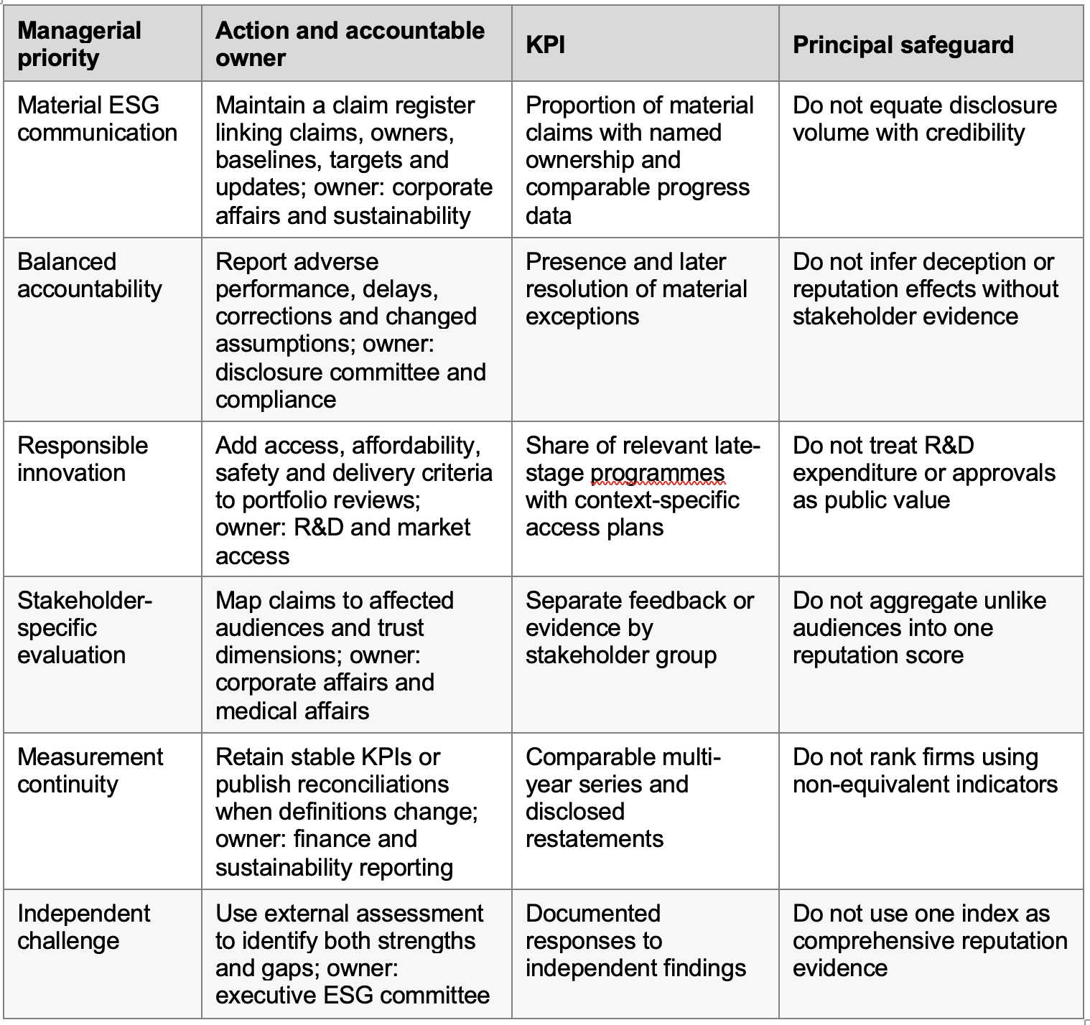

5.4 Policy and reporting implications
The evidence supports reporting requirements that improve comparability without assuming that standardisation guarantees responsibility. Institutional pressures can produce similar formats and language even when conduct differs (DiMaggio and Powell, 1983). Regulators, standard setters and assurance providers should therefore emphasise decision-useful definitions, boundaries and reconciliations rather than report presence alone. Climate and access indicators should identify baseline year, organisational and value-chain scope, measurement period, inclusion rules and whether figures are annual or cumulative. Where a KPI changes, the reporting entity should explain the change and provide a bridge to the previous measure.
Policy should also strengthen balanced disclosure. The controversy evidence indicates that adverse matters can be repeated, confined to legal reporting or omitted, and that assurance does not automatically ensure balanced presentation (Schwoy, Dutzi and Messing, 2025). Materiality rules should require organisations to explain how adverse information was identified, where it is reported and how remedial progress will be tracked. Assurance statements should specify exactly which indicators, definitions and processes were examined. A general assurance reference should not be allowed to imply verification of all narrative claims.
Pharmaceutical reporting also requires stronger social and innovation metrics. Environmental reporting is increasingly developed. However, public value cannot be inferred from innovation expenditure or technical achievement alone. Policy frameworks should encourage separate reporting of a range of aspects, such as scientific capability, access planning, affordability mechanisms, licensing and outcome evidence. These categories should not be mechanically combined due to the fact that their relevance differs by product, disease, geography and health system. The policy objective is traceability instead of a universal composite score.
Independent assessment has an important and still bounded role. Common methodologies can expose differences which company-defined indicators obscure. On the other hand, ESG-rating divergence shows that scope and weighting still shape outcomes (Berg, Kölbel and Rigobon, 2022). Policymakers should encourage methodological transparency. Along with that, it should require users to state what an index measures and excludes. This would reduce the risk of narrow access, environmental or investor-risk score being represented as objective corporate reputation.

5.5 Implications for responsible pharmaceutical innovation
Responsible innovation should operate as a governance practice across the innovation lifecycle. It must not function as an ESG narrative added after technical decisions. Anticipation requires early consideration of unmet need, safety, affordability and delivery constraints. Inclusion demands relevant patient, professional and health-system knowledge. On the other hand, reflexivity requires scrutiny of assumptions about demand, access and acceptable risk. Responsiveness requires evidence that programmes or access arrangements may change due to the change in stakeholder evidence or social conditions (Stilgoe, Owen and Macnaghten, 2013).
These principles imply differentiated access planning. A global access commitment is less informative compared to a plan that identifies multiple aspects, such as target populations, countries, partners, affordability mechanisms and delivery dependencies. Plans should be reviewed as products move through development, regulation and launch due to the fact that uncertainty changes at each stage. Transparent limits are preferable to ambitious and non-contestable commitments. Managers should also acknowledge the contributions of multiple players, such as public agencies, research institutions, health systems and commercial partners instead of attributing ecosystem outcomes to one firm.
Responsible innovation creates a bridge between scientific competence and moral legitimacy. However it should not be justified only as reputation management. Access, safety and responsiveness emerge as stakeholder obligations even if there is uncertainty in immediate reputational or financial benefits. This prevents the integrated framework from becoming purely instrumental. It also preserves the normative contribution of stakeholder and responsible-innovation perspectives.

5.6 Future research implications
Future research should test the five propositions from Chapter 4 in designs that preserve construct and stakeholder distinctions. P1 requires longitudinal comparison of claims, material adverse evidence, correction and later stakeholder evaluation. P2 requires studies linking innovation capability to access, affordability, safety and delivery rather than using R&D expenditure alone.On the other hand, P3 requires multi-stakeholder evidence which separates competence, integrity, transparency and benevolence.It also tests whether trust helps explain reputation evaluation. P4 requires prior reputation to be measured before new ESG or innovation signals. Lastly, P5 requires repeated observations across stakeholder groups and time.
From a methodological perspective, mixed longitudinal designs would be especially valuable. Researchers could combine systematic document coding with multiple aspects,such as independent performance indicators, regulatory evidence, civil-society framing and repeated stakeholder surveys. Such a design would show whether a claim was specific and balanced and the subsequent alignment of conduct.It can also demonstrate if audiences noticed the evidence and any change in evaluation.It would also distinguish visibility from trust and legitimacy from comparative reputation. Experimental vignette studies could complement this work by varying claim specificity, assurance, adverse disclosure and access performance.However, they should not replace evidence of real organisational conduct.
Geographic and stakeholder coverage need to be broadened. The current literature includes useful evidence from particular buyer groups, countries and reporting settings.However, it cannot represent the global pharmaceutical sector. Comparative studies should include a range of factors,such as patients, healthcare professionals, regulators, employees, investors as well as communities across high-income, middle-income and lower-income settings. Researchers should report disagreement as opposed to compressing all evaluations into one score.
Finally, the review itself should be replicated with broader traceable database coverage and independent screening. The verified corpus supports a transparent conceptual synthesis.However, it is limited in size and disciplinary balance. Future reviews should preserve export files, deduplication decisions, exclusion reasons, appraisal and coding trails.It should compare academic findings with company documents and independent assessments without merging their evidential roles. These steps would test the stability of the present framework under a larger evidence base.

5.7 Chapter summary
The implications of the review are conditional as opposed to universal. From a theoretical perspective, communication, performance, trust, legitimacy and reputation must remain distinct.On the other hand, innovation capability must be separated from responsible public value.From managerial point of view, organisations should govern material claims and disclose adverse evidence.They must also preserve KPI continuity, connect innovation to access and use independent assessment as a challenge mechanism. Policy should strengthen multiple elements,such as comparability, balanced disclosure, assurance boundaries and traceable social-innovation indicators. Responsible innovation should embed anticipation, inclusion, reflexivity and responsiveness throughout development and delivery.
Future research must test the proposed pathways across stakeholders and time instead of assuming that communication or innovation produces reputation. Chapter 6 now provides the concise overall conclusion.It evaluates achievement of the aim and objectives and answers the research questions it also states the contribution along with limitations, presents the final framework and identifies the priorities for empirical testing.

Chapter 6: Conclusion

6.1 Introduction
This dissertation performs evaluation in order to determine how and under what conditions ESG communication and pharmaceutical innovation are associated with corporate reputation in the post-pandemic pharmaceutical sector. It utilized a structured Extended Literature Review in order to integrate academic evidence with limited comparative insights from AstraZeneca and GSK. This chapter concludes the study with regard to its aim, objectives and research questions. It states its contribution and limitations. It also identifies the priorities for empirical testing.

6.2 Overall conclusion against the aim and objectives
The central conclusion depends on certain conditions. Neither ESG communication nor pharmaceutical innovation is capable of producing corporate reputation directly. Communication can prove to be informative for evaluation if claims are specific, balanced, comparable and aligned with later conduct. Innovation can contribute when scientific capability becomes responsible public value by maintaining several requirements, such as safety, access, affordability, delivery and responsiveness. Stakeholders may interpret these signals differently. On the other hand, legitimacy and reputation develop through repeated evaluation as opposed to technical achievement alone.
The six objectives were achieved within the limits of secondary evidence. The review evaluated the evolution and credibility conditions of ESG communication; distinguished innovation capability from responsible outcomes; compared the explanatory roles of stakeholder, signalling, legitimacy and reputation theories; identified conceptual and methodological debates; developed an integrated conditional framework; and translated the synthesis into managerial and future-research implications. This is a conceptual and evaluative contribution, not proof of causal effects.

6.3 Conclusions by research question
RQ1: How has ESG communication evolved following COVID-19? Later pharmaceutical evidence gives greater prominence to quantified ESG commitments, access, governance and climate accountability. However, it does not establish a sharp temporal break. Reporting breadth remains an inadequate indicator of credibility as factors, such as material coverage, adverse disclosure, boundaries and target comparability may change (Demir and Min, 2019; Schwoy, Dutzi and Messing, 2025).
RQ2: Under what conditions may innovation contribute to trust and legitimacy? Technical success can support competence judgements. On the other hand, legitimacy may also depend on whether benefits are safe, accessible, affordable and responsive to stakeholder needs. R&D expenditure indicates resource commitment as opposed to successful or equitable impact (Stilgoe, Owen and Macnaghten, 2013; Subramanian, Jain and Bhattacharyya, 2024).
RQ3: Which theories best explain the relationship? No single theory is actually sufficient. Stakeholder theory identifies evaluators and signalling theory explains credibility. Legitimacy theory explains social acceptance and reputation theory explains accumulated comparative evaluation (Freeman, 1984; Connelly et al., 2011; Deephouse and Carter, 2005).Other theoretical explanations such as responsible innovation, institutional theory and dynamic capabilities help to clarify public value, context and organisational capacity. They don’t replace the core theories.
RQ4: What debates and gaps remain? The principal disputes concern disclosure versus performance as well as aspiration versus selective communication. It also deals with competence versus fairness and legitimacy versus reputation. Lastly, it deals with convergence versus substantive responsibility. Evidence is constrained by multiple aspects. They are as follows: heterogeneous measures, limited database coverage, a small formal corpus and scarce longitudinal multi-stakeholder research. It is not possible to combine unlike constructs and audiences into one reputation effect.
RQ5: How can communication and innovation be integrated conceptually? The synthesis supports separate routes from communication quality to signal credibility and from innovation capability to responsible public value. These may inform stakeholder-specific trust, legitimacy and reputation under organisational, stakeholder, institutional, communication and temporal boundary conditions. Later transitions and the feedback loop are theoretically plausible but remain empirically untested.

6.4 Contribution of the dissertation
The theoretical contribution can be defined as an evidence-informed framework that separates multiple elements, such as communication, capability, public value, trust, legitimacy and reputation. It also shows how they may relate. It avoids both the direct ESG-to-reputation assumption and the treatment of innovation expenditure as social impact. Its value is contingent upon defining testable transitions and failure conditions.
The managerial contribution shifts emphasis from communication volume to accountable evidence. Pharmaceutical managers should govern material claims, disclose adverse performance and correction, preserve KPI continuity, link innovation reporting to access and affordability, and use independent assessments as bounded challenge mechanisms. The AstraZeneca-GSK comparison illustrates why company-defined indicators can support learning but cannot establish stakeholder opinion or reputational superiority. Independent access assessment improves comparison within its stated scope (Access to Medicine Foundation, 2024a).

6.5 Limitations
The formal review corpus consists of 15 assessed academic sources which were derived from the verified ScienceDirect and PubMed export base. Planned databases which were not able to produce traceable exports, were not represented as successfully searched. As a result, the corpus is transparent and limited in disciplinary breadth. It cannot establish sector-wide saturation. Screening, appraisal and synthesis were conducted by a single reviewer. Therefore, it created the possibility of selection and interpretive bias in spite of the documented coding and audit trail.
The evidence is heterogeneous. Documentary studies examine communication instead of stakeholder response. Innovation studies frequently use indirect proxies. On the other hand, stakeholder studies concern particular groups and contexts. Company publications are self-authored organisational evidence. Meanwhile, the Access to Medicine Index applies a defined external methodology as opposed to measuring comprehensive reputation. The 2022-2025 comparison is an operational boundary. Apart from that, 2026 publications report available FY2025 evidence in lieu of a complete 2026 period. These limitations restrict causal, longitudinal and generalisable conclusions.

6.6 Final framework and empirical testing
Figure 6.1 consolidates the refined Figure 4.1 as the dissertation's final framework; it does not add a new causal stage.
Figure 6.1. Final evidence-informed integrative framework
Note: Solid arrows indicate stronger review support; dashed arrows indicate provisional or untested relationships. The framework does not represent demonstrated causal effects.
The framework should be tested through a range of aspects,such as longitudinal, multi-stakeholder designs connecting claims, conduct, access outcomes, independent evidence and later evaluation. Priority tests concern whether balanced, conduct-aligned communication informs credibility.It also analyzes if responsible public value explains innovation legitimacy.Apart from that, it checks the ability of trust dimensions explaining reputation evaluations.Prioritty test contributes to determining how prior reputation shapes signal interpretation.It also evaluates how evaluations differ across stakeholders and time. Replicated reviews should use broader traceable database coverage and independent screening.

6.7 Final conclusion
Disclosure or scientific visibility is not sufficient enough to manufacture post-pandemic pharmaceutical reputation. It is an external, stakeholder-specific and time-dependent evaluation of whether communication is credible and innovation creates responsible public value. AstraZeneca and GSK illustrate increasingly measurable narratives and different access strengths, but neither company evidence nor one external index proves reputation. Credible claims and responsible innovation may contribute to legitimacy and reputation only through evidence, stakeholder interpretation, aligned conduct and repeated evaluation.

References
Access to Medicine Foundation (2024a) 2024 Access to Medicine Index. Amsterdam: Access to Medicine Foundation. Available at: https://accesstomedicinefoundation.org/resource/2024-access-to-medicine-index (Accessed: 13 August 2026).
Access to Medicine Foundation (2024b) AstraZeneca plc: 2024 Index company profile. Amsterdam: Access to Medicine Foundation. Available at: https://accesstomedicinefoundation.org/company/astrazeneca-plc (Accessed: 13 August 2026).
Access to Medicine Foundation (2024c) GSK plc: 2024 Index company profile. Amsterdam: Access to Medicine Foundation. Available at: https://accesstomedicinefoundation.org/company/glaxosmithkline-plc (Accessed: 13 August 2026).
Akyildirim, E., Corbet, S., Muñiz, J.A. and Scrimgeour, F. (2026) 'Market perceptions of ESG reputational risk in the US pharmaceutical industry', Corporate Social Responsibility and Environmental Management, 33(3), pp. 4502-4530. doi: 10.1002/csr.70396.
AstraZeneca (2023a) Annual Report and Form 20-F Information 2022. Cambridge: AstraZeneca plc. Available at: https://www.astrazeneca.com/content/dam/az/Investor_Relations/annual-report-2022/pdf/AstraZeneca_AR_2022.pdf (Accessed: 13 August 2026).
AstraZeneca (2023b) Sustainability Report 2022. Cambridge: AstraZeneca plc. Available at: https://www.astrazeneca.com/content/dam/az/Sustainability/2023/pdf/Sustainability_Report_2022.pdf (Accessed: 13 August 2026).
AstraZeneca (2024a) Annual Report and Form 20-F Information 2023. Cambridge: AstraZeneca plc. Available at: https://www.astrazeneca.com/content/dam/az/Investor_Relations/annual-report-2023/pdf/AstraZeneca_AR_2023.pdf (Accessed: 13 August 2026).
AstraZeneca (2024b) Sustainability Report 2023. Cambridge: AstraZeneca plc. Available at: https://www.astrazeneca.com/content/dam/az/Sustainability/2024/pdf/Sustainability-Report-2023.pdf (Accessed: 13 August 2026).
AstraZeneca (2025a) Annual Report and Form 20-F Information 2024. Cambridge: AstraZeneca plc. Available at: https://www.astrazeneca.com/investor-relations/annual-reports/annual-report-2024.html (Accessed: 13 August 2026).
AstraZeneca (2025b) Sustainability Data Annex 2024. Cambridge: AstraZeneca plc. Available at: https://www.astrazeneca.com/content/dam/az/Sustainability/2025/pdf/Sustainability-Data-Annex-2024.pdf (Accessed: 13 August 2026).
AstraZeneca (2026a) Annual Report and Form 20-F Information 2025. Cambridge: AstraZeneca plc. Available at: https://www.astrazeneca.com/investor-relations/annual-reports/annual-report-2025.html (Accessed: 13 August 2026).
AstraZeneca (2026b) Sustainability Data Annex 2025. Cambridge: AstraZeneca plc. Available at: https://www.astrazeneca.com/content/dam/az/Sustainability/2026/pdf/Sustainability-Data-Annex-2025.pdf (Accessed: 13 August 2026).
Bae, G., Ahn, J.-H., Lim, K.-M. and Bae, S. (2022) 'Corporate social responsibility of pharmaceutical industry in Korea', Frontiers in Pharmacology, 13, 950669. doi: 10.3389/fphar.2022.950669.
Barnett, M.L., Jermier, J.M. and Lafferty, B.A. (2006) 'Corporate reputation: the definitional landscape', Corporate Reputation Review, 9(1), pp. 26-38. doi: 10.1057/palgrave.crr.1550012.
Barney, J. (1991) 'Firm resources and sustained competitive advantage', Journal of Management, 17(1), pp. 99-120. doi: 10.1177/014920639101700108.
Berg, F., Kölbel, J.F. and Rigobon, R. (2022) 'Aggregate confusion: the divergence of ESG ratings', Review of Finance, 26(6), pp. 1315-1344. doi: 10.1093/rof/rfac033.
Beyne, J. and Moratis, L. (2023) 'A material world: how can materiality assessments be used to define organisational sustainability priorities, while taking into account the United Nations' SDGs?', Corporate Governance, 24(3), pp. 557-575. doi: 10.1108/CG-03-2023-0106.
Braun, V. and Clarke, V. (2006) 'Using thematic analysis in psychology', Qualitative Research in Psychology, 3(2), pp. 77-101. doi: 10.1191/1478088706qp063oa.
Calciolari, S., Cesarini, M. and Ruberti, M. (2024) 'Sustainability disclosure in the pharmaceutical and chemical industries: results from bibliometric analysis and AI-based comparison of financial reports', Journal of Cleaner Production, 447, 141511. doi: 10.1016/j.jclepro.2024.141511.
Chaturvedi, U., Sharma, M., Dangayach, G.S. and Sarkar, P. (2017) 'Evolution and adoption of sustainable practices in the pharmaceutical industry: an overview with an Indian perspective', Journal of Cleaner Production, 168, pp. 1520-1531. doi: 10.1016/j.jclepro.2017.08.184.
Chesbrough, H.W. (2003) Open Innovation: The New Imperative for Creating and Profiting from Technology. Boston, MA: Harvard Business School Press.
Cho, C.H., Laine, M., Roberts, R.W. and Rodrigue, M. (2015) 'Organized hypocrisy, organizational façades, and sustainability reporting', Accounting, Organizations and Society, 40, pp. 78-94. doi: 10.1016/j.aos.2014.12.003.
Christensen, L.T., Morsing, M. and Thyssen, O. (2013) 'CSR as aspirational talk', Organization, 20(3), pp. 372-393. doi: 10.1177/1350508413478310.
Connelly, B.L., Certo, S.T., Ireland, R.D. and Reutzel, C.R. (2011) 'Signaling theory: a review and assessment', Journal of Management, 37(1), pp. 39-67. doi: 10.1177/0149206310388419.
Cook, L., LaVan, H. and Zilic, I. (2018) 'An exploratory analysis of corporate social responsibility reporting in US pharmaceutical companies', Journal of Communication Management, 22(4), pp. 439-458. doi: 10.1108/JCOM-02-2017-0020.
Critical Appraisal Skills Programme (2018) CASP Qualitative Checklist. Oxford: CASP. Available at: https://casp-uk.net/casp-tools-checklists/qualitative-studies-checklist/ (Accessed: 12 August 2026).
Deephouse, D.L. and Carter, S.M. (2005) 'An examination of differences between organizational legitimacy and organizational reputation', Journal of Management Studies, 42(2), pp. 329-360. doi: 10.1111/j.1467-6486.2005.00499.x.
Delmas, M.A. and Burbano, V.C. (2011) 'The drivers of greenwashing', California Management Review, 54(1), pp. 64-87. doi: 10.1525/cmr.2011.54.1.64.
Demir, M. and Min, M. (2019) 'Consistencies and discrepancies in corporate social responsibility reporting in the pharmaceutical industry', Sustainability Accounting, Management and Policy Journal, 10(2), pp. 333-364. doi: 10.1108/SAMPJ-03-2018-0094.
Denyer, D., Tranfield, D. and van Aken, J.E. (2008) 'Developing design propositions through research synthesis', Organization Studies, 29(3), pp. 393-413. doi: 10.1177/0170840607088020.
DiMaggio, P.J. and Powell, W.W. (1983) 'The iron cage revisited: institutional isomorphism and collective rationality in organizational fields', American Sociological Review, 48(2), pp. 147-160. doi: 10.2307/2095101.
Donaldson, T. and Preston, L.E. (1995) 'The stakeholder theory of the corporation: concepts, evidence, and implications', Academy of Management Review, 20(1), pp. 65-91. doi: 10.5465/amr.1995.9503271992.
Eccles, R.G., Krzus, M.P. and Ribot, S. (2015) 'Meaning and momentum in the integrated reporting movement', Journal of Applied Corporate Finance, 27(2), pp. 8-17. doi: 10.1111/jacf.12113.
Falcone, R., Ansani, A., Coli, E., Marini, M., Sapienza, A., Castelfranchi, C. and Paglieri, F. (2022) 'Trusting COVID-19 vaccines as individual and social goal', Scientific Reports, 12, 9470. doi: 10.1038/s41598-022-13675-3.
Fombrun, C. and Shanley, M. (1990) 'What's in a name? Reputation building and corporate strategy', Academy of Management Journal, 33(2), pp. 233-258. doi: 10.2307/256324.
Freeman, R.E. (1984) Strategic Management: A Stakeholder Approach. Boston, MA: Pitman.
Frostenson, M. and Helin, S. (2017) 'Ideas in conflict: a case study on tensions in the process of preparing sustainability reports', Sustainability Accounting, Management and Policy Journal, 8(2), pp. 198-219. doi: 10.1108/SAMPJ-02-2015-0015.
Gold, E.R. (2022) 'What the COVID-19 pandemic revealed about intellectual property', Nature Biotechnology, 40, pp. 1428-1430. doi: 10.1038/s41587-022-01485-x.
Gomulya, D. and Mishina, Y. (2017) 'Signaler credibility, information asymmetry, and stakeholder responses to emerging-market firm acquisitions', Academy of Management Journal, 60(4), pp. 1385-1412. doi: 10.5465/amj.2015.0611.
Grant, M.J. and Booth, A. (2009) 'A typology of reviews: an analysis of 14 review types and associated methodologies', Health Information and Libraries Journal, 26(2), pp. 91-108. doi: 10.1111/j.1471-1842.2009.00848.x.
Grant, R., Niebel, D., Hunt, W., Members of the British Association of Dermatologists' Sustainability Sub-committee and Tso, S. (2025) 'Variability in triple bottom line commitments of multinational pharmaceutical and cosmeceutical companies: insights from 2023 corporate and environmental, social and governance reports', Clinical and Experimental Dermatology. doi: 10.1093/ced/llaf133.
Greenwood, M. (2007) 'Stakeholder engagement: beyond the myth of corporate responsibility', Journal of Business Ethics, 74, pp. 315-327. doi: 10.1007/s10551-007-9509-y.
GSK (2023a) Annual Report 2022. London: GSK plc. Available at: https://www.gsk.com/en-gb/investors/financial-reports/corporate-reports-archive/ (Accessed: 13 August 2026).
GSK (2023b) ESG Performance Report 2022. London: GSK plc. Available at: https://www.gsk.com/media/elpbehqq/esg-performance-report-2022.pdf (Accessed: 13 August 2026).
GSK (2024a) Annual Report 2023. London: GSK plc. Available at: https://www.gsk.com/media/iwxac4h1/annual-report-2023.pdf (Accessed: 13 August 2026).
GSK (2024b) ESG Performance Report 2023. London: GSK plc. Available at: https://www.gsk.com/media/w2kpioqk/esg-performance-report-2023.pdf (Accessed: 13 August 2026).
GSK (2025a) Annual Report 2024. London: GSK plc. Available at: https://www.gsk.com/media/wrvfwob1/annual-report-2024.pdf (Accessed: 13 August 2026).
GSK (2025b) Responsible Business Performance Report 2024. London: GSK plc. Available at: https://www.gsk.com/media/2a0pomqk/responsible-business-performance-report-2024.pdf (Accessed: 13 August 2026).
GSK (2026a) Annual Report 2025. London: GSK plc. Available at: https://www.gsk.com/en-gb/investors/financial-reports/annual-report-2025/ (Accessed: 13 August 2026).
GSK (2026b) Responsible Business Report 2025. London: GSK plc. Available at: https://www.gsk.com/media/di5bk40q/responsible-business-report.pdf (Accessed: 13 August 2026).
Gupta, V. (2021) 'Global access to COVID-19 vaccines: a responsibility of innovation systems', Nature Biotechnology, 39, pp. 519-520. doi: 10.1038/s41587-021-00950-3.
Gusenbauer, M. and Haddaway, N.R. (2020) 'Which academic search systems are suitable for systematic reviews or meta-analyses? Evaluating retrieval qualities of Google Scholar, PubMed and 26 other resources', Research Synthesis Methods, 11(2), pp. 181-217. doi: 10.1002/jrsm.1378.
Gyftopoulos, S., Drosatos, G., Fico, G., Pecchia, L. and Kaldoudi, E. (2024) 'Analysis of pharmaceutical companies' social media activity during the COVID-19 pandemic and its impact on the public', Behavioral Sciences, 14(2), 128. doi: 10.3390/bs14020128.
Hahn, R. and Kühnen, M. (2013) 'Determinants of sustainability reporting: a review of results, trends, theory, and opportunities in an expanding field of research', Journal of Cleaner Production, 59, pp. 5-21. doi: 10.1016/j.jclepro.2013.07.005.
Hong, Q.N. et al. (2019) 'The Mixed Methods Appraisal Tool (MMAT) version 2018 for information professionals and researchers', Education for Information, 34(4), pp. 285-291. doi: 10.3233/EFI-180221.
JBI (2026) Critical Appraisal Tools. Adelaide: JBI. Available at: https://jbi.global/critical-appraisal-tools (Accessed: 12 August 2026).
Lange, D., Lee, P.M. and Dai, Y. (2011) 'Organizational reputation: a review', Journal of Management, 37(1), pp. 153-184. doi: 10.1177/0149206310390963.
Lee, H., Kim, S.Y., Kim, G. and Kang, H.Y. (2019) 'Public preferences for corporate social responsibility activities in the pharmaceutical industry: empirical evidence from Korea', PLOS ONE, 14(8), e0221321. doi: 10.1371/journal.pone.0221321.
Lincoln, Y.S. and Guba, E.G. (1985) Naturalistic Inquiry. Beverly Hills, CA: Sage.
Lyon, T.P. and Montgomery, A.W. (2015) 'The means and end of greenwash', Organization and Environment, 28(2), pp. 223-249. doi: 10.1177/1086026615575332.
Malay, O.E. (2021) 'Improving government and business coordination through the use of consistent SDGs indicators: a comparative analysis of national and business sustainability indicators', Ecological Economics, 184, 106991. doi: 10.1016/j.ecolecon.2021.106991.
Merkl-Davies, D.M. and Brennan, N.M. (2007) 'Discretionary disclosure strategies in corporate narratives: incremental information or impression management?', Journal of Accounting Literature, 26, pp. 116-196.
Mitchell, R.K., Agle, B.R. and Wood, D.J. (1997) 'Toward a theory of stakeholder identification and salience', Academy of Management Review, 22(4), pp. 853-886. doi: 10.5465/amr.1997.9711022105.
Moratis, L. (2016) 'The credibility of corporate CSR claims: a taxonomy and its pragmatic implications', Corporate Social Responsibility and Environmental Management, 23(1), pp. 1-12. doi: 10.1002/csr.1368.
Morsing, M. and Schultz, M. (2006) 'Corporate social responsibility communication: stakeholder information, response and involvement strategies', Business Ethics: A European Review, 15(4), pp. 323-338. doi: 10.1111/j.1467-8608.2006.00460.x.
Opoku, R.A., Adomako, S. and Tran, M.D. (2023) 'Improving brand performance through environmental reputation: the roles of ethical behaviour and brand satisfaction', Industrial Marketing Management, 111, pp. 1-14. doi: 10.1016/j.indmarman.2022.11.011.
Page, M.J. et al. (2021) 'The PRISMA 2020 statement: an updated guideline for reporting systematic reviews', BMJ, 372, n71. doi: 10.1136/bmj.n71.
Pajuelo-Moreno, M.L., Barroso-Méndez, M.J. and Gallardo-Vázquez, D. (2024) 'Relationship between sustainability disclosure and corporate reputation: evidence from a meta-analysis', Business Strategy and the Environment, 33(8), pp. 8593-8615. doi: 10.1002/bse.3933.
Pirson, M. and Malhotra, D. (2011) 'Foundations of organizational trust: what matters to different stakeholders?', Organization Science, 22(4), pp. 1087-1104. doi: 10.1287/orsc.1100.0581.
Ponzi, L.J., Fombrun, C.J. and Gardberg, N.A. (2011) 'RepTrak Pulse: conceptualizing and validating a short-form measure of corporate reputation', Corporate Reputation Review, 14, pp. 15-35. doi: 10.1057/crr.2011.5.
Popay, J. et al. (2006) Guidance on the Conduct of Narrative Synthesis in Systematic Reviews. Lancaster: Institute for Health Research, University of Lancaster.
Reichman, M. and Simpson, P. (2016) 'Open innovation in early drug discovery: a review of the literature', Drug Discovery Today, 21(5), pp. 779-785. doi: 10.1016/j.drudis.2016.02.006.
Rindova, V.P., Williamson, I.O., Petkova, A.P. and Sever, J.M. (2005) 'Being good or being known: an empirical examination of the dimensions, antecedents, and consequences of organizational reputation', Academy of Management Journal, 48(6), pp. 1033-1049. doi: 10.5465/amj.2005.19573108.
Ruan, Y., Yang, R. and Dong, Y. (2024) 'ESG disclosure and green innovation: the roles of financing constraints and analyst attention', Journal of Cleaner Production, 434, 140250. doi: 10.1016/j.jclepro.2023.140250.
Saunders, M., Lewis, P. and Thornhill, A. (2019) Research Methods for Business Students. 8th edn. Harlow: Pearson.
Saxena, K., Balani, S. and Srivastava, P. (2021) 'The relationship among corporate social responsibility, sustainability and organizational performance in pharmaceutical sector: a literature review', International Journal of Pharmaceutical and Healthcare Marketing, 15(4), pp. 548-567. doi: 10.1108/IJPHM-12-2020-0104.
Schniederjans, D.G. and Khalajhedayati, M. (2023) 'Corporate responsibility communication and score trends: a buyer and supplier perspective', International Journal of Production Economics, 262, 108780. doi: 10.1016/j.ijpe.2023.108780.
Schuhmacher, A., Gassmann, O., Bieniok, D., Hinder, M. and Hartl, D. (2022) 'Open innovation: a paradigm shift in pharma R&D?', Drug Discovery Today, 27(9), pp. 2395-2405. doi: 10.1016/j.drudis.2022.05.018.
Schwoy, S.M., Dutzi, A. and Messing, J. (2025) 'Silence is golden? Analysing the transparency of ESG controversies in corporate reporting within the pharmaceutical and textile industry', Management Decision, 63(2), pp. 665-707. doi: 10.1108/MD-10-2023-1988.
Schäfer, C. (2026) 'Leveraging corporate reputation to drive patient loyalty: strategic insights into intangible assets in Germany's SARS-CoV-2 vaccine market', International Journal of Pharmaceutical and Healthcare Marketing, 20(1), pp. 193-214. doi: 10.1108/IJPHM-04-2025-0039.
Shea, B.J. et al. (2017) 'AMSTAR 2: a critical appraisal tool for systematic reviews that include randomised or non-randomised studies of healthcare interventions, or both', BMJ, 358, j4008. doi: 10.1136/bmj.j4008.
Singh, G. and Kumar, A. (2025) 'Driving ESG excellence in the pharmaceutical sector through an analytical approach: a roadmap for score improvement', Environmental Science: Advances, 4, pp. 1200-1215. doi: 10.1039/D5VA00286A.
Snyder, H. (2019) 'Literature review as a research methodology: an overview and guidelines', Journal of Business Research, 104, pp. 333-339. doi: 10.1016/j.jbusres.2019.07.039.
Spence, M. (1973) 'Job market signaling', Quarterly Journal of Economics, 87(3), pp. 355-374. doi: 10.2307/1882010.
Stilgoe, J., Owen, R. and Macnaghten, P. (2013) 'Developing a framework for responsible innovation', Research Policy, 42(9), pp. 1568-1580. doi: 10.1016/j.respol.2013.05.008.
Subramanian, B., Jain, N.K. and Bhattacharyya, S.S. (2024) 'Exploring the direct impact of environmental, social and governance (ESG) factors on organisational innovation output and institutional isomorphism: a study in the context of multinational life sciences organisations', Benchmarking: An International Journal. doi: 10.1108/BIJ-05-2024-0391.
Suchman, M.C. (1995) 'Managing legitimacy: strategic and institutional approaches', Academy of Management Review, 20(3), pp. 571-610. doi: 10.5465/amr.1995.9508080331.
Teece, D.J., Pisano, G. and Shuen, A. (1997) 'Dynamic capabilities and strategic management', Strategic Management Journal, 18(7), pp. 509-533. doi: 10.1002/(SICI)1097-0266(199708)18:7<509::AID-SMJ882>3.0.CO;2-Z.
Teece, D.J. (2007) 'Explicating dynamic capabilities: the nature and microfoundations of sustainable enterprise performance', Strategic Management Journal, 28(13), pp. 1319-1350. doi: 10.1002/smj.640.
Thomas, J. and Harden, A. (2008) 'Methods for the thematic synthesis of qualitative research in systematic reviews', BMC Medical Research Methodology, 8, 45. doi: 10.1186/1471-2288-8-45.
Tranfield, D., Denyer, D. and Smart, P. (2003) 'Towards a methodology for developing evidence-informed management knowledge by means of systematic review', British Journal of Management, 14(3), pp. 207-222. doi: 10.1111/1467-8551.00375.
Unsal, O. and Hippler, W.J. (2024) 'Corporate misconduct and innovation: evidence from the pharmaceutical industry', Research in International Business and Finance, 71, 102490. doi: 10.1016/j.ribaf.2024.102490.
Veleva, V., Bodkin, G. and Todorova, S. (2017) 'The need for better measurement and employee engagement to advance a circular economy: lessons from Biogen's zero-waste journey', Journal of Cleaner Production, 154, pp. 517-529. doi: 10.1016/j.jclepro.2017.03.177.
Walker, K. (2010) 'A systematic review of the corporate reputation literature: definition, measurement, and theory', Corporate Reputation Review, 12(4), pp. 357-387. doi: 10.1057/crr.2009.26.
Wouters, O.J., Shadlen, K.C., Salcher-Konrad, M., Pollard, A.J., Larson, H.J., Teerawattananon, Y. and Jit, M. (2021) 'Challenges in ensuring global access to COVID-19 vaccines: production, affordability, allocation, and deployment', The Lancet, 397(10278), pp. 1023-1034. doi: 10.1016/S0140-6736(21)00306-8.
Yang, C., Yang, R., Zhou, Y. and Liu, Z. (2024) 'E, S, and G, not ESG: heterogeneous effects of environmental, social, and governance disclosure on green innovation', Corporate Social Responsibility and Environmental Management, 31(2), pp. 1220-1238. doi: 10.1002/csr.2627.
Zhang, H., Lai, J. and Jie, S. (2024) 'Quantity and quality: the impact of environmental, social, and governance performance on corporate green innovation', Journal of Environmental Management, 354, 120272. doi: 10.1016/j.jenvman.2024.120272.

Appendices
The appendices provide methodological transparency and source-level auditability. They do not add new findings.

Appendix A: Linked search families and operational status
Table A1. Search families
Search family | Conceptual structure | Operational treatment
A: ESG communication and reputation | ESG, sustainability or CSR communication AND pharmaceutical or life sciences AND reputation, legitimacy, trust or credibility | Validated ScienceDirect and PubMed adaptations formed the formal export base
B: Innovation and reputation | Pharmaceutical or drug innovation, R&D or vaccine AND reputation, legitimacy, trust, credibility or public value | ScienceDirect attempt produced unstable pagination; no export admitted
C: Responsible innovation and access | Pharmaceutical or life sciences AND responsible innovation, access, affordability or public value AND stakeholder, legitimacy, reputation or trust | Used to guide supplementary discovery; no independent formal export claimed

Appendix B: Seven-domain summary rubric
Table B1. Common summary scoring
Domain | Score 0 | Score 1 | Score 2
Aim clarity | Unclear | Partly stated | Explicit and aligned
Design suitability | Misaligned | Partly suitable | Appropriate to the question
Data or corpus transparency | Not described | Partial detail | Sufficiently described
Analytical rigour | Not explained | Limited explanation | Clear and appropriate
Evidential support | Unsupported | Mixed support | Traceable support
Limitations | Not acknowledged | Briefly acknowledged | Relevant limits explained
Relevance | Peripheral | Useful context | Direct or strong contribution
Note: The common score summarises, but does not replace, design-sensitive appraisal. The unretrieved report received no inferred score.

Appendix C: Worked coding examples
Table C1. Evidence-to-theme examples
Evidence unit | Initial code | Descriptive category | Analytical theme | RQ link | Interpretive boundary
Some controversies were omitted or confined to legal reporting (Schwoy, Dutzi and Messing, 2025) | Selective adverse disclosure | Reporting imbalance | Credibility and claim-action alignment | RQ1; RQ4 | Does not itself demonstrate stakeholder reaction or intentional deception
ESG scores were associated with R&D expenditure used as an innovation proxy (Subramanian, Jain and Bhattacharyya, 2024) | ESG-innovation association | Resource and capability relationship | Innovation capability | RQ2; RQ5 | R&D expenditure is an input or commitment indicator, not an innovation output or reputation measure

Appendix D: AstraZeneca-GSK comparison protocol
Table D1. Symmetrical document comparison
Category | AstraZeneca source | GSK source | Comparison criteria
Innovation | Annual reports and R&D sections, 2022-2025 | Annual reports and R&D sections, 2022-2025 | Innovation type, partners, outputs, uncertainty and public-value framing
Access | Annual access and sustainability reporting, 2022-2025 | Annual access and responsibility reporting, 2022-2025 | Commitments, geographic scope, affordability, delivery and acknowledged limitations
ESG | Annual ESG and sustainability reporting, 2022-2025 | Annual ESG and responsibility reporting, 2022-2025 | Materiality, specificity, balance, baselines, metric changes and progress evidence
Governance | Annual reports and governance sections, 2022-2025 | Annual reports and governance sections, 2022-2025 | Accountability, safety, ethics, oversight and corrective disclosure
Note: The comparison preserves equivalent years and document functions. Company reports are analysed as organisational evidence and do not establish stakeholder reputation.

Appendix E: Formal academic corpus and analytical fingerprints
This appendix records the 15 formal academic sources used as the evidential backbone of the chapter. It gives each source's role, design or evidence base, verified analytical contribution and principal limitation. The table does not include the unretrieved SCR-0070 report and does not convert supporting sources into PRISMA-included studies.
Table E1. Formal academic corpus: source fingerprints
ID and role | Reference and design | Verified analytical contribution | Principal limitation and permitted use
SCR-0001 - core | Schwoy, Dutzi and Messing (2025), Management Decision. Content analysis of 190 ESG controversies in 104 reports from 16 listed pharmaceutical and textile firms. | Many controversies appeared once, in legal sections or not at all; 26 per cent were not disclosed and assurance did not ensure balance. | Report-level evidence does not measure stakeholder response. Used for disclosure credibility and adverse-information analysis.
SCR-0019 - core | Subramanian, Jain and Bhattacharyya (2024), Benchmarking: An International Journal. Necessary-condition analysis of ESG scores, financial data and R&D expenditure in 86 multinational life-sciences organisations. | ESG scores were associated with R&D expenditure, which the source used as an innovation-output proxy. | This dissertation treats expenditure as an input or commitment indicator; mixed-sector, single-year evidence does not establish output quality or reputation.
SCR-0037 - core | Opoku, Adomako and Tran (2023), Industrial Marketing Management. Two-wave survey of 211 industrial buyers from pharmaceutical firms in Ghana. | Environmental reputation was associated with brand satisfaction and performance; ethical behaviour moderated and satisfaction mediated the pathway. | Buyer perceptions in one country do not represent all stakeholders or prove a communication effect.
SCR-0072 - contextual | Beyne and Moratis (2023), Corporate Governance. Belgian survey, report analysis and interviews concerning materiality and SDG alignment. | Materiality and SDG priorities varied with stakeholder priorities, capacity and communication limits. | Cross-sector exploratory context; used to explain issue selection, not pharmaceutical reputation.
SCR-0075 - core | Demir and Min (2019), Sustainability Accounting, Management and Policy Journal. Content analysis of pharmaceutical CSR reports against 11 SASB topics. | Reporting was broad but inconsistent; only four of eleven material topics appeared in every pharmaceutical report. | Pre-COVID report content measures disclosure, not authenticity or stakeholder evaluation.
SCR-0089 - core | Singh and Kumar (2025), Environmental Science: Advances. Document-based pharmaceutical ESG assessment using weighted policy, action, certification, outcome and reporting dimensions. | ESG credibility is linked to evidence, measurable outcomes, reporting and governance. | The roadmap does not independently verify implementation or test reputation effects.
SCR-0096 - contextual | Frostenson and Helin (2017), Sustainability Accounting, Management and Policy Journal. Longitudinal qualitative case study using interviews and internal and public documents. | Sustainability reporting involved tensions between financial rationality, sustainability and selective snapshots. | Single non-pharmaceutical case; used for negotiated framing and institutional tension.
SCR-0116 - core | Calciolari, Cesarini and Ruberti (2024), Journal of Cleaner Production. Bibliometric analysis and automated comparison of Italian pharmaceutical and chemical financial reports. | Pharmaceutical disclosure increased in examined categories but differed in climate communication and sector pattern. | Financial-report corpus and automated categories may miss narrative meaning.
SCR-0117 - core | Chaturvedi, Sharma, Dangayach and Sarkar (2017), Journal of Cleaner Production. Exploratory review of pharmaceutical sustainability sources using environmental, economic and social categories. | The sector debate connects cleaner production, waste, energy, reporting and stakeholder communication. | Earlier mixed-source review; does not directly analyse reputation or post-pandemic conditions.
SCR-0125 - contextual | Schniederjans and Khalajhedayati (2023), International Journal of Production Economics. Textual and quantitative analysis of responsibility reports and buyer-supplier relations. | Positive communication sentiment and some alignment related to score trends, but topic alignment did not consistently track performance. | Mixed chemical-pharmaceutical and historical buyer-supplier context; scores are not reputation measures.
SCR-0155 - core | Cook, LaVan and Zilic (2018), Journal of Communication Management. Comparative content analysis of US pharmaceutical CSR reports and business press. | Company reports and external press differed in emphasis, particularly for environmental and sustainability language. | US setting and frequency-based coding do not measure reputation directly.
SCR-0330 - core | Saxena, Balani and Srivastava (2021), International Journal of Pharmaceutical and Healthcare Marketing. Literature review of pharmaceutical CSR, sustainability and organisational performance. | The relationship among CSR, sustainability, community image and performance is plausible but weak and heterogeneous. | Earlier broad review and mixed source selection limit direct comparison.
SCR-0538 - contextual | Malay (2021), Ecological Economics. Comparative analysis of Belgian national and business sustainability indicators, including pharmaceutical reporting. | Business indicators showed uneven SDG alignment and target consistency. | Belgian context and indicator presence do not prove performance or reputation.
SCR-0590 - contextual | Veleva, Bodkin and Todorova (2017), Journal of Cleaner Production. Biogen case using waste audits, company data, interviews and employee survey evidence. | Measurement and employee engagement supported a zero-waste programme while output indicators had limits. | Single biotech case focused on operations, not external reputation.
SCR-0808 - core | Grant, Niebel, Hunt, the British Association of Dermatologists' Sustainability Sub-committee and Tso (2025), Clinical and Experimental Dermatology. Analysis of 2023 reports from 10 pharmaceutical and six cosmeceutical firms. | Net-zero and carbon-neutrality commitments varied in target years, scopes, baselines, offsets and interim reductions. | Small convenience sample and unvalidated commitments constrain implementation or reputation inference.
Table E2. Role of additional sources
Source category | Examples used in the chapter | Analytical function | Boundary
Foundational and theoretical | Freeman; Suchman; Connelly et al.; Barnett et al.; Barney; Teece et al.; Stilgoe et al. | Define constructs and explain mechanisms | Not counted as formal empirical studies
Supporting empirical and synthesis | Berg et al.; Pajuelo-Moreno et al.; Pirson and Malhotra; Falcone et al.; Lee et al.; Bae et al.; Wouters et al.; Gold; Gupta; Gyftopoulos et al.; Reichman and Simpson; Schuhmacher et al.; Schäfer | Extend comparison beyond the 15-source corpus | Context and method are stated; transfer is not assumed
Independent contextual evidence | Access to Medicine Foundation (2024a, 2024b, 2024c) | Compare access, delivery, R&D and governance under one methodology | Defined index evidence, not comprehensive reputation measurement
Company-authored evidence | AstraZeneca (2023a-2026b) and GSK (2023a-2026b) | Compare matched 2022-2025 strategy, ESG metrics and narrative positioning | Organisational publications, not independent proof of stakeholder opinion
Note: The source roles in this appendix are consistent with the Chapter 2 evidence hierarchy. The unretrieved SCR-0070 report is excluded from the included studies and receives no inferred finding or appraisal score.

