Event Plan

Big Ideas by the Sea:
Scarborough Big Dig

Scarborough Old Town, Paradise and various locations

Tuesday 24th May to Thursday 2nd June 2022, 0900 to 1600

Version 2.1 of 06/04/2022

Contents

Plan Production & Control 4
Event Outline 4
Crowd profile 4
Event Management Structure 4
Crowd Management 4
Emergency Procedures 4
Evacuation Procedures 4
Road Traffic Management 4
Public Transport Management 4
Severe Weather & Event Cancellation 4
First Aid 5
Fire Precautions & Equipment 5
Communications 5
Media 5
Waste Management 5
Toilets 5
Lost Child/Vulnerable Adult Policy 5
Event Insurance 5
Equality Impact Statement 5
Appendix 1 – Public address Scripts 7
Appendix 2 – Licensing Conditions 7
Appendix 3 – Risk Assessments 7
Appendix 4 - Glossary 7

Plan Production & Control

This event plan has been created by Big Ideas by the Sea for its sub-event The Big Dig. It has been co-authored by John Oxley, co-director of Big Ideas by the Sea and ARCADE, freelance event producers.

The current version of this document is shown on the front cover with a main version number for major changes or additions and a sub-number for minor additions and corrections. The version number will be accompanied by the date that each revision was completed.

Event Outline

The Scarborough Big Dig (SBD) forms part of a programme of activity being curated by John Oxley and Kane Cunningham for Big Ideas by the Sea, an environmental and creative festival showcasing for the second time in May 2022.

The Big Dig has been created to provide an opportunity for the residents of Scarborough Old Town (Castle Ward) to witness and engage in archaeological investigations of the area in which they live, raising awareness of and encouraging participation in Big Ideas by the Sea.

The Big Dig consist of the excavation of a single archaeological trench up to ten metres square in green open space at Paradise, plus up to ten, one metre square trenches across Scarborough Old Town on private property in private gardens.

The event will run for ten days. The site being secured and prepared on the first day of the event and made good and all event paraphernalia removed by the afternoon of the final day when the event concludes.

The Paradise dig site will be viewable by the public. The Paradise excavation will feature guided-viewing opportunities for anyone who has booked in advance. Members of the public pre-booking their guided visits will do so via the Ticketsource online booking system and visits are based on times and capacity restrictions.

The event will be focussed on the archaeological activity and will not feature any ancillary activities.

The event will be managed and supervised throughout by a team that consists of John Oxley, Big Ideas by the Sea CIC, Chris Hall, Scarborough Archaeological and Historical Society and Marie Woods, Heritage Adventures Ltd.

Event locations
The Big Dig will take place in the Old Town of Scarborough on open space at Paradise. There will be two HERAS fenced compounds single location, which is owned and managed by Scarborough Borough Council.
Excavation Compound 1: Paradise, green open space
Located: Paradise, green open space
GPS Co-ordinates: 54.286135, -0.392487
What3Words reference: ///props.yards.buyers

Finds Processing Compound 2: Paradise, green open space
Located: Paradise, green open space
GPS Co-ordinates: 54.286122, -0.392954
What3Words reference: ///sunk.bugs.gifted
Public access and viewing within each fenced compound will be by scheduled appointment (guided tours) only.

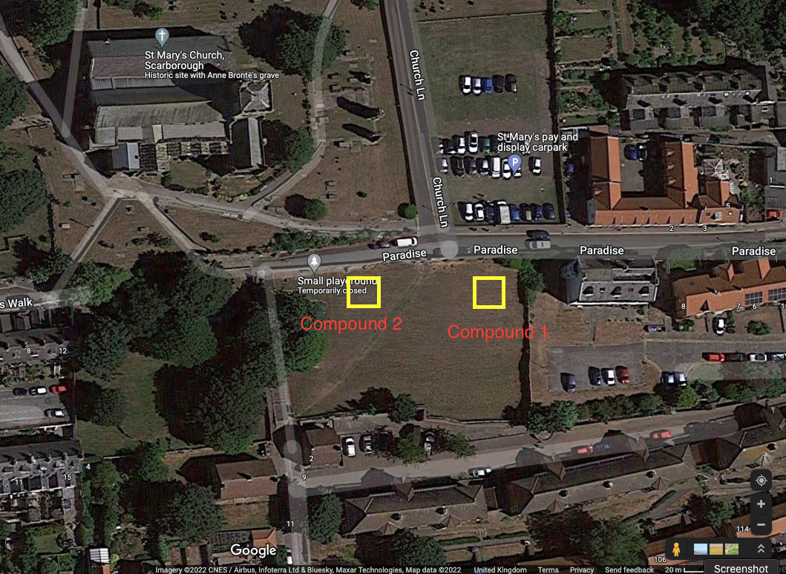

Participant and Audience profile

The primary participants of The Big Dig will be volunteers drawn from (a) the longstanding Scarborough Archaeological and Historical Society (b) residents of the Old Town (c) school groups and (d) refugee groups. The location of the site, within areas containing social housing, will give residents an opportunity to view and participate in the.

Taking part in archaeological excavations and the post-excavation processes will provide a unique and non-traditional activity for residents to engage in, whilst opening a dialogue about the past, present and future of the place in which they live.

As the compounds are in a public open space, it is anticipated that the activities will attract visitors to the location as audience. In addition, information circulated by Big Ideas by the Sea and Scarborough Archaeological and Historical Society will likely attract people who have an interest in the history and archaeology of the town.

It is expected that at any one time there could be around 50 viewers as audience members, made up of single adults, couples and families with children. This audience will include residents and visitors to the town.

Event Management Structure

The event management team of The Big Dig will report to the Big Ideas by the Sea CIC. All technical and archaeological aspects of the event will be managed by John Oxley, Marie Woods, and Chris Hall.

The table below provides guidance on key roles and responsibilities and contact numbers.

Role | Name | Responsibilities | Contact Mobile
Event Manager | John Oxley | Overall Event Manager
Deputy Event Manager | Chris Hall | Deputising as Event Manager
Deputy Event Manager | Marie Woods | Deputising as Event Manager
Health and Safety Manager | John Oxley | Ensuring dig sites remain safe to operate, ensuring HERAS fencing remains in a safe condition, responsibility for accident book and accident reporting
Lead First Aider | Marie Woods | Ensuring sufficient first aid provision, deployment and monitoring of first aid activity, ensuring compliance with event reporting requirements
Lead Safeguarding Officer | Marie Woods | Through Heritage Adventures Limited
Security Manager | John Oxley/Chris Hall | Ensuring that dig site enclosures are secured overnight including liaison with third-party security as required
Chief Marshall | Chris Hall | Leading all briefings, ensuring all participants have read and understood risks and assessments, deploying staff, managing breaks, taking care of pastoral needs
Media Relations | John Oxley | Initial contact for all media contact, arranging vehicle accommodation and accompanying media representatives into restricted zones
Welfare Manager | Marie Woods | Ensuring that welfare facilities remain available at the Market Hall and that they are used appropriately and with respect.
Production Manager | John Oxley | Deliveries, infrastructure

Crowd Management

Each compound will be cordoned off from the public on onlookers using HERAS-fenced enclosures. The public will not be permitted to enter any enclosures except on pre-booked guided tours. The HERAS-fencing will be placed onto the green space being excavated and will not be located on any footpath, thoroughfare, or roadway.

Each compound will be assigned a team of volunteers who will manage the public viewing of the works. Each team will consist of a team leader and first aider.

Volunteers will ensure that pathways are kept accessible for the public and that audience members do not impede access to any properties. These volunteers will receive a briefing at the start of each day that will include expected activity at each dig site so they can act as ‘information points’ for members of the public asking questions.

The Big Dig will include interpretation panels fixed to sections of HERAS fencing to enable the public and onlookers to understand what is taking place.

Communication between dig sites and event management will be through mobile phones; with numbers being provided to each team by the event management each day.

Each site will have a controlled entrance within the HERAS enclosure to provide access to participants and guided tours.

Guided tours will be available for pre-booking via the Ticketsource online booking system. Each tour will be limited to 10 people and will be free-of-charge. Visitors participating in guided tours will benefit from interpretation of activity by an expert. Visitors will always be accompanied from the point where they begin their tour until the tour has concluded.

Emergency Procedures
MAJOR INCIDENTS
It is not anticipated that any element of The Big Dig has the potential to become a major incident, but volunteers will be briefed in observing and monitoring activity around their site. With the compound being separated by a solid brick wall adjacent to pavements and roadways, constant attention will be paid to traffic, event-created driver distractions being a hazard or behaviours which could be indicative of a momentum-type attack. Volunteers will be empowered to close a site should they have any concerns about the safety of the public, participants, or volunteers.
In the event of a major fire, chemical spillage, or other major incident in the area, this will be immediately reported to the Event Manager and the event evacuation plan will be activated.
The Event Manager will contact the Emergency Services via 999 reporting the following information:

- The exact location of the incident
- The type and extent of the incident (and its cause, if known)
- Potential hazards present (such as chemical, high voltage power etc.)
- An estimate of the number of people injured or trapped

SERIOUS INCIDENTS
In the event of a serious incident, all activity at the site will be closed and the Event Manager will be contacted. Serious incidents would likely activate the emergency plan, including the evacuation of the site and the summoning of the emergency services.
We would define a serious incident as:
- any eventuality, action or omission which may present a real health and safety danger to member of the public or the participants and volunteers of the event.
- Any eventuality, action or omission which may present a real threat to Big Ideas by the Sea property or reputation.
- Any eventuality, action or omission which may present a real threat to partners of Big Ideas by the Sea, including Beyond Housing and other stakeholders, or their reputations.
- Anything that may present a danger to the environment or to public health
PRACTICAL APPLICATION OF THE EMERGENCY PLAN
The Big Dig will employ an Emergency Plan to address the requirements of operating in an emergency. This plan will be included in the briefing to all volunteers on each day of the event and will include the following instructions:
- All participants of the event must sign-in and sign-out when they arrive on site each day. They must further sign-in to each dig site and sign-out should they leave it. This is to ensure that there is robust recording of who is present at each site at any time so that they can be accounted for in an evacuation. Site sign-in/sign-out logs should be removed along with personnel when a dig site is evacuated.
- St Mary’s Church has been identified as the primary muster point for all event-related personnel.
- An evacuation of an affected area would be needed to remove people from immediate danger. This would include the public, participants of the event and all volunteers. All event personnel must assemble at the primary muster point to be marked as safe. If there are casualties, they should also be evacuated, if possible. If they cannot be evacuated, then event staff will remain with them if it is safe to do so. Procedures required in an emergency would be:
  - Raising the alarm and informing the public and onlookers
  - Immediate onsite emergency response
  - Summoning the emergency services and continuing to liaise with them
  - Crowd management and evacuation
  - Evacuation of those with disabilities
  - Traffic management; including guiding emergency vehicles to incident locations
  - Incident control
  - The provision of first aid services
- The Event Manager, or their deputy, would carry responsibility for both summoning and assisting the Emergency Services. They will continue to liaise with the Emergency Services and hand over responsibility to them should be incident be serious.
- The public and onlookers will be directed away from the incident towards a safe area and once marked as safe, event personnel will prevent the public from returning.
- Volunteer teams at each dig site should remain aware of members of the public with disabilities so that they can be effectively and appropriated evacuated alongside others.
- At all times, event personnel should protect property from damage
The Big Dig will use both physical addresses and What3Words to direct Emergency Services to any incidents and each dig site volunteer will be equipped with these details in both physical and digital form (on their mobile phones). Within daily briefings, the importance of the correct pronunciation of the three words utilised in a location’s What3Words address will be emphasised to ensure the correct location has been conveyed.
Each compound will have the following information available:
- The exact location of the site (What3Words and GPS co-ordinates)
- The location where any staff member is working or operating from
- Instructions detailing how to access the site
- A member of event staff dressed in high-visibility attire to guide emergency vehicles to the site
- A list of emergency contact numbers for all event personnel
- At least two mobile phones which connect to their networks with a strong signal
- The location of the nearest public telephone box and confirmation that it is in working order
- The pre-arranged use of a telephone in a private house as a contingency
- A basic first aid kit maintained with all contents in date
- A supply of fresh water in sealed bottles

Big Ideas by the Sea and its personnel and volunteers engaged in The Big Dig will be able to handle minor incidents, but emergency situations would require the Emergency Services. All such communications with the Emergency Services would be via the Event Manager unless the nature of an incident dictated that such contact was more urgent. It should be noted that Big Ideas by the Sea and its personnel and volunteers engaged in The Big Dig are not trained or equipped to manage emergency situations.

The primary muster point for all event-related personnel is Friar’s Way Car Park unless this location is rendered impracticable due to the ongoing incident. In which case, an alternative muster point will be communicated by text message to all event mobile devices.

Road Traffic Management

Whilst there is no specific traffic management requirement for this event, event personnel and volunteers will monitor traffic flow and the movement of the public on Paradise. In the event of a potential hazard, compounds will be temporarily closed to clear the public.

HERAS fencing will be delivered and unloaded from 9am on Tuesday 24th May whilst other event paraphernalia will be delivered and unloaded on the same day from a single van. A small mechanical excavator will be delivered, work on site to de-turf the excavation area, and will be removed from site on the same day.

Severe Weather & Event Cancellation

In adverse weather, the participants will likely continue with their excavations however, it would be expected that public viewing would diminish. If excavation is suspended due to the weather, then dig sites will be made safe before participants depart and any entrance to the inside of an enclosure will be secured. Participants will communicate with any public who have remained despite the weather so they’re aware the site has been suspended.

If the weather, or other eventuality, forced the cancellation of the event, its overall effect would be minimal. All sites would be made safe and secured and Event Management would contact anyone who may have booked guided tours for later sessions to inform them of the cancellation.

On resuming operations after any weather event, the lead participants will assess the dig site for safety and take the necessary steps to clean up and remove any hazards. If the excavation trench has been adversely affected by the weather it will abandoned for the remainder of the event, made safe, and reinstated before the HERAS fencing is removed.

First Aid
Big Ideas by the Sea will identify several of its personnel qualified to act as providers of First Aid during The Big Dig. The event will be suspended if there is not at least one First Aider present who has been trained to First Aid at Work standard.
Treatment for minor injuries will be provided at the Event Control Centre on Friar’s Way Car Park or in situ if the casualty cannot be moved.
Event First Aid personnel will aid and treat until the Emergency Services arrive or, if they are not required, until the casualty has received sufficient treatment or attained a recovery to allow them to continue with their activities.
All First Aid incidents will be recorded by Big Ideas by the Sea in an accident book. Incidents will be reviewed at the end of each day and learnings will be briefed to all personnel the following day.
All First Aid personnel will:
- Be at least 16 years old
- Have no other duties or responsibilities at the time of the event
- Have identification
- Have protective clothing and personal protective equipment
- Have relevant training
- Be physically and psychologically able to carry out the role

Fire Precautions & Equipment

There is no inherent fire risk associated with the activities taking place during The Big Dig and no dig site is being operated above gas supply pipework or electrical cabling.

Each dig site will be equipped with two buckets of sand for extinguishing minor fires of the type caused by a discarded cigarette or match and volunteers will have been briefed in their use. Facilities will be in place to refill any sand buckets that have been deployed.

FIRE ON SITE:
In the event of an emergency related to fire, the Event Manager will notify the Fire Service through ‘999’ and will liaise with them to ensure their swift and safe arrival. The public and participants will be evacuated from the site through deployment of the Emergency Plan and access to the affected site will be restricted.

The primary muster point for all event-related personnel is St Mary’s Church unless this location is rendered impracticable due to the ongoing incident. In which case, an alternative muster point will be communicated by text message to all event mobile devices.

No event representative or volunteer will return to any dig site until they are cleared to do by the Senior Fire Officer present.

Communications

All communications between the event management, participants and volunteers will be via mobile telephones, employing either voice for one-to-one communication or text messaging through WhatsApp for low-priority group communications.

Smartphones in use will be the property of the participants and volunteers. Appropriate consents will be collected from individuals working or volunteering for the event so that contact number lists can be created and distributed by Big Ideas by the Sea. Contact lists would be distributed to all participants and volunteers and would be shared with Emergency Services and local authority representatives for the sole purpose of operating the event. WhatsApp groups created to support the operation of the event will be discontinued and removed once the event has concluded.

All participants and volunteers must ensure that their mobile devices are fully charged at the start of each day, and they must contact the event manager if they believe their charge will be depleted before the end of their shift. The Event Manager will redeploy personnel to rebalance the number of functioning smartphones at each dig site.

Media

In the event of interest from media organisations, a space will be made available for vehicles in the Friar’s Way Car Park by Big Ideas by the Sea. Unaccompanied access to the sites by media representatives will be no different to that of the public. Media representatives wishing to gain access to any enclosure must be accompanied by a member of Event Management.

Media enquiries will primarily be managed by John Oxley, who will determine the specific interest which has generated the visit and then summon any other appropriate event management individual.

Big Ideas by the Sea will be recording the activity in each dig site using video and still photography. Consent will be sought from participants and warning notices will be posted for members of the public. The photography and videography taking place will be for documentary use following the event and some elements will be live-streamed. A contact will be provided for anyone who has concerns about the footage collected.

Waste Management

Notices will be fixed to HERAS fencing requesting that visitors take any waste or rubbish home with them; as they would during any visit to the town.

Within the dig site enclosure, Big Ideas by the Sea will provide waste bins with liners to collect participants’ rubbish and prevent it from being blown against the fencing. These bins will be emptied, and the waste removed at the end of each day – recycling such waste where possible.

At the end of each day, participants and volunteers will walk the dig site and the areas in between compounds to pick up any excess waste or rubbish that may have been generated by the event and remove it from the area – recycling such waste where possible.

Toilets and Welfare

Welfare facilities will be provided within St Mary’s Church.

Public toilets are available at the Market Hall.

St Mary’s Church has been designated as the location for morning, lunch, and afternoon breaks. All participants and volunteers will be encouraged to make use it.

Lost Child/Vulnerable Adult Policy

Big Ideas by the Sea have produced Lost Child and Vulnerable Adults procedure and policy which will be submitted alongside this document.

Event Insurance
Big Ideas by the Sea is insured through Simply Business, policy number HIBI2900249XB, as an event organiser. The policy includes:
- Public Liability up to £5,000,000
- Employer’s Liability up to £10,000,000
The policy commenced on 05/11/2021 and expires on 04/11/2022

Equality Impact Statement

Big Ideas by the Sea aims to prevent discrimination against anyone who may wish to participate in The Big Dig. We will not discriminate against those of different races, religions or beliefs, disability, sex, gender-reassignment, sexual orientation, age, marriage or civil partnership, or pregnancy or maternity.

There may be some practical difficulties in accommodating the needs of some disabled participants although any such requests would be assessed on an individual basis, with the intention of a positive outcome.

Verbal, as well as written, interpretation of the activity will be available for visitors. Interpretation will be provided in English.

Licensing Conditions

The Big Dig does not include licenced entertainment or the sale of alcohol and, thus, does not require a Temporary Event Notice.

Risk Assessments

See separate attached risk assessment.

Glossary

Big Ideas by the Sea | Big Ideas by the Sea is a festival that will take place in Scarborough, UK, in May 2022. The festival aims to be the North’s leading environmental and creative festival by 2025. This not-for-profit annual festival will bring leading speakers, thinkers, and creative people from science, the arts, business, technology, and the environment to debate the Big Ideas that concern all of us.
The Big Dig | The Big Dig is a series of archaeological activities, primarily the digging of trenches, aimed at locating and narrating the cultural heritage of Scarborough.

