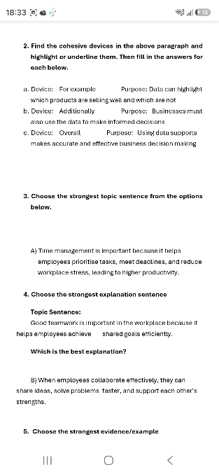
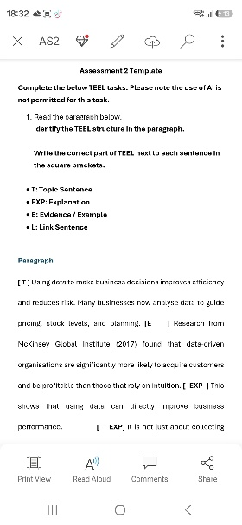
AS2 Assignment
One thing I found difficult about this assignment was being able to identify which sentence is either a topic sentence, explanation, evidence or link sentence. I had to make sure that i identified what each sentence was. I was able to confidently answer the questions about the paragraph. I can confidently complete the questions about the paragraph above.
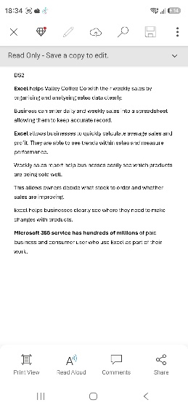
DS2 Assignment
At first I found difficult being able to choose a company that would benefit from using Excel. One think i improved was that i was able to see how excel would benefit a coffee shop company. Find ways in which excel would benefit a company in succeeding and growing them businesses.
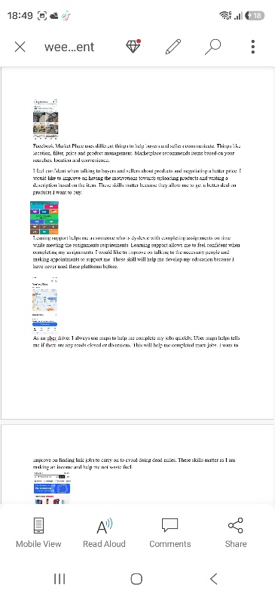
DS1 Assignment
At first i found difficult identifying different business and tools that i use on a daily routine. I improved on talking about how theses tools benefit my daily life and make it easier. I can confidently talk about how these companies and tools are used in my daily life.

