 | Contemporary Challenges: Making a Difference  Assignment 2  Shivarni Nair D/O Gunasegaran 2226207

TOPIC - SOCIETY CONTINUES TO THROW AWAY HUGE AMOUNTS OF SINGLE USE PLASTICS
STUDENT NAME:
STUDENT ID:

Table of Contents
Section 1: Decision making frameworks and techniques 3
Section 2: Reflection on the process Using Gibbs Reflective Cycle 8
presentation link …………………………………………………………………………………………………………………………………10
Reference List 11

Section 1: Decision making frameworks and techniques
Single-use plastics are a major issue now all over the world since they harm the environment and have negative social impacts. You need to use tools that will assist you in taking actions that will last in order to resolve this issue. One tool that can assist you in making a decision is Multi-Criteria Decision Analysis (MCDA) (Markkanen et al., 2020). This tool assists in assessing and ranking the many solutions and actions that can be made to address the issue of single-use plastic. Here, we discuss how MCDA can be used to address the issue of too much single-use plastic waste in society through a point-by-point study:
MCDA begins by ascertaining who is concerned with or impacted by the issue of single-use plastic. Businesses, the general public, governmental organizations, and environmental organizations may fall within this category (Borg et al., 2020). Clear goals are set, such as reducing plastic pollution, minimizing its effect on the environment, making sure it can be done economically, and raising public knowledge. A set of guidelines is made to compare different ways to deal with waste from single-use plastics. Criteria could include how it affects the climate, how much it costs, how socially acceptable it is, how well it follows the rules, and how technologically possible it is (Sekarwinahyu et al., 2019). Different options are looked at, such as banning some single-use plastics, encouraging recycling programs, putting in place plastic taxes, and coming up with biodegradable replacements. Each option is judged based on the set standards, and data is collected to figure out how well they work (Gibb, 2019). Stakeholders give each measure a certain amount of weight based on how important it is. For example, the effect on the environment might be given more weight than the cost to the economy. The weighting process takes into account what is most important to each party and makes sure that the decision is in line with their goals and values. Alternatives are given a score for each criterion, which shows how well they meet that criterion. For example, an option might get a high score for how it affects the environment but a low score for how much it costs. These scores are used to figure out how well each option did overall (Herberz, et a., 2020).
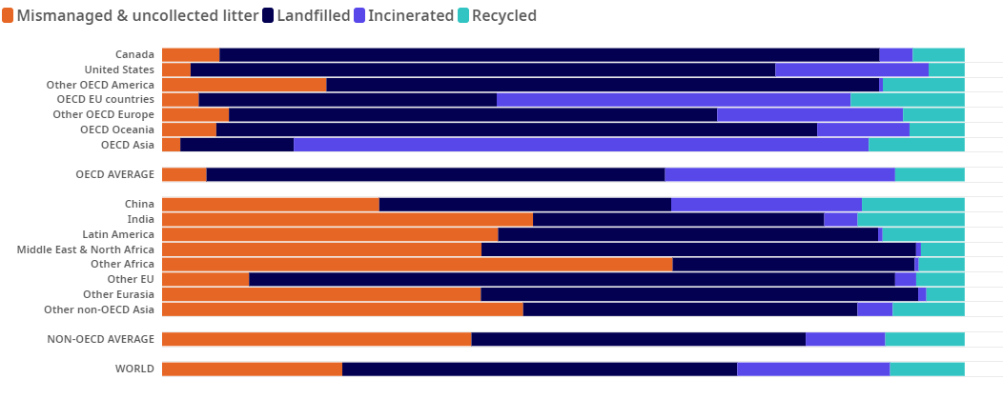
Figure 1: Share of plastics treated by waste management
(Source- OECD, 2023)

A sensitivity analysis is done to see how changing the weights of criteria or the data used to rank options affects the ranking. This analysis helps figure out which factors have the biggest effect on the decision and lets changes be made with more knowledge (Simon et al., 2021). The alternatives are ranked by how well they work overall. The option with the highest score is chosen as the best way to deal with the problem of single-use plastic. After a solution is chosen, a plan is made to keep track of how it is put into action and how well it works. Changes can be made if needed based on what people say and what data is being collected all the time. MCDA makes the decision-making process more open by showing clearly how each option was analyzed and why a certain choice was made. To get people's support and help, it's important to communicate well with them.

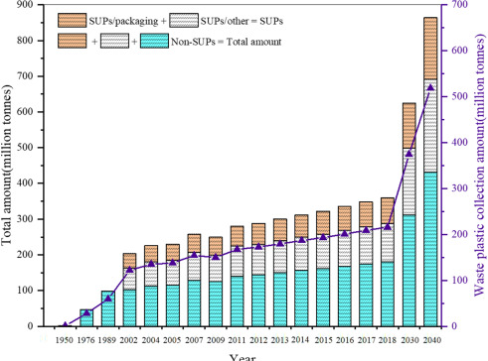
Figure 2: Single-use plastics: Production, usage, disposal, and adverse impacts
(Source- Chen et al., 2021)
Tools Used
As new information comes in or as things change, the choice can be looked at again and changed as needed.
In the end, using Multi-Criteria Decision Analysis (MCDA) is a structured and methodical way to deal with the problem of too much single-use plastic trash in society. MCDA helps make sure that choices are well-informed, clear, and in line with the values and priorities of the community (Tullo, 2019).
It does this by involving stakeholders, setting clear goals, and looking at a variety of options. Through monitoring and constant improvement, MCDA supports sustainable actions that can decrease the damage single-use plastics do to the environment and make society healthier.
Utilization by group to come to a solution
A useful approach for addressing complicated issues like plastic usage and environmental preservation is multi-criteria decision analysis (MCDA). Due to the considerable contribution that excessive plastic usage makes to environmental deterioration, these two issues are inescapably linked. Using MCDA, we may analyze and prioritize different criteria in a methodical manner to find practical solutions that strike a compromise between environmental preservation and human convenience (Ncube et al., 2019).
The first step of MCDA in the context of plastic usage and environmental preservation is to establish pertinent criteria. Environmental effect, economic viability, societal acceptance, and regulatory compliance are a few examples of these factors. According to their relative importance, each criterion can be given a weighting that reflects the values and priorities of the stakeholders engaged, which could include everything from government organizations to environmental NGOs to the general public.
Next, MCDA enables the evaluation of several options. Alternatives can include things like enacting stronger plastic laws, promoting eco-friendly substitutes, or encouraging consumer awareness campaigns (Narancic & O'Connor, 2019). To establish how well each alternative performs, compare it to the criteria. This evaluation may include numerical facts, professional judgments, and public opinion.
Then, MCDA uses a variety of techniques, including weighted sum, weighted product, and outranking techniques like PROMETHEE, to aggregate these judgments. These methods produce a comprehensive picture of how each alternative performs in relation to a variety of parameters, exposing trade-offs and synergies.
The capacity of MCDA to clearly depict and discuss results is one of its strengths. The options that best support the goals of reducing plastic usage and protecting the environment can be seen by decision-makers. Additionally, sensitivity analysis can be used to evaluate how well the selected solution holds up to various situations and uncertainties (Godfrey, 2019).
MCDA can help people make wise decisions when it comes to using plastic and protecting the environment by concurrently taking into account social, economic, and environmental factors. For instance, it can show that while prohibiting single-use plastics might significantly improve the environment, it might also provide economic difficulties for some sectors of the economy or social problems with accessibility.
In conclusion, the MCDA provides a methodical, open, and inclusive approach for resolving the difficult problem of plastic usage and environmental preservation. It equips decision-makers to make more informed decisions that are in line with the long-term health of our planet while taking into account pragmatic issues and trade-offs by embracing diverse criteria and stakeholders' viewpoints. This strategy is a step in the right direction for tackling the serious problem of plastic pollution and preserving our natural ecosystem.
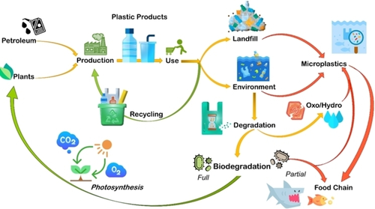

Figure 3: Various fates for petro-based and bio-based plastics, including landfill, recycling, and environmental degradation.
( source - Filiciotto, L, 2021)

Section 2: Reflection on the process Using Gibbs Reflective Cycle
The investigation of decision-making frameworks and methods intended to address the single-use plastic dilemma has been enlightening, bringing up a variety of feelings and insights. I will explore my thoughts, feelings, and insights throughout this process using the Gibbs Reflective Cycle.
Description
The investigation of decision-making frameworks and methods started with a basic comprehension of the gravity of the single-use plastic problem. The complex relationships between human behavior, governmental actions, technological developments, and environmental effects were fascinating. As I learned more about the subject, I discovered a complicated network of interconnected elements that support the continued usage of single-use plastics in modern society.
Feelings
At first, there were feelings of alarm and sympathy for the devastating effects that single-use plastics have on the environment. The seriousness of the situation prompted a desire to investigate potential remedies out of a mixture of haste and irritation. A glimmer of optimism was provided by the exploration, which uncovered novel approaches and frameworks that might help stop the plastic issue (Adeani et al., 2020). A sense of optimism and encouragement was provided by the constructive steps being made through policies, circular economy programs, and technology advancements.
Evaluation
The thorough examination of decision-making frameworks revealed the complex processes at work. Regulations and prohibitions became effective instruments, causing people to consider how governments may influence behavior and promote sustainable behaviors (Markkanen et al., 2020). The examination of circular economy strategies brought home how crucial it is to move away from a linear consumption model and toward a more comprehensive, sustainable strategy. An important shift in accountability was shown by the study of Extended Producer Responsibility (EPR), which has the potential to transform waste management.
Analysis
The study revealed how these frameworks work in concert, with legislative actions laying the groundwork for change, circular economy methods directing sustainable production and consumption, and EPR bridging the gap by coordinating financial incentives with environmental responsibility. It became clear how significantly behavioral economics and public awareness campaigns have impacted societal change. This interconnection made it clear that the problem required a thorough, multifaceted solution.
Conclusion
My comprehension of the intricacy of the single-use plastic dilemma and the variety of options needed to address it has deepened as a result of the exploration process. The range of feelings—from worry to hope—reflected the necessity and opportunity for progress in this area. The report emphasized the need for cross-sector cooperation and a paradigm shift in how people view plastics and environmental responsibility.
Action Plan
The knowledge I've received through this investigation compels me to actively advocate for change. I want to have discussions on single-use plastics' effects with my friends and coworkers in order to spread the knowledge I've learned. Additionally, I intend to take part in or support projects that advance sustainable practices, whether that means promoting laws that encourage the use of less plastic or supporting companies with strong EPR programs (Sekarwinahyu et al., 2019). The significance of both individual and collective acts in bringing about real change has been reaffirmed by this process of reflection.

Presentation links :
- https://iumwgroup-my.sharepoint.com/:v:/g/personal/23020011_student_iumw_edu_my/ETcUn_P12WRFufBY8lXoyc4B9oDkeiyWinPkj7C1iSP25Q?e=IZtcsk

- https://iumwgroup-my.sharepoint.com/personal/23020011_student_iumw_edu_my/_layouts/15/stream.aspx?id=%2Fpersonal%2F23020011%5Fstudent%5Fiumw%5Fedu%5Fmy%2FDocuments%2FASSIGNMENT%202%5FVIDEO%20PRESENTATION%5FCONTEMPORARY%20CHALLENGES%2EMOV&referrer=OfficeHome%2EWeb&referrerScenario=RecentVideo%2EView

Reference List
Adeani, I. S., Febriani, R. B., & Syafryadin, S. (2020). Using GIBBS’reflective cycle in making reflections of literary analysis. Indonesian EFL Journal, 6(2), 139-148. https://journal.uniku.ac.id/index.php/IEFLJ/article/view/3382
Borg, K., Curtis, J., & Lindsay, J. (2020). Social norms and plastic avoidance: Testing the theory of normative social behaviour on an environmental behaviour. Journal of Consumer Behaviour, 19(6), 594-607. https://onlinelibrary.wiley.com/doi/abs/10.1002/cb.1842
Chen, Y., Awasthi, A. K., Wei, F., Tan, Q., & Li, J. (2021). Single-use plastics: Production, usage, disposal, and adverse impacts. Science of the total environment, 752, 141772. https://www.sciencedirect.com/science/article/pii/S0048969720353018
Filiciotto, L., & Rothenberg, G. (2021). Biodegradable plastics: Standards, policies, and impacts. ChemSusChem, 14(1), 56-72. https://chemistry-europe.onlinelibrary.wiley.com/doi/abs/10.1002/cssc.202002044
Gibb, B. C. (2019). Plastics are forever. Nature Chemistry, 11(5), 394-395. https://www.nature.com/articles/s41557-019-0260-7
Godfrey, L. (2019). Waste plastic, the challenge facing developing countries—ban it, change it, collect it?. Recycling, 4(1), 3. https://www.mdpi.com/2313-4321/4/1/3
Herberz, T., Barlow, C. Y., & Finkbeiner, M. (2020). Sustainability assessment of a single-use plastics ban. Sustainability, 12(9), 3746. https://www.mdpi.com/2071-1050/12/9/3746
Markkanen, P., Välimäki, M., Anttila, M., & Kuuskorpi, M. (2020). A reflective cycle: Understanding challenging situations in a school setting. Educational Research, 62(1), 46-62. https://www.tandfonline.com/doi/abs/10.1080/00131881.2020.1711790
Narancic, T., & O'Connor, K. E. (2019). Plastic waste as a global challenge: are biodegradable plastics the answer to the plastic waste problem?. Microbiology, 165(2), 129-137. https://www.microbiologyresearch.org/content/journal/micro/10.1099/mic.0.000749
Ncube, L. K., Ude, A. U., Ogunmuyiwa, E. N., Zulkifli, R., & Beas, I. N. (2021). An overview of plastic waste generation and management in food packaging industries. Recycling, 6(1), 12. https://www.mdpi.com/2313-4321/6/1/12
OECD (2023), Share of plastics treated by waste management, https://www.oecd.org/environment/plastic-pollution-is-growing-relentlessly-as-waste-management-and-recycling-fall-short.htm
Sekarwinahyu, M., Rustaman, N. Y., Widodo, A., & Riandi, R. (2019, February). Development of problem based learning for online tutorial program in plant development using Gibbs’ reflective cycle and e-portfolio to enhance reflective thinking skills. In Journal of Physics: Conference Series (Vol. 1157, No. 2, p. 022099). IOP Publishing. https://iopscience.iop.org/article/10.1088/1742-6596/1157/2/022099/meta
Simon, N., Raubenheimer, K., Urho, N., Unger, S., Azoulay, D., Farrelly, T., ... & Weiand, L. (2021). A binding global agreement to address the life cycle of plastics. Science, 373(6550), 43-47. https://www.science.org/doi/abs/10.1126/science.abi9010
Tullo, A. H. (2019). Plastic has a problem; is chemical recycling the solution. Chemical & Engineering News, 97, 39. https://cendev.acs.org/environment/recycling/Plastic-problem-chemical-recycling-solution/97/i39
Williams, M., Gower, R., Green, J., Whitebread, E., Lenkiewicz, Z., & Schröder, P. (2019). No time to waste: Tackling the plastic pollution crisis before it’s too late. https://opendocs.ids.ac.uk/opendocs/handle/20.500.12413/14490
Xu, E. G., & Ren, Z. J. (2021). Preventing masks from becoming the next plastic problem. Front. Environ. Sci. Eng, 15(6), 125. https://journal.hep.com.cn/fese/EN/article/downloadArticleFile.do?attachType=PDF&id=29199

