UNIVERSITY OF WALES TRINITY SAINT DAVID
Entrepreneurship
LCMB7004
Business Plan
Name :- Parth Rajani
Student Id :- 2243264
Lecturer :- Masud Ibrahim

Introduction
The following essay will be about the discussion of the business idea for EnGreen, which is all about renewable Energy and the chosen business idea is 'Photovoltaic social Noise Barrier' to promote renewable Energy for the barrier of traffic noise. This is likely through the following decades in the UK, as the technologies progress, which the function in reducing the air pollution can be highly essential. Barrier design can thus accommodate such key drivers as noise reduction, visual screening in traffic, as well as air pollution reduction.

Overview of proposed business idea
Today, there is high traffic on highways throughout the world, which is highly concerning for everyone. As the grime goes, this issue becomes very challenging (Tawalbeh et al., 2021). The present business plan is to promote the business in the UK. PVNBs are the technologies organised for mitigating the levels of noise, shielding receivers through noise pollution caused by road traffic, as well as producing clean Energy. Its structure and design are composed of a noise barrier system through the PV installation, which converts sunlight to electricity.
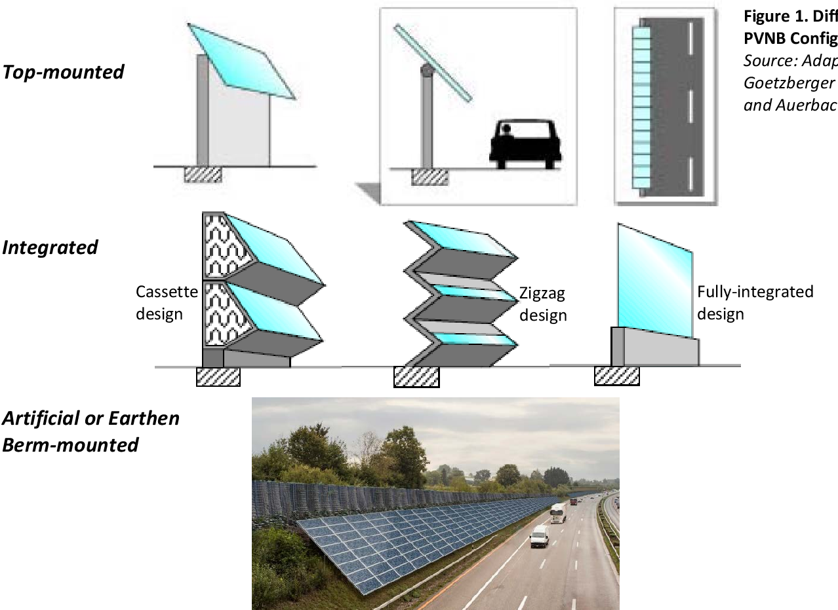
Figure 1: PVNBs in the Highway
(Source: Zimmerman, 2020)
The PV modules will be integrated into the barriers to support the components inside the sound-absorbing or soundproofing panels (Zhong et al., 2021). The design of the PV noise barriers must conduct multiple components to guarantee optimal operation lik, such as barrier locations, materials, dimensions, the range of solar radiation, local climate, as well as the azimuth in the barrier. PV noise barriers accomplish a couple of different goals. The first one is to lower the standard of acoustic Energy, which is scattered or diffracted back from the source, and the second one is the dollar cells in the modules of PV to convert solar energy to electricity and reduce carbon emission without compromising its capability for also to reduce noise.
The earliest research on PVNBs identified the key to mitigating air pollution accordingly. The research in working on the environmental noise barriers identified that, through various instances in which there is the challenge in traffic noise transport traffic, which is also likely to impact views as well as the visual quality in the area. In various cases, the PV noise barriers provided the solutions for both of these challenges (Agathokleous and Kalogirou, 2020). The concerns across the globe in regard to air pollution presently indicate which PV noise barriers get the further function through the potential towards its utilisation through reducing air pollution through roads.

Identification of the gap in initiating the business idea
High Costs: Solar PV is generally a cost-efficient way to supply a huge range of electricity required. Therefore, producing electricity is costly. Allover, the cost of dollar PV installation in the UK will be specifically decreasing; thus, decreasing remains essential as per this technology for being affordable for each and every one. PV noise barriers are expensive to install compared to traditional noise barriers of noise. Convincing potential consumers to invest through these barriers will be critical. The market requires emphasise
Poor Awareness: Various potential consumers will not become aware or concerned about the advantages or existence of PV noisier barriers (Aghaei et al., 2020). The efficient marketing strategies of the UK must focus on promoting education to the market in its benefits, such as green Energy or renewable energy generation, noise reduction, as well as sustainable enhancement.
Location issues: The existence of solar radiation will vary depending on the location. Such places, like the Southwest, are specifically very solar radiation more than the other places, like the Northeast of the UK. It could mean solar energy generation, which depends on particular locations in which the systems could be required to be installed.
Laws and Regulatory Causes: The market of the UK is subjected to strict regulations as well as permitting needs. The marketing efforts must include the proper explanation in regulatory procedures as well as how the organisation or business will assist the clients through navigating this.
Competition: The market towards renewable energy essentials develops, and competition maximises (Benöhr and Gebremedhin, 2021). It is required to differentiate the PV noise barriers from competitors by addressing iconic features, like modern noise reduction technologies and integrated storage of Energy.
Consumer’s different concerns: Some consumers will be hesitant to install PV noise barriers because of the concert in its visual effect. Marketing materials must showcase the aesthetic design components that exist, emphasising how the barriers will compound to multiple climates.
Financial Options: To highlight the high costs, consider providing financial partnerships or options through financial institutions to make the investment too accessible towards key consumers (Bognár et al., 2020)
Target Audience: Recognising significant consumer segments which are mostly to benefit through PV noise barriers, like highway authorities, property developers or renewable energy organisations, as well as tailoring the marketing strategies of the business.
Public perception: Perception of Renewable Energy as well as green technologies will vary across the public. Highlighting or addressing any misconceptions is effective in this regard, as well as promoting the environmental advantages of PV noise barriers.
Government Policies: It is important to stay informed of the governmental policies of the UK, which relate to renewable Energy as well as noise reduction. These will specifically affect the demand for the new product idea of the business, in which incorporating them into their marketing messages will be critical.
Future Performance: Solar PV gets issues in regard to the uncertainty in how much of the rays of the sun this could get, as the weather will differ as time goes by. It could prove critical by describing the level of Energy for storing for future performance (Coban et al., 2022). Sometimes the sunlight is properly available at night when there is still electricity demand. Moreover, the availability of radiation will not match the demand for peak electricity. The mechanism towards effective energy storage as well as efficient recovery is required towards the reason. Consumers will be awarded in the long-term performance as well as management of PV noise barriers. Providing guarantees and warranties will help alleviate this awareness and develop trust.

Proposed location of the business and legal entity
In installing PV noise barriers in the market of UK, the business will start their installation from London as this is very effective place in the UK in noise pollution. As in this place vehicle pollution is more likely to affect people and their health. The UK has the legal policy and its goal is to ensure 15 percent in their energy demand to meet through renewable resources through 2020 through the very cost-effective method. For this new business idea to promoting the business of PVNBs is very critical.
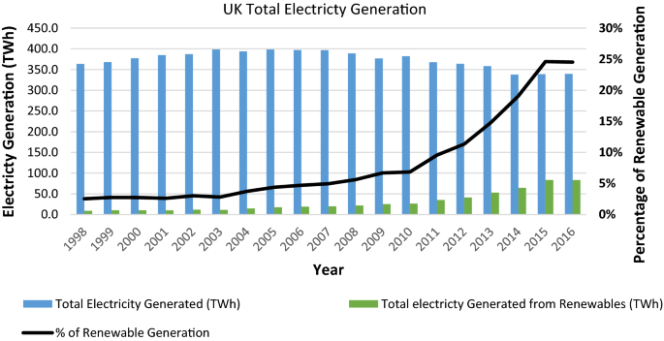
Figure 3: UK’s policy in renewable energy
(Source: Cavallaro and Nocera, 2022)

SWOT Analysis of the business
Strengths | Weaknesses
The future of the UK is poised to be the key solar power.  Sunlight availability is limited and adaptable for shading and not any sun conditions.  Proven technology, scalable through low maintenance cost and operations costs.  Existence of soft loans as well as government incentives towards expansion and development. | Government incentives are needed for embarking more subsidies and facilities towards solar ventures.  High capital as well as space costs towards the success of the grid utility plant (Dai, 2021).  Huge business is generally preferred because of its capital-intensive nature.  Distributed system structures cause base load challenges.  Research, as well as growth project simulation designs toward shaded situations, are not undertaken.
Opportunities | Threats
Ambitious targets in government towards solar projects.  PV developers for getting simple statutory as well as clearances over projects.  Prioritisation of sector implementation in the roadside through remote places with Government budgeting.  Association Formation in Renewable Energy Agencies in States for frequent lead watching in solar programmers (Franco and Franco, 2021).  Highly advanced Green jobs through marketing with the Council in Energy, CEEW research institution with high-quality research through partnerships with private and public institutions. | Huge risks in obsolescence as the novel technology.  The reduction of Cash Flow through the off-season.  UK has identifying professionally efficient persons towards PV industries.

Analysis of the Target market
The UK witnessed developing awareness in regard to climate sustainability as well as the requirement towards solutions of renewable Energy. Around these solutions, PV technology emerged as a promising avenue, providing clean Energy when addressing urban issues like noise pollution. The following section identifies the targeted market in PV noise barriers in London in the UK, focusing on the aspects driving its adoption as well as the potential advantages they provide to both the private and government sectors.
Nature of segmentation | Attributes | Chosen consumer segments
Geographic | Country | UK
Behavioral | Adoption habits | Most likely to adopt
Like multiple developed nations, the UK suffers from escalating noise pollution because of the increased urbanisation of transportation (Gu et al., 2021). As an outcome, there is a heightened demand towards noise barriers, which not only mitigate the sound but also provide renewable or sustainable energy production. PV noise barriers provide this dual initiative, connecting through the commitment of the UK government to renewable Energy as well as green infrastructure growth. Government incentives and initiatives, like subsidies as well as tax benefits towards the projects of renewable Energy, get additional accelerated adoption of PV noise barriers (Gu et al., 2020).
One of the potential target markets towards PV noise barriers in the UK is the projects of urban infrastructure, such as railways, highways as well and public transportation systems. However, integrating the challenges to present or the planned infrastructure not only decreases noise pollution but also generates clean Energy towards nearby communities. Transport to London, responsible for the transportation system of the capital, has become actively investing through some initiatives, setting a precedent towards other cities.
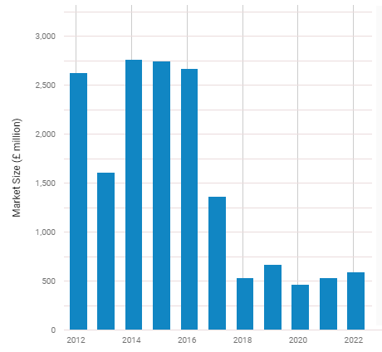
Figure 2: Solar Power in the UK
(Source: Benöhr, 2021)
Beyond the public projects, the residential and commercial industries also represent the specific market towards PV noise barriers. In commercial spaces, like industrial areas or office complexes beside busy roads, the barriers provide a quieter environment for the staff, improving wellbeing and productivity (Gu et al., 2020). In residential spaces, especially near the highways, PV noise barriers give residents a peaceful living environment when providing the grid of local Energy. The environmentally conscious customer base through the UK amplifies the market towards PV noise barriers. As people are very aware of environmental change as well as environmental degradation, there is a developing preference towards eco-friendly solutions. Photovoltaic noise barrier, through harnessing solar Energy, provides for reducing CO2 emissions as well as promotes renewable living.
As per the analysis by Jung (2019), the green factor appeals to environmentally conscious companies and people, making the niche market towards the innovative barriers.
Strategies to capture the Target Market
Through the pursuit of sustainable Energy, PV noise barriers provide a promising avenue to the UK market. For successfully adopting PV noir barriers through the UK, multiple strategies.
Understanding the market of UK dynamics is paramount. Considering the brief market research for recognising significant regions through high noise pollution as well as powerful sunlight exposure is critical. By focusing efforts on these aspects, organisations will tailor their marketing as well as distribution strategies efficiently (Mühleisen et al., 2021). The targeted initiative ensures the resources are used effectively, increasing the effect of PV noise barriers. Collaboration through local governments as well as environmental agencies is another potential strategy. Connecting through partnerships will facilitate the integration of these barriers to urban planning approaches.
Through connecting with governmental sustainability aims, manufacturers will get support in the form of incentives or subsidies. It not just creates barriers to more affordable towards the end-user yet also promotes widespread adoption around cities as well as highways (Soares and Wang, 2023). In addition, emphasising the long-term advantages of PV noisier barriers is vital. Addressing the economic benefits, like reduced electricity bills as well as potential income with the generation of excess Energy, will appeal to both individual customers as well as businesses. In addition, it emphasises positive environmental effects, are as reduced carbon footprint as well as reliance on fossil fuels, and resonates through the eco-conscious population of the UK.
Incorporating advanced financial options is another efficient strategy. Providing lease-to-own schemes and partnering through financial institutions to give low-interest loans will make the first investment very manageable towards customers as well as companies (Tawalbeh et al., 2021). By easing the budget burden, these schemes lead more people to embrace PV noise barriers, thus expanding the market. Moreover, investing through technological innovations is essential. Frequent R&D will lead to enhancements through effective aesthetics and durability in PV noise barriers. Innovations like transparent social panels and customisable designs will improve its appeal, making them very attractive for architects, urban planners as well and homeowners. Sustainably pleasing designs will blend seamlessly into multiple environments to ensure wider acceptance.
Van der Borg (2020) stated that awareness and education campaigns play a specific role in fostering public acceptance. Manufacturers will collaborate through educational institutions, conducting workshops as well as participating in community events to educate people about the benefits of PV noise barriers. Through addressing awareness, the campaigns will develop trust as well as confidence around potential consumers. Making a robust support as well as a management system is vital towards consumer satisfaction. Providing warranties, daily management services as well and readily available consumer support will instil confidence in buyers. According to the research of Zdyb (2019), positive consumer experiences not only lead to consumer retention but also generate positive word-of-mouth, driving more individuals to consider PV noise barriers as a viable solution. The effective adoption of PV noise barriers through the UK market necessitates a strategic initiative which encompasses market research, collaboration, and emphasising long-term advantages, innovative financial, education, and technological advancements, as well as reliable support and environmental-friendly urban landscape, connecting through the green energy goals of the UK.

Financial Plan
To generate a sustainable Renewable energy business plan by promoting PV noise barriers in the UK market, it is necessary to develop a comprehensive budgeting plan which covers the funding needs and key external funding resources (Zhang et al., 2022). By allocating $500,000 toward research and development, a sizable amount of the funding will be used to enhance the microgrid systems' resilience and efficiency over time. $1,200,000 - This sum covers the price of energy storage devices, smart grid technologies, and renewable energy equipment (Zhong et al., 2021). Marketing, sales, management, as well as continuing monitoring and support costs, total $600,000. $900,000 will be set up for installation, upkeep, and customer assistance to guarantee the microgrid systems' dependable operation.
Expences | Amount
R&D | $500,000
Energy Storage Devices | $1,200,000
Marketing, sales, management | $600,000
Installation, upkeep, and customer assistance | $900,000
Total | $3,200,000
$3,200,000 is what's needed in total. Sources of potential outside funding: The business strategy will investigate collaborations with venture capital companies that focus on sustainability and renewable Energy. These investors are appropriate for the company in that they often search for chances in cutting-edge and high-impact industries. Grants and subsidies are provided for climate resilience projects and renewable energy projects by federal and state government organisations. To help defray the costs of development, organisations will pursue these financing opportunities aggressively.
The ability to acquire funds for the purchase of infrastructure and equipment is possible with conventional bank loans and business financing solutions. As per the opinion of Zimmerman (2020), financial firms that are competent in the renewable energy industry will be involved. Impact investors and crowdfunding platforms can be interested in sponsoring climate-resilient energy projects that have a significant positive social and environmental impact. This will investigate these possible sources of further funding. Working with key partners, such as suppliers of renewable energy technologies or well-established energy corporations, may help this business with finances and operations.

Conclusion
PV noise barriers throughout the UK market find a diverse and specific target market encompassing the projects of urban infrastructure, residential growth, commercial spaces, as well as environmentally conscious customers through the support of the government with policies as well as incentives promoting sustainable and renewable Energy, adoption of the barriers poised towards sustainable development. The demand towards renewable solutions remains to rise; PV noise barriers stand as a testament to the intersection of technology and environmental consciousness, as well as urban planning, providing a glimpse into the greener as well as future towards the UK.

Reference list
Agathokleous, R.A. and Kalogirou, S.A., (2020). Status, barriers and perspectives of building integrated photovoltaic systems. Energy, 191, p.116471.
Aghaei, M., Ebadi, H., de Oliveira, A.K.V., Vaezi, S., Eskandari, A. and Castañón, J.M., (2020). New concepts and applications of solar PV systems. In Photovoltaic Solar Energy Conversion (pp. 349-390). Academic Press.
Benöhr, M.L. and Gebremedhin, A., (2021). Photovoltaic systems for road networks.
Bognár, Á., Kusnadi, S., Slooff, L.H., Tzikas, C., Loonen, R.C., de Jong, M.M., Hensen, J.L. and Debije, M.G., (2020). The solar noise barrier project 4: Modelling of full-scale luminescent solar concentrator noise barrier panels. Renewable Energy, 151, pp.1141-1149.
Cavallaro, F. and Nocera, S., (2022). Are transport policies and economic appraisal aligned in evaluating road externalities? Transportation Research Part D: Transport and Environment, 106, p.103266
Coban, H.H., Lewicki, W., Miśkiewicz, R. and Drożdż, W., (2022). The Economic Dimension of Using the Integration of Highway Sound Screens with Solar Panels in the Process of Generating Green Energy. Energies, 16(1), p.178.
Dai, Y., Yin, Y. and Lu, Y. (2021). Strategies to facilitate photovoltaic applications in road structures for energy harvesting. Energies, 14(21), p.7097.
Franco, A.C. and Franco, L.S., (2021). Photovoltaic solar energy and environmental impacts in the industrial sector: a critical overview of barriers and opportunities. Energy Sources, Part A: Recovery, Utilisation, and Environmental Effects, pp.1-13.
Gu, W., Li, S., Liu, X., Chen, Z., Zhang, X. and Ma, T., (2021). Experimental investigation of the bifacial photovoltaic module under real conditions. Renewable Energy, 173, pp.1111-1122.
Gu, W., Ma, T., Ahmed, S., Zhang, Y. and Peng, J. (2020). A comprehensive review and outlook of bifacial photovoltaic (PV) technology. Energy Conversion and Management, 223, p.113283.
Gu, W., Ma, T., Li, M., Shen, L. and Zhang, Y. (2020). A coupled optical-electrical-thermal model of the bifacial photovoltaic module. Applied Energy, 258, p.114075.
Jung, J., Han, S. and Kim, B., (2019). Digital numerical map-oriented estimation of solar energy potential for site selection of photovoltaic solar panels on national highway slopes. Applied Energy, 242, pp.57-68.
Mühleisen, W., Loeschnig, J., Feichtner, M., Burgers, A.R., Bende, E.E., Zamini, S., Yerasimou, Y., Kosel, J., Hirschl, C. and Georghiou, G.E., (2021). Energy yield measurement of an elevated PV system on a white flat roof and a performance comparison of monofacial and bifacial modules. Renewable Energy, 170, pp.613-619.
Soares, L. and Wang, H., (2023). Sustainability impact of photovoltaic noise barriers with different design configurations. Transportation Research Part D: Transport and Environment, 116, p.103624.
Tawalbeh, M., Al-Othman, A., Kafiah, F., Abdelsalam, E., Almomani, F. and Alkasrawi, M., (2021). Environmental impacts of solar photovoltaic systems: A critical review of recent progress and future outlook. Science of The Total Environment, 759, p.143528.
Van der Borg, N.J.C.M., (2020), November. A traffic noise barrier equipped with 2160 AC modules. In the Sixteenth European Photovoltaic Solar Energy Conference (pp. 2651-2653). Routledge.
Zdyb, A., Żelazna, A. and Krawczak, E., (2019). Photovoltaic System Integrated Into the Noise Barrier–Energy Performance and Life Cycle Assessment. Journal of Ecological Engineering, 20(10), pp.183-188.
Zhang, K., Qian, Z., Yang, Y., Chen, M., Zhong, T., Zhu, R., Lv, G. and Yan, J. (2022). Using street view images to identify road noise barriers with ensemble classification model and geospatial analysis. Sustainable cities and society, 78, p.103598.
Zhong, T., Zhang, K., Chen, M., Wang, Y., Zhu, R., Zhang, Z., Zhou, Z., Qian, Z., Lv, G. and Yan, J., (2021). Assessment of solar photovoltaic potentials on urban noise barriers using street-view imagery. Renewable Energy, 168, pp.181-194.
Zimmerman, R., Panda, A. and Bulović, V. (2020). Techno-economic assessment and deployment strategies for vertically-mounted photovoltaic panels. Applied Energy, 276, p.115149.

