DETERMINATION OF THE FORMULA OF MAGNESIUM OXIDE

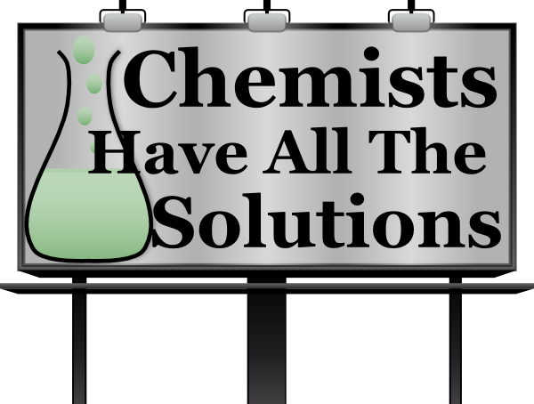

Module: Chemistry
Module Code: ACDB 4011
By: Kieran Wusthoff
Table of Contents
Purpose of the Experiment 3
Hypothesis 3
Theory 3
Chemicals & Equipment 5
Procedures 5
Observations / data 6
Calculations 6
Results and discussion 7
Conclusions 7
Bibliography 7
Appendix 8

Purpose of the Experiment
The aim of this experiment is to determine the formulae of magnesium when the subject reacts it with oxygen. By analysing the mass/mole ratio they will determine the formula of magnesium oxide. When magnesium is reacted with oxygen, we get magnesium oxide (MgO). The main tasks include weighing and recording the mass of chemicals and equipment and heating chemicals. The chemical that would need weighing is the magnesium and the equipment would be the crucible and cover. It was very important to accurately weigh these before the experiment takes place as any inaccuracies could make this an unfair test. For this experiment they will be calculating mass of oxygen (which reacted with magnesium), moles of oxygen and magnesium, mole ratio of Mg to O, determined formula of the oxide, percent by mass of Mg in the oxide, percent by mass of O in the oxide and the balanced chemical equation.

Hypothesis
The hypothesis for this experiment is that the mass of the magnesium will change when heated. All magnesium mass will react with all oxygen mass within the crucible. When the magnesium reacts with the oxygen it will form Magnesium oxide. The addition of oxygen should increase the final weight of the magnesium resulting in magnesium oxide. They expect the chemical formula to be $2Mg+O_{2 }→2MgO$.

Theory
For this experiment it is important to understand some basic laws and definitions. These include law of conservation of mass, law of definite proportions, stoichiometry, and the empirical formula.
The law of conservation of mass states that “The mass in an isolated system can neither be created nor be destroyed but can be transformed from one form to another”. The mass of the reactants and products must match up in a low energy thermodynamic process in accordance with the law of conservation of mass. The equation for conservation of mass is as follows: $\frac{∂p}{∂t}+ ∇ \left(pv\right)=0$
Where P is density, T is time, V is velocity, and $∇$ is divergence. [1]
The law of definite proportion states that “the elemental composition of pure compounds is a fixed ratio of elements by mass”. This means Another way to say that compounds have a fixed ratio of compounds by mass is to say that they always have the same percentage composition. [2]
Chemistry's study of the relative amounts of the constituents involved in reactions is known as stoichiometry. The quantities of the constituents before the reaction may be what you are examining. It's possible that you're examining how much material the reaction produces. By definition “stoichiometry is a section of chemistry that involves using relationships between reactants and/or products in a chemical reaction to determine desired quantitative data”. [3]
The empirical formula for a compound provides the most straightforward ratio of the number of various atoms that are present. “For example, in ethane, C₂H₆, the ratio of the number of carbons to hydrogen atoms is 1:3. The empirical formula is CH₃. For hydrogen peroxide, H₂O₂, where the simplest ratio is 1:1, the empirical formula is HO” [4].
The calculations and equations that will be used in this experiment are as follows: Mass of element: $Mass \% of element= \frac{Mass of element in sample}{total mass of sample } ×100$
Mole ratio: $\frac{Moles of B}{Moles of A}= \frac{Coefficent B}{Coefficent A}$

Molar Mass: [5]
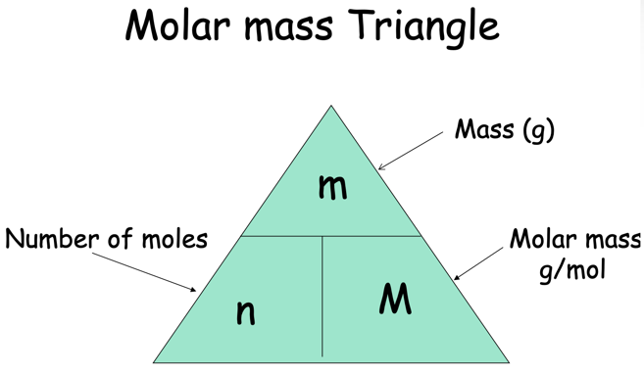
These laws and concepts are very important for OME. For example, we understand that combustion is the reaction of fuel with oxygen. These fuels can provide sulphur, hydrogen, carbon, and other combustible gases. When combined with oxygen (the oxidiser) there is a chemical reaction that releases energy in the form of light, rapid gas expansion and heat.

Chemicals & Equipment
In this experiment the chemicals they will be working with and will be exposed to are magnesium (Mg) chips, oxygen, (O) and magnesium oxide (MgO). The equipment consists of; crucible tongs, crucible and cover, clay triangle Bunsen burner, analytical balance and a ring stand. The magnesium is the form of magnesium chips. It is easier to manipulate the mass of magnesium when it is in the form of chips. For this experiment it helps them adjust the weight of the magnesium to the user’s desire. The crucible tongs are used to adjust the crucible and cover whilst hot as touching these will cause burns. The clay triangle is used to hold the crucible above the Bunsen burner whilst leaving the crucible exposed to the flame. The Bunsen burner is used to heat the crucible containing the magnesium chips. The Bunsen burner is also placed on a heat resistant mat. The analytical balance is used to accurately weigh the magnesium chips. Finally, the ring stand is used to hold and elevate the clay triangle which holds the crucible.

Procedures
Before carrying out the experiment it is important to wear the correct PPE. These include a lab coat, safety goggles and gloves. It is also important to make sure that long hair is tied back.
Firstly, they set up the ring stand and Bunsen burner on the heat-resistant mat and place the clay triangle on the top of the ring.
Next, they light the Bunsen burner and open the air vent at the bottom. They adjust the air vent to obtain a blue flame with two blue cones. When the Bunsen burner is not in use it is important to ensure that the yellow safety flame has been set. This is done so by using the air vent.
Next, they check the crucible and cover is free from clean and dry. They also check if the crucible and cover do not have any defects as this could affect the results. They should then weigh the crucible and cover and record the values in the data table.
Next, add approximately 1 - 1.5g of magnesium chips to the crucible, weigh it and record the combined mass of crucible, lid, and magnesium.
Next, they place the crucible on the clay triangle with the lid set slightly of centre. This is to allow air to enter but to prevent the magnesium oxide from escaping.
Next, they start to heat the underneath of the crucible. By gently brushing the crucible for approximately one minute the magnesium begins to heat. Then they leave the Bunsen burner on the heat mat to continue the heating magnesium. This is to last for 10 minutes. After 10 mins they should see that the magnesium has turned into a grey-white powder.
Finally, allow the crucible to cool. Once cooled record the mass of the crucible, cover, and the product of the reaction (Magnesium Oxide). These results should be added to the data sheet.

Observations / data
The magnesium starts this experiment in the form of magnesium chips / ribbons. These are small and thin strips of magnesium. Upon starting the experiment, it was clear that there was no immediate reaction. However, after a few minutes they could see there was a visible reaction. Upon further inspection they could see that the magnesium within the crucible began to give of heat and significant light. After leaving for approximately 30 mins the experiment is now complete. Opening the crucible cover they can see there is a grey / white substance. This is the Magnesium Oxide.

Calculations
Mass of Crucible and Cover | 66.7g
Mass of crucible, cover, and magnesium | 67.8g
Mass of magnesium before heating | 1.1g
Mass of crucible cover and product after heating | 68.8g
Mass of product after heating | +1= 2.1g
Mass of oxygen which reacted with magnesium | 2.1 – 1.1 = 1g
Moles of Oxygen | 1 / 16 = 0.0625 moles
Moles of Magnesium | 1.1 / 24 = 0.0450 moles
Mole ratio of Mg to O | $$\frac{0.0625}{0.0450}=\frac{0.0450}{0.0450}=1.38 1 :1.38$$
Determine the formula of the oxide | $Mg=\frac{0.0450}{0.0625}=0.72×3=2$  $$O=\frac{0.450}{0.450}=1$$
Percentage by mass of Mg in the oxide | $$Mass \%= \frac{1.1}{2.1}×100=52.3\%$$
Percentage by mass of O in the oxide | $$Mass \%= \frac{1}{2.1}×100=47.6\%$$
Balanced Chemical Equation | $$3Mg+O_{2 }→3MgO$$

Further calculations and data sheet can be found in appendix 1,2,3

Results and discussion
Upon completing the heating of the magnesium, they can see there is now a grey-white substance. The theoretical chemical equation for Magnesium oxide is $2Mg+O_{2 }→2MgO$. However, for this experiment they have calculated that the chemical equation is. $3Mg+O_{2 }→3MgO$. This is the Magnesium Oxide. It’s also important to note that the total mass of the product has increased by 1g. They calculated this by subtracting the “mass of crucible cover and product after heating” by the “mass of the crucible cover and magnesium (before heating)”. This totalled the 1g. The 1g increase is the oxygen that reacted with the magnesium to get magnesium oxide.

Conclusions
In conclusion the experiment was a success. By following the procedure, risk assessment and carrying out research prior to the experiment the subject was successfully able to carry out the experiment without any issues. Because of this they were able to accurately carry out their calculations. Having reflected on the experiment it also shows how their hypothesis was correct. In stating that the mass of the magnesium would increase once heated and exposed to oxygen, forming magnesium oxide. There was however some difficulty in calculating the ratio and the formula of oxide.

Bibliography

[1] | “BYJU'S.com,” BYJU'S, [Online]. Available: https://byjus.com/physics/law-of-conservation-of-mass/. [Accessed 27 July 2023].
[2] | “Study Smarter,” StudySmarter GmbH, [Online]. Available: https://www.studysmarter.co.uk/explanations/chemistry/physical-chemistry/law-of-definite-proportions/. [Accessed 27 July 2023].
[3] | “Dictionary.com,” © 2023 Dictionary.com, LLC, [Online]. Available: https://www.dictionary.com/browse/stoichiometry#. [Accessed 27 July 2023].
[4] | J. Clark, “Chemguide.uk,” © Jim Clark 2021, [Online]. Available: https://www.chemguide.uk/14to16/calculations/empirical.html. [Accessed 27 July 2023].
[5] | “Slide Player,” © 2023 SlidePlayer.com Inc., [Online]. Available: https://slideplayer.com/slide/8120217/. [Accessed 27 July 2023].
[6] | J. D. G. G. S. H. Steven Chu, “Britanica.com,” ©2023 Encyclopædia Britannica, Inc., 13 June 2023. [Online]. Available: https://www.britannica.com/science/spectroscopy. [Accessed 28 July 2023].
[7] | “Thermofisher.com,” Thermoscientific, [Online]. Available: https://assets.thermofisher.com/TFS-Assets/CAD/Application-Notes/Raman-FTIR-TechNote-Final.pdf. [Accessed 28 July 2023].

Appendix
“Spectroscopy is the study of the absorption and emission of light and other radiation by matter, as related to the dependence of these processes on the wavelength”. There are two key types of spectroscopies. These include Raman and FTIR. [6]
Raman spectroscopy is a vibrational spectroscopy technique where a single wavelength laser is focused on a sample. The laser “excites” the bonds of a molecule, which generates measurable scattered light to identify the material in question. Raman is a highly effective method for reliable identification of an unknown substance based on its underlying chemistry. Raman spectroscopy is great for white or light-coloured powders and sealed containers.
FTIR spectroscopy FTIR is an absorption spectroscopy technique, where mid-infrared light is passed through the sample. Some wavelengths may be absorbed while others merely pass through the sample unaffected. Specific molecular bonds absorb a specific amount of energy and these losses of energy correspond to the peaks returned in an analysis. FTIR absorptions provide outstanding and easily interpretable results for many substances. FTIR spectroscopy can be used for coloured substances and fluorescent materials. [7]
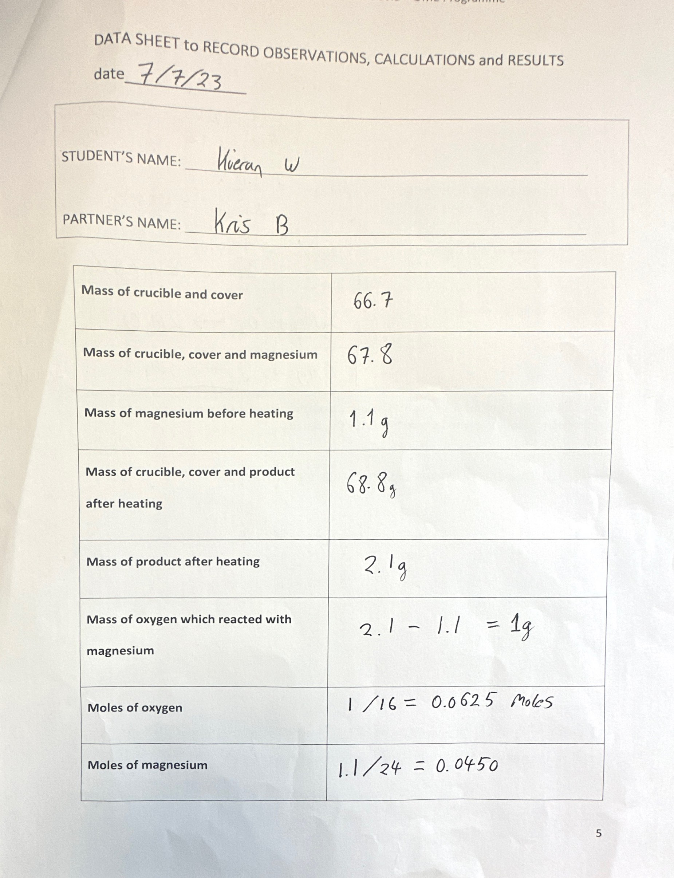
Appendix 1: Data sheet
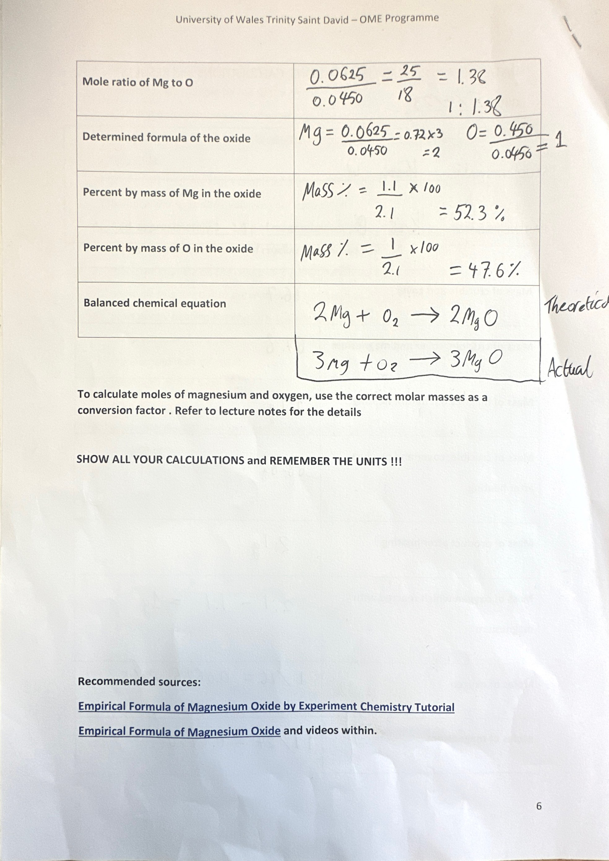
Appendix 2: Data sheet continued
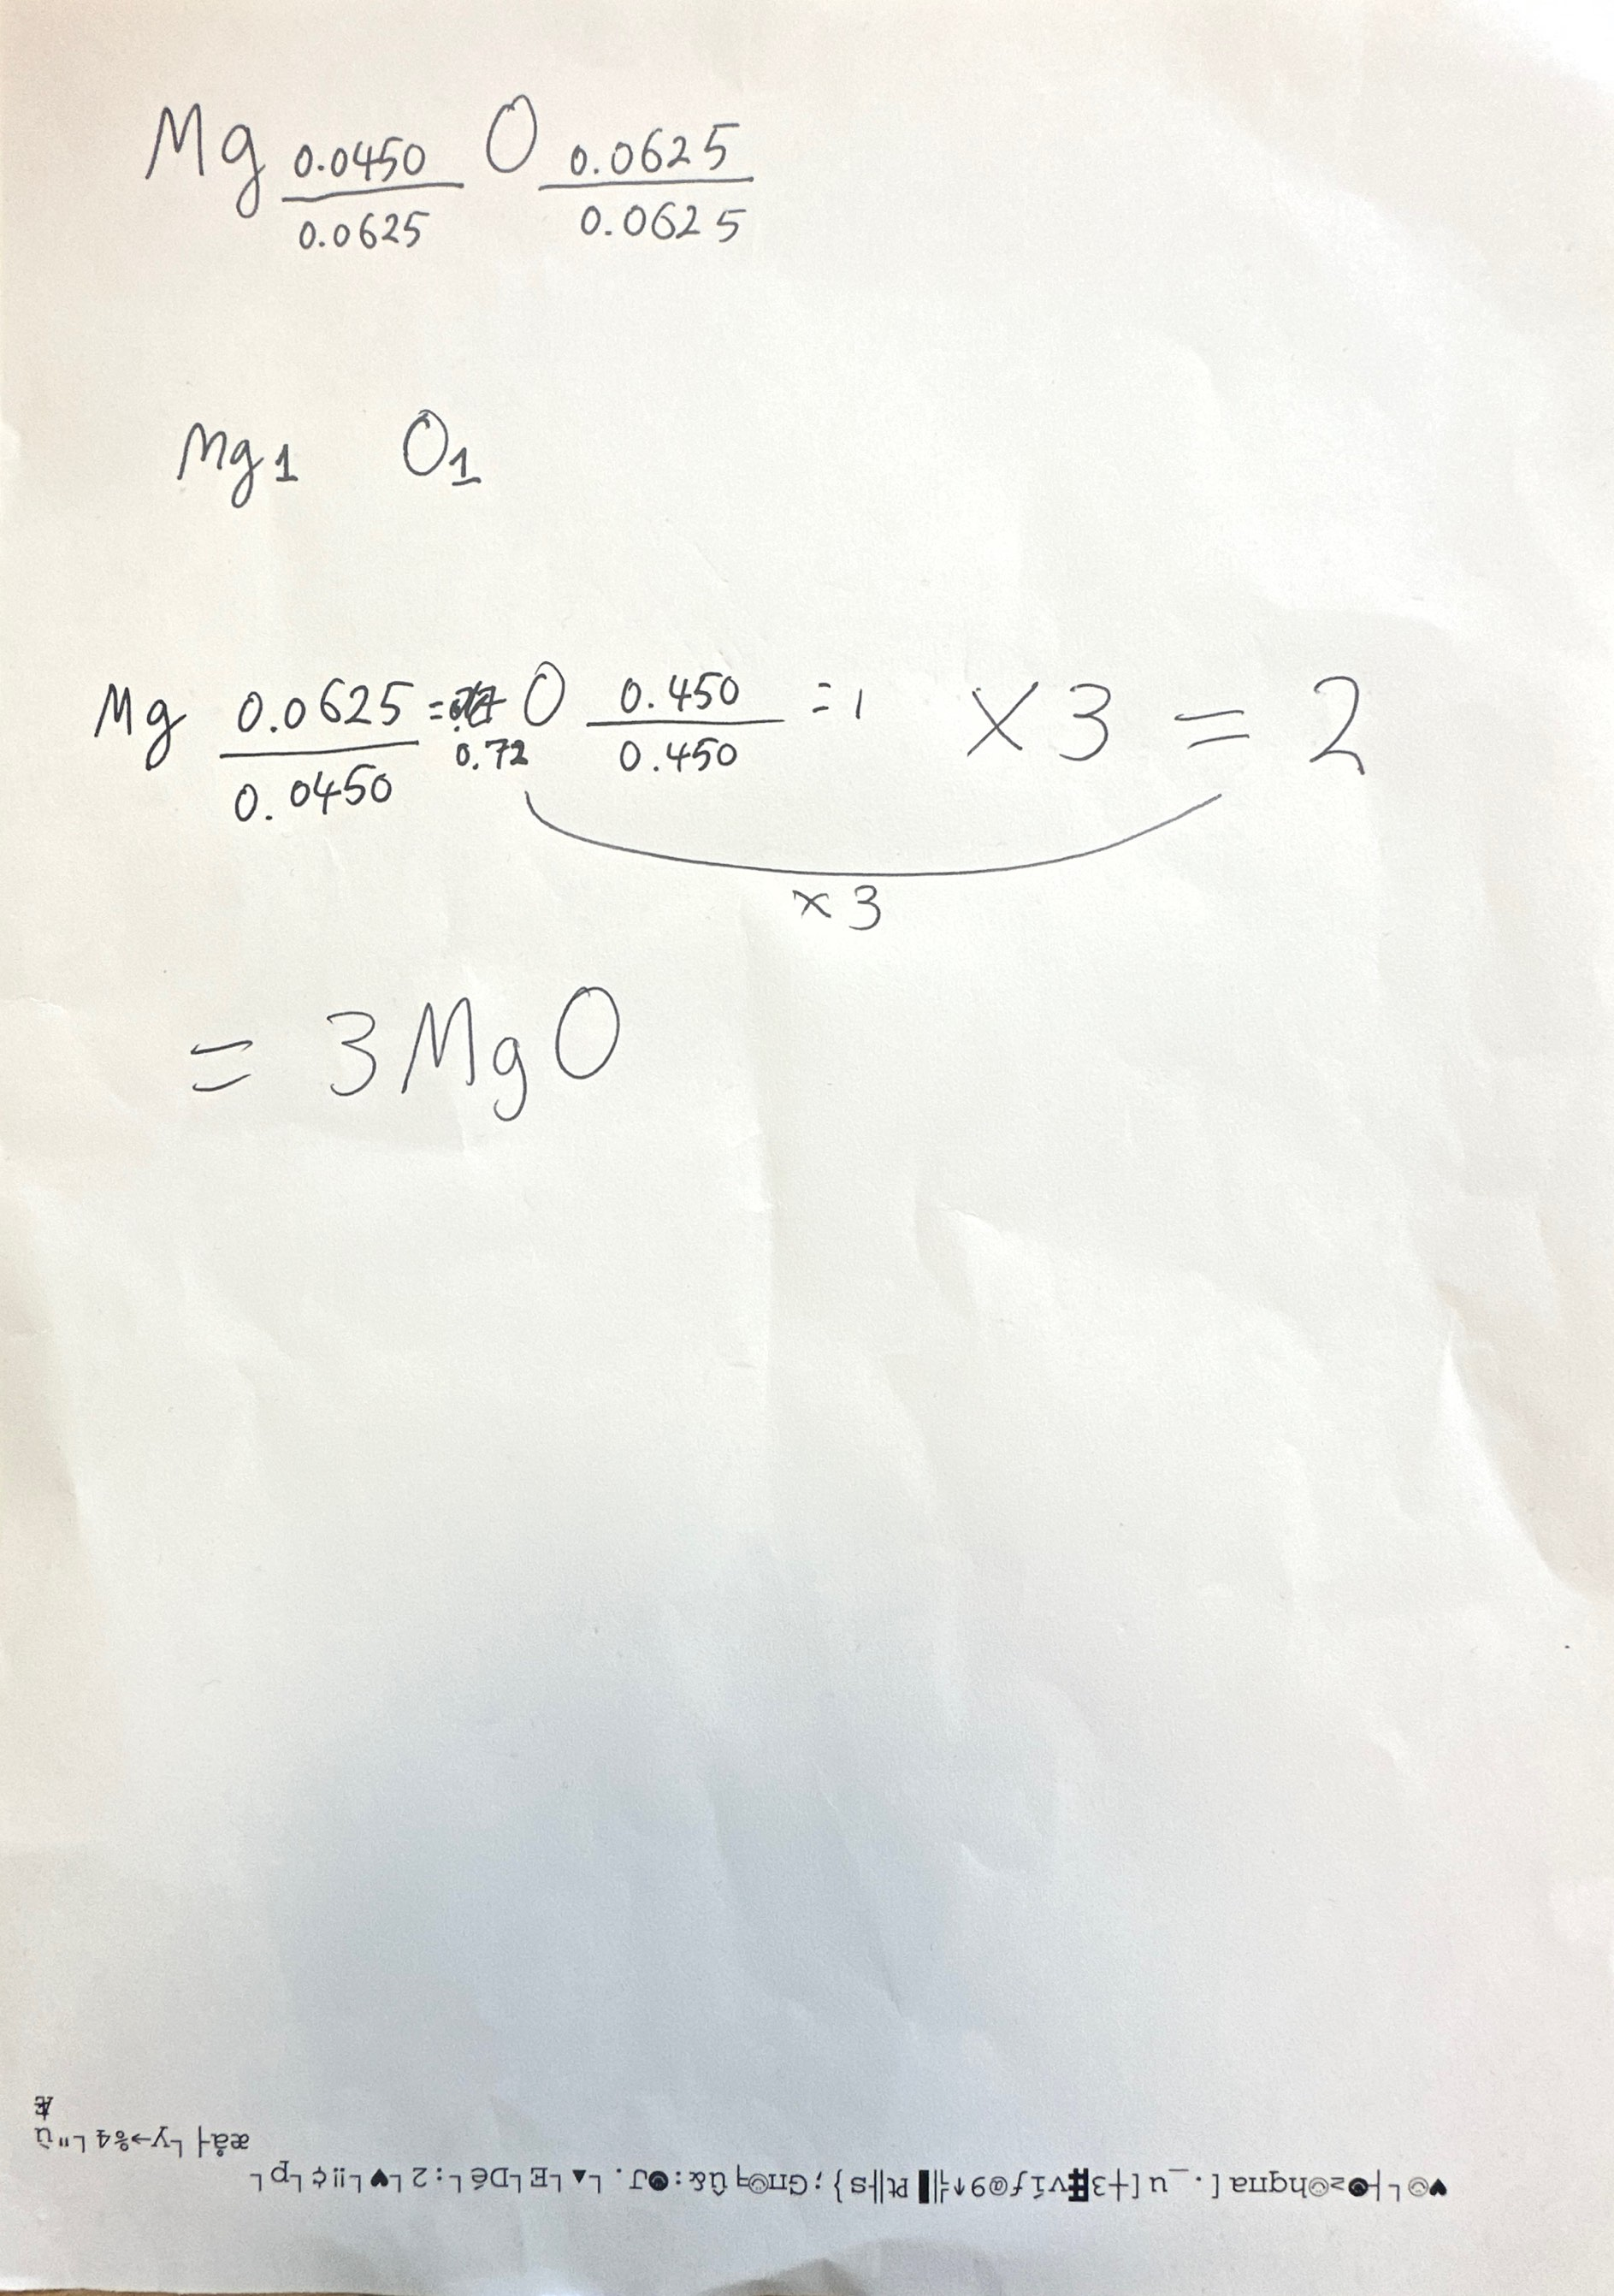
Appendix 3: Calculations and working out

