Data Handling and Business Intelligence

Student name: Radoslava Hristova
Student ID: 2110952
Table of Contents
Part 1 2
Data analyses 2
Data exploration 2
Excel tool 2
Data pre-processing 2
Identify null values 2
Spell check 3
Using Find and Replace 3
Pivot table and chart 5
Creating pivot tables and charts to analyze data 5
Analyses of Hotel reservation dataset 11
IF Function 15
Part 2 17
Solution 1 17
Solution 2 17
Solution 3 17
Solution 4 17
Solution 5 18
Solution 6 19
Solution 7 21
Reference 24

List of figures
Figure 1 Line chart of average price 14
Figure 2 Bar chart of Room Type 15
Figure 3 Column chart of Special Request 16
Figure 4 Slacked column chart of Meal plan 16
Figure 5Visualization of bookings 18
Figure 6 Number of female and male students 19
Figure 7 Count of qualified and not qualified students for free lunch 19
Figure 8 Pre-test and post-tests mean and median 20
Figure 9 K-Means clustering 21

List of tables
Table 1 Pivot table of average price 13
Table 2 Pivot table of Room type Reservation 14
Table 3Pivot table of special request 15
Table 4 using COUNTIF function 17
Table 5 Contingency table of cancelled booking and not cancelled booking 18

Part 1

Data analyses
The process of collecting, extracting, cleaning, filtering, or sorting data and then processing the raw data for extracting meaningful insights from it, is known as Data analysis. This process requires various techniques, tools, methods and procedures to analyze the data. It helps to provide a conclusion from the raw data that makes sense and easier to make data-driven decisions (Kent, 2020).

Data exploration
The dataset used in this report is the “Hotel Reservation” dataset. It has the information of customers such as “Adult no.” and “children No.” and their booking details. The hotel has 3 different types of Meal plans and 7 Room types of reservation. The dataset has an arrival year column as well. That helps to differentiate the performance of the hotel each year. It has information about canceled and not canceled information. The dataset has an average price variable which will be used to calculate the average price each year.

Excel tool
Microsoft excels for analyzing the data is the best tool. As it has many options and features that are suitable for data analysis. It has many features that allow cleaning and sorting the data. It has advanced data analytics tools such as pivot tables. It is the most broadly used spreadsheet program. It saves time and prevents errors as well as monotony. It is used to perform statistical testing. It also has features to create pivot tables and charts. There are many graphs and chart options, each has its properties and specialty. Aside from pivot tables, excel allows one to perform many formulas such as SUM, IF, AVERAGE, etc. The report uses many functions such as find and replace which helps to find specific values and allows to replace them with others. It makes the work easier as it reduced the work effort to go and change each value individually. With the click on “Replace all”, the selected value change with the desired values (Fairhurst, 2019).

Data pre-processing
Before performing analyses of the data, the data should be cleaned and sorted. Data cleaning include checking null values, spelling error or mistake, duplicate values and irrelevant columns (Roy et al., 2018). Excel has a built-in function to identify data errors. Some useful functions or features of excel for data cleaning and data analysis are stated below:

Identify null values
To identify the null values, the “Filter” option in the Data tab is used.
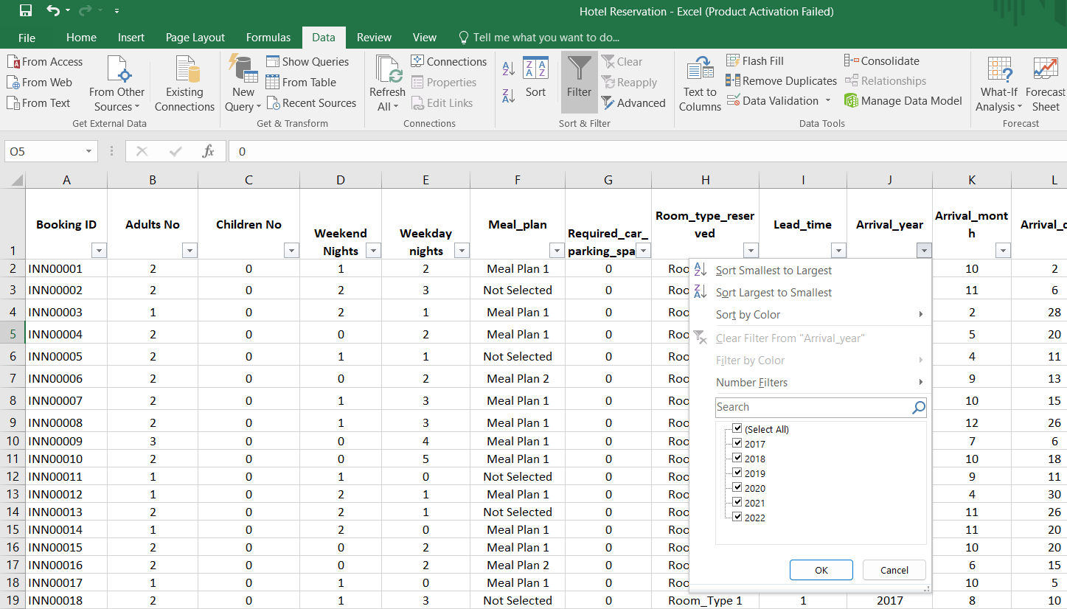
After using the filter option, null values were checked. It was found that there is no null present in the dataset. With the help of the filter option, it was found that the data is present for six years that is 2017-2022.

Spell check
The spelling error is also a part of data cleaning. Sometimes it was observed that at the time of entry, users inserted the wrong spelling which may create misinterpretation of data. Spelling errors also come under data cleaning. After observing the data (Filter option), it was identified that in the column of “Booking Status”, the values such as “Canceled and Not_Canceled” are wrong (correct according to the American English). So, to correct the spelling error, the excel function “Find and Replace” is used.

Using Find and Replace
Step-1: select the column “Booking Status”, in the home tab, at the right end “Find and select” is present and click on it. Drop down list appeared, and select the “Replace” option (Gharani, 2019).
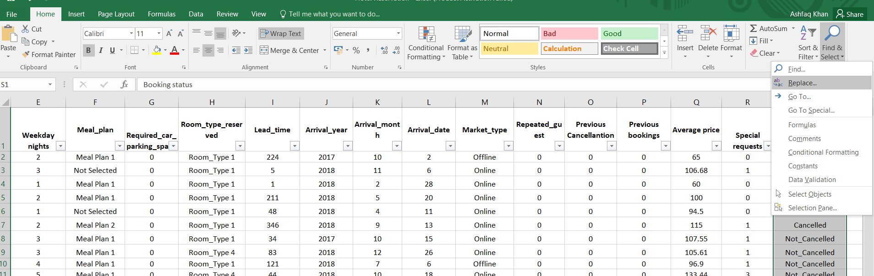
Step-2: After selecting the Replace option, insert “Not_Canceled” in Find what and Replace with the correct spelling that is “Not_Cancelled”. Click on Replace all.
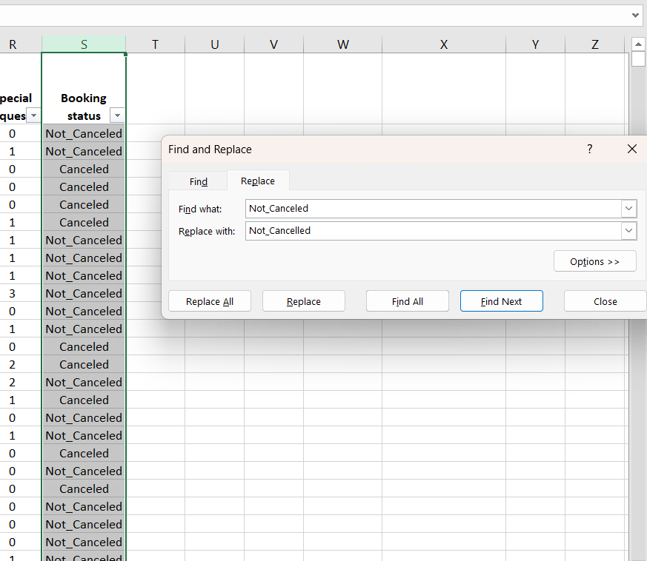
Step-3: Again, correct the spelling error of “Canceled” with “Cancelled”.
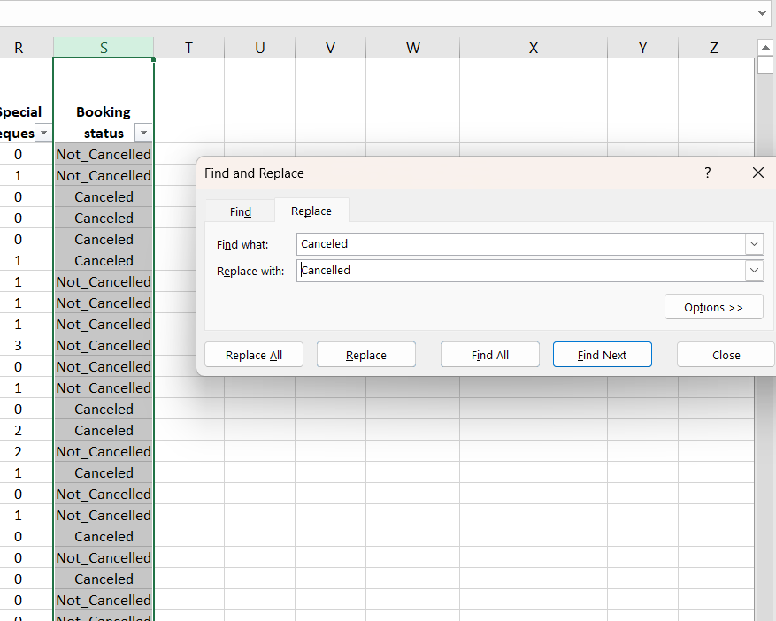

Pivot table and chart

Creating pivot tables and charts to analyze data
Step-1: Select the entire data by shortcut Ctrl + A, open the Insert tab, and click on the Pivot table option (Microsoft, 2023).
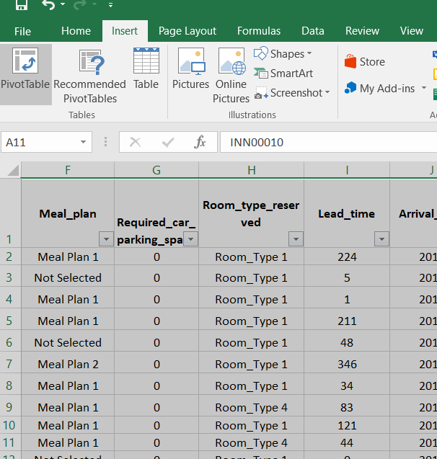
Step-2: A dialog box appeared, clicked on the new worksheet sheet option and then OK.
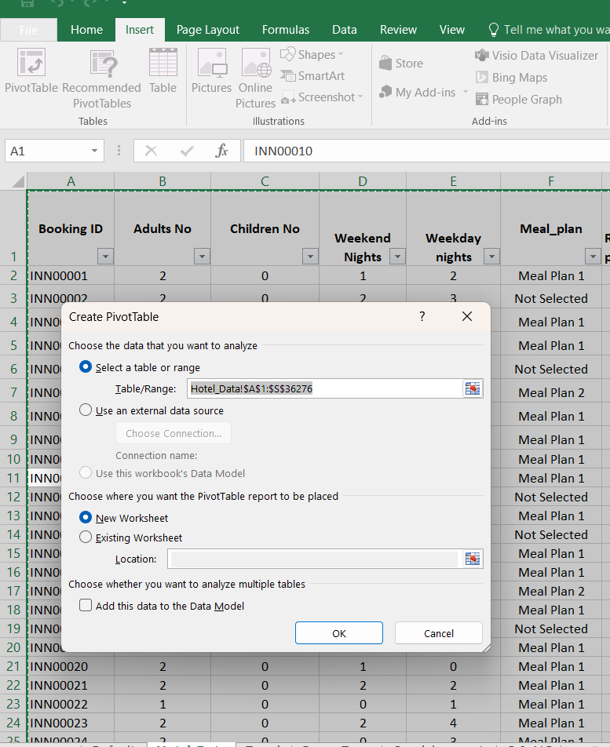
Step-3: A new worksheet is open, with pivot table format.
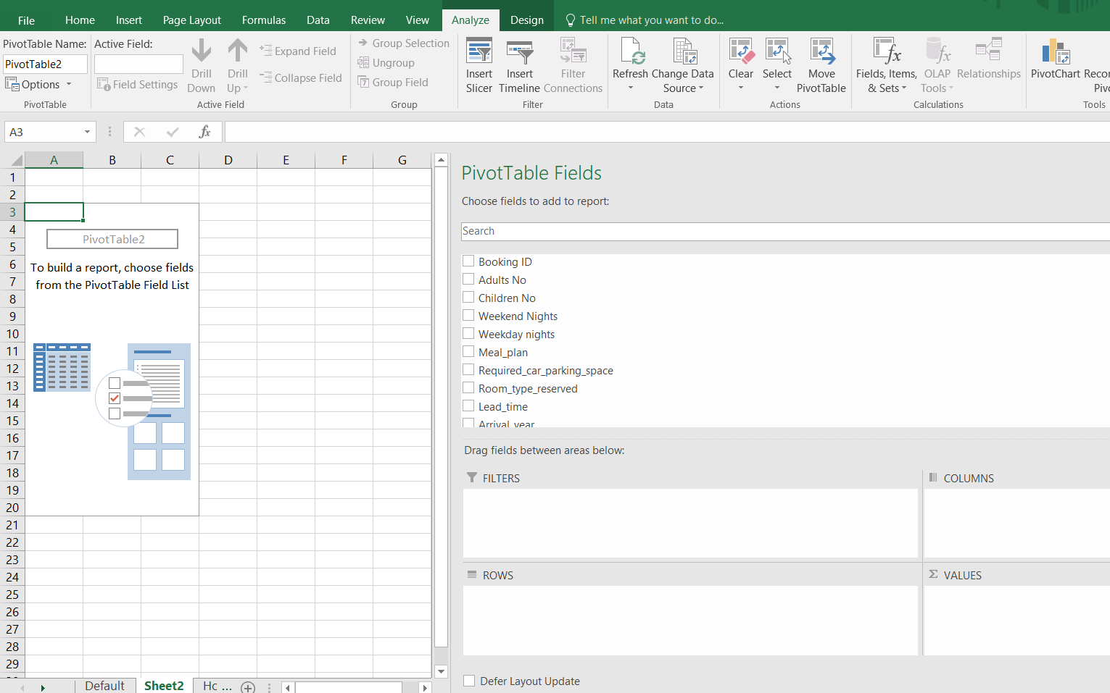
Step-4: Dragged Arrival year in Rows and Average price in the values field. It created the pivot table automatically.
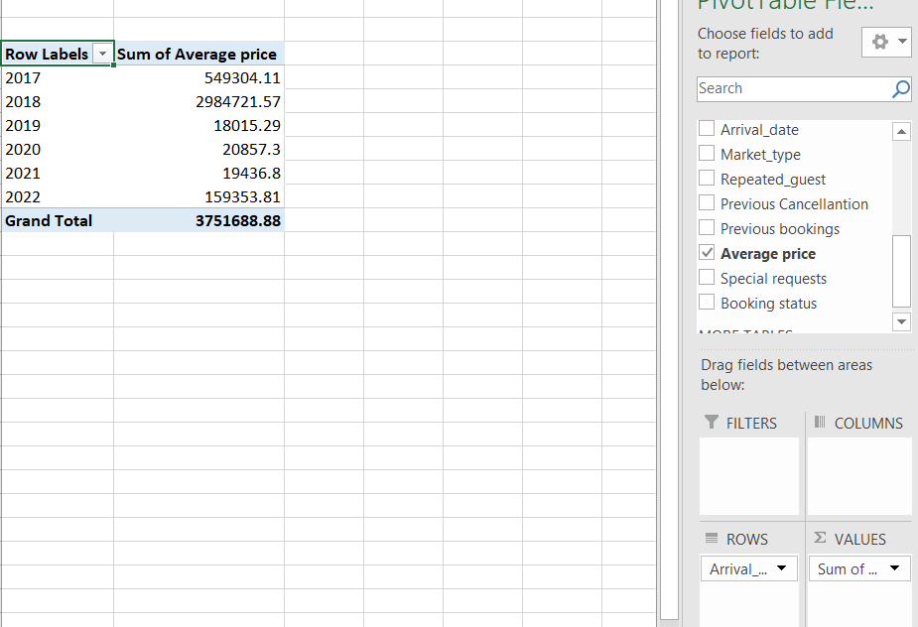
Step-5: Create a chart by clicking the “Pivot Chart” option and choose the desired chart and click OK.
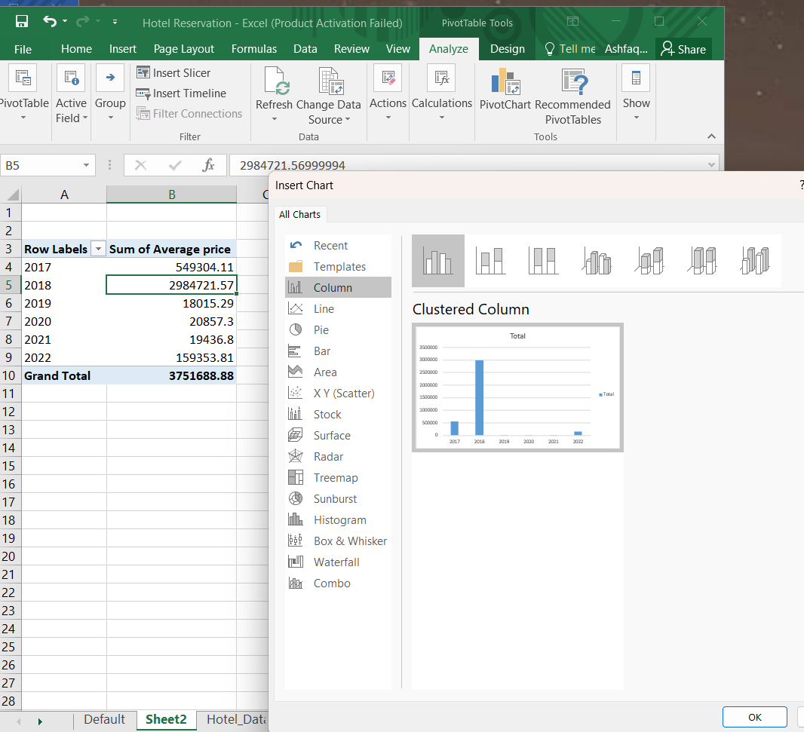
Step-6: Design the chart by clicking on the two options shown at the end of the top right corner.
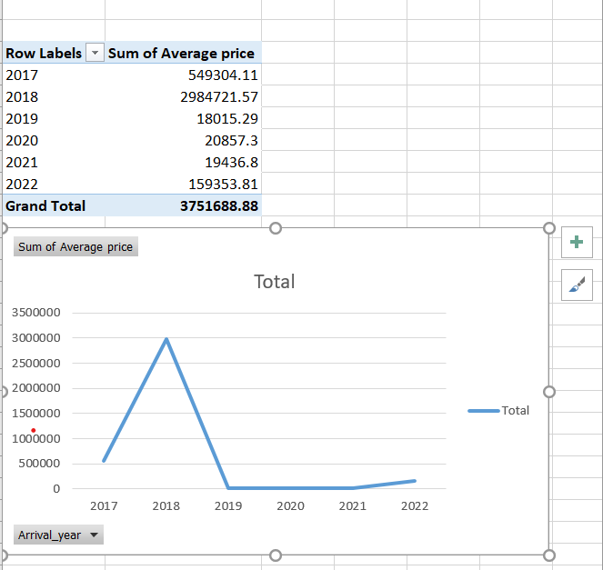

Analyses of Hotel reservation dataset
The average price decline of increase is identified through the help of a pivot table and chart.

Table 1 Pivot table of average price
Row Labels | The sum of the Average price
2017 | 549304.11
2018 | 2984721.57
2019 | 18015.29
2020 | 20857.3
2021 | 19436.8
Grand Total | 3592335.07

Figure 1 Line chart of average price
(Source: Author, 2023)
The above line chart shows the average price rate over the year from 2017 to 2021. As can be clear from the chart that the most profitable year for the hotel was 2018. As the line chart shows the peak in 2018. After the year 2018, it shows a decline in the average year from 2019 to 2021. The difference between the average price of 2018 and 2021 is huge. The above pivot table shows the average price for each year.

Table 2 Pivot table of Room type Reservation
Row Labels | Count of Room_type_reserved
Room_Type 1 | 28130
Room_Type 2 | 692
Room_Type 3 | 7
Room_Type 4 | 6057
Room_Type 5 | 265
Room_Type 6 | 966
Room_Type 7 | 158
Grand Total | 36275

Figure 2 Bar chart of Room Type
(Source: Author, 2023)
There are 7 types of rooms available in the hotel. A bar chart helps to analyze the data perfectly as the length of the bar shows the difference clearly. According to the bar chart, it can be seen that the visitor mostly booked Room type 1. Within six years out of 36275 bookings, Room type 1 was booked 28130 times. Aside from this, Room Type 4 was also booked by visitors mostly, it was booked around 6057 times. It was identified that Room type 3 was booked only 7 times in six years. It was the least booked Room type.
Table 3Pivot table of special request
Row Labels | The sum of Special requests
2017 | 3220
2018 | 17931
2019 | 108
2020 | 132
2021 | 123
2022 | 964
Grand Total | 22478

Figure 3 Column chart of Special Request
(Source: Author, 2023)
The special request in the hotel was also analyzed. A special request was made by the customer or visitor to make their stay more comfortable. In 2018, the visitor asked for special requests 17931 times. After that, the special request went down and again started to recover by the year 2022.

Figure 4 Slacked column chart of Meal plan
(Source: Author, 2023)
The hotel served three types of meal plans, labeled Meal Plan 1, Meal Plan 2 and Meal Plan 3. Meal plan 1 was ordered mostly in the hotel. In the 2018 year, Meal Plan 1 was ordered about 21654 times out of all the orders which were around 27835. From the year 2019 to 2022 the Meal Plan orders showed fewer numbers. Fewer visitors might be the reason.

IF Function
It is the most useful function in excel. It allows the creation of logical comparisons among values. It has two result criteria. The first result shows the TRUE value if the condition match otherwise shows the FALSE result. It also allows one to check multiple conditions. If the function can also use with multiple other functions such as SUM, COUNT, etc.
IF function is used to calculate total cancelled and not cancelled bookings. IF function is combined with the COUNT function or can say COUNTIF Function. A contingency table is created by using the COUNTIF function.
The below table shows the formula used to calculate the total cancelled and not cancelled bookings for six year from 2017 to 2022.
Table 4 using COUNTIF function
Year | Not canceled | Canceled
2017 | =COUNTIFS(J1:J36276, 2017, S1:S36276, "Not_Cancelled") | =COUNTIFS(J1:J36276, 2017, S1:S36276, "Cancelled")
2018 | =COUNTIFS(J1:J36276, 2018, S1:S36276, "Not_Cancelled") | =COUNTIFS(J1:J36276, 2018, S1:S36276, "Cancelled")
2019 | =COUNTIFS(J1:J36276, 2019, S1:S36276, "Not_Cancelled") | =COUNTIFS(J1:J36276, 2019, S1:S36276, "Cancelled")
2020 | =COUNTIFS(J1:J36276, 2020, S1:S36276, "Not_Cancelled") | =COUNTIFS(J1:J36276, 2020, S1:S36276, "Cancelled")
2021 | =COUNTIFS(J1:J36276, 2021, S1:S36276, "Not_Cancelled") | =COUNTIFS(J1:J36276, 2021, S1:S36276, "Cancelled")
2022 | =COUNTIFS(J1:J36276, 2022, S1:S36276, "Not_Cancelled") | =COUNTIFS(J1:J36276, 2022, S1:S36276, "Cancelled")

The below table is the result of used formula

Table 5 Contingency table of cancelled booking and not cancelled booking
Year | Not cancelled | Cancelled
2017 | 5214 | 886
2018 | 17733 | 10305
2019 | 116 | 61
2020 | 132 | 66
2021 | 139 | 53
2022 | 1056 | 514

The following table shows the total number of Not cancelled and cancelled bookings. It can be identified by the table that the highest cancelled booking was in the year 2018. It was around 10305 in total. The lowest cancelled booking was in the year 2021 which is 53.

Figure 5Visualization of bookings
(Source: Author, 2023)
A pivot table is created by the contingency table to make the chart for visualizing the data effectively. A column chart is created to show cancelled and not cancelled bookings.
Discussion
it was analyzed and obtained from the above analyses that the hotel was performing well in the year 2018. Making good average price, bookings and ordered meal amount were all profitable in that year. However, after the 2018 year, a major fall down was observed in the hotel. The hotel needs to identify the root cause and solve it to improve their condition.

Part 2

Solution 1

Gender
 |  | Frequency | Percent | Valid Percent | Cumulative Percent
Valid | Female | 1056 | 49.5 | 49.5 | 49.5
Valid | Male | 1077 | 50.5 | 50.5 | 100.0
Valid | Total | 2133 | 100.0 | 100.0
Figure 6 Number of female and male students
Out of 2133 students, there are 1056 females and 1077 males.

Solution 2

Lunch
 |  | Frequency | Percent | Valid Percent | Cumulative Percent
Valid | Does not qualify | 1215 | 57.0 | 57.0 | 57.0
Valid | Qualifies for reduced/free lunch | 918 | 43.0 | 43.0 | 100.0
Valid | Total | 2133 | 100.0 | 100.0
Figure 7 Count of qualified and not qualified students for free lunch
Out of 2133 students, only 918 students are qualified for the reduced and free lunch. The amount of not qualified students is higher. There are about 1215 students who do not qualify for reduced and free lunch.

Solution 3
Mean and median cannot be calculated on ordinal values such as qualified and not qualified.

Solution 4

Statistics
 |  | Pretest | Posttest
N | Valid | 2133 | 2133
N | Missing | 0 | 0
Mean |  | 54.96 | 67.10
Median |  | 56.00 | 68.00
Figure 8 Pre-test and post-tests mean and median
The mean of the student pretest score is 54.96 and the median is 56.00. Whereas the mean of the student posttest score is 67.10 and the median is 68.00. The mean difference between posttest and pretest scores is about 12.14 whereas the median difference is 12.

Solution 5
K-means is used to find the centroids as well as iterate until it identifies the optimal centroid (Sinaga and yang, 2020). Here K-means clustering is performed on gender. Here 0 refers Male and 1 refers Female.

Initial Cluster Centers
 | Cluster
 | 1 | 2
Gender | 1 | 0

The initial cluster centers table shows that two clustered forms are
Cluster 1 is of Females
Cluster 2 is of Male

Iteration History
Iteration | Change in Cluster Centers
Iteration | 1 | 2
1 | .000 | .000
a. Convergence achieved due to no or small change in cluster centers. The maximum absolute coordinate change for any center is .000. The current iteration is 1. The minimum distance between initial centers is 1.000.

The above result or table of Iteration History shows the number of iterations. It shows the changes in cluster centers. According to the result, it shows 0.000 changes in the center of clusters. The minimum distance calculated between the initial centers is 1.00.

Final Cluster Centers
 | Cluster
 | 1 | 2
Gender | 1 | 0

The final cluster centers result shows that Cluster 1 refers Female cluster and cluster 0 refers male cluster.

Number of Cases in each Cluster
Cluster | 1 | 1056.000
Cluster | 2 | 1077.000
Valid |  | 2133.000
Missing |  | .000
Figure 9 K-Means clustering
The above table shows the result of the final clustering outcomes. This clustering process identifies the total number of females and males through the cluster.
Here cluster 1 (female) makes a group of 1056 individuals
Cluster 2 (Male) makes a group of 1077 individuals
It means there are 1056 female students and 1077 male students according to the K- Means clustering.

Solution 6
Data Mining real-world examples are as follows:
Service Providers: Data mining has been utilized extensively by service providers to keep existing customers happy. Using Business Intelligence and Data Mining, certain service providers may try to foresee customer defections ("churn") to competing businesses.
Commerce Sector: Data Mining might help supermarkets and other companies better understand their customers' wants and needs. By analyzing previous purchases, data mining tools show customers' recurring spending patterns. Data mining may be used for things like product recommendations and product lookups (Binu and Rajakumar, 2021).
Science, Technology, and Instruction: Human genetics is one area where sequence mining is used extensively. Discovering how variations in DNA sequence impact susceptibility to illness is an important use of this method.

E-commerce: Several e-commerce sites employ data mining to provide ancillary services like cross-selling and up-selling to their customers.
Organizations with a Mission to Reduce Crime: Government agencies entrusted with crime prevention are joining the ranks of corporations utilizing data analytics to discover trends in their data. The data includes descriptions of all the major crimes that have happened in recent years. Organizations working to reduce crime may be able to leverage the insights gleaned from this data by analyzing patterns and trends to make more accurate predictions (Maryoosh and Hussein, 2022).

Textual Data Mining real-world examples are as follows
Proper marketing for the proper audience: Text mining has the potential to help businesses receive a solid return on investment from their contextual internet advertising initiatives. Text mining allows for more relevant advertising on websites.
Cybercrime security: Businesses may do well to embrace a cybersecurity program using text mining technologies to battle the rising tide of cybercrimes like phishing, data breaches, and cyberbullying.
Fraud detection: When the bulk of data is collected in text format, as it is in the case of fraud detection via claims inquiry, text analytics becomes a wonderfully effective tool. Insurers are utilizing text mining technologies to prevent fraud and speed up the claims process by combining the results of text analysis with structured data.
Business Intelligence: This "business intelligence" is used by many companies as a reliable resource for making informed business decisions. Here, text mining shines, since it helps the analyst skip through the petabytes of internal and open-source data and get directly to the answer.
Social media: Using social media platforms as a source of research data; such sites provide a wealth of unstructured data. Text analytics has the potential to aid in both of these endeavors by sifting through massive volumes of unstructured data to ascertain consumers' opinions on various brands and products.

Solution 7
Pros and Cons of Excel
Pros | Cons
Versatility: Excel can be used for a wide range of tasks, such as data analysis, budgeting, and financial forecasting. | Steep Learning Curve: Excel can be difficult to learn, particularly for those who are not familiar with spreadsheets or data analysis.
Easy to Use: Excel’s user-friendly interface makes it easy to enter and manipulate data. | Limited Functionality: Excel has limited functionality compared to more specialized software, which can make it challenging to perform complex data analysis tasks.
Customizable: Excel can be customized with macros and add-ins to meet specific needs. | Prone to Errors: The risk of errors increases with larger data sets, complex calculations, and inexperienced users.
Data Visualization: Excel’s charts and graphs provide a powerful tool for visualizing data. | Excel files can be vulnerable to security breaches, especially if they contain sensitive data.
Time-Saving: Excel’s automation features can save time and reduce errors, especially for repetitive tasks (Incerti, et. al., 2019). | Limited Collaboration: Collaboration can be challenging, especially when working with large or complex files, as multiple users may need to edit the same file at the same time ‌ (Myayan, 2021).

Practical example: An educator may use Excel to track student grades and attendance, create charts and graphs to visualize student performance, and analyze student data to identify areas for improvement.

Pros and Cons of SPSS
Pros of SPSS | Cons of SPSS
Wide Range of Statistical Analysis: SPSS offers a wide range of statistical analysis options, making it suitable for complex data analysis tasks. | Expensive: SPSS is commercial software and can be expensive for individuals or small organizations to purchase.
User-Friendly Interface: SPSS has a user-friendly interface that makes it easy to learn and use, even for non-experts. | Steep Learning Curve: Although the interface is user-friendly, the software can be challenging to learn, especially for those who are not familiar with statistical analysis.
Powerful Data Management Features: SPSS has powerful data management features that make it easy to clean and transform data before analysis. | Limited Customization: SPSS has limited customization options compared to other statistical software, which can be frustrating for advanced users who require more flexibility.
Excellent Data Visualization: SPSS has excellent data visualization capabilities, making it easy to create high-quality charts and graphs. | Limited Flexibility: SPSS is designed to work with structured data and may not be suitable for unstructured or semi-structured data.
Large User Community: SPSS has a large and active user community, making it easy to find support and resources online (Raman and Muktadir, 2021). | Limited Collaboration: Collaboration can be challenging, especially when working with large or complex files, as multiple users may need to edit the same file at the same time (Ibm.com, 2022).

SPSS Example: A student who has never used statistical software before may find SPSS easier to use than other software due to its user-friendly interface. However, the student may still need to invest time in learning the software and statistical analysis concepts.

Reference
Binu, D. and Rajakumar, B.R. eds., 2021. Artificial intelligence in data mining: Theories and applications. Academic Press. https://books.google.com/books?hl=en&lr=&id=0ugGEAAAQBAJ&oi=fnd&pg=PP1&dq=data+mining+real+world+example&ots=CEGA039WUt&sig=YDQdn6-RmQ2CrAM_nYxVWo-iF9Q
Fairhurst, D.S., 2019. Using Excel for business and Financial Modelling: A practical guide. John Wiley & Sons. https://books.google.com/books?hl=en&lr=&id=6cSODwAAQBAJ&oi=fnd&pg=PP19&dq=excel+tool+and+function&ots=atjLFk5R42&sig=YH9hQXAiq60LhNSvufmJAaDbEBo
Gharani, L. (2019). Excel’s Find and Replace (surprising features). [online] Xelplus - Leila Gharani. Available at: https://www.xelplus.com/excel-find-and-replace/ [Accessed 29 Mar. 2023].
Ibm.com. (2022). IBM Documentation. [online] Available at: https://www.ibm.com/docs/en/cloud-paks/cp-data/4.0?topic=issues-spss-modeler [Accessed 29 Mar. 2023].
Incerti, D., Thom, H., Baio, G. and Jansen, J.P., 2019. R you still using excel? The advantages of modern software tools for health technology assessment. Value in Health, 22(5), pp.575-579. https://www.sciencedirect.com/science/article/pii/S1098301519300506
Kent, R., 2020. Data construction and data analysis for survey research. Bloomsbury Publishing. https://books.google.com/books?hl=en&lr=&id=2SFHEAAAQBAJ&oi=fnd&pg=PR1&dq=explain+data+analyses&ots=uDLJL5PhAT&sig=HthtPtH86cWKQKAlaE0t5C7PdZQ
Maryoosh, A.A. and Hussein, E.M., 2022. A Review: Data Mining Techniques and Its Applications. https://www.researchgate.net/profile/Amal-Maryoosh/publication/359704850_A_Review_Data_Mining_Techniques_and_Its_Applications/links/624b589a21077329f2f210a7/A-Review-Data-Mining-Techniques-and-Its-Applications.pdf
Microsoft.com. (2023). Create a PivotTable to analyze worksheet data - Microsoft Support. [online] Microsoft.com. Available at: https://support.microsoft.com/en-us/office/create-a-pivottable-to-analyze-worksheet-data-a9a84538-bfe9-40a9-a8e9-f99134456576 [Accessed 29 Mar. 2023].
Myayan (2021). What are the Advantages and Disadvantages of MS Excel. [online] myayanblog. Available at: https://www.myayan.com/advantages-and-disadvantages-of-ms-excel [Accessed 29 Mar. 2023].
Rahman, A. and Muktadir, M.G., 2021. SPSS: an imperative quantitative data analysis tool for social science research. Int. J. Res. Innov. Soc. Sci, 5, pp.300-302. https://www.academia.edu/download/79116055/300-302.pdf
Roy, S., Sharma, P., Nath, K. and Kalita, J. (2018). Pre-Processing: A Data Preparation Step. [online] ResearchGate. Available at: https://www.researchgate.net/publication/323808183_Pre-Processing_A_Data_Preparation_Step [Accessed 29 Mar. 2023].
Sinaga, K.P. and Yang, M.S., 2020. Unsupervised K-means clustering algorithm. IEEE access, 8, pp.80716-80727 https://ieeexplore.ieee.org/iel7/6287639/8948470/09072123.pdf
‌

‌

