Assignment 1
Google Headquarters Project in London, UK

Module Name: Project Management

Module code: LCBB5005

Student: Mariana Larisa Neagoe (1921885)
Lecturer: Prof. Dr. Faizu Edu
Contents
1. INTRODUCTION 3
2. Project Plan Review 4
2.1 Project management phases 4
2.2 Google Headquarters UK approach 6
2.3 Phase 1: Project Conception and Initiation 7
2.4 Phase 2: Planning 9
2.5 Google Headquarters UK Project Management Scope 9
2.6. Budget Review 10
2.7 TIMELINE ANALYSIS 11
2.8 QUALITY Analysis 12
2.9 Risk analysis and stakeholders 13
2.9.1. Google sustainability strategy 15
3. Conclusion 16
4. References 17

INTRODUCTION
As we are living in a technology era were the progress is fast and competition among organization is fierce, the operations based on projects are becoming the key of success, the way to achieve their goals and to fulfill their missions.
Project management is becoming a mandatory practice inside the organizations and an object of study for many scholars.
“Project management is the application of knowledge, skills, tools, and techniques to project activities to meet the project requirements. “
(Project Management Institute, Inc., A Guide to the Project)
According to Indeed Editorial Team (2023) the process of utilizing standards, skills, tools, and methods to carry out tasks and attain goals is commonly referred to as project management. It is the coordination of tasks from the very start to the end of a project. It also entails making sure deliverables fulfill time frames and customer requirements.
This essay will present how Google Headquarters UK was approached from Project Management point of view. With a value of 1 billion pound, the Google campus which is build in King Kross Station, London area almost 61000 sqm, it is an ambitious project that will provide a place of work for over 4500 people and it will take the idea of an office to next level generation. In the same building we will find stores, coffee shops, a gym, a multi-use game area (MUGA), pool facilities and a roof garden that will be a recreation space for the workers. This new building will come to complete the existing one in 6 Pancras Square and a third construction which will house seven thousands employees. The delivery date of the project is by the beginning of 2024. (Gillespies, 2024)
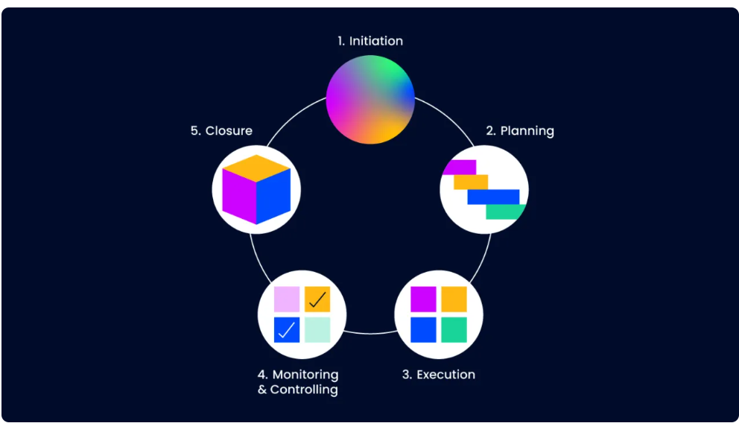
Through this essay we will review the essential element of the project such as: budget, time, quality, stakeholders and risk factors.
https://thedigitalprojectmanager.com/projects/pm-methodology/project-management-life-cycle/

2. Project Plan Review
Core elements of a project like budget, time, quality stakeholders and risk factors cannot be assessed without a clear understanding of Project Management stages and phase or what it is a project life cycle.

2.1 Project management phases
The project life cycle is the sequence of stages that are necessary for a project to be completed successfully. It defines the sequence of methods and phases that are used to deliver projects and describes the overall project delivery workflow and the steps needed to move a project forward and complete it successfully. (Aston, 2023)
A project management has 5 stages and these are: initiation, planning, executing, monitoring & controlling, and closing.
The essential areas of project management that project managers need to concentrate on in order to successfully plan, organize, oversee, and complete projects with the cooperation of project teams and stakeholders are known as project management knowledge areas.
Each of these areas of project management knowledge must be managed through the five phases of the project life cycle: Project initiation, Project planning, Project execution, Monitoring and controlling, Project closing. These are the chronological stages that each project progresses through. They are also known as Project Management Process Groups (PMPs) in PMI's PMBOK.
The ten knowledge areas are:
- Project Integration Management
- Project Scope Management
- Project Schedule Management
- Project Cost Management
- Project Quality Management
- Project Resource Management
- Project Communication Management
- Project Risk Management
- Project Procurement Management
- Project Stakeholder Management

2.2 Google Headquarters UK approach
A very important aspect in Project Management are the tools, techniques and methodologies approached to deliver a successful job.
Analyzing Google Headquarter UK, the stages the process went through we can say that they used The Traditional Approach or Waterfall in order to develop this project.
Waterfall approach is one of the most common project management. This approach is characterized by a well-defined process, clear milestones, and a sequence. The sequential nature of the waterfall approach makes it ideal for projects that are divided and organized, have subsequent phases dependent on the completion of previous ones, require consistency in terms of deadlines, spending schedules, or oversight procedures. (Coursera Staff, 2023)
All this aspects can be found in Google Headquarter project. A complex project, the campus has several floors which are topped up with a roof garden.
Google stakeholders completed a project to build a 5,000-seat office tower with retail space, a 25-meter-long swimming pool, and a 200-meter running track. It will be KCR's largest single building. Different companies worked together to complete the project step by step.
Engineers AKT II, landscape expert Gillespies, and AJ100 heavyweight BDP as executive architect compose the design team for this enormous project. (Waite, 2017)
All five phases are important but determinant for the success of the project we may say are the Phase 1: Project Conception and Initiation and Phase 2: Planning.

2.3 Phase 1: Project Conception and Initiation
Phase 1 is characterized by Project Charter or Project Initiation Document (PID) and the Business Case.
A business case serves as the project's foundational document and describes the initiative's economic viability. It describes the opportunity's worth and includes a feasibility study. It also describes the project's feasibility, cost-effectiveness, and commercial viability. (Usmani, 2022)
There are other tools to asses the viability of the project like: SWOT and STEEPLE Analysis.
The GOOGLE Headquarters UK journey started with the ,,go-ahead’’ business as Camden Council has approved the construction of Google's 300-meter-long headquarters, which will be located in the center of King's Cross, London. BIG & Heatherwick Studio designed the building.
The planning officers’ report recommended that the large-scale project be approved because the design “responds strongly and thoughtfully” to the historic shapes and uses in which it would impact. (Waite, 2017).
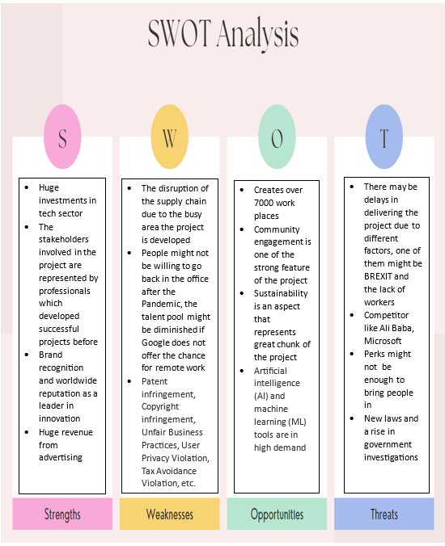
The SWOT analysis of the project is another strong instrument that can back up GOOGLE Headquarters project.
There’s a reason why Google is one of the world’s most successful multinational companies. It’s because Google’s innovative culture, acquisition prowess, and product ecosystem all contribute to its success.
The revenue of the company allows further investment and also the capability to tackle any possible issues or face future challenges. Also, the perks they are willing to offer to their employees makes Google an attractive company. Nevertheless, the COVID-19 experience is still fresh in peoples mind and also there were many cases of breaching the Data Protection, in other words, there are parts that can be improved.

2.4 Phase 2: Planning
Project planning outlines goals and routes for all parties involved. It involves creating a project schedule, defining requirements and deliverables, and documenting project plans. It helps manage time, money, quality, changes, risk, workforce, and outside vendors.

2.5 Google Headquarters UK Project Management Scope
Project scope defines the scope of the project and defines the exact goals, deadlines, and outputs the team will work towards. The project’s goals and objectives can be achieved in a timely and effortless manner by defining the scope of the work. (Martins, 2022)
The goals that a project manager is setting must be SMART (Specific, Measurable, Achievable, Relevant, and Time-Bound) and CLEAR (collaborative, limited, emotional, appreciable, refinable).
Google Headquarters UK scope is to deliver the King Kross campus by the beginning of 2024 and the cost of the project rise at 1 billion pounds.
Google will build a new campus capable to accommodate up to 7,000 staff. It will support the integration of King's Cross into the knowledge-based economy and the Knowledge Quarter.
The aim is to build this huge space of over 1 million sq feet office and ground floor retail stores as an amazing destination for Google’s associates and Londoners as well. (Gardiner & Theobalt, n.d.)

2.6. Budget Review
The budget for a project is the total expenses for all tasks, activities, and completion dates needs to be mutually agreed upon by all parties.
During the Kick-off phase, the project budget is prepared and managed by the project manager until the completion of the project. A well planned project budget is the key to the success of the service economy where smooth and sustainable scaling is critical for business growth. (Viter, 2022)
With an investment of £730 million ($1 billion), Google hopes to "excite" the workplace and increase capacity in the UK by 50%. The announcement states that Google will purchase Central St. Giles, a site in London where it currently a tenant, and will spend £730 million to increase its headcount from 6.400 to 10,000 in the UK. (BBC, 2022)
The skyscraper, which will ultimately house Google's new London headquarters, is currently being built next to the train tracks that go to and from King's Cross station. The landscaper will be taller than the 310-meter-tall Shard skyscraper, measuring 330 meters in length made of glass. (Partridge, 2022)

2.7 TIMELINE ANALYSIS
According to PMI (2014), a project is a brief endeavor or undertaking with the goal of generating a unique good, service, or outcome. A project's short duration suggests that it has a set start and finish (time-wise). This suggests that there is a deadline for the project's completion. Furthermore, we see that time, along with scope and budget, is an essential element of a project's life cycle when we examine the project triangle.
The planning stage of the time management process has received a lot of attention, but other stages of the process—such as designing and planning, implementing, controlling and monitoring, and closing out and evaluation—also require time management.
Google intended to start in 2018 the construction of a building that will be ,,longer than the Shard is tall’’ according to Sam Shade from Business Insider and their aim is to complete the project by January 2024.
Initially, in 2013 they announced that UK HQ will commence in 2013 and will be finalized in 2016. But because Google cofounder Larry Page considered the project presented by AHMM ,,too boring’’ they had to postpone the plans and they settle for a lease on 6 Pancras square.
In May of 2017 submitted to Camden Council the plan to transform the 7-11 stores area (Zone A Building) into an office building (Building Class B1) with a multipurpose games area, cafe, gym, swimming pool, events center, and roof garden as extra staff amenities. Ground floor retail (Building Class A1) with two basement levels, four accessible parking spaces, and a loading bay.
The construction is planned to start in 2018, and to be finished in 2024. Meanwhile, the project was updated in 2022 as the project was slightly modified in relation to Zone A, the ground floor frontage. (Buildington, 2022)
So far, Google is optimistic regarding the completion of the project by 2024.

2.8 QUALITY Analysis
Simply put, quality in project management refers to what stakeholders or customers anticipate from the project's deliverables. The integration of planning, quality assurance (QA), and quality control (QC) can be referred to as project quality.
The Google HQ UK project manager is the person in charge with the quality of the project. (Malsam, 2022)
Quality Planning
From a programmatic point of view, Google’s goal is to create an exciting working environment for its employees. The design team explained their approach was to focused the layout around three large, constantly stacked floorplates that provide a range of single height, double height, and three height workspaces with unique volumetric qualities.
Quality Control
BIM was used to coordinate services within voids, allowing for early engagement of contractors and pre-fabrication. The building has eight floors, with five facing the station. The design elevates office floors to allow for retail buildings beneath the western façade.
Quality assurance
Because the headquarters is such a unique place to live and work, the project also required the blockwork solution. Four thousand people work at Google's building, and noise can cause unneeded, even harmful, annoyances. Lignac 140mm blocks provide 65dB (dB) of sound insulation when equipped with acoustic panels, which makes them a great choice for a mixed-use project like this one.

2.9 Risk analysis and stakeholders
In order to make sure that every relevant party are informed of potential risks and participate in the risk management process, stakeholder involvement is an essential part of risk management.
There are several aspects that need to be considered in this case:
- Identify the internal stakeholders (employees, managers) and external ones (customers, suppliers, reulators) which are involved in the risk management process.
- Analyze the stakeholders expectations and needs and how they are affected by risks
- Communicate in an efficient manners so that all the parties involved understand the risks and how these are mitigated. This is the way to build their trust.
- Involve de stakeholders in the management of the risk by requiring their feedback on the risk assessment process.
- Empower the stakeholder so that they will become responsible for their own risk
- If they need to understand the risk management process make sure they are trained accordingly.
- Monitor and review the efficiency of the risk management process to make sure that all the risks are covered and stakeholders are happy
- Keep up with the stakeholders expectations and their changing needs and be ready to adjust the project according to their necessities
- Be transparent about the risk management process, let the stakeholders to have access to essential information and data related to the project
- Make sure that the organizational goals are in line with the risk management process
Google Headquarters internal stakeholders are the employees and the shareholders.
The external stakeholders are represented by Camden Council with its local community, suppliers and vendors, the companies that were contracted to deliver the project, Thomas Heatherwick and Danish architects BIG as well as Gillespies, the company that is hired to deliver the rooftop garden.
Also a very important stakeholder are the environmental agencies which their main concern is the environment protection and the sustainability of the project.
On the risk categories we include the financial risks, the operational risk and the environmental .

2.9.1. Google sustainability strategy
From the very beginning, Google intention was to create a sustainable and flexible workplace.
That is was all the materials involved in the process, strategies adopted are meant to protect the people and the environment,
As the world is transitioning to flexible, hybrid work, Google introduces new technologies and collaboration spaces to enable their teams to stay connected wherever they work. Sustainability In the drive for a carbon-neutral future, that is why Google is putting sustainability at the heart of the building’s design. With all onsite equipment and kitchen appliances being electric, they’ll be able to monitor energy consumption on an hourly basis and compare it to renewable energy in the region. The office will be energy efficient in real-time through a network of 13.500 connected devices. Solar shading will help control building temperature by reducing solar glare. The building’s construction and interior design have a 20% carbon footprint due to the use of locally sourced, low carbon materials.
Google offers funding, mentoring, and training to more than 60 grassroots charities in Camden. We have provided virtual work experience to more than 200 students in Camden schools during the past two years. They have offered assistance to more than 1,000 local COVID-19 victims via their Community Help Kit. Together, these efforts have helped Google to forge strong bonds and acquire invaluable information that will help us value local businesses' and residents' perspectives in our long-term plans.

3. Conclusion
The size of the Google Headquarters, huge budget that was allowed, the innovative methodologies and techniques the project managers adopted is transforming Google Project a corner stone in future researches related to Project Management.
The fact that Google as a company is financial sound company is diminishing the risk of a project failure. The project was well organized and planned, each stage was monitored and controlled and the result of all the effort and investment will definitely be an exceptional one.
As long as all the people involved in the project are aware of the importance of their role any risk is diminished considerably and big percent of the success of the project is ensured.

4. References
Aston, B. (2023), What Is The Project Life Cycle: The 5 Phases Explained, Available at: https://thedigitalprojectmanager.com/projects/pm-methodology/project-management-life-cycle/, ( Accessed on 21 November 2023)
BBC, (2022), Google will spend £730m to 'reinvigorate' its UK offices, Available at: https://www.bbc.co.uk/news/business-59980216, ( Accessed on 24 November 2023)
Brown, L. (2023), The 10 Project Management Knowledge Areas, Available at: https://www.invensislearning.com/blog/project-management-knowledge-areas/, ( Accessed on 21 November 2023)
Buildington, (2022), Google HQ King’s Cross KGX1, Available at: https://www.buildington.co.uk/buildings/news/view/16997, (Accessed on 24 November 2023)
Construction UK Magazine, (2023), Google HQ: Bearing the weight of a grand vision, Available at: https://constructionmaguk.co.uk/google-hq-bearing-the-weight-of-a-grand-vision/, ( Accessed on 24 November 2023)
Coursera Staff, (2023), Types of Project Management: Approaches, Industries, and Personalities, Available at: https://www.coursera.org/gb/articles/types-of-project-management, ( Accessed on 21 November 2023)
Gardiner & Theobald, (n.d.), Google’s King’s Kross Development, Available at: https://www.gardiner.com/projects/googles-kings-cross-development, (Accessed on 23 November 2023)
Gillespies, (2023), Google Headquarters King's Cross, London, UK, Available at: https://www.gillespies.co.uk/projects/google-headquarters, ( Accessed on 21 November 2023)
Harris, R. (2022), A space for connection in King's Cross, Available at: https://blog.google/around-the-globe/google-europe/united-kingdom/kings-cross/, (Accessed on 23 November 2023)
ICIBISE Journal, (2023), Arriving on Platform G: Google’s new King’s Cross office, Available at: https://www.cibsejournal.com/case-studies/arriving-on-platform-g-googles-new-kings-cross-office/, (Accessed on 25 November 2023)
Landau, P. (2023), The 10 Project Management Knowledge Areas (PMBOK), Available at: https://www.projectmanager.com/blog/10-project-management-knowledge-areas, ( Accessed on 21 November 2023)
Malsam, W. (2022), Project Quality Management: A Quick Guide, Available at:
https://www.projectmanager.com/blog/project-quality-management-quick-guide, (Accessed on 24 November 2023)
Martins, J. (2022), The quick guide to defining project scope - in 8 steps, Available at: https://asana.com/resources/project-scope, , ( Accessed on 21 November 2023)
Oburu, A. O. (2020). Effective project time management. International Academic Journal of Information Sciences and Project Management, 3(6), 47-55
Partridge, J. (2022), Google in $1bn deal to buy Central Saint Giles offices in London, Available at: https://www.theguardian.com/technology/2022/jan/14/google-deal-buy-central-saint-giles-offices-london, (Accessed on 24 November 2023)
Shead, S. (n.d.), An Inside Look at the Plans for Google's Massive New London Headquarters, Available at: https://www.inc.com/business-insider/google-headquarters-uk-offices-london-landscraper-pool-basketball-court.html, (Accessed on 24 November 2023)
Tepeli, E. (2023), Why stakeholder involvement is important for risk management?, Available at: https://www.projectmanagement.com/blog-post/73832/why-stakeholder-involvement-is-important-for-risk-management-#_=_, (Accessed on 25 November 2023)
Usmani, F. (2022), Business Case: Definition, Example, and Template, Available at: https://pmstudycircle.com/business-case/, ( Accessed on 23 November 2023)
Viter, I. (2022), Creating a Project Budget – A Complete Guide, Available at : https://www.forecast.app/blog/how-to-create-a-project-budget, (Accessed on 24 November 2023)
WA Contents, (2022), Detailed Plans Unveiled For Google’s First UK Headquarters By BIG And Heatherwick Studio, Available at: https://worldarchitecture.org/architecture-news/cvcne/detailed-plans-unveiled-for-google-s-first-uk-headquarters-by-big-and-heatherwick-studio.html, (Accessed on 25 November 2023)
Waite, R. (2017), Council gives go-ahead for Heatherwick and BIG’s £600m Google HQ at King’s Cross, Available at: https://www.architectsjournal.co.uk/news/council-gives-go-ahead-for-heatherwick-and-bigs-600m-google-hq-at-kings-cross, ( Accessed on 21 November 2023)

