


Module title:
Knowledge and information management skills for the workplace
Section 1 & 2

Module code:
BMSK5006

Student name:
Mr Mufazol Ali

Student number:
1708932

Lectures name:
Dr Domnan Freeman Miri

Table of Contents
Introduction 3
Definitions 4
Useful and useless data 5
How knowledge differs from data and information 5, 6
Tacit and explicit knowledge in a card game 7
Five decision made, determined by data, information and knowledge 7, 8
Lack of pre-existing data, information and knowledge for the five decision 9
Demographic data 10,11,12,13
Case study; overview of the company 14
How American airlines [AA] approach to their competitive strategies of cost 14
leadership and product differentiation
In what ways did SABRE provide AA with a competitive advantaged 15
Porters five analysis 15, 16, 17
What factors played a part in the erosion of AA lead over its competitors and how 18
did they react
Case study: part 2; definition of an information system 19
Computer based information system with relevant business example for each 20
Category
Explanation of how a computer-based information system can support managers 21
In organisation
Conclusion 22
Reference lists 23, 24, 25

Introduction
In section 1 of the report will be evaluating the concept, the importance of knowledge and information management. Will be understanding the key factor in knowledge management and the process of data, information and knowledge that’s required for the development of an organisation. Collecting useful, relevant data and turning it into useful information and gaining knowledge to make important and critical decision within an organisation. The task for this section of the assignment is to answer a set of questions to the module topic: knowledge and information management skills for the workplace.
In section 2 of this assignment will undertake a case study on American airlines and Semi -automatic business research environment [SABRE] a software designed to coherent with American airlines strategy. This case study will aim at discovering how computerised Information system played a crucial role in shaping of the American Airlines.
Knowledge and information management, it is frequently stated that it is significantly important to distinguish between data, information and knowledge, [Anthony, [2007]. The general view is, data is facts that can become information to certain organisations or individuals, data only becomes meaningful if it is combined and structured which later becomes knowledge. When the meaningful information is put into context than it can be used to make important and critical decision. Furthermore, the general view sees data as a requirement for information, and most certainly information is a requirement for knowledge.
The exploration of the conceptual hierarchy of data, information and knowledge, shows that data only occurs after having the information, and that information emerges only after having the knowledge [Ashley 2004]. The reversed hierarchy of knowledge shows to lead to a different method in the development of information system that supports knowledge management and organisational memory. There is also an argument that the differences may have serious implications for organisational flexibility and renewal [Tuomi, 2015]. There is no common acceptance regrading conceptual reference and terminology, this to be applied to define or explain the current or new concepts for information systems (Falkenberg et al., 1998]. Whereas the above quote dates to the earlier century, however the message is very much as relevant as ever (Weinberger, 2010).
The definition of knowledge in a professional workplace environment is, the way in which knowledge is gathered, organized and used within the organisation. Organisations also set up knowledge management [tools] models so that they can share such knowledge more effectively and easily [Cambridge University Press, 2019].
The definition of data/information management techniques is to collect valuable information from the dated collected, communicating this information within the organisation, and processing this information to make critical and important decision [Business directory, 2019].
According to a report carried out by IBM Marketing Cloud [2017], there is more data made in the past 2 years than in the past 5000 years. Human beings are attaining 2.5 quintillion [omg, yep that’s right, that’s 18 zeros] bytes of data which is being produced every day in this world. However, not all organisations are seeing the benefit of this overwhelming widespread of data. So, the key question a company should ask is, how useful is the data they are collecting. Furthermore, the company/organisation should analyse and know what’s useful data and what’s useless.
Data: Simple facts and figures which transmits to something specific, however it is not organized in any form or way and it does not provide any additional information regarding the patterns, context etc.
Information: For the data to develop into meaningful information, it is essential to be, categorized, contextualized, calculated and condensed (Davenport & Prusak 2000). Information therefore portrays a bigger picture; it is data with relevance and purpose (Bali et al 2009). It may express a trend in the environment or possibly signal a pattern of sales for a certain given period. Fundamentally information is discovered "in answers to questions that begin with such words as who, what, where, when and how many" (Ackoff 1999). The ability of turning data into meaningful information is invaluable, mainly in large organisations that produce a huge amount of data across numerous sections and functions. The brains of human being mainly needs to assist in contextualization.
Knowledge: Knowledge is intimately related to do and it implies the know-how and clear understanding. The knowledge gained and controlled by everybody is a product of his/her experience and most certainly it encompasses the norms by which he/she evaluates their latest inputs from their settings, surroundings (Davenport & Prusak 2000).
I wish that wisdom were the kind of thing that someone could distribute by sitting next to someone – if wisdom could sprang, for example, from the one that was full of knowledge and wisdom to the one that was merely empty, like the water in two cups.
Plato, 1989, p. 530: Symposium, 175d)

1. Useful and useless data.
The useful and useless data really depends on the industry you’re in and the potential benefit the data/information can bring to an organisation or the individuals. One question an organisation should ask is, the collected data…. are you analysing, measuring the information in a methodical way and do you make a collective effort to store the information systematically?
Can the same set of raw data be useful to some and useless to others?
So, how does an organisation know what’s useful to them. Well, the first question they should be asking is, what are they looking to archive, trying to solve? Second question they should ask themselves is; do you have any defined notions (theorise). Raw data by its own isn’t useful. However, useful data to an individual[s] can become useful information. Valuable information leads to good knowledge of understanding. What you get from data is actionable insights, an individual or organisation needs to identify what information they are looking for. For instance, just like a miner goes down the deep ditches and they keep removing piles of dirt’s, soil and rocks till they find a rough-cut precious stone of some importance. In a similar way a company has dig through to see what useful data to them is personally and what is useless. Many organisations consider if they gather enough data they are on the right track. However, that’s not rather the case.

2. how knowledge differs from data & information.
The definition of data can be described as the facts. Data can be letters, writing, numbers or symbols. Data on its own doesn’t really have any significance, data is the fact surrounding us. However, after processing the data it becomes valuable information. So, basically the information we have is from processing the data and whomsoever takes in that useful information has gained some form of knowledge [fig 2] which is applied to gain wisdom [fig 1]. Data [raw], information [meaning], knowledge [context & understanding], wisdom [applied]. Fig 1

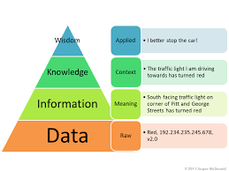
Fig 1 Fig 2
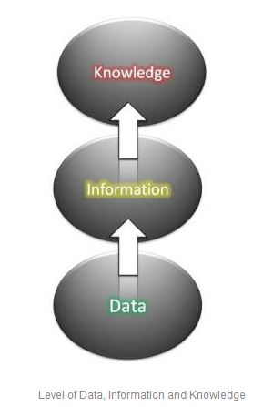
Critical analysis of data, information and knowledge:
Many authors and individuals define the term data differently however, this analysis will show data is unscripted, untranslated message and facts. These message and facts are not yet interpreter so, consequently the view is that data is defined, described as, plain raw fact. Different authors use different definition of the term information for example; data with significance, useful information, meaningful message, data with meaning etc. So, consequently information should hold a meaning to person who acquired it and to others so, the view is, information is defined as a form of leaning with understanding. The term knowledge is also defined differently by different authors for example they use the term such as “know how”, “why and how”, “commitment and belief”, “judgement”, etc. Somewhat amazing that has a connection with the human brain and mind. So, consequently the view is; knowledge is defined as; Information is knowledge administered in the mind of the individuals

3. Tacit and explicit knowledge in a card game.
In a card game a player will require tacit and explicit knowledge. Tacit knowledge is implanted in the mind of the humans through life experience and work life. Tacit knowledge was initially described by Polanyi in 1966. It is occasionally referred to as know-how (Brown & Duguid 1998) and it also refers to intuitive, difficult to define tacit knowledge as it is principally based on experience. For this reason, tacit knowledge is frequently contexed reliant and it is very personal in nature. It is sometimes difficult to communicate, converse and profoundly rooted in act, action, commitment, dedication and involvement (Nonaka 1994).
Explicit knowledge is occasionally referred to, knowing-what (Brown & Duguid 1998). Explicit knowledge is digitized and codified in documents, books, memos, reports, etc. Recorded, recognised information that can simplifier a course of action. Explicit knowledge is which can be effortlessly distinguished, identified, articulated, and shared. So, consequently a system that’s easy to identify, store and retrieve (Wellman 2009). Therefore, a card player will require, explicit knowledge which is already codified, and tacit knowledge which is implanted in the mind of the individual from their vast life experience.

4. Five decision made today, determined by data, information and knowledge.
1st decision: Monday morning, getting ready to take my son to school. Now, usually I have Indian tea in the morning, but I made the decision to drink coffee instead.
Data: Been running late last couple weeks. Needed something with caffeine plus Indian tea takes time to make as it must be boiled in a pot with many different ingredients.
Information: Coffee is quick and simple to make, saves time.
Knowledge: Indian tea takes too long to make; coffee is quick and easy. It saves me approximately 10 minutes which gives me enough time to get to my son’s school.
2nd decision: My sons’ school is approximately 10-15 minutes’ drive and I usually take two different routes depending on the traffic. However, on this morning there was heavy congestion and I exhausted both usual routes. So, needed an alternative route, at this point made decision to use the sat-nav to find another route to my sons’ school.
Data: Stuck in traffic, busy route, google map [sat nav]
Information: Always busy at this time of the morning as route is near Birmingham city centre.
Knowledge: Leave early, alternative route.
3rd decision: After dropping off my son to school, headed towards the university. After parking the car, walking up to the university, at this point decided to pop into the shop next to the university and buy two cans of red bull drink.
Data: Seeing the shop, red bull is an energy drink, long drive later.
Information: This shop sells red bull; red bull gives you energy.
Knowledge: Red bull is a caffeinated drink which helps to keep you energized, help to keep you awake.
4th decision: While walking up to the shop counter to pay for the red bull, at this point made another decision to buy couple packs of chewing gums from the aisle next to the counter.
Data: indication, seeing the chewing gum on display.
Information: Not knowing the health benefits of chewing gum. Also, it gives fresh breath, can clean teeth and chewing while driving can help me to focus.
Knowledge: chewing gum increases saliva, which is a very important section for oral health, also helps to protectoral cavity and removes bad odours from breath [Baldev, 2012].
5th decision: Later, in the afternoon headed for work, I own an Indian takeaway 30 miles away from Birmingham. Got on the M6 motorway and the traffic was horrendous, got to the M42 motorway and the traffic was pretty much standstill there was an accident ahead. At this point made the decisioned to change all the online opening time of the business from 5pm to 5:30pm as we were very likely to be late.
Data: Motorway signs, huge traffic, google, 4G network.
Information: Signs stating accidents ahead, 40 miles per hour signs, slow down signs
Knowledge: We are going to be late, hence the online opening time needed changing, knowledge of road signs, sat-nav etc.

5. Lack of pre-existing data, information and knowledge for the above decision.
Decision 1.
Not knowing Indian tea takes long time to make which would have made me late.
knowing coffee is quick to make and coffee has caffeine in it as caffeinated drinks helps to stay awake.
Not having the knowledge to make coffee, not realising it will save me time.
Decision 2.
Not knowing the route [traffic condition]
Not knowing city centre is always busy at this time of the morning.
Not having the knowledge of alternative routes, not knowing to leave early.
Decision 3.
Not knowing the shop is there, not having the data what red bull is.
Not having the information that this shop sells red bull; red bull is an energy drink.
Not having the knowledge that caffeinated drink like red bull helps to energize and keep you awake.
Decision 4.
Not visually seeing the chewing gum on display i.e. chewing gum in the back of the aisle.
Not knowing or having the information what chewing gum is exactly for.
Not having the knowledge that chewing gum increases saliva, and many other health benefits, not having the knowledge that sugar free chewing gum has many dental benefits i.e. sugar free gums doesn’t cause tooth decay [chewing gum facts, 2019].
Decision 5.
If there was no hazard/warning signs [data], then there would be no data to analysis which would have caused major disturbance.
If there was no information from the signals and signs, then the motorway could be a dangerous place.
If there we had no knowledge of the motorway then we couldn’t have known that we are going to be late for work hence we were able to changer the online opening time.
All the above decision without the pre-existing data, information and knowledge. Without the raw data the information wouldn’t be available and without the information there would be lack of knowledge.

6. Demographic data.
The new product/concept is an authentic Indian street food restaurant and takeaway. The new venture will provide fresh affordable Indian street food for all regardless of age, race, religion, income etc. The organisation collected demographic data from the local sample population via a questionnaire. The sample population for this survey was individuals from the of 16 and over and from all background. The return rate of the survey was an astounding 90% which was a remarkable result, as there was 100 questionnaires distributed. There was a significant amount of data collected, which was turn into information [as shown in the diagram below] and this information will be turned into valuable knowledge.

Analysing the data, information and knowledge.
Data information collections plays a significantly important part in the statistical analysis. [Smeeton and Goda 2003). In this part of the task will analysis the data which has been collected from the questionnaire. The objective is to clarify the gathered information and use this useful information to gain knowledge on the subject.
Figure 1. How frequently do you dine in at an Indian restaurant in a month?
The information obtained from this data collection shows; over 50% revealed they dine in 1-2 times a month, 20% revealed they dine in 2-5 times a month, over 5% said they dine in 5 times or more in a month and 5% revealed they don’t eat Indian food.
Figure 2. How frequently do you order an Indian takeaway in a month?
The information obtained from this data collection was; over 50% order 1-2 a month, 25% 2-5 times a month and under 5% order 5 times or more.
Figure 3. How often do you have an Indian meal delivered to your home?
The information gathered from this data collection was; over 50% 1-2 times a month, 30% said 2-5 times a month, 5% 5 times or more a month and 5% don’t have a delivery.
Figure 4. When placing a takeaway order, do you?
• Place it directly through the takeaway phone
• Place your order via online internet websites
• Pop into the takeaway order and wait for your meal
The information collected from this data collection shows; 35% phone direct through the takeaway, a staggering 55% order via online websites and 10% order their food in the shop.
Figure 5. Your favourite Indian dish?
1st place Korma is the most well-liked dish, in 2nd place tikka masala, then the hot and spicy Madras, followed by Bhuna and Jalfrezi

Figure 6. Would an Indian street food restaurant and takeaway be appealing to you?
The information from the data collection shows a staggering 80% said an Indian street food restaurant and takeaway would be appealing to them and just under 10% not so appealing. of the people said an Indian/Bangladeshi restaurant and takeaway will be appealing to them and under 10% said not so appealing
Information and Knowledge gained from the demographic data collection.
From this demographic data collection, we have gathered a substantial amount of information which can be turn into valuable knowledge for implementation. For example [fig 4] shows the huge increase in customers using online websites to place their order such as Just Eat, Uber Eats, etc. From this we gained the knowledge to open our own user-friendly apps and website where customers can order direct through to us instead of these other intermedia channels.
Mild dishes such as Korma and Masala [fig 5] are well liked, the outcome from this is to innovate more tastier delicious dishes like korma and masala, also hot and spicy dishes like madras which is also very popular.
Another example how we can implement this knowledge, we will use this knowledge [fig 6] to encourage and make it appealing to the customers that usually don’t like Indian food, we will have free sample tasting events where new customers can taste our authentic street food on offer, this will help to convert potential customers to our cuisine and promote the new venture.

Case study – part 1
Overview of the company:
- American airline [AA]
- Head office of the company is in Texas, USA.
- In terms of their revenue in 2001 it was $2.1 billion.
- American airlines employ around 5,500 employees across 45 countries.
- Their main product is airline ticket.
- The types of customers are travellers and travel agents.

1. How American airlines [AA] overall approach to their competitive strategies of cost leadership and product differentiation.
The American airlines began their operations in the year 1934 [Murry, 2013]. During this time the airline market wasn’t much competitive, and the AA functioned on a monopoly basis till 1978, thereafter the airlines regulation act was implemented. This regulation act pretty much changed the whole American airline industry. So, consequently American airline was compelled to revise their whole strategy to compete with other entrant and competitors in the airline industry. The competitive advantage and product differentiation was the the introduction of online reservation and buying online ticketing, using the internet as a marketing tool and the having the option for customers to browse for tickets [online shopping]. Also new entry of organisations such as Expedia, cheap tickets and other online shopping channels. This is where American airline took a huge competitive advantage. American Airlines made a superior product differentiation then of its competitors by using its ticket supplying channels such as the travel agencies more effectively by the means of the state-of-the-art technology i.e. SABRE. Another important point to know is that travel agencies accounts for approximately 80% of Americans income due to this technology [E. Mazareanu, 2019].
2. In what ways did SABRE provide American airlines [AA] with a competitive advantage? Analysis to the strategic use of information systems, i.e. entry barriers.
SABRE a well-made software, a well-made information system that compliments the needs of AA customers, for example if the customer wanted to fly on a certain date with the availability of booking online, they can do so, this was a huge competitive advantage for AA. SABRE can store, retrieve, and process data on thousands of daily flights. AA have SABRE terminals installed with travel agents, by doing this they are automating the procedure of booking airline tickets which reduces the refusal of bookings to its flyers [Levin, 1987].
The main factor is delivering customers with a service which is optimal, providing convenience, overflowing with vital information, time efficiency and well-organised use of customer service resources.
In times where there is stiff competition it is extremely vital for companies to be capable to provide these services at the lowest cost and to deliver it in the most convenient manner possible (Linoff and Barry, 2011).
Analysing American airlines with Porters five [5] forces framework to gain competitive advantage [Chappelow, 2019]. A useful tool to analysis the performance, competitiveness, etc, of an organisation.
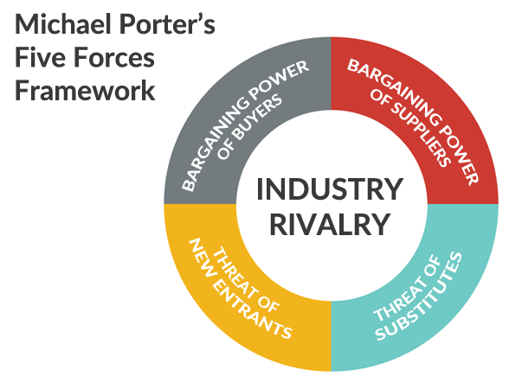
Threats of New Entrants
New entrants that enter the airline market will bring with them innovative ideas and new ways to do things, to be able to compete with big players like AA. New entrants will assess their strategy on pricing i.e. decreasing costs, looking at gaps in the market, providing new and attractive schemes to their clienteles. So therefore, AA will face and will have to manage many different challenges to safeguard a competitive advantage by building barriers.
Steps AA can take to challenge threats of new entrants by creating new innovative products, simplifying and facilitating the needs to have a competitive edge. By having new innovative products will bring forth new customers well as keeping existing customers engaged to AA.
Financing training, development and research, developing sales volumes at a large scale where AA can reduce cost of each unit.
With having strategic plan in use, it may discourage any new entrants to enter a marketplace which is already active with players like American airlines who are well established. Regularly reviewing strategy and keeping high standards will considerably lessen the windows and discourage new entrants to the airline industry.

Bargaining Power of Suppliers
Main airline companies can buy from many different suppliers. Likewise, many leading suppliers in the service industry can use their negotiating ability to obtain a much higher price from established airline companies as they are financially well off. So, consequently supplier bargaining power will have an impact which will generally see a lower profitability for the main airline companies.
Steps AA can take to challenge the bargaining powers of suppliers; by increasing, developing new supply chain where they can deal with numerous suppliers. Testing, exploring new products, by means of different resources [materials] so, for example if prices shoot up of a certain product or material then AA can move around to different suppliers.
Also, to establish devoted suppliers who will depend on the airline company. Moreover, AA can develop third party suppliers which can also be beneficial as these third-party suppliers/ manufactures will have considerably less bargaining powers in contrast to major suppliers.

Bargaining Power of Buyers
Buyers will want the best products in the market. Buyers can also be very demanding to get the best product at the lowest price they can get. This can significantly have a substantial effect on AA’s profit margin in the long term. Powerful buyers with the ability to negotiate hard will want deductions, discounts and special offers.
Steps AA can take to challenge the bargaining powers of the buyers.
AA can tackle these issues by constructing a sizeable customer base. This can help by decreasing buyers bargaining power and it can deliver an opening to AA to rationalise production and the sale procedures.
Also, by quickly introducing innovative new products. By doing this, for example when customers look for special offers and discounts on well recognised items so, if AA keep on creating new innovative product then this can have a limitation on the buyers bargaining powers.
Threats of Substitute Products or Services
Whenever there is a new comparable services/product out in the market that’s meets the demand of the the customers in different ways, these old companies will see a loss in their profit margins. For example, if the treat of a substitute product is high if they offer an attractive and value for money proposition that is exceptionally different from the current industry.
Steps AA can take to challenge the treat of substitute products or services; they can do this by understanding customer’s needs, being more service concerned rather than just concentrate on the products. To understand the essential significance of customers than just focusing on what they are buying.
Rivalry among the Existing Competitors
If there is intense rivalries with the current companies in the airline industry, this can lead to prices going down which will see a low profit margin in the airline industry. AA’s competitive market can be very stressful as AA functions in a very competitive industry. In the long term it can have effect on the profitability of the company.
Steps AA can take to challenge the rivalry among the existing competitors in the main airline industry. AA can achieve this by creating differentiation in their products. They can do this by constructing, evaluating to compete better in their field. They can also co-operate with their competitors to enlarge the size of the market rather than competing in a smaller scale of market.
Reflection of Porter Five Forces on American Airlines.
After using the porters five to analysis the five competitive forces of American airlines. This clearly shows what impacts the profit of major airline companies in the industry. Identifying, recognising changing trends in the market initially can quickly exploit the up and coming opportunity. Understanding and having a clear picture of the porters five, American airlines representative/managers can use these forces to gain the advantage in their favour.
3. What factors played a part in the erosion of AA’s lead over its competitors and how did they respond.
American airline have been recording losses since 2001, many other domestic airlines have been struggling too but had enough money to recuperate [Johnson, 2011]. However, AA have not been capable in recording any substantial return in the last decade. One reason why AA have been unsuccessful to co-ordinate other airlines is because they still were dependent on business fares [Barney, 2010]. Many other airlines, for example if you take southwest airlines, they have been very competitive through their reduction of lower price. This demonstrates low cost airlines are passengers first choice, reason being maximum customers can be financially struggling hence they look for cheap fares.
After the terrorist attack in September 2001 it has unfavourably affected the whole airline industry. Traveling by air became lest favourite and passengers chose other means of transport. In the year 2007/08 there was a recession where the US and other parts of the world felt the recession that had a significant impact in the economic growth. Almost all the airline industry reacted quickly to make changes dropping their prices however, AA has done very little to make any significant changes (Casadesus-Masanelland Tarzijan, 2011). In 2008 the AA employees demonstrated when it was placed as the worst performers when it came to cause inconvenient to customers. On a regular basis flight were cancelled in the US which was caused by AA. Furthermore, lost baggage’s of passengers, delays and many other inconvenient pretty much defined AA (Johnson, 2011). Also, AA had a very disorganised structure. They seemed to finally realise that when they submitted for chapter 11 bankruptcy. American airlines high costs structures made their organisation venerable at a time where others in the industry were struggling for efficiency. These are some of the factors which played the part in the erosion of the organisations lead over its competitors.
How the company reacted and turn it around:
Shortly after when US airways stated they will merge with AA, soon after they started working and pin-pointing their weak points. AA started with their cost structures by reconstructing it by cutting jobs. AA merging with US airways has significantly established a much bigger network which gave both combined airlines a chance to offer competitive on many of their routes. Managing to structure their cost, better running income and they improved their profitability in three years. In 2014 it turned profitable and they have continued their growth substantially. AA had a lucky break at the right time by the merger in the much improving economy. Within this short time AA used this opportunity and bounced back from their difficult and trouble times, with gaining competitive profitability.

Case study – part 2 – information system
1. Definition of an information system.
Organisations deal with large sum of data; data is facts and it is systematically organised in the database. Data is organised to assists information answering questions to solving any problems. An information system is basically defined as a software where it helps to arrange and analysis data. The key purpose for an information system is turning raw data into beneficial information which can be used in important decision making in an organisation.
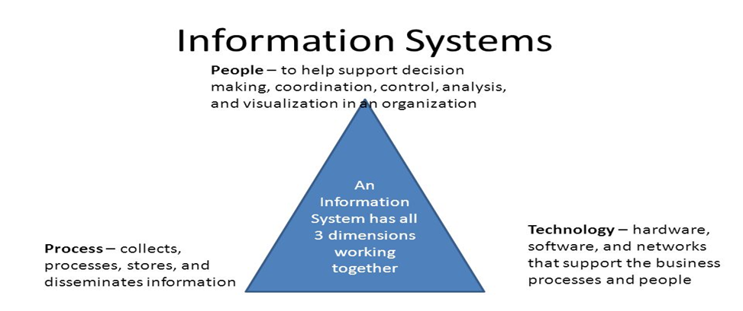
Image by Andrea Powers
Basic Components of Information Systems
Information system used within an organisation may differ but they all typically contain the following components:
- Hardware: A computer-based information systems uses computer hardware, such as monitors, processors, printers and keyboard.
- Software: Is the programs used to systemically organise, process and analyse the data.
- Databases: Is the Information system that work with data, which is organised into tables and files.
- Network: Is various elements that needs to be joined to each other, specifically when there are many people in the organisation are using the same information system.
- Procedures: Describe how the specific data is processed and analysed in order to archive relevant answers for which the information system is designed.

2. Computer based information system, with relevant business examples for each category identified.
Computer based information system is vital for many organisations, it is a component for collecting, processing, storing and for gaining, providing valuable information, knowledge.
Organisations and businesses all over the world depend on computerised information system to run their operations smoothly, for example it helps a business to communicate with customers, suppliers and it also helps to be competitive in the marketplace.
Large interorganisational supply chains uses information system to run their businesses daily. For example, companies will use information systems for processing finance of their business, managing human resource and doing online/offline promotions/marketing to reach existing and potential customers.
Large organisations are entirely developed around computerised information systems. Such as eBay a very large auctioning platform; Amazon a massive online shopping channel; and Google which is a very large information system by its own right, a search engine which makes most of the revenue from keyboard marketing and online internet searches.
As individuals as well who rely on information systems normally internet based for managing their day to day life for entertaining, studying, shopping via various channels, personnel/business banking.
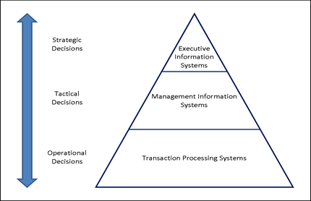

3. Explanation of how a computer-based information system can support managers at each level in an organisation.
Generally, managers of an organisation get information for important decision making in many different forms. The main information process is the company’s computer-based information system, where it creates information by using electronic computer technology. The use of computerised information for solving organisational problems has quickly developed over the years. Technological advancement has made this archivable for managers having straight access to computers decision making support system.
The pyramid diagram below demonstrates the stages of computer-based information system for workers, managers, senior managers and executives’ managers.
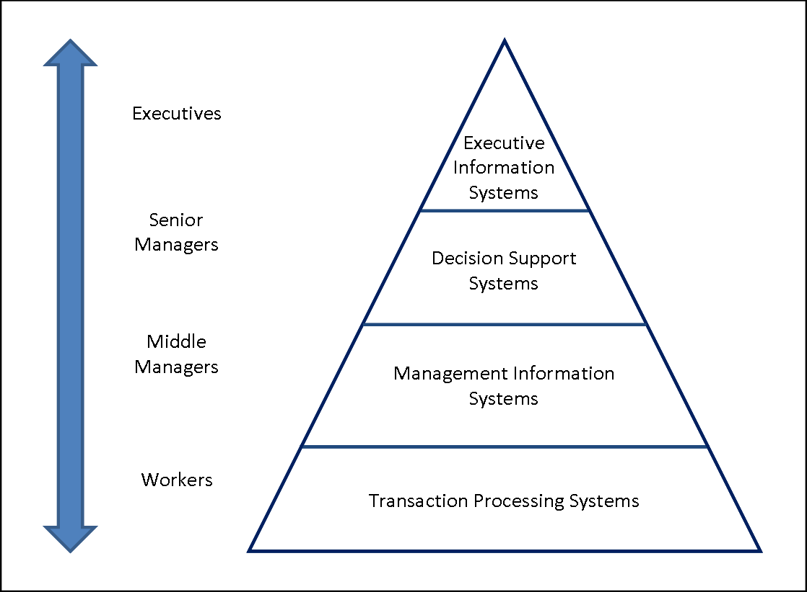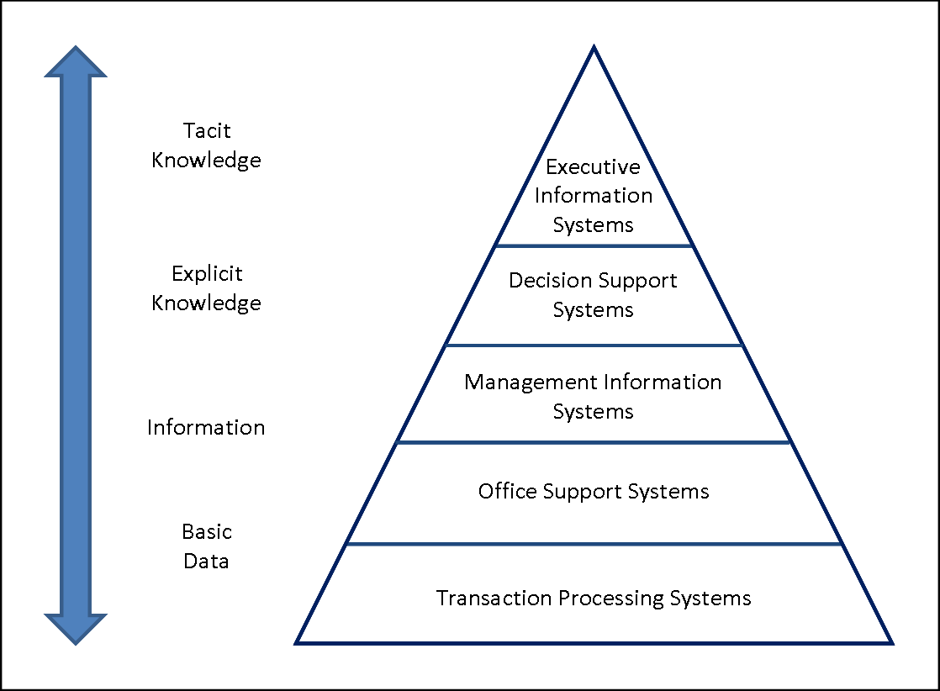
Classic Pyramid Models
This technology is a way by which raw data is transformed and systematically organised for organisations use which helps the managers in making decisions and achieving their objectives. Over the year’s computers have substituted manual technology for collecting and processing large amount of data. Managers now a days rely on some form of computer-based information to help in this current competitive market.
The form of computer-based information system is for input, output, storing, processing, computer software, computer hardware.
The hardware of the computer is an equipment for the input, the processing method and the output of an information system.
The software of the computer contains instructed programs that organises the workload of the computer’s hardware mechanisms to able the process of the business for employees to use this information system more effectively.
Conclusion
Data, Information and knowledge can be described, defined and communicated in many ways, and how we use and have conversation regarding specific information is significantly important in a progressively information-based world-wide economy. The core connection and relation between data, information, and knowledge which is combined with essential understanding of the three subject is very much the key elements to gaining wisdom of human beings. Data is primarily used as raw elements so, from data you generate information, of course these data must be put into context. Very importantly, knowledge isn’t always out there for us to find but knowledge must be created and made. In an organisation computer-based information system are used by managers to improve productivity and increase efficiency.
The Americans airlines advancement to retrieve and process large amount of data daily on thousands of flights and handling of thousands of passenger’s data, information leads naturally to the computer-based information system. The airline industry was initially among the first to operate this advance technology (Petzinger, 1995). The marketing advantages of AA was SABRE computer reservations systems which created competitive advantage and product differentiation which introduces the online reservation and buying online tickets, using the internet as a marketing tool and the having the option for customers to browse for tickets [online shopping] was an significant development for the airlines. In an organisation computer-based information system are used by managers to improve productivity and increase efficiency.

Reference lists

Journals & books:
Ackoff RL. 1989. From data to wisdom. J Appl Syst Anal. 16, 3-9. [Google Scholar]
Ackoff, Russell L. [1989]. "From Data to Wisdom." Journal of Applied Systems Analysis 16: 3–9.
Anthony Liew, [2007]. Journal of Knowledge Management Practice, Vol. 8, No. 2, Understanding Data, Information, Knowledge and Their Inter-Relationships
Ashley Braganza, [2004], International Journal of Information Management, Volume 24, Issue 4, Pages 347-356
Barney, J. (2010). Gaining and Sustaining Competitive Advantage. London: Pearson Education limited.
Casadesus-Masanell, R., Tarzijan, J.(2011).When One Business Model Isn't Enough. Harvard Business Review, 90(2), 132-137.
Davenport, T. H. & Prusak, L. (2000). Working knowledge: How organizations manage what they know. Boston, MA: Harvard Business School Press.
David Weinberger, [2nd February 2010]. Knowledge management. The Problem with the Data-Information-Knowledge-Wisdom Hierarchy
European Journal of Business and Management [2014]. ISSN 2222-1905 (Paper) ISSN 2222-2839 (Online) Vol.6, No.16
Falkenberg, E. D., Hesse, W., Lindgreen, P., Nilsson, B. E., Oei, J. L. H., Rolland, C., Stamper, R. K., Assche, F. J. M. V., Verrijn-Stuart, A. A. & Voss, K. 1998. A Framework of Information System Concepts: The FRISCO Report, The Netherlands, Department of Computer Science, University of Leiden.
Ikka Tuomi, [2nd December 2015] Journal of Management Information Systems. Volume 16, 1999 - Issue 3
John Seely Brown and Paul Duguid [April 2001]. Knowledge and Organization: A Social-Practice Perspective. Vol. 12, No. 2, pp. 198-213.
Johnson, S. (2011). How will American Airlines' bankruptcy affect workers? New York Amsterdam News, 102 (50), 10-38.
Lance Murray [13th February 2013]. A history of American Airlines; Dallas business journal.
Levine, M. E. (1987). Airline competition in deregulated markets: Theory, firm strategy, and public policy. Yale Journal on Regulation, 4, 393-494.
Linoff, G. & Barry, M. (2011) Data Mining Techniques: For Marketing, Sales, and Customer Relationship Management. Indianappolis: Wiley Publishing Co.
Nonaka, I. (1994) A Dynamic Theory of Organizational Knowledge Creation, Organization Science, 5(1), pp. 14-37
Petzinger, T. (1995). Hard landing. New York: Random House.
Plato, [1989], p. 530: Symposium, 175d
Polanyi, Michael. Personal Knowledge: Towards a Post-critical Philosophy. London: Routledge and Kegan Paul, 1958; University of Chicago Press, 1974.
Shields, R. [2001]. The New 'Knowledge Speak': the implications of contested definitions of knowledge and information. Australasian Journal of Information Systems, 8, 142-149.

Online websites:
Cambridge University Press [2019] knowledge management. Accessed on [19/09.2019]. Available from: https://dictionary.cambridge.org/dictionary/english/knowledge-management
Smeeton, N., Goda, D. (2003). Conducting and presenting social work research: some basic statistical considerations. Accessed on: 10/10/2019, available from: https://ori.hhs.gov/education/products/n_illinois_u/datamanagement/datopic.html
https://www.quora.com/What-is-the-appeal-of-chewing-gum-Why-do-people-chew-it
Chewing gum facts, [2019]. Health benefits of gum chewing. Accessed on: 20/10/2019, available from: http://www.chewinggumfacts.com/chewing-gum-benefits/health-benefits-of-gum-chewing/
Andrea powers [2019] SlidePlayer.com Inc. Available online: https://slideplayer.com/slide/8182341/
American Airlines Website, History of AMR Corporation and American Airlines. Available online from: http://www.aa.com/i18n/amrcorp/corporateInformation/facts/history.jsp (Accessed on; 11th November 2019).
E. Mazareanu, [11th October 2019], Statista. Accessed on: 07/11/2019. Available from: https://www.statista.com/statistics/250577/domestic-market-share-of-leading-us-airlines/
Business directory, [2019] Web finance Inc. Accessed on [18/09/2019] Available from: http://www.businessdictionary.com/definition/information-management.html
IBM marketing cloud, 2017. IBM corporation. Accessed on: 25/09/2019. Available from: https://www.ibm.com/case-studies/ibm-marketing-cloud
Tejas Baldev, [13th September 2012]. Quora. Accessed on: 20/10/2019, available online
Y JIM CHAPPELOW, [20th November 2019]. Porters five forces. Accessed on;20/11/2019. Available online from; https://www.investopedia.com/terms/p/porter.asp

