Effective use of Geographical Information Systems to manage local Governments highway maintenance requirements.

Beverley Holland
Faculty of Applied Design and Engineering
Swansea Metropolitan University
Email: beverley.holland@smu.ac.uk

Steven Gardiner
GIS Analyst
Neath Port Talbot Borough Council
s.gardiner@neath-porttalbot.gov.uk

The use of Geographical Information Systems (GIS) technology has become an integral part of managing issues within both the social and physical geographical domains. Government both local and national has access to a vast data bank of statistics that can be used effectively within GIS to help with analysis and predictions. At Neath Port Talbot County Borough Council South Wales the use of new technology is encouraged and recent changes in winter weather forecasting has led to the investigation and development of a GIS to enhance their winter services.

The highway authorities in the United Kingdom have been preventing the formation of snow and ice on our roads for many years now, but this action has only recently become law ‘highway authorities are under a duty to ensure, so far as is reasonably practicable, that safe passage along a highway is not endangered by snow or ice.’

Knowing how road surface temperatures react on a nightly basis has several advantages and using this knowledge can help optimize/redesign salting routes so that a route could cover as many cold areas as possible, limiting the number of routes that would have to be treated during a nightly operation. This has a financial and environmental impact on salting route planning. Treating all routes as appose to just the ones that fall below zero could incur a higher financial outlay and from an environmental perspective, salt although a natural resource, is not native to inland wetlands and watercourses which is where it eventually ends up.

An established method of road temperature prediction is a technique known as thermal mapping.
The theory behind thermal maps is that most factors that effect road surface temperature are spatially fixed, such as surface construction, altitude, exposure and traffic. Thus a pattern of cold and warm sections along a route for a given weather condition can be displayed as a colour coded map.

This paper examines how, via the statistical analysis of a season’s worth of winter road surface temperature data, gathered using a technique known as ‘Geomatics’ which allows the forecaster to spatially reference points along a route with GPS, and the ability to render such data within a GIS, better identification of possible hazardous conditions on our winter roads can be visualised and thus more effectively treated.

Introduction

In the United Kingdom, the Government, both national and local have a duty of care to provide a safe environment for the citizens within its domicile whilst endeavouring to keep within a given budget. Many acts have been legislated to help with this process, the following; the Highways Act of the UK was passed as an act of parliament in 1980 setting out the governance of its highways. Amendments were made to the Highways Act in 2003 as follows:

‘highway authorities are under a duty to ensure, so far as is reasonably practicable, that safe passage along a highway is not endangered by snow or ice.’ (1)

Thus local authorities were forced to review their winter service operations. During a winter period it is not possible to precautionary salt every highway within an authority. For this reason priority is given to certain roads. For example within Neath, Port Talbot Borough Council (NPTC) priority is given to: ‘A’ and ‘B’ roads carrying industrial traffic, access to hospitals, Fire stations and emergency centres’.(2) These routes are designed to make the best use of council resources keeping as many roads open during icy conditions as reasonably practicable. As well as financial and personnel constraints there are other constraints that restrict what could be deemed as a best salting route. One of these is the physical length of a route, NPTC consider it important that a route should take no longer than 3 hours to complete, also the process is constrained be the amount of salt a gritting vehicle can hold thus limiting the area of road that it can precautionary treat.

At NPTC there is a strong belief that, where appropriate, new technologies should be encouraged. This is in order to provide the highest possible level of service to the public whilst maintaining appropriate budgetary controls.

GIS and Local Government

“The use of a computer based information system to aid the decision making process is not a new concept. However, with Geographical Information Systems (GIS) and their ability to support the development of visual information systems, communication of the processed data could hopefully reach a wide audience”(3)

To explain further in its basic form GIS (Geographical information Systems) is a simple data collecting tool, a map on a computer. What’s unique about GIS is not what data you can store but how collected objects can be displayed. A GIS allows a user to position an object spatially. This means that collected objects can be viewed in their real world position against a background map.

The use GIS is becoming an integral part in managing society. Government both local and national have access to all sorts of statistical data. In the United Kingdom for example all census information is available on the following site www.statistics.gov.uk. This data is directly linked to area and therefore spatially referenced. This site coupled with various partner sites, for example CASWEB providing UK-borders maps, which map unitary authorities, voting wards, parish boundaries to name but a few geographical group sets and the famous Ordnance Survey organisation can all be used effectively to map our nation and help local government in their quest to provide for their citizens.

Using Technology to control budgets

GIS is a very data hungry tool the more information you put into it the more information you can get out of it. Maguire et al (2005), stresses that data is the most important part of GIS ⁽⁴⁾. There are two main methods of data collection required in this case study the first is using the features of a background map such as a house or a junction to locate your object, the second requires the use of GPS to exactly pinpoint the spatial location. Being able to see the exact position of objects which for all intents and purpose are your assets is a very useful business tool.

From a highway engineering point of view, confidence in the potential of GIS has grown considerably. As with all highway authorities, records of council assets were kept manually using paper records. However, NPTC has been using GIS since its existence in 1996. During this time vast amounts of data has been collected giving vital information on condition, type and position of highway inventory assets. This places NPT in the position to use the true power of a GIS which is as a decision making tool. Described as a special kind of decision-support system ⁽⁵⁾, GIS gives a user the ability to analyse data spatially

A recent technological investment is that of the new “Network Forecast” provider used within the Environment Directorate. The network forecast is used, within the directorate, to carry out its duty of winter gritting.

A key feature of Network Forecasting is that it is geographically referenced and not textual. Having this data, in a geographical format, allows this it to be used within a GIS. The Environment Directorate is very experienced with geographical information and has been using this information to enhance its service for many years. Prior to the introduction of this new data acquisition method data available could not be used within GIS. This new service, processed within a GIS, could provide the council with valuable knowledge on how their roads perform over a winter period.

Therefore the question becomes “Through visualisation of historical winter forecasting data can a unitary authority namely NPTC enhance their overall road network forecasting service and thus make our winter roads less hazardous?”

Network Forecasting explained

NPTC in conjunction with WNI Oceanroutes (one of the world's largest private weather service company) has been at the forefront of developing a new form of road weather prediction know as Network Forecasting, first introduced at the Cold Comfort Conference in 2000. Where Network Forecasting differs from more traditional methods is that it uses geomatics to predict road temperatures. Using geomatics and the increase in computing power over recent years allows the forecaster to accurately predict road temperatures anywhere along road.

Geomatics allows the forecaster to spatially reference points along a route with GPS. At NPTC this is at every 50m but this resolution can be increased or decreased. By spatially referencing points and using them within a GIS, a database of geographically referenced attributes can be built such as latitude, altitude, topography etc, but most importantly sky-view factor. Sky-view factor is calculated with a fish eye lens and measures the exposure each forecast point has. Research of these methods has been carried out at the University of Birmingham by Chapman and Thornes and led to the development of XRWIS (6).

These recent developments in weather forecasting have cast doubt on the accuracy and usefulness of thermal mapping. Thermal mapping has several limitations, as it is a fingerprint to how a route performs it only gives possible minimum temperatures and not a time at which roads will reach 0ºC. This time is critical to the engineer, as they have to make sure all precautionary routes are treated by this time. Secondly, they do not allow for enough flexibility, as only having three different scenarios seriously limits their effectiveness with factors such as wind direction not accounted for. Network forecasting is a much more dynamic approach to forecasting. Treating each point as an individual and not part of a sequence of events allows it to account for endless possibilities.

An example of Network Forecasting proving that thermal mapping is limited in its assumptions has recently been discovered by NPTC. A section of road under thermal mapping (see fig 1) was always thought to be warm, but forecast data from the WSI (Weather Service International NPTCs weather forecaster) (see fig 2) consistently showed this section as being cold.

The discrepancy between the two methods prompted further investigation. A weather station was commissioned at the site to monitor actual temperatures. The results from this study would help validate the Network Forecast. This has had major consequences for NPTC as under normally used forecasting methods this section of road would not have been treated exposing the authority to risk.

Currently NPTC have a forecast for every 50m along their precautionary salting network, giving a total of 10,156 forecast locations per night, each giving a predicted temperature every hour. Over a winter gritting season October to April, this produces massive amounts of historical data, which, prior to this study, was not utilized.

GIS, Visualisation and better use of available data.

With all this data to hand, begs the question of how this information is displayed?. It is said that meteorological data is best projected in a GIS environment ⁽⁷⁾. The improvements in GIS applications means that they are immeasurably more data rich than in the past ⁽⁴⁾. The digital world is proving to be hot competition to the traditional map. Being able to display a map on a screen offers far greater flexibility and customization ⁽⁴⁾. Viewing and presenting geographical data to aid decision making is known as Geovisualisation. This described as a form of visual communication allows the user to see much more than what’s on the screen, simplifying massive amounts of data, allowing users to explore, synthesize, present and analyze data more thoroughly than before ⁽⁴⁾. It is stated by Longley et al that geovisualisation has four principle purposes: Exploration, Synthesis, Presentation and Analysis. The two important principles for this study are Presentation, how the data is displayed to the user and Analysis, what information is displayed to the user. The advantage of presenting data in this way is that it is interactive. The user has the ability to dynamically explore regions of the display targeting areas for detailed analysis as well as general overviews. The way that data can be presented within GIS is also a form of analysis. Within a GIS different data sets can be displayed on top of each other this can give data meaning. Showing traffic flows on a road might give reason to the number of accidents that occur on it.

Design & Implementation

The product that has been produced exists in two distinct phases. There is the processing phase and the visualization phase. The Processing phase interoperates the raw weather forecast information into meaningful manageable sets of data. While the visualization phase sets about looking at this information within GIS allowing for advanced interpretation.

The visual appearance of this phase of the development is not as important as visualisation in the later part, but it is still important that the approach used in its creation is consistent to standard windows environments. Users who are familiar with the windows environment can simply use this program with very little training (see fig 3. For final design window). As you can see from fig 3 the program has a progress bar. From the start this was seen as a very important design aspect. The purpose of this phase of development is to post process acquired data, visually we are just reporting on processing progress. With the amount of data requiring processing, it could be possible that the screen would not change for up to an hour. The progress bar allows the user to see that processing is happening and no time out error has occurred t also gives the user some indication as to how long the full process will take.

5.1.2 Data Access

The information supplied by the Forecaster comes in dbase IV format with the file extension .dbf. Over a season (November to March) this produces 151 files which need to be accessed and processed. In order to access these files a method know as ADO (ActiveX Data Object) was used. ADO is the preferred data access technology recommended by Microsoft.

Below is the code used for setting up an ADO connection;

objConn = CreateObject("ADODB.Connection")
objConn.ConnectionString = "driver={Microsoft dBase Driver (*.dbf)};" & _ "driverid=277;dbq=" & mFolder
objConn.Open()

With the above statements it is very important that you get the ConnectionString right. Different drivers are used depending on what format database you are accessing. The above code gives you access to the location where your databases are stored, the next step is to access the specific database.

adoRS = CreateObject("ADODB.Recordset")
adoRS.Open("SELECT * FROM " & mName, objConn, ADODB.CursorTypeEnum.adOpenStatic, ADODB.LockTypeEnum.adLockReadOnly)

This creates a Recordset of the database you want. The SQL statement “SELECT * FROM “ ensures that all the records and all the fields are returned. If you only wanted specific data ranges then a “where clause” could be added but in this case all the data was required.

5.1.3 First Phase Processing

Over the winter season the 151 days produces 3624 bits of information from each forcast point with 6885 forcast points the season produces 24,951,240 bits of data. Using the minimum temperature for a day, a single daily record could be created for each geographical forecast point reducing the amount of information by a factor of 24.

minValue = adoRS.Fields(2).Value
For a = 2 To adoRS.Fields.Count - 1
If minValue > adoRS.Fields(a).Value Then
minValue = adoRS.Fields(a).Value
End If
Next

5.1.5 Output Data Tables
From the summarised data tables, three tables are produced each using different statistical analysis methods on a monthly and complete season basis. The tables produced show the following information:

- Probability
- Mean Average
- Minimum Average

Probability is calculated using the formula P = I / E. where P is probability I the number of instances an event occurs by E the total number of event. In this study the event is the temperature falling below 0ºC. By calculating the probability you can measure the likelihood or risk of this event occurring.

If value < 0 Then
iProbability = iProbability + 1
End If
Using an empirical approach to calculating the probability (8) the sample is proceesed as follows; The code checks the event i.e the temperature falling below 0 ºC and if it does, adds 1 to the value of iprobability (I). Repeated through all the summarised data points the probability is calculated:

iProbability = iProbability / fieldlist.Length
The Mean Average is calculated using the formula mean = Σx/n which calculates the sum of the values in a data set divided by the total number of values.

iAverage = iAverage + value

The mean value as a measure of central tendancy is used to discover sections of road that are consistantly colder. By calculating the mean value you are providing a figure that is representational of a given point, a geographical location. This allows you to compare one points performing analysis and drawing conclusions. To calculate the mean l, all the values in a row have to be added together in order to create the sum. In this program this is done per month and per season. The sum on completion of adding all values together is divided by the total number of values to produce the mean.

iAverage = iAverage / fieldlist.Length

The minimum value is the table which is of least importance where it comes to making decisions on the data. The purpose of the minimum table is to see just how cold months are. Knowing this minimum temperature for each point per month could help show not so much cold sections but possible errors in the forcast itself. The minimum value is create as previously explained in the first phase processing section.

5.1.6 Saving Data
Like other data access controls ADO was used to write data to a file. This is a very important part of the post processing procedure as it is with these files that visual analysis will take place within the GIS environment. The following code creates the connection:

objConn = CreateObject("ADODB.Connection")
objConn.ConnectionString = "driver={Microsoft dBase Driver (*.dbf)};" & _ "driverid=277;dbq=" & mFolder

objConn.Open()
Here a new table is created containing all necessary fields.
objConn.Execute("CREATE TABLE " & Replace(txtSaveFile.Text, ".dbf", i & ".dbf") & addFields)
data is added to the table.
objConn.Execute("Insert into " & Replace(txtSaveFile.Text, ".dbf", "0.dbf") & " Values(" & theAverageString & ")")

As you can see from the above code there is no need to create a Recordset when writing a file. The files created using this method are in dbase IV format which is compatible with ArcGIS. Fig 4 and 5 show the raw data ab teh post processed data format.

5.2 Implementing Visual Data

The true value of this study was to test the ability to visualise the processed data within the ArcGIS environment. As the processed data has an X and Y coordinate attached to it this data is easily imported into ArcGIS. Using the command “import X Y data” a table can be visualised and further processed into a shapefile (shapefile is the file format used within ESRIs ArcGIS). At this point the visual data is still meaningless, as all points are represented in the same way. (See fig 6). As temperatures change over the winter period, with generally colder temperatures in December, January and February it is important that all months are represented equally and consistently. This had to be taken into account when deciding how to represent the data visually. In order to visually represent data consistently an appropriate legend should be used. It is the legend that gives the visual data an identity and meaning (See fig 7). Fig 8 below provides an indication of first level analysis carried out during the second phase of this studies processing requirement namely within the GIS. Applying the legend rules we are able to visualise the probability of points falling in temperature for month November through to March 2007/2008. The image is of the road network system in NPTC. Fig 9 shows the minimum temperature at the same geographical locations and for the same time period.

At this point the data is fully implemented at a 2D level, in order to view this data and perform analysis on it, on a 3D basis; further processing needs to be done. The current data only has X and Y coordinates, to make it 3D a Z value is needed. As a Z value is not supplied with this data, it needs to be interpolated for a 3D surface modal. There are two types of surface model that exist a DTM (Digital Terrain Model) and DSM (Digital Surface Model) both are similar, but with slight differences. The DTM was used as this best represents the lay of the land. This transformation allows the data, not only to be used within a 3D environment, but also perform analysis on its height, which previously could not be done.

Advanced Analysis

From the analysis, sections were selected based on there attributes. A query was used to select sections that had an average of less than 3, and a probability of more than 0.2. SQL Statement ‘Average’ < 3 AND ‘Probability’ > 0.2. The results of this query are displayed in red on the map shown in Fig 10.

In order to help explain why some sections are colder than others, the first thing looked at was height. The Neath Port Talbot area is split at 100m and 300m. As height is a major factor in temperature, the next query concentrates on identifying sections of road that are below 100m. The following s SQL query is applied ‘Average’ < 3 AND ‘Probability’ > 0.2 AND ‘Z’ < 100. As you can see from the red areas on the above plan, (Fig 11) there are several areas within Neath Port Talbot that meet these criteria.

For analysis purposes, these points are grouped into sites, based upon their geographical relationships. By grouping them into sites (see Fig 12) we are able to simplifying the analysis process as we are now looking at area sections. This is possible because the site groupings are affected with similar physical/human factors.

Under the traditional approach to winter precautionary salting, on marginal nights where temperatures are forecasted close to zero, only high level routes would be gritted. These high level routes are routes 4,5,6,9 and 10. If we now show these routes as a layer, overlaying the sites that we have previously identified,. We can now see the areas where the authority was susceptible to the greatest risk (Fig 13) in particular sites 1 and 4.

5.3 3D Analysis
To help create an understanding of why these areas exist, the remaining sites were shown within the 3D environment of ArcGlobe. As you can see from Fig 14 which provides a view of site 1, there are several environmental factors that affect this site. Viewing the data within the 3D environment and with aerial photography helps to visualise these. As this view is looking in a northerly direction, you can see that to the east you have a large mountain. This would restrict the sunlight this site gets in the morning. Also a large tree canopy tunnelling over the road could further restrict the amount of sunlight reaching this site.

Site 4 (Fig 15) is also affected by a large mountain, but this time it is to the west. This restricts the evening sunlight that this site gets. You can also see that there is quite a bit of housing development in this area but mostly setback from the road. Fig 15 also shows that this site is rising in altitude. These are all observations anyone can make, but it is the method of viewing the data that allows this to be done so easily.

6 Conclusion and Recommendations

As mentioned before, the law on winter gritting states that you must do everything reasonably practicable (1) to ensure that roads are clear from snow and ice. Thus we can suggest that in this era of efficiency savings and budget cuts, exercises such as this are fundamental to improving a service. Having greater knowledge of how your road network performs during cold conditions can only help. Exercises such as this, not only make best use of the information at hand, they also help meet one of the councils corporate objectives “To continuously improve service quality” ⁽⁹⁾.

As can be seen from the results produced within the GIS, it is a very powerful tool providing data visualisation. The ability to quickly, graphically view where at risk areas could be, is a tremendous advantage to any decision maker. GIS has shown that, under past weather predicting method, the authority would have been placed under considerable risk of failure to perform its duties. One section of road in question, (site 1) has shown the same probability of the road surface temperature falling below Zero, as other high route sections, when processed in the new system, but has always been part of a low level route.

Finally we need to reflect on the capabilities of 3D analyst an extension to ArcGIS which allows for interpretation of data in a 3D environment. Vector and raster data can be combined to provide effective visualisation and allow for 3D analysis of surface data.(10)

Now that this new technology has highlighted flaws in previously used forecasting techniques NPTC feel they must continue to investigate the validity of this new method of forecast analysis. At present the study assumes that the forecasts received form WSI are correct and this data must at some stage be checked for credibility. However, many benefit from using such a system can be highlighted, this information could help highway authorities to redesign their precautionary salting routes. By having the higher probability sections, on as few routes as possible, would reduce the number of vehicles required on some nights, and the amount of salt. Both of these would result in a cost saving. We could say that this will provide an environmental benefit as less salt will be distributes which could ultimately contaminate hedgerows and land.

Future work on this study continues at NPTC, during the winter season 2008/09 NPTC trialed two network forecast, one by WSI and the other by MeteoGroup. In order to accurately compare the performance/ accuracy of the Network Forecast, it was proposed that a Campbell scientific IRIS unit, would be placed in a secret location along a gritting route. The IRIS unit is an infrared device designed to give an accurate reading of the road surface temperature, where the network forecasts intersect the location of the IRIS unit a direct comparison can be made. Some initial finding are favorable with both data provides performing well in comparison to NPTC data check with WSI providing a 95% accuracy result. The testing will continue and the system will be used to help with winter road surface temperature analysis.

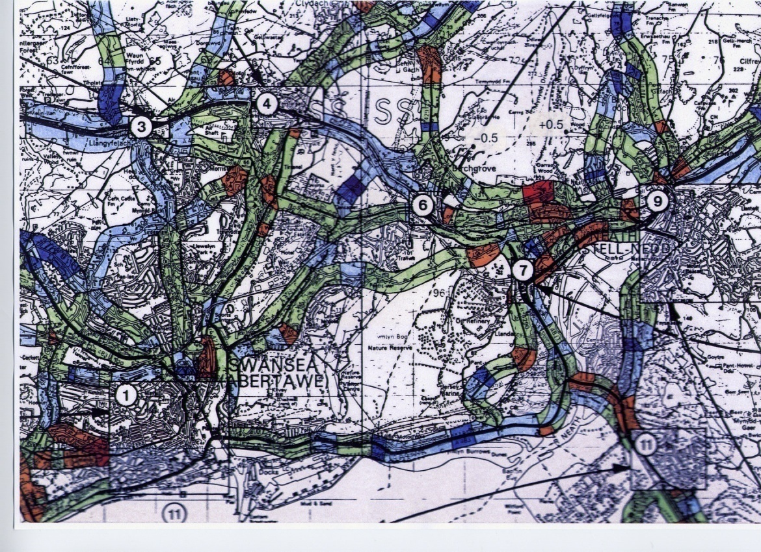
Red shows warm section

(Fig 1) Shows forecast thermal map with warm section on Drumau Road.

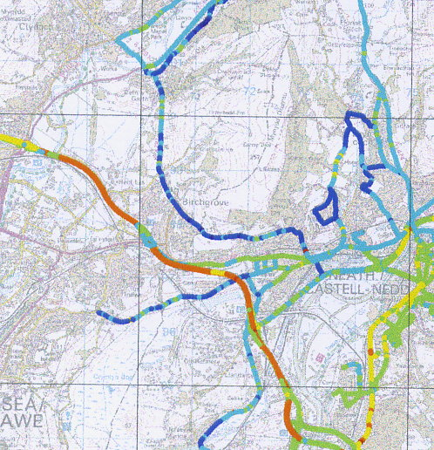
© Crown Copyright 100023392 2008
Shows the same section of road being cold.

(Fig 2) Show network forecast with Drumau Road being cold.

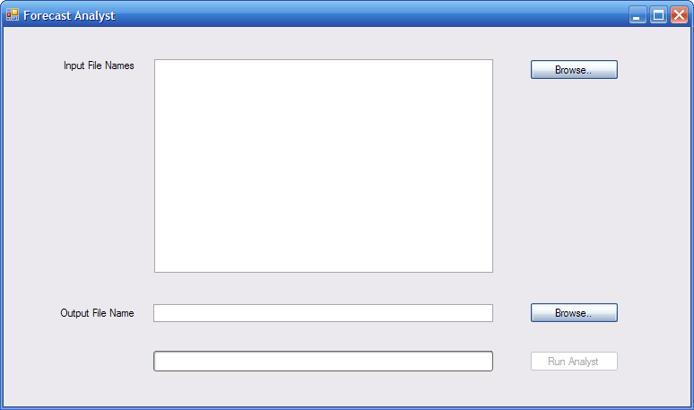
List box
Buttons
Labels
Progress bar
Text box
(Fig 3) Visual Basic design highlighting components used.

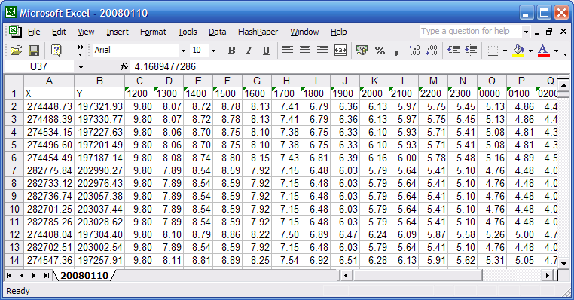
(Fig 4) Structure of raw weather forecast data.

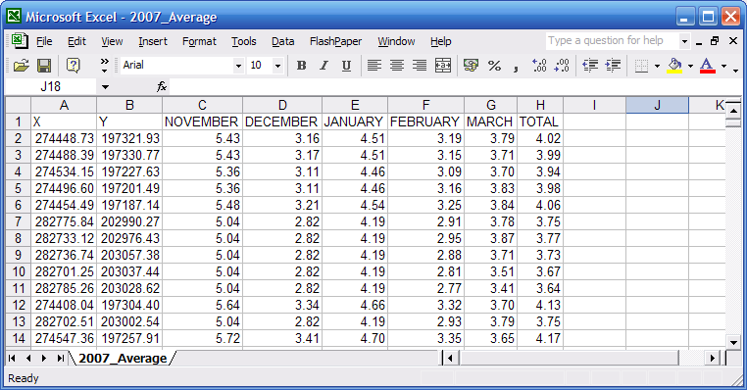
(Fig 5) Structure of processed weather forecast data.

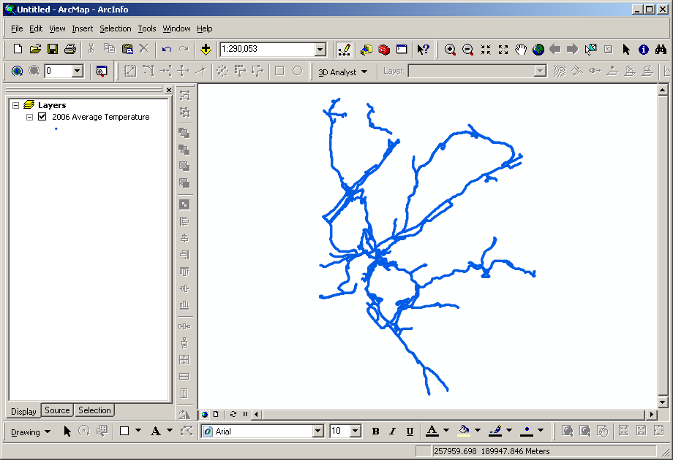
(Fig 6) Example of data within ArcGIS without a legend applied.

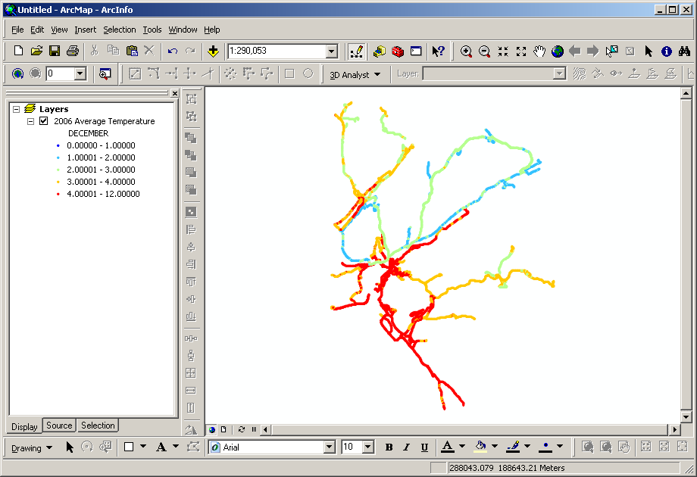

(Fig7) Example of data within ArcGIS with a legend applied.

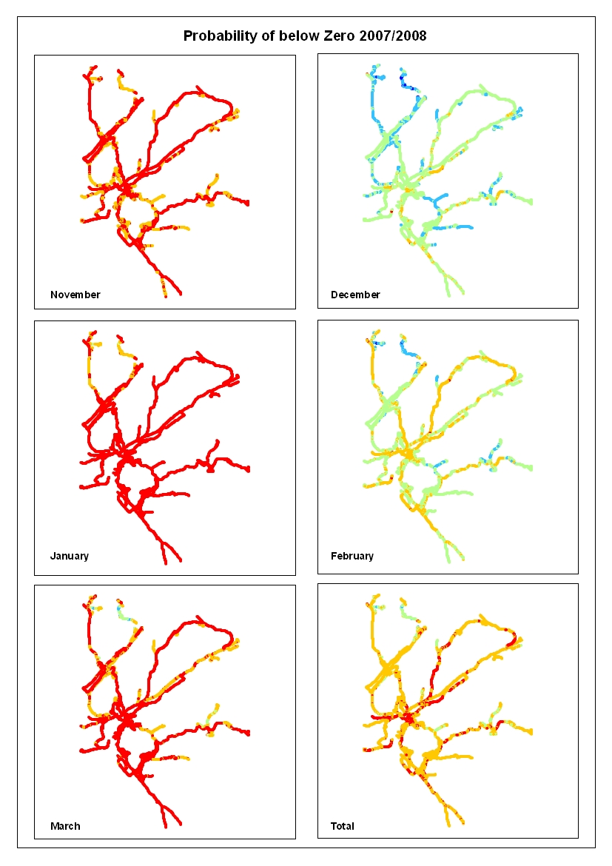

(Fig 8) Show the probability of points crossing 0ºC per month and total for the season.
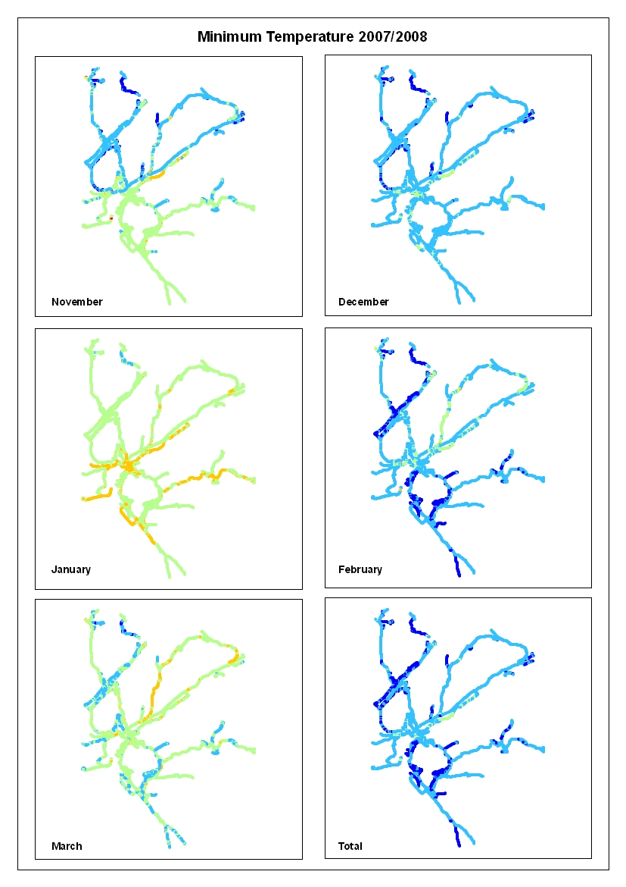
(Fig 9) Shows the minimum temperature per month and a season total.

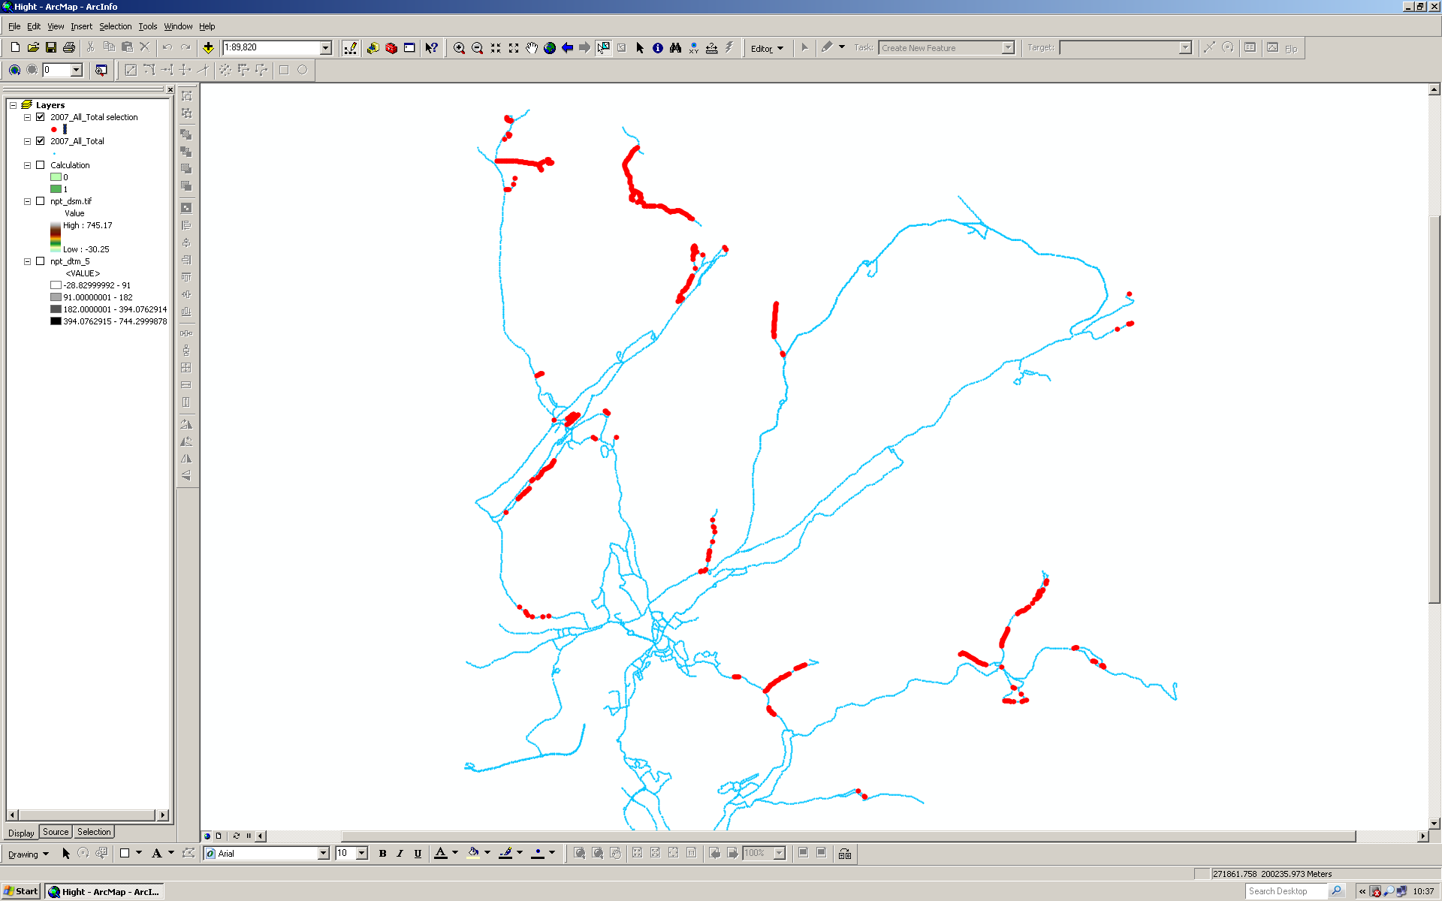
(Fig 10) Shows points that meet the SQL requirements within ArcGIS.

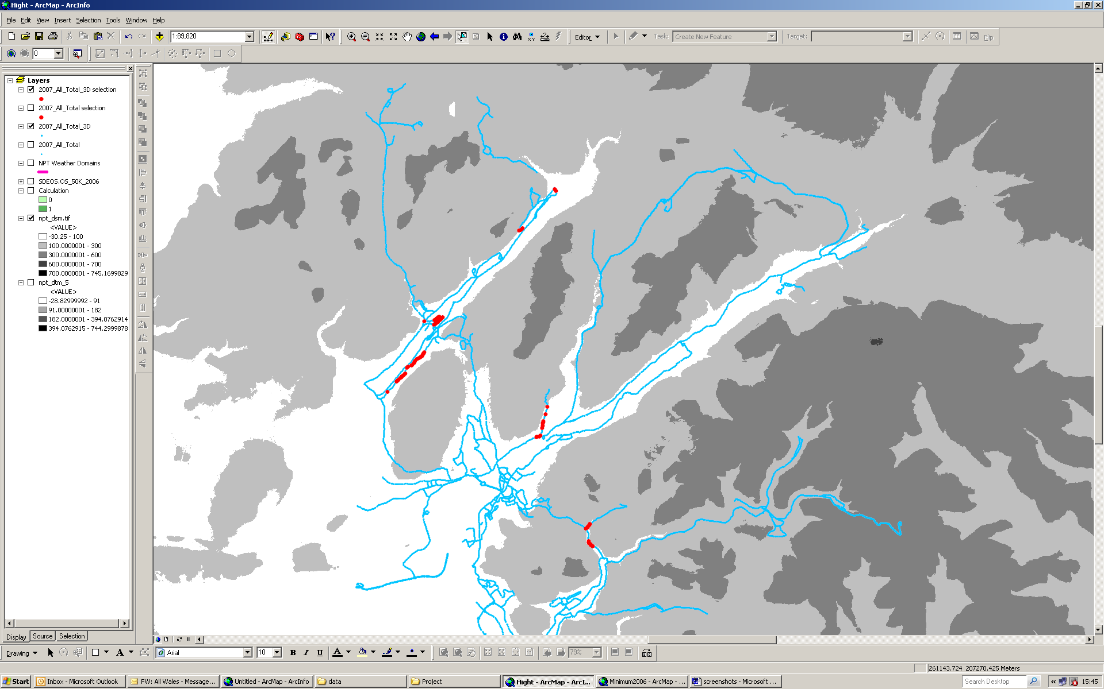
(Fig 11) shows selected point with height data that fall below 100m.

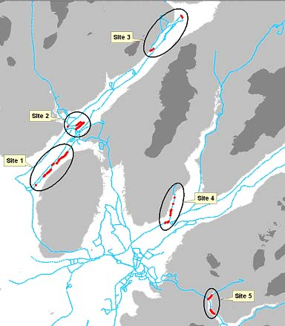
(Fig 12) Shows selected points grouped into sites.

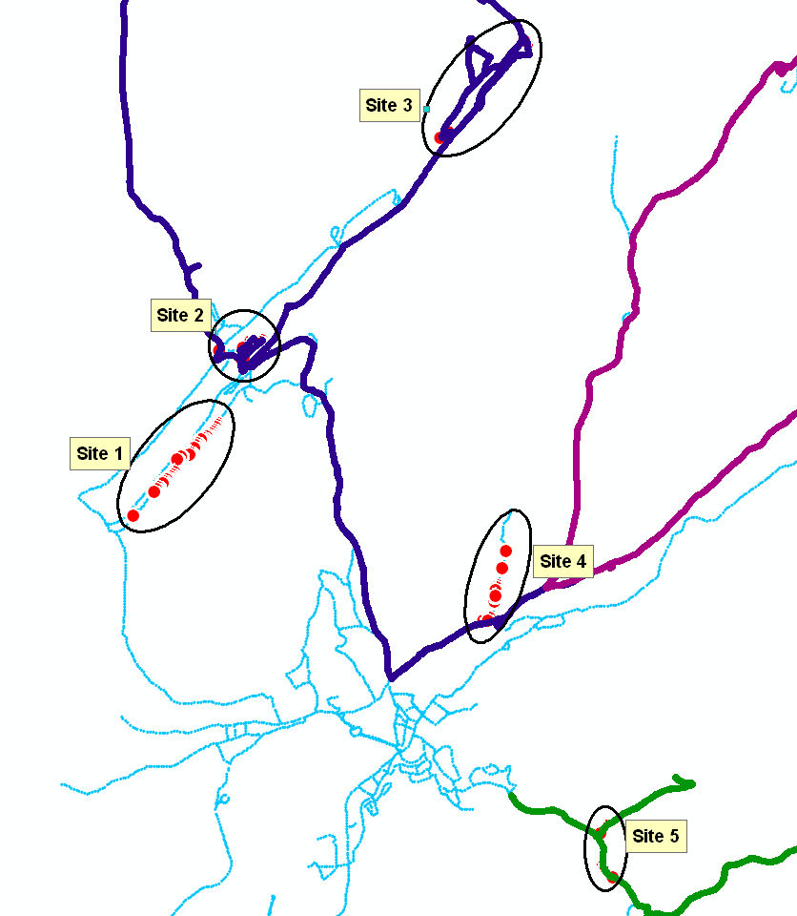
(Fig 13) Shows sites with Gritting routes 4,5,9 and 10 overlaid.

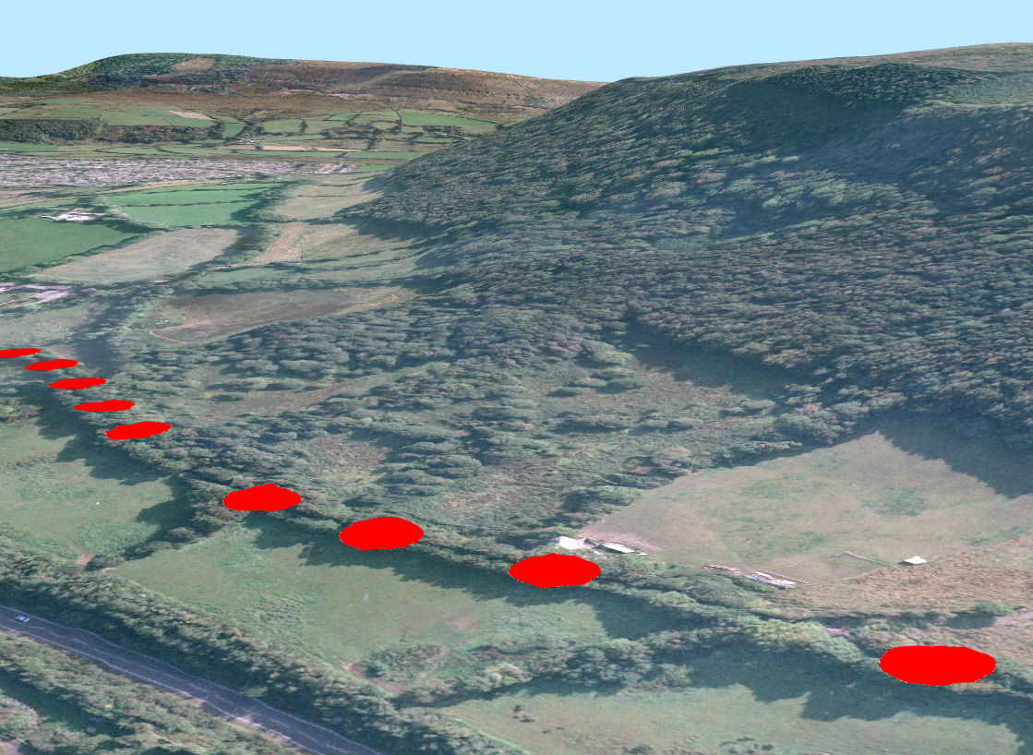
© Crown Copyright 100023392 2008
(Fig 14) Site 1 in ESRIs 3D Analysts ArcGlobe.

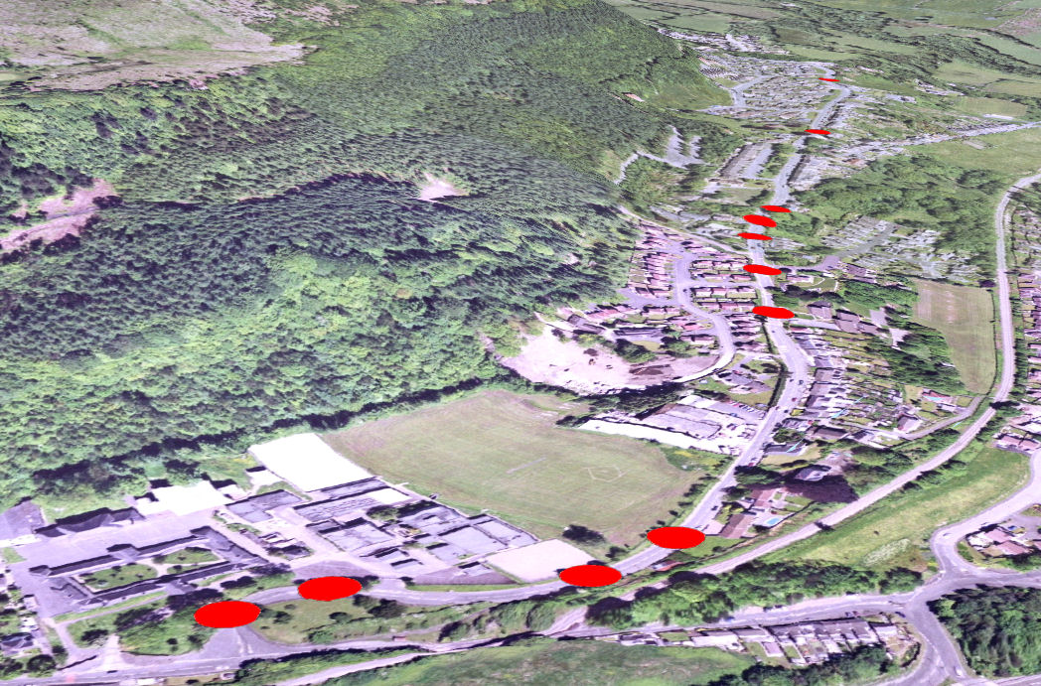
© Crown Copyright 100023392 2008
(Fig 15) Site 4 in ESRIs 3D Analysts ArcGlobe.
References

1. HMSO. Highways Act 1980. (c. 66 Section 41(1a)), London : s.n.
2. NPTC. 1. Neath Port Talbot CBC. “Winter Service Plan 0708”. [Online] Available: http://www.neath-porttalbot.gov.uk/ [Accessed: February 3rd 2008].
3. Integration of High Definition Surveying and Geographical Information Systems – . Holland, Leigh,Kidner. 2008.
4. Longley, Goodchild, Maguire, Rhind. Geographical Information Systems and Science. s.l. : John Wiley & Son , 2005. 2.
5. Maguire D, J. Computers in Geography. London : Longmans, 1989.
6. Thornes, Chapman ans. 2000.
7. Piotro, K. Hussain, I,.Rehman, K. Historical Weather Data Analysis of UK. [Online]
8. Owen F, jons R. Statistics. London : Pitman Publishing, 1994. 4.
9. CBC, Neath Porttalbot. Aims and Objectives. [Online] NPTC, 10 April 2008. http://intranet.neath-porttalbot.gov.uk/corporate/aimsobjectives.
10. Wilson, J,P. Fortheringham, A,S. The Handbook of Geographical Informatiopn Science. Oxford : Blackwell publishing, 2008.
11.

