The Research of the symbolization and visual characteristics of chimeric monsters in works of art.

Major: 3D COMPUTER ANIMATION DESIGN

Student: Xu Jiayi
Tutor: Philip Organ

1st Dec .2021

Announcement on the Originality of Dissertation

Declaration: I declare that this thesis is my own original work, conducted under the supervision of my doctoral supervisor. All sources for reference work are identified to the best of my knowledge. No part of this research has been submitted in the past for publication or for degree purposes. I am legally responsible for the truthfulness of this declaration.

Date: 6/12/2021
Signature: Jiayi Xu

Contents
Abstract............................................................................................................5
1 Introduction ..................................................................................................6
2 Chimera monsters in mythical works...........................................................6
2.1 The development of modern chimeric monster design……………….……9
3 Symbolization expression in a chimera monster design……………….…...13
3.1 Symbolization of terror………………………………………………….……13
3.2 Symbolization of Unknown…………………………………………….……15
3.3 Ferocious symbolization……………………………………………….……17
3.4 Lovely symbolization…………………………………………………….……18
3.5 The symbolization of justice…………………………………………….……19
3.6 The symbolization of evil……………………………………………….……20
3.7 The symbolization of power…………………………………………….……21
Conclusion......................................................................................................22
References ………….…………….……………………………………………...23
Bibliography.………….……….……….…………….…………………………...24
Words：3796

Figure Content
Figure1………….........……………………………………7
Figure2………….........……………………………………7
Figure3………….........……………………………………8
Figure4………….........……………………………………8
Figure5………….........……………………………………9
Figure6………….........……………………………………10
Figure7………….........……………………………………10
Figure8………….........……………………………………14
Figure9………….........……………………………………15
Figure10………….........……………………………………16
Figure11………….........……………………………………17
Figure12………….........……………………………………18
Figure13………….........……………………………………19
Figure14………….........……………………………………20

Abstract
In the long development of human culture, human beings have created one work of art after another about chimeric organisms through the imagination of the sky. Such works of art are attached to the social environment at that time and exist, different regional cultures, different backgrounds of the times, will be born of different styles of chimeric biological image. This kind of artistic image will have a specific symbolic visual characteristic. This paper will look up historical, artistic, and literary materials to study the design sources of chimeric monsters in works of art, as well as symbolic visual features.

Key Words: Chimeric monsters, Symbolization, Visual features

- Introduction
Chimera, the origin of the word Chimera, is a monster in ancient Greek mythology, which means "mother goat" in Greek, first appeared in Homer's Epic, and was the child of Typhon and alpha. In "Spectre," it is thought to be the child of the titum Gaia and the athalus. The above is a description of Chimera from Bibliotheca. This is the earliest text description of a Chimera-like monster in human writing. In medicine there is a term called chimerism, which refers to the phenomenon of a person having at least four different sets of DNA fragments of different organisms. Chimerism is derived from the word Chimera. And as times change, the word Chimeric can refer not only to monsters in a particular legend. It can also refer to monsters in all recreational works that do not exist in real life and have many different biological or non-biological visual features.

2. Chimeric monsters in mythical works.
A similar monster appears in the Bible, and Behemoth is a good example of this in Christian Standard Bible (CSB).
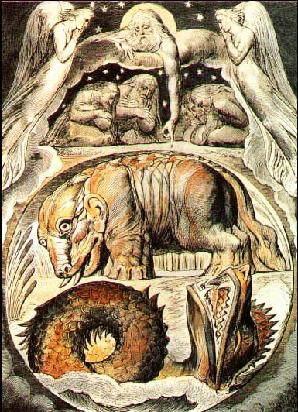
Behemoth is described in the Bible Look at Behemoth, which I made along with you. He eats grass like cattle. Look at the strength of his back and the power in the muscles of his belly. He stiffens his tail like a cedar tree; the tendons of his thighs are woven firmly together. His bones are bronze tubes. his limbs are like iron rods. He is the foremost of God’s works; only his Maker can draw the sword against him. The hills yield food for him, while all sorts of wild animals play there. He lies under the lotus plants, hiding in the protection[e] of marshy reeds. Lotus plants cover him with their shade; the willows by the brook surround him. Though the river rages, Behemoth is unafraid; he remains confident, even if the Jordan surges up to his mouth. Can anyone capture him while he looks on, or pierce his nose with snares? （ Bible. 1952）
Figure 1: Behemoth
Most scholars believe that Behemoth was designed from hippos. Behemoth's tail design source is a tree.
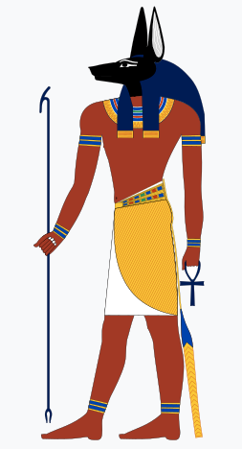
In Egyptian mythology, people enter a wheat field after death, in which a god named Anubis will judge the souls of the people. If the dead man does evil after death, he will enter the land of nothingness, and if the dead man is kind-hearted, then he will live in a posthumous world with abundant food and beautiful scenery. Anubis's image is made up of a wolf's head and human body, and its head design is modelled on Afrian wolf, but in modern monster design, designers will make Anubis's head shape more like Dobermann's.
Figure 2: Anubis
The dragon in Chinese mythology is a well-known legendary creature. Chinese dragons have design references to snakes, bird paws, sheep horns, lion's head, fish scales, and shrimp beards, as well as horse mane.
In Japanese mythology, the てんぐ is also a very famous monster, its human body has the wings of crows, the paws of birds and the head of crows.
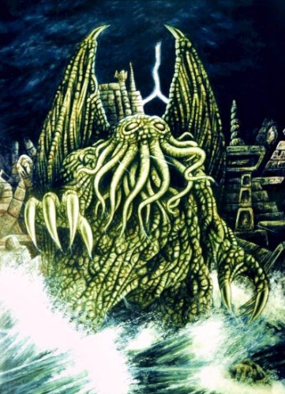
In some of the new myths of modern times, there are many excellent monster designs. For example, all kinds of monsters in the Cthulhu myth. Lovecraft describes the monster as "a monster, vaguely with a human outline, but with a head that has many tentacles like an octopus, a body like a gel covered in scales, giant claws, and a pair of narrow wings behind it ... It has a bloated and fat body.... With mucus flowing, the huge green body hobbled out of the dark opening and into people's view... It's like a mountain walking between heaven and earth.” （H. P. Lovecraft，1922）
Figure 3: Cthulhu
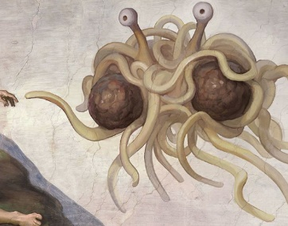
In the fairy tale of Flying Spaghetti Monsterism, the god who created the world looks like a crab, but this strange crab is made up of noodles and meatballs.
Figure 4: Flying Spaghetti Monsterism

2.1 The development of modern chimeric monster design
From the day of the birth of mankind, human beings began to create and record stories. From early text and paintings to modern videos and games, humans have designed a large number of Chimera monsters. As computer CG technology matures, the design style of the Chimera monster has changed. In this chapter this article will mainly study the evolution of the design of Chimera monsters in modern entertainment works.
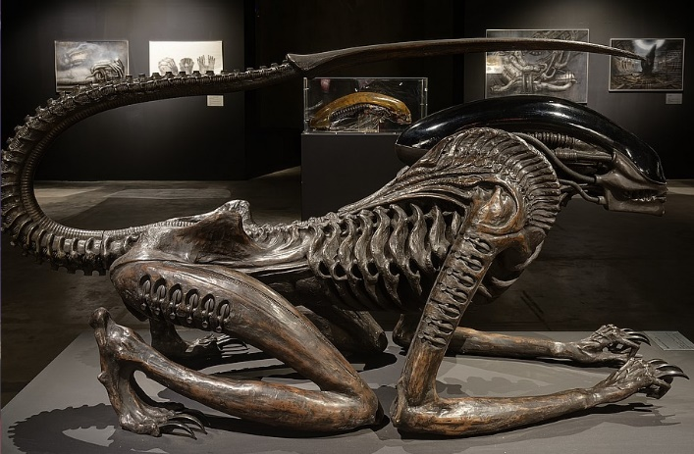
In the 20th century, the most famous monster, Alien, was a chimeric monster designed by artist H.R. Giger by combining the physical features of the human body with that of insects. His series of designs conveys an advanced design concept to other designers, and chimeric monster designs do not have to be limited to animal-animal combinations. Designers can combine the visual characteristics of animals with machinery to create more modern-looking chimeric monsters In H.R. Giger's work, those characters often have visual features such as human genitalia, arthropod insects, bat wings, soft tissue animals, mechanisms, and pipes.
Figure 5: Alien
As shown, the monster statue was hand-designed by H.R. Giger. The monster's torso and upper limbs have significant human bone features. At the back foot of the monster, reference is made to the cat's foot skeleton. It has a nautilus cross-sectional pattern on its scapula. The animal's tail has the visual characteristics of a scorpion and a human spine. Its head resembles the ship's cockpit, but the shape refers to some molluscs, such as slugs. On the other hand, the monster's whole body has a sophisticated mechanical structure, which can give a hard and flexible feeling.
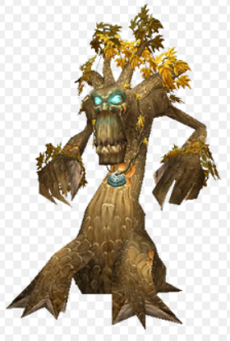
In the famous Warcraft series, there are many excellent chimeric monster designs. A good example is treant in the game, which first appeared in the novel Lord of the Rings. The design concept has been better developed in World of Warcraft, where the essence of the tree has a human appearance, wood-like skin, they are tall, with plant roots on their feet and leaves in their hair. The treant design in World of Warcraft, however, follows most of the visual features of The Lord of the Rings, but there are still many visual differences between the treant in World of Warcraft and the tree essence in the Lord of the Rings. In World of Warcraft, for example, the facial design of the treant is derived from the face of a chimpanzee, while the leg of the treant is derived from the legs of a quadrified animal. Such a design would make the treant look more in line with the real-life impression of the tree "solid" and avoid copyright issues for the Lord of the Rings.
Figure 6: Treant
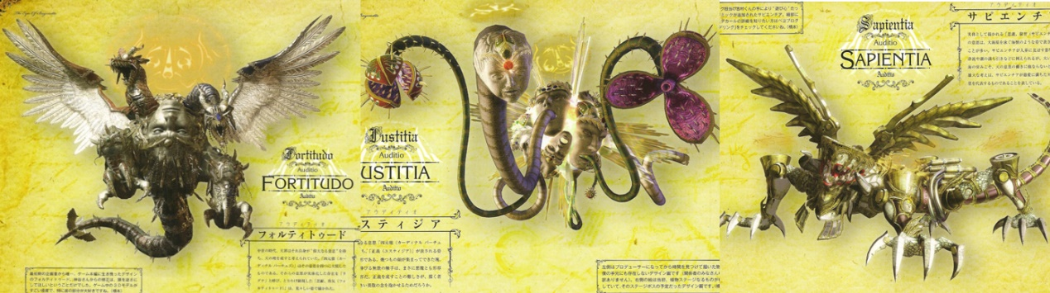
In the 2008 Platinum game produced an action game, there are a lot of excellent monster design. The game has a large number of angels and demons, and the design of these angels and demons refers to a large number of anatomy and botany. Take the monster character in the game as an example, monster Fortitudo. Designers use the shape of the legendary dragon in Europe, in the shape of the dragon has a great deal of anatomical knowledge. This knowledge includes the body structure of the following creatures, the head of the lizard, the wing s of the pigeon, the neck of the snake, the horns of the cow, the legs of the bird and the tail of the lizard. And on the basis of the dragon also carried out further design of the character's shape, the dragon's body is wrapped in a huge sculpture. The sculpture looks like a human face, while the interior of the face is a twisted piece of meat. Such a design allows the audience to feel sacred and powerful. When the monster's face is broken, the inner flesh is displayed in front of the audience, which can make the audience feel the fear.
Figure 7: Fortitudo and Uistia
The game's second monster, Uistia, has a lot of faces on his head, and those faces have plant-stab vines in their mouths. The design elements of this monster are not as complex as other monsters, but they feel weird and scary. The third monster in the game is a reptile, but he has a lot of mechanical structure on his body, and the monster's entire torso is like the engine of an old car. When the monster's mouth is open, the tentacles of the octopus stick out inside the mouth.
In 2016, a game called No Man's Sky was launched, and the game has a good reputation among players for its excellent quality. On the other hand, the game creates a whole new universe, and trillions of chimeric creatures. Game designers automatically generate trillions of extraterrestrials by randomly combining the body parts of various creatures on Earth with excellent algorithms. Among these creatures are eyes with tentacles. There are also birds with turtle shells on their backs, and even on some planets players can see ringed plants with lizard heads. Despite their wide variety, most of them lack design aesthetics because they are randomly generated by computer code.

3. Symbolization expression in a Chimeric monster design
Professor Bychkovz mentioned this point in his article Symbol in Art as An Aesthetic Principle. The being of a true work of art is determined, in the final analysis, by whether a fully-fledged act of artistic symbolization has taken place. (Bychkov,2012,51)
In the design of Chimeric monsters, designers often use symbolic designs to express the various characteristics of monsters. For example, if a flying monster usually has wings, a quick-moving monster usually has cat characteristics. These symbolic visual features not only show the meaning of monster features, but also convey a special aesthetic to the audience.

3.1 Symbolization of terror
In many horror movies, corrupt and spoiled corpses and arthropod insects tend to be a symbol of terror. The corrupt corpse is originally associated with the fear of death, when the creature dies, the body will slowly show the visual characteristics of corruption. When people see this, they tend to feel nausea and discomfort, which is associated with death and danger. Humans' fear of arthropods stems from insects such as spiders, dragonflies and scorpions. In the jungle, these insects tend to carry deadly toxins, and the fear that human ancestors lived with them for tens of thousands of years has been firmly etched in people's subconscious. Although most humans no longer live-in dangerous places, fear of carcasses and arthropods still exists, so many designers have applied that fear to the design of Chimeric monsters.
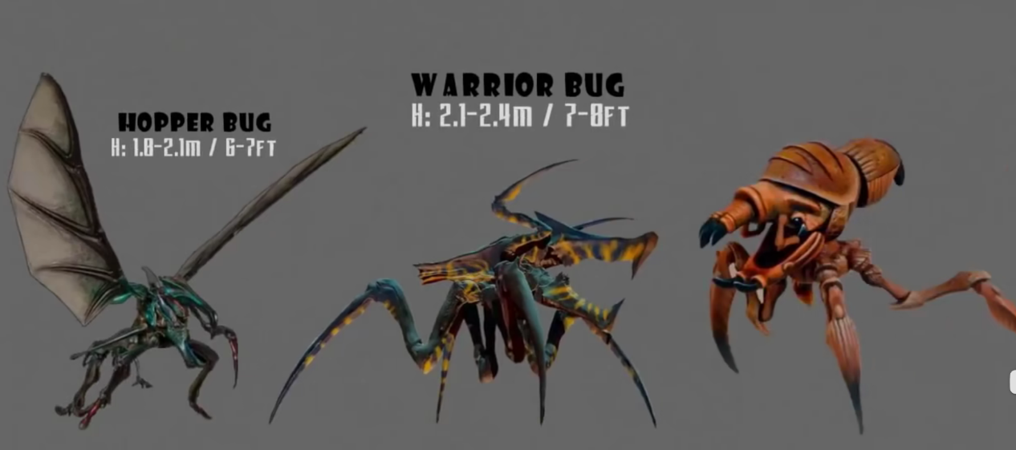
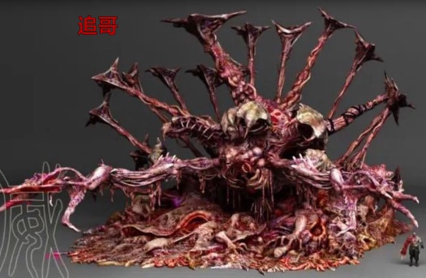
The characters in Capcom's game " Resident Evil" have a number of similar symbolic designs. Monsters in biochemical crises, most of them have rotting appearances and fangs and claws. These decaying appearances include shedding skin, exposed bones outside the body, pus wounds, and abnormal movement. These visual features combine with the game's worldview of the dead body, and when players see these Chimeric creatures, the brain evokes fear of death instincts.
Figure 9: Monsters in Starship Troopers
Figure 8: Monster in Resident Evil
In the film "Starship Troopers", the monster character is designed to apply the visual characteristics of many arthropods. These monsters are insect-like, with sharp limbs and mouths like spiders, and their saliva melts steel. In the film, the mountain-strewling insects waved sharp limbs at the human army, causing many viewers to be startled.
3.2 Symbolization of Unknown
Human perception of the unknown has both the element of fear and the desire to explore, the same sign of the unknown also has two sides, it can make the audience pay more attention to the monster's design and the story behind, but also let people have fear of the unknown. The simplest explanation for unknown symbolization is the visual features that are out of common sense and irregular. For example, if a person has an eye on his hand, people may be curious about his body structure. If the person has eyes all over his body, people will not only find him strange, but even cause fear of him. So proper irregular design can stimulate people's desire to explore, and excessive irregular design can cause fear.
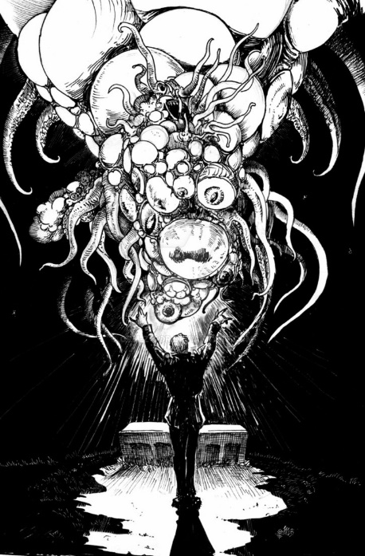
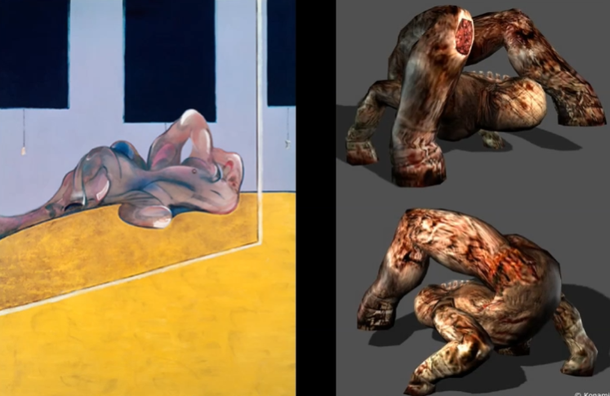
In the Cthulhu mythology, there are a large number of monster characters with such irregular appearance characteristics. Take Yog-Sothoth in Lovecraft's book, for example, where a large number of eyeballs, octopus tentacles, meat pieces, and teeth make up the monster. All the limbs of this monster grow in irregular shapes, they are different in size and position. The monster is more like a creature that has been exposed to radiation mutations. It is precisely because of the large number of irregular monster designs in the Cthulhu myth that the Cthulhu myth has become synonymous with the unknown and fear.
Figure 10: Yog-Sothoth
Figure 11: Bacon's paintings and the monsters in Silent Ridge
There are a number of unknown symbolic visual feature designs in the game Silent Ridge. Monsters in Silent Ridge often have twisted limbs and exposed organs that appear where they shouldn't be, precisely because they give the player a fear of the unknown. Silent Ridge's monster designs are inspired by Francis Bacon's surrealist paintings, which are filled with artistic expressions of pain and have many strange-shaped human beings. The faces of the people in these pictures are distorted and their bodies are melted. In her book, Michel mentions bacon's interpretation of her work when she interviewed bacon "his work is full of tw
isted human bodies, some of which can lead to speculation about the unknown, and people can guess what happened to the character"(Michel,1993), which stimulates human desire for exploration and imagination.
3.3 Ferocious symbolization
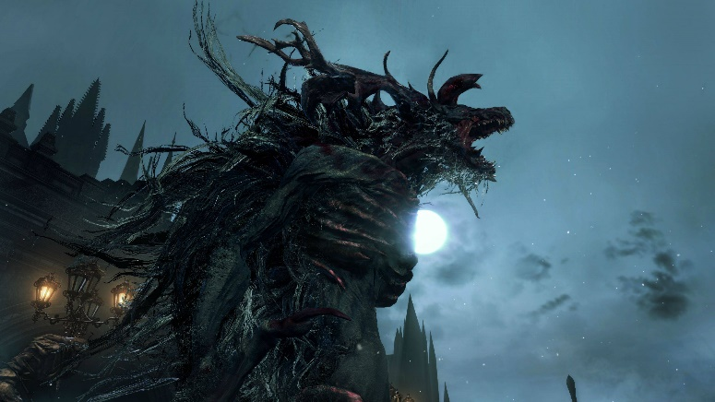
Sharp teeth and claws can represent ferocity in works of art, as predators in nature often have these visual features. From ancient times to the present, people have an instinctive wary and fear of carnivores. The reason is that our ancestors, the apes, faced the threat of these predators when they lived in the jungle. Lions, wolves, bears, crocodiles, these predators all have sharp teeth and sharp claws, which are the most useful tools for their predation.
Figure 12: Monsters in Blood
In the game's blood-source curse, a large number of Chimeric monsters have this design. These monsters have sharp teeth and claws, and players are often surrounded and killed by this ferocious group of monsters in the game, just as tigers hunt.

3.4 Lovely symbolization
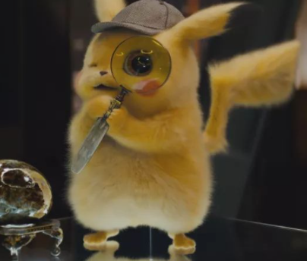
In addition to ferocious and scary monsters, Chimeric monsters often have cute monsters. Pikachu in anime Pokemon and Stitch in Lilo and Stitch are good examples. These monsters have big eyes and ears, soft hair, lovely meat mats on the palms, full appearance and so on. The reason is that humans are born with the impression of safety and comfort in round and soft things, just as humans like to sleep on soft beds with soft pillows. Long ears stem from people's love of rabbits and dogs, which tend to be human pets. On the other hand, their ears express their emotions, and when they are excited, they tend to have their ears pricked up, which not only does not pose a danger to people but is particularly cute. So long ears are often used to design cute characters. The big eye of the character is a reflection of the modern human aesthetic. So, in modern design, dogs and cats, as well as rabbit ears, and the meat mats in their palms, have become cute symbolic features.
Figure 13: Pikachu

3.5 The symbolization of justice
The symbolic features of justice are the wings and feathers of pigeons, the armor of knights, and eagles. Angels representing justice in the Bible have the wings and feathers of pigeons, which are the earliest symbolic expressions of pigeon wings. In many fairy tales about knights' armor, princes or knights always defeat dragons, evil wizards, and save the world, and the armor they wear has a symbolic character similar to justice. Eagles are a symbol of freedom, courage and justice in many cultures, and this symbolic expression is reflected in the national emblem of the United States.
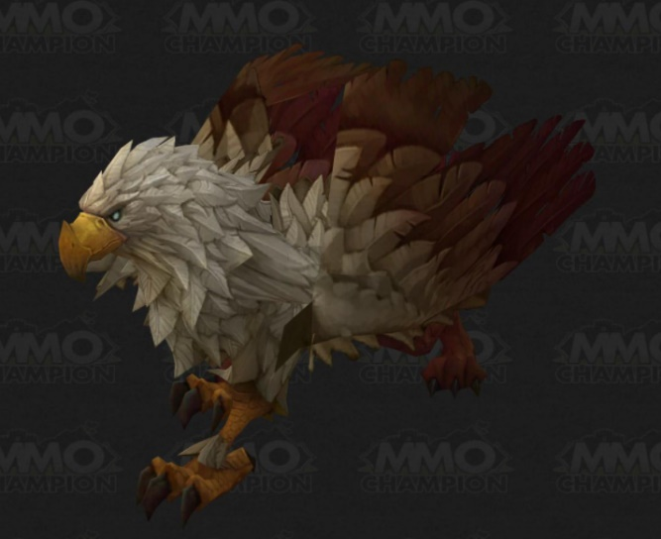
In the game World of Warcraft, there is a creature called the griffin, the first half of its body is an eagle and the second half is a lion, in the game it is the player's mount, accompanied by the players to save the Azeras continent again and again.
Figure 14: Griffin

3.6 The symbolization of evil
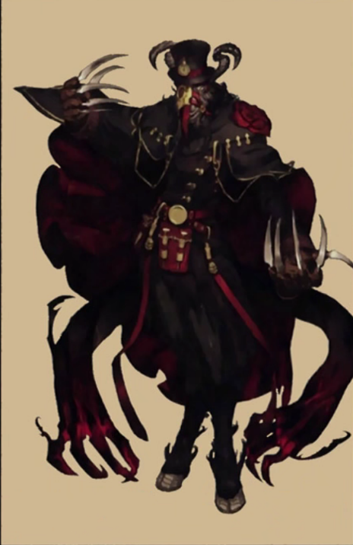
There are many symbolic features in different famous cultures that can represent evil, and this article will give examples of those that appear widely in entertainment works. Goats, in Christian folklore, represent evil, and the image of goats is closely associated with the devil Satan. A record of goat symbolization in Illustrated Encyclopedia of Traditional Symbols” Christian: The Devil; the damned; sinners; lust; lubricity. The scapegoat is Christ burdened with the sins of the world.” (Cooper, J.C,1989). And the goat's beard is much like that of a wise old man. Therefore, in modern works, goats often represent the embodiment of evil and wisdom. In the anime overlord, there is a character with the characteristics of the goat symbol, Yu Yu This character is set in the animation is a disaster of the world, representing evil and destruction of it, can use the destructive dark witchcraft. He has the head and lower body of a goat, the claws of a lizard. It is the designer who incorporates the symbolic features of goats into the character's design to make the character's appearance look intelligent and evil.
Lizards, the legendary European art of dragons inspired by lizards, are referenced by the lizard's body and bat wings because the lizard belongs to cold-blooded animals and has strong limbs, sharp claws, and armor-like skin patterns. Lizards may not be scary in people's minds, but when they are magnified hundreds of times, they give a huge sense of oppression. In European legend, dragons are evil creatures of greed and violence, often plundering resources to collect gold coins and kidnapping princesses, while nets or warriors defeat him on behalf of the righteous.
Figure 15: The role in Overlord
Bats, people's evil impressions of bats are related to vampire legends. Vampires, on the other hand, are derived from bats, which fear that light will move at night, feed on animals' blood and spread plague. So, in many literary and film works evil characters will have bat wings, just like demons and dragons in World of Warcraft.

3.7 The symbolization of power
Lions and cows represent strength. Cattle represent pure strength, brute force. And the symbolism of the lion is not only the use of force but also the political power and status. This is why the symbolic features of lions in Europe can become the badges of some royal families. According to the book The Gods of the Egyptians, in 2532 B.C., an architect designed a chimeric monster sculpture, Great Sphinx of Giza, based on the Egyptian pharaoh Khafre. (Budge, E.A.W,1969) Sphinx appeared even earlier than the word Chimera. According to the above research, it can also be proved that the symbolic characteristics of lions represent the king and power.

Conclusion
Because the aesthetic of modern people has changed in the tide of surrealism and postmodernism, so some relatively curious design in the market originally more popular, in summary, the design of chimeric monsters can be composed of different animals, plants, non-biological combinations. Most of the appearances of these creatures in early myths and folklore were made up of different beasts. In modern times due to the development of computer technology, 3D modeling technology can help designers to better use their imagination. Some designers try to combine animals with plants to design new monsters, others combine animals with machinery to design new monsters, and others disrupt biological organs and combine them in disorder to create scary monsters. Until now, computer algorithms have been used to generate large numbers of chimeric monsters in sub-era games. On the other hand, in the design of Chimera monsters, symbolic features are also a very important design concept. Because Chimera monsters are made up of different creatures, Chimera also has the symbolic characteristics of those creatures. So understanding the symbolic characteristics of living things and their implications is very important for designing Chimera monsters.

References
[1] Y Testament Newydd ; [and], the New Testament : Y Beibl Cymraeg Newydd, Agraffiad Diwygiedig. The Holy Bible, English Standard Version (2004). s.l: Cymdeithas y Beibl.
[2] Lovecraft, Howard P. (1999) [1928]. "The Call of Cthulhu". In S. T. Joshi (ed.). More Annotated Lovecraft (1st ed.). P17. New York: Dell. ISBN 0-440-50875-4.
[3] Bychkov, V.V. (2012) ‘Symbolization in Art as an Aesthetic Principle’, Russian studies in philosophy, 51(1), pp. 64–79. doi:10.2753/RSP1061-1967510103.
[4] Bacon, F. and Archimbaud, M. (1993) Francis Bacon: in conversation with Michel Archimbaud. London: Phaidon Press.
[5] Budge, E.A.W. (1969) The gods of the Egyptians, or, Studies in Egyptian mythology. New York: Dover Publications.

Bibliography
1. Bacon, F. and Archimbaud, M. (1993) Francis Bacon : in conversation with Michel Archimbaud. London: Phaidon Press.
2. Bychkov, V.V. (2012) ‘Symbolization in Art as an Aesthetic Principle’, Russian studies in philosophy, 51(1), pp. 64–79. doi:10.2753/RSP1061-1967510103.
3. Mittman, A.S. and Hensel, M. (2018) Primary sources on monsters. Volume 2, Demonstrare. Leeds: Arc Humanities Press. doi:10.1515/9781942401223.
4. Y Testament Newydd ; [and], the New Testament : Y Beibl Cymraeg Newydd, Agraffiad Diwygiedig. The Holy Bible, English Standard Version (2004). s.l: Cymdeithas y Beibl.
5. Budge, E.A.W. (1969) The gods of the Egyptians, or, Studies in Egyptian mythology. New York: Dover Publications.
6. Aguirre, M. and Buxton, R. (2020) Cyclops: The Myth and its Cultural History. Oxford: Oxford University Press. doi:10.1093/oso/9780198713777.001.0001.
7. Foster, M.D. (2015) The book of yokai: mysterious creatures of Japanese folklore. 1st edn. Berkeley: University of California Press. doi:10.1525/j.ctt14btg72.
8. Aguirre, M. and Buxton, R. (2020) Cyclops: The Myth and its Cultural History. Oxford: Oxford University Press. doi:10.1093/oso/9780198713777.001.0001.

