COMPONENT 1: REFLECTIVE REPORT
STUDENT NAME AND NUMBER: SHABANA KAUSER 2332882
MODULE TITLE AND CODE: PRINCIPLES OF HEALTH AND SOCIAL CARE PRACTICE - BMHP5016
LECTURER: PRECIOUS IGBINIGIE

INTRODUCTION
This report explores the core principles of health and social care, focusing on person centred care, partnership working and ethics. These principles are embedded with legislation, policy frameworks, and professional standards to promote care that is safe, effective, compassionate, and accountable. Current UK health and social care policy emphasises personalised, integrated and ethically accountable services (NHS England, 2019). The purpose of the report is to critically reflect on the importance of these principles, demonstrate how they are applied in real life practice, and examine how they influence professional development.
Task 1 critically reflects the importance of principles and why they are essential in health and social care practice. Discussing their benefits and challenges in practice, linking them to relevant theory and policy. In Task 2, I will be applying the principles to a real-life case study, Mrs C story (NHS England, n.d), demonstrating how they operate in practice. Task 3 using Gibbs Reflective Cycle to evaluate how these principles influence my professional role, identifying strengths and areas for development.

TASK 1: REFLECTION ON THE IMPORTANCE OF PRINCIPLES OF HEALTH AND SOCIAL CARE
Person centred care, partnership working, and ethical practice are fundamental principles within health and social care. These principles guide professional conduct, shape decision making, and contribute to the delivery of safe, effective, and compassionate services.
Person centred care refers to an approach in which individuals are actively involved in decisions about their care and treated with dignity and respect. According to NHS England (2019), personalised care enables people to have a choice and control over how their care is planned and delivered (NHS England,2019). This approach recognizes individuals as experts in their own lives, it promotes dignity, respect, and autonomy. The importance of person-centred care can be linked to the theory of Abraham Maslow and his Hierarchy of needs. Maslo suggests that individuals must have their psychological and safety needs met before progressing to psychological well-being and self-actualization (Cherry,2024).

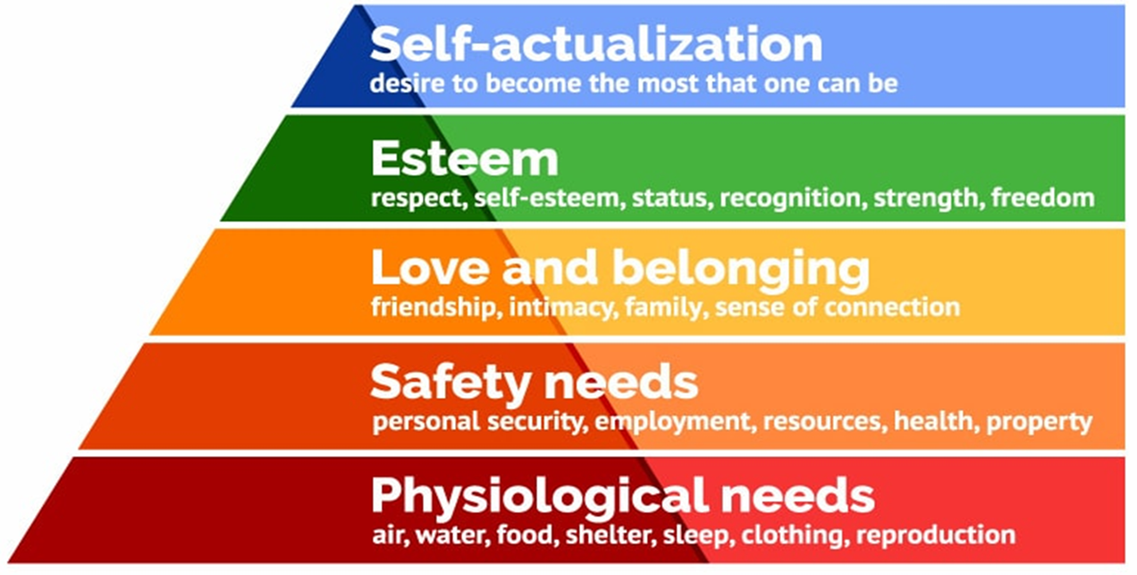
Maslow’s Hierarchy of Needs

In health and social care, meeting emotional, social and cultural needs alongside physical needs promotes holistic wellbeing. The Care Act 2014 further reinforces this by placing a duty on local authorities to promote individual well-being and independence (Legislation.gov.uk, 2014).
Partnership working refers to collaborative practice between professionals, organisations, service users and families. The Social Care Institute for Excellence (SCIE,2018) highlights that effective partnership working improves communication and coordinated care delivery. This reflects Bronfenbrenner Ecological Systems Theory, developed by Urie Bronfenbrenner, which highlights how individuals are influenced by interconnected systems such as family, community and wider policy structures (Guy-Evans,2025)
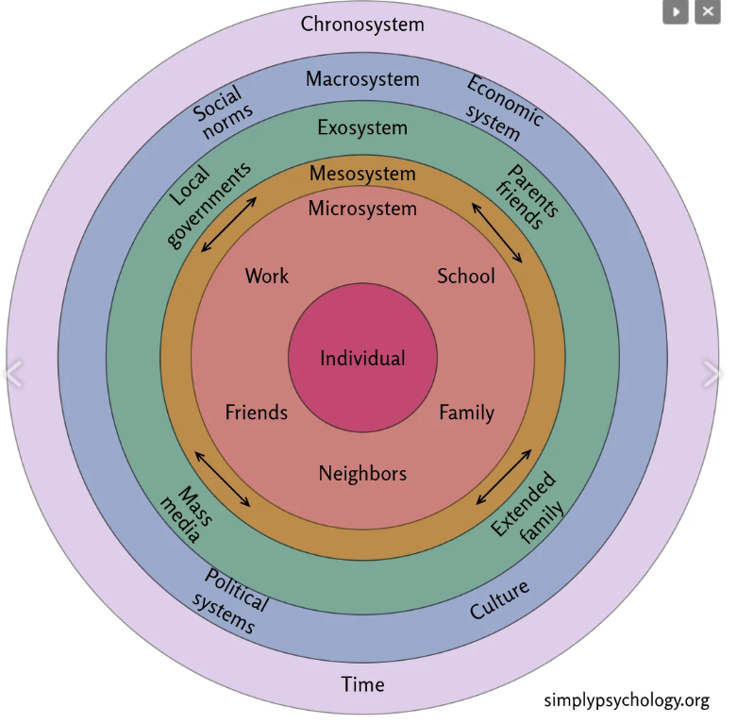
In practice, this may involve multidisciplinary teams working together to plan and review care. Partnership working is significant because many individuals have complex needs that require input from different professionals. Without partnership working, care may become fragmented, increasing risks and reducing quality. Despite its benefits, barriers such as poor communication, differing professional priorities, and organisational pressures can limit effective collaboration (SCIE, 2018). The Health and Care 2022 further supports collaborative working through integrated care systems designed to improve overall health and wellbeing for the population (GOV.UK.2022).
Ethics forms the foundation of professional decision making and ensures that care is delivered in a morally responsible and accountable manner. Key ethical principles include respect for autonomy, promoting wellbeing (beneficence), avoiding harm (non-maleficence), and ensuring fairness (justice) (Macmillan Cancer Support, 2021). The Mental Capacity Act 2005 provides a legal framework to protect individuals who may lack capacity while supporting their right to be involved in decisions about their care wherever possible (Legislation.co.uk,2005). Ethical practice therefore promotes fairness, safeguards vulnerable individuals and strengthens accountability within health and social care.
These principles are further strengthened by the 6Cs of nursing, the 6 Cs are a framework of core values essential to compassionate care, introduced by NHS England.
- Care
- Compassion
- Competence
- Communication
- Courage
- Commitment (NHS England,2015)
The 6Cs reinforce person centred care by emphasising compassionate relationships and effective communication. They support partnership working through collaborative communication and professional competence.

TASK 2: PRACTICAL EXAMPLES OF CONCEPTS IN PRACTICE
A clear example of these principles in practice is Mrs Cs story, published by NHS England. Mrs C was a widow living independently with severe COPD and advanced lung cancer. Through a personalised care plan, she received coordinated support where both her clinical needs and personal priorities were met.
Person Centred Care in Practice
Mrs C’s care focused on what mattered most to her rather than just clinical related. Person centred care was shown through shared decision making and comprehensive care planning. Mrs Cs care plan documented her treatment preferences, social needs and future wishes. This was done by shared decision-making conversations. This aligns with NHS Englands (2019) comprehensive personalised care model. Importantly, she was offered a personal health budget, enabling her to employ a trusted neighbour as a carer. This promoted autonomy and dignity.
This approach reflects the principles outlined in the Care Act 2014, which places a duty on professionals and services to promote individual wellbeing, dignity, and autonomy (Legislation.gov.uk,2014). By priortising Mrs Cs values and preferences, professionals helped her maintain control throughout her illness. This demonstrates how person centred care enhances confidence, independence, and overall quality of life.
Partnership Working Across Services
Partnership working was central to Mrs C’s care. Her personalised care plan was shared across services, including her GP, community nursing team, respiratory and oncology specialists, ambulance services and out of hours providers (NHS England,n.d). This coordinated communication ensured continuity and reduced the risk of fragmented care. This reflects NICE (2018) guidance promoting integrated support.
In addition to this, Mrs C was connected to social prescribing services, which included community activities, shopping assistance, and digital technology support, to reduce isolation and enhance social engagement. This supports the Care Act 2014 to promote wellbeing. It also demonstrates collaboration between health professionals, community services and voluntary organisations, this reflects integrated care established under the Health and Care Act 2022, which aims to improve population health outcomes through coordinated services (Legislation.gov.uk,2022).
Ethical Decision Making
Ethical standards guided the care provided to Mrs C. She was supported to make informed decisions about treatments, resuscitation preferences and symptom management options. Her autonomy was respected, and she was empowered through a personal health budget to employ a trusted neighbour as a caregiver rather than accept unfamiliar agency carers (NHS England n.d).
This complies with the Mental Capacity Act 2005, which promotes supported decision making and protects individuals who may lack capacity while maintaining their rights wherever possible (Legislation.gov.uk,2005). By respecting her wishes and ensuring clear and consistent communication, professionals upheld the ethical principles of autonomy, beneficence, and non-maleficence.
Impact and Challenges
The impact of this personalised, collaborative, and ethical approach was significant. This resulted in improved confidence, greater independence, and enhanced social connections for Mrs C. However, delivering such comprehensive care requires time, effective professional communication, and adequate resources. In practice, workforce pressures and service demands may create challenges in applying these principles in practice.
Overall, Mrs C’s story shows how person centred care, partnership working, and ethical decision making enhance quality, integration and patient satisfaction with health and social care practice.

TASK 3: SELF-REFLECTION AS A HEALTH AND SOCIAL CARE PROFESSIONAL 650 words
Using Gibbs Reflective Cycle (1988). I reflect on how person centred care, partnership working and ethical practice influence my daily work as a health and social care professional.
Description
I saw a patient who had recently been diagnosed with type 2 diabetes. During the consultation, the patient appeared overwhelmed, anxious and emotionally detached from self-management advice. She avoided eye contact and gave very little responses when discussing dietary changes and blood glucose monitoring. It became obvious that the emotional impact of the diagnosis was preventing her from engaging fully with the clinical information provided.
Feelings
Initially, I felt concerned that the patient was not taking the advice and worried that they might leave feeling unsupported. I recognised that focusing solely on the clinical side such as HbA1c targets would not address their emotional distress. I felt it was important to take my time during the consultation so i can prioritise reassurance and understanding the patient. Reflecting on the situation afterwards, I felt more confident that my approach aligned with professional standards and person centred values.
Evaluation
I applied person centred care by actively listening and encouraging the patient to express their concerns about their diagnosis. I used open-ended questions (descriptive detailed answers) to understand what the condition meant for them personally and explored any fears they had about long term complications. This approach aligns with the Nursing and Midwifery Council (NMC) Code, which requires professionals to treat people as individuals, respect their dignity and involve them in decisions about their care (NMC,2023).
I applied partnership working by collaborating with the GP and making a referral to a dietitian to ensure coordinated and consistent advice. Effective multidisciplinary teamwork is essential to avoid fragmented care and is supported by guidance from the Social Care Institute for Excellence (SCIE,2018), which highlights the importance of integrated working to improve outcomes. Through this collaboration, my patient received holistic support addressing both medical and lifestyle needs.
Analysis
Maslow's hierarchy of needs (1943) helped me understand that psychological reassurance and emotional security must be addressed before the patient could focus on lifestyle changes. If anxiety remains unresolved, engaging with self management strategies may be limited. This reinforces the importance of recognizing emotional wellbeing as part of holistic care.
Ethical principles also guided my practice. Respect for autonomy required that i provide clear information and support informed decision making without imposing my own views. The Care Act 2014 emphasises promoting wellbeing, including emotional and phycological aspects (Legislation.gov.uk,2014). In addition, the mental capacity act 2005 protects individual's rights to make their own decisions and ensures consent is obtained appropriately (Legislation.gov.uk,2005). By ensuring confidentiality and shared decision making I upheld accountability and professional integrity.

However, this experience highlighted areas for improvement. I felt less confident contributing during multidisciplinary team (MDT) discussions, particularly when presenting patient concerns. I recognized the need to strengthen my understanding of policies and evidence-based guidelines to increase my confidence and leadership within a collaborative setting.
Conclusion
This reflection highlighted that effective care is built on strong relationships, collaborative practice, and an ethical foundation. My strengths include empathy, clear communication, and commitment to dignity and respect. Adapting my approach improved patient engagement and demonstrated the value of person centred practice. However, I also identified areas for development, particularly in building confidence in MDT meetings and expanding my understanding of relevant policies and legislation.
Action Plan
To enhance my professional development, I will:
- Engage in continuing professional development (CPD) on diabetes management.
- Regularly review NICE (2018) guidance and CQC (2023) standards to strengthen evidence based practice.
- Strengthen communication abilities to advocate more confidently and effectively on behalf of patients.
- Engage in mentorship opportunities to enhance my confidence when participating in MDT discussions.
- Continue reflection using the Gibbs model to support continuous improvement.

CONCLUSION
Person centred care, partnership working and ethical practice form the foundation of high-quality health and social care. Theoretical frameworks such as Maslow’s Hierarchy of Needs and Bronfenbrenner’s Ecological Systems Theory provide understanding into holistic care, while legislation including the Care Act 2014 and Health and Care Act 2022 embeds these principles within the statutory requirements. The case of Mrs C’s demonstrates how these principles improve real world outcomes. Through learning from experiences and continuous professional development, practitioners can enhance their competence and contribute to safe, integrated, and compassionate services.

REFERENCES
Cherry,K. How Maslow’s Hierarchy of Needs Explains Human Motivation. [online]. Available at: https://www.verywellmind.com/what-is-maslows-hierarchy-of-needs-4136760 (Accessed: 19/02/2026)
GOV.UK. (2022). Expected ways of working between integrated care partnerships and adult social care providers. [online]. Available at: https://www.gov.uk/government/publications/adult-social-care-principles-for-integrated-care-partnerships/expected-ways-of-working-between-integrated-care-providers-and-adult-social-care-providers (Accessed: 23/02/2026)
Guy-Evans, O. Bronfenbrenner’s Ecological Systems Theory. [online]. Available at: https://www.simplypsychology.org/bronfenbrenner.html (Accessed: 20/02/2026)
Legislation.gov.uk (2005). Mental Capacity Act 2005. [online]. Available at: https://www.legislation.gov.uk/ukpga/2005/9/contents (Accessed: 23/02/2026)
Legislation.gov.uk (2014). Care Act 2014 [online]. Available at: https://www.legislation.gov.uk/ukpga/2014/23/contents (Accessed: 20/02/2026)
Legislation.gov.uk (2022). Health and Care Act 2022. [online]. Available at: https://www.legislation.gov.uk/ukpga/2022/31/contents (Accessed: 26/02/2026)
Macmillan Cancer Support (2021).Ethical decision making. [online]. Available at: https://www.macmillan.org.uk/coronavirus/healthcare-professionals/ethical-decision-making (Accessed: 23/02/2026)
NHS England (n.d) Mrs C’s story. [online]. Available at: https://www.england.nhs.uk/personalisedcare/comprehensive-model/case-studies/mrs-cs-story/ (Accessed: 20/02/2026)
NHS England (2015). Introducing the 6C’s. [online]. Available at: https://www.england.nhs.uk/6cs/wp-content/uploads/sites/25/2015/03/introducing-the-6cs.pdf (Accessed: 23/02/2026)
NHS England (2019) Universal personalised care. Available at: https://www.england.nhs.uk/publication/universal-personalised-care/ (Accessed: 19/02/2026)
Nursing & Midwifery Council (2023). Read The Code online. [online]. Available at: https://www.nmc.org.uk/standards/code/read-the-code-online/ (Accessed: 27/02/2026)
SCIE (2018). Multidisciplinary Teams: Integrating care in places and neighbourhoods. [online] Available at: https://www.scie.org.uk/integrated-care/multidisciplinary-teams/ (Accessed: 20/02/2026)
The University of Edinburgh (2024). Gibbs 'Reflective Cycle. [online]. Available at: https://reflection.ed.ac.uk/reflectors-toolkit/reflecting-on-experience/gibbs-reflective-cycle (Accessed: 26/02/2026)

