Paula Smith 1903588. HPAR6012. Due Date 22nd Dec 2024.

(Re)presenting and (Re)constructing the Past.

Portfolio.

My interpretation of this assignment is the combination of exploring theoretical concepts concerning re-presentation of archaeology including multi-narratives from the past, with my creation of an innovative piece of work that demonstrates this.
Archaeology is a way of thinking about the past as well as the scientific recording of artifacts, working on what remains and translating them into something tangible- bringing ghost-like signs of what was once present and re-presenting them to the future. Threats to the material past and managing the loss due to modern development is a constant challenge, including recording the mundane, without which there is no sense to be made of these past human lives .
What is chosen to be recorded and preserved is always a selective process, with values attributed not inherent . In 2011 the United Nations High Commission for Human Rights reporting on their investigation included cultural heritage as a right. Adopting a human rights-based approach appreciates cultural diversity, cultural heritage as well as human rights. Broadening the concept to include things we are not proud of but need to learn from, as well as aspects that give a sense of dignity, worth and identity as a community is important. Also, consideration of who makes the decision about what is significant, Councils, Governments or the local community - and if the latter, how do we decide who these people are?

A creative project.
The choice of creative project initially seemed difficult. Should it be the Pillbox in Lampeter- the start of my interest in the history of the town and particularly its role in the Second World War? Now a sheep shelter, I could make it in wool, felted or knitted it would be within my capabilities and might even look good.
However, the news about undergraduate teaching being moved away from Lampeter University, diminishing the campus and certainly depleting the human presence in the institution to a skeleton crew, has been evocative. My own reaction included, there is a lot of active distress. This seemed an obvious choice for exploration.
More common in times of war Reactive Heritage is a response to disaster. In war the architecture can be targeted to erase the history of associated people, the remnants of the past carrying forms of identity and memory. The material reality of the campus is not under threat of dramatic destruction, but one of decay and neglect over many years. It is the cultural heritage here that is at risk of being neglected and allowed to fade away.
Choosing a Reactive Heritage approach to this rapidly evolving situation as the focus of my creative piece, has been led by the response of the wider community. The ending of undergraduate teaching at this University means different things to different people. The current students and staff are having our daily lives changed, while the old alumni are mourning happy times from when the campus was at its height, and the local town is concerned over lost trade, employment and educational opportunities for themselves and their children. This multi-narrative will be difficult to distil in a coherent way.
Using a Deep Mapping approach will capture more than the tangible material history, by including the dreams and hopes of the community within and surrounding the campus . To do this, an exploration of the history is needed, as well as an awareness of the meaning this University holds for those currently involved and those still alive who have a relationship with it.

The response from the community surrounding Lampeter University has come from several directions. Within the campus, when the voluntary redundancies were offered to the lecturers, many took the opportunity to leave, seeing the unhappy prospect of yet more cutbacks ahead. The staff were told enough had taken the offer to stabilise the situation. Then the news of the teaching moving to Carmarthen was released to staff and students at the same time- mid lecture. This really unsettled everybody. Severance pay was then offered, followed by individual meetings with non-teaching staff offering jobs in Carmarthen or redundancy. One person even offered Birmingham or London as there was no job for him in Carmarthen. This has created a community filled with shock, distress, sadness, fear, defeat. The rhythm of each move from the Vice Chancellor has chipped away resistance and demoralised the group.

Image- sad person- freepik.com.
From outside the campus, the town and regular Market in the University grounds are dismayed. It is another major loss of employment, activity and customers. Although all remember the high days when the University increased the population by 1,000 people, and have been very aware of the decline, this news is a big blow.
Online, The Lampeter Society, of old alumni who have reunions and an active online presence, have become the organisers of protest . A Demonstration on the 20th December 2024 inspired 100 people to march through town and rally at the old Porters Lodge- now the Museum .
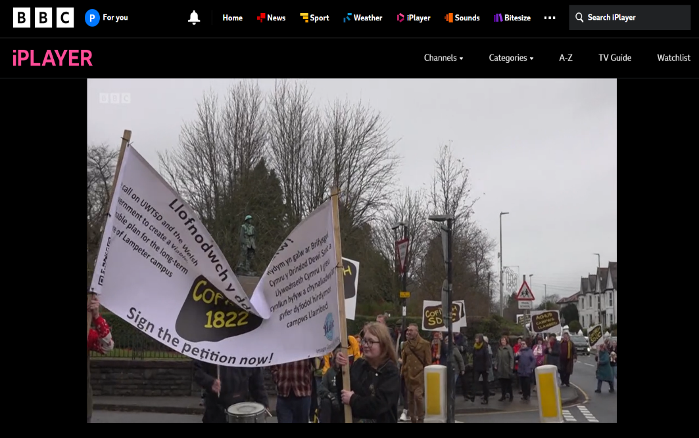
BBC evening news 20th Dec. 2024.
https://www.bbc.co.uk/iplayer/episode/m00265g7/bbc-wales-today- evening-news-20122024
The petition to the Senedd currently stands at over 3,200 signatures, and is aiming for 10,000-
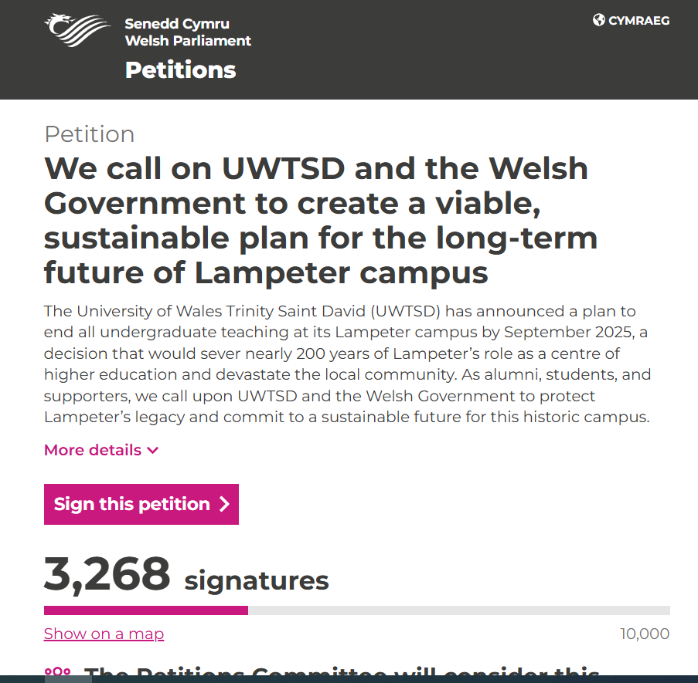
https://petitions.senedd.wales/petitions/246410
The campaign image was first designed by Haf, an ex-student, on mugs she sold at the fair- and it has now become THE image of protest-

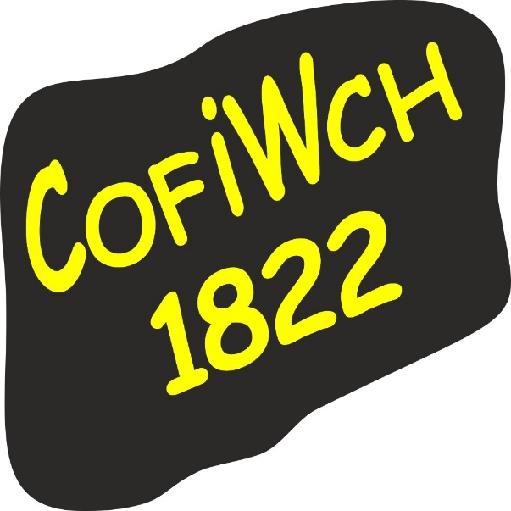
Image courtesy of –
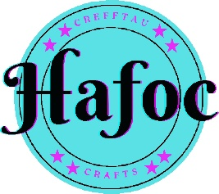

This is Lampeter history in the making, concerning the University and the town combined. United by opposition to the planned move, in the face of probable failure to prevent it. The idea to ‘not go quietly’, and hope for assurance for the town for a viable alternative that will serve this community, persists.
However, although digital media has the ability to survive in the ‘cloud’ for ever, there is currently no proposition for any permanent memorial to the importance of this little University. The events this week and those planned will be recorded in data in the ‘cloud’, experience, memory, and fable- but this is ephemeral. Important, but subject to natural decay and surrender to whatever the future holds.

Presence in absence.
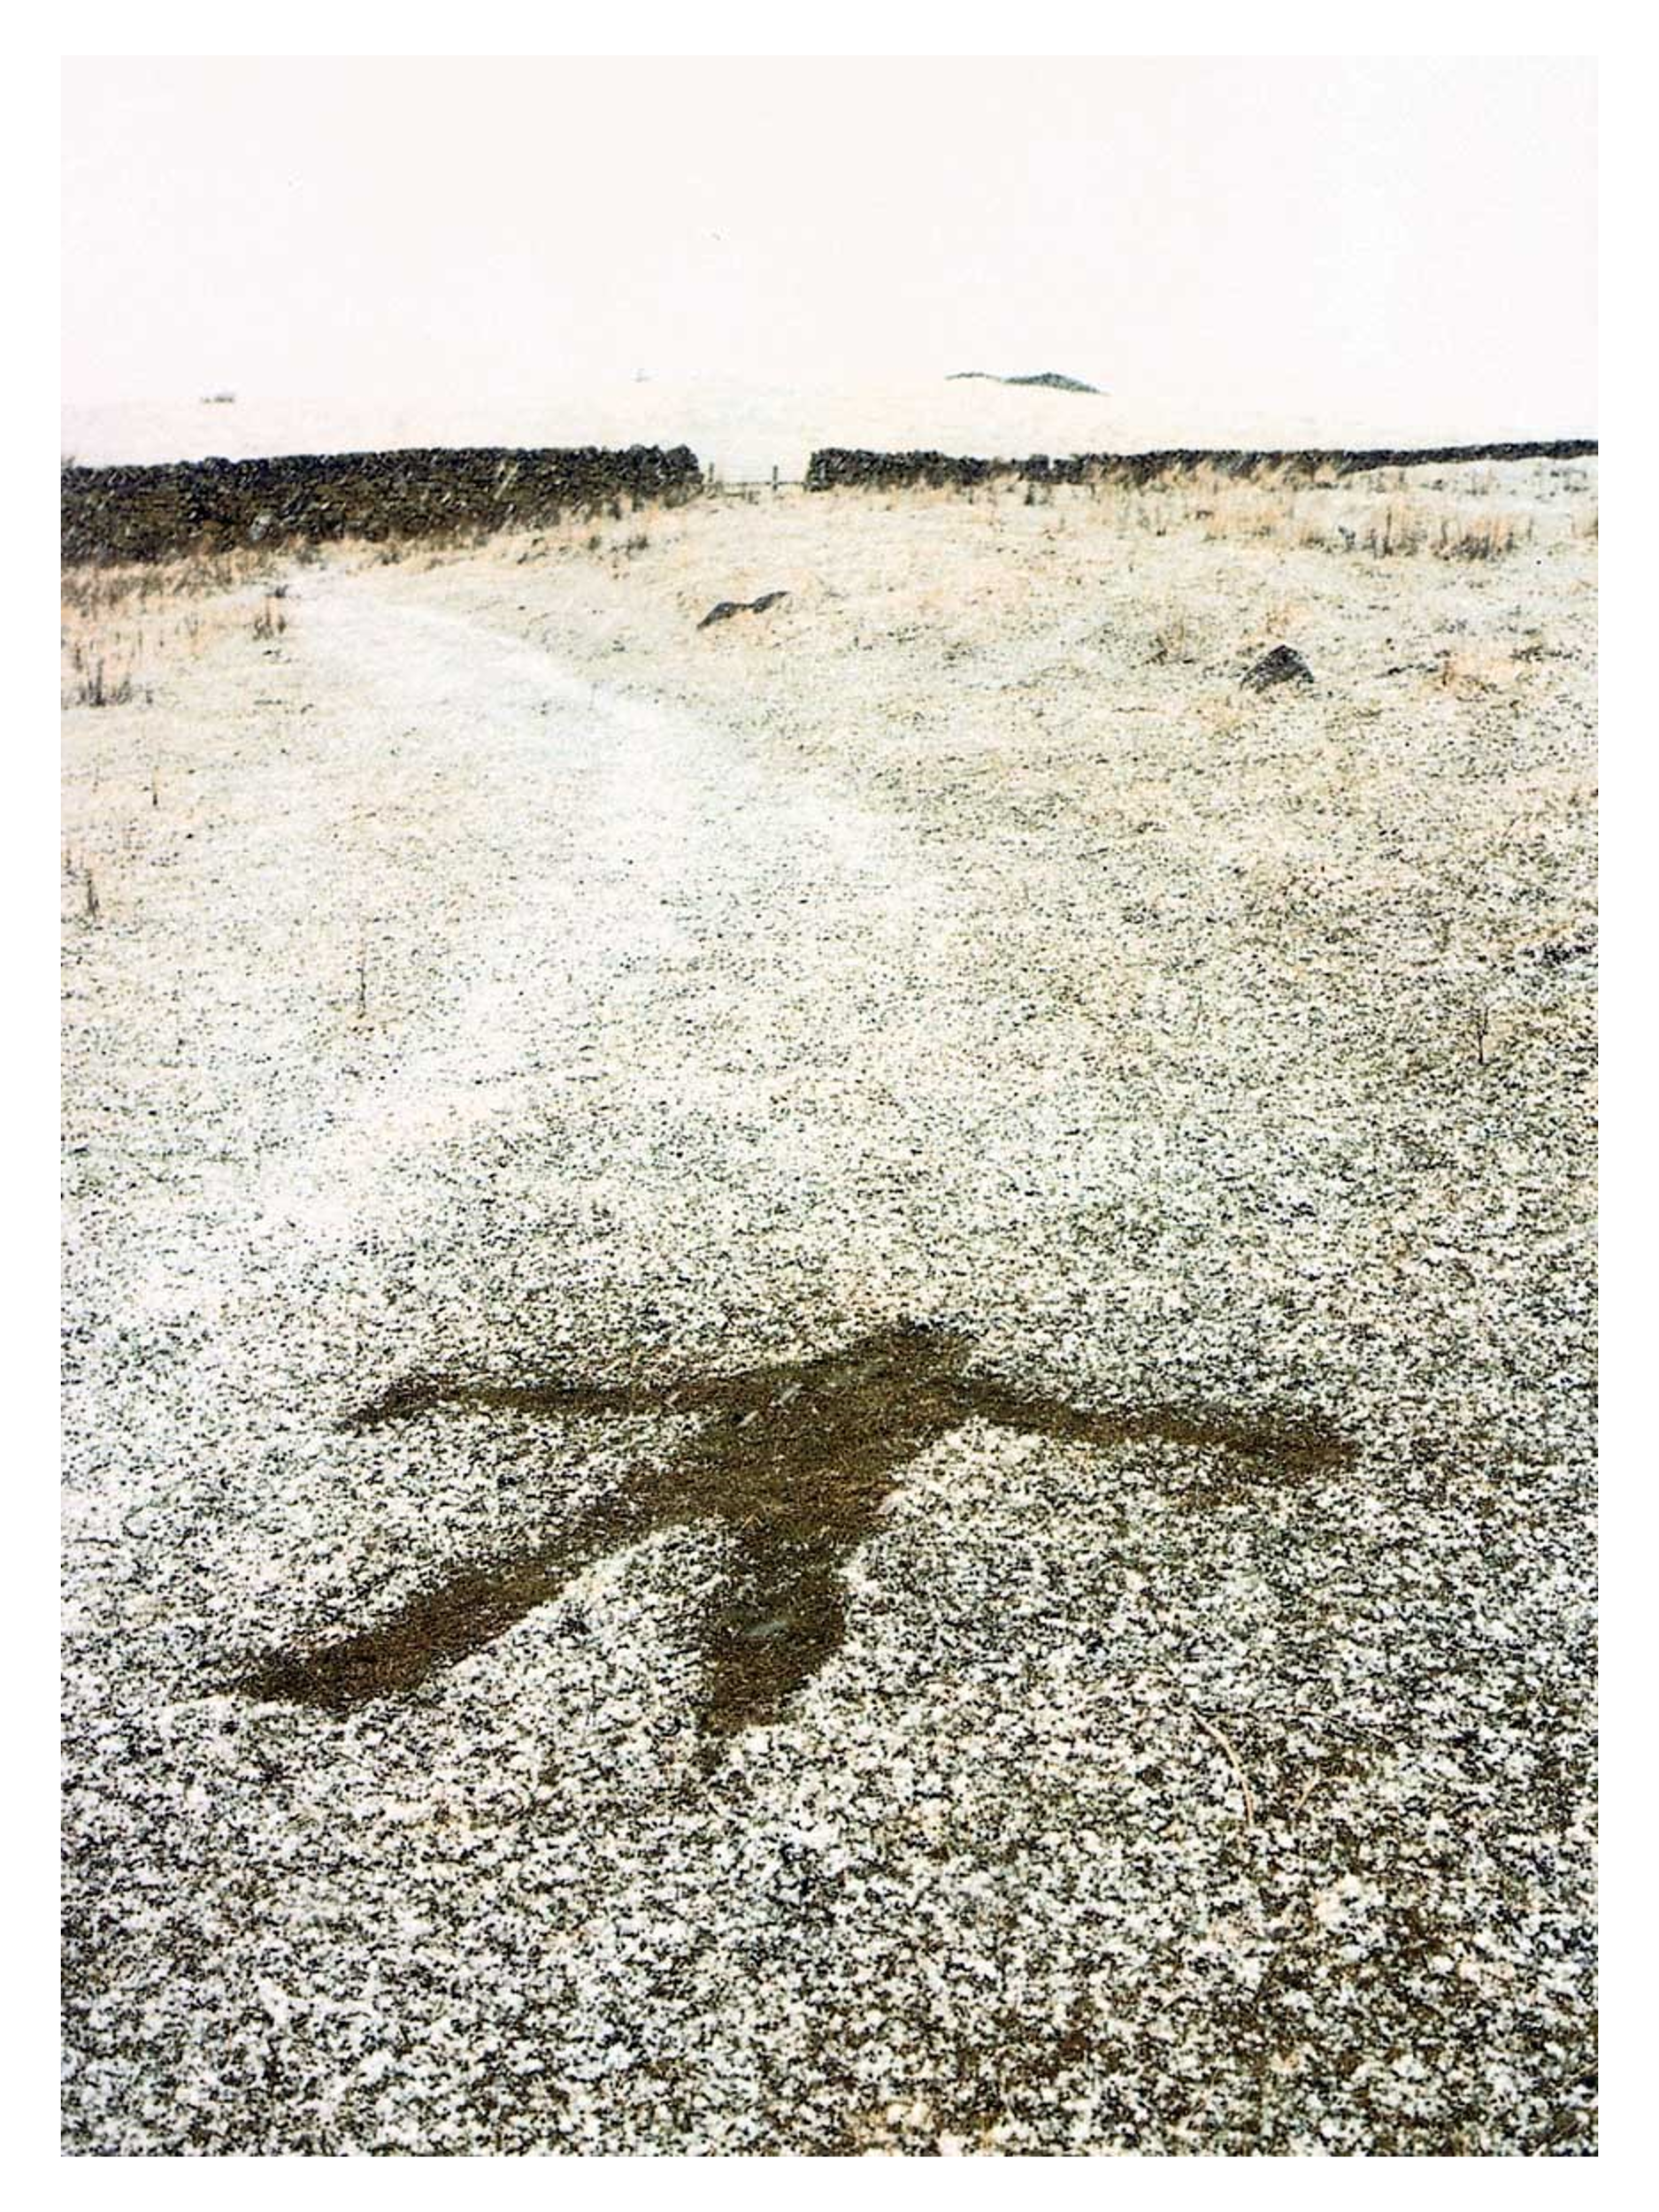
Andy Goldsworthy. Beneath the surface.
Andy Goldsworthy explored the idea of the ephemeral traces we leave behind in the landscape, in “collaboration with nature” and including the returning of his art to nature as it evaporates/melts/disperses with time . Interested in the concept of decay and examining the state of change within nature, things not just being, but being in time .
Much of the excitement and activity in response to the University news will disperse and leave little trace, other than in memory and online. In the physical reality of Lampeter town, time will move on, and the campus may be left to decay further or be re-used for another purpose without reference to the past. A physical, permanent memorial would provide a focus for the narrative of an historic place of learning. This might relate to the presence and traces left behind by the current occupants of the campus, including any traces left by planned events in the future as the last graduation ceremony appears on the horizon. The inevitable death and decay being part of the life cycle of the natural world.
However, the cultural heritage of this University and its relationship with the town that has grown alongside it, I feel is important. It should not be allowed to evaporate with the sunrise or be submerged by whatever is to follow.
Considering Heritage to be a future-making practice we need to consider what the future might be like. We cannot assume it will be the same as today, particularly with the current plans afoot, and no knowledge of what might follow for the campus. It might not be valued in the same way and what emotions it evokes will change.

What are Heritage Futures and why do they matter? Science Animated. YouTube. https://www.youtube.com/watch?v=CkTfudU1Crk&ab_channel=ScienceAnimated

This perspective led me to think of the campus, minus the students and staff, as a deserted landscape. Is there a need for a permanent monument to the history of the University, and how will the rich history of thousands of people whose lives have been changed by studying and working here, be captured and communicated to the future?

Monuments are often intended to impress and dictate a response, the narrative being clear and unchanging, whereas a counter- monument invites a critical reflection and is therefore more nuanced. An ambition to include as many perspectives as possible within one monument indicates an approach which will allow for a personal response, which will continue to evolve and communicate into the future.
A multi-narrative approach may include -
A Testimonial Book, in physical form in what remains of the University- possibly in the Archives, as these will not be moving (however they will only be open by appointment) or in the Museum ( but this is only open in the summer on certain days)- and online where more space for lengthy narratives can be made.
A commemoration day each year, which could be led by different stakeholders each year. For example, the old alumni through the Lampeter Society, the local teenage mountain bike riders who currently pester the Porters with their antics, the childcare groups and individuals who use the grounds as a safe play area. A central plinth or procession arrangement could be added to by each group each year. A commemoration day would ensure the upkeep of the monument at least yearly.
Creating a monument that communicates heritage should be consultative, connecting people with their own heritage . Consultation may provide information that was not known, and whatever the result, when people have had a voice in the making, they are more likely to have a sense of ownership. A studio in Washington DC has provided inspiration for both the final monument and the process of making it , their vision being to promote glass as a sculptural medium for private and public domains, with objectives including community education and involvement.

Choosing a monument.
A few options presented themselves to me- silhouettes of students walking across the grass, a murmuration of mortar boards thrown into the air (1 and 2 below)- but both only really represented the student experience. The glass monuments from Washington Glass Studio inspired some ideas of a panel or archway I felt worth exploring.

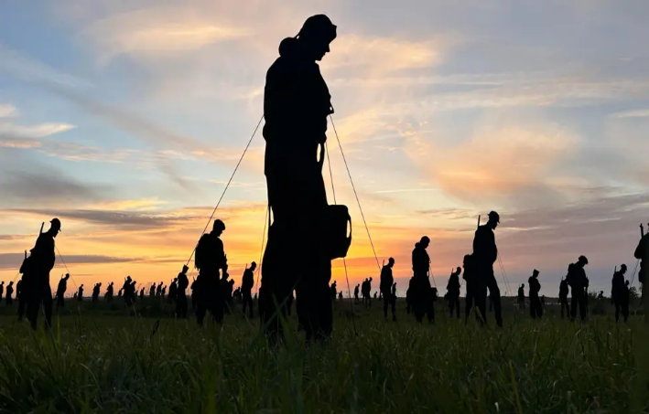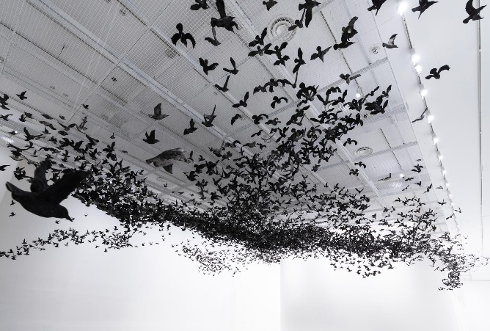
1 2
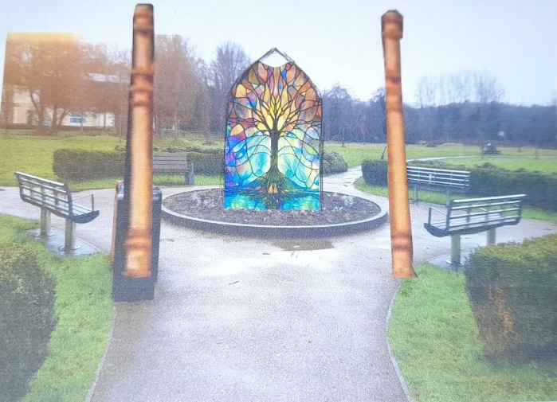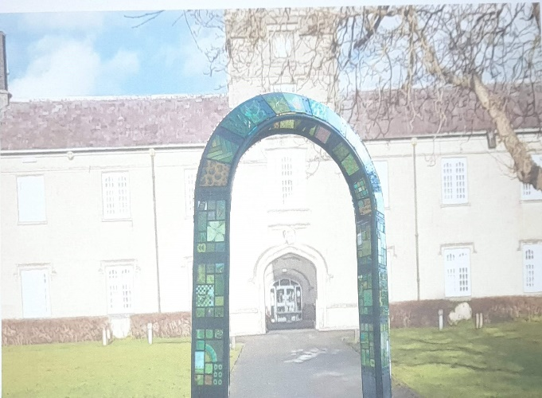
3 4

I settled on glass, which has the ability to hold detail and be dramatic from afar(3 and 4 above) such as the Arch at Unity Healthcare constructed with the community in Washington DC (4).
Stained glass is also beautiful. The desire to create beautiful things is as “old as human society” says Marian Noga (2018) and confers a cultural value which will convey the importance of what is being lost and the necessity of a pathway to opportunity so much needed by this community.
Location.
The location of a monument can influence its power and communicate its importance in relation to its surroundings. As the meaning and surroundings will be subject to change through time, the placement needs to be considered in relation to other memorials, buildings, and the flow of people and traffic. It involves considering the emplacement of the memory within a broader cultural landscape .
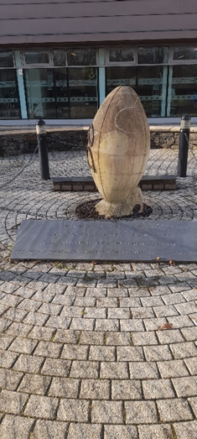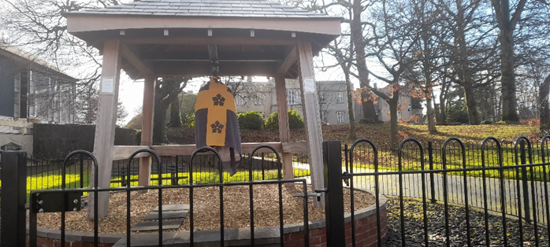
Other monuments on the campus.
As we do not know what will become of the campus, this is particularly difficult. The obvious choice would be near the Old Building, as the original College and oldest building on the site, but the material upkeep of the building might not be relied on. Stephens Castle, the medieval Motte is older, so should a monument go on top of this? Protected by Coflein as a scheduled monument this might not be possible . Otherwise, the area currently most used by the public is the park by the river- would this be the best place for a monument? Using the ‘roundabout’ flower bed already served by seating and solar lighting, this area already has a public function as a place of meeting and reflection.
Possible placement-
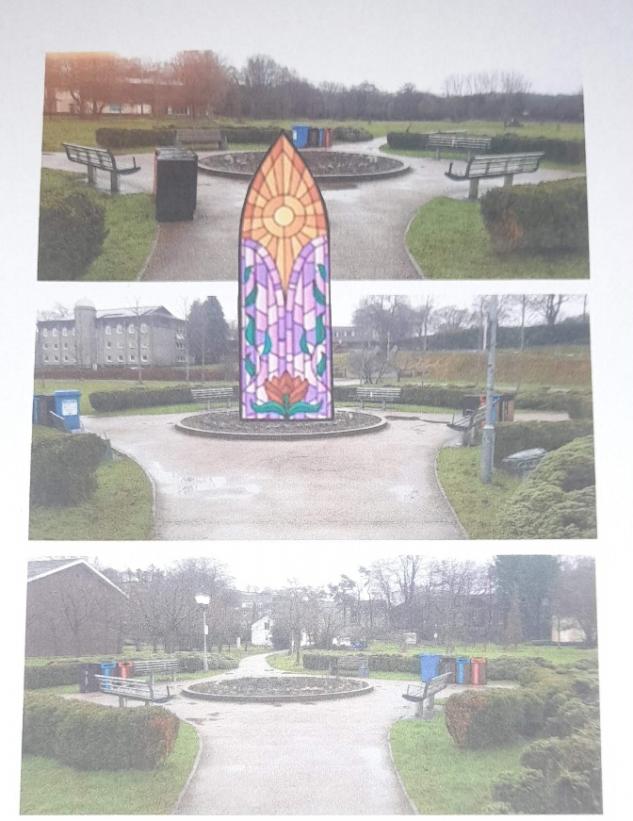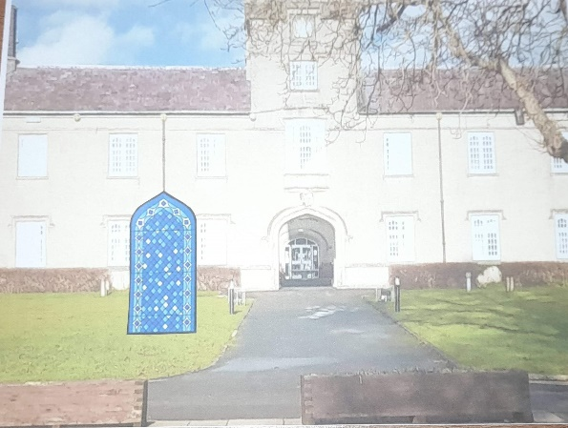
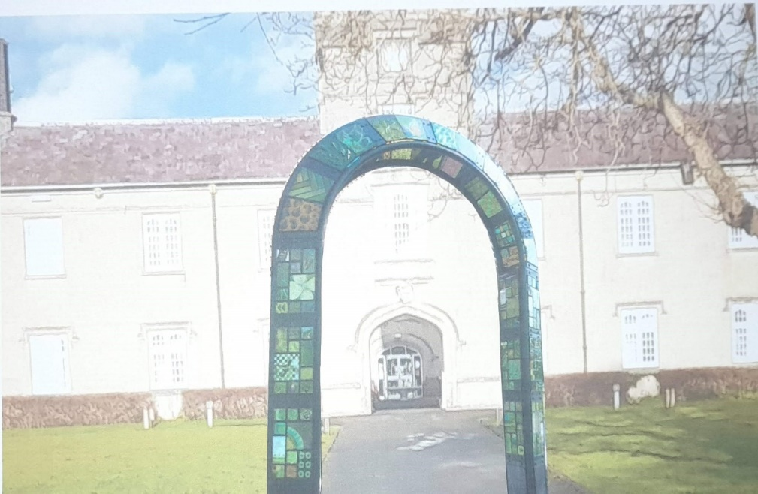

The image.
I want the design to incorporate as much of the backstory as possible, as well as representing the expansion and effect of the University, and expressing a projection of hope to the future. Having a community led focus, the opportunity for various stakeholders designing individual panels for inclusion will give the finished monument a patchwork appearance. If set in an expanding surround, on a plinth or along a processional path through a gateway, within a spiral garden with room for additional plaques, future stakeholders can ‘buy-in’ to its ongoing creation.

These ideas are explored in the workbook also submitted. It addressed-
Why is Lampeter here?
Why was the University built here?
What effect has that had on the Town?
What effect has that had on the world?
How the courses offered expanded and contracted as time passed.
A projection in hope, for the future.

The monument itself-
I could not get away from a tree image, representing the deep roots and spreading effect of the University in the town, and in its place in the world. A gateway for Welsh students to access higher education, linked to Oxford and Cambridge Universities, those disadvantaged by geography or finances were given a path. Scholarships to the grammar school, College and English Universities were part of the original mission, and this gateway is still needed today. An archway would represent this too, with a processional walk towards to Old Building would also be a good design.
The patchwork of panels would give room for stakeholder designs, and chime with the ides of a ‘patchwork of production’ for this Market town- producing cattle and horses dispatched along the Drovers Road becoming a producer of students set to explore and influence the world.

2534.
Images
Image- sad person- freepik.com. Available at: https://www.freepik.com/free-vector/flat-design-sad-person-silhouette_42112637.htm#fromView=keyword&page=1&position=1&uuid=3173d78a-ae79-48ba-9ef1-04fd524708a8&new_detail=true Accessed on 21-12-24.
Panel of possible ideas-
1- D-Day, servicemen- Normandy. https://www.bbc.co.uk/news/articles/c78dmjp357zo
2- Murmuration. National Gallery of Victoria. https://www.thisiscolossal.com/2019/05/murmuration-cai-guo-qiang
3- authors own.
4- Washington Glass Studio Projects. “Gateway To Community”. Available at: http://washingtonglassschool.com/washington-glass-studio-projects
Imposed on authors own image.
All other images not identified are authors own.

Bibliography.
Andy Goldsworthy. Britannica. 2024. Available at: https://www.britannica.com/topic/Andy-Goldsworthy Accessed on: 20-12-24.
Andy Goldsworthy. The Art Story Foundation. 2024.Available at: https://www.theartstory.org/artist/goldsworthy-andy/#:~:text=Time%20passing%20is%20the%20main,is%20the%20key%20to%20understanding. Accessed on: 21-12-24.
Bodenhamer, David J, Trevor M Harris, and John Corrigan, ‘Deep Mapping and the Spatial Humanities’, International Journal of Humanities and Arts Computing, 7.1–2 (2013), 170–75 . Available at: https://www.euppublishing.com/doi/abs/10.3366/ijhac.2013.0087 Accessed on:11-12-24.
Dyckoff, T. Let’s move to Lampeter, Ceredigion: a neat little town, if you like students. The Guardian. 6th July 2018. Available at: https://www.theguardian.com/money/2018/jul/06/lets-move-to-lampeter-ceredigion-neat-town-if-like-students Accessed on 21-12-24.
Harris, Donna Ann, ‘Book Review: Consultation and Cultural Heritage: Let Us Reason Together’, The Public Historian (University of California Press, 2015), 148–49 .Available at: https://librarysearch.uwtsd.ac.uk/permalink/44WHELF_UWTSD/1ir6fgh/cdi_crossref_primary_10_1525_tph_2015_37_1_148 Accessed on 28-12-24.
Harrison, Rodney. Heritage Futures and Future Heritages – Inaugural Lecture by Professor Rodney Harrison. 2017. Available at: Heritage Futures and Future Heritages – Inaugural Lecture by Professor Rodney Harrison - YouTube. Accessed on: 11-12-24.
Logan, William, ‘Cultural Diversity, Cultural Heritage and Human Rights: Towards Heritage Management as Human Rights-Based Cultural Practice’, International Journal of Heritage Studies : IJHS, 18.3 (2012), 231–44. Available at: https://librarysearch.uwtsd.ac.uk/permalink/44WHELF_UWTSD/1ir6fgh/cdi_crossref_primary_10_1080_13527258_2011_637573 Accessed on: 29-11-24.
Mitchell, Katharyne. "Monuments, memorials, and the politics of memory." Urban Geography 24.5 (2003): 442-459.Available at: https://d1wqtxts1xzle7.cloudfront.net/61564608/memorials_monuments_2nd_edition-libre.pdf?1576812333=&response-content-disposition=inline%3B+filename%3DMemorials_and_Monuments.pdf&Expires=1735396768&Signature=bhPkiCXQ89iX1cWfYifVWMVBC6~4LHbLQuFqd9E~WDQw5wXuLiaa4xzt3ik5AJctbbpvLs5G7j-lDFAozyNM5I9Y8xbqFzioauGUxgk2KRT31vn~YDgFmGB9rn-YWPpMs2UDOcm7enRPQoqWB7z2tRFbx6KutlmnXeCLNse3GlWDcKJ79PkUQP4~H8gg4FolhpCghFTDowvtBZu3JKq6G6hG4~GggvWUx0OF9xZKKwZjBNX9oOxfVJJ6DsPzp4DzYJXhMEVt5SzlY8mSnwbKDS~bPJzv7Gnzg7f52X5o2OqHLImGoCvkQJlWLEso65J9ou7qFBW609lCbFtDvcPrEw__&Key-Pair-Id=APKAJLOHF5GGSLRBV4ZA Accessed on: 28-12-24.
Shanks, M. (2012). The Archaeological Imagination (1st ed.). Routledge. Available at: https://www.taylorfrancis.com/books/mono/10.4324/9781315419176/archaeological-imagination-michael-shanks Accessed on: 11-12-24.
Spitz, E.H. ‘Loss as Vanished Form: On the Anti-Memorial Sculptures of Horst Hoheisel’, American Imago, 62.4 (2005), 419–33. Available at: https://librarysearch.uwtsd.ac.uk/permalink/44WHELF_UWTSD/1ir6fgh/cdi_proquest_journals_197191965. Accessed on: 22-12-24.
Stephen’s Castle, Lampeter;Lampeter Motte. Coflein. 2024.Available at; https://coflein.gov.uk/en/site/303859/ Accessed on: 28-12-24.
The Lampeter Society. Facebook. 2024.Available at: https://www.facebook.com/groups/2404221966 Accessed on 21-12-24.
The Washington Glass Studio. 2024.Available at: http://washingtonglassschool.com/studio#:~:text=The%20Washington%20Glass%20Studio%20was,artists%20working%20in%20different%20media. Accessed on: 28-12-24.
Vicente-Gilabert, C., Del Espino-Hidalgo, B., & Del Pulgar, M. L. G. (2024). Bridging Heritage and Citizens: A Methodological Consultation-Based Approach. The Historic Environment: Policy &amp; Practice, 15(2), 221–247. https://doi.org/10.1080/17567505.2024.2341360 Accessed on:28-12-24.
Xochilt, A.(2018) Heritage Preservation in War: Proactive and Reactive Approaches Applied to the Old City in Sana’a, Yemen. University of Pennsylvania. Available at: https://core.ac.uk/download/pdf/219378434.pdf Accessed on: 29-11-24.
Gateway to Community. Washington Glass Studio Projects. May 2014. Available at: http://washingtonglassschool.com/washington-glass-studio-projects Accessed on: 20-12-24.

Bibliography for image themes-
Roman Wales- https://cadw.gov.wales/learn/sites-through-centuries/roman-wales
Sarn Helen Roman road. https://coflein.gov.uk/en/site/303531/
Wales in the Dark ages- Walker, David, Medieval Wales. (Cambridge: Cambridge University Press, 1990) Available at: https://librarysearch.uwtsd.ac.uk/permalink/44WHELF_UWTSD/11c0l68/alma991297902421 Accessed on 1-12-24.
St Stephens Castle- https://coflein.gov.uk/en/site/303859
Lampeter Castle. https://www.britainexpress.com/wales/ceredigion/lampeter-castle.htm
Medieval Lampeter- https://www.dyfedarchaeology.org.uk/wp/discovery/projects/lampeter/
Full report- https://www.dyfedarchaeology.org.uk/wp/wp-content/uploads/historic-towns-2020/EPRN_125663_LAMPETER.pdf
Bishop Burgess and Coleg Llambed. https://www.academia.edu/3630382/Bishop_Burgess_and_Coleg_Llambed

Shanks, M. (2012). The Archaeological Imagination (1st ed.). Routledge.
Ibid.
Logan, William, ‘Cultural Diversity, Cultural Heritage and Human Rights: Towards Heritage Management as Human Rights-Based Cultural Practice’, International Journal of Heritage Studies : IJHS, 18.3 (2012), 231–44.
Ibid.
Xochilt, A.(2018) Heritage Preservation in War: Proactive and Reactive Approaches Applied to the Old City in Sana’a, Yemen. University of Pennsylvania.
Bodenhamer, David J, Trevor M Harris, and John Corrigan, ‘Deep Mapping and the Spatial Humanities’, International Journal of Humanities and Arts Computing, 7.1–2 (2013), 170–75 .
Pers Comms: when author was promoting the petition, 14th Dec 2024.Market and Shops.
Dyckoff, T. Let’s move to Lampeter, Ceredigion: a neat little town, if you like students. The Guardian. 6th July 2018.
The Lampeter Society. Facebook. 2024.
Andy Goldsworthy. Britannica. 2024.
Andy Goldsworthy. The Art Story Foundation. 2024.
Harrison, R. Heritage Futures and Future Heritages – Inaugural Lecture by Professor Rodney Harrison. 2017.
Spitz, E.H. ‘Loss as Vanished Form: On the Anti-Memorial Sculptures of Horst Hoheisel’, American Imago, 62.4 (2005), 419–33
Vicente-Gilabert, C., Del Espino-Hidalgo, B., & Del Pulgar, M. L. G. (2024). Bridging Heritage and Citizens: A Methodological Consultation-Based Approach. The Historic Environment: Policy &amp; Practice, 15(2), 221–247.
Harris, Donna Ann, ‘Book Review: Consultation and Cultural Heritage: Let Us Reason Together’, The Public Historian (University of California Press, 2015), 148–49
The Washington Glass Studio. 2024.
Gateway to Community. Washington Glass Studio Projects. May 2014
Mitchell, Katharyne. "Monuments, memorials, and the politics of memory." Urban Geography 24.5 (2003): 442-459.
Stephen’s Castle, Lampeter;Lampeter Motte. Coflein. 2024.

