UNIVERSITY OF WALES TRINITY SAINT DAVID
UWTSD LONDON
MODULE TITLE: Employability and Career Development
MODULE CODE: LCLM4005
TASK 1: Assignment 1 - Mock Interview Preparation Document
(CV, Cover Letter, and Job Advertisement)
STUDENT NAME: Iryna Maksymuk
STUDENT ID: 2516276
LECTURER: Vicky Giannaka
DATE OF SUBMISSION: 20 July 2026
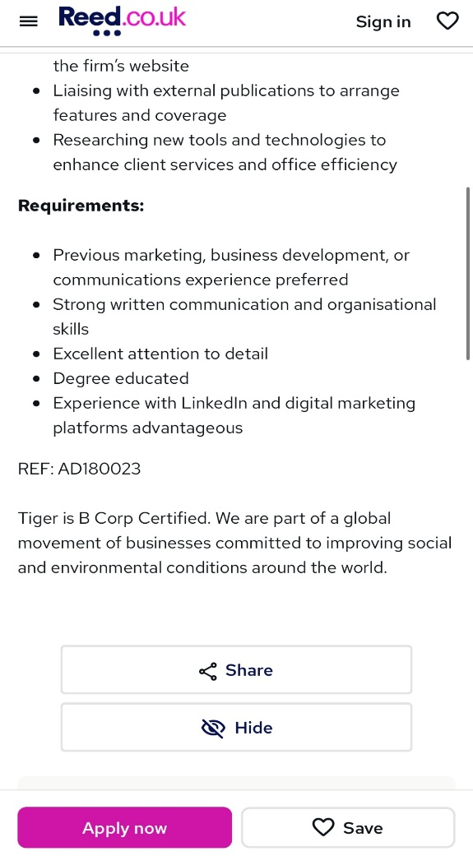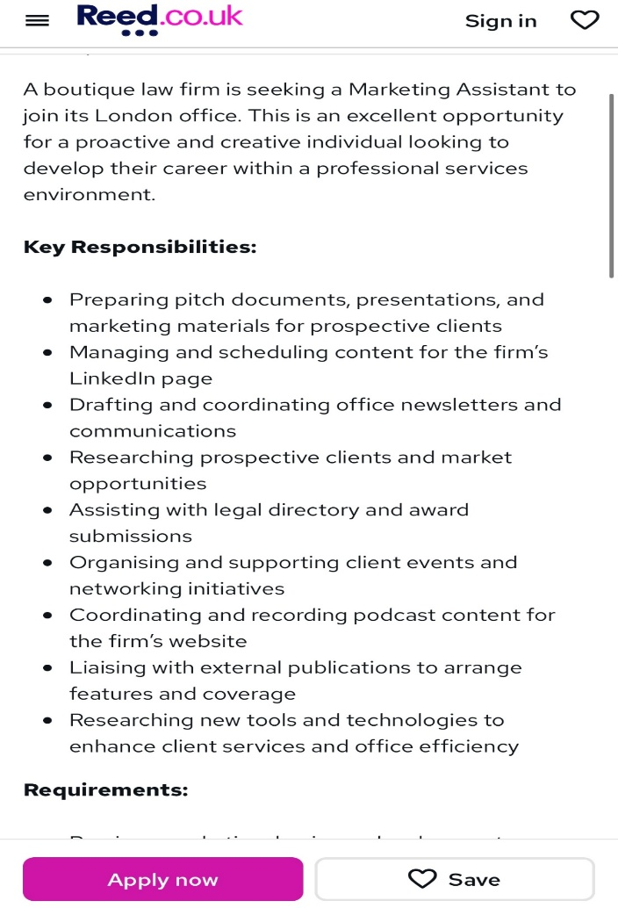

Iryna Maksymuk
London, United Kingdom
Phone: 07405299558
irinamaksumyk27@gmail.com

PROFESSIONAL SUMMARY
A dedicated and analytical first-year CertHE Business Skills for the Workplace student at UWTSD London. Possesses a strong foundational understanding of business communications, digital branding, and market research concepts. A proactive learner who independently practices content creation using Canva and studies digital platforms like LinkedIn. Seeking to develop practical corporate experience as a Marketing Assistant at Tiger Recruitment.

EDUCATION
CertHE Business Skills for the Workplace (Expected Graduation: 2028)
University of Wales Trinity Saint David (UWTSD London) | 2025 – Present
• Key Modules: Business Management, Digital Skills, Business Communications
• Academic Focus: Developing commercial awareness, professional writing, and digital workplace literacy.

KEY ACADEMIC EXPERIENCE & INDEPENDENT PROJECTS
First-Year Business Student | UWTSD London | Sept 2025 – Present
• Analysed UK business case studies during university seminars, focusing on corporate communication and market positioning.
• Practised creating professional visual materials and presentation slides using Canva to meet academic requirements.
• Studied B2B communication channels, focusing on how professional services firms utilize LinkedIn for corporate networking.
• Explored the basic principles of audience engagement and structured data analysis as part of the Digital Skills module.

CORE SKILLS
• Digital & Tech Literacy: Basic Content Planning, Visual Formatting (Canva), MS Excel, PowerPoint
• Communication: Professional Writing, Team Collaboration, Academic Research, Active Listening
• Organisation: Time Management, Deadline Adherence, Attention to Detail

INTERESTS & INDEPENDENT PRACTICE
• Digital Media & Podcasts: Actively follow professional corporate podcasts and industry trends to understand modern B2B communication strategies.
• Creative Content: Independently practice visual design and layout structuring using Canva to build corporate presentation templates.
• Professional Networking: Monitor how London-based law firms and boutique consultancies utilize LinkedIn for personal branding and client engagement.

LANGUAGES
- English (Fluent / C1)
- Ukrainian (Native)
- Polish (Elementary / Basic understanding)

Reference on request

Dear Hiring Manager,
RE: Application for the Marketing Assistant Position (Ref: AD180023)

I am writing to express my strong interest in the Marketing Assistant position at Tiger Recruitment, as advertised on Reed.co.uk. As a first-year CertHE Business Skills for the Workplace student at UWTSD London, I am eager to apply my foundational skills in digital branding and professional communication to support your team.
I specifically chose to apply to Tiger Recruitment because of your B Corp Certification. During my university seminars, I have focused heavily on corporate responsibility and market analysis. Learning that your organization is committed to improving social and environmental conditions worldwide aligns perfectly with my personal values and academic drive.
Through my modules at UWTSD London, including Digital Skills and Business Communications, I have trained myself to create clean, professional visual materials using Canva. Furthermore, I have developed a solid theoretical understanding of how professional services firms position themselves on LinkedIn. I am highly organized, attentive to detail, and ready to take on the administrative and creative responsibilities required for this role.
Thank you for your time and consideration. I look forward to the opportunity to discuss in an interview how my academic focus and dedication can contribute to Tiger Recruitment.

Yours sincerely,
Iryna Maksymuk

