Cert. HE S4BA Assignment
TURNITIN Submission
Title page.
Software applications for businesses, Valentin Stefan Mirica 2211628, course: Digital Skills CerTHE
Task 1: e-portfolio
Link to portfolio: https://valentinsmirica.weebly.com

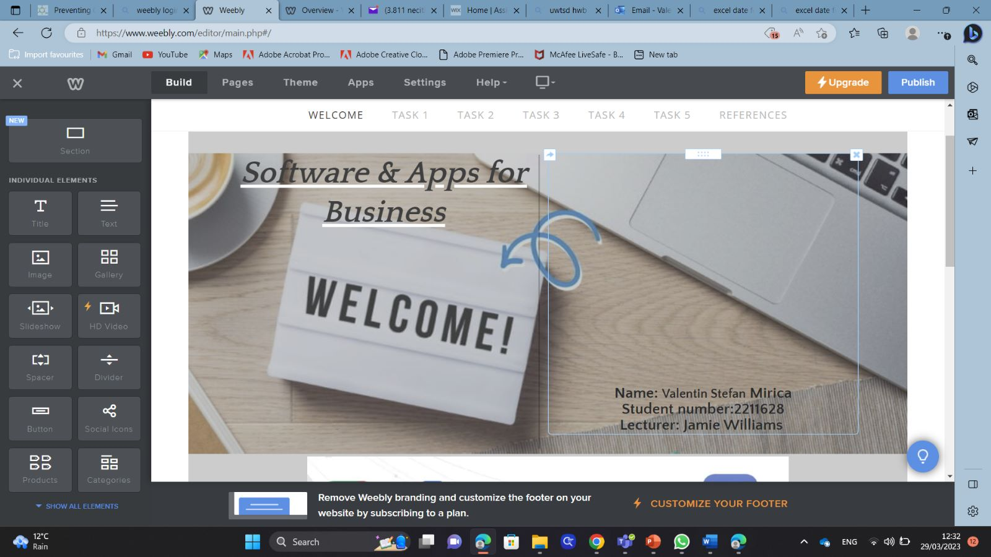Screenshots for task 1:

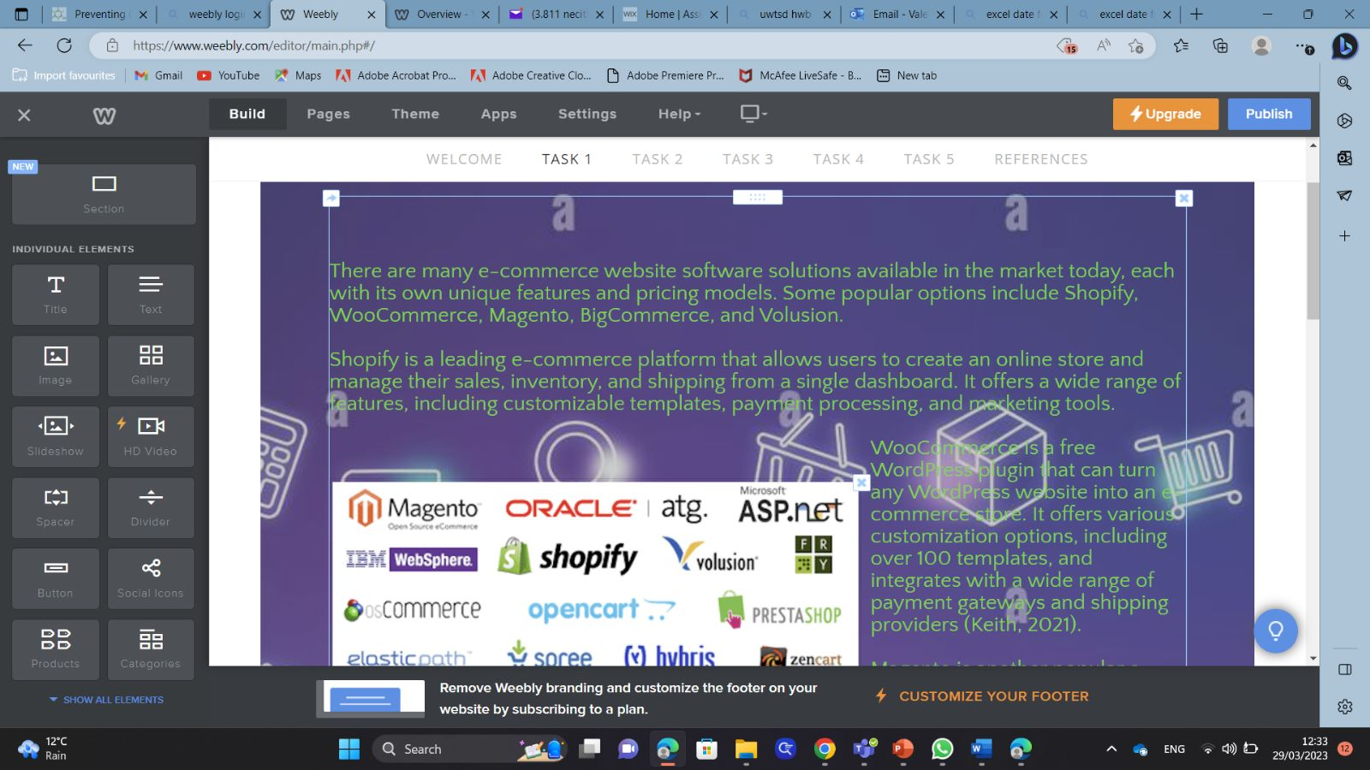

Task 2 – Mind-map
Screenshot of my mindmap:

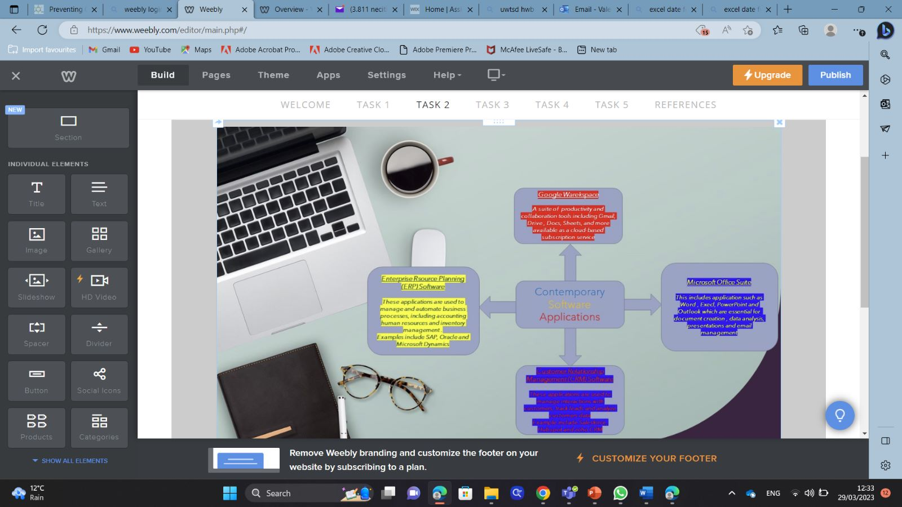
Task 3 – Office Applications.
- Include here: A screenshot of task 3a and 3b task answer. 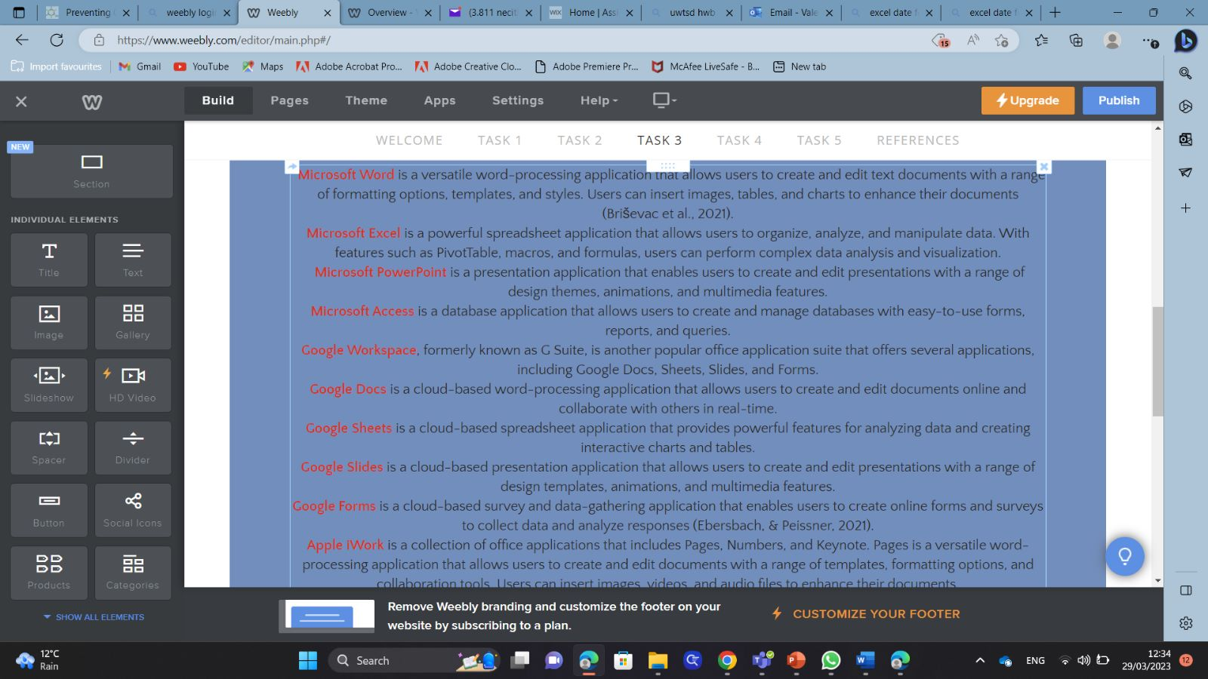

Task 4 – Digital Dashboard and Data Analytics software.
- Include here: A screenshot of task 4a or 4b task answer. 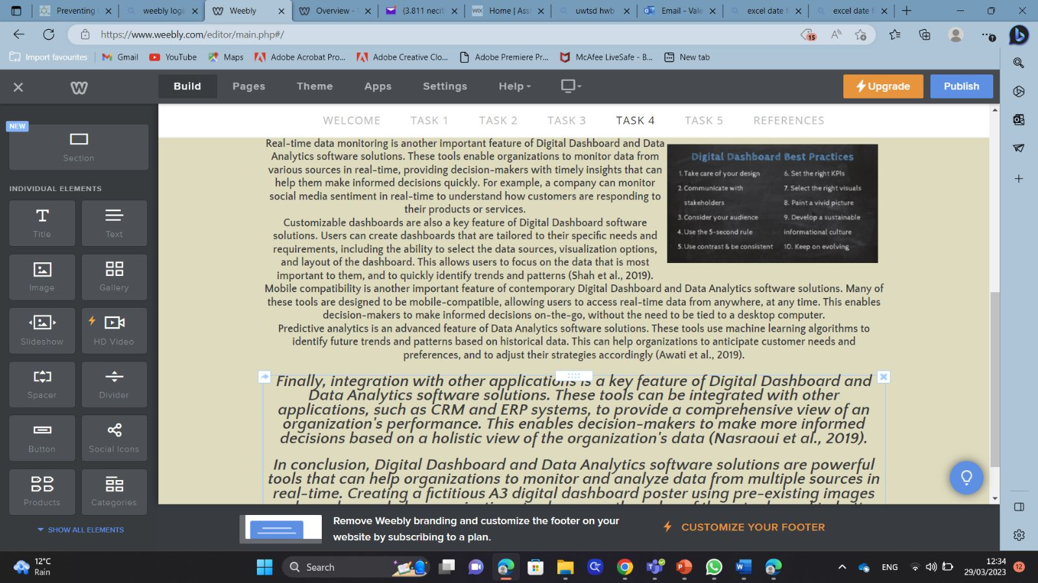

Task 5 - Communication, Collaboration & Project Management
- Include here: A screenshot of task 5a and 5b task answer. 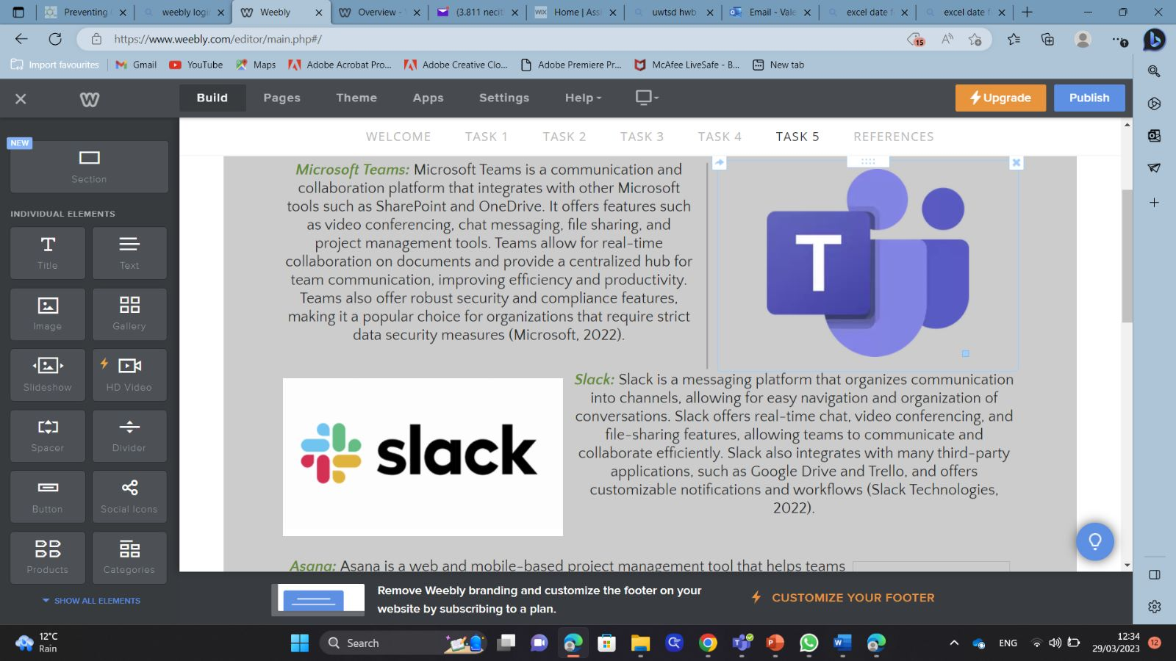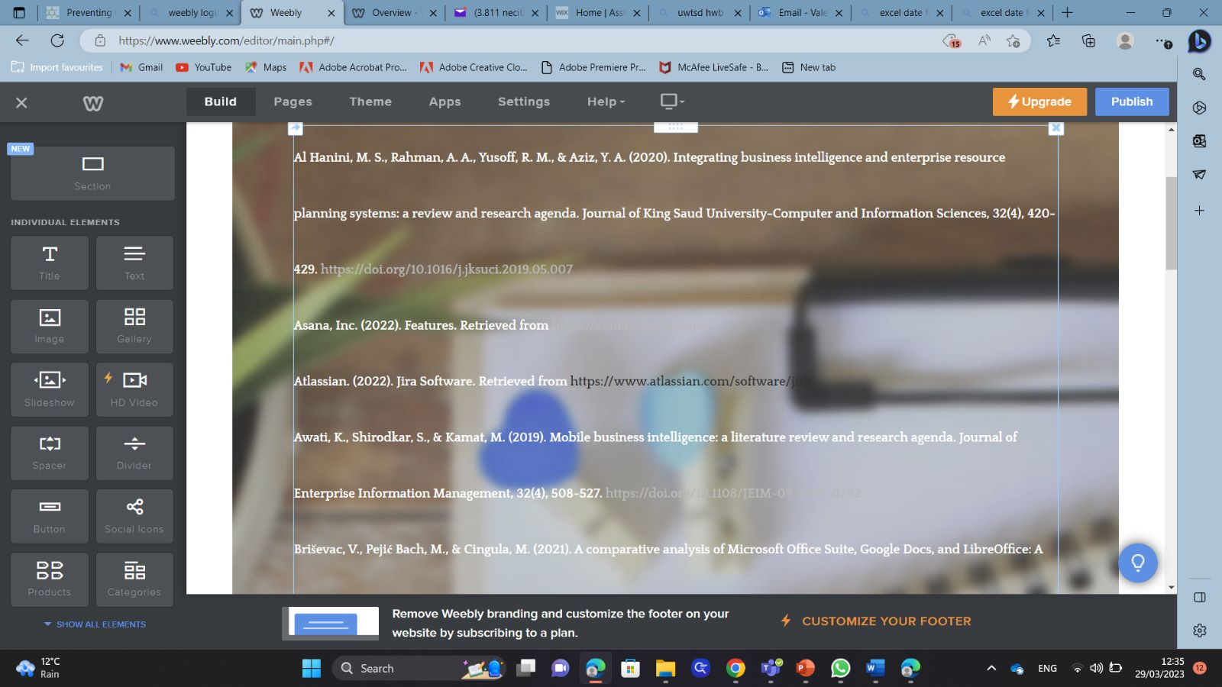

IMPORTANT LINK TEST REMINDER: to ensure your work is accessible for marking it is important to test your work can be accessed by the tutors. To do this either try opening the e-portfolio link in a private/incognito tan in a web browser or sign out of the e-portfolio and to try to open it in a web browser with the link you are providing in this document.

