LCBB4002

COMMUNITY ENGAGEMENT ASSIGNMENT-1

UNIVERSITY OF WALES TRINITY SAINT DAVID _LONDON

BURBERY’S ORGANIZATIONAL STRUCTURE AND SWAT ANALYSIS

LECTURER : TANJA NATHAN

STUDENT ID : 1815969

STUDENT NAME: ALINA IAMANDI

Table of Contents
Introduction 3
The sector in which it operates, the size, structure and explain its goals, mission, and values 4
Identify its customers and what they expect from the organization in terms of goods and/ or services. 5
SWOT analysis of Burberry 7
SWOT Analysis 7
Explain the role of the employees within the organization and how they support the organization achieve its goals 9
Explain about training and development and why this is important to organizations. 11
Select a role from your chosen organization and explain the importance of this role to the organization. 12
Explain the skills and knowledge needed to carry out the role 12
Explain what training and development requirements need to be considered. 13
Conclusion of this project over Burberry 14
References 15

Introduction
This report is focused on to the market and business analysis and evaluation of Burberry, which is a fashion brand. This report would be discussing about the sector in which Burberry is going to work, its size, mission and goals. Further this report would discuss about the positives, organizational structure of Burberry, including SWOT analysis of Burberry to understand the business of Burberry.
Further, this report would also discuss about the training and development programs which should be involved in the Burberry to improve the quality and skills of the employees. The job role and description of a particular post in Burberry would be discussed.

The sector in which it operates, the size, structure and explain its goals, mission, and values.
The Burberry has been working in the luxury fashion industry originated from London, England. The products which Burberry deals in includes fashion outwear, trench coats, etc. these are the main products upon which it is dealing. Established in 1856, Burberry has entered in the high fashion market, where it is focused upon currently. In terms of the size of Burberry, it has 9552 employees currently working in Burberry. The revenue of Burberry has been increased to 2732 euros in 2018. Burberry organization deals in perfumes, clothing’s and cosmetics.
The goals and mission of Burberry are to fulfill all the demands, and expectation of their customers. It is the objective which is set by the management of Burberry is to provide quality products and value for money products and services (Weston, 2016).
The organizational structure of Burberry organization
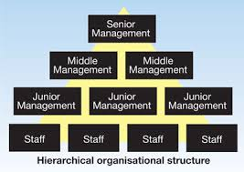
Burberry follow hierarchy organizational structure, where senior management at the top and staff working in the different brand outlets at the bottom.

Identify its customers and what they expect from the organization in terms of goods and/ or services.
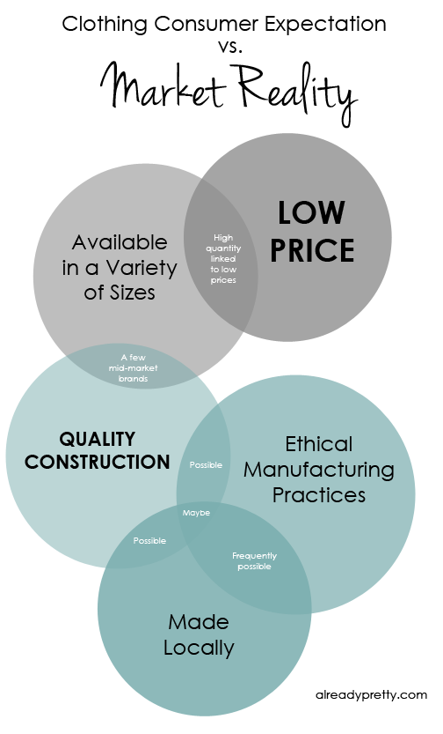

The fashion enthusiast who have the trust over the product and services of Burberry are the key customers for Burberry. Burberry also has collaboration with some of the leading outlets or retailers who are also the big customers who resell their products with their profit margins.
Customers expect from Burberry to provide value for money product with low prices. Burberry make clothes value for money, but when Their customers buy from their exclusive outlets, the prices rise hence Burberry had invested less in their outlets and more in the Product quality so that they can provide value for money products.
The customers of Burberry expect from them to sell their products on outlets like lands’ end, Talbots, which provide productive services at fairly low prices. The customers of a fashion brand like Burberry expect to have a variety of products at fairly low prices. People need to buy their complete required clothing and fashion products from one brand upon which they feel trusted. Hence it is important for a brand like Burberry to have a variety of products which a common human would need.
Burberry should focus on the cost of materials, economic climate, market segment, etc. to work towards fulfilling the needs of the customers. In some cases, it has been found out that once a product been sold consumers expect to have a good after-sales service from that brand. Hence Burberry should also focus on the after-sales services for their existing customers (Peng, 2017).

SWOT analysis of Burberry

SWOT Analysis
Strengths  - With the history of 156 long years, Burberry has remained an iconic brand and has been identified as trusted fashion brand among the customers. Burberry has been responsible to provide quality brands with high-quality fashion branding.  - Burberry is not focused on promoting its products on to Television, Burberry has remained in celebrity endorsement and hence it helped them to be different other brands.  - Burberry has a total of 500 stores all around the world, expanded in 50 countries. Burberry has a global presence and helped them to work harder. | Opportunities  - With the changing lifestyle with developing education, the developing countries have good steep demand in the premium goods and services.  - It is a good opportunity for Burberry to enter in a new market like Thailand, Egypt, Greece, etc. which are underdeveloped, penetrating such market would have a good chance of high revenue return for Burberry.  - Burberry should focus on developing a new product line or expanding some existed product line, doing so will help Burberry to be differentiated from other brands.
Weaknesses  - Burberry is dealing in the premium segment, but they are providing quality products with these high prices, but it does not help Burberry to get high revenues.  - Asian market: The subsequent changes in income and government changes adversely affect the buying behavior of consumers of Asia, hence the market of Burberry which is western brand does not able to expand much in such market. | Threats  - Competition in the fashion market is quite high, where many brands are already available hence Burberry has been facing a lot of competition, but competitiveness has increased the revenue of Burberry.  - One of the major issues which fashion brand like Burberry faces are fake companies which sell their products which sometimes decreases the goodwill image of Burberry (Shamila, 2017

Explain the role of the employees within the organization and how they support the organization achieve its goals
In the words of Sah (2018), success does not come along; it is the employees who help Company Burberry to expand and achieve their goals. employees in the companies are the units which help Burberry to achieve their goals. Big giants and companies like Burberry know how to drive and engage with the employees to achieve common goals (Sah, 2018).
The role of the employees working in an organization like Burberry is to work towards the organizational objectives and to achieve it. Employees should work according to the personal objective and organizational objectives both.
In the small business, employees have a much better chance to have a role which will affect more effectively. It is important and role of employees to be aware of the structure of the organization, as it will help employees to work more efficiently. A well-boosted morale of employees helps organization to reach their objectives set by them (Shamila, 2017).
The role of employees according to their position:
Executive positional employees  The employees working in the executive positions in the organizations have the most power in Burberry. It is the role of the employees working as executive sales manager to analyses the past and current sales data, to analyze the growth data of Burberry every year. It is the role of employees working in executive positions to take some crucial decisions including hiring and firing the employees by monitoring the performance of the employees working. | Managerial positional employees  Managers do not have the authority which executives have like firing the employees or hiring the employees. In various business in Burberry, the managers working in Burberry have to monitor the quality and efficiency of the product and services which they would be providing to their customers. | Supervisory position employees.  Supervisors do not have the authority to make their own decisions, rather they have to work under managers. Supervisors have to supervise the quality of the products and services manufactured in Burberry and have to report it to the managers in case of defect (Weston, 2016).

Explain about training and development and why this is important to organizations.
As per the analysis of Rodriguez, (2017), many Employers, unlike Burberry think that training and development is an expensive program, but it is important to provide training and development opportunities to the employees working in Burberry. Training and development programs help employees to expand their knowledge regarding the market on which they are dealing with like fashion knowledge in case of Burberry (Rodriguez, 2017).
Addressing employee weaknesses | Improved employee Performance | Employee job satisfaction and trust
Every employees or majority of employees in Burberry and any organization like Burberry would have some weak skills, and it is important to develop or improve such skills in their employees. such training and development program would help Burberry to identify those weak skills of their employees so that they can work upon those skills of those employees. | When an employee gets the necessary training, he or she would perform better than before, hence it is important to improve the performance of the employees.  Such training and development program develop a more strong knowledge of the fashion industry in their employees which ultimately enhance the performance of the employees (Uggla, 2015). | Employees who have the access to training and development programs have an extra edge over the other employees on other brands, it is because such employees think that their employer thinks about their development and progress, which build a good and trusted bond among the employee and Burberry.

Select a role from your chosen organization and explain the importance of this role to the organization.
The Executive director of the board in any brand remains a link between the board and the management. It is not compulsory for an executive director to attend the board meeting. Despite the attendance of the executive director in the board meetings, it is the role and responsibility of an Executive director to let the board know about what the staff and volunteers of their brand like Burberry are doing. It is the responsibility of an executive director to monitor whether their brand is working towards the goals and objectives or not.
Sometimes, the duties of an executive director in Burberry organization may change, but in the case of Burberry, the executive director must monitor upon the policies and programs going on in Burberry. There are certain announcement and decisions which were been taken periodically in brands regarding new product launch etc., in such cases executive director has to be the spokesperson to public.
Explain the skills and knowledge needed to carry out the role.
Each executive position required some basic skills as these positions are for the long run and the person working as executive director affect the policies, image, and performance of the Burberry for the long run, hence it is important to understand the skills and knowledge which an executive director should possess.
Generic skillset and knowledge:
- It is important for an executive director to possess excellent communications skills and public relations.
- He should also possess the skills of working under intense pressure and must be a team
- He should also have leadership skills, as an executive director sometimes can lead or play a leadership role in their organization (Nurcahyo, et. al., 2018).

Explain what training and development requirements need to be considered.
Orientation
In the words of Bell, et. al. (2017), it is a one-time training program used to aware new joining in Burberry about the Mission, visions, and goals of Burberry. The corporate culture, organizational structure, and key policies will be addressed to the employees.

Soft skills development training
This training is given to employees who are in direct contact with the customers, skills such as communications skills, interpersonal skills will be taught in this training program.
Onboarding training
While Orientation training program is for all in a checklist form, Onboarding training programs are planned in a specific department in Burberry used when a group of employees is in their new job roles in the shortest period.

Conclusion of this project over Burberry
This particular project has helped me to understand how such roles and responsibilities of some of the employees can impact much over the market of Burberry. This project has enlightened my Knowledge over the Burberry marketing, their organizational structure, mission, vision, and policies.
This report has helped me to understand the Strengths, weaknesses of Burberry under strict competition and their related opportunities and threats. This report helped me to understand the concepts and theories under SWOT analysis and how this analysis can help to understand the market of a particular brand.
In the later part of the report, this report has discussed the roles and responsibilities involved under various job roles and a specific job role. The job role and duties of the executive director were discussed in this project with the associated training and development program under this report.

References
- Ahrendts, A., 2013. Burberry's CEO on turning an aging British icon into a global luxury brand. Harvard Business Review, 91(1), pp.39-42.
- Bell, B.S., Tannenbaum, S.I., Ford, J.K., Noe, R.A. and Kraiger, K., 2017. 100 years of training and development research: What we know and where we should go. Journal of Applied Psychology, 102(3), p.305.
- Gasparini, R., Burberry: A Marketing Success Story.
- Nguyen, K.L. and Bug, P., 2016. Burberry: a model for successful technology integration.
- Nurcahyo, R., Akbar, M.I. and Gabriel, D.S., 2018. Characteristics of startup company and its strategy: Analysis of Indonesia fashion startup companies. International Journal of Engineering & Technology, 7(2.34), pp.44-47.
- Peng, N. and Chen, A.H., 2017. Consumer Perspectives of Cultural Branding: The Case of Burberry in Taiwan. In Advances in Chinese Brand Management (pp. 133-151). Palgrave Macmillan, London.
- Rodriguez, J. and Walters, K., 2017. The importance of training and development on employee performance and evaluation. World Wide Journal of Multidisciplinary Research and Development, 3(10), pp.206-212.
- Sah, S.K. and Dadwal, S.S., 2018. Managing Strategic Change and ERP Implementation under Distinctive Learning Styles: Quantitative case of Burberry PLC.
- Shamila, A.K.P.P., 2017. Impact of Attitude toward Luxury Fashion Consumption on Online Purchase Intention. In 6th International Conference of Management and Economics, University of Ruhuna, Sri Lanka.
- Uggla, H., 2015. Aligning Brand Portfolio Strategy with Business Strategy. IUP Journal of Brand Management, 12(3).
- Weston, S., 2016. Branding Burberry: Britishness, heritage, labor and consumption (Doctoral dissertation, Goldsmiths, University of London).

