

What Makes an Effective Video Game Tutorial.

by
Luke Morgan

Supervisor: Adam Head

Project submitted as part of the requirements for the award of
BA(Hons) Computer Games Design

23rd April 2024
DECLARATION

I, Luke Morgan declare that I am the sole author of this Project; that all references cited have been consulted; that I have conducted all work of which this is a record, and that the finished work lies within the prescribed word limits.

This work has not previously been accepted as part of any other degree submission.

Date : 23/04/2024

FORM OF CONSENT

I, Luke Morgan hereby consent that my Project, submitted in candidature for the BA(Hons) Computer Games Design degree, if successful, may be made available for inter-library loan or photocopying (subject to the law of copyright), and that the title and abstract may be made available to outside organisations.

Date : 23/04/2024

Contents
Introduction 4

History of Tutorials 5

What Are Examples of Good Tutorials? 7

Methods of Teaching 9

Case Study: Portal 11

Creating a Tutorial 15

Playtesting 17

Demo Version 2 18

Playtest 2 19

Conclusion 21

References 22

Introduction
Tutorials are one of the first things you will see in most games. From simple button prompts to full training sequences, tutorials will teach the player the controls and mechanics of the game.
They are an essential part of any game as without them you’ll never know how the game works. 2022s Modern Warfare 2 [1] opens with no clear tutorial with only simple button prompts and a cinematic to introduce the game.
Has the tutorial become outdated? Do people have a good enough understanding of how games play that it has become unnecessary for tutorials to exist? what makes an effective tutorial? These are questions that will be answered by this paper.
“Programmed instruction provided to a user at a computer terminal, often concerning the use of a particular software package and built into that package.”
This is how Dictionary.com [2] describes a tutorial, this is consistent with tutorials in video games. These are usually sections at the beginning of a game that shows the player key controls and mechanics so that they can know what to use throughout the rest of the game.

History of Tutorials
Before Video games, tabletop games like Dungeons and Dragons (D&D) had to teach the player through an extensive handbook, the first edition players handbook [3] had a page count of 130 pages explaining every aspect of the game from races to classes to spells however, for most players the way the game was learnt was by playing games with more experienced players and watching others play with the handbook only acting as support material. This is similar to modern day tutorials.
Early video games such as those found on the Atari 2600 and Nintendo Entertainment system (NES) usually lacked an in-game tutorial. Due to the low memory and processing speeds of these systems, any memory spent on explanations of gameplay would be a waste. This meant any explanation of the story and controls were often contained in a manual, or it was expected that the player would work out these aspects of the game for themselves. This in a way is very similar to tabletop games like D&D.
Super Mario Bros [4] is an example of an early tutorial. The games first level neatly teaches the player most of the mechanics through gameplay. The game introduces a lone box to begin, the player can jump up and hit it to collect a coin. To encourage the player to jump the developers added an enemy called a ‘Goomba’ at the beginning of the level which walks towards the player, as a result the player will naturally try to jump to avoid it and may even hit their head on the block gaining a coin. This teaches the interactions that Mario can have on enemies and the world. The game continues with this method of teaching throughout the game. Letting players experiment with the game and try to work things out for themselves.
Even at the introduction of full 3D games on the fifth generation of consoles, most games only had descriptions in manuals, for example the original Resident Evil [5] has a manual which has a few diagrams of controls and descriptions on what each button does but lacks a full in-game tutorial.
However, as games and games consols have become more complex the need for in depth game tutorials became a necessity. This begins at the end of the fifth-generation and beginning of the sixth with games like Halo CE [6] and Tom Clancy’s Splinter Cell [7] Both of which include a basic tutorial to show the player how to play. It was noticed that both games included contextualised tutorials that had a reason to exist in their respective universes. Halos Tutorial is explained as being members of the crew of your spaceship running tests on the master chiefs armour after his time in cryo-sleep. Splinter Cell says its tutorial is a training course to make sure Sam Fisher is up to the Job. This simple addition of contextualising the tutorial gives it a reason for it to exist outside of teaching the player and lets the player remain immersed in the experience.
Most seventh-generation consol games continued to include in-game tutorials but, in the eighth and ninth generation of games it was noticed that less games seemed to include tutorials see the previously mentioned Modern Warfare 2 [1]. Because of this it is possible to conclude that standardised control schemes have been adopted by the majority of games in their respective genres. For example, there are not many differences between the controls of a Call of Duty game and a Battlefield game. Not to say that tutorials are completely absent from eighth and ninth generation games, a lot still do, especially those that have unique gameplay mechanics and control schemes.
Another possible reason for the decline in the number of tutorials is that they can be boring and tedious. This tedium is especially prevalent in strategy games such as Europa Universalis IV [8] this game uses a lot of complex systems together and therefore take a long time to explain. A lot of these large strategy games just have text boxes with lots of text explain how a certain mechanic works. Other strategy games slowly introduce features to the player by locking more complicated ones until they’re needed. However, this also causes tedium as experienced players who already know how to use these more advance mechanics are unable to use them until the game allows them to. To avoid the possibility of tedium a lot of these games returned to using large manuals, however rather than physical manuals like in the days of the NES, most only have a digital version or have it included in the in-game menus.

What Are Examples of Good Tutorials?
What should a good tutorial do and how should it achieve those goals. A good tutorial should have two goals:

Teach the player.
The primary function of any tutorial should always be to teach the player. If a tutorial isn’t doing that then it’s not a tutorial at all. It should not just show the player the controls but also teach the mechanics of the game.

Keep the player engaged.
The tutorial cannot allow the player to get bored. Games are entertainment and should endeavour to be entertaining for their duration, even in the tutorial.

So, what are some Examples of tutorials like this?
Fallout New Vegas [9] Is a ‘Post apocalyptic role-playing game’ being an RPG it has a lot of mechanics and importantly allows the player to make decisions that will affect the story of the game. The game teaches these principles very well. It first makes the entirety of its tutorial skippable. If you’ve played the game before it just lets you walk out of the tutorial area and continue to the full game. This simple addition to the tutorial avoids boring experienced players. The games tutorial begins with the basics, teaching movement and getting the players character set how they want. It then gives the player the choice to ‘learn some survival skills from Sunny Smiles’ this is another short tutorial on shooting and crafting where mechanics are explained then the player by Sunny Smiles and then the player performs these actions, this short tutorial culminates in a shootout with some low-level enemies where the player must defend themselves using all the skills they’ve been taught.
After this fairly standard tutorial the game does something a little different it sets up a small conflict. The player gets introduced to a small group call the powder gangers who wish to raid the town. This is where the RPG elements are explained to the player without them even realising. This small conflict is a scaled down version of the whole game and the player can decide to solve this issue with the powder gangers in many different ways. Defend the town with the help of the locals by convincing them to help (something you can do again much later in the game to defeat the final enemy faction), kill the person the powder gangers want dead or help the powder gangers themselves. This short simple quest is showing the player that there are multiple ways to solve problems and that you don’t have to play the role of the traditional good guy.
This tutorial fulfils both goals that were established earlier, for new players this is an intriguing conflict that they must work to solve, keeping them engaged whilst experienced players can either ignore it or explore a different pathway of the tutorial to see what happens. It also expertly explains the mechanics of the game by having the player experience most actions that they will have to do later, such as convincing characters and completing combat.
Another example of a good tutorial is in The Legend of Zelda: Breath of the Wild [10] This game is massively open world with a large map and a focus on survival and adventure elements. It opens with in an area called ‘the great plateau’ this is a large training area. It teaches the player the mechanics of the game like shrines and map towers in a contained area. The area is contained so new players don’t get lost and wander off into endgame areas before they’re ready.
Again, like New Vegas the game allows the player to solve problems in different ways and one example of this is the snowy area. This area can only be accessed by the player if they have something to help them survive the cold. The game allows the player multiple ways to do this by encouraging exploration. The player may notice some of the hot chillies and craft some spicy food, or the player may find some of the winter clothes nearby which better insulate them, alternatively the player may just stock pile enough food that they can negate the cold damage that they’re taking by eating often. This teaches the player that there are multiple ways to solve problems and by not directly telling the player, encourages this independent thinking.
Breath of the Wild isn’t a hand holding sort of game it won’t explain much to you directly, it will give you the tools and say figure it out. This is what this tutorial is trying to teach you and by only giving small nudges in the right direction it does this perfectly.

Methods of Teaching
Tutorials are in essence a form of Teaching and therefore follow similar principles that a teacher would follow to teach a class. There are many different types of tutorials just as there are different types of teaching. The website Indeed [11] breaks down teaching in to 9 different methods: differentiated instruction, Lecture based Learning, Technology based learning, Group learning, individual learning, Inquiry based learning, Kinaesthetic Learning, Game based learning and expeditionary learning. Not all these methods are possible in a video game tutorial, technology-based learning isn’t really practical when the player is already using technology to play the game same can be said for expeditionary learning. However, most of these other methods can and have been used in video game tutorials throughout the years.
The examples of early games like Mario [4] would use methods such as inquiry-based learning. Inquiry based learning is where the student learns through via investigation, the end goal of this method is for the student to be able to come to conclusions on their own with little help from the teacher. This method has the advantage of allowing the student to grow and develop their own methods. For this to be implemented in games the control scheme needs to be simple, a person can only work out so much on their own and complicated control schemes, like those seen in more modern games make it hard for new players to learn without any extra help. Mario and other games of its time had simple controls and concepts that allow the player to work out the mechanics for themselves lending itself to this style of teaching.
These early games also implemented lecture-based learning in their manuals. However, these manuals can seem tedious to a player and many players will go in with the attitude of wanting to play the game not read a book. As the previously mentioned Indeed article states: ‘students, especially those of a young age, may have short attention spans’, this applies to games as well, long manuals or text boxes will bore a lot of players who just want to get to playing the actual game. We also seem to see a lot of lecture-based teaching in strategy game such as City Skylines [12]. Games like this use large text boxes to explain complicated topics. In the example of City Skylines, the player will be prompted with the use of each new building and mechanic as they unlock them, as well as a written prompt down the bottom giving them tips. Games like this have steep learning curves and experimentation is one of the only ways to improve at them so a blend of the lecture based, and inquiry-based teaching is really the only option.
Game based learning is another method employed a lot in tutorials. This method uses challenges and games to teach students. This is a natural fit for tutorials by nature of being in games and is effectively used in a lot of games, one of the best examples is in Call of Duty 4 [13] This game teaches the player the basic controls and movements through a lecture based method where another character runs through them with you. Following this the player must complete ‘the cargo ship’ this is a small test against the clock where the player must implement everything they have been taught so far. It’s a risk-free environment where the worst thing that can happen is they have to do it again. This tutorial is great as it gets the player to complete a short fun challenge whilst also learning more about the game. It also appeals to experienced players. If you know what you’re doing the ‘cargo ship’ becomes a fun challenge to beat your best time, for newer players it forces them to use all the mechanics together in an actual challenge whilst keeping the stakes low. This ensures that the player has learnt all the mechanics and can use them together.
Group learning is not something seen often in games and usually not in the initial game tutorial as most tutorials are completed alone. However, some games do have a lot of its learning through its community. An example would be Hell Divers 2 [14] this is a game that puts a lot of focus on its players and community and therefore a lot of things players learn about the game is by playing with others and finding things out together. Mechanics like enemy weak spots and mission objectives are not learnt through the tutorial but by playing the game with others and sharing knowledge that you have gathered by playing the game. This method doesn’t work for all games, lots of games are single player only and therefore can’t implement this method but a lot of multiplayer games do have this as an element of player learning.

Case Study: Portal
Portal [15] is a 2007 game developed by Valve. The game is set in ‘the mysterious Aperture Science Laboratories’ where the player must navigate numerous puzzles with the end goal of escaping the testing facility. As the game is a puzzle game it is always introducing new puzzle elements that the player must master, in effect turning the whole game in to one large tutorial or as said by Robin Walker (one of the games developers) ‘Portal is effectively an extended player training exercise’. Due to this fact an in-depth study was conducted on this game to see how it handles player learning.
The game opens in a small glass room where the player can learn to walk jump and look. This is emphasised by button prompts appearing on screen and informing the player of the controls, this is one of the only examples of the game explicitly telling the player how the game works. the player is just left in the room for a minute, this minute of just dialog gives the player time to just experiment with the controls and get used to the feel of them. The rest of Portal generally uses a ‘show don’t tell’ methodology to teach the player how to play. The first instance of ‘show don’t tell’ is immediately demonstrated when the first portal opens. This Portal is specifically placed so that the player will be able to see themselves when it is looked through, this simple trick immediately shows the player that portals connect to spots in space, this was implemented after player in testing reported not understanding how the portals actually functioned.
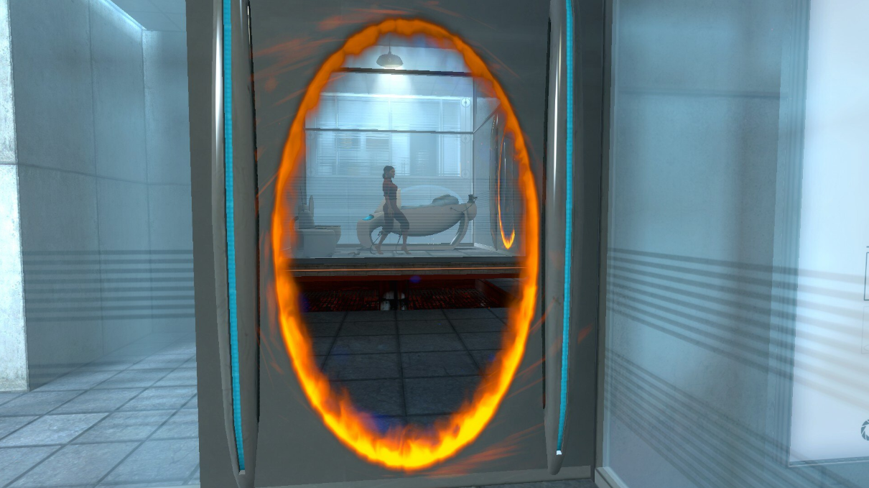

The game also demonstrates a use of colour to direct the player. One of Valves other games, Half-life [16] also used this Idea of colour to direct the player. In a documentary [17] released to celebrate 20 years of half-life, Valve mention that whilst play testing a lot of players got lost so they implemented coloured stripes that stood out against the grey walls. This helped the player better understand what room they were in whilst also directing the player to where the game wanted them to go. This idea of colour directing the player is also used in Portal. We see that the portals are vibrant blues and oranges which stand out against the white walls of the facility making it clear to the player where each portal is. Blue and orange are also opposite each other on the colour wheel and therefore contrast with each other and are hard to confuse. They also made sure that the player was wearing an orange jump suit so they could stand out and be easily sported through a portal. Everything else in Portal’s environments are usually variations of greys, blacks and whites with essential puzzle elements being highlighted in colour and light.
When the player enters the first ‘test chamber’ they are introduced to the first puzzle elements, boxes and buttons. The developer commentary states this begins conditioning the player to associate these two things together, when a player sees a button, they look for a box to place on it, and vice versa. They use this method of conditioning the player to associate things again when introducing the idea of ‘portal flings.’ They create overhangs in the environment and make the player look down at a portal surface encouraging them to jump through a portal from hight. This again associates hights with portal flings and when players see hights and overhanging ledges they naturally think to perform a portal fling.
The final method I found that valve use in portal was re-enforcing. This is when the used the AI voice of GLADOS to re-enforce an idea. For example, in one chamber they wanted the player to use a cube to block an incoming projectile. But found through playtesting that lots of players would time crouches and jumps instead. To force the player to use the cube they introduced the companion cube and got GLADOS to talk about the cube a lot so the player would gain a weird sort of attachment to the cube and would be encouraged to bring it with them through the rest of the test. This is a method Valve use sparingly, as listening to the long dialog can become tedious and the player gets a lot more out of physically completing the tests rather than just having everything being explained to them.
Valve continues introducing new elements all the way till the end of the game. In the final boss fight they use all these methods of teaching together. In this fight the player must launch rockets at GLADOS so ‘Personality cores’ drop off of her. These ‘cores’ must then be carried by the player to the incinerator. This boss fight is clearly explained in the arena itself by using all the previously stated methods.
- Show don’t tell: the player sees the first personality core fall off GLADOS before they get access to the rockets. This shows the player that the cores can be knocked off.
- Colour: the personality cores are vibrant colours and the incinerator glows. Both of these help them to stand out.
- Conditioning: the player has previously used the incinerator to burn the companion cube and the rockets to blow up glass. This allows them to already be conditioned on how these mechanics work.
- Re-enforcement: GLADOS repeatedly advices the player not to put the cores in the incinerator, being as GLADOS is the antagonist this directs the player to do so anyway.
All of these elements combine to make an exciting boss fight that allows the player to use all the elements they’ve previously learn in new ways.
However, the main thing that was noticed from looking at Portal was Valves consistent use of playtests. Valve hired a psychologist named Mike Ambinder [18] to work as a consultant on playtesting for many valve games including Portal. Valve has a constant playtest philosophy and states in a GDC conference [19] that the point of playtesting is always fun. This shows in their work. Even though Portal is a constant tutorial it remains fun for the duration and never falls to tedium, this is in no doubt thanks to the playtests.
So many of the in-game developer commentary bubbles mentioned things that changed due to player responses, such as the previously mentioned companion cube that was added in response to testers not brining the cube with them. This shows how much playtesting Valve does for their games and by keeping the playtests focused on fun rather than data they get genuine feedback on what parts feel tedious this allows portal, even in its restrictive opening levels to remain fun. It also means that valuable data like players not understanding how a portal works can be quickly adjusted soon after implementation and not months later when making changes is harder.
In the words of Valves co-founders Gabe Newal
‘At Valve, we see our game designs as hypotheses and our playtests as experiments to validate these hypotheses. In addition, we always want to iterate and improve on our work, and we are constantly seeking feedback – through playtests and other means – in order to do so. By making use of a wide array of user research techniques, we will make better decisions and as a consequence, better games’
This quote shows how much emphasis Valve puts in to testing their games and gives probably the best reason as to why their tutorials are so well crafted: Extensive user testing. By doing playtests at every point of the game’s development from very early on till the final stages valve manages to get extremely well thought out and easy to follow fun game.

Creating a Tutorial
To test the effectiveness of these tutorial methods a test demo was created using the unreal engine [20]. The goal of this demo was to effectively teach the player a few different features.
- Navigate the world by walking looking and jumping.
- Be able to grasp more complicated features like shooting and interacting with doors.
- To be able to solve 3 simple puzzles using only these features.
The first thing the player had to be taught was how to navigate the world. To achieve this a simple area was created with simple button prompts on the walls stating the control scheme. To limit overwhelming the player the first sign only has a prompt for the movement keys WASD, the player must then navigate a walk to the right followed by a walk to the left with the help of some arrows, this ensured that the player had read the sign and could follow the instructions. then when the player correctly moves through to the next area they are introduced to looking with the mouse and jumping with space. The same methodology as before is used here. The player has to move the mouse to see the prompt to jump.
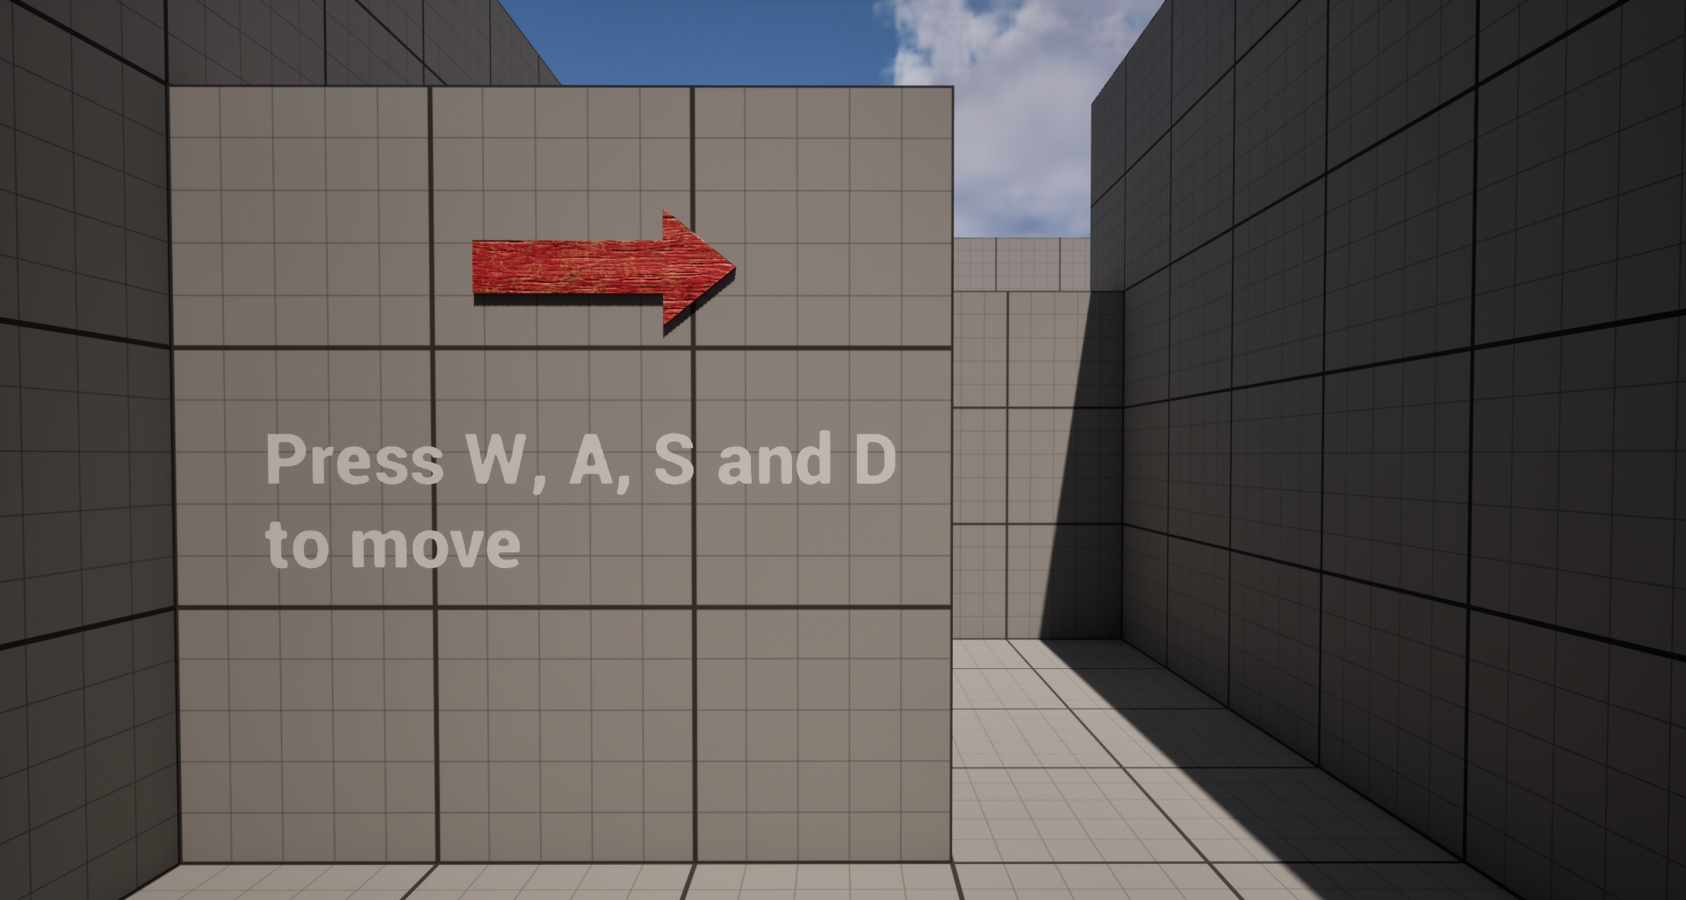
The walls were deliberately left grey with red arrows point the direction to go that way the red of the arrows stands out against the walls and gives clear direction to the player. This is implementing the same principles of colour as seen in Valves Portal.
I also added a simple blue door with a small handle at the bottom clearly visible, that the player can open by pressing E. this adds another simple mechanic the player to learn to use.
After the player has been introduced to all of the basic movements a simple chamber with a gun and wooden board was added. The player can shoot the board with the gun after which it will fall, a small target dummy is also in this room so the player can get used to aiming. The board was clearly made of wood so it would stand out against the grey and being as it was something the player hadn’t seen before they wouldn’t try to interact with it like they had done with the previous door. I used the same model for boards and doors wherever they appeared, this consistency implemented valves ideas of conditioning by conditioning the player to associate this element with being knocked over and being opened whenever a player saw them.
Now that the player had been introduced to the basic mechanics two simple puzzles were added that built upon these ideas. A small room with another wooden board that the player couldn’t immediately shoot down. Instead, the player has to shoot a ball on a nearby ramp so it will roll down and knock over the board.
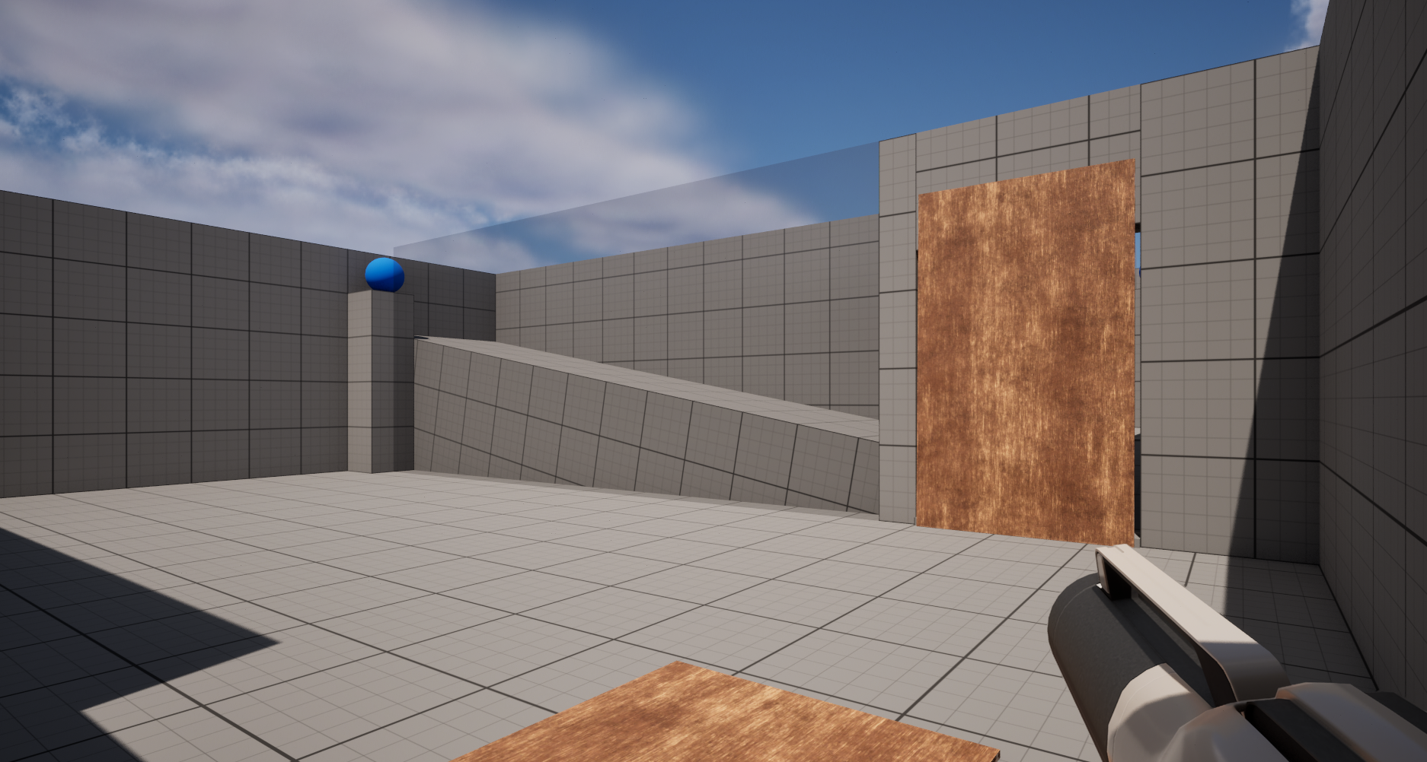

The second room was a variation on the first with the same basic principle but this time with a door blocking the balls path that the player must open like they were shown previously.
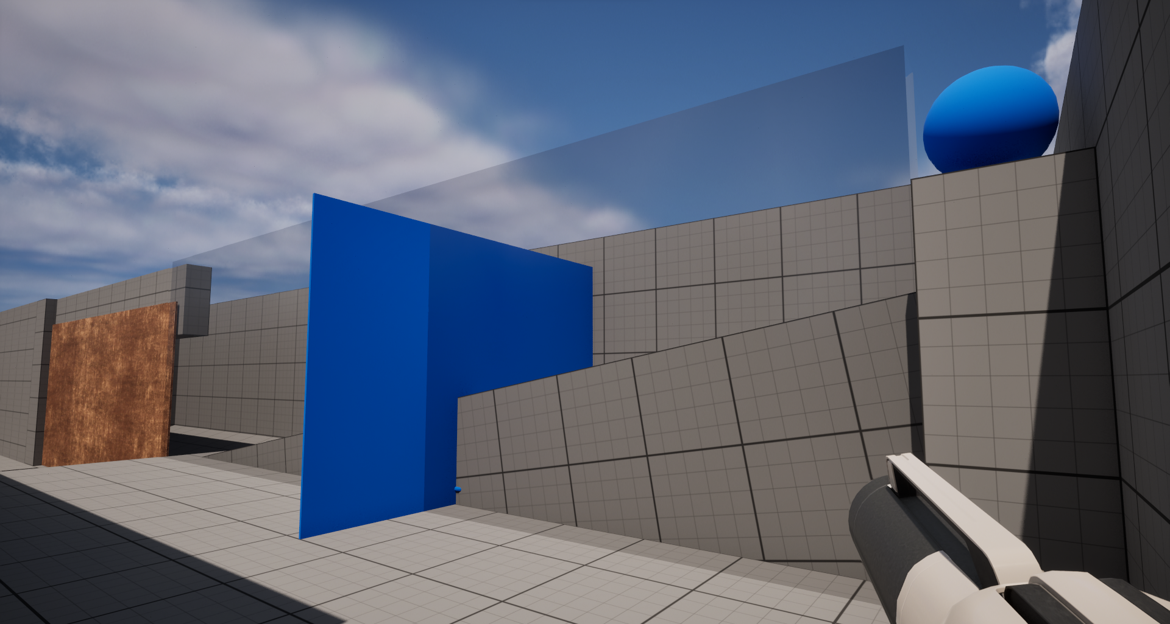

Playtesting
A play test was conducted to determine the effectiveness of this tutorial. All participants were given no instruction unless they directly asked and were left to play the demo on their own whilst notes and observations were made.
When players were learning the controls one common thing that players did was accidently move the mouse too far and miss the next prompt for jumping. Interestingly this didn’t cause any serious issues as most players managed to work out from previous gaming experience that the jump key was space.
All players successfully worked out to shoot the wooden board down to move forward with no help at all. This is likely due to two reasons: 1 the board is clearly placed ahead of the player, so they naturally walk towards it and 2 most players shot the target dummy first and many missed it accidently shooting the board.
The first area for improvement came when players entered the first puzzle room. Most players after shooting the first board immediately saw another and tried to do the same thing. A few didn’t and took time to look around the area before shooting but not all did. This led to many players repeatedly shooting the board and eventually, due to the engine’s physics, managed to shoot it down anyway, however many players did find the ball and correctly solved the puzzle by shooting it so it would knock over the board, but most at least shot the board once before looking at the ball.
In the second area all players who had shot the ball in the previous puzzle immediately shot this ball but only 3 lifted the door to let it through, most people shot the second board or got stuck and had to be prompted to lift the door. Many walked around a bit and started to shoot the door and one player managed to jump across the gap.
From these play tests a few key bits of data were clear:
Players understood clearly that objects could be affected by physics. All players immediately grasped that objects like the ball and boards could be affected by the gun and only shot other things like the second door when no clear solution was presented.
Players associated the boards with being shot down. After shooting down the first board all players assumed that wooded boards could be shot down in a similar fashion. This is like the association that valve did in Portal however the intent was to show that wooden boards could be affected by physics not that all boards need to be shot. This could be remedied by having another puzzle between the first board and the door where the player must shoot multiple boards.
Players saw the second board and immediately reacted. This is likely due to the second board being the first thing the players see after shooting the first and therefore assume they must shoot this one too.
Players didn’t work out to open the second door. This could be because of two reasons: 1 - players didn’t realise the second door was a door because of its positioning. Or 2 - players didn’t remember the interaction necessary to open a door.

Demo Version 2
To find some solutions to the issues raised during playtesting of the first demo some changes were made to the layout of the demo.
The initial starting area teaching controls wasn’t causing any issues and therefore stayed the same with some minor changes like lowering the wall that the player must jump over slightly as a few players were struggling to get the jump right.
The first puzzle room with the ball and ramp was moved across so that the first thing the player saw was the ball not the board. Another red arrow was also placed below the ball to bring even more of the players attention to it. This should hopefully remedy the issue of players not initially noticing the ball and instead shooting the board.
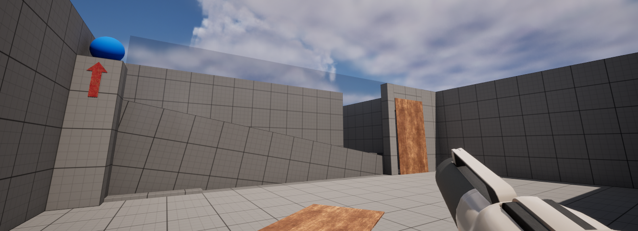
The second large change made to the demo was the Position of the second door. To test what the issue with the door was, it was moved so the handle was more prominently displayed to the player. If the issue with the door is that players don’t remember the interaction then the players shouldn’t open the door, however as the door is now more prominently displaying the handle it should be clearer to the player that it is a similar door to earlier and should remember that they are able to interact with it and lift it out of the way.

Playtest 2
A second playtest was conducted with the updated demo to see if the changes had any effect on the game. The results were very promising and most if not all of the issues were solved.
As with the first test all players successfully navigated the first room teaching them the basics of movement and shooting. The first big change in the players came in the first puzzle. None of the players shot the board initially. All walked into the room looked at the ball with the arrow indicating towards it then moved around the rest of the room observing the puzzle before finally shooting the ball. This was what I intended and demonstrate the importance of the layout of puzzles.
The second puzzle also had massive improvements, all players noticed the ball as in the first test, but all also saw that the blue was a door and could therefore be opened. The simple change of making the door more noticeable worked and players immediately opened it.
Overall, the changes made to the demo made huge improvements, and players had a much better grasp of the intended mechanics. This process of playtesting drastically improved the effectiveness of the demo and without it the tutorial would have been a lot worse. This is a methodology that will be implemented more in the future.

Conclusion
Even if the tutorial is becoming less prevalent in games their existence is still a necessity. Without them we would never have been able to some of our favourite games. Games that lack tutorials because they are believed to be tedious, and risk boring players should look at games like portal and implement similar features to try and improve.
Extensive user testing from start to end is proven by games like half life and portal to improve the quality of your game, and testing in areas such as the tutorial should not be forgotten.
The most effective ways to teach a player how to play seems to vairy depending on the genre of the game, however this research shows that visual interactive tutorials that limit lecturing explanations, such as that in Valves Portal do the best job at keeping the player engaged and interested whilst still teaching the player. Tutorials like this one are the way that a game should approach teaching the player. Valves fun first mentality allows the player to enjoy the game whilst still being taught the mechanics and this should be the best mentality when creating a tutorial.

References

[1] | Infinity Ward, “Call of Duty: Modern Warfare II,” Activision, Woodland Hills, 2022.
[2] | Lexico Publishing, “Dictionary.com,” Lexico Publishing, 14 May 1995. [Online]. Available: https://www.dictionary.com/browse/tutorial. [Accessed 15 April 2024].
[3] | G. Gygax, Advanced Dungeons & Dragons - Players Handbook, Lake Geneva: TSR HOBBIES, INC, 1978.
[4] | Nintendo, “Super Mario Bros.,” Nintendo, Kyoto, 1984.
[5] | Capcom, “Resident evil,” Capcom, Osaka, 1996.
[6] | Bungie, “Halo: Combat Evolved,” Microsoft, Bellevue, 2001.
[7] | Ubisoft, “Tom Clancy's Splinter Cell,” Ubisoft, Montreuil, 2003.
[8] | Paradox Tinto, “Europa Universalis IV,” Paradox Interactive, Stockholm, 2013.
[9] | Obsidian Entertainment, “Fallout New Vegas,” Bethesda Game Publisdhing, Irvine, 2010.
[10] | Nintendo, “Legend of Zelda: Breath of the Wild,” Nintendo, Kyoto, 2017.
[11] | Indeed editorial team, “Indeed,” Indeed, 6 December 2023. [Online]. Available: https://www.indeed.com/career-advice/career-development/teaching-methods. [Accessed 18 april 2024].
[12] | Colossal Order, “City skylines,” Paradox Interactive, Stolkhome, 2015.
[13] | Infinity Ward , “Call of Duty 4: Modern Warfare,” Activision, Santa Monica, 2007.
[14] | Arrowhead Game Studios, “Hell Divers II,” Sony Interactive Entertainment, San Mateo, 2024.
[15] | Valve, Portal, Bellevue, Washington: Valve, 2007.
[16] | Valve, “Half Life,” Sierra Studios, Bellevue, 1998.
[17] | Valve, “Half-Life: 25th Anniversary Documentary,” Valve, 17 November 2023. [Online]. Available: https://www.youtube.com/watch?v=TbZ3HzvFEto. [Accessed 13 April 2024].
[18] | Linkedin, “Mike Ambinder,” Linkedin, NA. [Online]. Available: https://www.linkedin.com/in/mike-ambinder/. [Accessed 15 april 2024].
[19] | S. Bromley, “https://www.stevebromley.com/,” 1 September 2011. [Online]. Available: https://www.stevebromley.com/blog/2011/09/01/valves-philosophy-with-user-research-in-games-habe-newell-and-mike-ambinder/. [Accessed 15 April 2024].
[20] | Epic Games, “Unreal Enigne,” Epic Games, Cary, 2022.
[21] | M. Ambinder, “https://www.gdcvault.com/play/1566/Valve-s-Approach-to-Playtesting,” 26th march 2009. [Online]. Available: https://www.gdcvault.com/play/1566/Valve-s-Approach-to-Playtesting. [Accessed 15 april 2024].

