DS 1 Assignment

My Screenshots/Photos
- Please add 4–6 screenshots or photos of your digital life.
- You can use your phone or laptop.
- For each screenshot, write one or two sentences explaining what it shows.

Screenshot/Photo 1
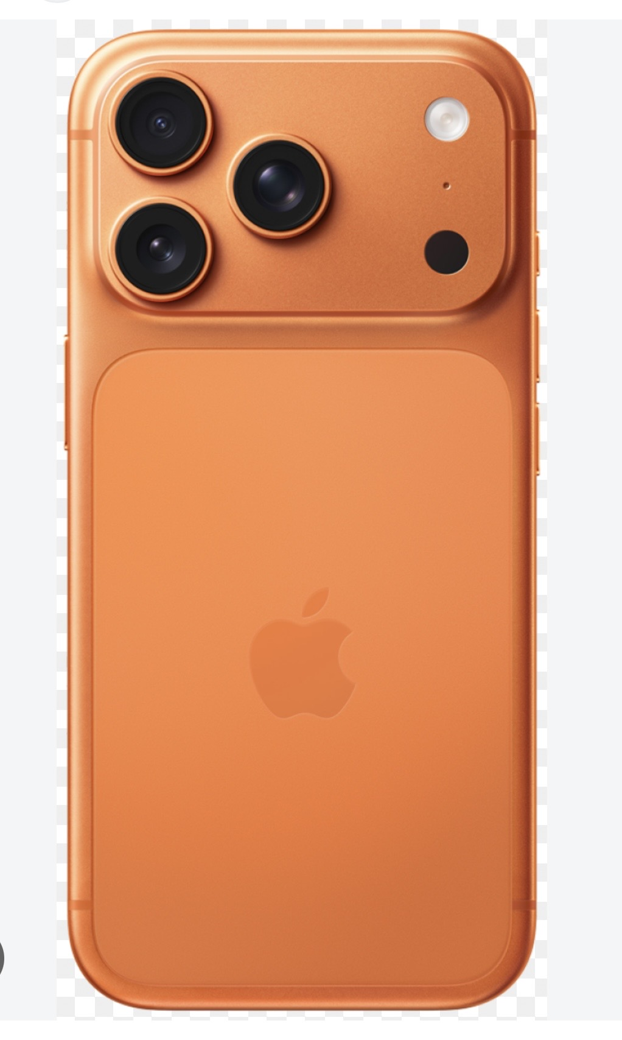 smart phone has a really big impact on our digital life.Smart phone helps us to connect with people around the world,it makes our life easier in many aspects i.e. our work life, student life,social and communication life,financial and shopping,entertainment.
[Write what this shows of your digital life]

Screenshot/Photo 2
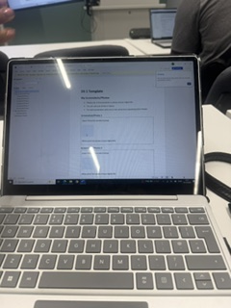 the laptop has fundamentally transformed modren life ,bridging gap between howwe work, learn,connect,ant entertain ourselves.Laptops benefit our daily lives like laptop has unlocked the ability to work from home, cofee shops,or while traveling .
[Write what this smashows of your digital ltheife]

Screenshot/Photo 3
[Insert Photo/Screenshot below]
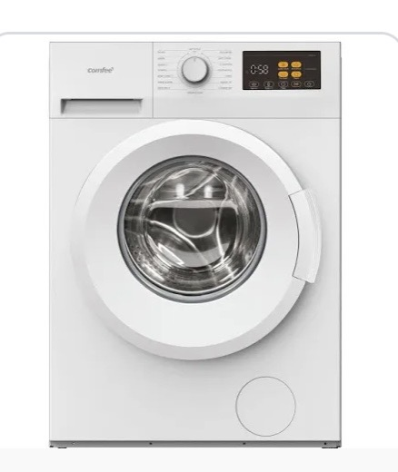 Smart washing machine makes our life way more easier than the old life. It saves us time,it does a lot of things all at once.We do not need to wash cloths by hand. Which hard work.
[Write what this shows of your digital life]

Screenshot/Photo 4
[Insert Photo/Screenshot below]
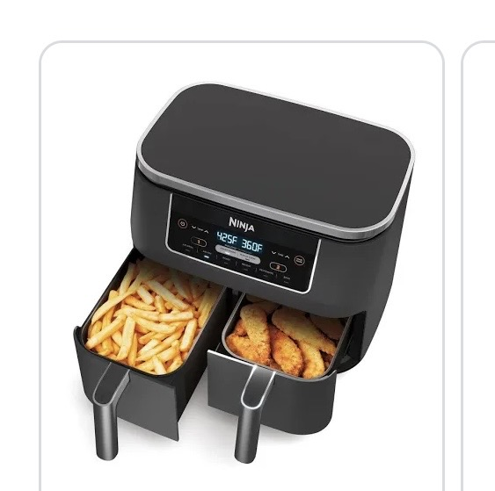Air fryer is really affective on oue health,we can have healthier options like we can make a fried item without the oil and it tastes delicious, it,s easy to clean, it makes full course meal in min.
[Write what this shows of your digital life]

Screenshot/Photo 5
[Insert Photo/Screenshot below]
[Write what this shows of your digital life]

Screenshot/Photo 6 DS 1 Assignment
[Insert Photo/Screenshot below]
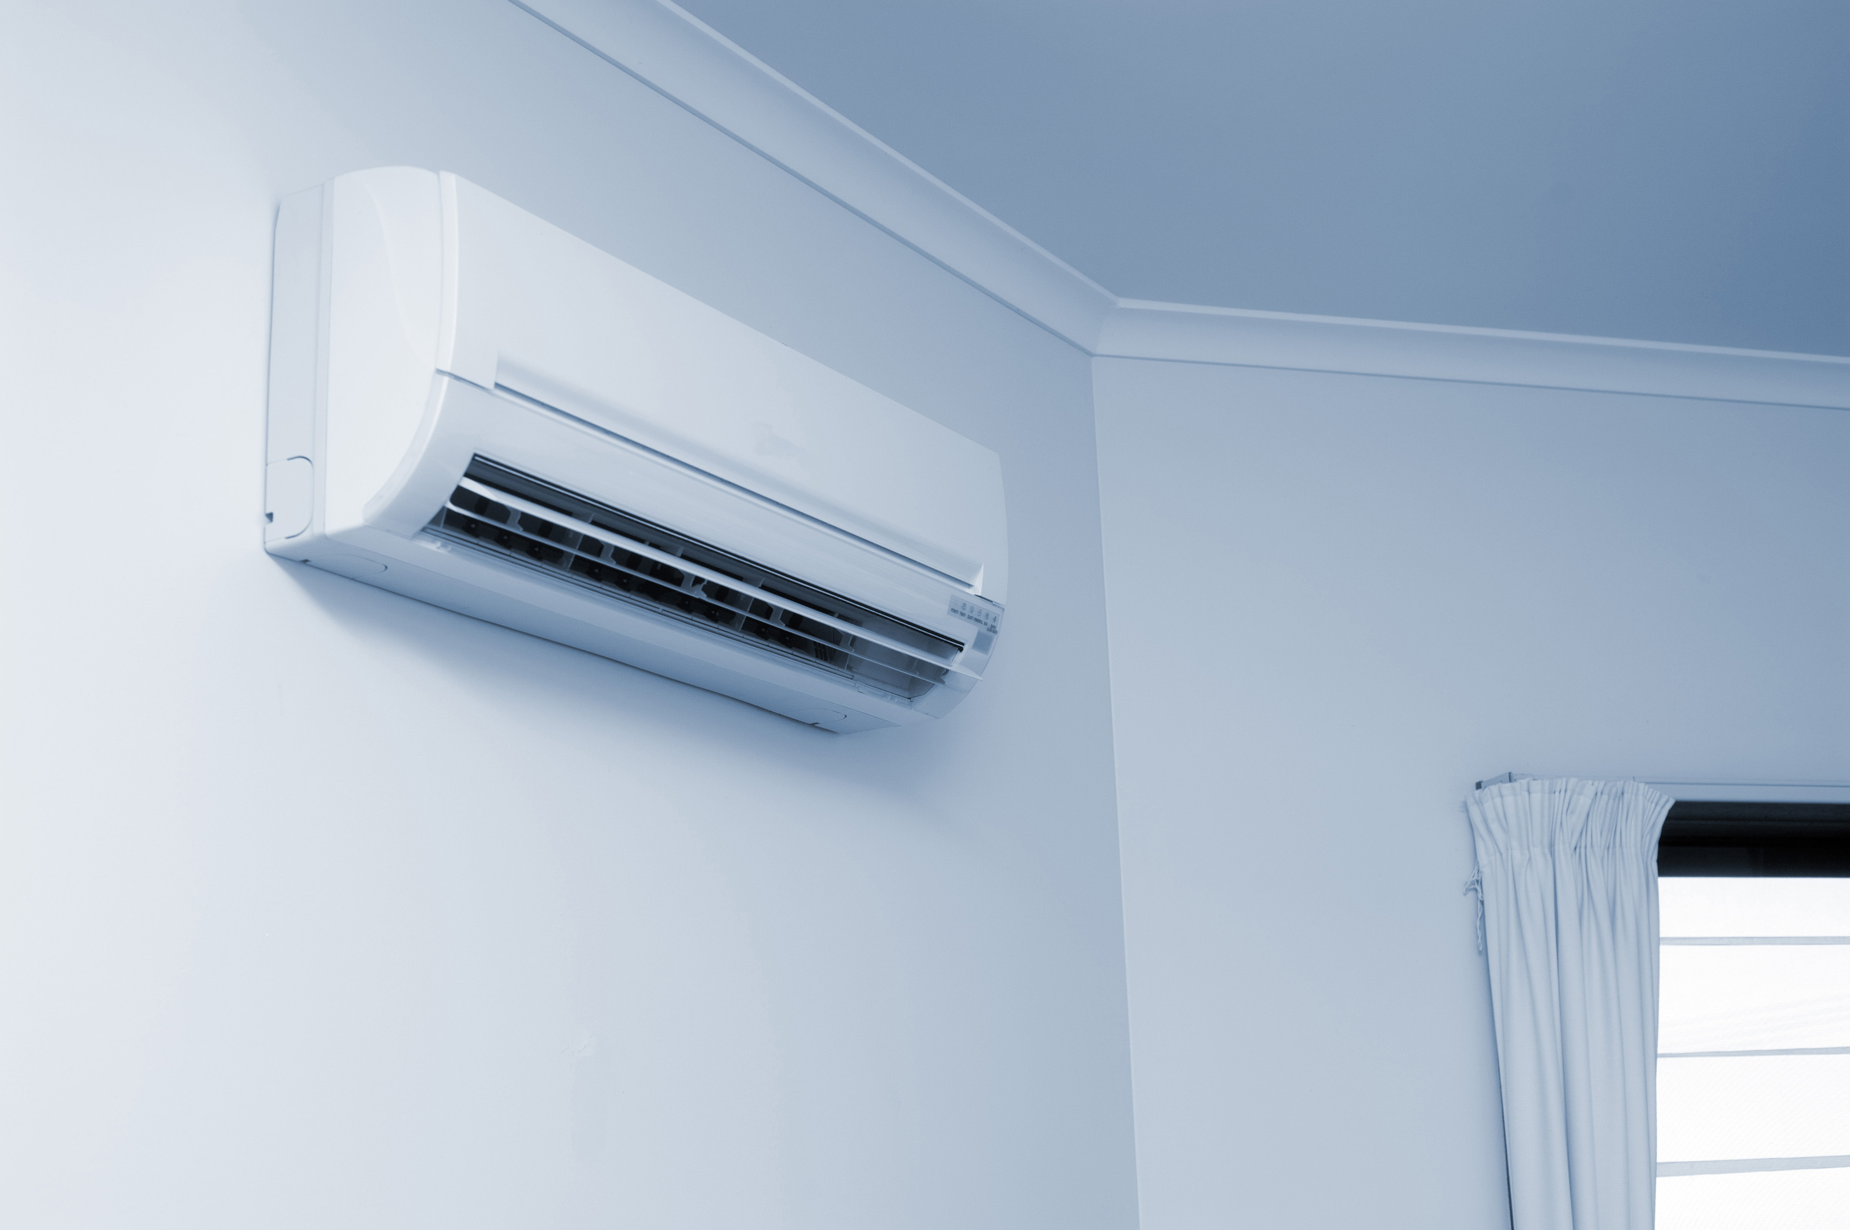 Air condition helps us a lot in the summer it helps us to stay cool during the heat , smart Air condition,s is even better since we can connect it to our phones and control the temperature.
[Write what this shows of your digital life]

My Short Reflection
- Write 5–8 simple sentences about your digital life.
- You can use the sentence starters below if helpful.
I use digital tools in my daily life, it is very affective and it makes my life easier in different aspects like beauty,home chores,travel, speaking on the phone.vacuum cleaner is very affective in cleaning properly and makes my life,s easier.We use lots of skin care products that are digital such as stemmer or straightener,laser forhier removal.We use cars and bikes airplane,s and ships more to go from one destintion to another quicker.

Sentence starters
- I use digital tools to …
- I feel confident when I …
- I want to improve …
- I often use these tools: …
- I sometimes feel nervous about …
- I hope this module will help me …
- Digital skills are important for me because …
You can write more if you want.

Submission Checklist
Before you submit, please check:
​​​ ☐ I added 4–6 screenshots
☐ I wrote short sentences for each screenshot
☐ I wrote my short reflection
☐ My work is my own
☐ My file opens correctly
​​☐ My file opens correctly

