

Problem-Solving and Innovation
Assignment 2: A critical analysis of external factors impacting High Street retailers in the UK
Module Code: BMSW4014
Task 2: Written report
Student name: Daniela Zanfir
Student ID: 2411191

Table of contents
1. Introduction 2
2. Findings 2
2.1 PESTLE Analysis 2
2.2 SWOT Analysis 4
3. Conclusion 6
4. Recommendations 6
5. Reference List 8

1. Introduction
Economic challenges in the UK high streets make it very difficult for shops to operate effective. Economic uncertainty, changing customer habits, and more competition from online sellers like Amazon have led to store closures and fewer shoppers in retail areas. Rising prices, the need for sustainability, and problems with digital change are currently putting more pressure on retail businesses. Many companies struggle with balancing their operating costs and what customers want. An evaluation has been done on how outside factors affect High Street shops by using the PESTLE framework and SWOT analysis. This study offers ideas to improve digital changes and sustainability efforts to help retail businesses become more sustainable and successful over time.

2. Findings

2.1 PESTLE Analysis
Political: Brexit has changed how trade works in the UK and impacted worker access as well as how imports and exports are handled. Retail companies face high customs fees and supply chain problems, making it hard to manage their goods. Physical store owners are dealing with serious financial pressure due to government business rate rules (Chan, 2022). High business rates are still a problem, even though there are ongoing calls for changes. This situation is putting many stores on the High Street at risk of closing. The British Retail Consortium (BRC) says the government needs to help stores handle their challenges (BBC, 2024).
Economic: The UK is currently facing a cost-of-living problem because inflation hit in 2023 11% and it is taking the market a long time to recover due to stagnant economic growth, the rising cost of energy and increasing cost of food.
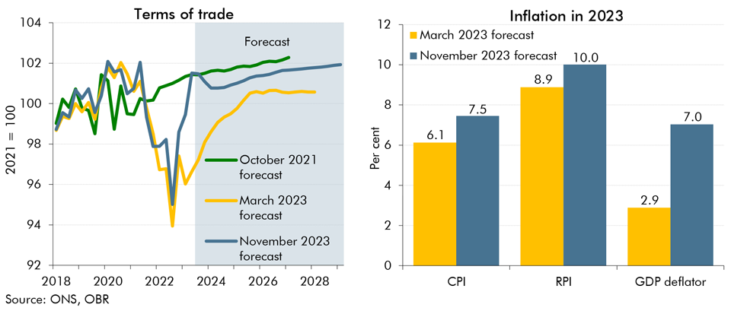
Figure 1: UK inflation rate in 2023
(Source: ONS, OBR)
People are prioritizing spending on energy and necessities. Rising running costs are a problem for stores and that has exacerbated by the rise in the National Insurance employer contribution. Due to this Tesco expects that its salary costs will go up by £250 million due to the changes they are making (Tesco, 2024). Retailers have a tough choice to make. They need to balance raising wages while also keeping prices fair. They want to be profitable but do not want to lose customers who care about prices and who will shop elsewhere given the choice.
Social: The COVID-19 outbreak changed how people shop, leading many to buy things online instead of in stores.
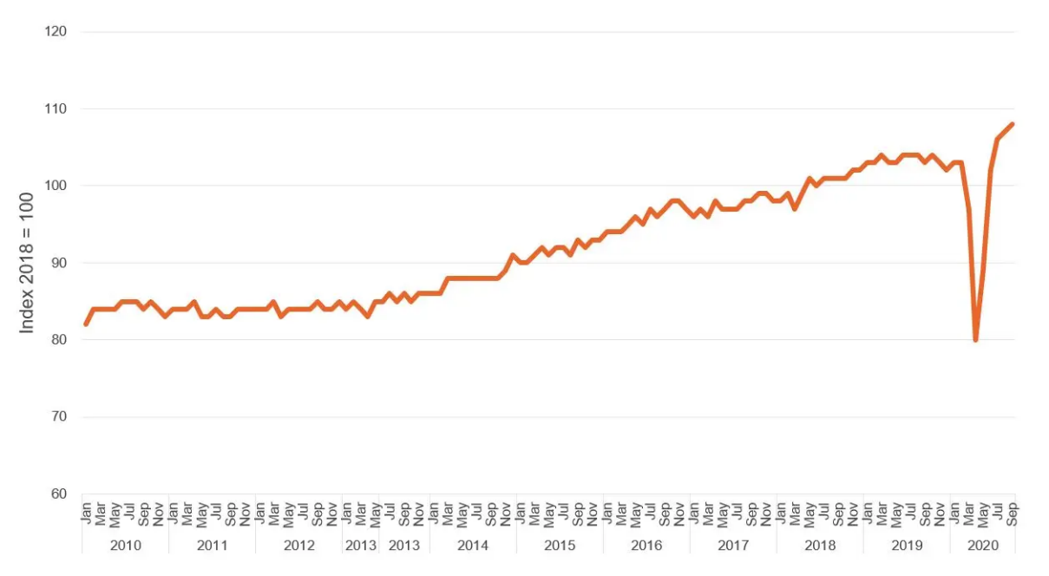
Figure 1: Retail sales, volume index, seasonally adjusted
(Source: Office for National Statistics)
Coronavirus compelled to customers to use internet and make it habit in their daily routine (Abiad, Arao, & Dagli, 2020). Less shopping on High Streets led to many businesses closing and fewer jobs in retail. By February 2021, the percentage of shoppers who stated they had been shopping more online had risen to almost 71 percent (Statista, 2020). Some consumers now prefer brands that are environmentally responsible, so stores that follow these standards are gaining customer trust. More and more customers are interested in ethical and healthy shopping habits today (Chan, 2022).
Technological: Online shopping and digital payment methods have become very common, causing significant changes in traditional retail. Stores use new payment methods and mobile wallet apps to make shopping easier for customers. Using artificial intelligence (AI) along with automation helps businesses improve their product management and provide personalised experiences for customers (Kumar, 2022). Many High Street stores are uncertain to implement new technology, which gives their online-only rivals an advantage. UK employment laws ensure that workers are paid fairly and that workplaces are safe, which affects how much retailers spend on labour. The General Data Protection Regulation (GDPR) and other data protection laws require businesses to keep customer information safe while shaping their marketing efforts and engaging with customers (Zhang et al., 2020).
Environmental: Environmental sustainability is now very important for businesses since rules about the environment match what customers expect regarding sustainability. Retailers need to focus on three important environmental steps: reducing plastic use, improving trash management, and lowering carbon footprints (Dal Mas et al., 2022). These actions are essential. Higher energy costs are making stores to find approaches to operate more economically in their businesses.

2.2 SWOT Analysis
UK High Street businesses operate in a complex market that has many factors influencing it, both from inside and outside the business. The SWOT evaluation method helps organisations see their current situation and future possibilities.
Strengths: High Street stores build strong brand recognition and customer trust because they have long-lasting relationships with their customers. When customers trust a store, they are more likely to buy from them again and stay loyal to the brand. Customers can touch and use goods in stores, which gives them immediate pleasure and advantages over buying online. John Lewis and other stores maintain high customer service standards, which helps them build strong ties with customers (Sammour et al., 2020). Customers are happier and buy more when they connect with workers and get to handle products in the store. High Street shops have benefits that help them create great shopping experiences that online sellers cannot match.
Weaknesses: Every shop business on the High Street needs to spend a lot on rent, employee wages, and energy bills. The British Retail Consortium says that rising business rates and increased costs for workers have put a lot of financial pressure on stores (BBC, 2024). Many stores are taking a long time to adopt digital change tools, which lets their online competitors get ahead. The slow start to digital development has restricted their online presence and weakened their supply chain efficiency. The rise in online shopping and difficulties in adapting to digital ways have caused 13,000 physical retail shops to close (Briedis, 2020). The weaknesses that High Street stores face is leading them to create new ways of operating to stay competitive in the market.
Opportunities: Omnichannel selling offers high-street stores great opportunities to blend online and in-store shopping experiences efficiently. Retailers with good online stores and physical shops give customers different ways to shop. The presence of active customers increases in retail spaces where both staff and environment create exciting and satisfying customer experiences (Bourg et al., 2023). Stores that provide both physical events and personalised services with educational classes create customer attraction that exceeds the online shopping experience. The rising demand for socially conscious and eco-friendly products provides High Street stores an excellent chance to market environmentally friendly goods alongside sustainable operations. High Street stores can improve their market standing through strategic applications that allow them to fulfil evolving customer needs.
Threats: Physical retailers on the High Street constantly face market competition from leading e-commerce companies, including Amazon because they provide comprehensive product lines along with free shipping options. The economic problems have made shoppers rely on monetary savings when buying merchandise while they research deals more diligently. Online shopping challenges the success of high-street stores by causing visitors to shop more online (Bourg et al., 2023). Higher street retailers must alter their operational plans because retailers and consumers shopping methods have evolved.

3. Conclusion
PESTLE and SWOT analyses demonstrate that UK High Street shops must navigate three main obstacles, including economic difficulties and battles against online buying and changing customer retail behaviours. High running costs, the need for digital changes, concerns about the environment, and delays in online shopping have made it difficult for them to stay in business. Companies can make money by using both real shops and digital tools to create a fun shopping experience for people looking for eco-friendly goods. To succeed, businesses need to use new digital technology, personalise their services with AI, and enhance customer interactions in their stores. Using ethical sources and reducing trash will help our company become more recognised and appreciated by customers. Retailers need to adapt their business practices to survive changes in the industry over time.
4. Recommendations
1st Recommendation: Digital Transformation
High Street shops need to embrace digital changes because online competition is increasing in today's market. Using a mix of online and in-store shopping will make it easier for customers and help the company sell more. Marks & Spencer now offers mobile shopping options, allowing customers to shop through both click-and-collect and their app (Retail IT, 2020). Mobile apps that use AI to personalise experiences help improve customer relations. At John Lewis, AI suggestion tools help customers find new goods and improve sales (Salesforce, 2023). Retail companies that use augmented reality changing rooms and virtual buying helpers create fun and engaging shopping experiences. This helps attract customers who are interested in technology. Improvements made online should also enhance customer experiences in stores (Dudukalov et al., 2021). Using self-checkout machines with smart screens and AI inventory management helps businesses work more efficiently and save money. Stores on the High Street should look at customer data to improve their product choices and make sure their real stores match their online stores based on what customers want.
Second Recommendation: Sustainability Actions
The sustainable shopping trend is growing quickly because over 60% of British shoppers check what brands do for the environment and how ethically they operate (Ceron, 2024). High Street stores should focus on being environmentally friendly by using eco-friendly packing, reducing trash, and improving the energy economy. Zara, H&M, and other stores started offering eco-friendly gathering and recycling programs to appeal to customers who care about the environment (Kim and Oh, 2020). Choosing ethical sources for products helps ensure responsible buying, which can boost the brand's image and increase customer trust. The Body Shop and Lush have shown that they can handle their supply chains in an ethical way (Varshney and Ahmed, 2023). High Street stores that adopt these sustainable practices improve their business image, save money, and meet new customer needs.

5. Reference List
Abiad, A., Arao, R. M., & Dagli, S. (2020). The economic impact of the COVID-19 outbreak on developing Asia
BBC, 2024. Shoppers and retailers set for ‘challenging’ 2024, says BRC. www.bbc.com. [online] 9 Jan. Available at: https://www.bbc.com/news/business-67914638 [Accessed 6 Feb. 2025].
BBC, 2025. What is the UK’s inflation rate and why is the cost of living going up? BBC News. [online] 15 Jan. Available at: https://www.bbc.co.uk/news/business-12196322 [Accessed 6 Feb. 2025].
Bourg, L., Chatzidimitris, T., Chatzigiannakis, I., Gavalas, D., Giannakopoulou, K., Kasapakis, V., Konstantopoulos, C., Kypriadis, D., Pantziou, G. and Zaroliagis, C., 2023. Enhancing shopping experiences in smart retailing. Journal of Ambient Intelligence and Humanized Computing, pp.1-19.
Briedis, H., 2020. Adapting to the next Normal in Retail | McKinsey. [online] Mckinsey. Available at: https://www.mckinsey.com/industries/retail/our-insights/adapting-to-the-next-normal-in-retail-the-customer-experience-imperative [Accessed 6 Feb. 2025].
Ceron, T.S., 2024. UK Fashion and Sustainability Market Report 2024. [online] Mintel. Available at: https://store.mintel.com/report/uk-fashion-sustainability-market-report [Accessed 6 Feb. 2025].
Chan, F., 2022. A study of social media influencers and impact on consumer buying behaviour in the United Kingdom. International Journal of Business & Management Studies, 3(07), pp.2694-1449.
Coppola, D., 2023. Global E-commerce Share of Retail Sales 2023. [online] Statista. Available at: https://www.statista.com/statistics/534123/e-commerce-share-of-retail-sales-worldwide/ [Accessed 6 Feb. 2025].
Dal Mas, F., Tucker, W., Massaro, M. and Bagnoli, C., 2022. Corporate social responsibility in the retail business: A case study. Corporate Social Responsibility and Environmental Management, 29(1), pp.223-232.
Dudukalov, E.V., Terenina, I.V., Perova, M.V. and Ushakov, D., 2021. Industry 4.0 readiness: the impact of digital transformation on supply chain performance. In E3S Web of Conferences (Vol. 244, p. 08020). EDP Sciences.
Kim, Y. and Oh, K.W., 2020. Which consumer associations can build a sustainable fashion brand image? Evidence from fast fashion brands. Sustainability, 12(5), p.1703.
Kumar, H., 2022. Augmented reality in online retailing: a systematic review and research agenda. International Journal of Retail & Distribution Management, 50(4), pp.537-559.
Retail IT, 2020. Over 300 M&S Stores Now Offer Checkout-Free Shopping: M&S Triples The Number Of Stores Offering Mobile Pay Go Technology Through The M&S APP. [online] Retailitinsights.com. Available at: https://www.retailitinsights.com/doc/over-m-s-checkout-free-shopping-m-s-triples-stores-mobile-pay-go-technology-app-0001 [Accessed 6 Feb. 2025].
Salesforce, 2023. John Lewis Partnership enriches the customer experience with data. [online] Salesforce. Available at: https://www.salesforce.com/resources/customer-stories/john-lewis-trusted-relationships-data-ai/ [Accessed 6 Feb. 2025].
Sammour, A.A., Chen, W. and Balmer, J.M., 2020. Corporate heritage brand traits and corporate heritage brand identity: the case study of John Lewis. Qualitative Market Research: An International Journal, 23(3), pp.447-470.
Statista, 2020a. UK: change in online shopping since COVID-19 2020-2021 | Statista [online]. Statista. Available from: https://www.statista.com/statistics/1230225/changes-in-online-buying-among-uk-consum ers-since-covid-19/ [Accessed 23 Aug 2021].
Tesco, 2024. Tesco PLC Annual Report and Financial Statements 2024. [online] Available at: https://www.tescoplc.com/media/zgvhd0dn/tescos_ar24.pdf [Accessed 6 Feb. 2025].
Varshney, D. and Ahmed, Y.A.M., 2023. Walking the Talk of Sustainability Practices: The Case of Lush Retail Ltd. Rutgers Bus. Rev., 8(1), pp.95-110.
Zhang, J., Hassandoust, F. and Williams, J.E., 2020. Online customer trust in the context of the general data protection regulation (GDPR). Pacific Asia Journal of the Association for Information Systems, 12(1), p.4.

