4/22/2026
Assessment 1
Software Applications for Business
Student Name: Margaret Bisong
Student ID: 2523604



Module NaMe: Software solutions for business
Module Code: ACCA 4026
Lecturer: anum paracha
Trinity saint david University of Wales (London Campus)

Table of Contents
Introduction 2
Main Body 2
Task 1 2
e-Commerce Website builders/software solutions 2
Task 2 2
Mind-map of Contemporary Software Applications 2
Task 3 3
Office Applications for Creating, Storing, Presenting, and Analysing Data 3
a. 3
b. 3
Task 4 3
Communication and Collaboration applications 3
a. 3
b. 4
Conclusion 4
References 4
Appendices 4

Introduction
In this assignment I will be mentioning software applications and their importance to business this will be software solutions to data storage, presentation creation, communications and documentation creation. And explain how and why these software application work well for business and their functions within a business.

Main Body

Task 1

e-Commerce Website builders/software solutions
For this task I will mention the difference of two website building software that will help businesses. Shopify and Wix these are two website builders that can create websites for a business, they are like each other, but they have different operation when it comes to how the operate and what they focus. Wix is a great website building software but is good for small businesses as it does have application that may help a small business set up payment from customers and it has many templates that will give you the ability to create different types of webpages such as CV’s and e-portfolios the give it a very diverse use when it comes to building a webpage. Wix is also free to use this make it very good if you just want to create a webpage for personal use and to just showcase your skills or information about yourself. Because of it customizing ability and its drag and drop features it can make very good-looking webpages and has a great and simple format makes it easy to understand. Wix has many applications that can be added on to your website to make it suit the needs of a website, and you can even do surveys and questionnaires for users and create community pages. Wix has may images that you can choose from to create an even more customisable look to the website, and you can also add your own pictures. Shopify is a website builder that mainly focuses of e-commerce this means it is mainly focusing on selling online. Shopify is good for larger businesses and established sellers just like Wix, Shopify gives you a range of software applications that can be added to your website to enhance your website and make using it more easier depending on what you would like to do with it. Shopify gives its users the opportunity to store and manage inventory to help manage stock and a lot of add-on applications to manage stock. There are many applications they will help sort payments for your e-commerce business because of it focus to be a platform for selling online. Using Shopify is good for experience website designers because you if you can learn to use its functions well you can create a very well-designed website. Wix has a free to use option and you can also pay for extra features, but Shopify is a pay to use application but will make scale your online business. Shopify is built to scale because even large businesses use it and can handle inventories at a high scale. So, if you plan to grow a business wix may be a good option because it is easy to use and can also use application that will help you customize a small shop, but it is important to remember that as you may grow on Wix then you may feel limited. If you are a business that is establishes or a big business, then Shopify is a better option because it allows you to do a lot more when it comes to selling online and stoking and handling inventory.[1][2][3]

Task 2

Mind-map of Contemporary Software Applications

Tak 2a. Describe mind mapping and explain the benefits of using mind mapping in business operations

When using a mind-mapping it is very important for readers of a mind-map to understand because it is a way of presenting ideas in a way that is simple. Ming-mapping is good because is can be a collaborative toll so that multiple people are able to and to it, this means your team can add their own ideas and create a full visual of a collective idea. This will work very well when creating a project because everyone can see it and are able to see ideas and to discuss each other’s ideas. When creating a mind-map it’s important to keep it simple and easy to follow one way of doing this is to create your mind map using different colour branches to make it easier to follow. When you do this the brain can separate information using colour because it helps separate different sections of the min-map and allows it to be easier to be followed by others that may not have knowledge of what going on. This means you can use it like a street map of information to guide people to information this mean that if you had to use a certain software like I did in my mind-map, this can also help others using software applications find their way. By using my mind-map I can show many different applications and the function without having to even open an application because of the way it is coloured and organised. This means that just by looking at it you can save time and even memorise certain part of it what may apply to what you need to know. When using a mind-map for business not only does it save time, but it allows team collaboration and stimulate thought and team effort. This is important because when you wish to work together as a team then it takes different viewpoints and experiences and you can now create a map of how to accomplish a goal or project this can also now be used a map to success. Therefore, a mind-map is very useful when using it for business because it can be used as a collaborative tool to add and collect information and ideas from different team members, it can be used to present information such as orders and guidance. Because of its structure it can make information easier to understand and easier to remember. Mind-maps are easy to create and can be created with the use of software applications such a minemister.com and can be created by hand this make it a flexible tool for organising and presenting ideas. Whether it’s for business or for personal use you can use this for different purposes within your own life this is what make it a great organiser and can help you to recite information you can also use colours prioritise information you wish to learn using colour branches to separate information. Using a mind-map will be very helpful to me when I am working as a team because it will help to share ideas between me and other people, I work with and to create a map that helps me to navigate through software applications and find information easier.[4][5][6]

Task 2b. Create a mind map of contemporary software applications that are used to support day-today business/Organisation operations.
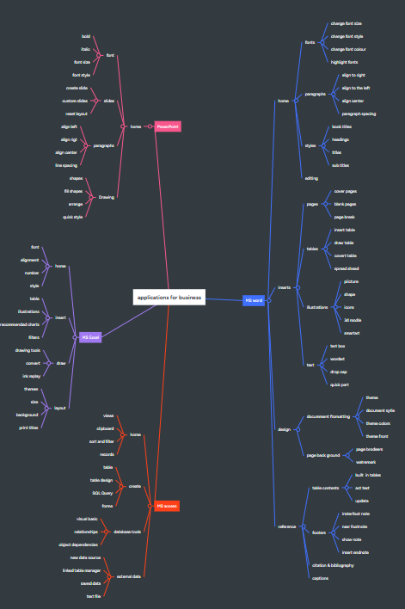

Task 3

Office Applications for Creating, Storing, Presenting, and Analysing Data

Task 3a.
MS Word
Microsoft word is a software application created by Microsoft and is a good application for a business because it allows you to create a document this could be things like essays, letters and even book. MS word focuses on text creation and because of this it makes it very useful to create different text documents. You also can customise text such as font styles and the size of the fonts. You can change the alignment of the paragraph, and you put different size spacing between words and lines. You can also add pictures into a document and charts and timetables this give you the opportunity to create a more visual document, and you will be able to add a lot more information. So, if I was to send somebody a word document with some business information such as a chart that displays how much money the business has made over a certain period, I could write a letter with a chart that is visually presented inside ethe document.
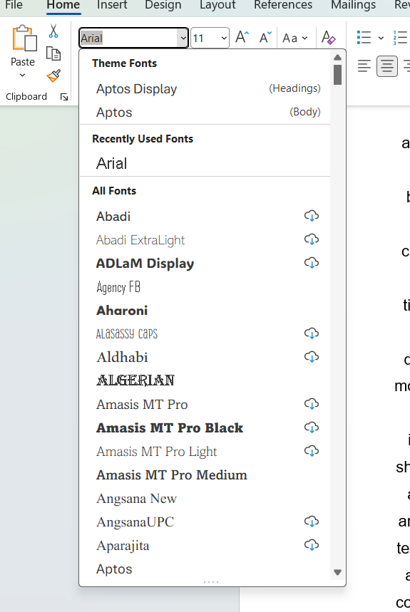
Screenshot List of different fonts
This give me the option to add information to my text, and I can demonstrate more than just text but the ability to share different forms of information. MS Word is also good for businesses because it allows me to send this document to other people this makes it a collaborative tool and I can share information or ideas from other people that may be within my team to the add or give me feedback. This is good if I wanted to create a contract for a client or a customer and I wanted to make sure it was good for my business and covered all the rules and didn’t break any laws. Then I would maybe ask someone to write a contract that knows about laws and someone else who knows my company rules and procedures, we will be able to send, receive and edit the document between each other. This is very effective because it means we don’t need to be in the same place to create this document and will save time and money because we don’t need to travel or book meeting to make small changes. You can also add cover pages to the document and headers to give it a more professional look and subheadings for structure. MS Word also allows you to add other applications to it to help you create documents that will make it easier to add information to a document. For example, you can use RefWorks, this add-on application allows you to add citations from Google scholar to your RefWorks account and because you know have it integrated to your MS Word it allows you to insert references easier because you can do inserts automatically. This make MS Word great for businesses because it allows you to create document and to share, edit and update them and is very flexible when you want to customise it. You also have many options when saving and storing document because you can save on computer, USB and cloud[7].

MS EXCEL
MS Excel is a great application for business because it allows you you to handle data easily because of its row, column and cell format you can input large amounts of data. By using its function, you can use its sum formulars to track sales, expenses and inventory, this is important for businesses who may have large quantities of stock and make large number of sales. You can also use it to manage employee and customer information and by using functions like VLOOKUP/XLOOKUP, SUM and IF will give you the ability to sort through data. In MS Excel you can also create charts from this data to give you a better understanding of what this data is, by doing this you may get a better visual of what is happening within this data and you with be able to edit it and see changes with your graph in real-time. MS Excell is also a great tool for collaborating with members of a team because multiple team members can have access to it you will be able to edit, update and add data.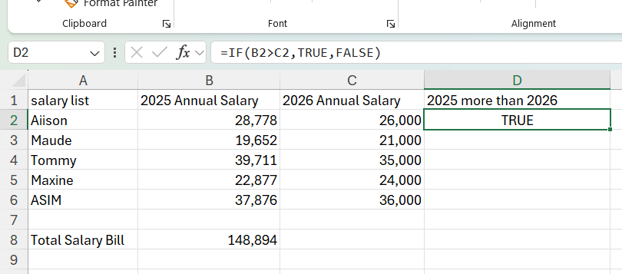
Screen shot of salary sheet I created

When using this within your business you will be able to share important data to employees if needed and keep track of important records such as payment, salaries and even time keeping. This software application is a great way to manage staff salaries because of its calculating abilities; this application offers a lot of different functions that will allows you to get such things as averages the can calculate the average of hours a employee has worked for example. So, using this application will reduce human error because it is calculated by computer and will save your business a lot of time and manual labour because it is quick and efficient. With its data analysis and insights you can create charts that give you a good visual and you will be able to get great insight of the business trend and by using the pivot table this allows you to then create a table from your main data worksheet and the pivot table can summarize that data and you can also get greater insight by also creating a charts from that table. Using MS Excel will save you a lot of time and money because it will give you more space and does not require a place to store data such as papers, folder and file cabinets. And because it is digital it means you have more methods to store, save and back up data, and you will save time and man hours because using its functions data can be found and presented quick. Therefore, MS Excel will save a business time and more and it is a quick and efficient way to run a business and will save money and is a flexible tool to track and manage projects and is a great why to calculate budgeting and accounting. For a big or small business to handle and to manage data this it a great tool because of its low cost and with enough training will be easy to use as it can be learned and if learned correctly will be very beneficial for a business[8].

MS ACCESS
Microsoft Access is a great way save data on a spreadsheet simple format as a full database system. It is a great way to organise and manage data and is more reliable than MS Excel and has a relational database structure that helps you to avoid the risk have information or data duplicated. Doing this allows the data to be more consistent. MS Access also has a function called SQL this ais a language that allows you to speaker to the database and to create tables, add data, delete data and update data. SQL is a quick way to find data because if you have for example ten thousand rows of data then finding and updating data may take some time but by using SQL query you will be able to find or update data quickly and efficiently. This application is also a collaborative tool because multiple people can access this database simultaneously and can change data in real-time. To train staff is not to technical because it is easy to use with basic training and will reduce any mistake when doing data entries using SQL.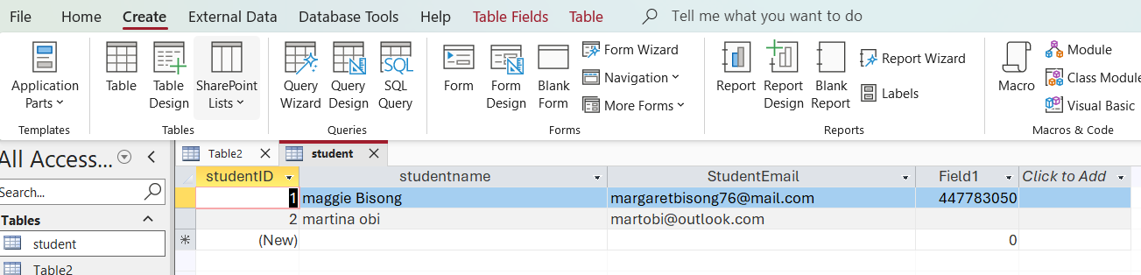 Because it is a Microsoft application you can also integrate ither application inside of it this gives you good workflow and the ability to insert data from excel. It is a good choice of database for small to medium business and is priced better then some other database system this is a great way so save money for your business as it also saves space because its digital and does not need too many people to retrieve data. You can also customise data fonts and colour to make it stand out more and cells this will help give it a more distinctive look. Columns can also be made wider or smaller this means you can customise a lot on your database. Cells can also be functionalized to have a specific purpose and can only allow you to put numbers and letters minimize the risk of mistakes and to give each cell specific data. Access can also track stock across multiple tables and will update when items are sold this will give you an accurate view of you stock balance because it can’t be duplicated. You can also generate reports from data and although they may be less flexible visually, but the reports will be coming from a more reliable data source. Having better control over data is very important especially if you have multiple users when using Access, it will reduce conflicts and errors when office staff are entering customer records simultaneously. So, when you are creating a database, you will need structure and planning this is important and Access is very good at being a reliable database software. It can also be saved in various ways and can be store on memory devices this mean that you are able to hold what would be hundreds of sheets of paper could now be stored in a device big enough to hold in your hand this make it very convenient for space[9].

POWERPOINT
PowerPoint is a great application software that allows you to create presentations because it allows you to gather all data, plans and ideas and present them. This application uses slide format that help you give a step by step visual of what you wish to present. This is good for if you have a business strategy and want to make it easy to follow then you can show your plans from start to finish. This is also good for project, financial research and anything else you wish to present. You can also create tables and charts to give even better visuals to your audience; this means that you can add informative visuals to your presentation with more accuracy. You can also add images to your PowerPoint presentation you may add images from your device such as downloaded images. There are also stock images that are already installed within the application that will give you a more immersive look for your slides. 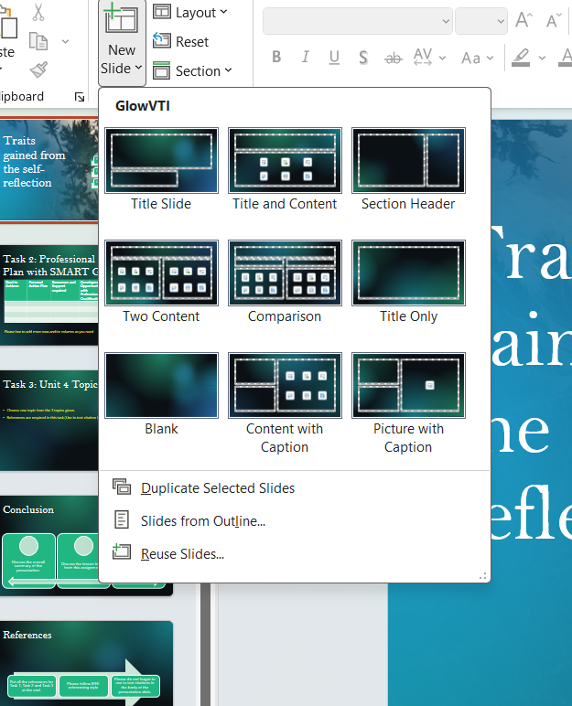
Screen shot of slide template creation

When creating a new slide, you also can choose from templates of slides that may have different layouts, or you can create a layout that suits you. Another great way to use PowerPoint could be to train staff because PowerPoint is easy to use you can use simple bullet point and imagery to create an educational presentation. This could also be sent or downloaded and be used as an exercise or training. By exporting to PDF or video you can share training material digitally and share with teams, by doing this make it a great collaboration tool. Collaboration is important when you wish to work as a team using PowerPoint because it means you can also share ideas a receive feedback from other team members. Presentations and slides can be edited and adjusted even the animation, and transition process can be adjusted, animations and transitions are a good what to give you presentation more live and visually immersive for viewers. The use of animations allows you to present information on each slide individually and allow you time for each bullet point. Using template designs give you the chance to use many different designs that will give you a more customized look to your presentation more professional look; by doing this with the use of images and the ability to use several different text fonts you can create a complete themed presentation of your choice. Therefore, the use of PowerPoint in businesses is a very powerful tool as it allows you so share your vision, educate, make sales pitches and be used in meeting giving you the chance to not only verbalize but to give your idea a visual and can make complex projects less complex. When using PowerPoint for your business it’s a great way to use clear and concise language that can be followed so using simple bullet points, clear images and charts will help you to display and share information effectively. PowerPoint also allows you to use add-on applications that can help you create presentations more easily and will give you a better workflow and more options to create different types of forms of presentations[10].

Task 3b.
IF FUNCTION
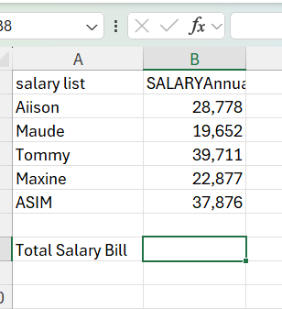
Highlight the cell at the column where you will like the function of results in this case I will like the total of column B
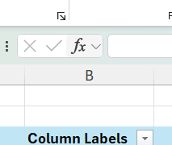
Click the insert function icon to choose the function you will like to use

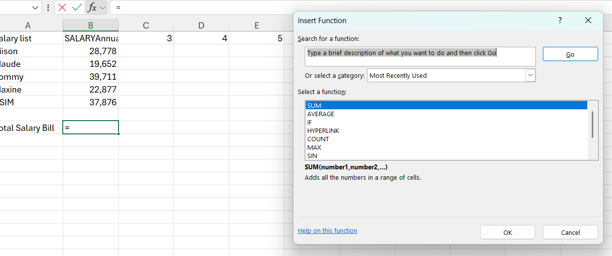
Because you want to get the total of a column you will choose “SUM” then click ok

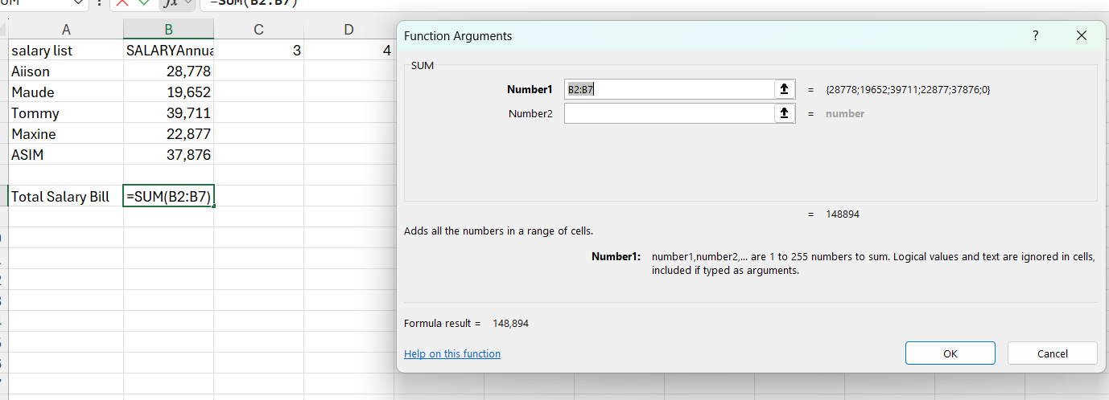
When your function agreements appear, you will be asked what column you will like to calculate in this case I want column B2 to B7 as show the formular can also be entered manually but insert function has done it for me automatically. Then click ok

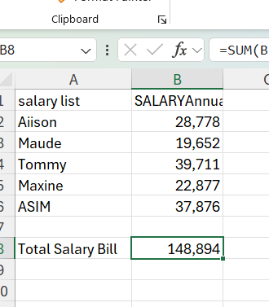
You will now have the total of sun of column B

IF FUNCTION

IF Functions is an insert function that can preform a calculation and give a value of said calculation. In this case I am asking is the annual salary of 2025 more than the salaries paid in 2026 if more give the answer/value “true” if less give the answer/value “false”.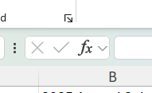
Highlight cell you will like data to appear then click insert function icon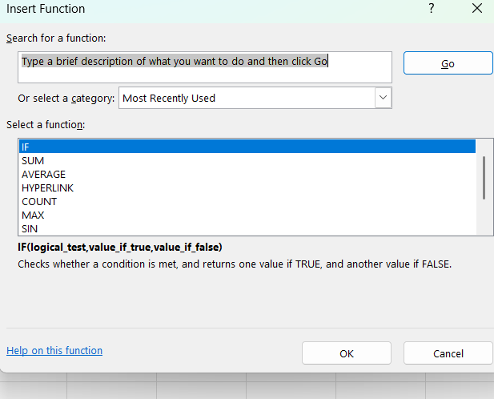
Click “IF” then clock ok
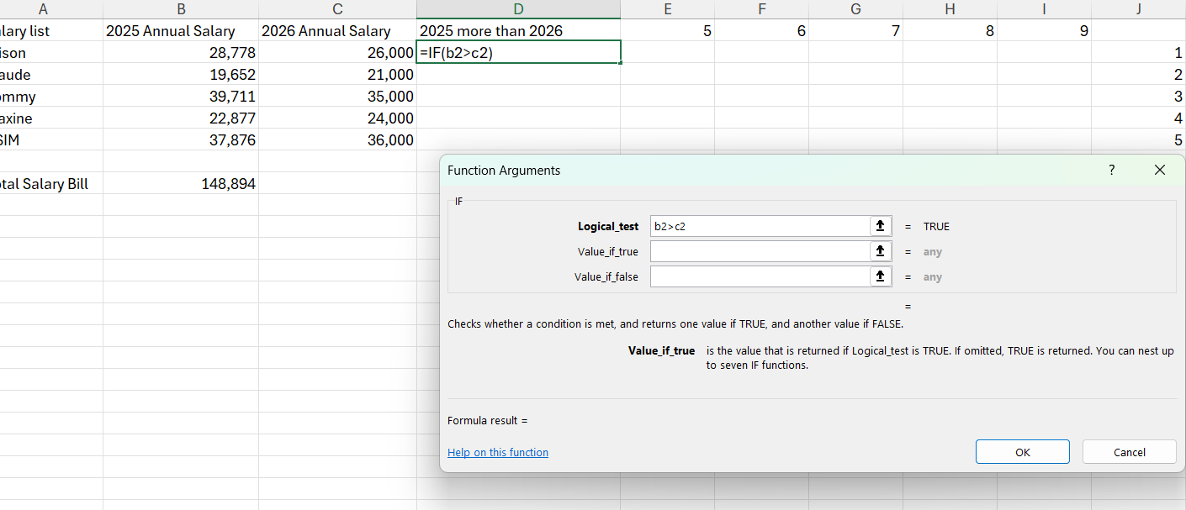
Enter the cells you would like to get the values for example I am asking is cell “B2” more or “>” = greater than “c2”

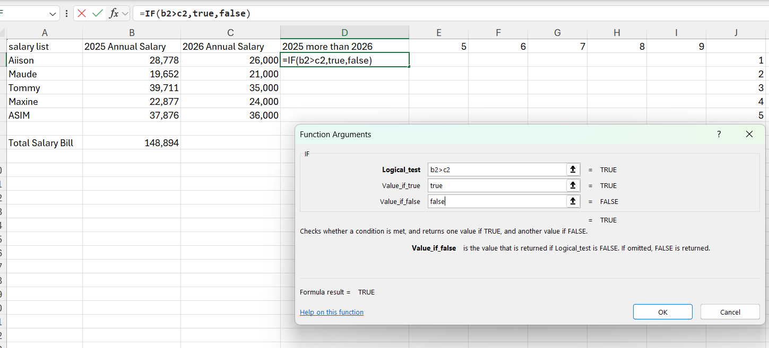
I then command if value is true to say “TRUE” if value is false say “FALSE”
This equations can be done manually by entering =IF(b2>c2,true,false) in cell d2
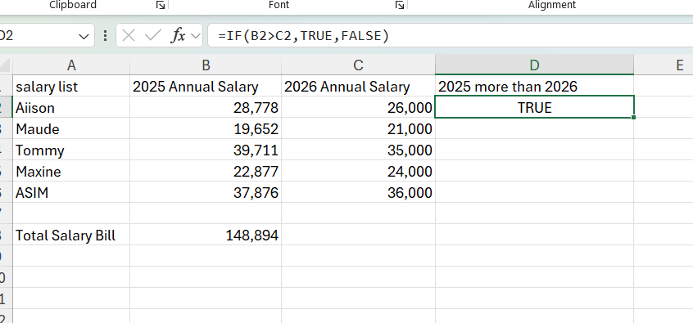
As you can see the result is true therefore, it is true that more salaries were paid in 2025 then 2026.

Task 4

Communication and Collaboration applications

Task 4a

Outlook
Is an email software application that allows you to communicate asynchronously with other email addresses. This is a great way to communicate because it shows record of when the email was sent and you can send important information safely to one another or to multiple at the same time. This is good for businesses because it allows the company to send promotional content such as news of the latest products, customer surveys or discounts. Customers can also use their email addresses to sign up for online accounts and because you can use links you can verify account more securely making sure the right person is opening the account. To CC is that everyone who receives the email can see who else has received the email but, when you BCC and email to multiple people then only the sender can see who else has received the email. But the receivers will not dee who else received the email that was sent to multiple people, this give BCC for of privacy when being sent because other users just know that they received the email and nobody else. Another good thing about creating a outlook email account is that it is free to use, this makes it a free to use application that a power tool then communicating inside and outside of a business. This application software is also able to send images and other documents therefore; this will be very beneficial when creating and sending document. Because you can send documents quickly and easily it saves time for you and your business this is also a good way to show proof of communication. Many companies are using emails to send to their customers after they have made a purchase this is a great way to do proof of purchase for when a customer may buy a product online or return a product online. Outlook also has a calendar function that allows you to create reminder, schedules and meeting this allows you to communicate with other though email and organise meeting with others. You can also choose to send it in advance and inform people how long the meeting will be for it will then send a notification email to does invited and they may confirm. This is a great way to see who is available or seen the meeting invitation, this is a good form of communication because dot only can you book meeting, but you can also confirm and plan more efficiently. Because it is a Microsoft application it also allows you to add other applications to it so that then you are creation emails for your business you also have quick access to any other application such as MS Excel, MS Word and PowerPoint. This makes Microsoft products work well together because of the integration between applications outlook makes working within an email application easy. This is what will make communicating and sending attachments and documents convenient when running a business. So, for the price because it’s free to use and the fact it integrates well with other application makes it a great choice for businesses when organising operations and business meetings[11][12].

MICROSOFT TEAMS
Microsoft Teams is a great way to communicate because it allows you to communicate synchronously and mean that it is instant. This software application can video, this means because you can hold a video call with multiple people at one time you can have conference calls. This application works well for conference calls because not only can you talk to people in real time in the world, but you could also see each other this is important for if you wanted to do a presentation or staff training. For a businesses this will be a great way to save money, time and resources because its convenience for communication and the ability to add callers and create groups make it a great way to create an environment where people are able to share ideas and speak while visually watching an idea be created or presented. To create a Microsoft Teams account all you need is an email address and you will be able to have your own account. The free version may have limited features, but you are able to use the meeting video caller and create chat groups that you till be able to speak to other members of a team. This application also allows you to integrate other applications to it this will allow you to do several things within the application and offers the Microsoft 365 that will integrate all your Microsoft applications such as MS Word, MS Excel or PowerPoint. When creating a group, you can start a chat room and have the option to start a conference meeting this also along with the option to send images and attachment from your own pc this will come in handy when creating a project because you’ll can create more of a visual. But the meetings video chat is what brings it all together with its ability to video with others team members and allowing you to talk, see and create in real time is what makes a truly collaborative tool when it comes to working as a team. And as for holding meeting and presentations it allows you to communicate and share in real-time such as getting contract signed or making business agreements. Even if you wanted to educate your staff or speak about new policies, you’ll be able to do this from the other side of the world this allows you to be present in multiple spaces in a short space of time. Because this application is stored on cloud you will be able to use it on many other devices this make it very useful for someone that is on the go the means, this application is flexible and does not require you to be in one place on only on one device. Therefore, this application is great for instant communication and allows you to conduct meetings visually gives you countless of opportunities to how, where and when you would like to attend, giving you a lot of flexibility and time to focus on other aspects of your business[13].

Task 4b.
OUTLOOK EMAIL

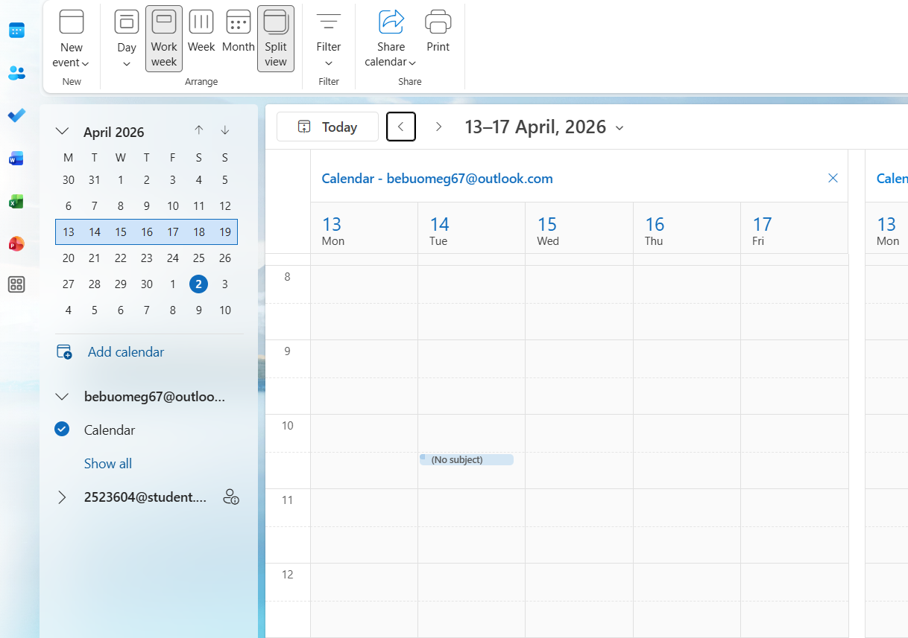
This is Outlook Calendar where you can create and organise meetings fist choose a date

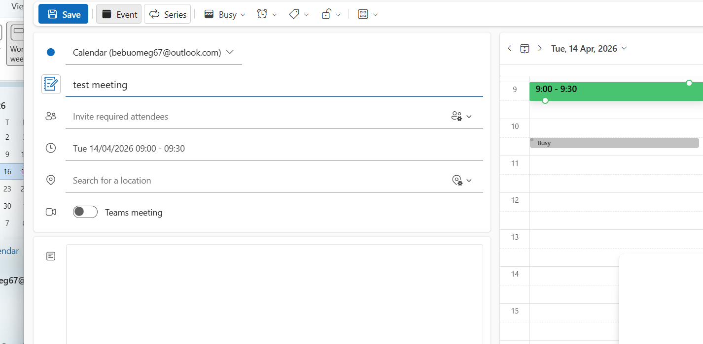
This is where you will put the details of the meeting

Add title will be your meeting title


You can enter the email addresses of the people you want to attend the meeting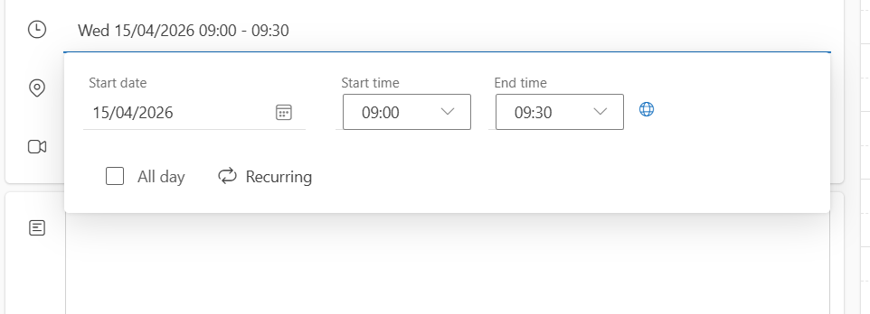
Date and time of meeting can be made recurred
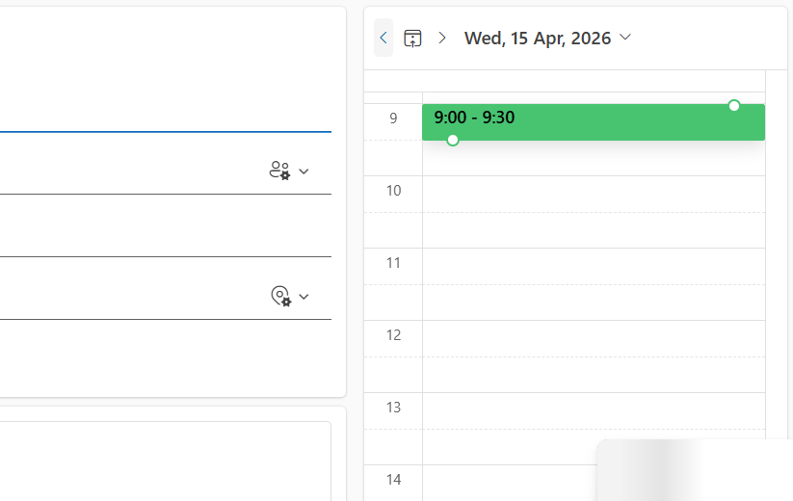
Date and time may be adjusted here


You can set a location here

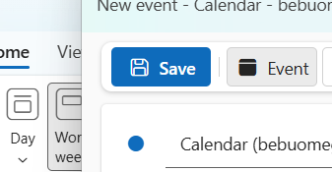
This where you save the meeting and emails well send automatically
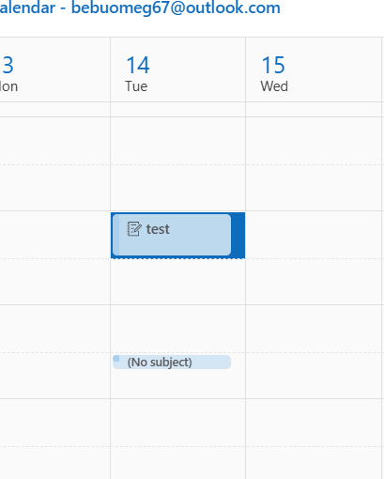
Your meeting will show on your calendar and can be edited anytime

MICROSOFT TEAMS
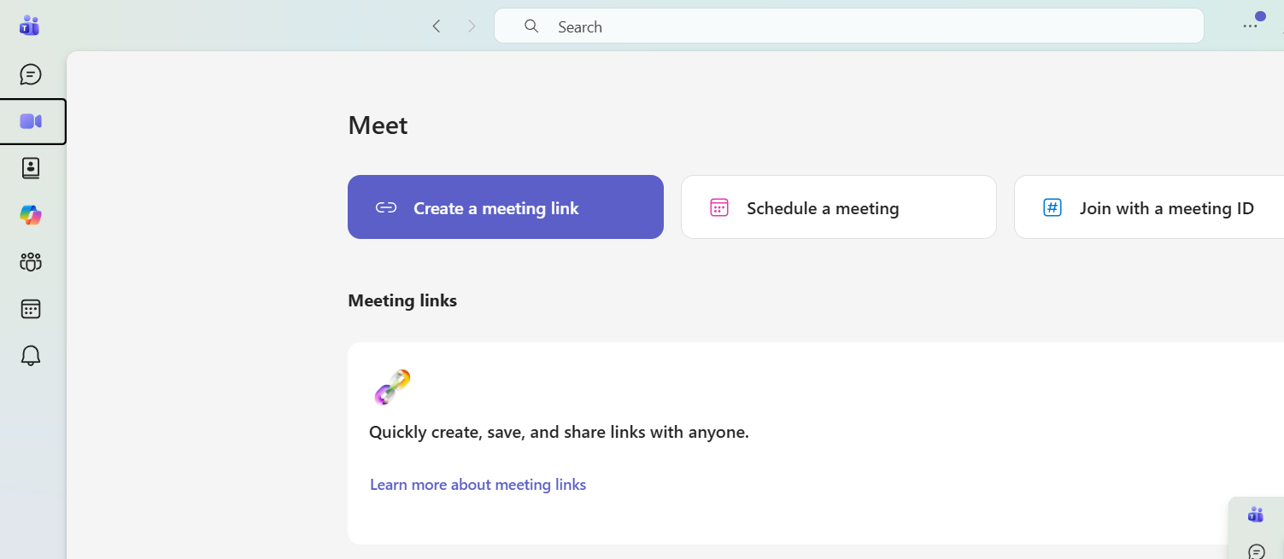
To schedule up a video call meeting click “schedule a meeting”
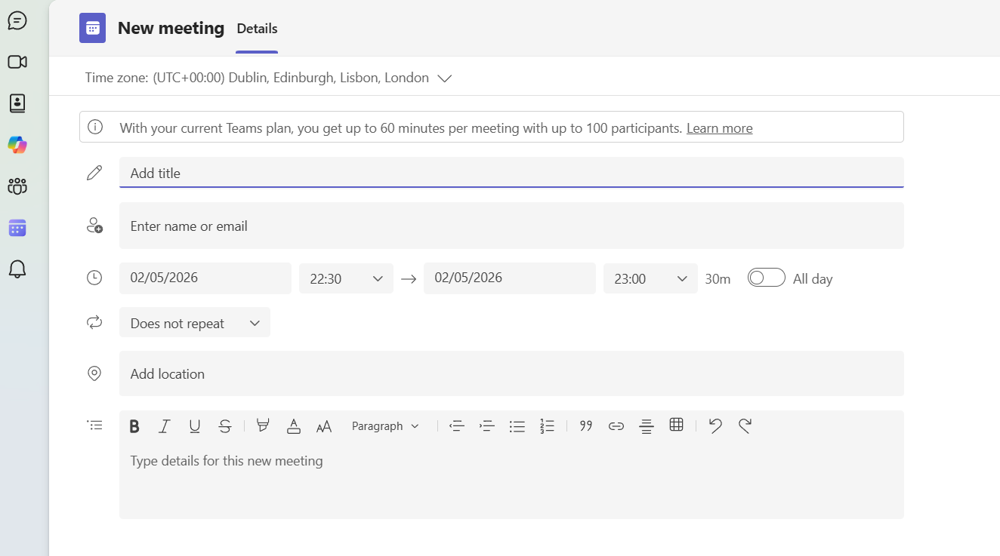
This is where you put detail of the video call meeting
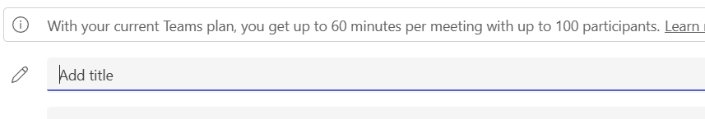
This will be the title of the meeting
Choose who you would like to attend the meeting

Select time and date of the meeting

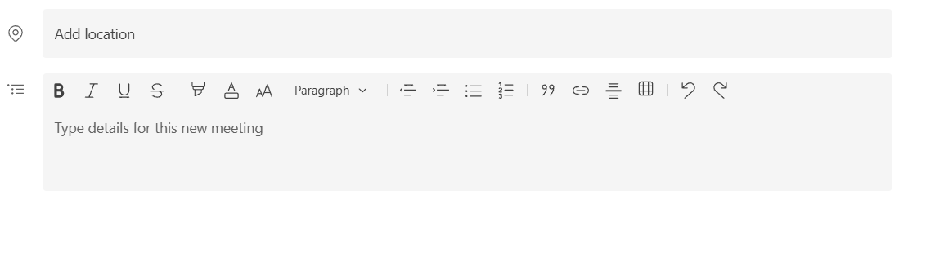
Set the location and any details about the meeting

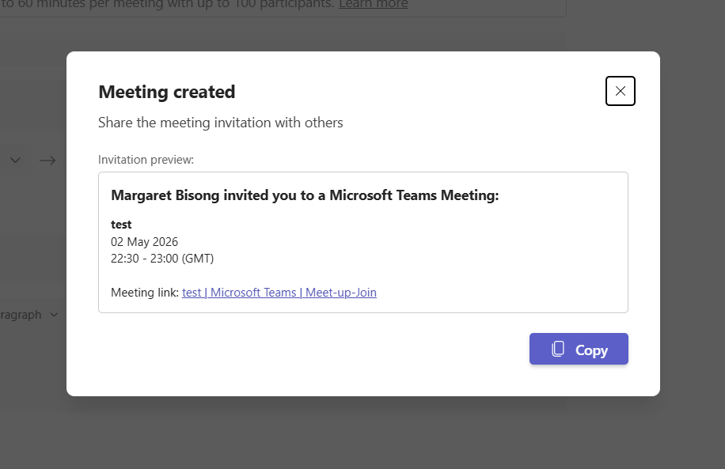
You can also copy and send this to others you may have forgotten or to other applications and will link the to your video call meeting.

Conclusion
My conclusion for this assignment is that software is the solution to a lot of business problems and knowing how to use them and knowing what to use these software applications for is vital. When running a business time, money and space is important to the growth of a business and software application have changed the way business is run. In this assignment I was able to learn and explain the importance of data storage and how to manage it. Documentation and creation, presentation creation and communication these are just a few important software when running a business.

References
References task 1
[1] P. Waddy, Selling Online for Dummies, John Wiley & Sons, 2025.
[2] Y. Cheng, "E-portfolios in EFL writing: Benefits and challenges," vol. 5, pp.52–69, 2022,
[3] J. DeRosa, Building DIY Websites For Dummies, John Wiley & Sons, 2024.
References task 2
[4] S. Windura, Mind map for business effectiveness, Elex Media Komputindo, 2008.
[5] T. Buzan and C. Griffiths,Mind Maps for Business: Using the ultimate thinking tool to revolutionise how you work, Pearson UK, 2013.
[6] F. Rustler, Mind mapping for dummies, John Wiley & Sons, 2012.
References task 3
[7] D. Lowe, PowerPoint 2016 for dummies, John Wiley & Sons, 2015.
[8] T. Hennig, T. L. Bradly, L. Linson, L. Purvis and B. Spaulding,Microsoft Access small business solutions: state-of-the-art database models for sales, marketing, customer management, and more key business activities, John Wiley & Sons, 2010.
[9] B. Kolluri, M. J. Panik and R. N. Singamsetti,Introduction to quantitative methods in business: with applications using Microsoft Office Excel, John Wiley & Sons, 2016.
[10] J. J. Marshall, Beginning microsoft word business documents: From novice to professional, Apress, 2007.
References task 4
[11] R. Withee, Microsoft Teams For Dummies, John Wiley & Sons, 2025.
[12] B. March, The Microsoft Outlook Ideas Book, Packt Publishing Ltd, 2006.
[13] F. Wempen, Outlook for Dummies, John Wiley & Sons, 2021.

