Question 1: Identify and discuss two art movements and evaluate through their differences the worldviews and principles they propose.

Name: Adam Cole

Student number: 2203934

Course: Photography

Module: Ways of Thinking

Tutor: Estefani Bouza

Word Count: 1454 (Not Including Bibliography)

Art movements, which represent the changing viewpoints and ideologies of their respective periods, have been essential in determining the direction of art history. The two art movements I have chosen to study to benefit my essay are impressionism and surrealism. These movements mark notable breaks from the artistic traditions that came before them; they originated in the late 19th and early 20th centuries.
In France, impressionism first appeared in the late 1800s. It has emphasis on preserving ephemeral moments and the influences of light and colour define it. Paintings by the Impressionists expressed a variety of emotions regarding contemporary life, including enthusiasm and fear. They also frequently reflected perspectives on socioeconomic status, development of the economy, science, and technological advancement (Facos. 2011. Page 337). The Dada movement and Sigmund Freud's theories impacted the development of impressionism in the early 20th century, distributing it worldwide and extending the creativity to the world. The rapid, tumultuous pace of contemporary existence, the peculiar appearances of contemporary living, or the visual effects of ordinary experience were all inspiration for Impressionist artists as they strove to develop techniques appropriate for their ideas (Facos. 2011. 337). Between 1860 and 1940, Impressionist painters began to follow different and new techniques to represent reality.
From the moment of its very first introduction to art, Surrealism was internationally admired and discussed (Read. 1971. Page 20). Surrealism emerged out of the political philosophy of Karl Marx and the psychoanalysis of Sigmund Freud and is widely considered to be the highest influential art movement of both the 20th century and modern art (Victoria, Wood. 2007. Page 1). Surrealism intended to get access to the realm of dreams and imaginations and delve into the depths of the subconscious. It places an enormous value on the individual interpretation and perception of the artist towards a scene or subject. Similarly, Impressionism places a strong emphasis on the individual interpretation and perception of the artist towards a scene or subject. It strives to communicate the feelings and sensory experiences of the artist. Paintings by surrealists are full of motifs that mimic jigsaw pieces and are inspired by the contrast between realism and fantasy. The creation of new effects by fusing the two worlds in order to reveal what was concealed in their subconscious is at the heart of surrealism. ( Naderi, Safian, Hossein. 2021. Page 401).

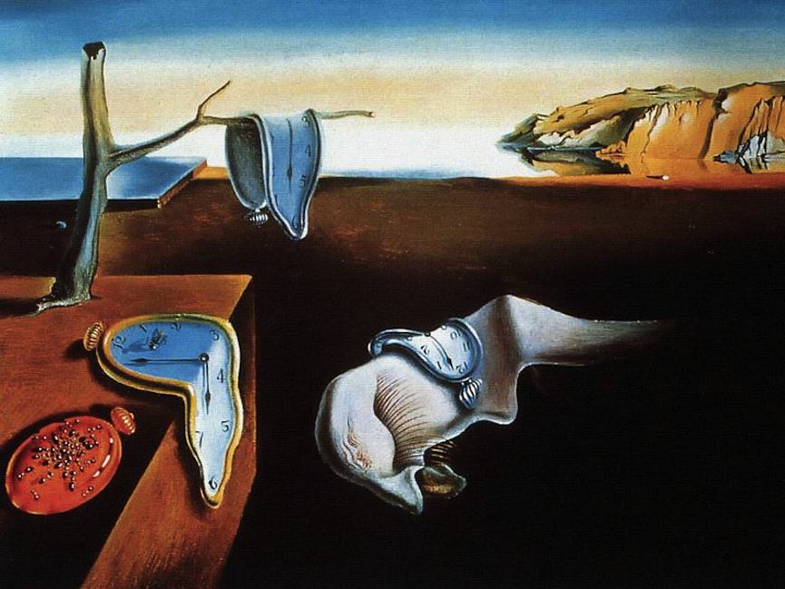
The Persistence of Memory- Salvador Dali. 1931 (Fig.1)

Renowned surrealist artist Dali explored the dreamlike and subconscious domains, as seen by his famous painting titled “The Persistence of Memory” (Fig.1) which displays melting clocks, which defy conventional understanding and represent the fluid aspect of time. Dali used an intricate method known as "hand-painted dream photography", exhibiting precise details. The barren landscape and warped shapes add to the dreamlike atmosphere, which is consistent with surrealism's focus on delving into the unconscious to reveal crucial truths. The artwork was created at a critical juncture in the history of art, given the circumstances of its day. As a leading member of the surrealist movement, Dali aimed to subvert social standards. Semiotics were employed by the surrealists, who were greatly influenced by Freudian psychoanalysis, to interpret dreams and the unconscious. To illustrate this, "The Persistence of Memory" offers a time-warped dreamscape that invites viewers to interpret its symbolic significance.
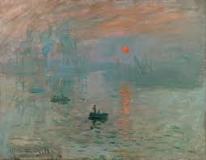
Impression, Sunrise. Monet, C. 1872 (Fig.2)

Much like a lot of his work, Claude Monet's (Dated) 1872 painting titled "Impression, Sunrise" (Fig.2) is a key component of the impressionistic history. The piece is praised for its unique aesthetic and creative method of encapsulating a scenic atmosphere. This painting (Fig.2) is highly credited for perfectly embodying the movement's focus on preserving the passing effects of ambience and lighting. His use of vivid colours and free brushstrokes produce an ambient aspect that emphasises the moment's urgency above detailed representation. This painting is where the word “impressionism” stems from which highlights its historical significance in not just the history of art but the history of the world itself. The piece (Fig.2) perfectly captures the movement's aim of expressing the artist's first impression of a scene. putting traditional realist norms to the test.
Deviating from conventions, impressionist artists eschewed the period's academic norms, which emphasised meticulous representation. Instead, they produced their works quickly and impulsively using broad strokes of paint. Surrealism has a similar method, Surrealism supported methods like automatism, which sought to get access to the unconscious mind, and defied traditional creative and social conventions.
Impressionist paintings frequently represent commonplace sights, landscapes, and moments from everyday life, offering a more approachable and realistic perspective of the world. However, Strange and dreamy aspects, such as twisted or impossible sceneries, dream symbolism, and illogical juxtapositions, are frequently seen in surrealist art. It is not as involved with traditional depictions of reality. This is where Surrealism and Impressionism begin to distance each other with difference.
Impressionism typically conveys a happy and upbeat vision of the world. The movement's emphasis on preserving the beauty of the natural environment and ordinary life provides the possibility of an appreciation of now as well as an awareness for life's transitory moments. The worldview put out by surrealism is frequently defined by a feeling of obscurity, absurdity, and the unsettling. It casts doubt on our understanding of reality and the distinctions between the two types of minds. Compared to Impressionism, it might be considered as being vaguer and more interpretive.
The rejection of conventional creative practices and academic practices is a commonality shared by both groups. Both encouraged artists to develop their own visions by attempting to subvert accepted conventions. They were distinguished, nonetheless, by the methods they employed and the ideas that guided their creative decisions.
In addition to being anti-rational, surrealism is also anti-emotional. Reducing surrealism to its most fundamental components will reveal the only building blocks that any practical edifice can be constructed upon. the fundamentals of psychology and natural science. From that materialistic foundation, we grow. However, we construct, produce. and possess our own building technique (Read. 1971. Page 38). Furthermore, such a re-evaluation of all aesthetic standards is demanded by surrealism. It shows little reverence for academic traditions, especially the 400-year-old previous classical traditions that could be described as capitalist (Read. 1971. Page 45).
The reception of Impressionism in China was determined by the concurrent and postponed entrance of European art in the latter part of the nineteenth and early twentieth centuries. When they were first introduced, they were more concerned with outmoded currents than with researching what would be helpful for the inevitable progression and, in fact, impending upheaval in Chinese art history (Cinquini. 2023. PP, 177-197). Impressionism's response contributed to what has been referred to as "The French Crisis of Chinese Art," an integration of the arts (Cinquini. 2023. PP, 177-197). In comparison to its achievement in Japan, this response would be deemed inadequate in China if its performance was to be assessed. In the end, Impressionism did not supply the primary Western sources of inspiration for the growth of contemporary Chinese painting (Cinquini. 2023. PP, 177-197)
The Art and Liberty movement officially started in 1938 as a response to the emergence of conservative extremism in Europe throughout the second world war. It challenged the established order in politics, the arts, and academics more than nationalism and fascism, which were growing throughout the area. The manifesto written by novelist and philosopher Georges Henein, emphasised the value of creativity and individuality as the primary forces of change (Sotheby’s, 2018). Italian artist Angelo De Riz fled Italy under fascist rule and took sanctuary in Egypt. He later joined the Art and Liberty movement soon after his immigration and subsequently became an Egyptian national. Furthermore, he collaborated extensively with Ramses Younan and Georges Henein with the goal of developing surrealism throughout Egypt and Egyptian art culture (Sotheby’s, 2018) . For a period of eight decades, the movement that left the nation with a significant creative and philosophical heritage was simultaneously forgotten and had its roots altered by those who succeeded it. They were portrayed as an unsuccessful attempt to introduce the Western Idea of idea into Egypt following the conflict, which failed because it was incompatible with the Egyptian way of life. Merely exhibition catalogues and reviews remained after several of the group's members were banished or incarcerated due to their radical beliefs(Martinique. 2017).
In conclusion, individual expression and a break from conventional creative rules are key components of both impressionism and surrealism. Their worldviews and subjects, however, are different. Impressionism offers a cheerful and upbeat perspective on the world while highlighting the beauty of life as it is. Conversely, surrealism investigates the cryptic and irrational facets of human existence by exploring the subconscious and dream worlds, which can lead to a more mysterious viewpoint.

Bibliography

Salvador Dali. The Persistence of Memory. 1931. (Fig.1). The Museum of Modern Art.

Naderi,M. Safian,M. Ardalani,H. (2021). A Critical Study of the Relationship between the Art of Surrealism and truth According to Heidegger. Iran: University of Tabriz, Faculty of Literature and Foreign Languages. (Accessed December 10th, 2023).

Read, H and Breton, A. (1971). Surrealism, Ed. With an Introduction by Herbert Read. London, Faber and Faber Limited. (Accessed December 11th, 2023).

Victoria. Wood,G (Editor). (2007). Surreal Things. London. (Accessed December 11^{th,} 2023).

Facos M. (2011). An Introduction to Nineteenth-Century Art. Taylor & Francis: Routledge. (Accessed December 9th, 2023).

Monet, C. Impression, Sunrise. 1872. (Fig.2). Musee Marmottan Monet.

Cinquini, P. (2023). Impressionism and Post-Impressionism: The controversial Reception in China (1910-1950). Oxford Art Journal. (Online). PP,177-197. Doi: Https://doi.org/10.1093/oxartj/kcad012

Sotheby’s. The Birth of Art and Liberty, Egypt’s Surrealist Movement. 2018. (Online). WOI: https://www.sothebys.com/en/articles/the-birth-of-art-and-liberty-egypts-surrealist-art-movement

Martinique, E. The Thrilling story of Egyptian Surrealism. 2017. (Online). WOI: https://www.widewalls.ch/magazine/egyptian-surrealism

