MARKET RESEARCH

University: University of Wales Trinity Saint David
Module: Digital Skills and Research Methods
Date: 5 th July 2022
Word Count:1743
Student Name: Alina Georgiana Mucenic Student number: 2108840
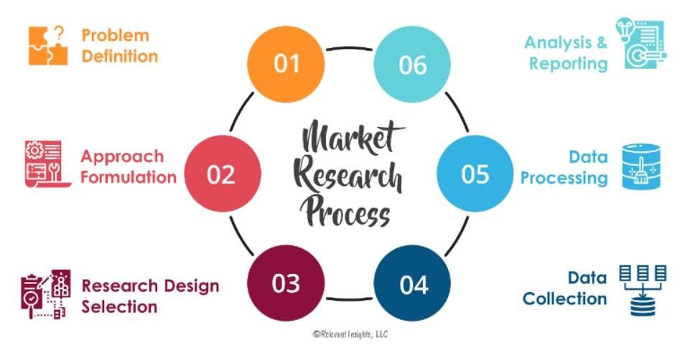
(Mora, 2022)

Table of Contents
Introduction
Market research
Competition analysis and apply
Questionnaire design & analysis
My questionnaire data analysis
Website design analysis
What is SEO and Why is it Important for Primary Research
Conclusion
References

Website login details
Email address: 480happydogs@gmail.com
Password: Rebec@08

Introduction
Professional research techniques are important to grasp reputable sources, and in this evaluation, I will cover how to analyse my questionnaire and website about my business in order to detect patterns and relevant data obtained from that questionnaire and website, as well.
Before I began my business plan, I created a questionnaire to gather data from a certain audience and to extract specific information from the selected respondents in order to further my company concept.
This project's objective is to have an in-depth discussion on market research, with the objectives of acquiring information, searching for credible sources, maintaining organisation, and inquiring about various aspects of sources while evaluating them.

Market research
In this assessment, we will discuss how it is necessary to do professional-level research in order to get a deeper understanding of reliable sources. In addition to that, some of the qualitative and quantitative research that has been conducted will be described in this article, along with the impact that it has had.
In terms of the collection and analysis of data, quantitative research is concerned with numbers and figures, while qualitative research is concerned with words and their meanings.
An in-depth understanding of how individuals perceive their social reality, and how they act in response to that, is provided by qualitative research results.
According to lorraine (2021,0nline) market research can be conducted by amassing secondary resources or by conducting primary research.

Competition analysis and apply
You may need to acquire updates more often (or less frequently) depending on the business you're in. Typically, we suggest doing a competition analysis once a month to keep track of emerging trends and alter your digital marketing plan; and once a quarter to undertake larger adjustments. (How to Do Competitor Analysis in Digital Marketing ,2021, n.d.)

Questionnaire design & analysis
In order to carry out primary research on the market, I design a survey that asks customers about their impressions of how the need of the clients for their pets and their viewpoint of the costs in connection with the services that are being provided, by getting straight to the source and avoid relying on pre-existing data samples. Questionars is an advanced set of research tools that gives you all the resources you need to generate research findings.
Even while primary research offers a lot of benefits, it is not always the most effective kind of research to use in a certain circumstance. It is essential to take into consideration the needs before selecting the most appropriate research approach for the circumstance.
My primary research it is focus on questionnaire data to identify trends and pertinent information about grooming service, age category and location. The design of the questionnaire should never be approached independently, but as an essential part of the successful design of the survey, which includes expecting how the responses obtained will be analysed. (Malcolm Williams
,2003)
The other goal of this project is to find out which investigations are the most common based on the answers to my questionnaire and to see if they fit with the organisational structures that are already in place for my business plan.

My questionnaire data analysis

Understand your target market and your customers' demands, strengthen your connections, determine the important business drivers, and increase your sales process to your services. (Research Software | Research Survey Software and Tool | QuestionPro®, n.d.)
I collect responses from the survey, and there are many different methods of data gathering that may be used to the development of my business plan.
For example our first step in market research, we made a marketing plan based on a survey that asked potential customers about the dog's services, where they lived, and how much money they spend in grooming at the moment.
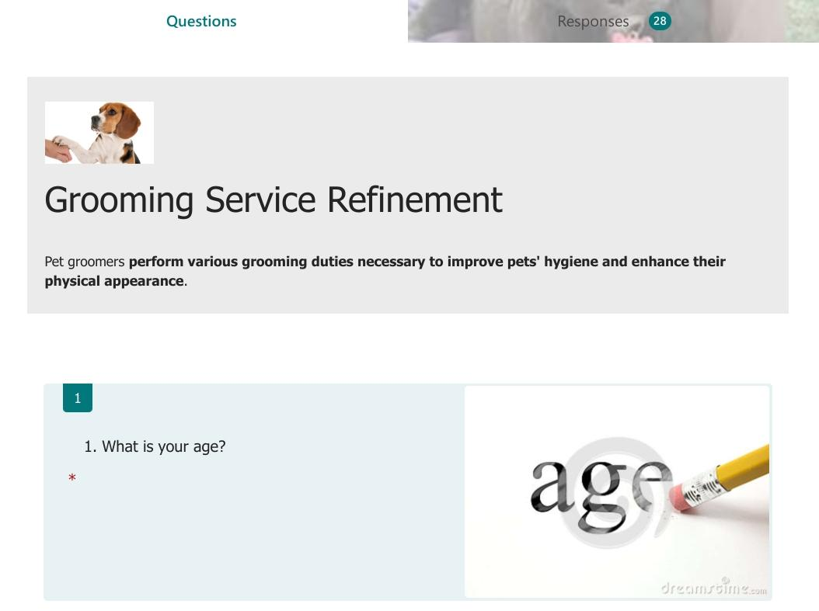

My initial inquiry on the list of things to analyse was "category based on age." Twenty-eight individuals, including both males and females, ranging in age from 18 to 75 were included in the research.

The results of the confirmatory factor analysis indicate that individuals who are between the ages of 35and 54 have the highest probability of being interested in receiving grooming services for their pets.
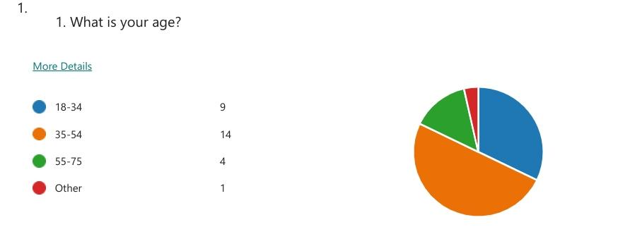

The grooming service relies heavily on its human resource since it must handle the demands of the customers' dogs in order to ensure that both the clients and their dogs are happy with the services provided and the products that are used.
As a consequence, I received a number of responses from people who wanted various kinds of grooming services for their dogs. The most popular response was that the complete set of refinement includes a pre-groom, warm water baths, blow dry, full body style, eyes and ears cleaned, and nail clip.
As well result of the survey data, we were able to determine the precise amount of money that they were prepared to spend on the services provided by our dog salon.

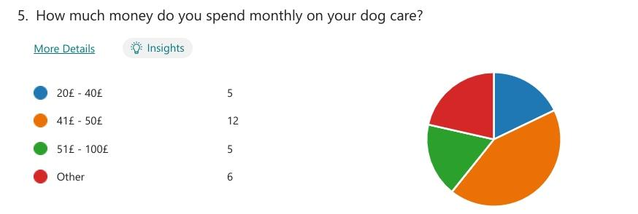

The fact that we were able to receive answers from another question about where we can market our company at the highest possible rates demonstrates that social media is one of the most reliable platforms.
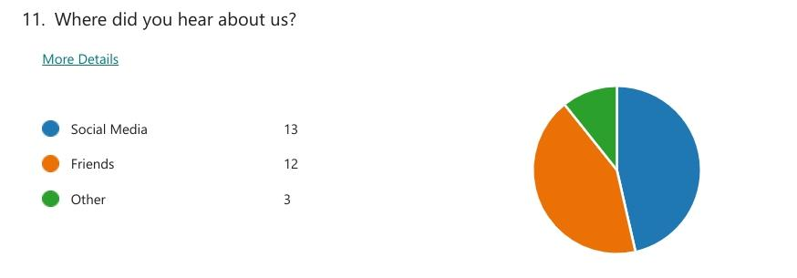

The market research data that I acquired from the questionnaire was of great use to me in the process of developing the website for my business.
Website design analysis
The website design is supported by strategy, is appealing and effective, and meets the needs of the business. When someone visits our website, they immediately understand who we are and what we have to offer. Visitors are guided by our design to do the actions we want them to. It is an obvious tactic.
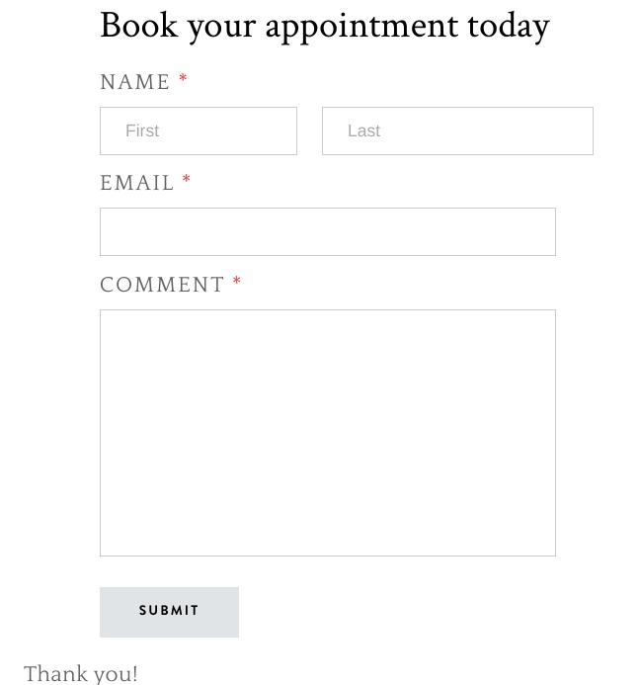

After doing some research, I discovered that yellow, along with black and white, is the greatest colours combination to represent my company. Yellow can quickly grab attention. (The Impact of the Color Yellow on Your Mood, 2022)This is because it satisfies all of the criteria for refined dog care, and it also gives the viewer a pleasant experience when they look at it. Questionnaire data impacted the design of the website, particularly colour theory. However, little is known about how colour influences viewer trust or satisfaction. ( Dianne Cyr, Milena Head, Hector Lariosc,2010) As a result, I picked a yellow design with a great deal of white since it stimulates emotion.

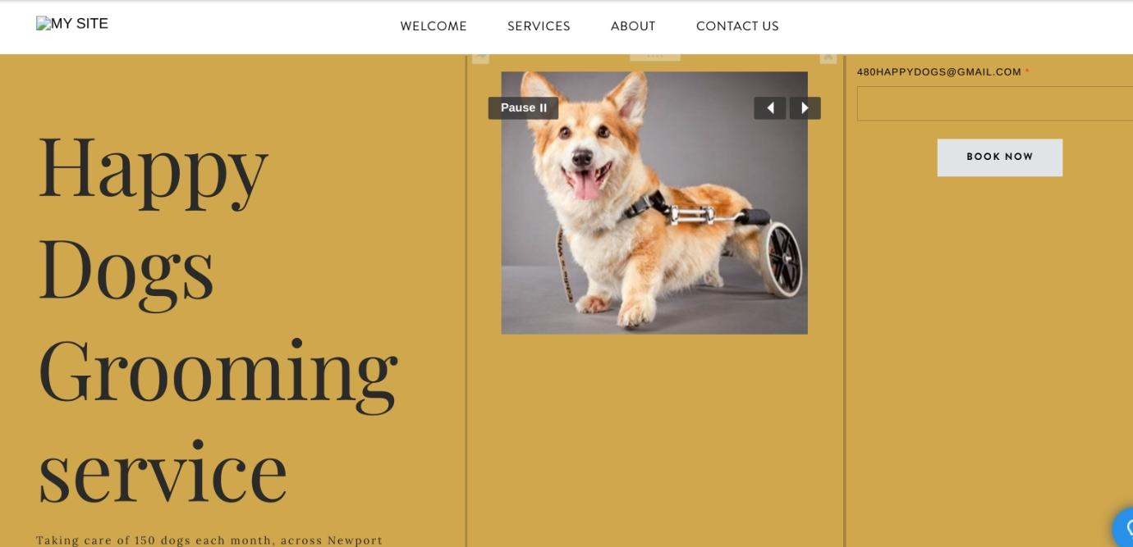

The market research data that I acquired from the questionnaire was of great use to me in the process of developing the website for my business. In light of the findings of my research into the various types of services, I made an effort to construct my website with photographs of both happy and disabled dogs.

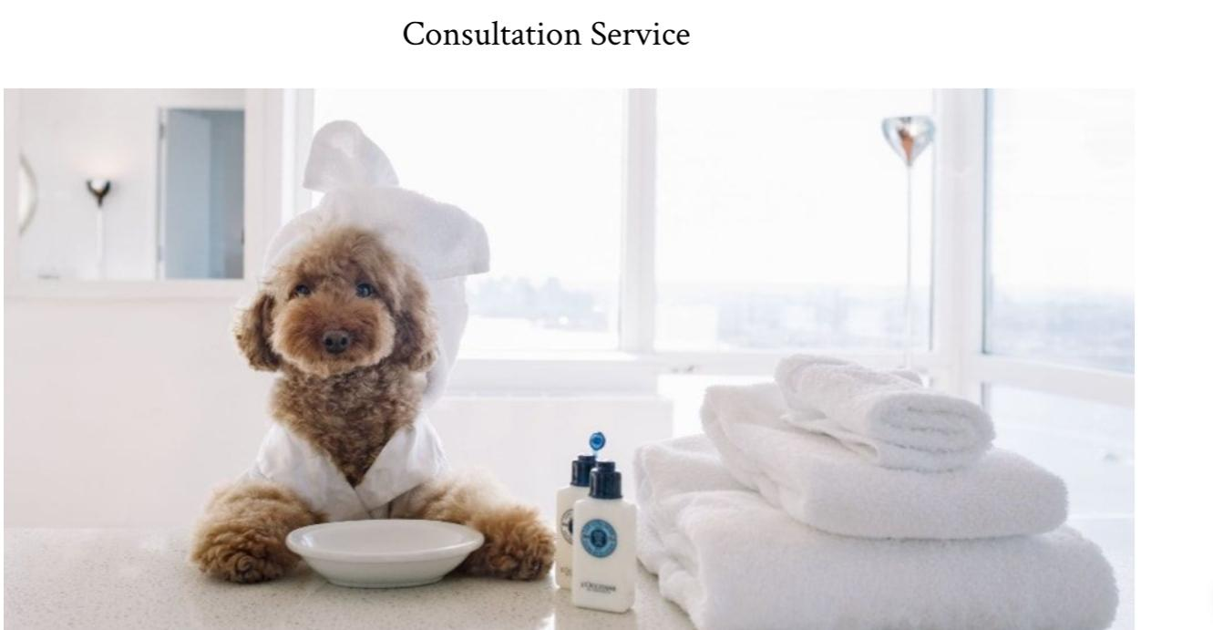
We've incorporated a consultancy service as well, so pups may get the help they need no matter what issues they encounter.

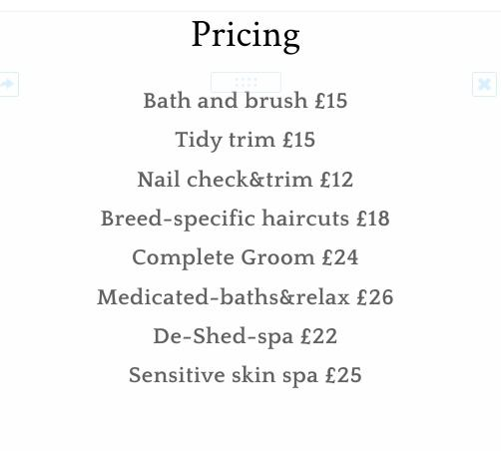
Furthermore, I create a price list for customers because it aids in determining return.
To make it easier for our customers to find us, I've included a section that contains our phone number, email address, and open time hours.
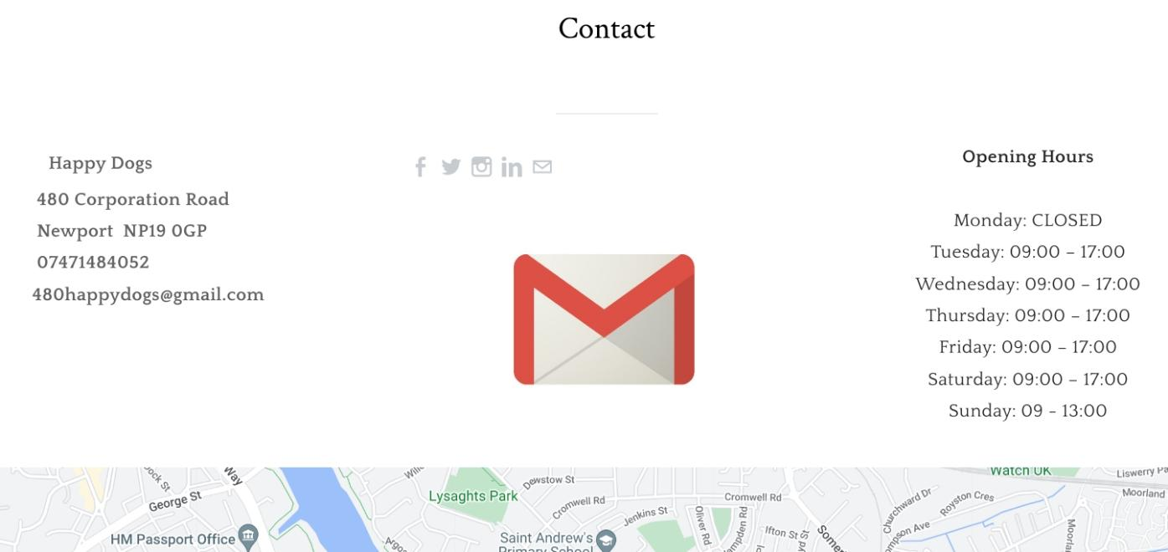

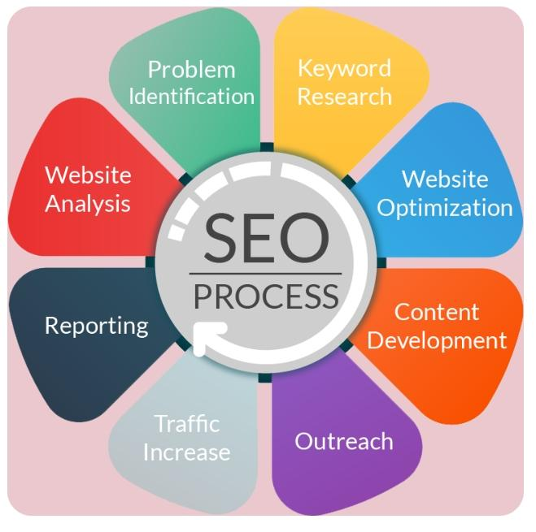
What is SEO and Why is it Important for Primary Research
(SEO Process - Digital Marketing | Digital Marketing Solutions, Website Analysis, Online Marketing Agency, n.d.)

Optimization for search engines, sometimes known as SEO, is a word. This technique includes making use of unpaid search engine results, which are also frequently referred to as "organic." The goal of this strategy is to increase the exposure of your website as well as the amount and quality of traffic that it receives. Despite its name, search engine optimization (SEO) is about more than just search engines. It's also about the individuals involved. It is essential to have an understanding of the concerns and answers that people have when searching for information online, as well as the language that they are using and the kind of material that they are interested in reading. In order to connect with people who are searching online for solutions that you can supply, you will need to know the answers to the questions that are presented below. Your search engine optimization (SEO) may be improved with primary research; material obtained this way is current, pertinent, and unique since it comes straight from the source. Customer surveys and interviews with industry professionals are used in the data collection process. The completion of questionnaires contributes to the development of my SEO strategy and would increase the likelihood that my website would be visited. use primary research to facilitate me with my SEO strategy, such as name, location, and what type of grooming service people preferred for their dogs.

Conclusion

The findings of this analysis lead one to the conclusion that website and market research are used in the process of gaining a deep understanding of the beginning stages of the business organization's management and marketing decision-making processes.

References
- Dianne Cyr, Milena Head, Hector Lariosc,(2010) International Journal of Human- Computer Studies, Colour appeal in website design within and across cultures: Amulti-method evaluation, volume,Pages 1-21,
- How to Do Competitor Analysis in Digital Marketing [2021]. (n.d.). Semrush Blog; www.semrush.com. Retrieved July 8, 2022, from https://www.semrush.com/blog/how-to-do-competitor-analysis-in-digital-marketing/?kw=&cmp=UK_SRCH_DSA_Blog_Core_BU_EN&label=dsa_pagefeed&Network=g&Device=c&utm_content=515816506010&kwid=dsa-1053501811347&cmpid=11776881484&agpid=113846073105&BU=Core&extid=20206706387&adpos=&gclid=CjwKCAjwq5-WBhB7EiwAl-HEklpviP18FpQxmzllJRdoD7sbpdhjgxNw4GvCaiu_QlCJjUV6r8EuVRoC9MwQAvD_BwE
- lorraine. (2021, July 26). The Importance of Market Research for Any Business - Pollfish Resources. Pollfish Resources; resources.pollfish.com. https://resources.pollfish.com/market-research/the-importance-of-market-research-for-any-business/?utm_source=google&utm_medium=cpc&utm_campaign1=gsem_col-dsa_gr-resources&utm_adgroup1=dsa_resources_market-research&utm_term=&utm_sitelink={sitelink}&utm_device=c&utm_creative=388148025339&gclid=CjwKCAjwq5-WBhB7EiwAl-HEkvtRZCpRpqSqWV93KWRprcrhhga_6NdDkiux59zxrZ55VOjfrTR6WBoCZ10QAvD_BwE
- Mora, M. (2022, March 15). Step by Step Guide to the Market Research Process - Relevant Insights. Relevant Insights; www.relevantinsights.com. https://www.relevantinsights.com/articles/step-by-step-guide-to-the-market-research-process/
- Malcolm Williams (2003), Questionnaire Design,Making Sense of Social Research,ARTICLE available at https://dx.doi.org/10.4135/9781849209434.n7
- Our Market Research Techniques - Spark Market Research. (2022, February 17). Spark Market Research; www.sparkmr.com. https://www.sparkmr.com/market-research-techniques/?utm_source=google&utm_medium=search&utm_campaign=13039_spark_agency_brand_awareness
- Research software | Research survey software and tool | QuestionPro®. (n.d.). Research Software | Research Survey Software and Tool | QuestionPro®; www.questionpro.com. Retrieved July 8, 2022, from https://www.questionpro.com/research-edition-survey-software/?utm_source=Google&utm_medium=Paid&utm_campaign=QuestionPro+-+Product+Specific+Campaign&utm_id=QuestionPro+-+Product+Specific+Campaign&gclid=CjwKCAjwq5-WBhB7EiwAl-HEknUfdOFsQk3N3pluGTiEIUsaU9VOlsXuaVG7d2Tk_0B2USm29NoGWRoCE1sQAvD_BwE
- SEO Process - Digital Marketing | Digital marketing solutions, Website analysis, Online marketing agency. (n.d.). Pinterest; www.pinterest.co.uk. Retrieved July 8, 2022, from https://www.pinterest.co.uk/pin/477451997985696314/
- The Impact of the Color Yellow on Your Mood. (2022, May 11). Verywell Mind; www.verywellmind.com. https://www.verywellmind.com/the-color-psychology-of-yellow-2795823
- 5 Ways to Evaluate the Quality of Your Website Design. (2015, April 23). Straight North; www.straightnorth.com. https://www.straightnorth.com/insights/5-ways-evaluate-quality-your-website-design/

all accessed on July 5 2022

