

Programme: BSc (Hons) Health and Social Care

Change makers: Creativity & Value Creation

Module code - BMHP5014 -BIRM
Lecture: Elena Leonova.
Student Name: Alessandra Vinhal
Student number: 2244815

Table of Contents
Task 1 – Concept Map 3
Task 2 - Self-Reflection of Group Activity 4
Task 3 - Case Study of a UK innovation 5
Task 4 - Research Task 7
Task 6 - NHS Leadership Framework Analysis 8
Task 7 - Self-Reflection Journal Entry 10
Reference List 11

Task 1 – Concept Map
- 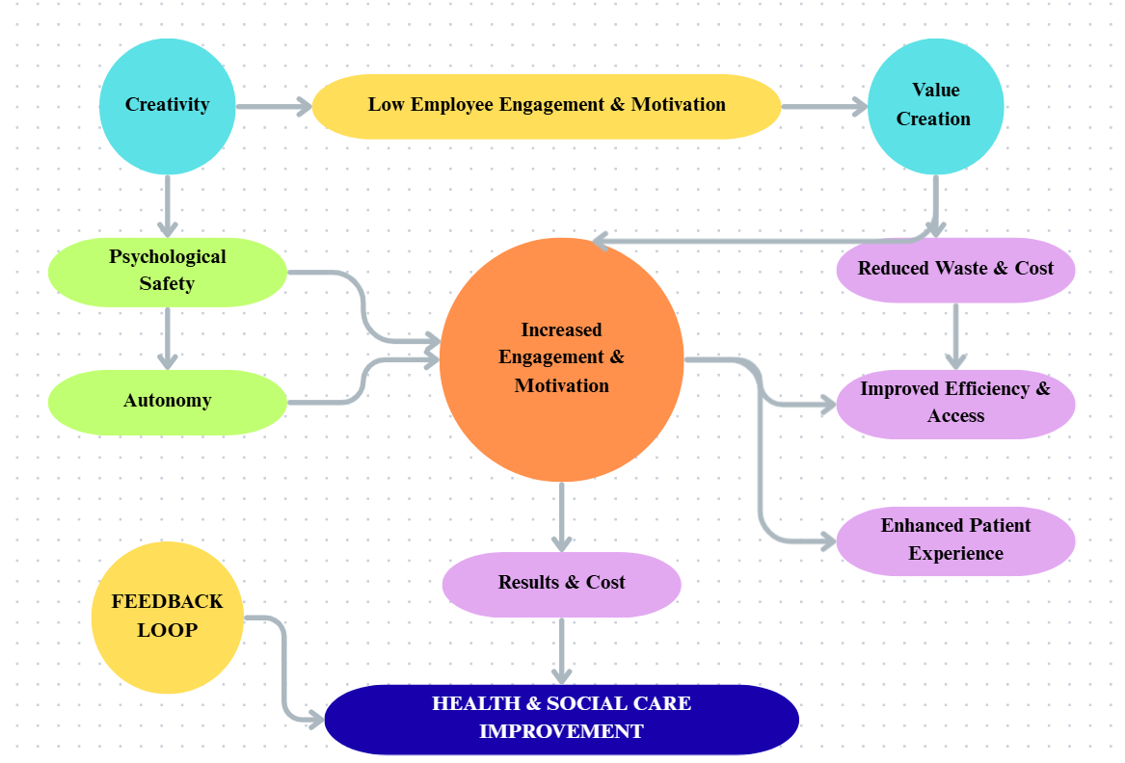
- Figure 1: Conceptual Map
A crucial relationship in health and social care, starting with the core problem of low employee engagement & motivation, is being established through the above conceptual map. From the above map, it can be understood that creativity acts as a direct solution to this problem, as it empowers the organisations to think innovatively about processes, patient pathways, and service delivery. It has been found that 53.9% Residential care locations and 58.5% Domiciliary care settings find it difficult to retain employees (GOV.UK, 2025). This shows the low engagement and motivation of the employees within the health and social care (HSC sector). Employees can gain both Psychological Safety and Autonomy due to creativity (Wang, Kang and Choi, 2022). These factors are of utmost importance in increasing engagement & motivation among staff.
Furthermore, value creation within the company is driven by engagement and motivation (Waseem, Biggemann and Garry, 2021). Tangible improvements such as reduced waste & cost, improved efficiency & access to services, and an enhanced patient experience can be obtained within HSC by focusing on value creation. Thereby, the organisations within the sector can attain better patient outcomes, more sustainable services, and a more positive working environment through these outputs of value creation, which contribute to overall Health & Social Care Improvement. The map also indicates that creativity and engagement can further be reinforced through a feedback loop.

Task 2 - Self-Reflection of Group Activity
Description
I was assigned in a group of 3-5 members where I was expected to generate as many as uses possible for a paperclip with 10 minutes (Divergent Thinking). In the second part, we were expected to reflect on the previous activity and then make notes based on the process or experience (convergent thinking).
Feelings
Although I felt excited and competitive during the divergent phase. The time limit initially stressed me immensely for which I struggled to outline a cumulative knowledge on paperclip.
Evaluation
I was capable outlining the uses of paperclip although there was a bit of conflict in the team as we lacked a common understanding. Such an approach created room for rapid, unfiltered idea generation. I assessed the associated risk and practicality of the ideas by the associated risk and practicality of the ideas.
Analysis
The approach has been successful as creativity gets stifled under rigid conditions, which silence voices and limit collaboration (Laker, 2024). Based on the past experience of the paperclip activity, I realised the main issue was related to ineffective time management and communication skills which prevented us from reaching a uniformity on the topic, which to some extent undermined the result. The activities fostered the notion that divergent thinking is about quantity while convergent thinking emphasises the simple best solution.

Conclusion
In conclusion, which helped us to be creative and solve the paperclip activity.
Action Plan, in future, I will intentionally apply the divergent phase (brainstorming 15+ solutions) before attempting the convergent phase.

Task 3 - Case Study of a UK innovation
Case Study: Artificial Intelligence in NHS Diagnostic Imaging
The throughput and volume needed for adequate diagnosis, especially during time-limited specialties like chest imaging, have pushed the NHS to the limit, especially during such moments like the pandemic that ensued in the wake of the COVID-19 pandemic. The Traditional image analysis system is marred by bottlenecks, delays in treatment, and excessive stress on radiologists and radiographers, that is very much dependent upon human clinical experience (Karera, Davidson and Engel‐Hills, 2024).
Creativity and Change Driver
This project is aimed at bringing together chest imaging scans into one single central database, coined as the NHS Chest Imaging Database. This database enables the provision of an engine for change using a cutting-edge method of data centralisation. This innovation was based on the core concepts of object classification and recognition. Herein, the examples include signs of pathology or lung disease. This, in turn, helps in delivering more consistent and faster results based on the application of advanced technologies. This approach forces change based on the design of a computerised 'co-pilot' for physicians. Herein, the transition will effectively alter the pace and accuracy of clinical routes based on an algorithm that provides almost instantaneous analysis and notification of potential issues from a single human-dependent diagnostic system.
Value Created for Patients
The use of this technology can yield significant benefits for both the patients and the healthcare institutions:
- Accelerated Diagnosis: Firstly, the speed of the technology is notable. With this speed the company will be able to significantly reduces the time between imaging and diagnosis. This will allow the company to make critical decisions within a short time span.
- Improved Accuracy and Consistency: Moreover, the technology has the potential to reduce the number of errors within the process by automating the steps. The mistakes from this infrastructure will be very less in comparison to the mistakes done by the human. Hence, NHS will be able to provide the patient with a high quality of care environment.
- Enhanced Staff Capacity: The technology makes the most of limited man-hours by shifting the original labour-intensive work of image sorting and preliminary analysis so that highly trained radiologists can dedicate their time and talent to the most problematic or uncertain cases.
- Better Treatment Planning: Hospitals can produce better outcomes through enhanced treatment planning so that interventions are developed specifically for the individual anatomical needs of the patient through the help of AI-based segmentation techniques.

Task 4 - Research Task

Vulnerable Group Access to Care is a widespread system and structural problem in health and social care that is commonly compounded by migration status issues, digital exclusion, and socioeconomic deprivation.
Fauk et al. (2022): Barriers for Ex-Migrant Workers, The paper delves into concerns of HIV-positive migrant workers who try accessing host nations' care services. It was established that the major gap between susceptible persons and established healthcare infrastructure has been created because of structural and system-level obstacles. Navigating proved all but impossible by virtue of illegal worker status and the absence of pre-travel information regarding the pre-trip healthcare systems of the host nation. Further, attempts towards seeking formal treatment proved complicated because of Limited level of expertise in the language of the host nation and overall ignorance of the way the healthcare system operates. Hence, because of the continuation of these challenges and peer influence, persons, rather than accessing formal services for HIV, resorted to self-medication that is a greater harm to their health.
Yap, Xu and Tan (2021):
A paradoxical dynamic is often created that intensifies the vulnerability of certain consumer groups due to the rapid integration of digital technology, especially during a crisis. The author critiqued the application of technology by underscoring its potential to introduce new forms of vulnerability, besides being a solution for coping with crises. 9The risks for disadvantaged groups like the elderly, socially isolated, or financially constrained who lack the necessary digital access, literacy, or equipment get heightened due to increased technological reliance. Sudden changes in consumption methods (forced switch to online appointments) during the crisis have the potential to push the traditionally non-vulnerable people into a state of temporary powerlessness (vulnerability), which can either be an enabler (providing telemedicine access) or an impediment (creating anxiety, data security risks, and distrust) for service users.
Task 5-
Podcast
Record a 2-minute. https://www.rev.com/app/file/NjkxYTU5Zjg1ZTdiYWQxNWNkM2Q5ZDdhTTZXX0JjMU5FQ1lG

Task 6 - NHS Leadership Framework Analysis

The NHS Leadership Framework is rooted in the concept of shared or distributed leadership, which is applicable to all staff in health and care, regardless of their specific role or function
(NHS, 2011). This runs on the philosophy that leadership can come from anyone within the organisation, irrespective of their position. The Framework is built around seven domains, which are related to the delivery of service and patient care at its core. Employees can understand. The organisation with this framework can create and implement a talent management strategy, reframe an existing leadership development programme, training and development programmes, contribute to recruitment and retention processes and much more. Moreover, this framework is supported by tools like self-assessment and 360° feedback, which shed light on the strengths and areas for development. The seven components of the framework include:
- Demonstrating Personal Qualities (self-awareness, acting with integrity).
- Working with Others (building relationships, encouraging contribution).
- Managing Services (planning, managing resources and performance).
- Improving Services (ensuring patient safety, encouraging innovation).
- Setting Direction (applying evidence, making decisions).
- Creating the Vision (developing and communicating a compelling vision for the future).
- Delivering the Strategy (developing, agreeing, and embedding strategic plans).
Application of a Component to Encourage Creativity and Improve Care
The chosen component from the framework is ‘improving services’, which is focused on the delivery of high-quality services and developing improvements. Under this, the element leaders can foster creativity and improve patient care by actively cultivating a safe, inquisitive culture by emphasising the element ‘Encouraging Improvement and Innovation’ (Zhang, 2024). The leaders can get innovative ideas from employees who are closest to the challenges and opportunities in care delivery by listening to their views and perceptions. This may require the leader to establish mechanisms which facilitate the employees to submit, discuss, and critically evaluate new suggestions. Further, it is important that these leaders make the staff feel secure while taking calculated risks by viewing mistakes as learning opportunities rather than failures. The leader directly links staff creativity to tangible improvements in patient health outcomes by championing successful experiments and actively facilitating their transformation into new service standards.

Task 7 - Self-Reflection Journal Entry
Journal Entry: Creativity, Value, and My Professional Practice
Date: 15th October 2025
The introduction of the Changemakers: Creativity & Value Creation module completely changed my working life perception because it shifted my creativity meaning from a vague notion to a describable, strategic vehicle of change for Health and Social Care (HSC).
Now I understand that creativity holds the key par excellence to systemic issues such as poor employee motivation and engagement in the profession. This change of attitude has very significant impacts in my work life because I know that Psychological Safety and Autonomy, the key needs of frontline staff, are obtainable through creativity. Conversely, this increased participation also inspires the workers to get involved in innovative processes. It is no longer associated with budgetary performances but a complete performance encompassing physical and intangible advancements such as quicker diagnosis, enhanced patient access, and a sustainability workplace I also very much believe that the group activity around Divergent and Convergent Thinking proved to be a most important lesson in how to change the way of thinking towards creativity. The module has also impacted my professional practice because I am now using the NHS Leadership Framework's 'Improving Services' area when I assess my role.
Conclusion:
In conclusion, it can be sated that through this project and module, I have been able to grasp the underlying significance of the role of creativity in driving value creation and improvement within the Health and Social Care (HSC) sector. The concept map posits that creativity fosters psychological safety and autonomy with the workplace, which is essential to address to core issues of the sector, like employee engagement and motivation. It is reflected that creativity is essential to increase employee motivation, which in turn is required for value creation and tangible improvement, like reduced waste and cost, improved efficiency and enhanced patient experience. I have seen how big choices on public spending starting in 2010 were mainly responsible for the accelerating decline if the NHS in the decade that followed. The implications for the future are clear.
The case study of the NHS’s use of artificial intelligence for diagnostic imaging exemplifies this ideology. The portfolio has also reinforced the importance of practices like combining Divergent and convergent thinking. The Improving service’s component within the NHS leadership frameworks is a key element which helps companies to foster creativity by champion successful experiments.
Leadership in health and social care building upon understanding of ethics knowing what's right or wrong. Demonstrating Personal qualities be self-aware, manage yourself well, keep learning and act with integrity. Improving services, Develop and communicate.

Reference List
Fauk, N.K., Gesesew, H.A., Seran, A.L., Raymond, C., Tahir, R. and Ward, P.R. (2022) ‘Barriers to accessing HIV care services in host low and middle income countries: views and experiences of Indonesian male ex-migrant workers living with HIV’, International Journal of Environmental Research and Public Health, 19(21), pp. 1-14. Available at: https://doi.org/10.3390/ijerph192114377
Karera, A., Davidson, F. and Engel‐Hills, P. (2024) ‘Operational challenges and collaborative solutions in radiology image interpretation: perspectives from imaging departments in a low‐resource setting’, Journal of Medical Radiation Sciences, 71(4), pp.564-572. Available at: https://doi.org/10.1002/jmrs.815
Laker, B. (2024) Why Rigid Hierarchies Might Be Killing Your Team’s Creativity. Available at: https://www.forbes.com/sites/benjaminlaker/2024/08/15/why-rigid-hierarchies-might-be-killing-your-teams-creativity/ (Accessed: 15 October 2025).
Murray,J.(2025)’alarming rise’ in mental health stigma in England, research shows Available at: https://www.theguardian.com/society/2025/oct/15/alarming-rise-in-mental-health-stigma-in-england-research-shows(Accessed:18 October 2025).
Maguire, D., Honeyman, M., Fenney, D. and Jabbal, J. (2021) Shaping the future of digital technology in health and social care. Available at: https://assets.kingsfund.org.uk/f/256914/x/f6444844fd/shaping_future_digital_technology_health_social_care_2021.pdf (Accessed: 15 October 2025).
NHS (2011) Leadership Framework. Available at: https://www.leadershipacademy.nhs.uk/wp-content/uploads/2012/11/NHSLeadership-Framework-LeadershipFramework.pdf (Accessed: 15 October 2025).
Wang, W., Kang, S.W. and Choi, S.B. (2022) ‘Servant leadership and creativity: A study of the sequential mediating roles of psychological safety and employee well-being’, Frontiers in psychology, 12, pp. 1-13. Available at: https://doi.org/10.3389/fpsyg.2021.807070
Waseem, D., Biggemann, S. and Garry, T. (2021) ‘An exploration of the drivers of employee motivation to facilitate value co-creation’, Journal of Services Marketing, 35(4), pp.442-452. Available at: http://dx.doi.org/https://doi.org/10.1108/JSM-11-2019-0458
Yap, S.F., Xu, Y. and Tan, L. (2021) ‘Coping with crisis: The paradox of technology and consumer vulnerability’, International Journal of Consumer Studies, 45(6), pp.1239-1257. Available at: https://doi.org/10.1111/ijcs.12724
Zhang, Y. (2024) ‘Cultivating a culture of innovation: The impact of leadership style on employee well-being and organizational creativity’, International Journal of Global Economics and Management, 2(1), pp.202-210. Available at: https://doi.org/10.62051/ijgem.v2n1.26
GOV.UK (2025) Adult social care workforce survey: April 2025 report. Available at: https://www.gov.uk/government/statistics/adult-social-care-workforce-survey-april-2025/adult-social-care-workforce-survey-april-2025-report (Accessed: 15 October 2025).

