

TITLE PAGE
Smart Student Attendance Management System
Module: Enterprise & Project Management
Student Name: Muhammad Ali
Student ID: 2440033
Submission Date: 24 July 2026
University: University of Wales trinity and saint David
Lecturer Name: Dr Osman Elgawi

Table of Contents
TITLE PAGE 1
INTRODUCTION 4
Project management and planning 4
Project Aim 4
Proposed solution 4
Technology and resources 4
Project constraints 5
Technical constraints 5
Gant Chart 5
Development method 6
Project design 7
System flow chart 8
Enterprise and innovation 8
PEST Analysis 8
Politica 8
Economic 8
Social aspect 8
Technology 9
Strengths and Weaknesses (SWOT Analysis) 9
Strength 9
Weaknesses 9
Opportunities 9
Threats 9
Legal and ethical considerations 9
Password protection 9
Safe code processing 9
Accessibility and fairness 10
Business plan for the startup 10
Legal setup 10
Logo and style 10
Sales strategy 11
Funding plan 11
Project reflection 11
Database management 11
Difference between PEST and SWOT analysis 12
Project management experience 12
Benefit to the school and society. 12
Project risks and solutions 12
Conclusion 13
References 14

INTRODUCTION
Technology is widely used in the education system to improve quality and performance. Many schools and colleges still use an old paper-based attendance system, which can be slow and full of mistakes. My project aims to create a smart attendance system to allow universities and schools to record attendance digitally. This system will reduce the use of paperwork and save time and effort. This report will discuss design, planning and pros and cons of the system.
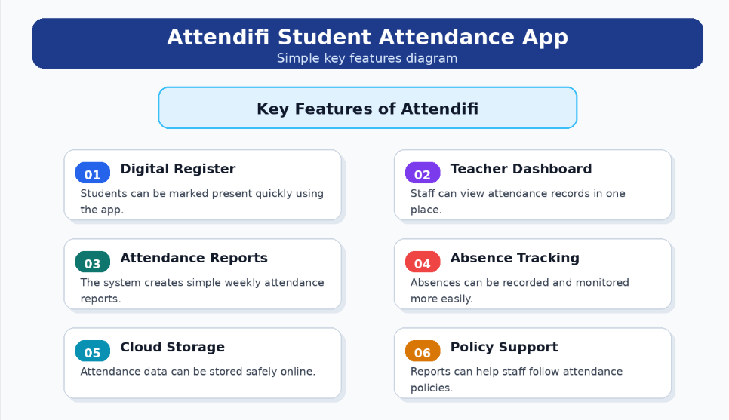

Project management and planning

Project Aim
The project aims to develop a smart student attendance system that allows teachers to record attendance digitally through the software. Public input can be vital for project management. [1].the project management plan is primarily made up of subsidiary management plans, such as the risk management plan, along with the project baselines, such as cost [2].
The app has three main features.
Admin dashboard: for office staff to upload student lists, set up class meetings and download attendance
Teacher screen: for the lecturer to see the list of students to mark their attendance

Project scope:
The system will allow teachers to log in using their details, like email and password, which will be stored in their accounts. then teacher will be able to manage student records to mark attendance and store their data securely. The application will avoid complex hardware installation or physical card readers finger prints and scanners. The whole solution is based on web browser architecture. The project scope for most projects won't be created in one setting or in one day. [3].

Proposed solution
The web-based application will help teachers to record attendance digitally. The system will store attendance in data base and generate reports if needed. The system will be called attendifi.

Technology and resources
Technology purpose
HTML user interface
JavaScript website functions
Python backend coding
Laptop&internet resources for the project

Project constraints
The project must be completed within the time frame. Reduce development time for advanced features. The project needs to be on budget. Due to the limited timescale, technical issues can arise.

Technical constraints
WEEK ACTIVITY
Week 1 | research
Week2 | Gather all the information.
Week3 | Implement design
Week4 | Implement database
Week5 | testing
Week6 | Evaluation and implementation

Gant Chart
A Gantt chart is the project management tool used to plan and track tasks over time. A Gantt chart will show activities on one side and the timeline to complete these tasks, such as in weeks, days or months. The length of the bar will show how long the task will take, and its position will show how long it will take to finish the task. The Attendifi chart will include research, planning, database setup, coding, testing and final evaluation. A gantt task will show which week it will happen and when it will finish. The main purpose of a Gantt chart is to make project planning easy to understand. When the task will be completed, and which task will overlap. A Gantt chart is useful because it will help manage time, avoid delays, organise work and monitor progress. if task takes longer than expected, the chart can be updated. More simply, it visual way to communicate a project schedule.

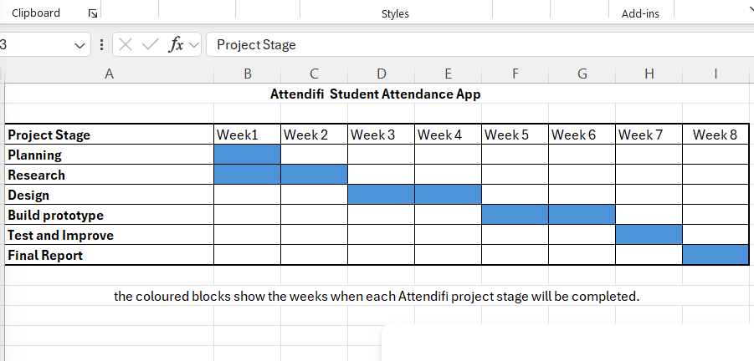

Image: GHANT CHART

Development method
We use an agile methodology, which means breaking down processes into smaller and manageable tasks. We repeat the cycle to achieve our objectives. This method helps flexible development and easy to make changes, and helps solve problems quickly. Agile development methods support mainly component-oriented software. Agile methods can be adaptive and reduce documentation. [4].
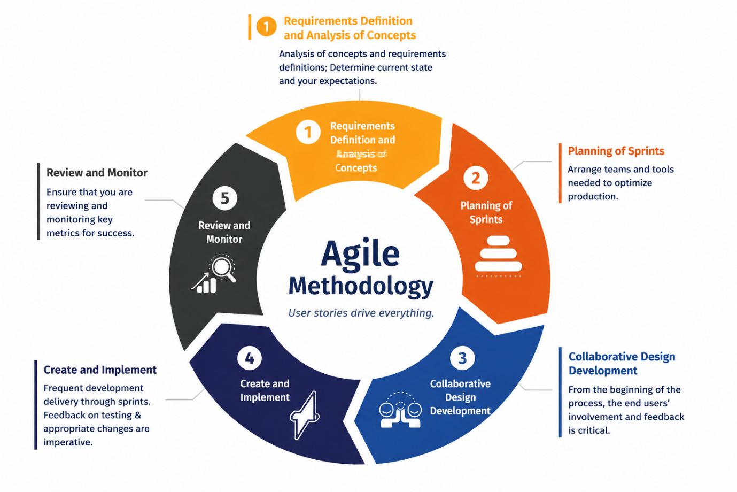
C:\Users\alib6\Pictures\Screenshots\agile methology.png

Project design
This project is designed for teachers to log in and mark student attendance digitally. This system can also generate reports if needed. The teacher and students can both view their attendance history. The programme also needs to have security features, reliability, and be easy to use for users.

System flow chart
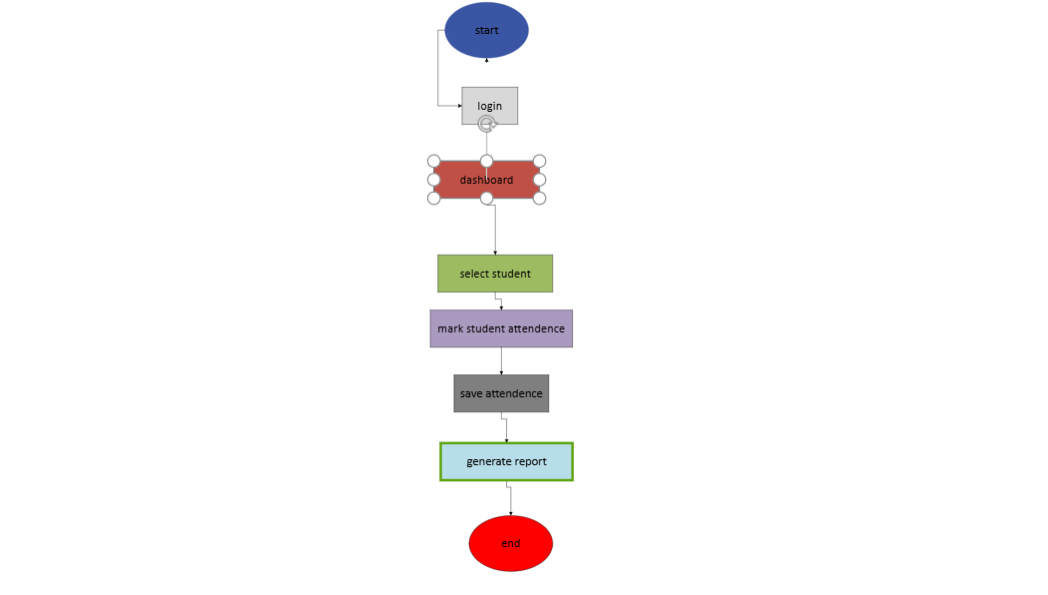
Drawing.vsdx

Enterprise and innovation

PEST Analysis
To sell attendance to the schools and universities, we need to understand the market trend using PEST.PEST analysis is also called environmental analysis.is made from the initial four words: politics, economy, society, technology [5].
Political: the government require schools to provide the attendance data before giving them funds to make sure students are attending the school. For international students, the visa rule also states that they have to attend schools or universities and report students who are skipping and missing classes.
Economic: Schools get a limited budget from the government. They cannot afford to spend thousands of pounds on these expensive app card readers or fingerprint machines. But the web app is a cheap and reliable alternative for schools and universities because they are web base and can be downloaded on all kinds of devices, ready to use.
Social aspect: students these days are familiar with modern technology like smartphones. Students will prefer a quick, smart login rather than waiting in long queues to tap their physical card.
Technology: these modern web browsers are fast and reliable, allowing small companies to host useful web software cheaply.

Strengths and Weaknesses (SWOT Analysis)
Swot analysis helps you understand the product attributes, the competition, and sales opportunities. [6].
Strength: the app is very simple to use, load, and works fast. The app requires no technical training, and it is free to install on most devices. It will help students and organisations to mark attendance just on their fingertips, which is very easy to use. Students and organisations can keep a digital record in no time, maintain attendance and generate quick reports if needed, which can be printed straight away too.
Weaknesses: the app has some weaknesses as well because it completely relies on the internet and smart phone. If the wifi goes down app will not be able to work. The student will not be able to check in until the connection is restored. Another main limitation for the app is to have the smart phone. If any student doesn’t have smart phone, that student won't be able to log in.
Opportunities: the app can be sold in the market for business purposes. The app can be marketed in seminars, meetings and social media.
Threats: The schools that have extra funding or have some funding left can build the same type of app to give competition. They can create their own free check-in system.

Legal and ethical considerations
The fact identifi stores private data like students' names. their number and email address. So the app needs to follow the UK Data Protection Act 2018
To stay fully legal, the software needs to have three protections
Password protection: the app does not save student passwords. The app encrypt end to end data. If the hacker steals data, it will remain safe.
Safe code processing: the backend uses configurable data enquiries. This stops hackers' attacks by spreading malicious spyware.

Accessibility and fairness
Software must be easy to use for all users. We must support students from low-income families who cannot afford to have a smartphone.to insure fairness attendifi includes a manual switch to the teacher screen. If the student has no phone teacher can click their name manually.

Business plan for the startup
To turn this project into a commercial business, we will set up a company called Attendifi System Ltd. Writing a business plan not only helps you stay on track, but it can also help secure funding. [7].most software accessibility requirements and recommendations cannot be automatically evaluated [8].

Legal setup: the business will register as a PRIVATE LIMITED COMPANY(LTD). By registering, the company user will be protected by separating personal savings from company debts. This means that if the business is facing financial troubles, personal assets like homes and bank accounts will be safe.
Logo and style: Creating a company logo will help the company to get recognised fast, and people will remember it quickly.
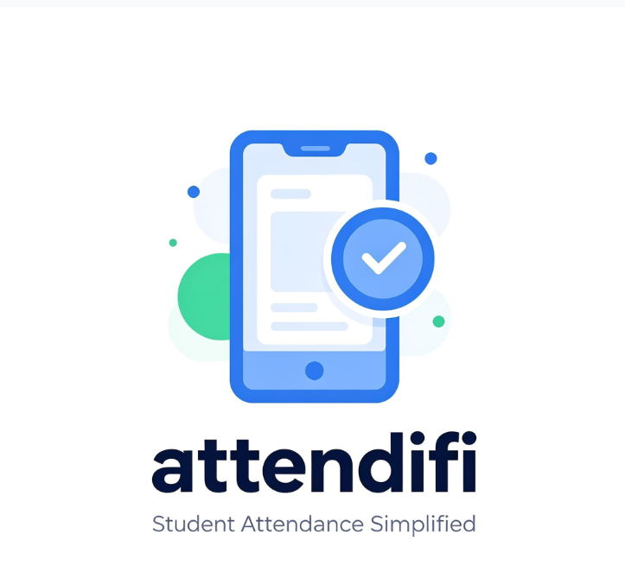
Sales strategy: Attendifi System Ltd will offer software subscriptions to schools and colleges. A small school will pay a yearly subscription, while large colleges will pay per student.
Funding plan: to raise money for the business without taking high-interest loans from a bank. The company will apply for government funding for small businesses, which helps small businesses to get started.
Project reflection: building attendance helps bridge the gap between what we learned in class room and the practical. The project requires building a complete apploication which means learning how to link user pages directly to the database.
I gained experience in three key computing areas by doing this project
Database management: by learning how to use queries that use foreign keys to connect tables and keep data clean.

Difference between PEST and SWOT analysis
During this project, I have learned important techniques for two types of analysis used in business models.

Project management experience
By managing this project offer valuable experience using a professional project management workflow. That means breaking bigger tasks into smaller tasks to make them more manageable. I learned how to complete tasks on time and in given time frame. Managing the task on time kept me completing and delivered project on time.

Benefit to the school and society.
The true benefit of attendifi to society is to save time and helps students to focus on their study so they can have more time to focus on their studies and help succeed. Automating the checking process eliminates manual roll calls, which are time-consuming, and this software can help save time. This software helps teachers to have more time, so they can focus on their students to deliver high-quality education. A live dashboard also acts as a warning system. Skipping classes is an early sign that a student is struggling with challenges. because paper process takes weeks to keep check on students and generate reports. attendifi helps keep a quick record of students.

Project risks and solutions
Every project faces technical challenges, some of which are listed below
Identified Risks Level Technical Solution
Absent students can text the PIN to their friends | High risk level | The check in pin will automatically expire in 60 seconds. Teachers can check live entries on their screens.
A sudden server crash can cause data loss | High-level risk | A backup can keep data secure in the backup server
Hundreds of students logging in at the same time can slow down the servers. | Medium level risks | The queries can help optimized process of data in milliseconds to keep servers from preventing.

Conclusion
This report provides a clear roadmap to build and launch a student attendance app. By using the time frame given project can be completed in the given time without running out of money nd resources. the data base design and clear information using tables, layouts and flow maps ensure the software stays lightweight enough to run smoothly daily on basic mobile devices.
From a business perspective, the market analysis shows a clear need for cheap software to run in schools and universities. Operating a limited company under a subscription model gives the app a realistic path to grow into a commercial business. ultimately, attendance shows how simple software can help solve problem which universities and schools face on a daily bases. Attendance will help classroom efficiency and protect student success.

References

[1] | K. R. M. C. J. S. N. C. H. R. P. N. R. C. (. T. R. B. Stuart D. Anderson, guidance for Cost Estimation and Mangement For highway Project During Planning,Programming Preconstruction, Transportation Research Board, 2007.
[2] | C. S. Stackpole, A users manual To PMBOK Guides, Wiley, 2010.
[3] | J. P. Teresa Luckey, Software Management For Dummies, Wiley, 2006.
[4] | I. Press, New trends in Software Methodologies , Tools and techniques, H. Fujita, M. Mejri, 2006.
[5] | Z. Qin, Introduction to E_commerce, Tsinghua University Press, 2009.
[6] | R. Kern, S.U.R.E Fire Direct Response Marketing, : McGraw-Hill Education, 2001.
[7] | N. Press, Entrepreneurs Launchpad, Dr Poornima Charantimath, 2025.
[8] | K. Miesenberger, Computers Helping People With Special Needs, Springer, 2008.

