David Steer P147367

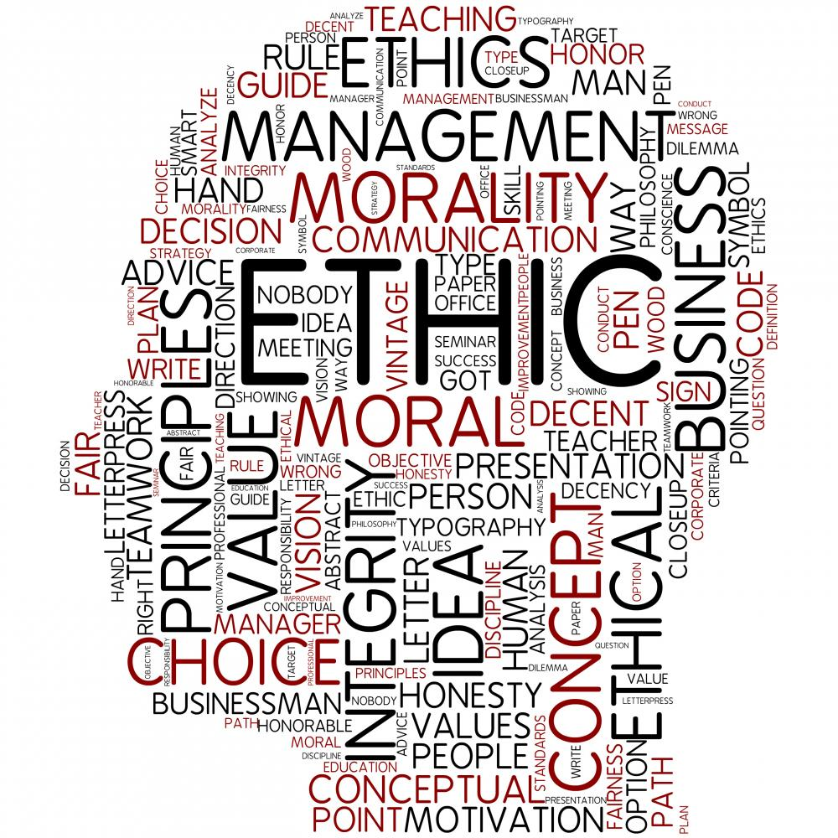

A report into business ethical issues
Management Ethics
Table of Contents
Table of figures 2
Introduction 3
Main Findings 4
What is Corporate Social Responsibility (CSR): 4
Arguments against sustainability and CSR: 5
Stakeholder theory versus shareholder theory 6
Conclusion 7
Reflection on the assignment and interaction with Advertising Lvl 6 Students. 8
References 10
Appendices 12
Appendix A Poster 12
Appendix B Defence of illustration 13

Table of figures

Fig 1: Carroll’s CSR Pyramid
Page 4
Fig 2: Stakeholders
Page 6
Fig 3: Stakeholder mapping
Page 6
Fig 4: Gibb’s Model of Reflection
Page 8
Fig 5: Berlo’s Model of Communication
Page 8

Introduction
This report will broaden knowledge and understanding from the graphic produced for The European Environment and Sustainable Development Advisory Councils (EEAC) and the defence of the illustration. These both will be included in the appendices.
The EEAC is an advisory sustainability council for national and regional governments which covers nine European countries. The goal to promote and drive sustainable developments and business. The council achieves this by advising Governments on new sustainable legislations, increasing awareness of the positives of sustainable business liaising with delegates from academia through to private sector and Governmental bodies, developing strategies to put to business and holding annual conferences on sustainability and corporate social responsibility.
The topic undertaken was should businesses be more responsible for sustainability, the repercussions and argument for and against implementing models or procedures of sustainability and Corporate Social Responsibilities into a large corporate company.
‘There is one and only one social responsibility of business – to use its resources and engage in activities designed to increase its profits so long as it stays within the rules of the game, which is to say, engages in open and free competition without deception or fraud.’ Friedman (1970).
One view of the social responsibilities of business highlighting that as long as the business adheres to laws or legislation within the locality of their operation the goal is to maximise profits and nothing more.
‘Our position is that organisations survive to the extent that they are effective. Their effectiveness derives from the management of demands, particularly the demands of interest groups upon which the organisation depend for resources and support’ Freeman (2010) citing Pfeffer & Salancik (1978, p. 2).
Another view point is with the increasing consumer buying behaviour focused on socially moral corporations, Baker (2015) illuminating that consumers are now ‘voting’ with their pockets which is a driving factor for businesses as the customer’s money is a resource that a company relies on.
These contrary statements show the divided stance of sustainability and corporate social responsibilities.
Within this report some of the models and theories that shall be applied are Corporate Social Responsibility (CSR), Carroll’s CSR Pyramid, Greenburg’s Social Customer Relationship Management model (SCRM) and Stakeholder mapping; Milton Friedman’s perspective versus Richard Freeman’s.
The report will furthermore include a reflection on producing the graphic with UWTSD Advertising third year students, Gibbs’ Model of Reflection will be utilized to ascertain the relevance of the experience acquired.

Main Findings
What is sustainability in business:
‘Sustainable development is about making sure that people throughout the world can satisfy their basic needs now, while making sure that future generations can also look forward to the same quality of life.’ Gardner (2014).
As discussed in the Defence of Illustration (see appendix B), Gardner (2014) describes the need for sustainable business that satisfies the needs of the population now and in the future. The concept shows that if companies plunder finite resources now, not only will the resource not be there for future generations but the business will not be able to profit in years to come as depicted by Ortiz-de-Mandojana and Bansal (2016) and pictured in the illustration for the EEAC (see appendix A). Ortiz-de-Mandojana and Bansal express that if a company were to develop sustainability concepts then it will become more resilient to outside threats and be able to seize long-term prospects.

What is Corporate Social Responsibility (CSR):
Corporate Social Responsibilities are as communicated by Sheehy (2015) are non-regulated decisions that a company may or may not uphold that have a benefit to sociological and societal affairs. These are not legal obligations which a company needs to adhere to. Sheehy (2015) furthermore illuminates that CSR is a grey area with corporations using the term to describe any manner of ‘corporate philanthropy’ as CSR while not changing the companies underlining ethics. Gomez-Carrasco et al (2016) presses alignment with this theory with a case study showing that charity or philanthropic activities can be shown by a company as a CSR framework even though they have a disconnect from the fundamental business practices allowing for use of CSR as a ‘veil’ for companies more unethical practices.
Fig 1: Carroll’s CSR Pyramid.
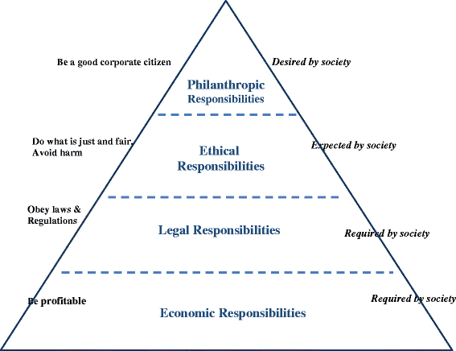
Source: (Carroll, 2016).
Carroll (2016) depicts in pictorial function the steps that are required, expected and desired by society showing that the only requirements of businesses are to uphold legal prerequisites and to be profitable agreeing with Friedman (1970). Whilst ethical responsibilities are expected of a company and not necessitated. Though philanthropic tendencies are desired by society. Allowing for this we see the difficulties for companies to take responsibility for ethical practices that are not a criterion to the law or in some instances can be detrimental to the fundamental foundations of business; to be profitable.
Greenberg (2009) explicates that consumers are changing the method in which they engage with companies and shows the developing need for SCRMS (Social Customer Relationship Management Models). This change in consumer behaviour is shown to stem from the consumers need to be included in business decisions in response to media attention on unethical company practices. Greenburg shows that with the rise of the necessity of these models to be incorporated into business practices it demonstrates the power in which the consumer has by educated ethical purchases. As discussed previously and forging this theory Baker (2015) ascertains that the power of real corporate ethical change is in the hands of the consumer effecting the underpinning resources of a business; financial assets.

Arguments against sustainability and CSR:
As described by DesJardins (2016) an argument against sustainability/CSR is that if the risk-managed by sustainability of the consumers’ needs is not met and this can be an intangible interpretation by both consumer and business alike, the company would have forfeited profits for exploration of these avenues for no logical justification. This a problem in the bracketed term of sustainability for CEOs. What are the expectations of the consumer? Does the company have any true power in which to change to a more ethical approach within its means and market? DesJardins goes on to show because there is no legal or legislative holding on a company for sustainability or CSR the business maybe at a greater risk from competitors who do not implement these procedures.
As shown in the introduction, Friedman (1970), the priority of business is to maximise profits this can also be extrapolated to consumers as well. A journal article by Janicka (2016) states that of the domestic investors the majority tailor the investments in the ’Financial-first investments’ meaning that consumers themselves are looking at maximising the returns on investments. Janicka shows that ‘Impact-first investors’, consumers worried about the impact on sustainability or environmental issues of their investment, even though on a slow ascension are still in a minority. This shows that even though consumers may say they want something they are necessarily willing the purchase to affect their pocket. As shown with the rise of Primark’s profits in 2016 by nine percent, Tugby (2016), even though they openly use ‘sweat shops’ and one burned down in a horrific blaze killing many workers due to having ‘yet to install basic fire-safety measures’ Butler (2016).

Stakeholder theory versus shareholder theory
Fig 2: Stakeholders
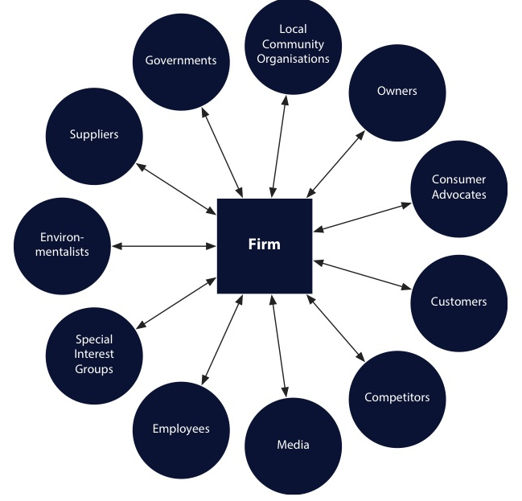
Source: (Freeman, 2010).
Freeman (2010) shows that there may be many outside influences on a business depicted as stakeholders these are entities that can have an influence on a firm’s ability to produce profit and maintain trading. Freeman describes these influencers as having power to change the way in which a business operates furthermore depicting a model in which to manage stakeholders, Stakeholder mapping.
Fig 3: Stakeholder mapping.
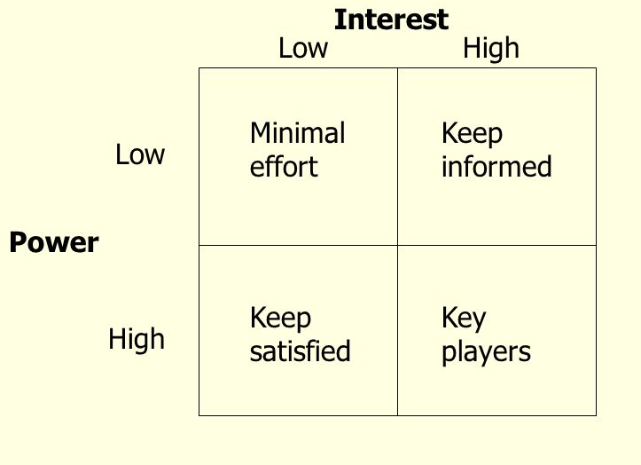
Source: (Freeman, 2010).
This model can show companies to which stakeholders have the most influence and how to manage their engagement with the company. With the growth of ethical consumers, Governmental bodies concern with sustainability and new EU regulations concerning mandatory implementation of CSR models, Chaplier (2014), sustainability and CSR models have gone from the minimal effort segment straight through to the key players. Chaplier explains that the EU regulation is fraught with loop-holes and ‘could prevent meaningful change’.
(Friedman M. , 1970) takes the view that the only important influencer on business decisions is the shareholder as they are directly affected by any business decision and can also immediately affect the business by pulling out their financial assets. In the stakeholder mapping these are the key players and the rest of Freemans stakeholders yield to the prioritisation. This is presence is generally originated in well-established global firms who have the highest impact on environmental and sociological issues.

Conclusion
In conclusion CSR and sustainability models are starting to become heavy hitters in the drive for better ethical policies. Though still not causing big global businesses to forfeit large profit margins for environmental issues. The rise of social enterprises and CSR legislations are a sign that consumers from a ground up perspective are driving Governments to come to terms with forcing companies to comply or have profits affected. For real change consumer buying behaviour would have to take the next step and boycott unethical companies, this being said a key motivator for the customer is price.
The question still remains of should companies implement CSR and sustainability models if their competitors are not and their customers are just driven by price or convenience.
There is an argument for big global business plundering the planet for profit has a detrimental effect not only on the inhabitants in the near future but also on their own profits once a finite resource runs out.

Reflection on the assignment and interaction with Advertising Lvl 6 Students.
For this section of the report I will be using the model of reflection by Gibbs (1988).
Fig 4: Gibb’s Model of Reflection.

Source: (Gibbs, Learning by Doing, 1988).
In this assignment, I was tasked to design a poster on ethic quandaries. I choose the topic should businesses make profits at the expense of the planet and its populace. The poster then was to be backed by a defence answering nine questions in regards to ethical concerns.
I then had the opportunity to liaise with Advertising Lvl 6 Students who were to give guidance on creating the most impact with a pictorial format.
On designing a brief prior to the meeting in a simple format with a few pictures, a quote and the topic in hand, the art students talked about how to make my message come across to the viewer in the most impactive way. The art students pointed me in the direction of Berlo (1960) and the model of communication.
Fig 5: Berlo’s Model of Communication.

Source: (Berlo, 1960).
This model upon digesting another view point taken from the creative thinking minds of the advertising students has allowed me to see that each individual spectator can have a different view point or opinion based on numerous factors; communication level, attitude before the viewing, knowledge or care of the subject and sociological and cultural demographic. This model changed my perception and understanding on how to convey a message and I believe it will benefit myself not only in my studies by creating better presentations but also in everyday conversations by understanding that I may have a passion and understanding on a subject but the other participant may not, this is also a necessary skill for business communications.
After showing me the model of communication the advertising students went on to show me how to make images more powerful by creating ‘less busy’ (fewer images, less text and simple colours) concepts. Showing me that in the world of graphic and advert design that a simplistic approach is more, allowing the viewer to connect with your message more.
With a couple of concept sketches to take with me I was left to my own devices to create the image. Through this process I would collaborate with the students over Facebook and bounce ideas back and forth gaining experience in best layout procedures and colour formats. I decided, with advice, to go with a minimal colour pallet with predominate black, white and greys to allow for the centre image of colour to ‘pop’ more.
On completion of the piece I asked the students to critic the image and other students to try and ascertain the message behind, linking back to new skills learnt from the model of communication. The critic and the established thoughts of the message was interesting as I did not give any other information other than the two images. The results are shown in appendix B. With the critique, I changed the image slightly as I felt a little out of my depth and the student had given me good advice in previous conversations. While the grasp of the message was solid enough for me to believe that the image purposed the message.
The experience was in my eyes a great experience leading to un covering a different creative aspect compared to the analytical mind I have been developing within the Business School. This process will stay with me after learning that people think and produce work or products differently. This is a great lesson to take into the world of work.
Any recommendations I have are concerned with the time spent with the Advertising students, I felt that it was not enough, if conceding more time, a greater experience would have been acquired. A structured brief would have also helped the other students to create better illustrations and concepts. A recommendation for the business school would be to spend a tutorial preparing a brief collecting images and writing what the student would like to convey. This would have sped up the process and given the Advertising students a better grasp of the task.
I believe that this activity should be run every year for students to practice briefing another ‘company’ and to prepare for a different maybe more creative outlook on a task.

References
Baker, J. (2015, April 2). The rise of the conscious consumer: why businesses need to open up. Retrieved November 15, 2016, from The Guardian: https://www.theguardian.com/women-in-leadership/2015/apr/02/the-rise-of-the-conscious-consumer-why-businesses-need-to-open-up
Berlo, D. (1960). The process of communication. New York: Rinehart, & Winston. Retrieved November 12, 2016
Butler, S. (2016, January 18). Bangladesh fashion factory safety work severely behind schedule. The Guardian, online. Retrieved November 15, 2016
Carroll, A. B. (2016). Carroll’s pyramid of CSR: taking another look. Springer Open, 1:3. Retrieved November 12, 2016, from https://jcsr.springeropen.com/articles/10.1186/s40991-016-0004-6
Chaplier, J. (2014). EU to force large companies to report on environmental and social impacts. The Guardian, online. Retrieved November 16, 2016
DesJardins, J. (2016). Is it Time to Jump off the Sustainability Bandwagon? Business Ethics Quarterly, 117-135. Retrieved November 16, 2016
Eisenstein, C. (2014, January 8). Let's be honest: real sustainability may not make business sense. Retrieved November 10, 2016, from The Guardian: https://www.theguardian.com/sustainable-business/blog/sustainability-business-sense-profit-purpose
Freeman, E. (2010). Strategic Management: A Stakeholder Approach. Cambridge: Cambridge University Press. Retrieved November 12, 2016
Friedman, A. L., & Miles, S. (2006). Stakeholders: Theory and Practice. Oxford: Oxford University Press. Retrieved November 12, 2016
Friedman, M. (1970). The Social Responsibility of Business is to Increase its Profits. New York Times, 17. Retrieved November 12, 2016
Gardner, J. (2014, Febuary 20). Sustainability - a local issue for us all. Retrieved November 10, 2016, from Adjacent Government: http://www.adjacentgovernment.co.uk/lg-edition-001/sustainability-a-local-issue-for-us-all/3316/
Gibbs, G. (1988). Learning by Doing. Oxford: Oxford Educational Unit. Retrieved November 15, 2016
Gibbs, G. (1988). Learning by Doing: A guide to teaching and learning methods. Oxford: Oxford Brooks University.
Gomez-Carrasco, P., Guillamon-Saorin, E., & Garcia Osma, B. (2016, March 7). The illusion of CSR: drawing the line between core and supplementary CSR. Sustainability Accounting, Management & Policy Journal, 125-151. Retrieved November 15, 2016
Greenberg, P. (2009). Social CRM Comes of Age. White Paper: Oracle. Retrieved November 13, 2016, from http://www.computerworlduk.com/cmsdata/whitepapers/3203130/social%20crm.pdf
Janicka, M. (2016). Financial Markets and the Challenges of Sustainable Growth. Comparative Economic Research, 27-41. Retrieved November 15, 2016
OfGem. (2016). Energy Company Obligation. London: ofgem. Retrieved November 12, 2016, from https://www.ofgem.gov.uk/environmental-programmes/eco
Ortiz-de-Mandojana, N., & Bansal, P. (2016). THE LONG-TERM BENEFITS OF ORGANIZATIONAL RESILIENCE THROUGH SUSTAINABLE BUSINESS PRACTICES. Strategic Management Journal, 1615-1631. Retrieved November 15, 2016
Pfeffer, J., & Salancik, G. R. (1978). The External Control of Organizations: A Resource Dependence. Stanford: Stanford University Press. Retrieved November 15, 2016
Sharp, D. (2002). Customer Relationship Management Systems Handbook. New York: CRC Press. Retrieved November 13, 2016
Sheehy, B. (2015, October 15). Defining CSR: Problems and Solutions. Journal Of Business Ethics, 625-648. Retrieved November 15, 2016
Tugby, L. (2016). Primark profits rise but weather dents UK like-for-likes. RetailWeek, online. Retrieved November 16, 2016

Appendices

Appendix A Poster
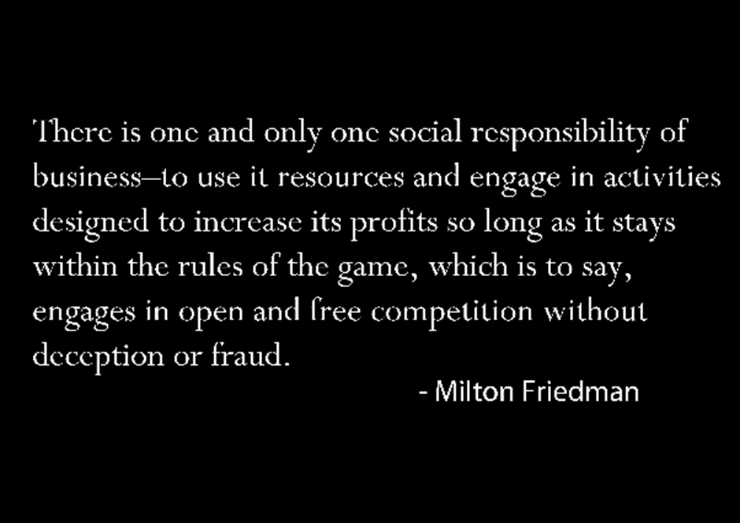
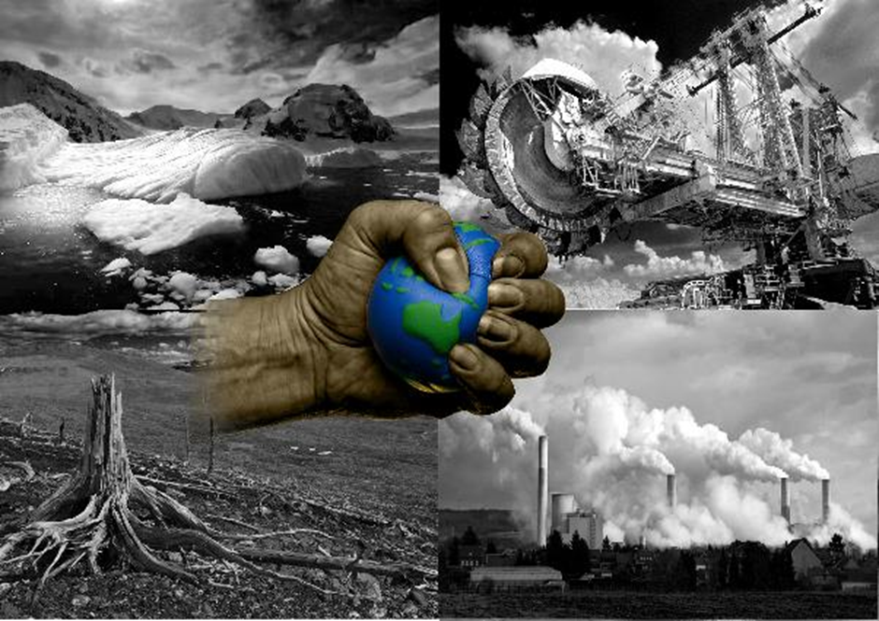

Appendix B Defence of illustration
Management Ethics David Steer P147367
Poster Defence
- Whose corporation/organisation are you representing?
The European Environment and Sustainable Development Advisory Councils (EEAC).
- What is the key message that you are trying to communication?
The key message I am trying to convey in my posters is to promote a different style of thinking for how we look at business in regards to sustainability and if big businesses continue their current unethical paths the repercussions could be catastrophic for the planet.
The report will then lead on to formulate a discussion if it is the role of businesses to be sustainable, governments to enforce sustainable legislations or the consumer’s responsibility to only buy from companies which are developing sustainability within their business model.
- What is the main target audience that you hope will read and understand your message?
I believe the target audience could be everyone as the message I am trying to communicate is an issue that affects us all.
‘Sustainable development is about making sure that people throughout the world can satisfy their basic needs now, while making sure that future generations can also look forward to the same quality of life.’ Gardner (2014).
With the reference to Gardner (2014), the problem and solution is in the hands of our current generation to protect our future generations. Gardner goes on to talk about strategies that could be implemented for Corporate Social Responsibilities.
- What would someone who disagrees with you say in response to your argument?
These arguments will be considered more within the report with academically sound research to bring to light counter-arguments for each point.
Why should one business forfeit profits when another business does not?
Is it not the responsibility of the business to adhere to the laws and regulations set out by the government and not go above these if not needed too?
Sustainability is someone else’s problem to deal with.
‘Let's stop pretending. If your company is going to make a significant step toward sustainability, it probably won't make business sense, at least not in any way that can be predicted or quantified.’ Eisenstein (2014).
Sustainability is contradictive to business sense.
This point was explored by Eisenstein (2014). Eisenstein illuminates the argument against sustainability with profit aligning itself against the concerns of people and planet. Eisensein aligns his theory with Friedman (1970).

- Why have you used the images and words you have selected?
On discussions with Advertising students at UWTSD and presenting them with a brief on the message and feelings I wanted to communicate. I decided on a stark contrast of two opposing views Friedman for business and then the repercussions if businesses were to just express one of his view points.
For the side of business I choose a Friedman quote explaining that there is only one social responsibility of a company to make as much money within the rhetoric of the law. The stark black image behind white font gave the statement more gravitas, the font was chosen to conjure up feelings of this is correct by formalising the statement.
For the side of sustainability I chose four images synonymous with issues that big business is producing in their drive for maximising profits.
Global warming and the melting of the ice caps, increased CO2 levels through high carbon emissions, deforestation and large open cast mining robbing the earth of materials on a mass scale.
These images I changed through knowledge of photoshop to a black and white filter with some altercations to make different areas of the images pop, for instances the white and blue filters on the ice caps picture. These were designed to allow flow from the previous image and allow the centre image to pop more.
The only colour on the two picture is of a hand squeezing the planet. The hand representing what we and business are doing to world: squeezing the world for all its assets.
The reason for this being the only colour in the piece is to draw the eye straight to the problem and the message.
I have asked a couple of students to critique or asked them what they took from the piece:
Emma Howe: Lvl 6 Advertising student UWTSD, helping with theory behind poster design.
For the critique, I think the images are perfect, love the use of black and white to add drama and seriousness. If possible I would rotate the hand as it doesn’t connect to the side of the page. If it came from the top or bottom it might fit better and not have as much empty space.
Sam Whittiker: Lvl 5 Business Management Student UWTSD.
One message I am getting is it could look like the pictures on the right have caused the pictures on the left another thing I am thinking is, the earth is being shown as being squeezed and the four pictures are the effects and causes.
Steffan Cussano: Lvl 5 Business Management Student UWTSD.
I personally believe that many businesses aren't staying within ethical rules, and thus is leading to the exploitation of many natural resources leading to the second image.
Rhiannon Smith: Lvl 5 Sustainability Management Student UWTSD
Capitalism is exhausting the world of it resources
- What research have you done to underpin your argument?
I have considered the emerging development in big business to take responsibility for sustainability and their CSR protocols. The new laws such as the Welsh Future Generations Act or surfacing agencies such as The European Environment and Sustainable Development Advisory Council. I have also looked at global issues which are caused by big global businesses which are causing problems for our current and future generations such as rising CO2 levels, global warming effects and the draining of nature resources.
I have also looked at the counter-arguments for sustainability to have a better overview of the whole issue.
The sources I have used are all secondary sources of data.
Some of the websites I have visited are below and the books and Journal Articles will be within my reference section.
http://onlinelibrary.wiley.com/doi/10.1111/j.1468-2370.2009.00275.x/full
http://www.adjacentgovernment.co.uk/lg-edition-001/sustainability-a-local-issue-for-us-all/3316/
https://www.theguardian.com/sustainable-business/blog/sustainability-business-sense-profit-purpose
http://iveybusinessjournal.com/publication/the-top-ten-reasons-why-businesses-arent-more-sustainable/
https://www.nas.org/articles/Sustainability_is_a_Waste_10_Reasons_to_Oppose_the_Sustainability_Movement
http://gov.wales/topics/people-and-communities/people/future-generations-act/?lang=en
http://mallenbaker.net/article/clear-reflection/arguments-against-corporate-social-responsibility-and-some-responses
http://www.environmentalscience.org/sustainability
http://www.strauss-group.com/cr_newsmention/the-importance-of-sustainability/
https://www.theguardian.com/sustainable-business/sustainability-key-corporate-success
http://www.wbcsd.org/Overview/About-us
http://eeac.eu/

- How strong do you think the evidence is to back up your argument?
As there is a change in consumer buying behaviour, corporations are becoming more receptive to the nature of Corporate Social Responsibilities this tied with new government regulations and legislations are making corporation slowly wake up to the need of CSR implementations. World summits, EU and UN conferences are talking more and more about sustainability for future generations. The UK has enforced CO2 emission laws for companies, OfGem (2016), with high tariffs for over emissions. This now directly effects profit, this being the driver for business means that companies must align with sustainability or forfeit maximising their profits.
The argument for global sustainability is more grey as there are not unifying laws across all nations which companies can manipulate to their advantage. This will be illuminated in more depth in the report and any recommendations shall be made in the conclusion.

- What would you hope would happen after the audience has understood your message?
I would like the audience to be aware of the repercussions of their purchases or interactions with non-sustainable companies. This might then change their buying behaviour and make more profits for sustainable business while leaving unsustainable business behind. Voting with your pocket.
To start having conversation about sustainability, this is important as changing hearts and minds starts with discussing and being more open with a topic.
- What models and theories will you be referring to in your reflective report?
I will be using CSR as a main theory. Also I will bring in the Social CRM model by Greenberg (2009) and how consumers are changing the interactions that are had with marketing and businesses.
Friedman and Freeman shall be discussed as contrasting discussions.
David Berlo’s (1960) model of communication.
A model of reflection I will use will be Gibbs Model of Reflection (1988).
Carroll’s CSR Pyramid (2016).
Stakeholder mapping, Friedman & Miles (2006) and Freeman (2010).

