Observational Analysis – Game
Physical | Technical | Tactical | Psychological
Making sure when he crosses in the ball, they get a bit physical to get to the ball | Making sure the players are looking for space not just kicking the ball around the pitch | Not having the control of the ball and not looking up who is around him
To make sure when you’ve got the ball to stay strong and make sure that you have control of the ball | Making sure you get in front of the ball not behind when the player can get the ball of you
 | Keeping there head up and keep the ball on the floor because you’ve got more control then
Overall Review and Link to Session Planner:

UWTSD Session Planner
Venue: lc2 |  |  | Age group:  Number Attending:
Date |  |  | Start time:  Finish time:
Equipment:
Bag football’s , cones

Nearest Telephone: reception | 1st Aid bag: reception
Risk Assessment completed:  yes | Additional Hazards and actions taken: yes
Learning from Observational Analysis: |  | Personal action points Observational Analysis:
Goals for the session:
Passing the ball on the floor making sure they have there heads up and looking where the ball is going finding the right time to pass the ball to the team mates

.
Introduction and warm-up
Find a space by a wall / partner pass the ball right foot first then left foot then pass the ball with both feet right then left continues movement.

Main Content/Game  Passing the ball on the floor and looking who is available around you and see if there is any opportunity |  | Organisation/diagram  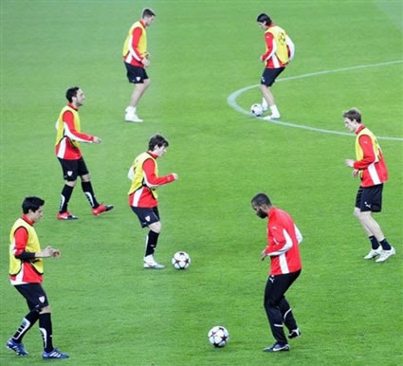  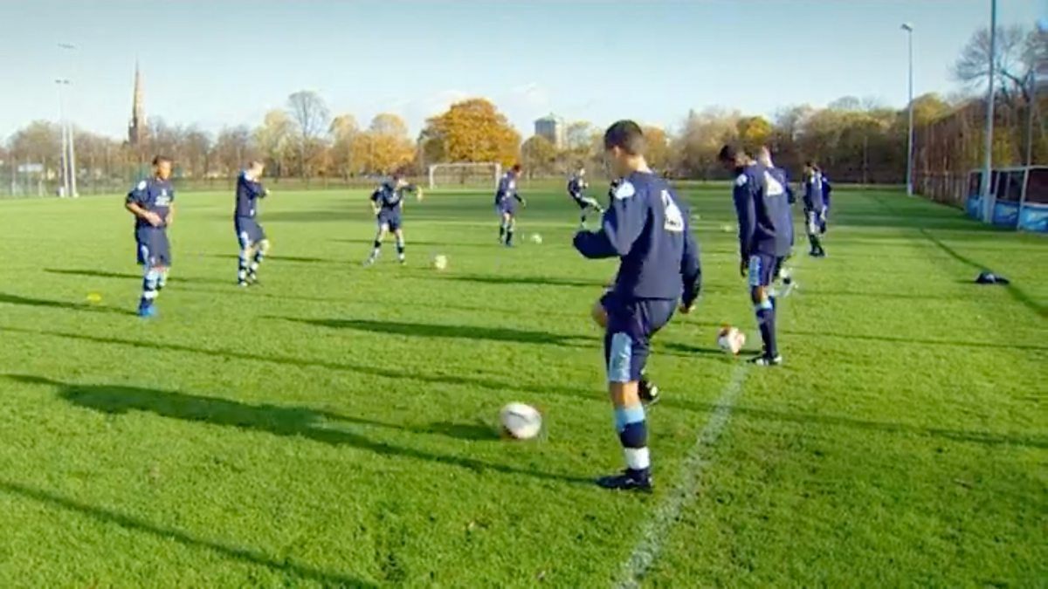
Ideas for Development (progression / regression):  Setup  Lots of small cones gates  Players work in pairs with one ball  Base drill  - Pass through as many gate’s as possible in 60 sec  Progression  - 1 touch only  - Weak foot only  - Pass move to different gates  - Add a passive defence  Regression  - 2+ touches allowed  - Larger gates  - Static partner |  | Diagram for activity  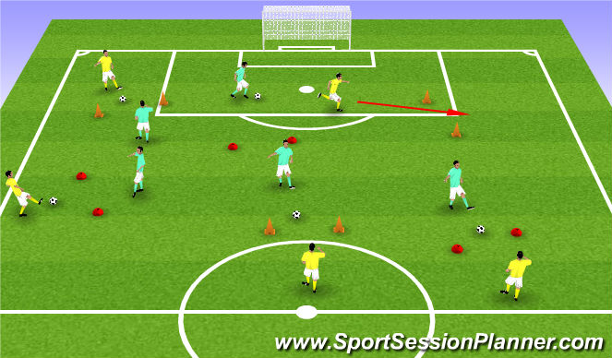

5Cs to be included in this session | Select 2 of the 5 and apply to session  HOW?
Competence

Confidence:

Connection: | The connection of the players are good they need to make sure the keep pushing up the scale to get stronger as a team but they make the right choices
Character and caring:

Creativity:

Observational Analysis – Game
Physical | Technical | Tactical | Psychological
 | Finding the space to shoot in the right location | Finding the right distance and making sure they are looking around for players
 | First touch needs to be controlled better | Making sure they don’t all stand in one place
 | Shooting needs to get stronger
Overall Review and Link to Session Planner:

UWTSD Session Planner
Venue: lc2 |  |  | Age group:  Number Attending:
Date |  |  | Start time:  Finish time:
Equipment: bag footballs , cones

Nearest Telephone: reception | 1st Aid bag: reception
Risk Assessment completed:  Yes | Additional Hazards and actions taken: yes
Learning from Observational Analysis: |  | Personal action points Observational Analysis:  A match  The players  The people performance
Goals for the session:
Shooting the ball into the goals

Introduction and warm-up

Players in pairs
One ball per pair
Small goals or cones for goals

Main Content/Game  Pass – move - receive - light shot/pass into target area  Both feet encouraged  Coaching points such as  Head up before striking  Side-foot accuracy  Good body shape  Follow through |  | Organisation/diagram  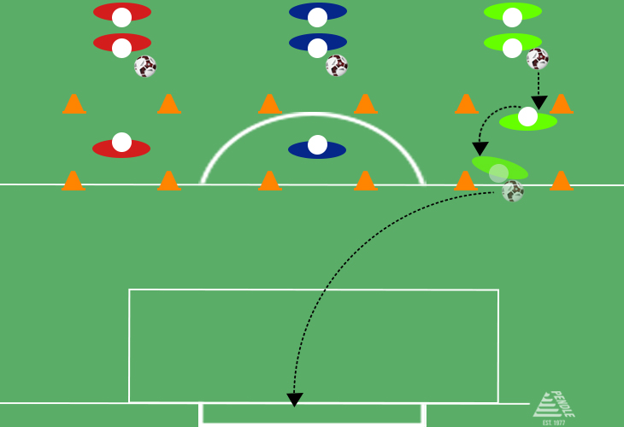  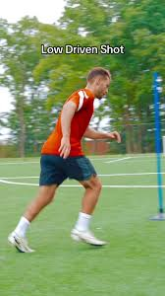
Ideas for Development (progression / regression):  Shooting accuracy  Passing under pressure  Defending 1v1  Decision-making in attack  Progression  Add pressure  Passive-active defence  Reduce time/space  Small area  Touch limit  Increase realism  Go from drill – game situation  Condition rules  One touch finish  Weak foot only  Score constraints  Extra points for certain action  Examples  Defender closes down  2v1 decision before shot  Game with finishing zones |  | Diagram for activity  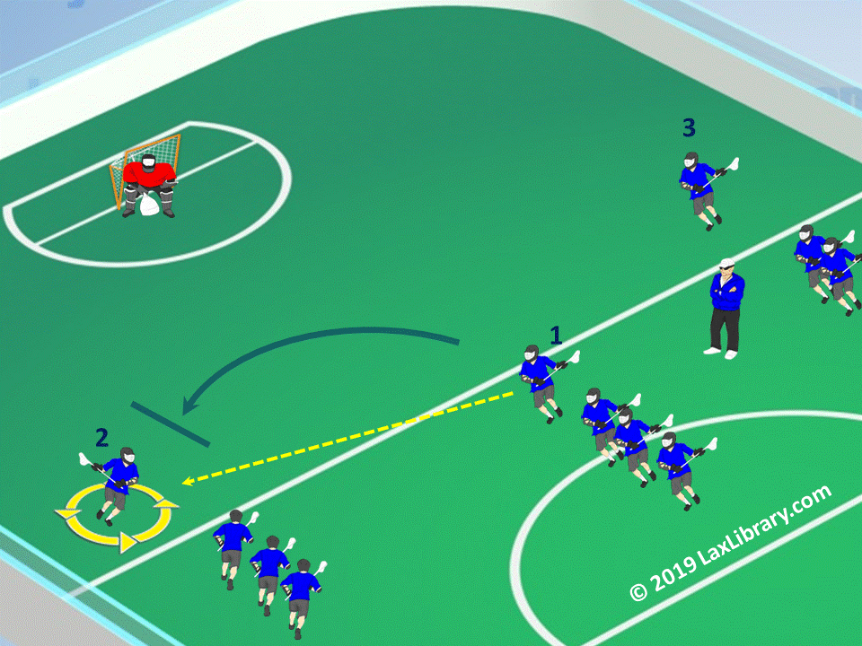  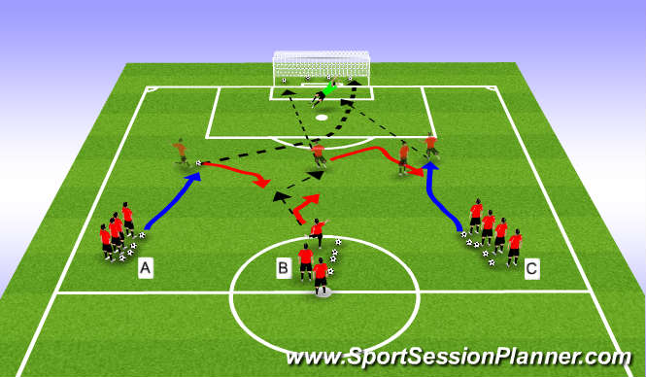

5Cs to be included in this session | Select 2 of the 5 and apply to session  HOW?
Competence

Confidence: | Having the confidence in shooting the ball not pulling back to pass the ball making sure when you receive the ball head up and looking for the space and the Strick
Connection:

Character and caring:

Creativity:

Cool-down:

Observational Analysis – Game
Physical | Technical | Tactical | Psychological
Overall Review and Link to Session Planner:

UWTSD Session Planner
Venue: |  |  |  | Age group:  Number Attending:
Date |  |  |  | Start time:  Finish time:
Equipment:

Nearest Telephone: |  |  |  | 1st Aid bag:
Risk Assessment completed: |  |  |  | Additional Hazards and actions taken:
Learning from Observational Analysis: |  |  |  | Personal action points Observational Analysis:
Goals for the session:

.
Introduction and warm-up

Main Content/Game |  |  |  | Organisation/diagram
Ideas for Development (progression / regression): |  |  |  | Diagram for activity
5Cs to be included in this session |  |  |  | Select 2 of the 5 and apply to session  HOW?
Competence

Confidence:

Connection:

Character and caring:

Creativity:

Cool-down:

