Project Management

Assignment 1

Project Summary

Student: Denisa-Andreea Matei
LCBB5005

Contents
Introduction 3
Project Summary 3
Conclusions: 8
References: 9

Introduction

The University of Wales Trinity Saint David (UWTSD) was formed on 18 November 2010 through the merger of the University of Wales Lampeter and Trinity University College Carmarthen, under Lampeter’s Royal Charter of 1828. On the 1 August 2013, Swansea Metropolitan University became part of UWTSD.
The University has campuses in various locations in Wales and in London.
In the context of the Covid-19 pandemic the university has undertaken Project Summary which involves the switch from face-to-face teaching to online teaching.

Project Summary

Briefly introduction of the project:
Project Summary is meant to facilitate the fully online teaching to the students of UWTSD.
This involves setting up the correct IT capacity in terms of people, software, but also to increase the online protection of data.
Project Scope:
Project Summary aims to give continuation to the day-to-day activities of the University, to maintain the good reputation of UWTSD in terms of high-quality teaching and good delivery of the course material.
Also, the Project wants to keep the University enrolling students and to maintain its capacity of auto financing.
This Project will generate the capacity for each student to be able to attend an on-line classroom and each teacher to be able to teach in an on-line environment.
For this purpose, the University is allocating a budget set to be spent on the following:
- Microsoft Teams software and users for each student and each teacher
- A team of IT people who would help to solve the technical issues
- A team of secretaries who would oversee creating the groups and to allocate everyone to the correct online classes.
- The suitable software and hardware
The project has to be delivered in 2 months.
Budget for the project:
A total amount of £500,000 was allocated for the project, to be spent as follows:
- 10 x IT people hired to solve IT issues – annual gross salary £30,000 each
- 3 x Secretaries hired to oversee the allocation of the groups, annual salary £25,000 each
- £100,000 allocated to upgrading the software and hardware for the new platform and also to improve the internet connection in such a way that multiple classes can be held at the same time with good quality.
- £25,000 allocated to the acquisition of additional software and hardware needed ad-hoc as well as for the HR department in charge of the additional recruitments.

Assumptions:
It is assumed that a team of Project Managers is already working for the university and has the capacity to onboard the project immediately.
The HR department will start on working right away to post the ads for the IT team and Secretaries.
HR Timeline:
- 1-2 days: creation and posting of the ads on social media platforms meant to attract candidates and sending them to the recruitment agencies
- 1-2 weeks: interviewing the candidates, selection and preparing to chose the ones that are receiving offers of employment; the offers of employment are sent to the selected candidates and they have two weeks for acceptance;
- 3-4 weeks: the offers’ responses have been received; the new employees have to get onboarded and in case of declined offers, there should be additional candidates hired, even if from the ones already interviewed or the interviewing process can start again. Given the urgency of finishing the project on time, the first version is preferred.
Project Manager’s Timeline:
- 1 month: hiring of the new teams (co-ordinated by the HR team)
- 2 months: researching for hardware and software companies and signing the contracts with these companies in order to meet the timeline and the budget
- 3 months: on-boarding the new teams and the new aquired software, testing that everything works as planned, addressed any issues.
New IT and Secretaries Teams’ Timeline:
- 2 weeks: on-boarding training to be completed
- 1 month: to start actively working on the delivery of the IT training and the agendas for the teachers and students
- 2 months: to be able to have a solution in place for each problem in terms of IT issues.
Constraints:
The context of the Covid-19 pandemic has stretched the timeline of delivering the project. It was needed that the project should be finished quicky in order to be able to start the online classes.
Also, the existing team had to be trained quickly and to integrate the new employees, as follows:
- The teachers need to be trained to use the new software – it was selected Microsoft Teams
- The IT team had to get up to speed to deal with difficulties and errors in using Microsoft Teams
- The IT team had to onboard their new colleagues
- The Secretaries team had to perform all the allocations of groups, sending calendar invitations for students and for teachers.

Stakeholders and their Involvement

Internal stakeholders:

The internal stakeholders part of the Project are the following:

- The project managers – in charge of taking care of all the steps of the project, planning and delivering; observing it on the duration of the implementation and assessing if there is enough time to deliver.
- The Human Resources department – in charge of hiring new employees based on the Project’s requirements
- The IT Team – in charge of new contracts with the relevant software, hardware and trainings.
- The teams of Secretaries – in charge of allocating the new agendas for the Teachers and for the Students
- The Teachers
- The Students

External Stakeholders:

The external stakeholders part of the project are as follows:

- Software and Hardware Companies contracted for the project
- Potential employees part of the recruitment process for the new positions
Project Organisation Structure and Roles and Responsibilities:
A project management organizational structure is used to determine the hierarchy and authority of people involved in a specific project. The structure defines each team member’s function and the reporting lines on a chart for team members to reference during a project.
It exists three types of organisational structures in project management: functional, matrix and projectized. Each structure is determined by the responsibilities of each member withing the organisation.
Because the Projects are Unique and it is highly unlikely to find two exactly the same projects, the roles of the members will change with each Project.

A functional structure:
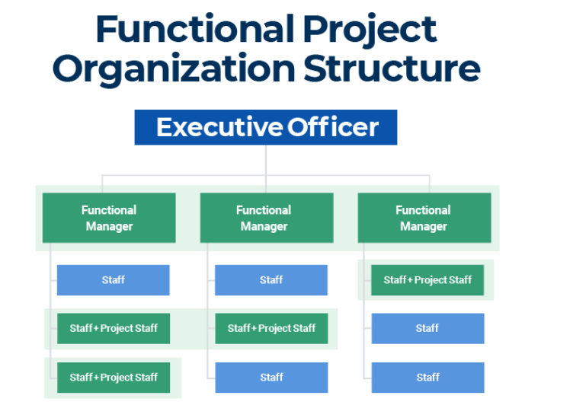
(www.smartsheet.com, n.d.)
A Projectizied Structure:

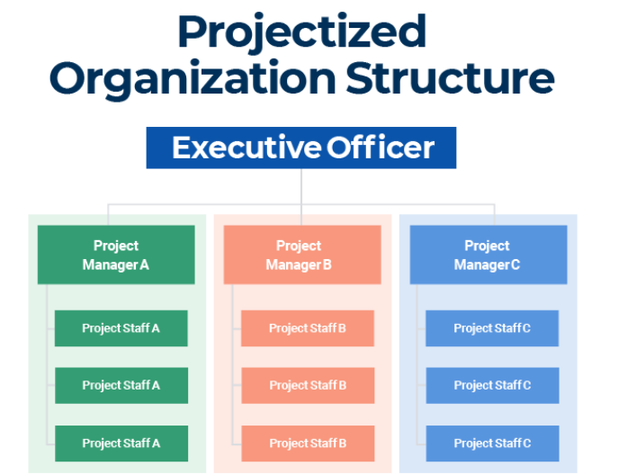

(www.smartsheet.com, n.d.)

Matrix Structure
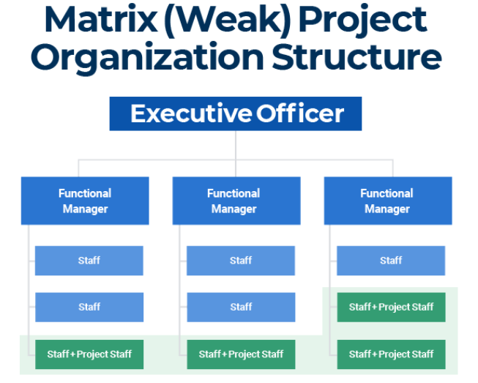
(www.smartsheet.com, n.d.)

Project Summary is using a Projectized Structure, where each Product Manager is working with other staff members for a specific task.
Project’s Pros: The Project Manager is owning all the decision making and it is always clear which are the goals and how far from achieving them are they. This will avoid lack of communication between team members.
Project’s Cons: Resources can be costly and the Product Manager cannot work on multiple projects at the same time.
Project Control Mechanisms
Project controls are a series of tools that help keep a project on schedule. Combined with people skills and project experience, they deliver information that enables accurate decision making. The project control process mainly focuses on:
Measuring planned performance vs actual performance.
Ongoing assessment of the project’s performance to identify any preventive or corrective actions needed.
Keeping accurate, timely information based on the project’s output and associated documentation.
Providing information that supports status updates, forecasting and measuring progress.
Delivering forecasts that update current costs and project schedule.
Monitoring the implementation of any approved changes or schedule amendments.
A control chart monitors the project’s quality. There are two basic forms of control chart – a univariate control chart displays one project characteristic, while a multivariate chart displays more than one.
Review and status meetings further analyse problems, finding out why something happened. They can also highlight any issues that might happen later.
Reporting Framework:
The communication was predominantly made by video-call and emails.
Bi-weekly video-calls were held in order to see the progress of the tasks with every other day e-mail assessment sent.
Project Planning with Milestones:
Given that the project had 3 months to finish, the following milestones were detailed:
- Posting the new job offers
- Finding the right providers
- Sending the job offer letters
- Signing the contracts
- Onboarding the new members
- Giving training to the new team
- Going live.

Conclusions:

The project was concluded during the 3 months and it successfully delivered what is was supposed to.
The software is now in use successfully – it was opted for Microsoft Teams.
The Students and the Teachers have been successfully trained for the new teaching environment.
The internet connection of the University has been improved as well as the servers used to hold all the online events.
The University is successfully continuing its activity by keeping on providing qualitative classes in a modern environment.
The University is able to onboard new Students and to facilitate its auto-financing.
The Project Managers can add to their portfolio a successfully finished project.
The Project was delivered on time and within the allocated budget.

References:

- www.uwtsd.ac.uk. (n.d.). The University | UWTSD. [online] Available at: https://www.uwtsd.ac.uk/about/ [Accessed 6 May 2022].

- www.smartsheet.com. (n.d.). Project Organizational Structure | Smartsheet. [online] Available at: https://www.smartsheet.com/content/project-management-organization#:~:text=A%20project%20management%20organizational%20structure.

- Project Management Qualification (2019). Project Monitoring and Control Techniques. [online] PMP® Blog - Project Management Professional Training. Available at: https://www.projectmanagementqualification.com/blog/2019/10/21/project-monitoring-control/.

- Joubert, S. (2019). Developing a Project Management Plan: 12 Steps to Success. [online] Northeastern University Graduate Programs. Available at: https://www.northeastern.edu/graduate/blog/developing-project-management-plan/.
‌

‌

