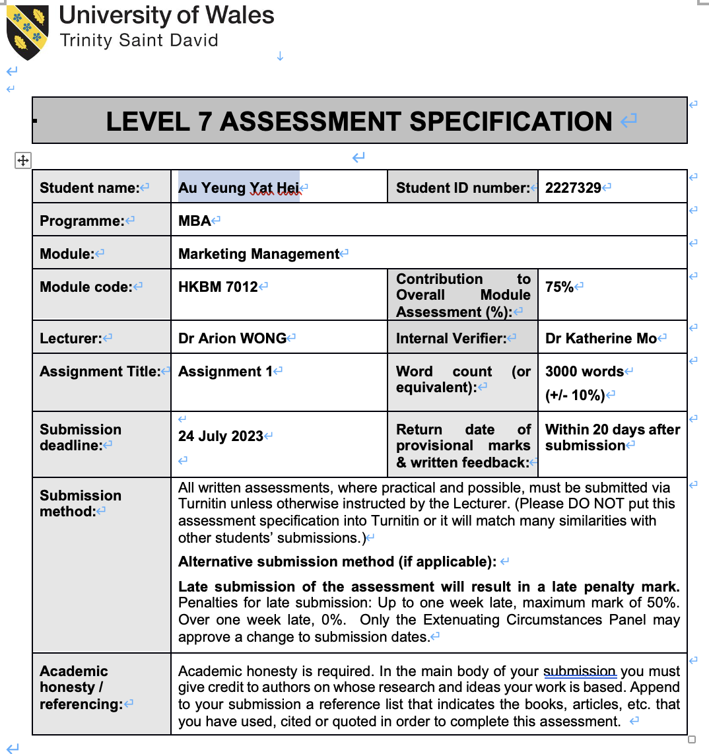
Executive Summary
For a traditional Chinese medicine manufacturer which was established for 125 years (Wai Yuen Tong, 2022), Wai Yuen Tong has been operating to provide various Chinese as well as Western pharmaceutical products and at the same time providing Chinese medicine out-patient clinic services. In the past decades, with the advance of information technology, customers can access more information of Chinese pharmaceutical products and relevant out-patient services through other sources like internet and social media. Wai Yuen Tong did not fell behind and took action to adopt the technology for marketing and promotion. This report will reveal what Wai Yuen Tong have done to market their product and what can be done to strengthen their marketing strategy.

Table of Contents

 |  |  | Page
1 | Introduction |  | 1
2 | Situation Analysis |  | 1
 | 2.1 | Porter’s Value Chain  2.1.1 Inbound, Outbound Logistics and Procurement  2.1.2 Infrastructure and Operation  2.1.3 Technology Development  2.1.4 Services  2.1.5 Marketing and Sales  2.1.6 Human Resources | 1  2  3  3  3  4  4
3 | Segmentation, Targeting and Positioning |  | 4
 | 3.1 | Segmentation | 4
 | 3.2 | Targeting | 5
 | 3.3 | Positioning | 6
4  5  6  7 | Marketing Mix  4.1 Product  4.2 Price  4.3 Place  4.4 Promotion  Future Development and in the Area of Marketing  Recommendation and Conclusion  Reference |  | 6  6  7  7  7  9  10  11

1 Introduction
Wai Yuen Tong was found in year 1897 by a government official of Qing Dynasty and his friends and subsequently relocated from Guangzhou to Hong Kong in year 1952 and eventually Wai Yuen Tong has become a registered company with its trademark and called Wai Yuen Tong Medicine Company Limited in Year 1980 (Wai Yuen Tong, 2023a) and became a listed company in Hong Kong Stock Exchange in 2010 (0897.hk) (HKEX, 2023).Wai Yuen Tong Medicine Company Limited (“Wai Yuen Tong”) is currently a Traditional Chinese Medicine (TCM) manufacturer is familiar among the Hong Kong people and gained positive reputation. (Wai Yuen Tong, 2023a).
2 Situation Analysis
To understand what are the activities the company is actually doing, certain analyzing models may be applied. Value chain analysis which is a model that usually applied to spot and distinguish different company activities and evaluate how those activities creates value for the company. (Mohammad, Haghigh and Danai, 2015). Once any activities which are contributing value to the company can be located and in contrast activities are categorized as “de-valuing” the company, management can take actions to stop the activities deteriorating and put more efforts to strengthen those contributing the value of the company.
2.1 Porter’s Value Chain
Many a times, the Porter’s Value Chain in 1985 has categorized the model
As primary and support activities and as for primary activities includes (i) Inbound Logistics, (ii) Operation, (iii) Outbound Logistics, (iv) Marketing Services and Sales and (v) Services., while support activities include (i) Procurement, (ii) Infrastructure, (iii) Human Resources and (iv) Technological Development (Porter's Value Chain, 2023). The below figure shows the construction of the basic construction of Porter’s Value Chain.
Figure 1, the Porter’s Value Chain Model
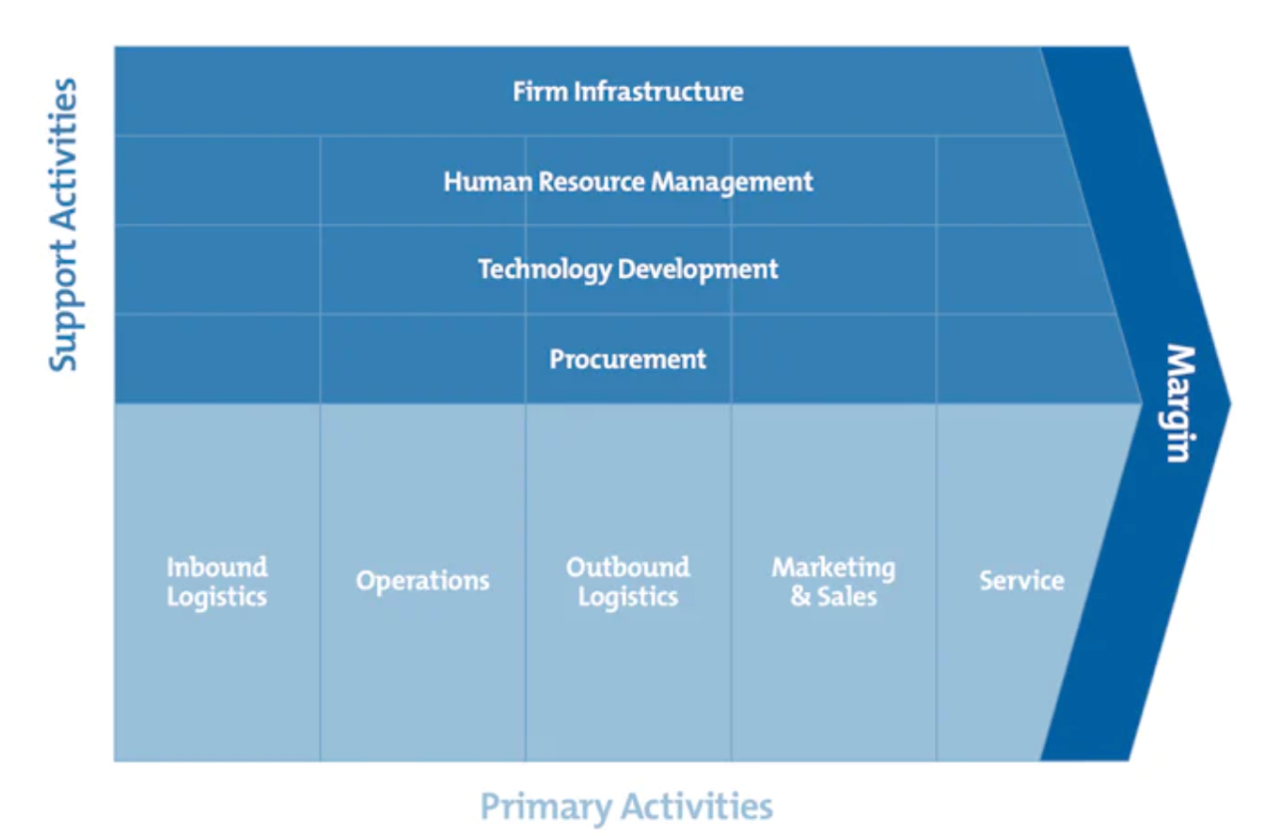
Source: Mind Tools, 2023
2.1.1 Inbound, Outbound Logistics and Procurement
For the Inbounding logistics, according to the annual report in year 2022, there was no detailed description, the largest supplier accounted for 8.8% of the company’s purchase (approximately 19.8% in year 2021) (Wai Yuen Tong, 2022). This had shown that the Wai Yuen Tong has been trying to diversified its supplier concentration which can lead to high costs of switch suppliers when sudden supply shock happens with whatever reasons (Zhang et al, 2020) by a single supplier and the purchasing price can be competitive. For the Outbound logistics, too there here was no detailed description, the sales to the top five customers accounted for 4.6% (approximately 8.9% in year 2021) (Wai Yuen Tong, 2022). This also shown that the customer base has been further diversified and eventually made such relationship-specific transactions with more flexible cost structures (Chang, Hall and Paz, 2017). The mentioned results made the management of procurement competitive as more and more diversified suppliers can create competition among the suppliers especially the purchasing team keep on the strategy strictly purchasing high-quality medicinal materials, without compromise the price. (Stheadline, 2022).
2.1.2 Infrastructure and Operation
Quality Pharmaceutical products usually rely on quality progress through its Infrastructure. To achieve quality operation, Wai Yuen Tong had built a TCM and Western medicine Good Manufacturing Practice (“GMP”) factory in Yuen Long, in accordance with the standard of “The Pharmaceutical Inspection Co-operation Scheme” (“PIC/S”), a strict manufacturing process and procedure in order in line with world-class recognition (Wai Yuen Tong, 2022).
2.1.3 Technology Development
In the past, Wai Yuen Tong has been using full manual process such as packaging to process medicines, however such model has become not effective to meet market standard. With the aid of Hong Kong Production Council, Wai Yuen Tong has designed and constructed an automatic packaging system for Chinese medicines. This system combines technologies such as intelligent robots, mechanical vision systems, mechanical structures and control software to meet the stringent and complicated packaging requirements of traditional Chinese medicine products (Hong Kong Production Council, 2023).
2.1.4 Services
Wai Yuen Tong focuses on healthcare needs of people in all aspects, this is done by its retail outlets providing one-stop TCM services to the customers, it also has got 60 outlets providing consultation to the patients. To communicate with people more on the knowledge of TCM, Wai Yuen Tong organizes TCM seminars and free TCM consultations with various organizations. Wai Yuen Tong also tried to provide such social occasions in order to promote more about TCM in the community (Wai Yuen Tong, 2023a)
2.1.5 Marketing and Sales
Wai Yuen Tong has been doing its marketing and sales with four aspects, with is diversified Chinese and Western pharmaceutical products, competitive price, large physical shop locations and all-rounded promotions including, paper printed advertisement, Television advertisement, and social media in order to cover as many customer and potential customers.
2.1.6 Human Resources
In respect of employee training, Wai Yuen Tong had launched online on-the-job training program for staff. As a result, on-the-job training for staff was not affected during the pandemic of COVID-19. Wai Yuen Tong will cautiously update the relevant contents to keep update with market demands and provide employees with suitable training, thereby increasing competitiveness and providing customers with the best services. (Wai Yuen Tong, 2023a)
3. Segmentation, Targeting and Positioning
When we need to have a clearer picture of how Wai Yuen Tong’s grouping of its customers, how to reach them and what the customers look at it or how Wai Yuen Tong wants the customer to look at it, segmentation, targeting and positioning are to be applied to understand its operation.
3.1 Segmentation
The strategy of segmentation is used to divide into different groups of customers whom have got their special needs or wishes to certain products and services (Goyat, 2011) and eventually to focus its marketing effort and force on the segments to create of improve the company’s competitive advantage.
According to the annual report of Wai Yuen Tong year 2022, there are four segments namely, (i) production and sale of Chinese pharmaceutical and health food
Products, (ii) production and sale of Western pharmaceutical and health
food products, (iii) property investment and last but not least (iv) management and sale of properties in agricultural produce exchange markets (Wai Yuen Tong, 2022). However, only the production and sale of Chinese pharmaceutical and health food
Products and production and sale of Western pharmaceutical and health are relevant to the major operation, the remaining two segments are not at the major branch of the business. Therefore, the marketing segment is divided into two health philosophy: Chinese and Western pharmaceutical and health food products., under the two brand names, “Madame Pearl’s” and Wai Yuen Tong respectively. (Wai Yuen Tong, 2022).
3.2 Targeting
After knowing the segmentations of the company, the company have to take action to decide which segment(s) to focus on and to put more effort to reach the customers of that segment. This can be done by analyzing each of the segments that can be appeal to on the basis of the population, potential development, competitors of the similar segment and decided how to approach those customers (Targeting, 2023).
As mentioned at the Segmentation section, there are two segments, Traditional Chinese Medicine (TCM) and Western Scientific Medicine (WSM) (Fu,2021). Study revealed that in Hong Kong, Chinese accept both traditional Chinese medicine (TCM) and Western medicine due to their strength and weakness, and they will pick TCM or Western medicine according to which illness people are facing (Lam, 2001). Therefore, both TCM and Western medicine are on equally importance and this can also be located at the Wai Yuen Tong’s annual report 2022 that although the revenue of “Production and sale of Chinese pharmaceutical and health food products” has increased by 12.76% year-of-year and while “Production and sale of Western pharmaceutical and health food products” has its revenue increased by 60% (Wai Yuen Tong, 2022)., this have shown that both the segments are still of high potential growth and the products and services are popular.
3.3 Product Positioning
By product positioning we means to make the product can be seen and by the customers and making some certain image(s) for the customers so that next time when the customers think of the particular product, they will recall what the brand or product and this is the concept of positioning (Ostaseviþiǌtơ and Silburyte, 2008).
Positioning is useful in an intense and competitive market that a company can give customers a clear identification and perception towards certain target segment without purchasing and thus bring the value added to the company.
Wai Yuen Tong commit to promote spreading the philosophy of Traditional Chinese Medicine (TCM) (Wai Yuen Tong, 2023a) and provide a comprehensive, quality products and services from TCM means for all people. It seems WSM placed at a transitional role to “pull” the WSM followers to TCM.
4 Marketing mix
4.1 Product
When referred to the term product it means any tangible goods or intangible services are currently set for consumers to consume by paying for it (Singh M.,2012). Wai Yuen Tong has got its unique and famous signatured product Young Yum Pills which can be found nowhere in the market (Wai Yuen Tong, 2023a). And as a TCM manufacturer, Wai Yuen Tong has got series of products divided by their function: Men and Women Formula, Disease Prevision, Stress and Fatigue, Relieves Muscular & Bone Aches, Expel Heat, Hair Care and a quite a special category – Pet Health Care. Apart from physical product, the services such as consultation, skin care, providing decoction service and last but not least, San-fu-tian moxibustion (Wai Yuen Tong, 2023a). The width of products and services made Wai Yuen Tong covers many types (or segments) of customers such as different sexes, ages with their unique needs.
4.2 Price
The Company can determine the selling price which think is competitive in the market (Darmanwan D. and Grenier E., 2021) The pricing strategy of Wai Yuen Tong is placed at a comparative lower price without making its image as inferior as its major rivalries like Eu Yan Sang and Ma Pak Leung. Taking one of Wai Yuen Tong’s product Bird’s Nest Pak Fung Pills as example, Wai Yuen Tong set the price as 176 Hong Kong Dollars (Wai Yuen Tong, 2023a) while Eu Yan Sang set the price as 228 Hong Kong Dollars (Eu Yan Sang, 2023) and Ma Pak Leung set the price at 208 Hong Kong Dollars with discount to its members down to 180 Hong Kong Dollars (Ma Pak Leung, 2023). This is not difficult to notice that Wai Yuen Tong has been taking pricing advantage over its competitors.
4.3 Place
For place traditionally only refers to the physical shops, but now add one more factor, that is convenience that customers can be easily to purchase and search information about products and services. (Nezakati, Abu and Toh, 2011). For Wai Yuen Tong, it has got two pillars, the product selling and meditation services (Wai Yuen Tong, 2023). Therefore, for physical shops Wai Yuen Tong has got 58 shops and 19 franchise (Wai Yuen Tong, 2023a) providing TCM product and consultation services in the Hong Kong Region. Those 77 network points covers most of the footprint of Hong Kong.
4.4 Promotion
Promotion is the means to transfer messages of products or services to common consumers in the company’s event or directly to general public. Promotion plays an important role to connect with individuals, groups of people or to organizations
and exchanging information and to make sure a single person or different groups of people to accept that product or service or the that company (Novak, 2011).
Nowadays, Wai Yuen Tong has been using any available ways of advertisement to promote their products and services, Social media include but not limited to Facebook, Instagram and Youtube are very common for Wai Yuen Tong to promote their products and even their health philosophy.
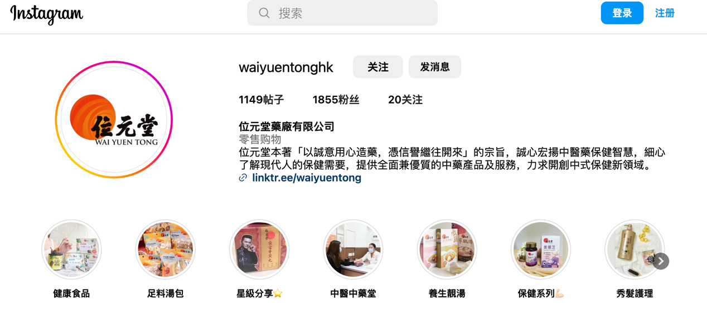
Source: Wai Yuen Tong, 2023b
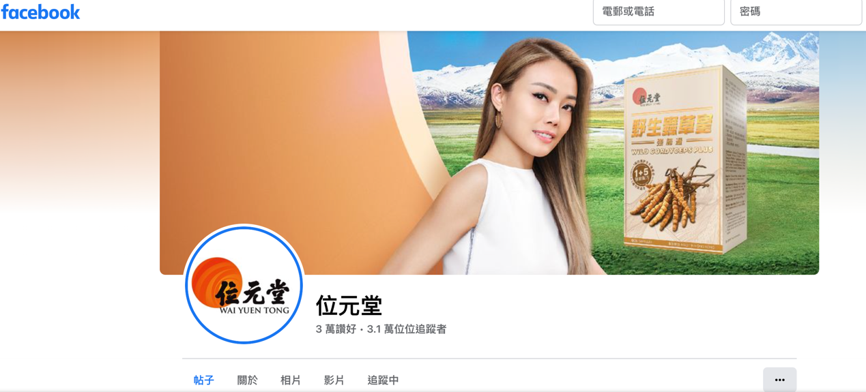
Source: Wai Yuen Tong, 2023c

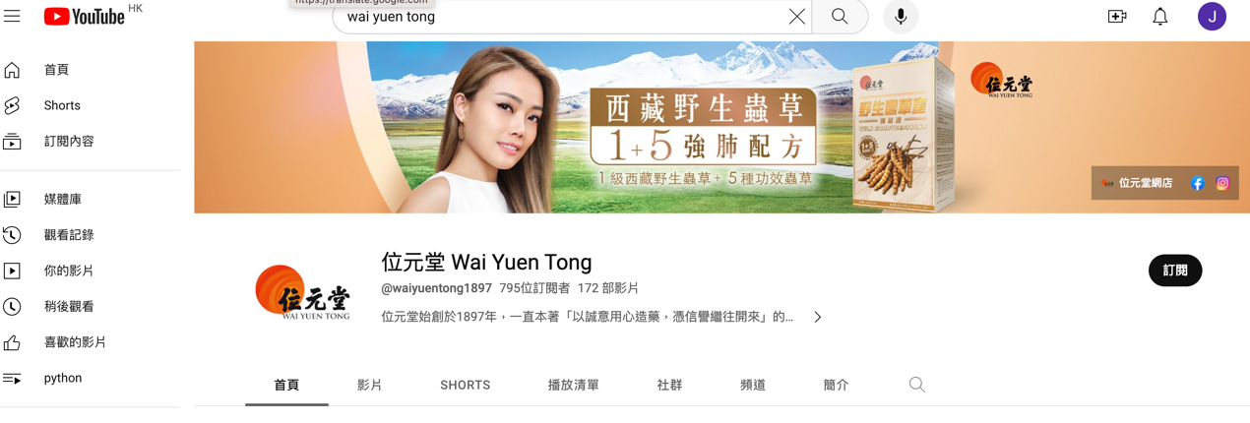
Source: Wai Yuen Tong, 2023d

Wai Yuen Tong has been using television advertisement for years. The most sensational one will be the one advertising Young Yum Yuen in 1970’s by Adam Cheng (Wai Yuen Tong, 2023a) and eventually invited his daughter Joyce Cheng to “response” to the old one.
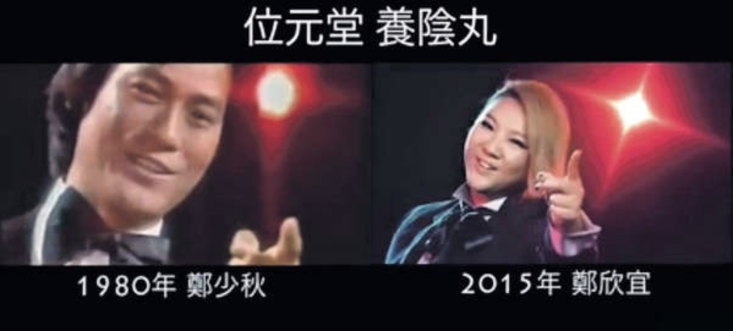
Source: Etnet, 2015

5 Future Development and in the Area of Marketing
Nowadays, people would proactively search what they want to buy on the internet. Therefore, internet can provide a wide variety of search services for finding websites, of various information including target products and their alternative, or even other search engines which might contain such information (Shugan, 2004). And as the purpose using social media for marketing can increase brand awareness in the public, advertising company’s product, receiving feedbacks of products or services and from time to time providing promotional offers. Using social media is inexpensive to reach potential customers and at the same time obtain market information. Therefore, using search engine (for example Key words) and social media will be the trend of marketing (Tenaiji and Cader, 2010), this is not to abandon traditional marketing methodology like television advertisement as television is still the source of information for decades but the role will be a transitional stage. Companies can first broadcast its television advertisement with notification to induce audiences to “click in” the companies’ page in their social media.
6 Recommendation and conclusion
For Wai Yuen Tong, it has got fully use all means of new technology to promote their products and services or even their brand. In fact, the response in terms of number of followers (example: Instagram)(Wai Yuen Tong, 2023b) and number of “likes” (example: Facebook) is at the small portion (Instagram: 21followers; Facebook: 30,000 likes and 31,000 followers)；and interesting findings for Youtube there are only 795 subscribers but some of the video clips can reach more that 570,000 viewers. Therefore, it can show it may be due to the attractiveness of the story board of the video clips of the product. And it is suggested that Wai Yuen Tong can do more on its story board of video clips of its product so that it can create more “noise” in the general public and at the same time not to deviate the position of the company.

7 Reference:

Darmanwan and Grenier, (2021), ‘Competitive Advantage and Service Marketing Mix’, Journal of Social Science Studies Vol. 1, No. 2, Available at https://ejournal.metromedia.education/index.php/jos3/article/view/9/15 (Accessed 5th July 2023)

Etnet, (2015), “欣宜女承父業拍廣告 視迷讚：散發正能量” available at https://www.etnet.com.hk/www/tc/lifestyle/internationalaffairs/entertainment/33428?utm_source=website&utm_medium=copied-text
(Accessed 19th July,2023)

Eu Yan Sang, (2023), Available at https://shop.euyansang.com.hk/SalePage/index/2782 (Accessed 18th July 2023)

Fu, (2021), “The Yin and Yang of traditional Chinese andW estern medicine”, Medical Research Reviews, Available at https://onlinelibrary.wiley.com/doi/full/10.1002/med.21793 (Accessed 20th July 2023)

Goyat (2011), “The basis of market segmentation: a critical review of literature”, European Journal of Business and Management, available at https://d1wqtxts1xzle7.cloudfront.net/13145417/11.The_basis_of_market_segmentation-libre.pdf?1390862356=&response-content-disposition=inline%3B+filename%3D11_The_basis_of_market_segmentation.pdf&Expires=1689695462&Signature=fvkU8Ye3u-CXiXHAIpz9yoc4yzMhqcu8TWJkx1T~UbHZ682ejGTDmYW-ILdLYfQPMloXXLFk9eJMRvh9qolyXBkrqCdWsTAzAZBLZWJrKZTxFfzB5e1CeHKbqDPfWnjdnf6c0b6qeGBFOIaLxKxMAJ5XZkX0xW3-G3BEHt7aq1tBKYHqDJjA02kYI4TOs5-4WFB96156y9yGkuiMD~-o~8O1VmvdM7vMLweOwLvyheuAL52~fjcI98IBNf3vf4VIEn34n17vi3rtSMLnjtJhBKC3D-DT7~ljxM0qPEK9LYepnTcZY4h7BrXSNzjxYxPlgU60KOV4PG2peGr9QBJEfA__&Key-Pair-Id=APKAJLOHF5GGSLRBV4ZA Accessed on 5th July 2023

HKEX, (2023), available at https://www.hkex.com.hk/Market-Data/Securities-Prices/Equities/Equities-Quote?sym=897&sc_lang=en Accessed 8th July 2023

Hong Kong Production Council, (2023), “ForeSight智瞻 - 生產力局再工業化成功案例 助中藥品牌位元堂 包裝效率快六倍 建立智能自動化GMP產品包裝生產系統”, Available at https://www.hkpc.org/zh-HK/hkpc-spotlights/foresight20220824-2 (Accessed 20th July 2023)

Lam, (2001), “Strengths and weaknesses of traditional Chinese medicine and Western medicine in the eyes of some Hong Kong Chinese”, J Epidemiol Community Health, Available at https://jech.bmj.com/content/jech/55/10/762.full.pdf Accessed 20th July 2023)

Ma Pak Leung, (2023), Available at https://www.mapakleung.com/Pak_Fung_Pill_TC (Accessed 18th July 2023)

Mind Tools, (2023), available at https://www.mindtools.com/ajhsltf/porters-value-chain (Accessed on 19th July 2023)

Mohammad, Haghigh and Danai, (2015), Value Added Production in the Company's Electrical Panel Builders West Based on Michael Porter's Value Chain, Available at https://www.researchgate.net/profile/Mohammad-Heydari-18/publication/319664053_Value_Added_Production_in_the_Company's_Electrical_Panel_Builders_West_Based_on_Michael_Porter's_Value_Chain/links/59b8e0080f7e9bc4ca39fc52/Value-Added-Production-in-the-Companys-Electrical-Panel-Builders-West-Based-on-Michael-Porters-Value-Chain.pdf (Accessed 8th July 2023)

Nezakati, Abu and Toh (2011) ‘Exploring Hierarchy Situation of 4A Marketing Mix on Malaysia’s Fast Food Restaurants’, World Applied Sciences Journal, Available at https://www.researchgate.net/profile/Hossein-Nezakati-2/publication/285985514_Exploring_Hierarchy_Situation_of_4A_Marketing_Mix_on_Malaysia‘s_Fast_Food_Restaurants/links/60c7363d4585157774d76897/Exploring-Hierarchy-Situation-of-4A-Marketing-Mix-on-Malaysias-Fast-Food-Restaurants.pdf (Accessed 6th July 2023)

Novak, (2011), ‘PROMOTION AS INSTRUMENT OF MARKETING MIX’, I International Symposium Engineering Management And Competitiveness 2011, Available at https://citeseerx.ist.psu.edu/document?repid=rep1&type=pdf&doi=a7ba6691bb0e869bc2e880951a156f112ade9f4e (Accessed 5th July 2023)

Ostaseviþiǌtơ and Silburyte (2008), “Theoretical Aspects of Product Positioning in the Market”, available at https://www.inzeko.ktu.lt/index.php/EE/article/view/11665 (Accessed 17th July, 2023)

Porter's Value Chain, (2023), Available at https://www.ifm.eng.cam.ac.uk/research/dstools/value-chain-/ (Accessed 2nd July 2023)

Shugan, (2004), “The Impact of Advancing Technology onMarketing and Academic Research”, Marketing Science, Available at https://pubsonline.informs.org/doi/abs/10.1287/mksc.1040.0096 Accessed 20th July 2023)

Singh, (2012), ‘Marketing Mix of 4P’S for Competitive Advantage’, IOSR Journal of Business and Management Available at: https://d1wqtxts1xzle7.cloudfront.net/28251386/G0364045-libre.pdf?1390873668=&response-content-disposition=inline%3B+filename%3DIOSR_JBM_www_iosrjournals_org.pdf&Expires=1688606494&Signature=OhYWKIA5Ek-HhAh21TjruhkxDr6nJZgvYe8NDqq1-o1VaB3c63Q8wWx57LjTc4BApH4xmFN5ogNw73jzVqUI9e0p8lCVGxoGHkrZEZe6BQbU3SQ~t2U4DUwk1vNHfjvsX1zZWwSXI2xuLA12L2Lu3RrZLNe6uT8m~FeXxR6tMq-p9ZPrbV~-S6hrz0co~h3V2YEyfiSboWCeuM5kAVeyrjYULS2FynrlwPF5tkDCup2R59Pav7bETm-rv2HYnw3P~oT1eaZtavi-b7IV7e2dSgBF5lMK3CN5PRAN6m17hMQYzUGE8qVYNhZGqmU~y18Xed04fGULv~7HoyvuXHedYQ__&Key-Pair-Id=APKAJLOHF5GGSLRBV4ZA (Accessed 5th July 2023)

Stheadline (2022), [每日雜誌｜致力提供完善治療 位元堂建中醫團隊傳承國粹], Available at https://www.stheadline.com/society/3182466/%E6%AF%8F%E6%97%A5%E9%9B%9C%E8%AA%8C%E8%87%B4%E5%8A%9B%E6%8F%90%E4%BE%9B%E5%AE%8C%E5%96%84%E6%B2%BB%E7%99%82-%E4%BD%8D%E5%85%83%E5%A0%82%E5%BB%BA%E4%B8%AD%E9%86%AB%E5%9C%98%E9%9A%8A%E5%82%B3%E6%89%BF%E5%9C%8B%E7%B2%B9 (Accessed 20th July 2023)

Targeting (2023), What are segmentation, targeting & positioning (STP) in marketing, Available at https://thestrategystory.com/blog/what-are-segmentation-targeting-positioning-stp-in-marketing/ (Accessed 6th July 2023)

Tenaiji and Cader, (2010), “SOCIAL MEDIA MARKETING IN THE UAE”, European, Mediterranean & Middle Eastern Conference on Information Systems 2010, Available at https://d1wqtxts1xzle7.cloudfront.net/7293013/c95-libre.pdf?1390850815=&response-content-disposition=inline%3B+filename%3DSOCIAL_MEDIA_MARKETING_IN_THE_UAE.pdf&Expires=1690057347&Signature=J7hhsU0g0aqtK9~tBO-lu1d7recOe7o4YEOvmEcuQIQVCGih~4z9B~azqQ39MBA9xk3IMDcZhCKBgMLxRLWLvK3B6aAOF-DEqltTU~Ps1LsZD2Rn7roP49gnVVYUampZeul~8xvm0~YJOpSbGGMN-3IKMVk3ppw1m2i~oI5kc1LwmEp0NM7Z6L6~6b33KvzrsT1LfBjhK~EW76quuonxZpfr9yAi~b6krR3IMTN6i7aCWlkhNnnZKZ7ucKj1t-MnHfu84IRpXEmMyq8ul8a7z~VjOyBNZGtZEJuoEhcMlPe0TLCCeYj89OjX4tbYbT~zLbKeiWkatFwUs2LPUuPfXQ__&Key-Pair-Id=APKAJLOHF5GGSLRBV4ZA (Accessed 20th July 2023)

Wai Yuen Tong, (2023a), Available at https://www.wyteshop.com/en/pages/company-introduction Accessed 2nd July, 2023

Wai Yuen Tong, (2023b) Available at https://www.instagram.com/waiyuentonghk/ (Accessed 19th July 2023)

Wai Yuen Tong, (2023c), Available at https://www.facebook.com/waiyuentonghk/?locale=zh_HK (Accessed 19th July 2023)

Wai Yuen Tong, (2023d), Available at https://www.youtube.com/@waiyuentong1897 (Accessed 19th July 2023)

Wai Yuen Tong, (2022) Annual report, Available at https://www.wyth.net/report_pdf/e-887914-wai-yuen-tong-0719-1600-ess-compressed-2022-07-22_en.pdf (Accessed 18th July 2023)

Zhang et al, (2020), “Does a firm’s supplier concentration affect its cash holding?”, Available at https://www.sciencedirect.com/science/article/pii/S0264999319309770 (Accessed 20th July 2023)

