SUMMARY

Teamwork is valued by businesses of all sizes and in a wide range of fields as a means of fostering employee engagement, fostering a sense of community on the job, and ultimately, increasing productivity. Companies often use a project-based methodology to create novel ideas or products and form teams to concentrate on their tasks to succeed. Over time, groups become more and more effective as members learn what is expected of them and how to best use the knowledge, skills, and traits of all team members to succeed in meeting organizational and personal objectives. Uncertainty and even disagreement are inevitable on the road to efficiency and maturing into genuine teams, but they should be accepted as the price to pay for preserving group cohesion and encouraging desired behavior as everyone works toward a shared objective. In this report, we looked at the characteristics of team and teamwork, the advantages and what may go wrong when using teams, model of team development and the effectiveness use of the team itself.

Table of Contents
SUMMARY 1
INTRODUCTION 3
OVERVIEW OF TEAM WORKING 4
MODELS OF TEAM DEVELOPMENT 6
TUCKMAN’S MODEL 6
HOMANS’ MODEL 7
TEAM ROLES 8
DISCUSSION 10
CONCLUSION AND RECOMMENDATION 12
REFERENCES 13

INTRODUCTION

It is crucial to the success of any company or organization that its employees work together as a cohesive unit. Teams are formed and utilized to actualize particular responsibilities and tasks, as well as to accomplish or assist in the completion of objectives that have been clearly expressed by the company. Only a high-performing team will do this if management wants to achieve its goals successfully. As a result, the purpose of this paper is to investigate the factors that contribute to the functioning of a team, the factors that contribute to the achievement of successful collaboration, how teams can grow and thrive, and the models that have been demonstrated to be the most effective.

OVERVIEW OF TEAM WORKING

According to West M.A., humans have a shared history of living, loving, growing older, and working in communities (West, 2012). To live, work, and play together, as well as to collaborate on a specific goal, is to be part of a team in any human civilization. Team is the process of measuring worker performance, conveying information, and investigating approaches to enhance performance. (John W. Newstrom et. al., 1993). In addition to helping the company as a whole, the morale and productivity of individual employees may be boosted when they feel that they are contributing to something bigger than themselves at work. For a team to function smoothly, each member must first have a solid grasp of his or her role and how to fulfil it (e.g., training), and secondly, each member must be sufficiently motivated to carry out the task at hand (e.g., intrinsic rewards). Productivity and efficiency rise when team members can rely on one another to get the task done.
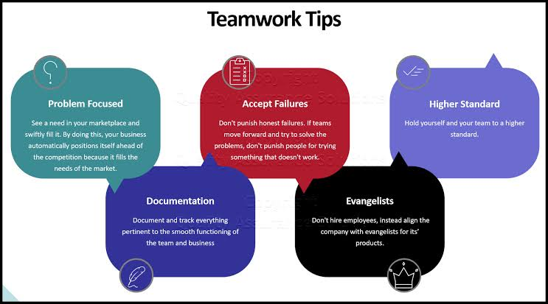
Figure 1 Showing the definition and concept necessary for team formation
Therefore, it is essential to comprehend team functioning, team dynamics, and team decision-making. Knowledge of collaboration events may help them attain their goals more efficiently. Employees may buy into an organization's core values since they are rooted in the company's history, structure, and traditions. Building trust between teammates is crucial to any team's success. Accordingly, its absence unavoidably contributes to a decline in team performance.

MODELS OF TEAM DEVELOPMENT

The fact that Tuckman's model acknowledges that groups do not begin completely formed and functioning makes it noteworthy and worth considering. His theory proposes that teams go through several phases, beginning with a loose collection of people and culminating in an efficient unit focused on a specific goal.

TUCKMAN’S MODEL

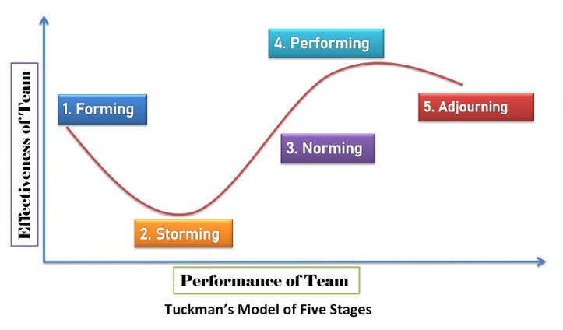
Figure 2 Showing Tuckman's Model of 5 stages

The majority of ideas about the growth of organizational groups center on trying to pin down the specific steps that organizations take from their inception to their eventual disintegration. Most papers use a model created by Bruce W. Tuckman in 1965 and refined since then to illustrate the steps that lead to the establishment of a group (Tuckman & Jensen, 1977). There are five (initially four) stages or phases in the development of a group, and this model has been adopted and expanded upon in several different ways over the years in management theory and theory on organizational behaviour (Coulter, 2005).
- Setting up stage (forming): represents the beginning of group dynamics; it is characterized by a degree of ambiguity and uncertainty that need the guidance and direction of an established leader.
- Conflict stage (storming): initial signs of trouble, disagreements, and fights for control, all inside the group itself; animosity amongst members, etc., is observable;
- Cohesion stage (norming): friendships and mutual support networks are forming, and the community as a whole is coming to accept certain rules and customs.
- Effectiveness stage (performing): members have developed interdependence of one another, relationships between them are mature and based on mutual trust, and they act daily as a whole, as a "mechanism" that works harmoniously and achieves effects of synergy; intensity of rivalry between them is functional and useful for the common purpose, members display a maximum engagement to the motivating objectives, etc. (Dessler, 2004);
- Dismantling stage or “breaking”: This is the point at which the organization begins to disband or "break," either because its goals have been accomplished or because some of its members have left.

HOMANS’ MODEL

Homans' central claim is that groups don't behave according to normative models (which specify what the group should create), but rather, they go via an intermediate stage (that of emergence) in which their actual behaviors are altered in accordance with enforced criteria. (Curşeu, 2007). Nonetheless, since the majority of ideas about the growth of organizational groups center on trying to pin down the specific steps that organizations take from their inception to their eventual disintegration. Bruce W. Tuckman's model is widely used in scholarly works to describe the dynamics of group dynamics.

TEAM ROLES

Today, the ability to work together efficiently as a team is considered a fundamental issue by most businesses. Numerous elements may affect a team's performance, but one that has received a lot of attention is the impact of job diversity on that performance. Both practitioners and academics make heavy use of the team role model developed by Meredith Belbin in the context of management teams (Belbin, 1981, 1993a) and made commercially accessible by Belbin Associates (1988). Team roles were defined in terms of the eight roles identified by Belbin (1981) and described as "a pattern of behavior typical of how one team member interacts with another to promote the success of the team as a whole." Among the eight roles, Belbin (1993) identifies the following traits:
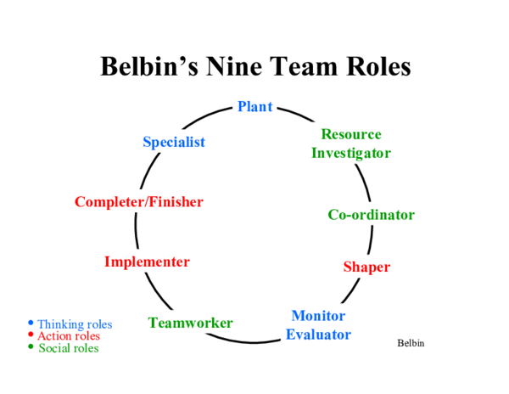
Figure 3 Showing the Nine Team Roles according to Belbin
- The role of the implementer is to see that the team's ideas and plans are put into action. For this, you'll need a practical mindset and the will to keep going despite setbacks.
- The coordinator is the person who oversees and directs the group's daily operations. This entails making sure everyone is on the same page with the team's goals and challenges, giving everyone a role to play, and inspiring everyone to do their best.
- Shaper raises questions, debates, and disagrees. Is goal-oriented, outgoing, impatient, and insightful.
- Plant's focus is on contributing to the team's goal-realization process by suggesting new approaches. Creativity, ingenuity, and invention are prerequisites for success in this position.
- The Resource Investigator's job is to go outside the team and pull ideas, data, and materials from the world around them. Developing relationships, coordinating with others, and negotiating with others are all part of this job.
- The role of the Monitor Evaluator is to analyze the team's current proposals and ideas and determine whether or not they are practical and helpful in reaching the team's goals.
- Teamworker fosters and sustains cohesive teams. By easing tension and resolving conflicts within the group and encouraging open dialogue between team members, this goal may be achieved.
- The finisher's job is to make sure the team meets all of its goals and that no errors are made, either intentionally or unintentionally. Also essential are the vigilant pursuit of specific errors and the constant cultivation of a feeling of urgency between team members.

DISCUSSION

The study by Campion, Medsker, and Higgs [1993] found that there is a correlation between team members' liking for working together and the efficiency of their efforts. Workers and managers at a big financial services firm participated in an assessment of 19 group characteristics including composition, context interdependence, job design, and process. We compared these factors to measures of efficacy such as staff satisfaction, output, and supervisor opinions. The sample size was large enough to be statistically significant (39 workers, 70 managers, and 80 sets of historical data). All three measures of efficacy were shown to be predictably associated with the traits, with the vast majority of the attributes also being predictive of individual measures of effectiveness. Campion argues that self-managed teams in particular benefit from the intrinsic drive afforded by group work settings. Campion's research is bolstered by the findings of a study conducted by Stevens and Campion, which examine the role that human resources (HR) plays in the success and efficiency of team building in the workplace.
Data from a cross-sectional survey conducted in 2007 and 2008 by Chuang, Dill, Morgan, and Konrad [2016] was obtained from 661 frontline healthcare employees at 13 significant healthcare employers. Both a regression model and a fuzzy-set qualitative comparative analysis model were used to investigate the data. According to their findings, both high job satisfaction and good quality of care need supervisor support and team-based work procedures. However, implementing just supervisor assistance and team-based work practices was not enough to achieve these benefits; additional high-performance work practices were also necessary. Multiple arrangements of high-performance work practices were linked to either superior care quality or greater job satisfaction in the same research. However, there was only one combination of high-performance work practices that was enough for both: a mix of supervisor assistance and team-based work, as well as some degree of flexibility in the workday. While studies have shown that cooperation has many positive effects, they have also uncovered certain drawbacks, such as the fact that many individuals dislike participating in group projects. There has been a rise in the usage of work teams, to the point that they are sometimes implemented in contexts where alternative methods, such as individual work, would be more appropriate. The results of research on quality circles and factories, respectively, show that neither is very successful.
The efficiency of teams was found to be mixed in a study conducted by the Saratoga Institute. With respect to salary, performance evaluation, and team design, the Saratoga Institute polled sixty-one American businesses on their practices. When asked about their progress in overcoming the risks associated with cooperation and reaching their operational objectives, more than half of the firms claimed success. With these numbers, it seems that 50% of businesses are failing to achieve their objectives. As a result, more work has to be done before the team-based organization can be considered fully successful. Work groups within an organization require well-defined purposes and objectives. The team has to have clear, quantifiable, and motivating objectives and goals that are constantly communicated to them. These targets and goals should be aligned with the company's ethos, guiding principles, and strategic priorities, and they should lead to measurable, attainable, and attainable outcomes. Sundstrom [1990] found that to assure successful teams, companies needed to evaluate elements including organizational context, boundaries, and team growth. Organizational team performance and efficiency were examined by Guzzo and Dickson [1996] in their comprehensive literature study. When several adjustments are made all at once, such in components like human resource management techniques, performance indicators show the most improvement. They also discovered that businesses whose management strategies emphasized the value of teams in the workplace were more likely to succeed in a variety of metrics of performance.

CONCLUSION AND RECOMMENDATION

Getting to the bottom of teamwork's foundational elements and its efficacy in realizing the organization's aims is the primary focus of this paper. Cooperation gives access to a wealth of knowledge and information, as well as the cultural distinctions that contribute to a culture of teamwork and the ability to make beneficial problem-solving decisions. For a team to function smoothly, each member must first have a solid grasp of his or her role and how to fulfill it (e.g., training), and secondly, each member must be sufficiently motivated to carry out the task at hand (e.g., intrinsic rewards). Teamwork is essential to the success of any business, and any enterprise that is serious about achieving its goals must ensure that its teams are performing at peak efficiency. Therefore, it is essential to comprehend team functioning, team dynamics, and team decision-making. Organizational ideals and assumptions serve as compass points for employees. Each team member has inherent value and merit, and the team as a whole has the potential and obligation to work together to find solutions to issues and bring about good change.

REFERENCES

Belbin Associates (1988). Interplace: Matching People through Jobs. Cambridge: Belbin Associates
Belbin, M. (1981). Management Teams, Why They Succeed or Fail. London: Heinemann
Belbin, M. (1993a). Team Roles at Work. Oxford: Butterworth-Heinemann
Campion, M.A. Medsker G.J. and Higgs C. (1993). “Relations between work group characteristics and effectiveness: Implications for designing effective work groups”. Personnel Psychology, vol. 46, pp. 823-850
Chuang, E. Dill, J. Morgan J.C. and Konrad T.R. (2012). “A configurational approach to the relationship between high-performance work practices and frontline health care worker outcomes”. Health Services Research, vol. 47(4) 1460(22), Available: http://infotrac-college.cengage.com [Jun, 5 2016]
Curşeu, P.L., (2007), Grupurile în organizaţii, Ed. Polirom, Iaşi
Golonka, K. and Mojsa-Kaja, J. “Emotional intelligence and team roles – Analysis of interdependencies with regard to teamwork effectiveness”. Contemporary Management Quarterly / Wspólczesne Zarzadzanie, vol. 12(4), pp. 32-44, 2013
Guzzo R. and Dickson, M. (1996) “Teams in organizations: Recent research on performance and Effectiveness”. Annual Review of Psychology, vol. 47, pp. 307-338
Hackman, J.R &Vidmar N (1970) Effects of size and task type on group performance & member reactions. Sociometry, 33, 37-54
John W. Newstrom et al (1993). “Organizational Behavior, Human behavior at work” 9th ed. published by Mc-Grahill-Inc. USA
Plaminek, J. (2006). How to solve conflicts: 27 rules for effective negotiations. 1 ed. Praha: Grada Publishing, 2006.ISBN 80-247-1591-0
Sundstrom, E. DeMeuse, K.P. and Futrell, D. (1990) “Work teams: Applications and Effectiveness”. American Psychologist, vol. 45, pp. 120-133
Tuckman, B.W., Jensen, M.A.C., (1977), Stages of Small-Group Development Revisited, Group and Organizations Studies, 2, 4; pp. 419-427, ABI/INFORM Global
West M.A. (2012). Effective: Practical Lessons from Organizational Research, Oxford, Blackwell Publishing, 3rd Edition. p. 7

